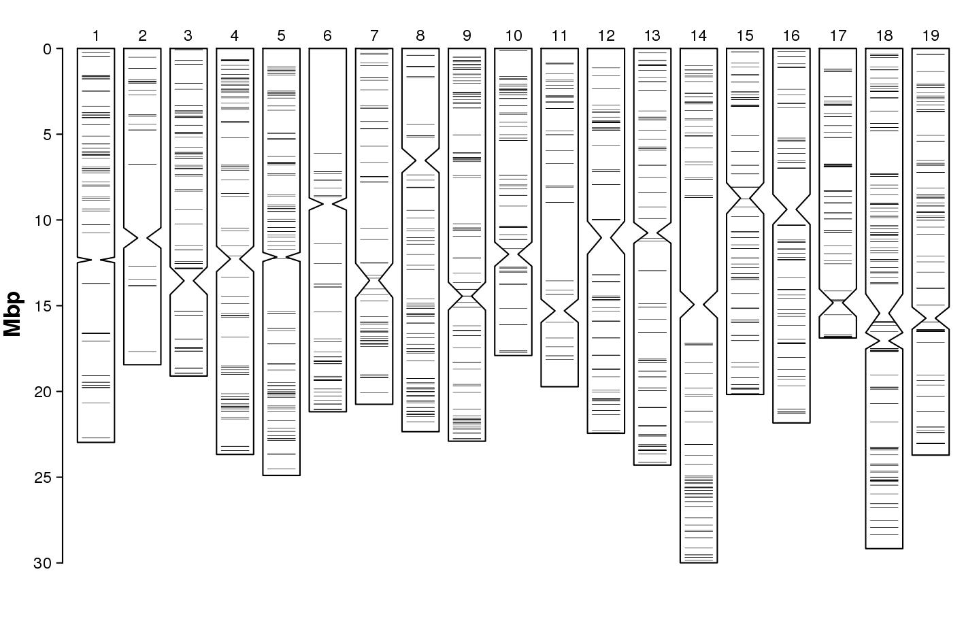
Supplementary figure 1: Random distribution of unmatching SNPs (Mendelian inconsistencies) across genome) for ‘Surina’ (IPTPO08) parentage (‘Belina starohrvatska’ (‘Heunisch Weiss') (AF13) × ‘Bljuzgavac’ ('Blank blauer') (AF21))
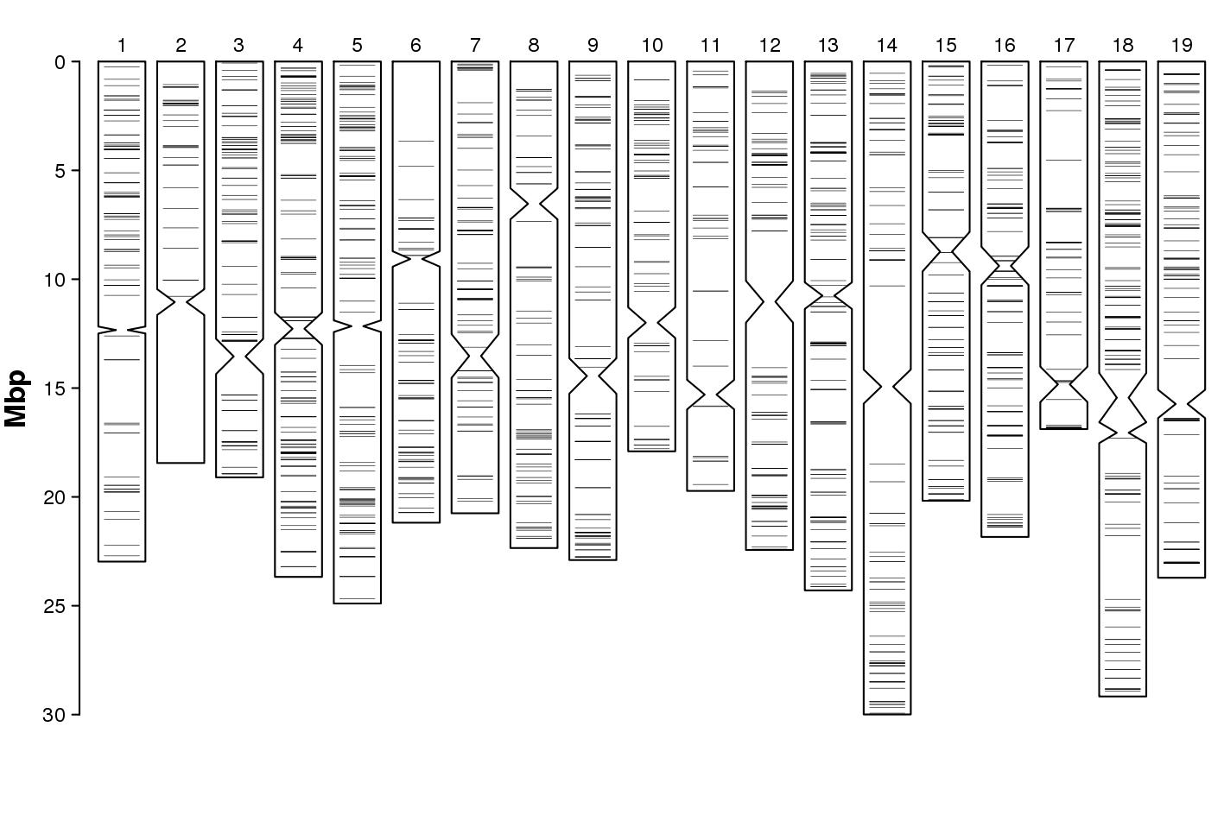
Supplementary figure 2: Random distribution of unmatching SNPs (Mendelian inconsistencies) across genome for ‘Svjetljak’ (AF32) parentage (‘Belina starohrvatska’ (‘Heunisch Weiss') (AF13) × ‘Bljuzgavac’ ('Blank blauer') (AF21))
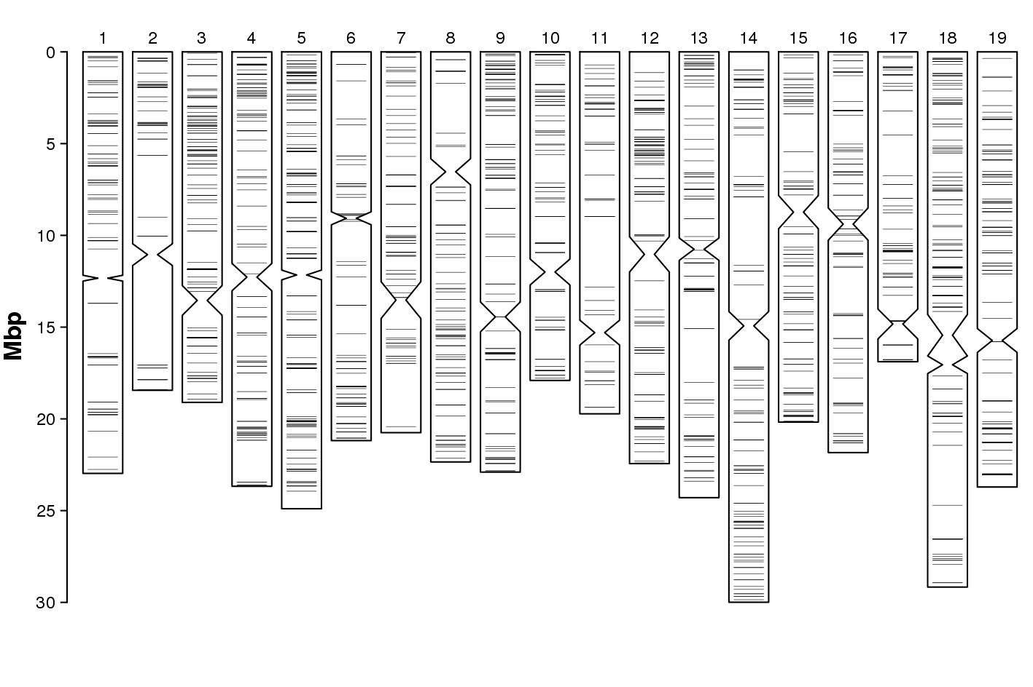
Supplementary figure 3: Random distribution of unmatching SNPs (Mendelian inconsistencies) across genome for ‘Ranfol’ (AF18) parentage (‘Belina starohrvatska’ (‘Heunisch Weiss') (AF13) × ‘Bljuzgavac’ ('Blank blauer') (AF21))
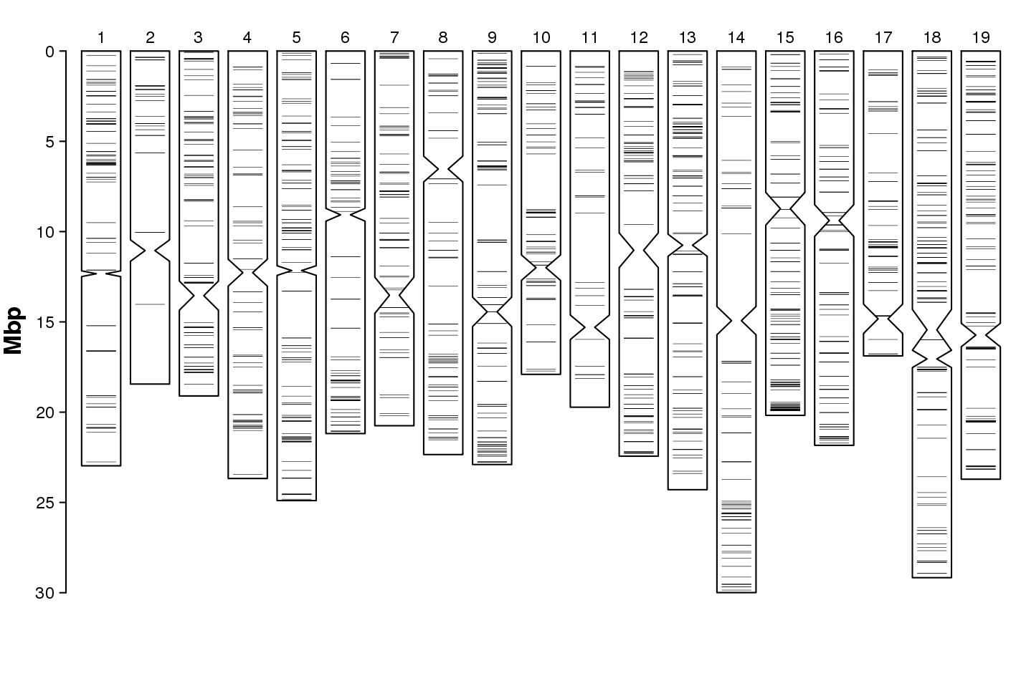
Supplementary figure 4: Random distribution of unmatching SNPs (Mendelian inconsistencies) across genome for ‘Plavec žuti’ (AF12) parentage (‘Belina starohrvatska’ (‘Heunisch Weiss') (AF13) × ‘Bljuzgavac’ ('Blank blauer') (AF21))
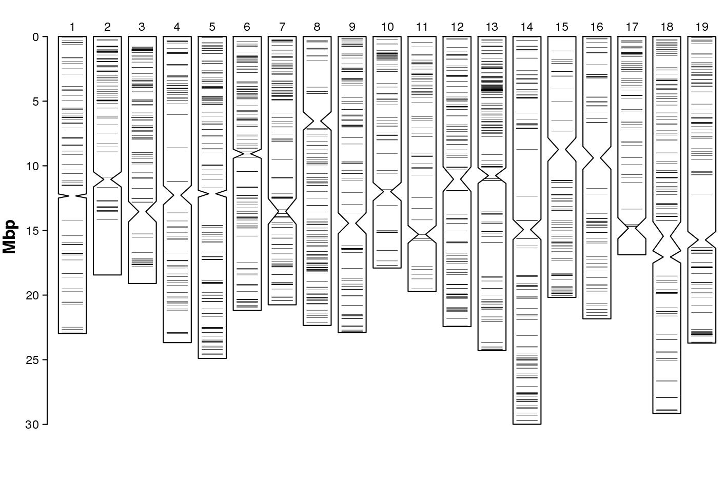
Supplementary figure 5: Random distribution of unmatching SNPs (Mendelian inconsistencies) across genome for ‘Debit’ (HR64) parentage (‘Bombino bianco’ (HR44) × ‘Lasina’ (HR23))

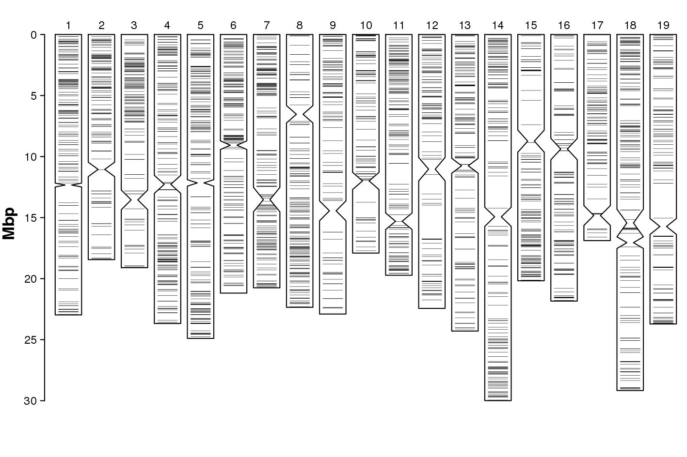
Supplementary figure 6: Random distribution of unmatching SNPs (Mendelian inconsistencies) across genome for ‘Krstičevica’ (HR67) parentage (‘Bombino bianco’ (HR44) × ‘Plavina’ (HR28))
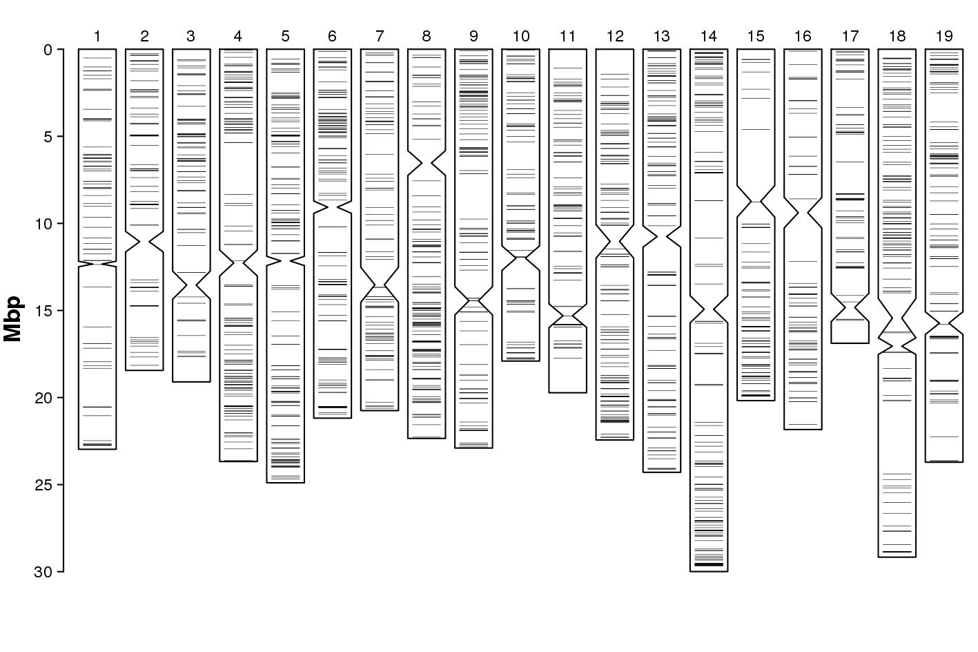
Supplementary figure 7: Random distribution of unmatching SNPs (Mendelian inconsistencies) across genome for ‘Ljutun’ (HR24) parentage (‘Bombino bianco’ (HR44) × ‘Plavac mali’ (HR33))

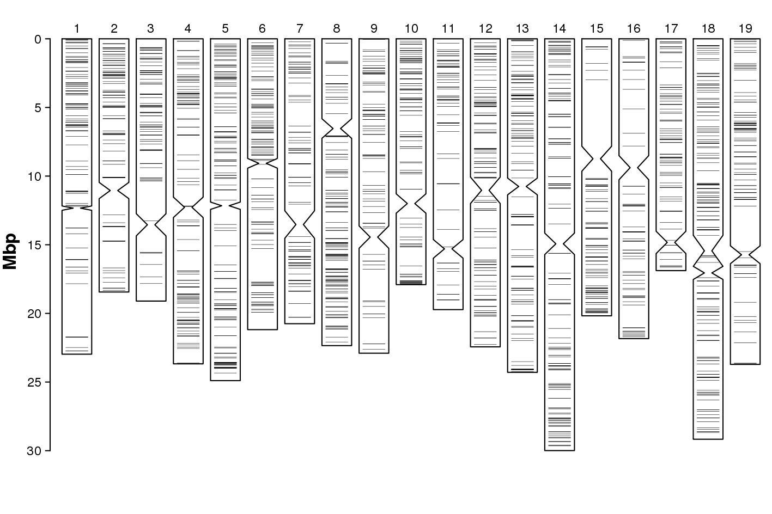
Supplementary figure 8: Random distribution of unmatching SNPs (Mendelian inconsistencies) across genome for ‘Ninčuša’ (HR32) parentage (‘Bombino bianco’ (HR44) × ‘Plavac mali’ (HR33))

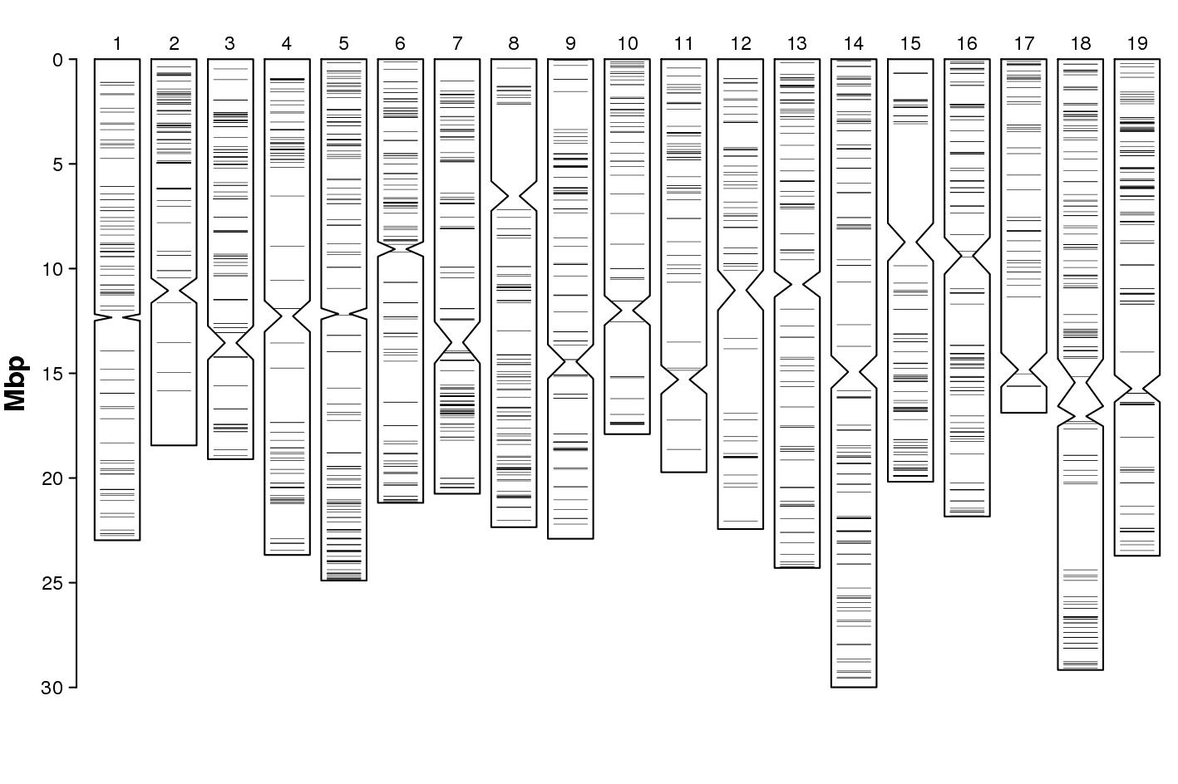
Supplementary figure 9: Random distribution of unmatching SNPs (Mendelian inconsistencies) across genome for ‘Kurtelaška’ (AF24) parentage (‘Bombino bianco’ (HR44) × ‘Maraština omiš’(HR19))
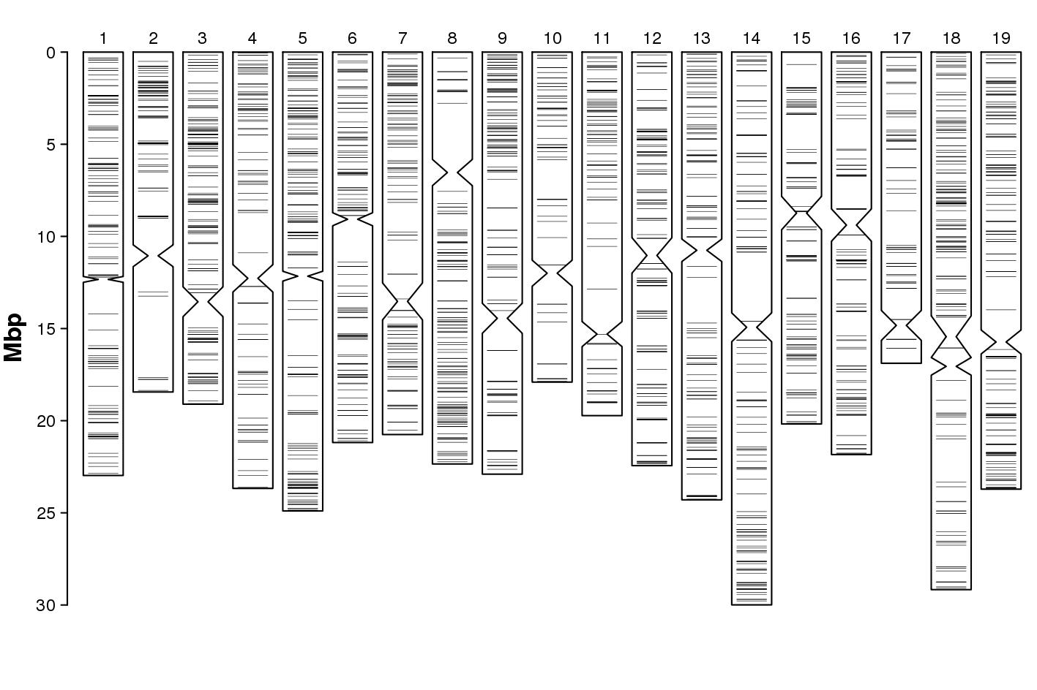
Supplementary figure 10: Random distribution of unmatching SNPs (Mendelian inconsistencies) across genome for ‘Gegić’ (HR41) parentage (‘Bombino bianco’ (HR44) × ‘Bilina privlačka’ (AF15))
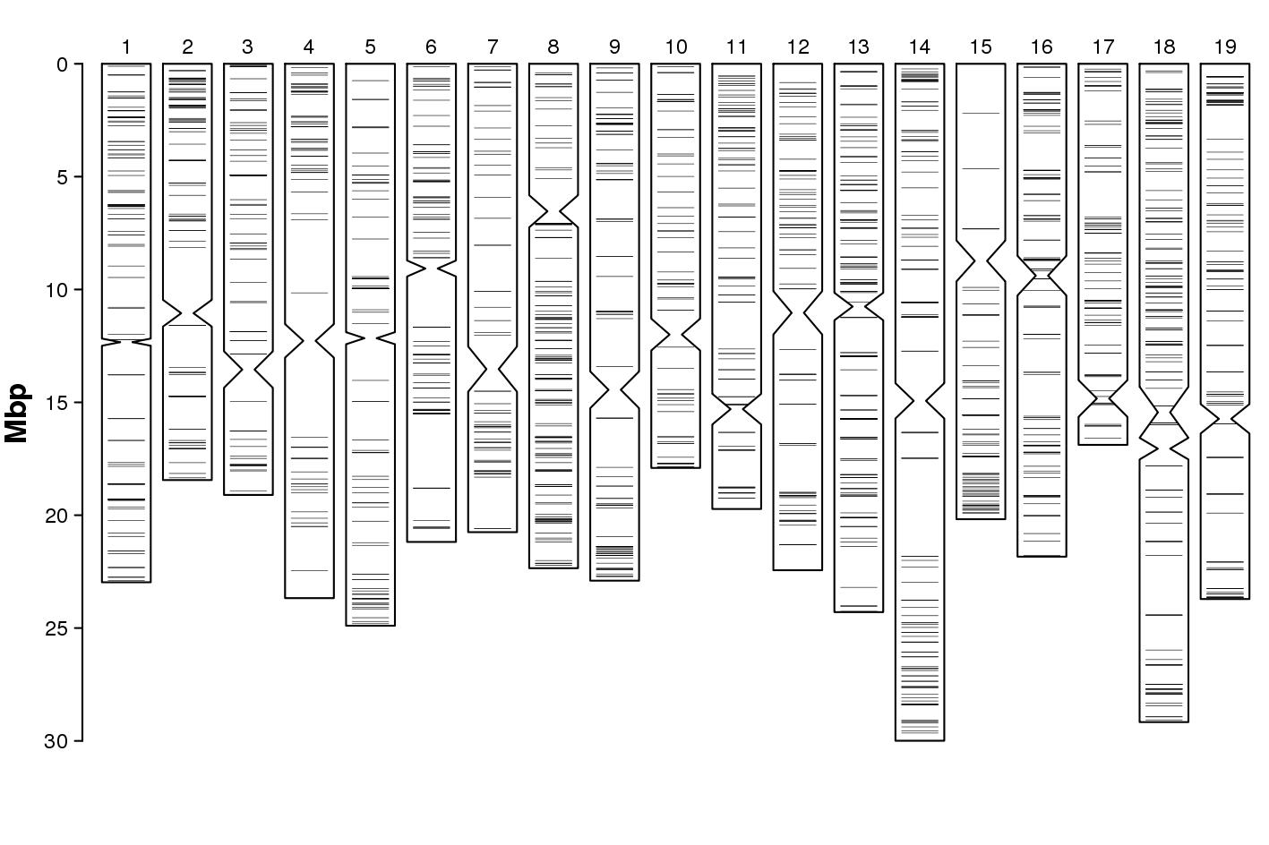
Supplementary figure 11: Random distribution of unmatching SNPs (Mendelian inconsistencies) across genome for ‘Glavinuša kaštela’ parentage (‘Plavac mali’ × ‘Vugava vis’)
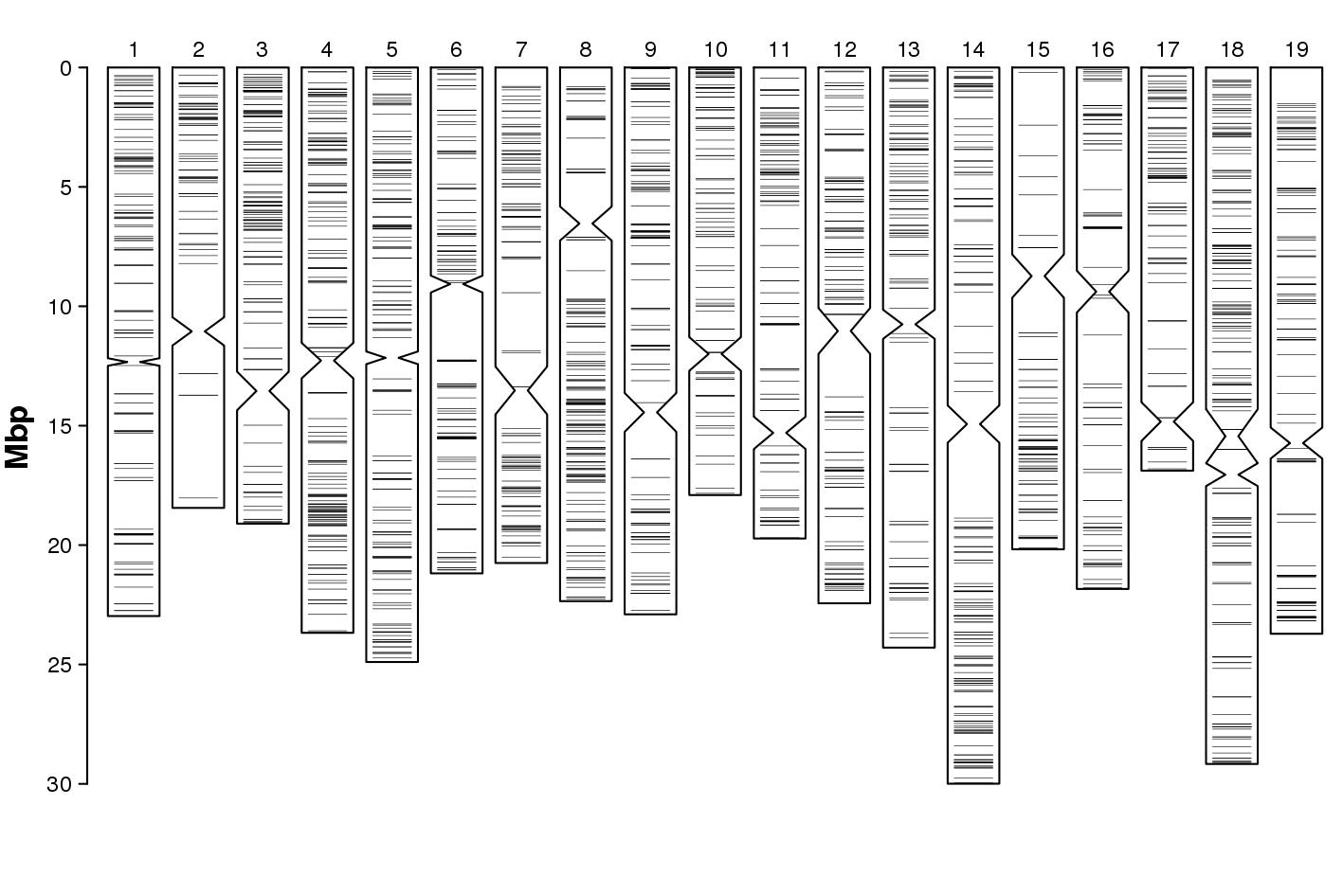
Supplementary figure 12: Random distribution of unmatching SNPs (Mendelian inconsistencies) across genome for ‘Pošip bijeli’ (HR05) parentage (‘Zlatarica blatska’ (HR61) × ‘Bratkovina bijela’ (HR60))
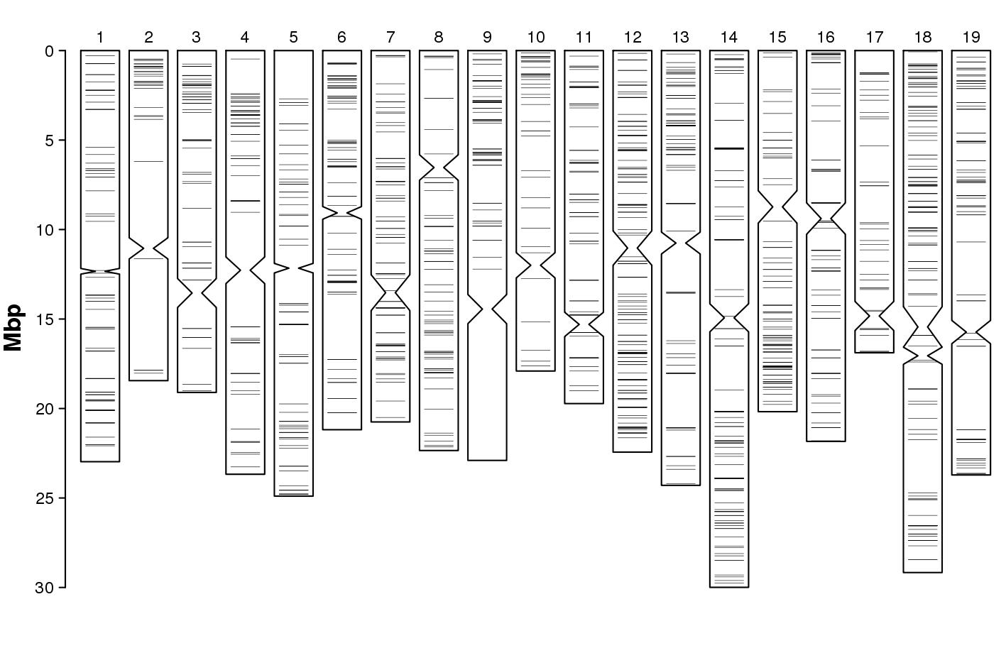
Supplementary figure 13: Random distribution of unmatching SNPs (Mendelian inconsistencies) across genome for ‘Mejsko bijelo’ (AF34) parentage (‘Žumić’ (AF05) × ‘Duranija’ (IPTPO07))
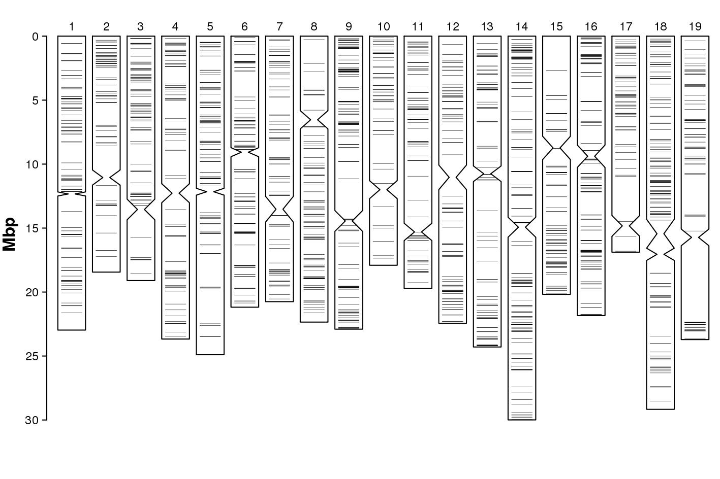
Supplementary figure 14: Random distribution of unmatching SNPs (Mendelian inconsistencies) across genome for ‘Dolcin’ (IPTPO10) parentage (‘Rukatac’ ('Malvasia bianca lunga') (HR01) × ‘Verdić’ (‘Glera’) (AF19))
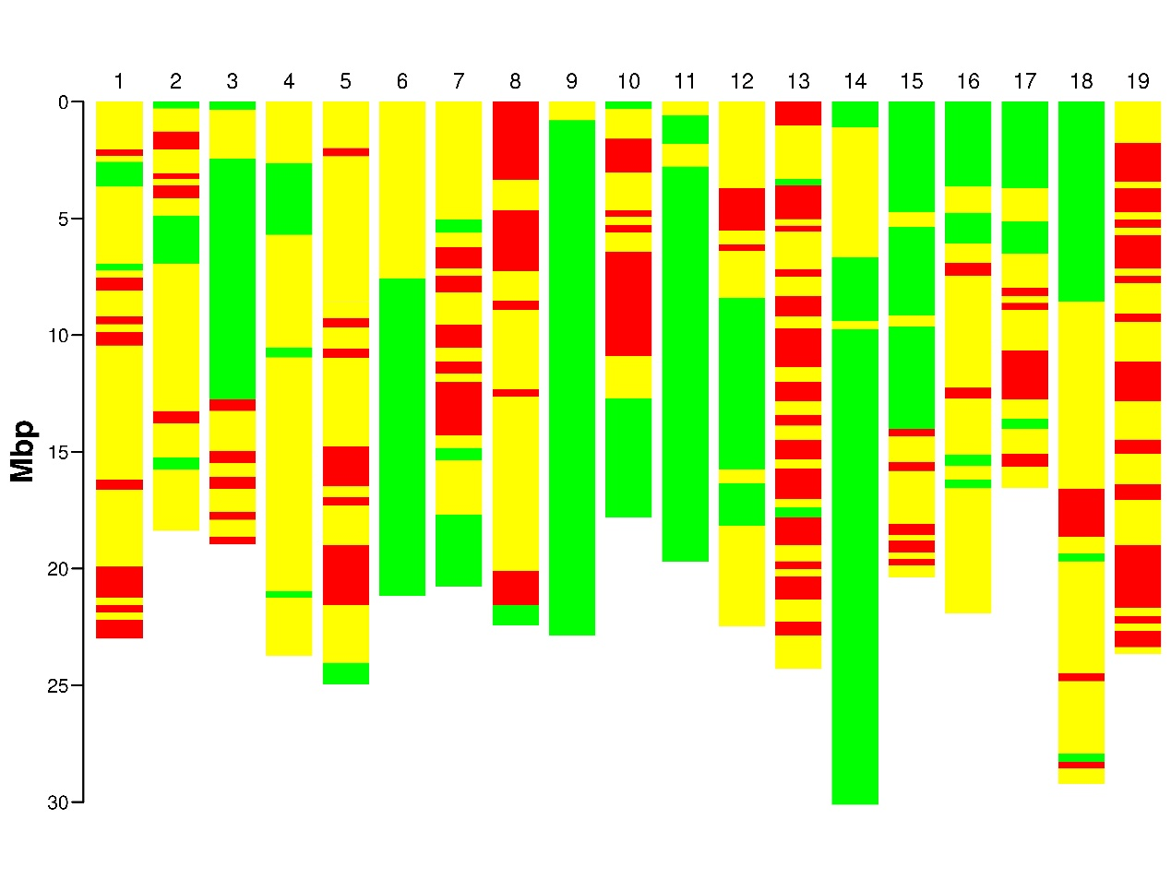
Supplementary figure 15: IBD coefficients between ‘Plavec žuti’ (AF12) and ‘Surina’ (IPTPO08); IBD0 -Red, IBD1 – Yellow, IBD2 - Green
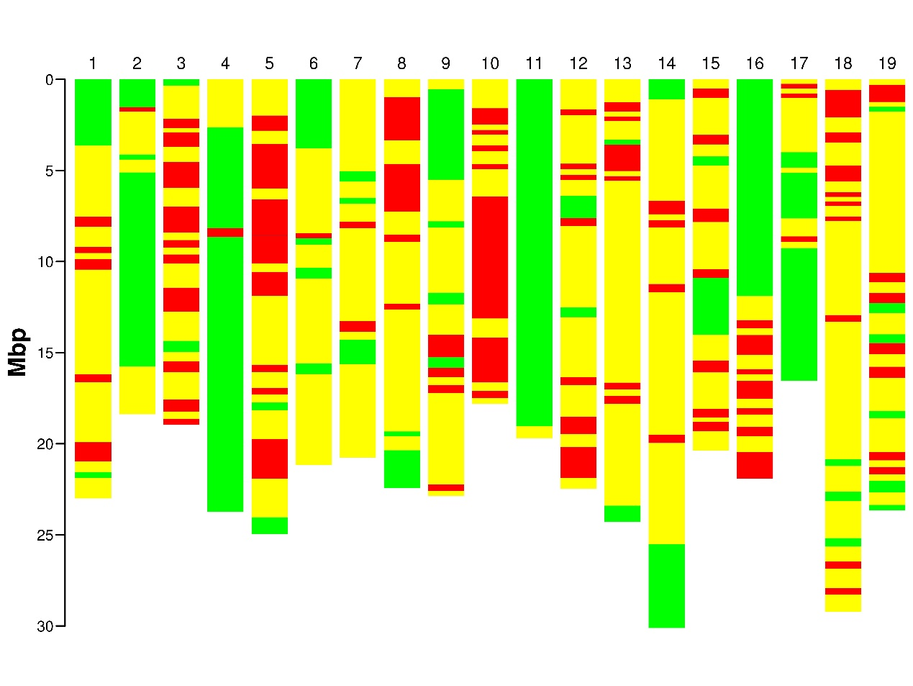
Supplementary figure 16: IBD coefficients between ‘Plavec žuti’ (AF12) and ‘Ranfol’ (AF18); IBD0 -Red, IBD1 – Yellow, IBD2 - Green

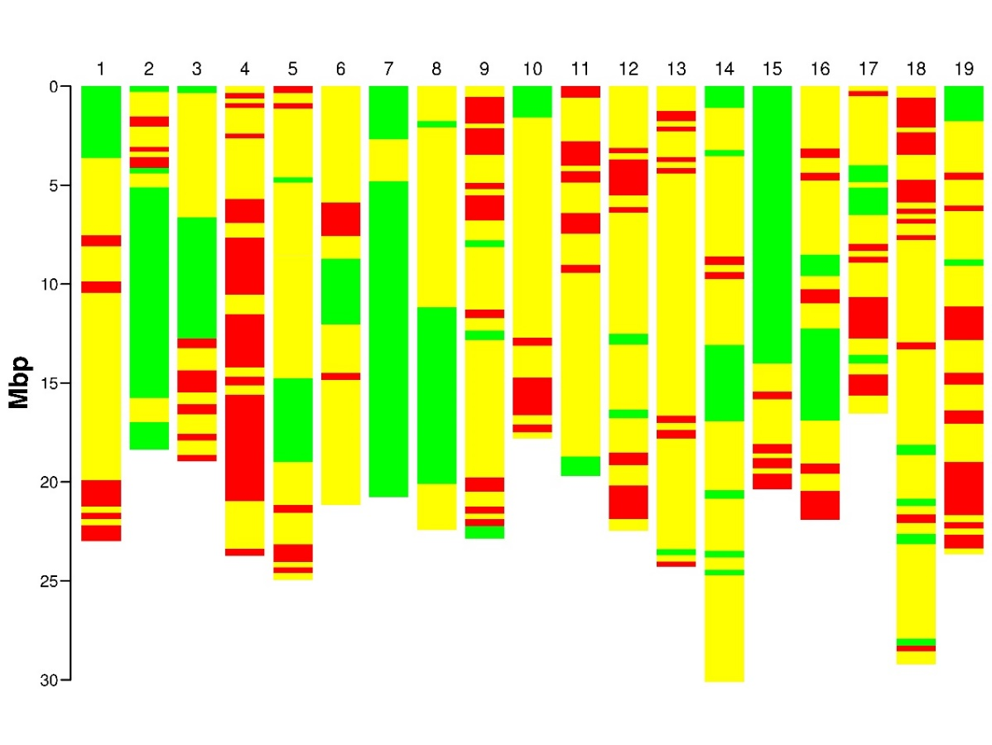
Supplementary figure 17: IBD coefficients between ‘Plavec žuti’ (AF12) and ‘Svjetljak’ (AF32); IBD0 -Red, IBD1 – Yellow, IBD2 - Green
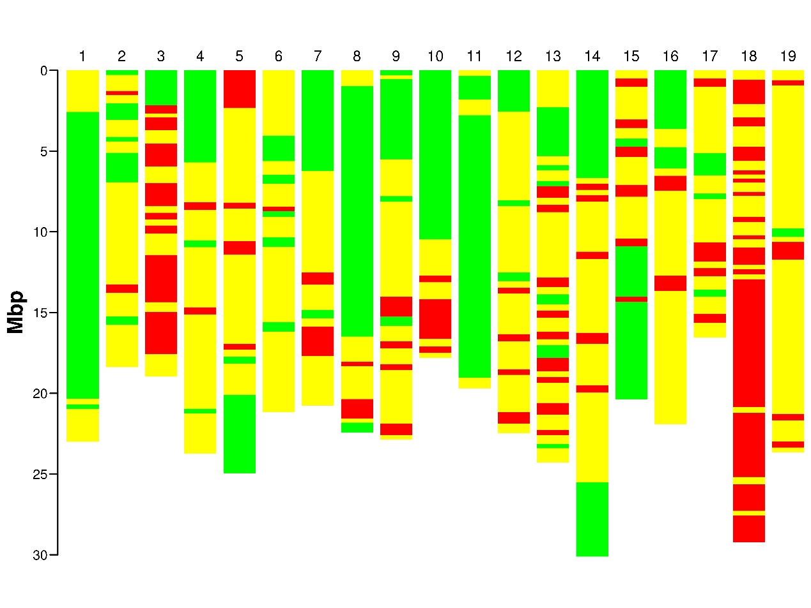
Supplementary figure 18: IBD coefficients between ‘Ranfol’ (AF18) and ‘Surina’ (IPTPO08); IBD0 -Red, IBD1 – Yellow, IBD2 - Green

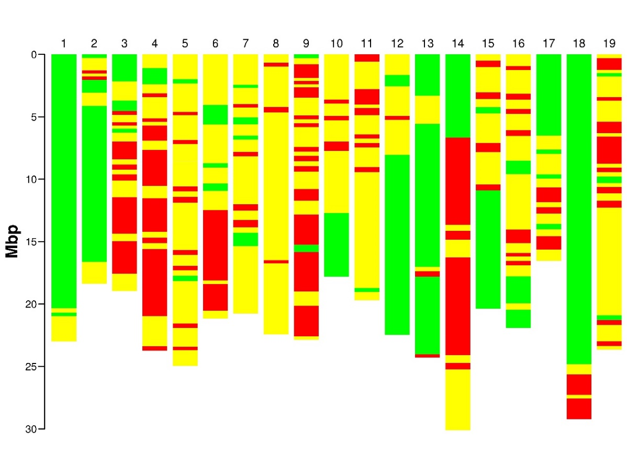
Supplementary figure 19: IBD coefficients between ‘Ranfol’ (AF18) and ‘Svjetljak’ (AF32); IBD0 -Red, IBD1 – Yellow, IBD2 - Green
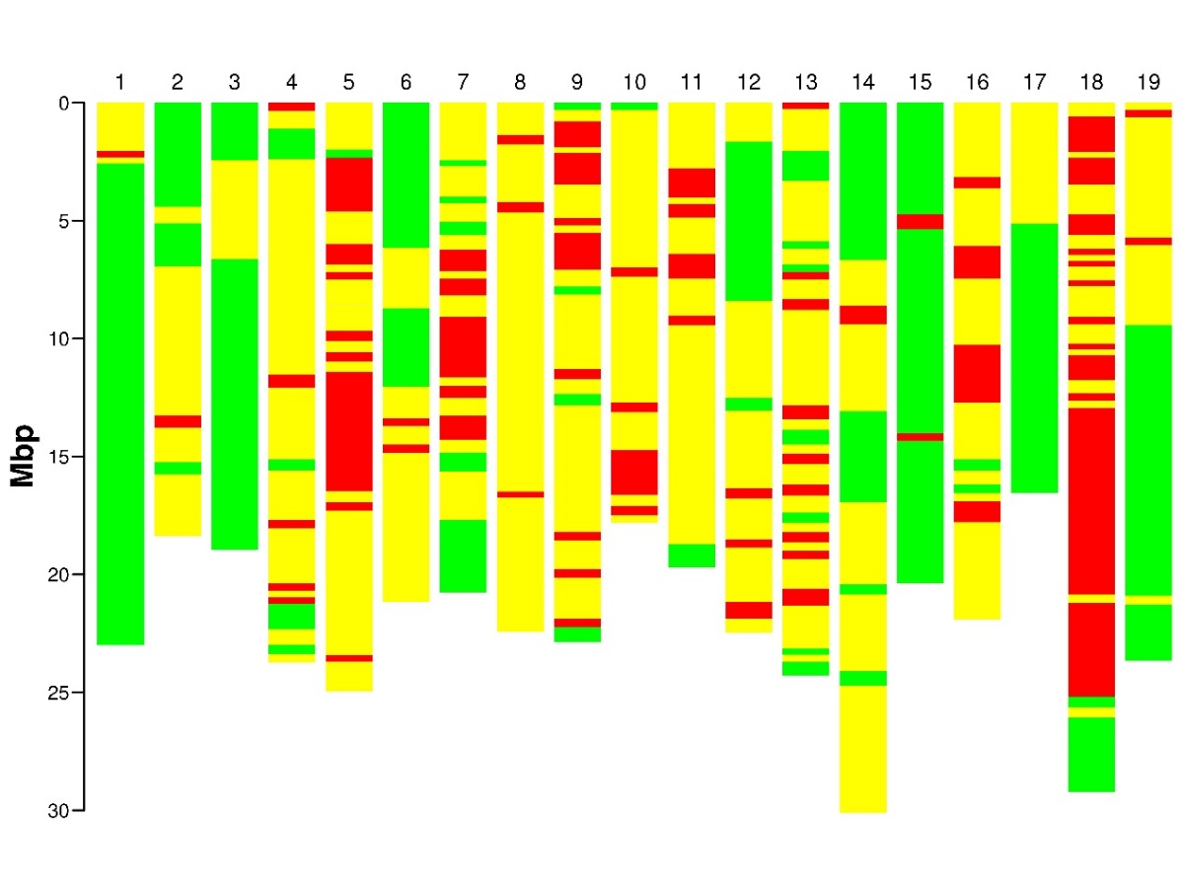
Supplementary figure 20: IBD coefficients between ‘Svjetljak’ (AF32) and ‘Surina’ (IPTPO08); IBD0 -Red, IBD1 – Yellow, IBD2 - Green

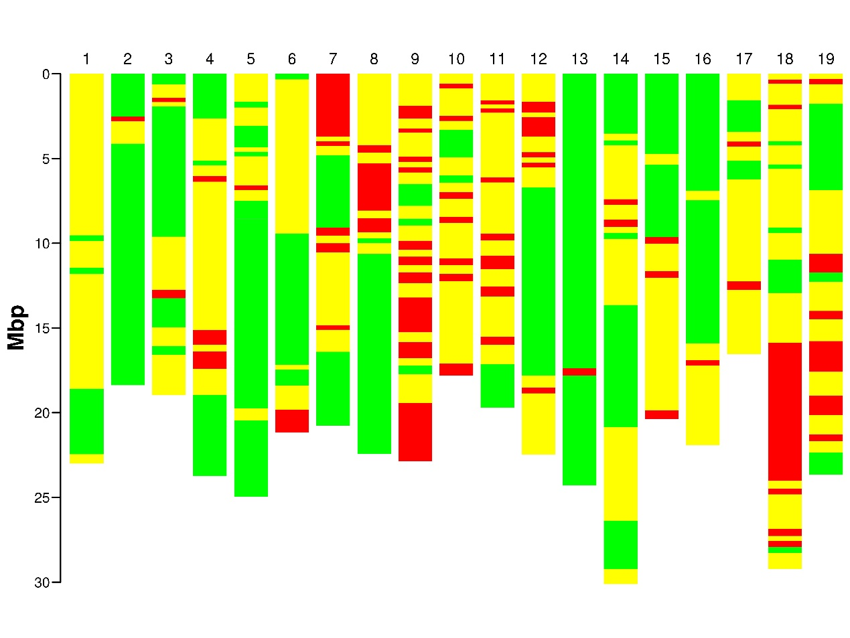
Supplementary figure 21: IBD coefficients between ‘Ljutun’ (HR24) and ‘Ninčuša’ (HR32); IBD0 -Red, IBD1 – Yellow, IBD2 - Green

