Supplementary Figures

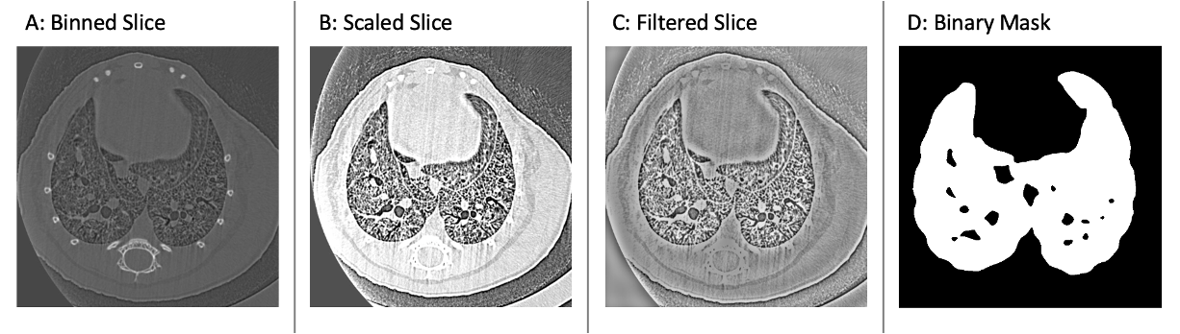
Supplementary Figure S1: A: A CT slice after it has undergone the 2x2x2 binning process; B: A CT slice after it has undergone scaling. The bones have been blended so that they have less contrast compared with the chest wall; C: A CT slice after it has undergone a high-pass filter. The strong contrast between the chest wall and the lungs has been attenuated and the features in the lungs are enhanced; D: A binary mask of the lungs where the white pixels have a value of one and represent lung tissue and air, and the black pixels have a value of zero and represent everything else.

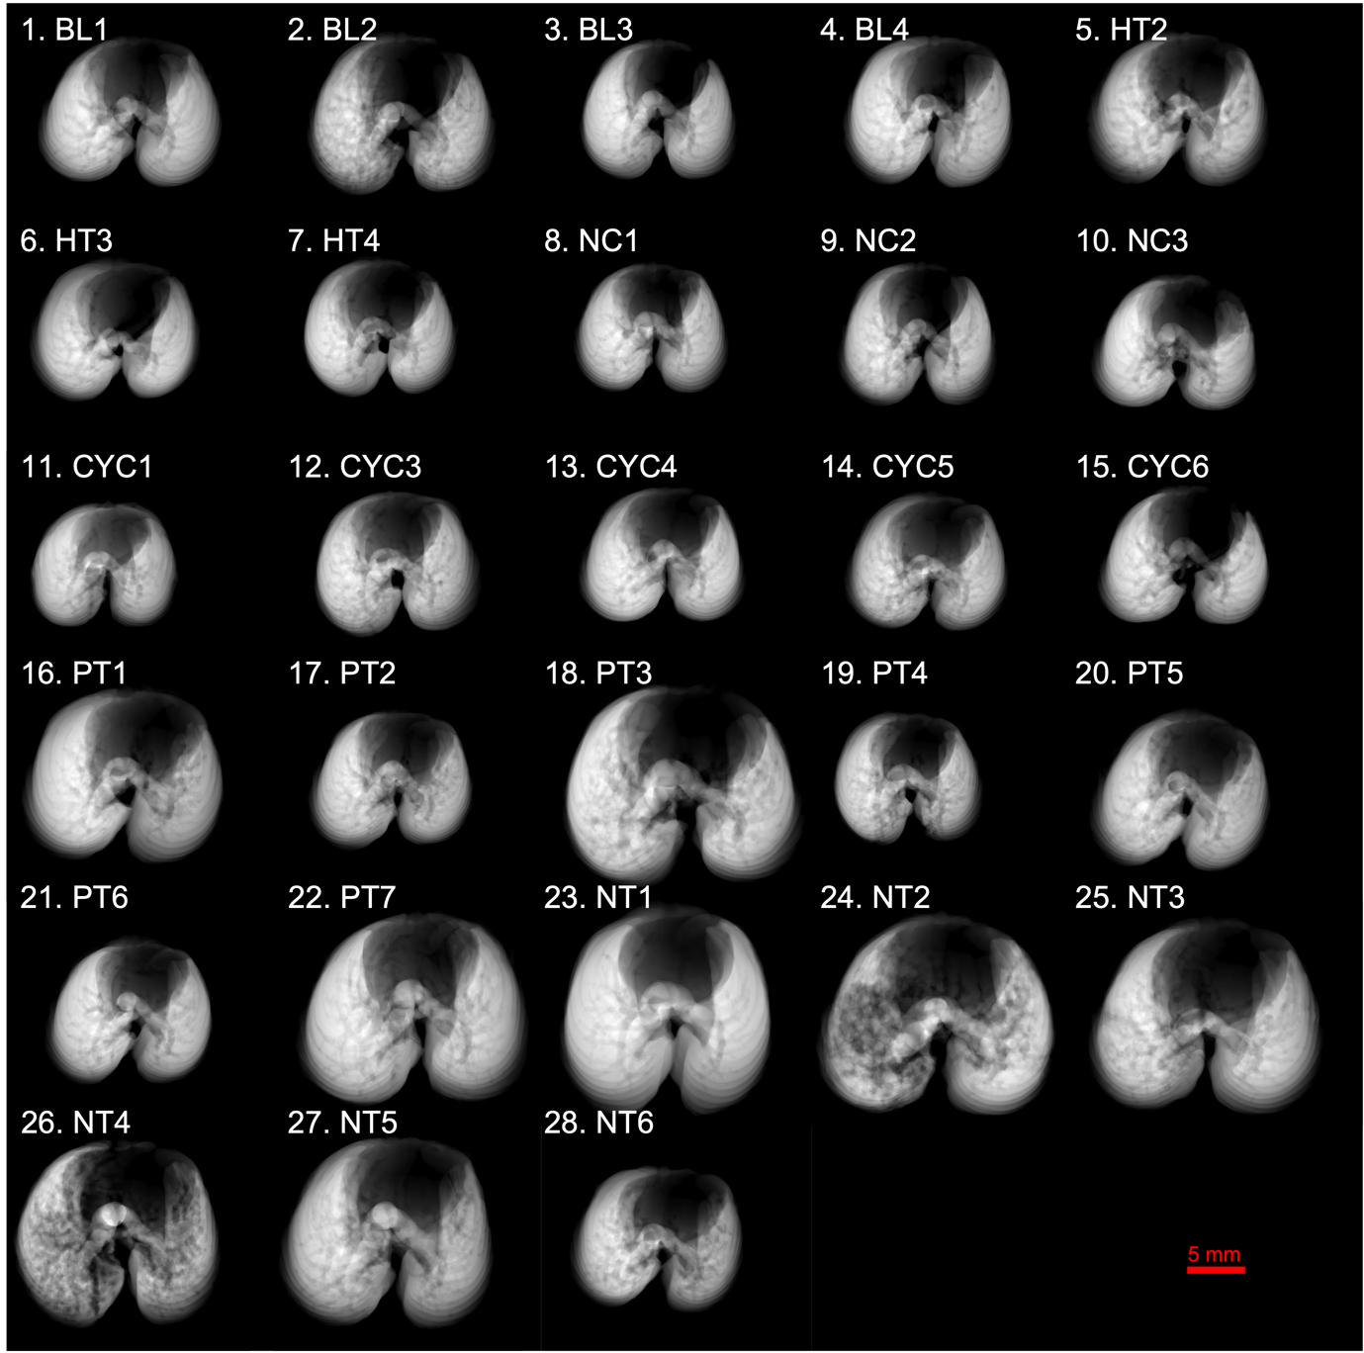
Supplementary Figure S2: Projected thickness of air (PTA) for the baseline (BL), healthy (HT), negative control (NC), cyclophosphamide control (CYC), positive treatment (PT) and negative treatment (NT) mouse groups. Each panel shows the PTA for a different mouse. The shadow in the anterior chest represents where the heart sits. The lines that can be seen running through the lung fields are the blood vessels. Panels 1-4 show the PTA for the BL mice, 5-7 for the HT mice, 8-10 for the NC mice, 11-15 for the CYC mice, 16-22 for the PT mice, and 23-28 for the NT mice.

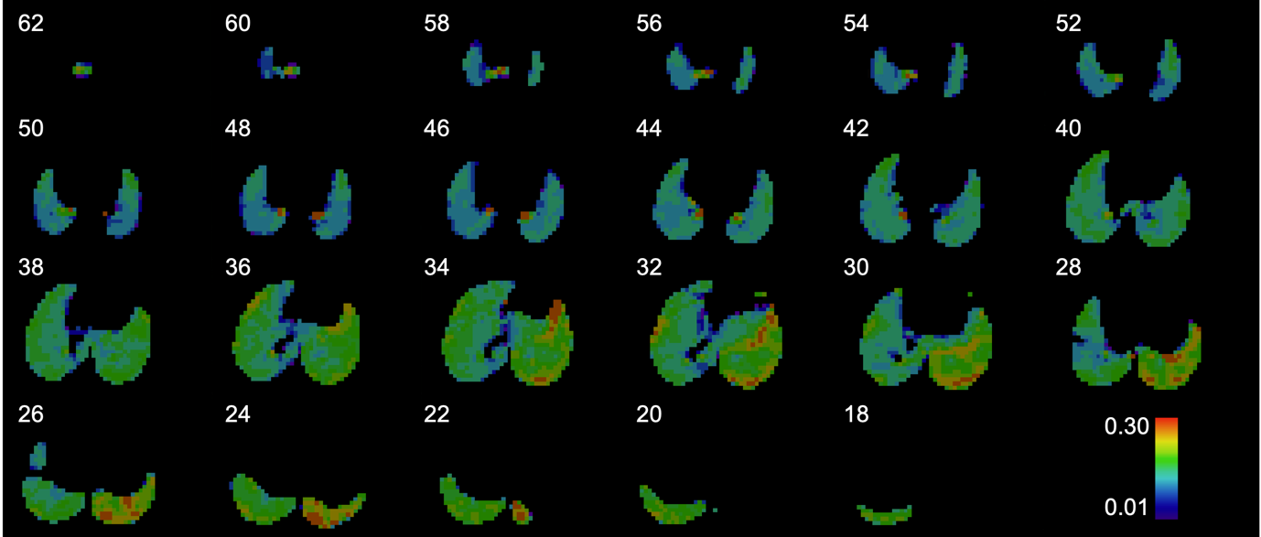
Supplementary Figure S3: Every second frame from the lung expansion map of Negative Treatment mouse 3 (NT3). There are 64 frames in total, the first 16 of which do not contain the lungs. The frames depicting the apical lungs, 46-62, demonstrate poorer lung expansion with predominant areas of aqua and blue. The basal frames on the other hands, 18-26, show better lung expansion as evidenced by the regions of green, orange, and red. Looking at the mid-section frames, 28-44, better lung expansion in the left lung with areas of orange and red compared with the right lung which shows poorer lung expansion with areas of aqua and blue.

