FIGURE
Supplementary Figure 1
A
C
BB
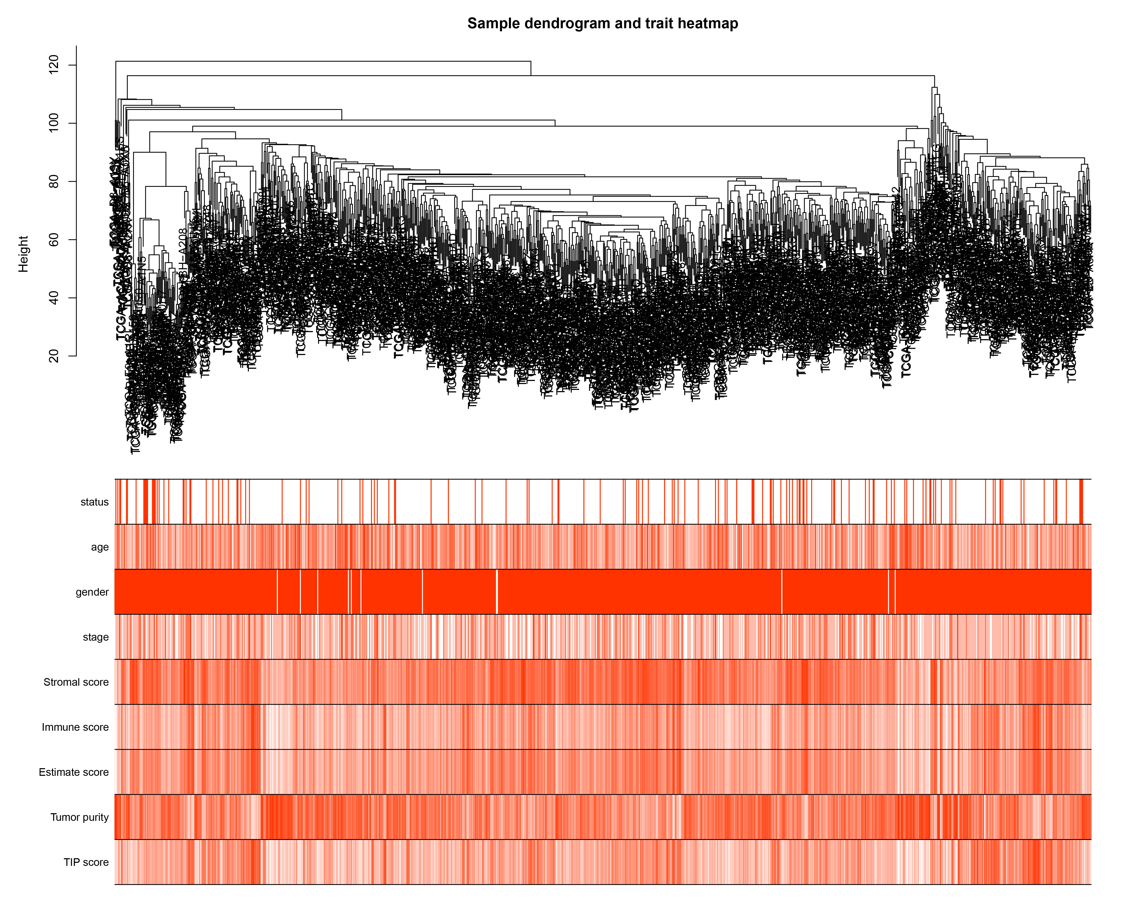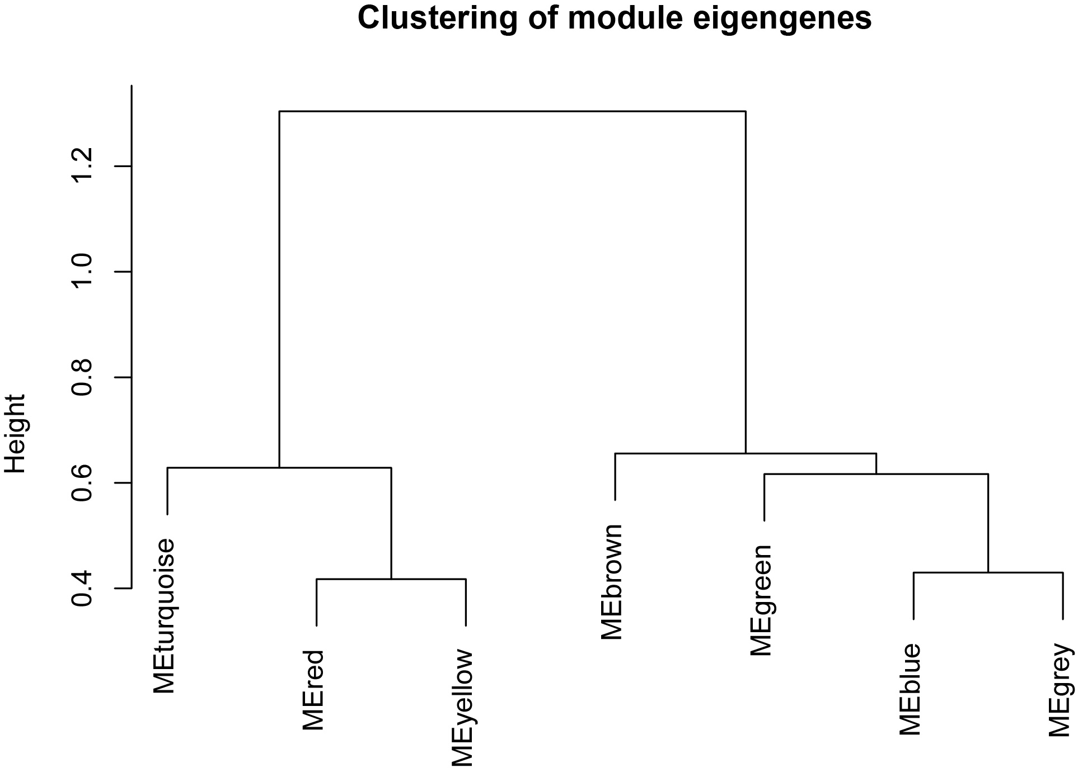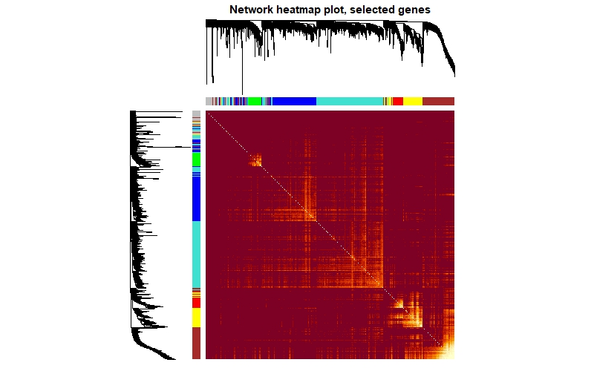

Supplementary Figure 2 Supplementary Figure 3
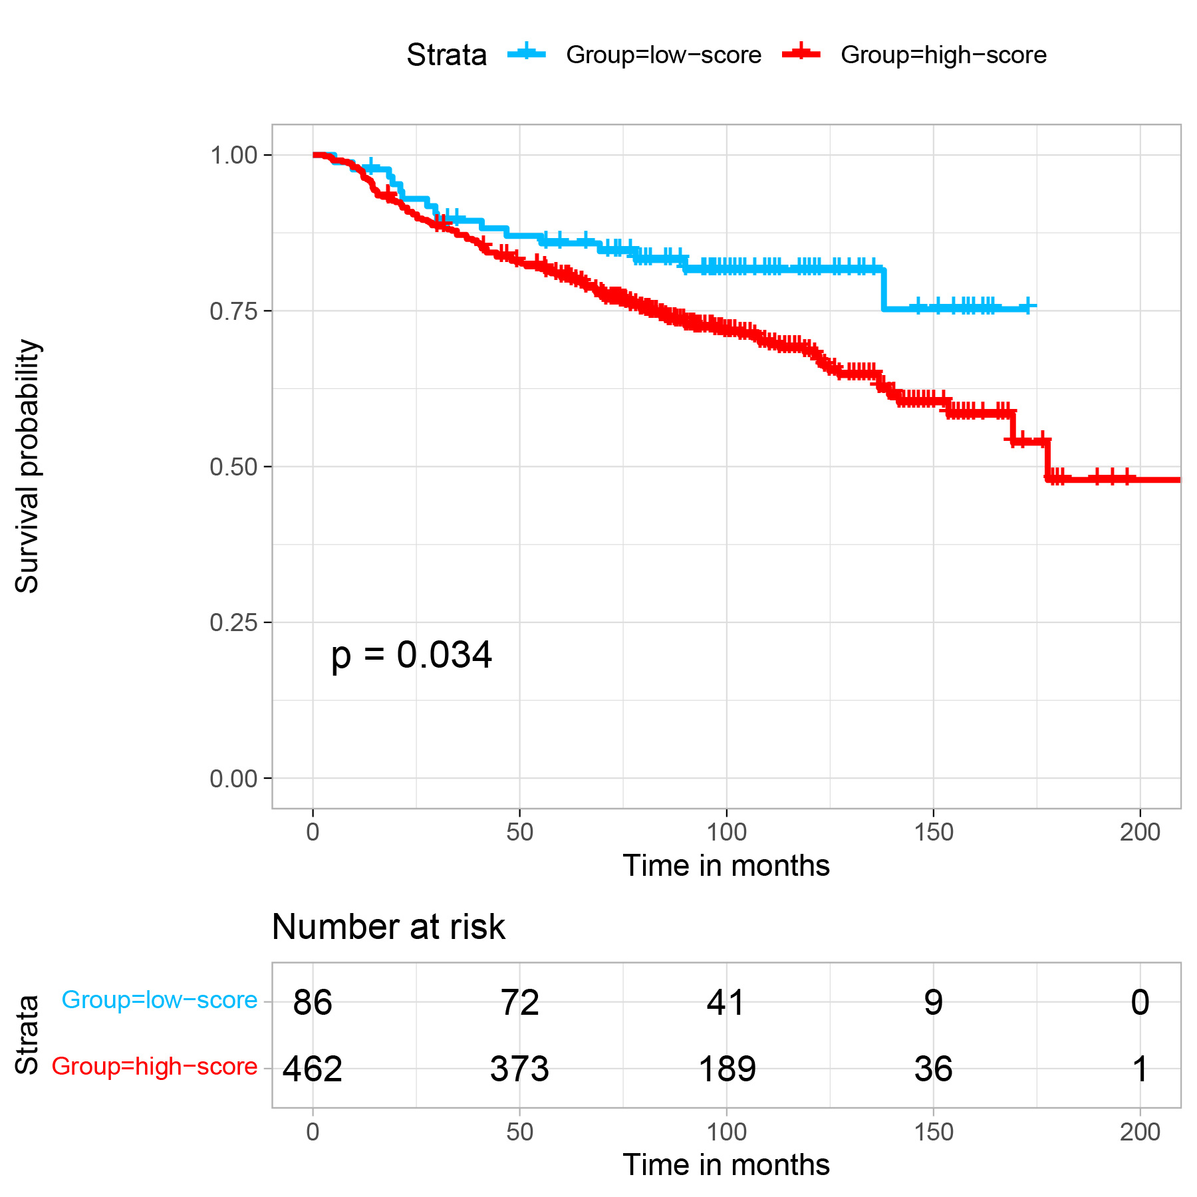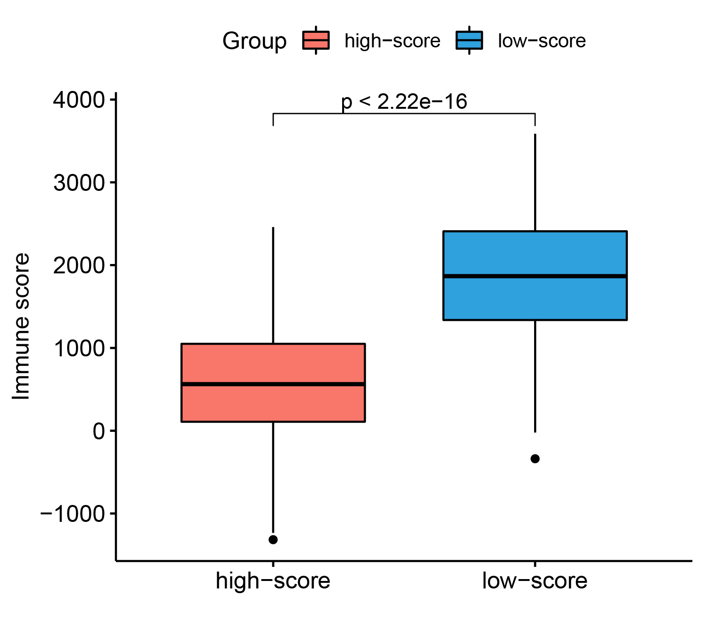

Supplementary Figure 4
A

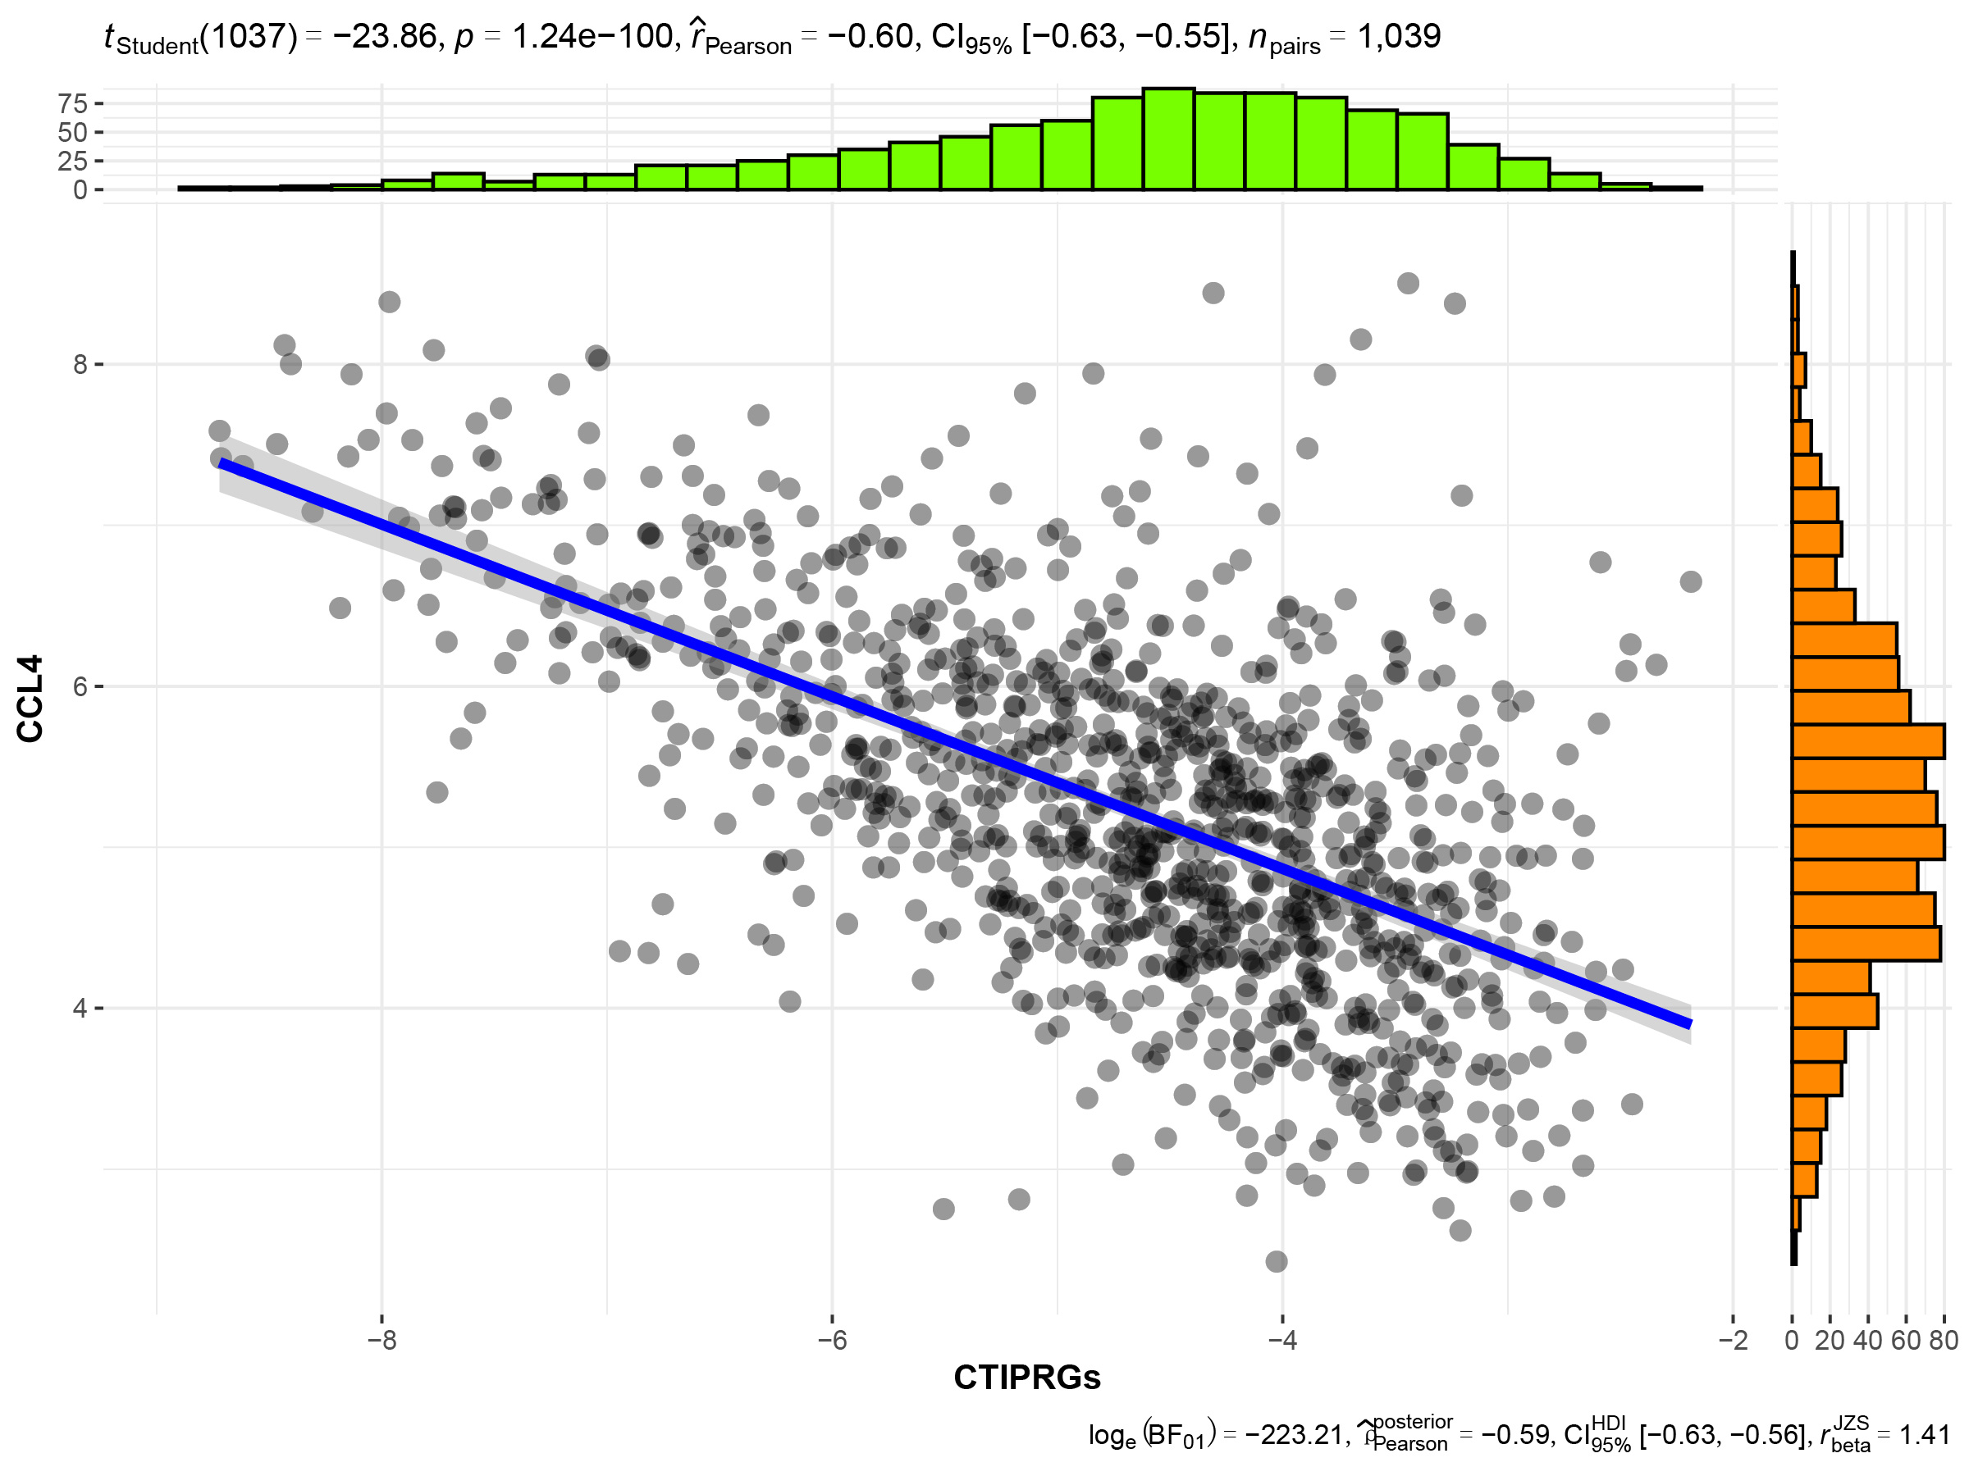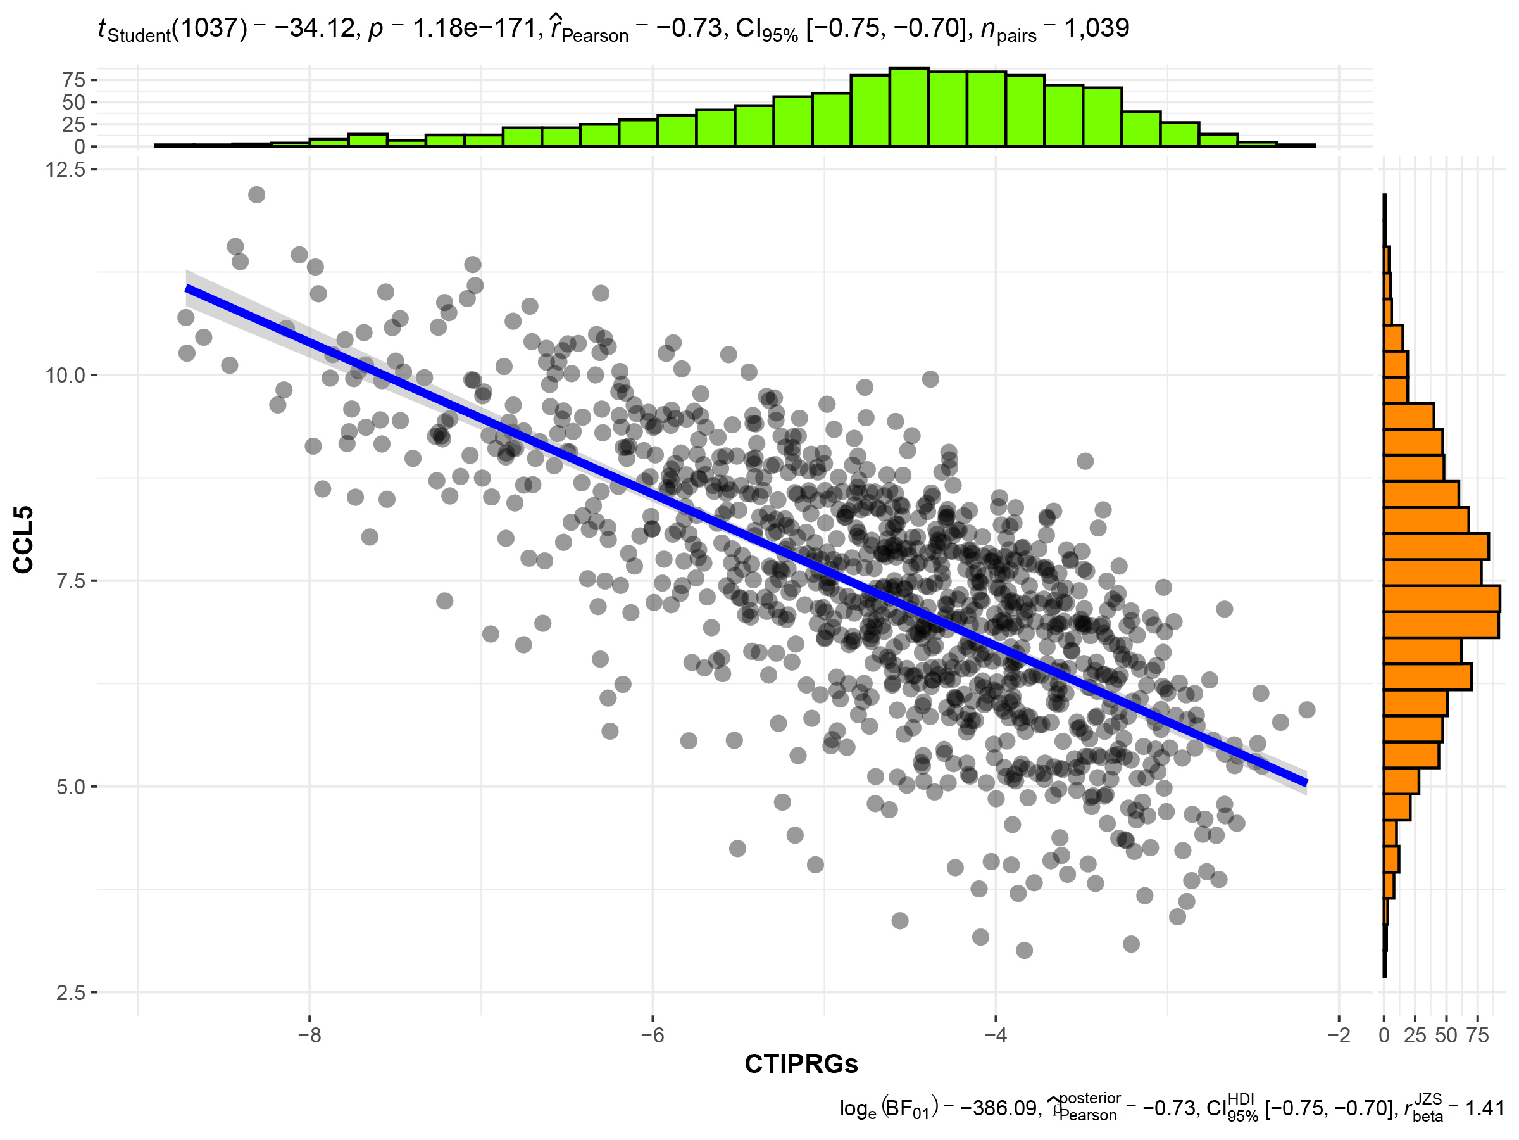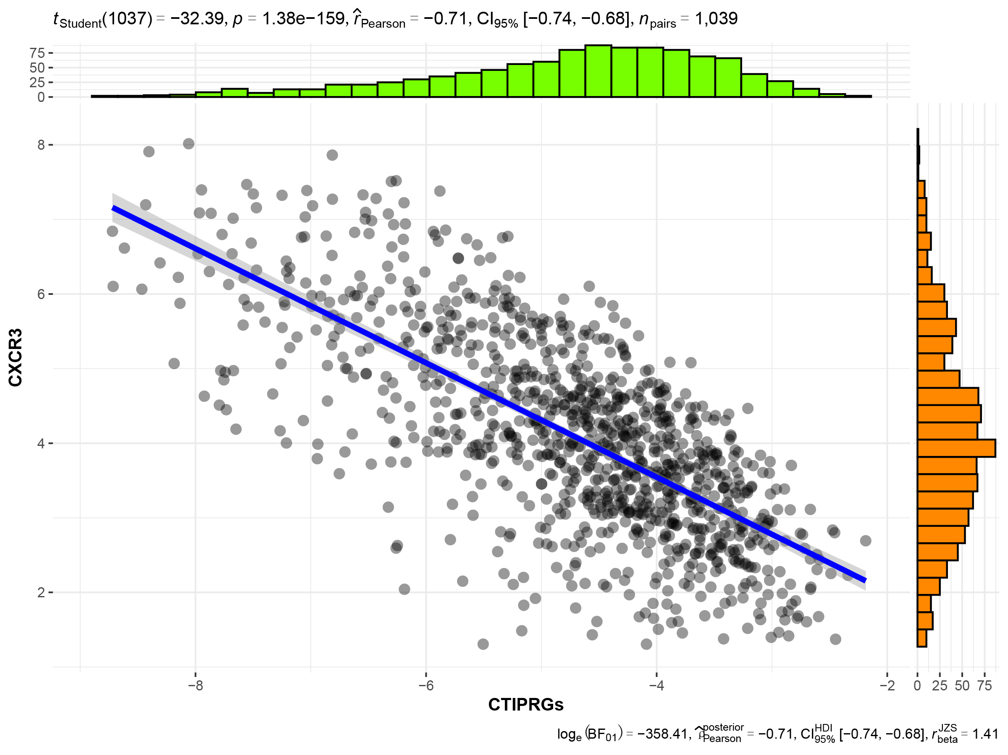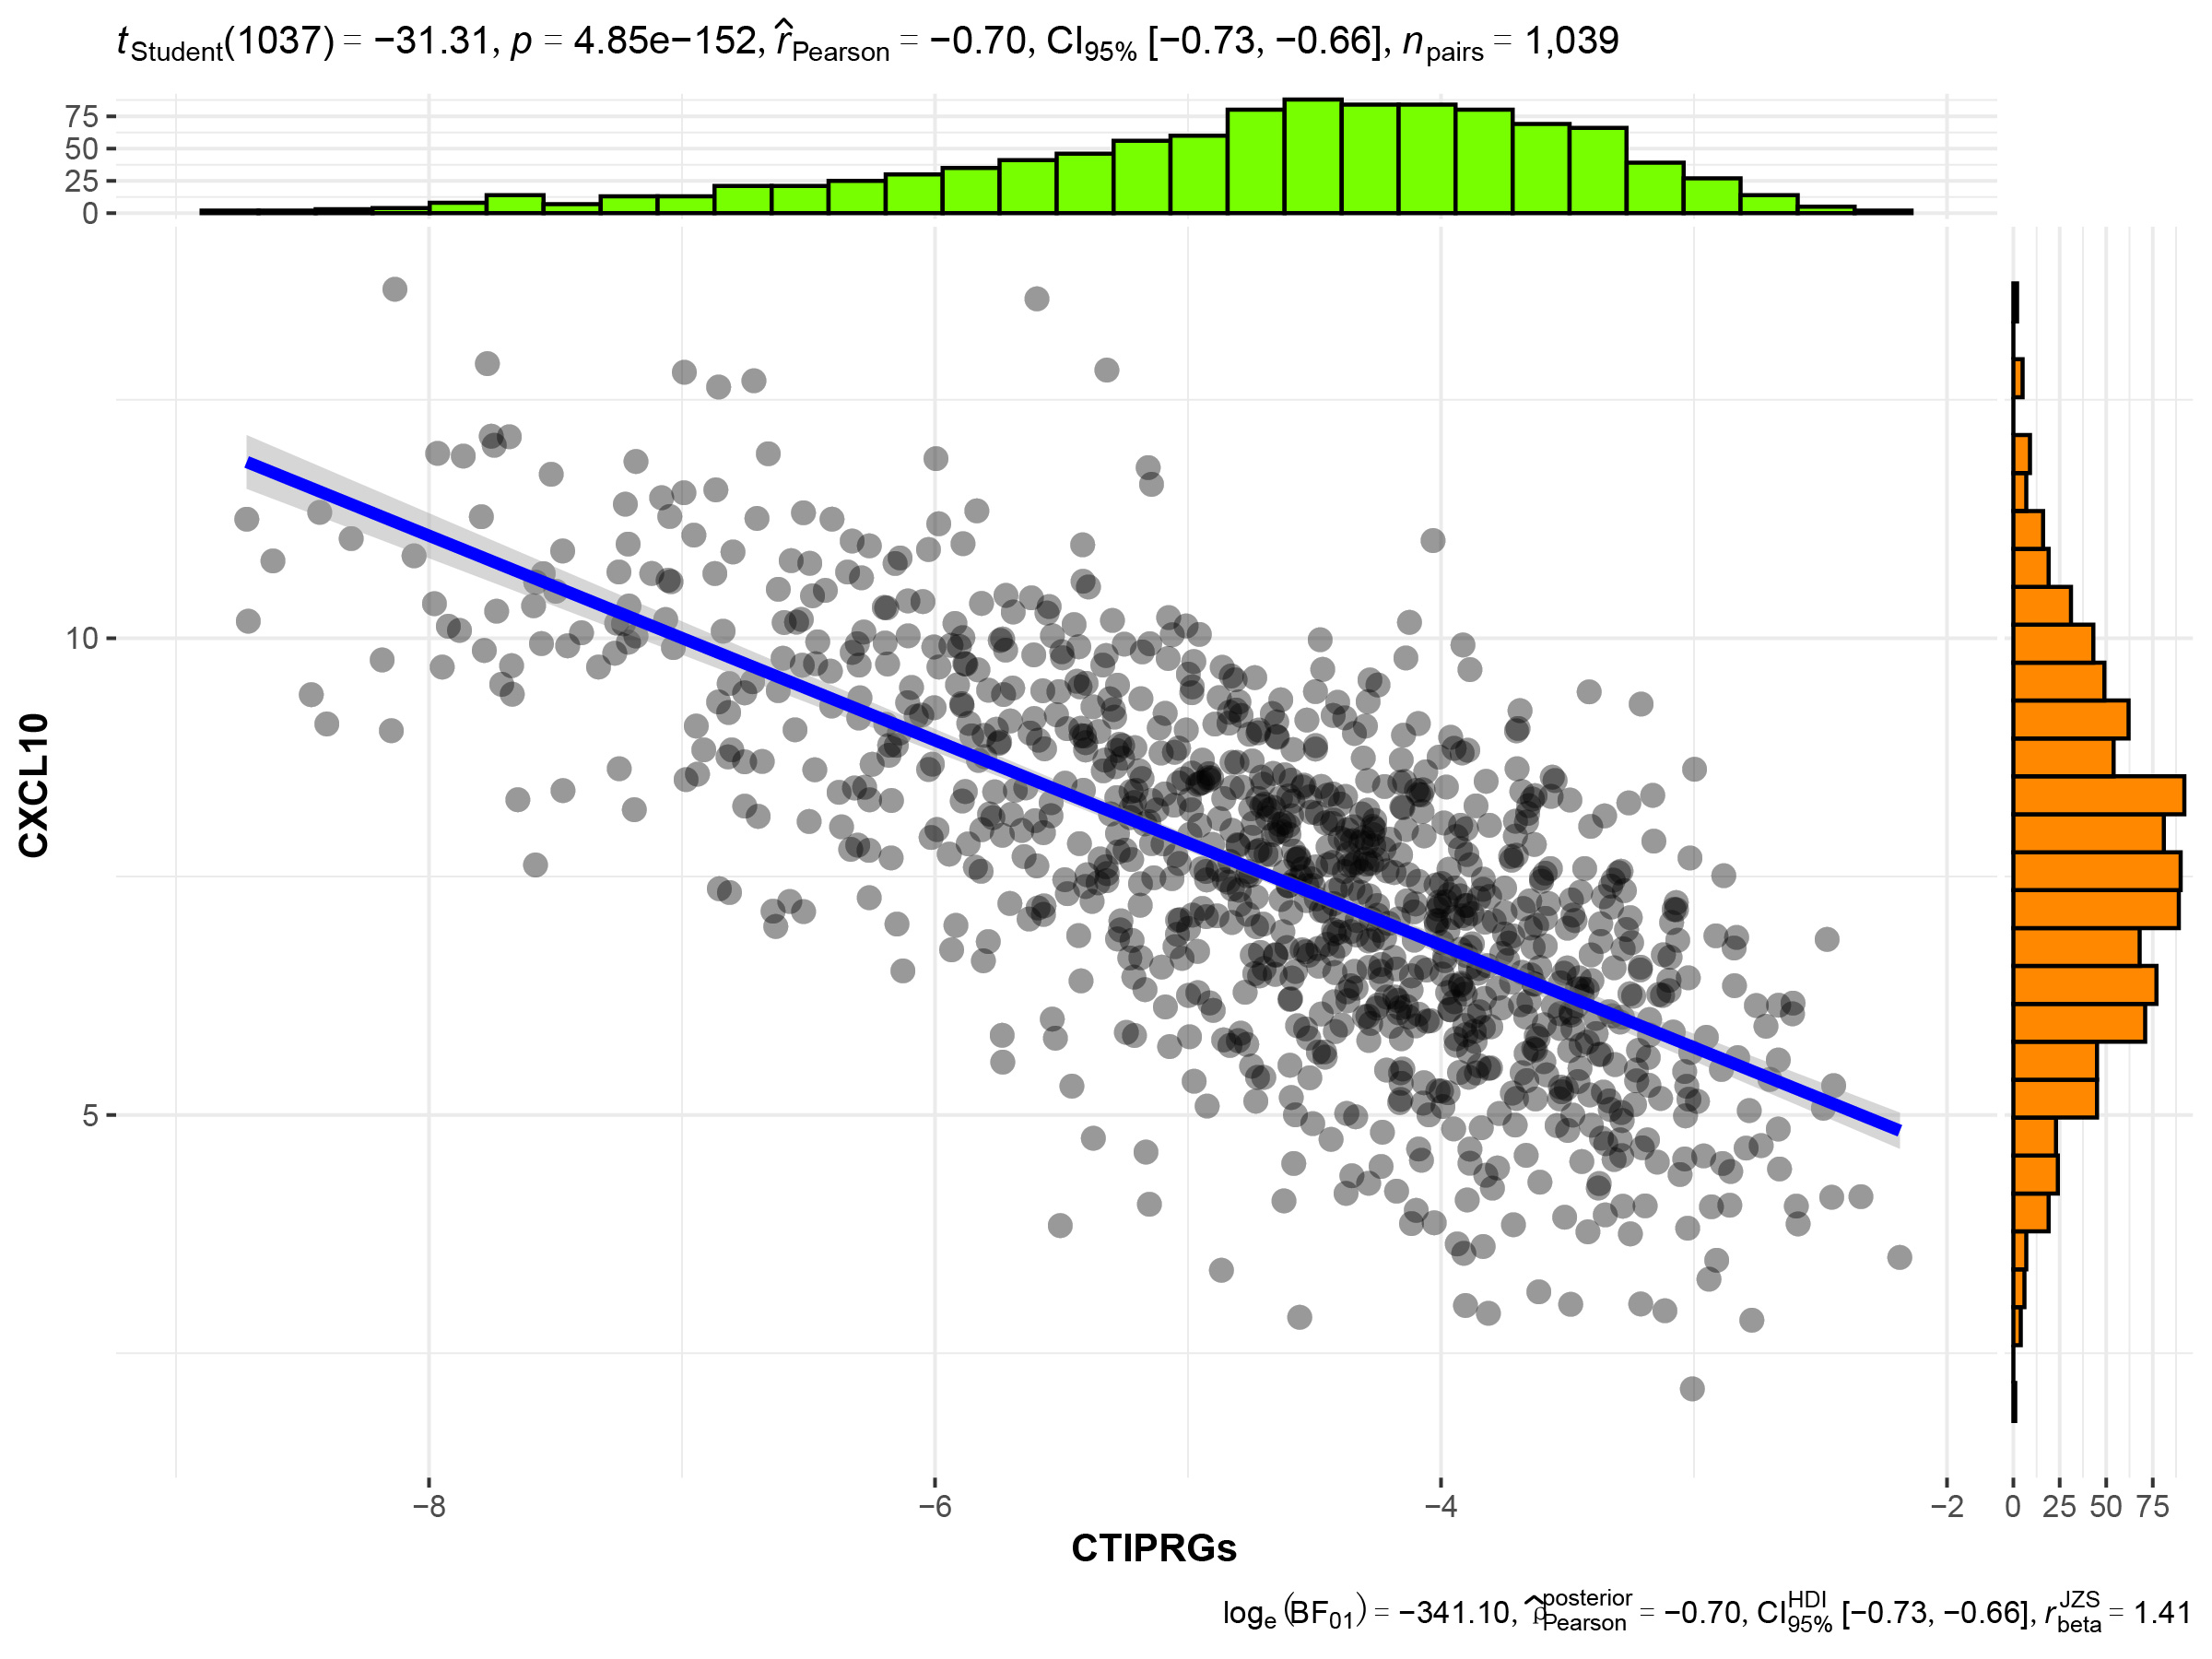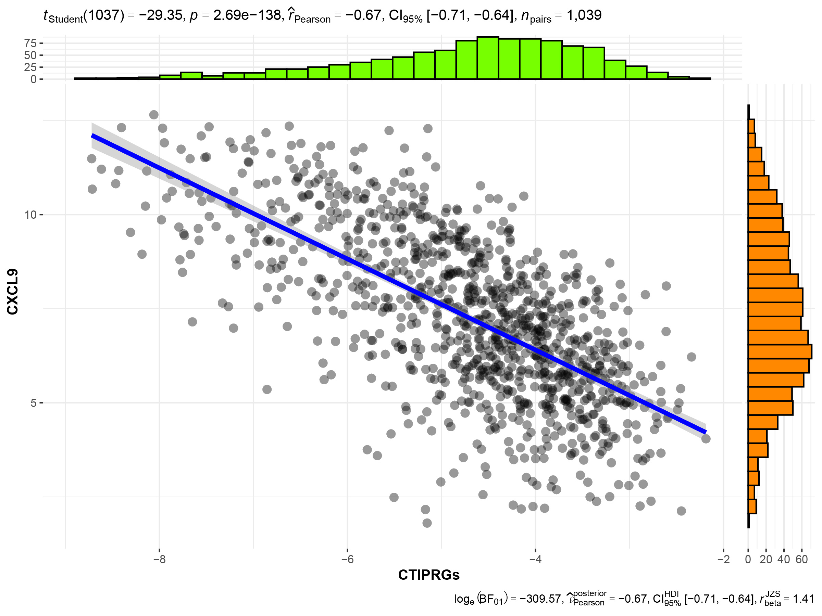
BC

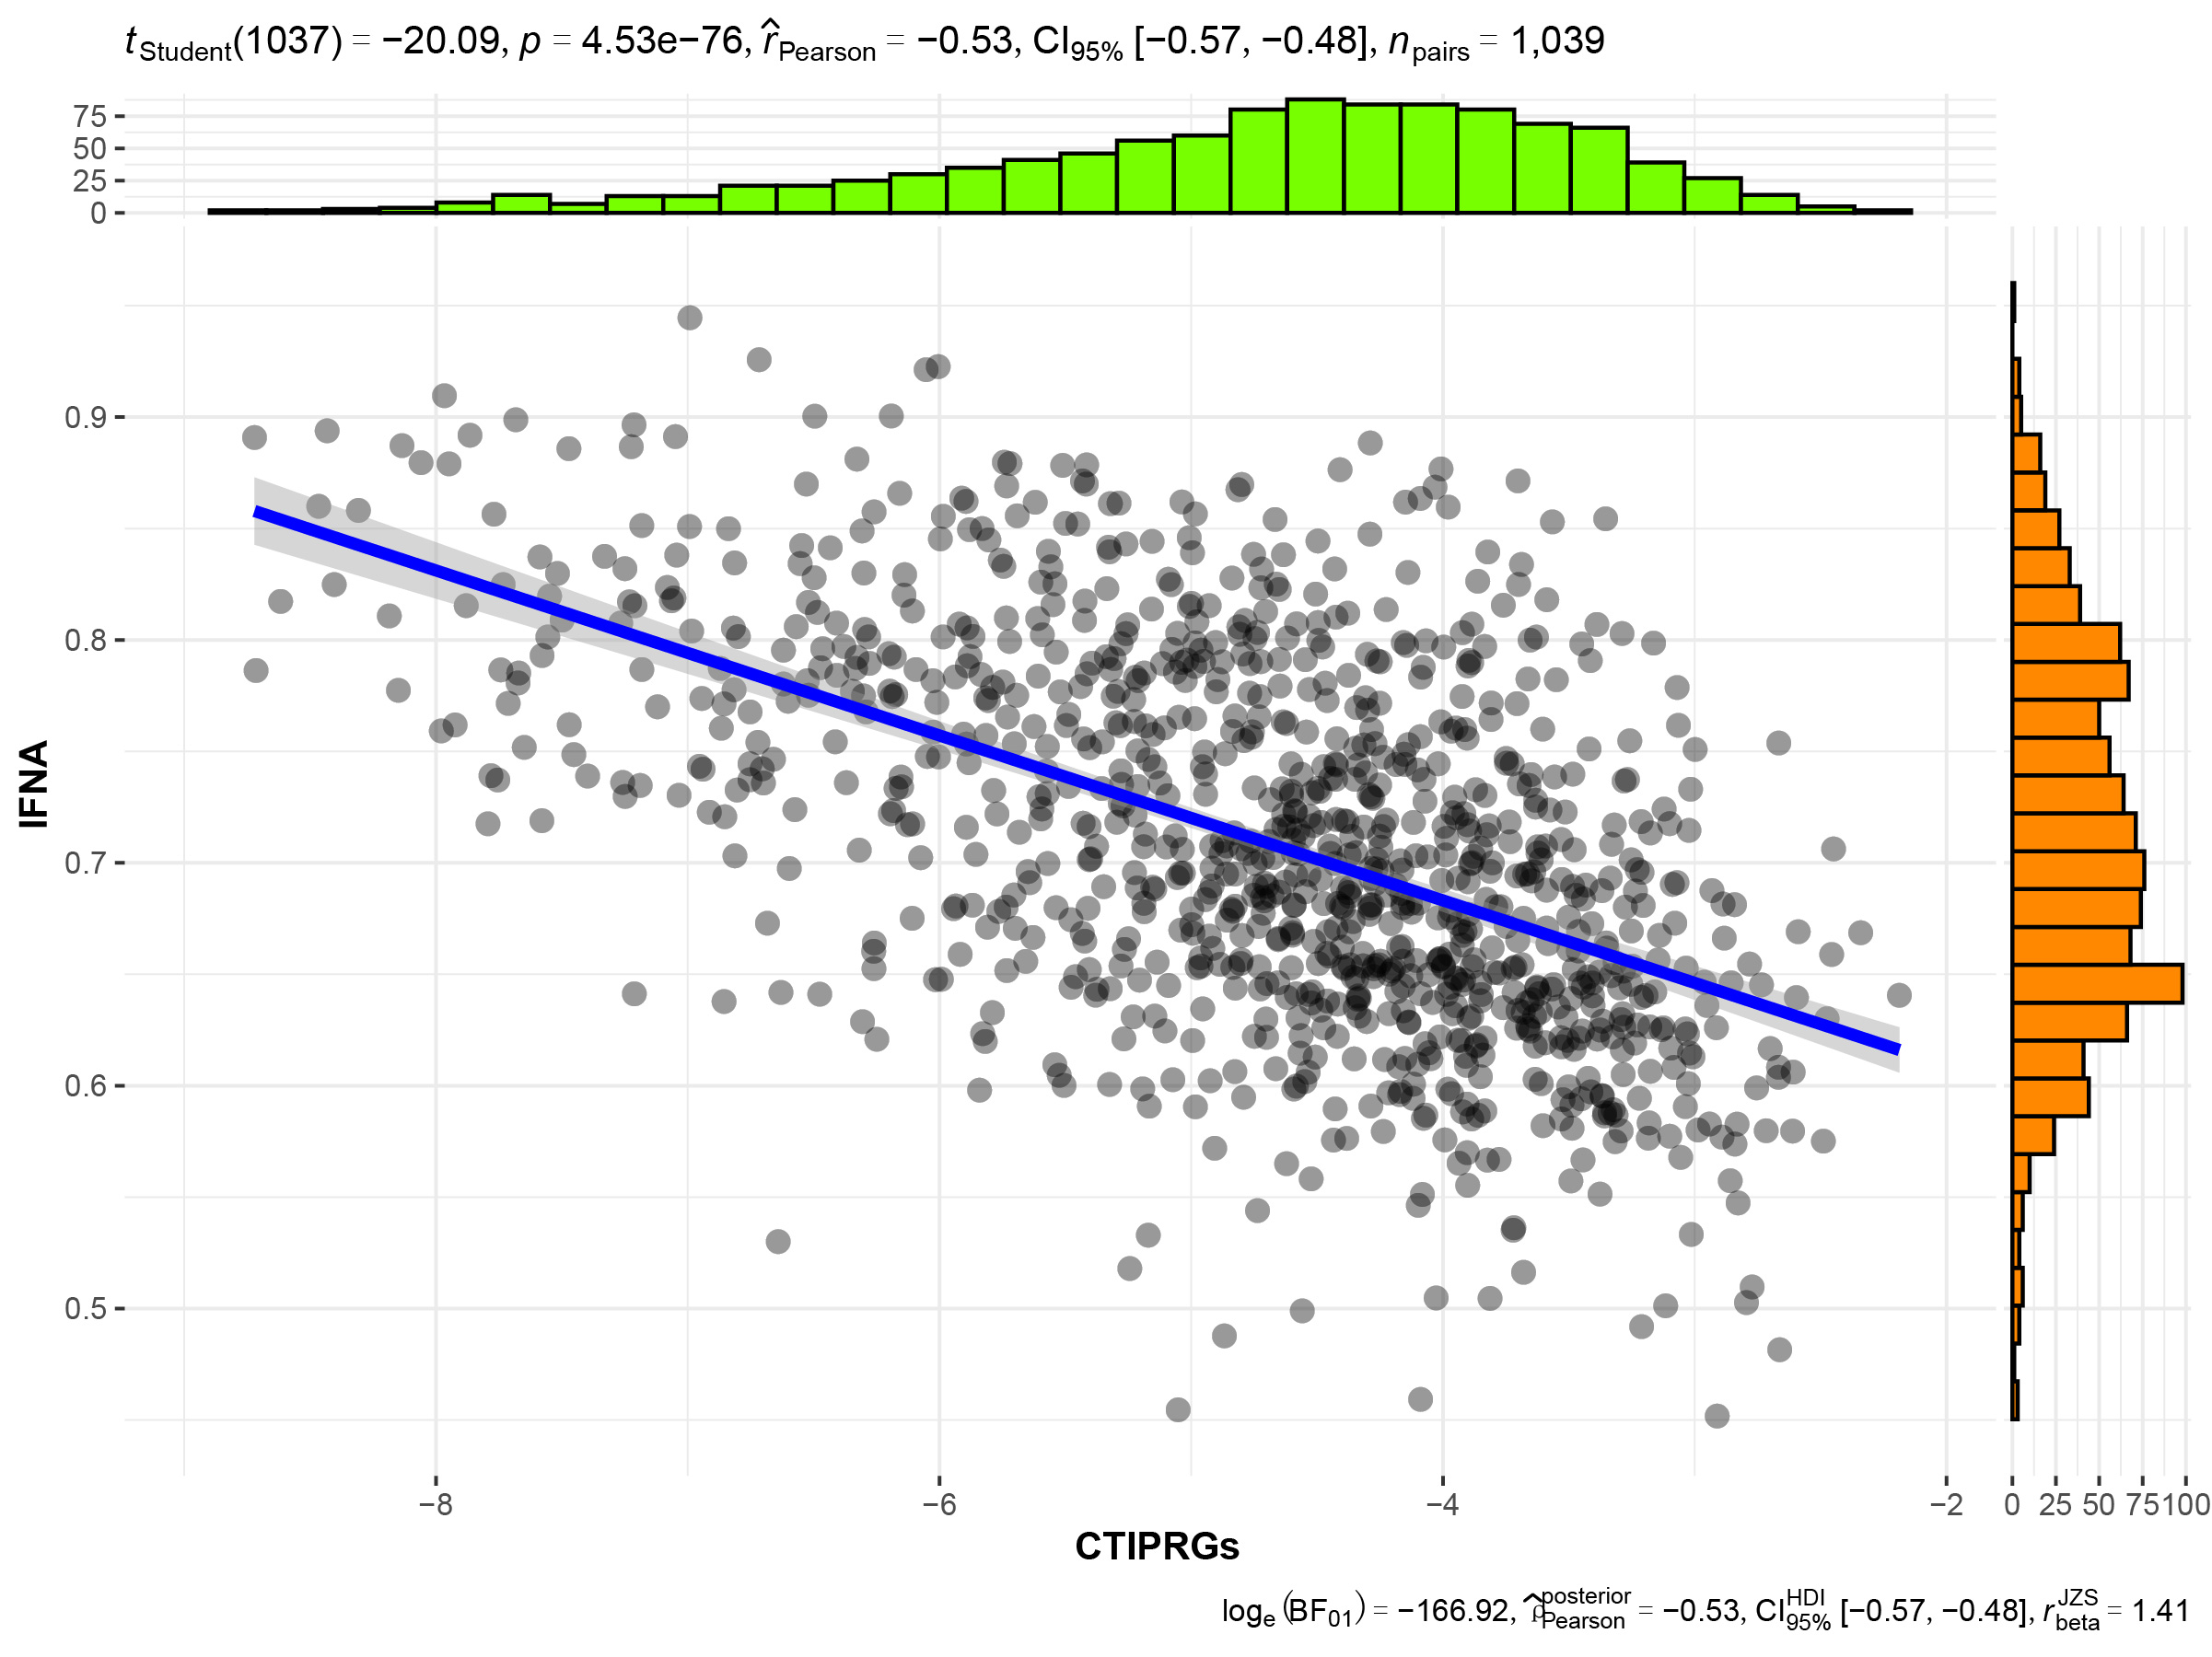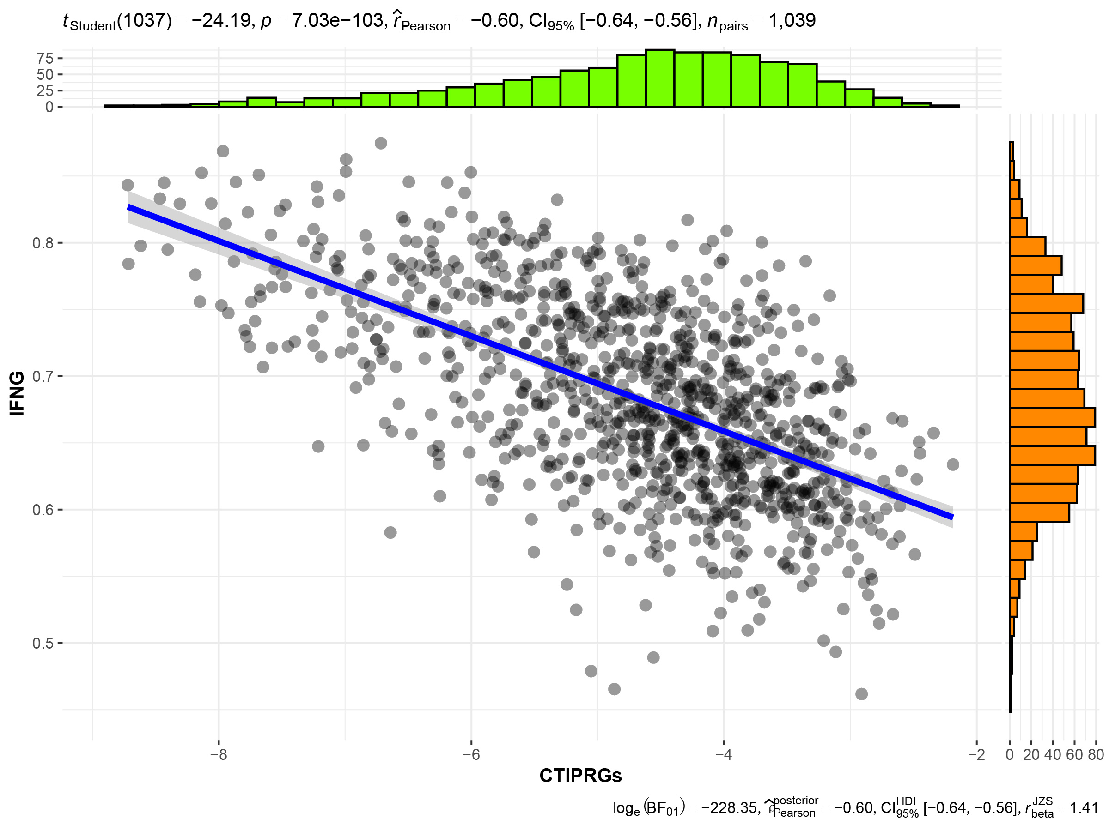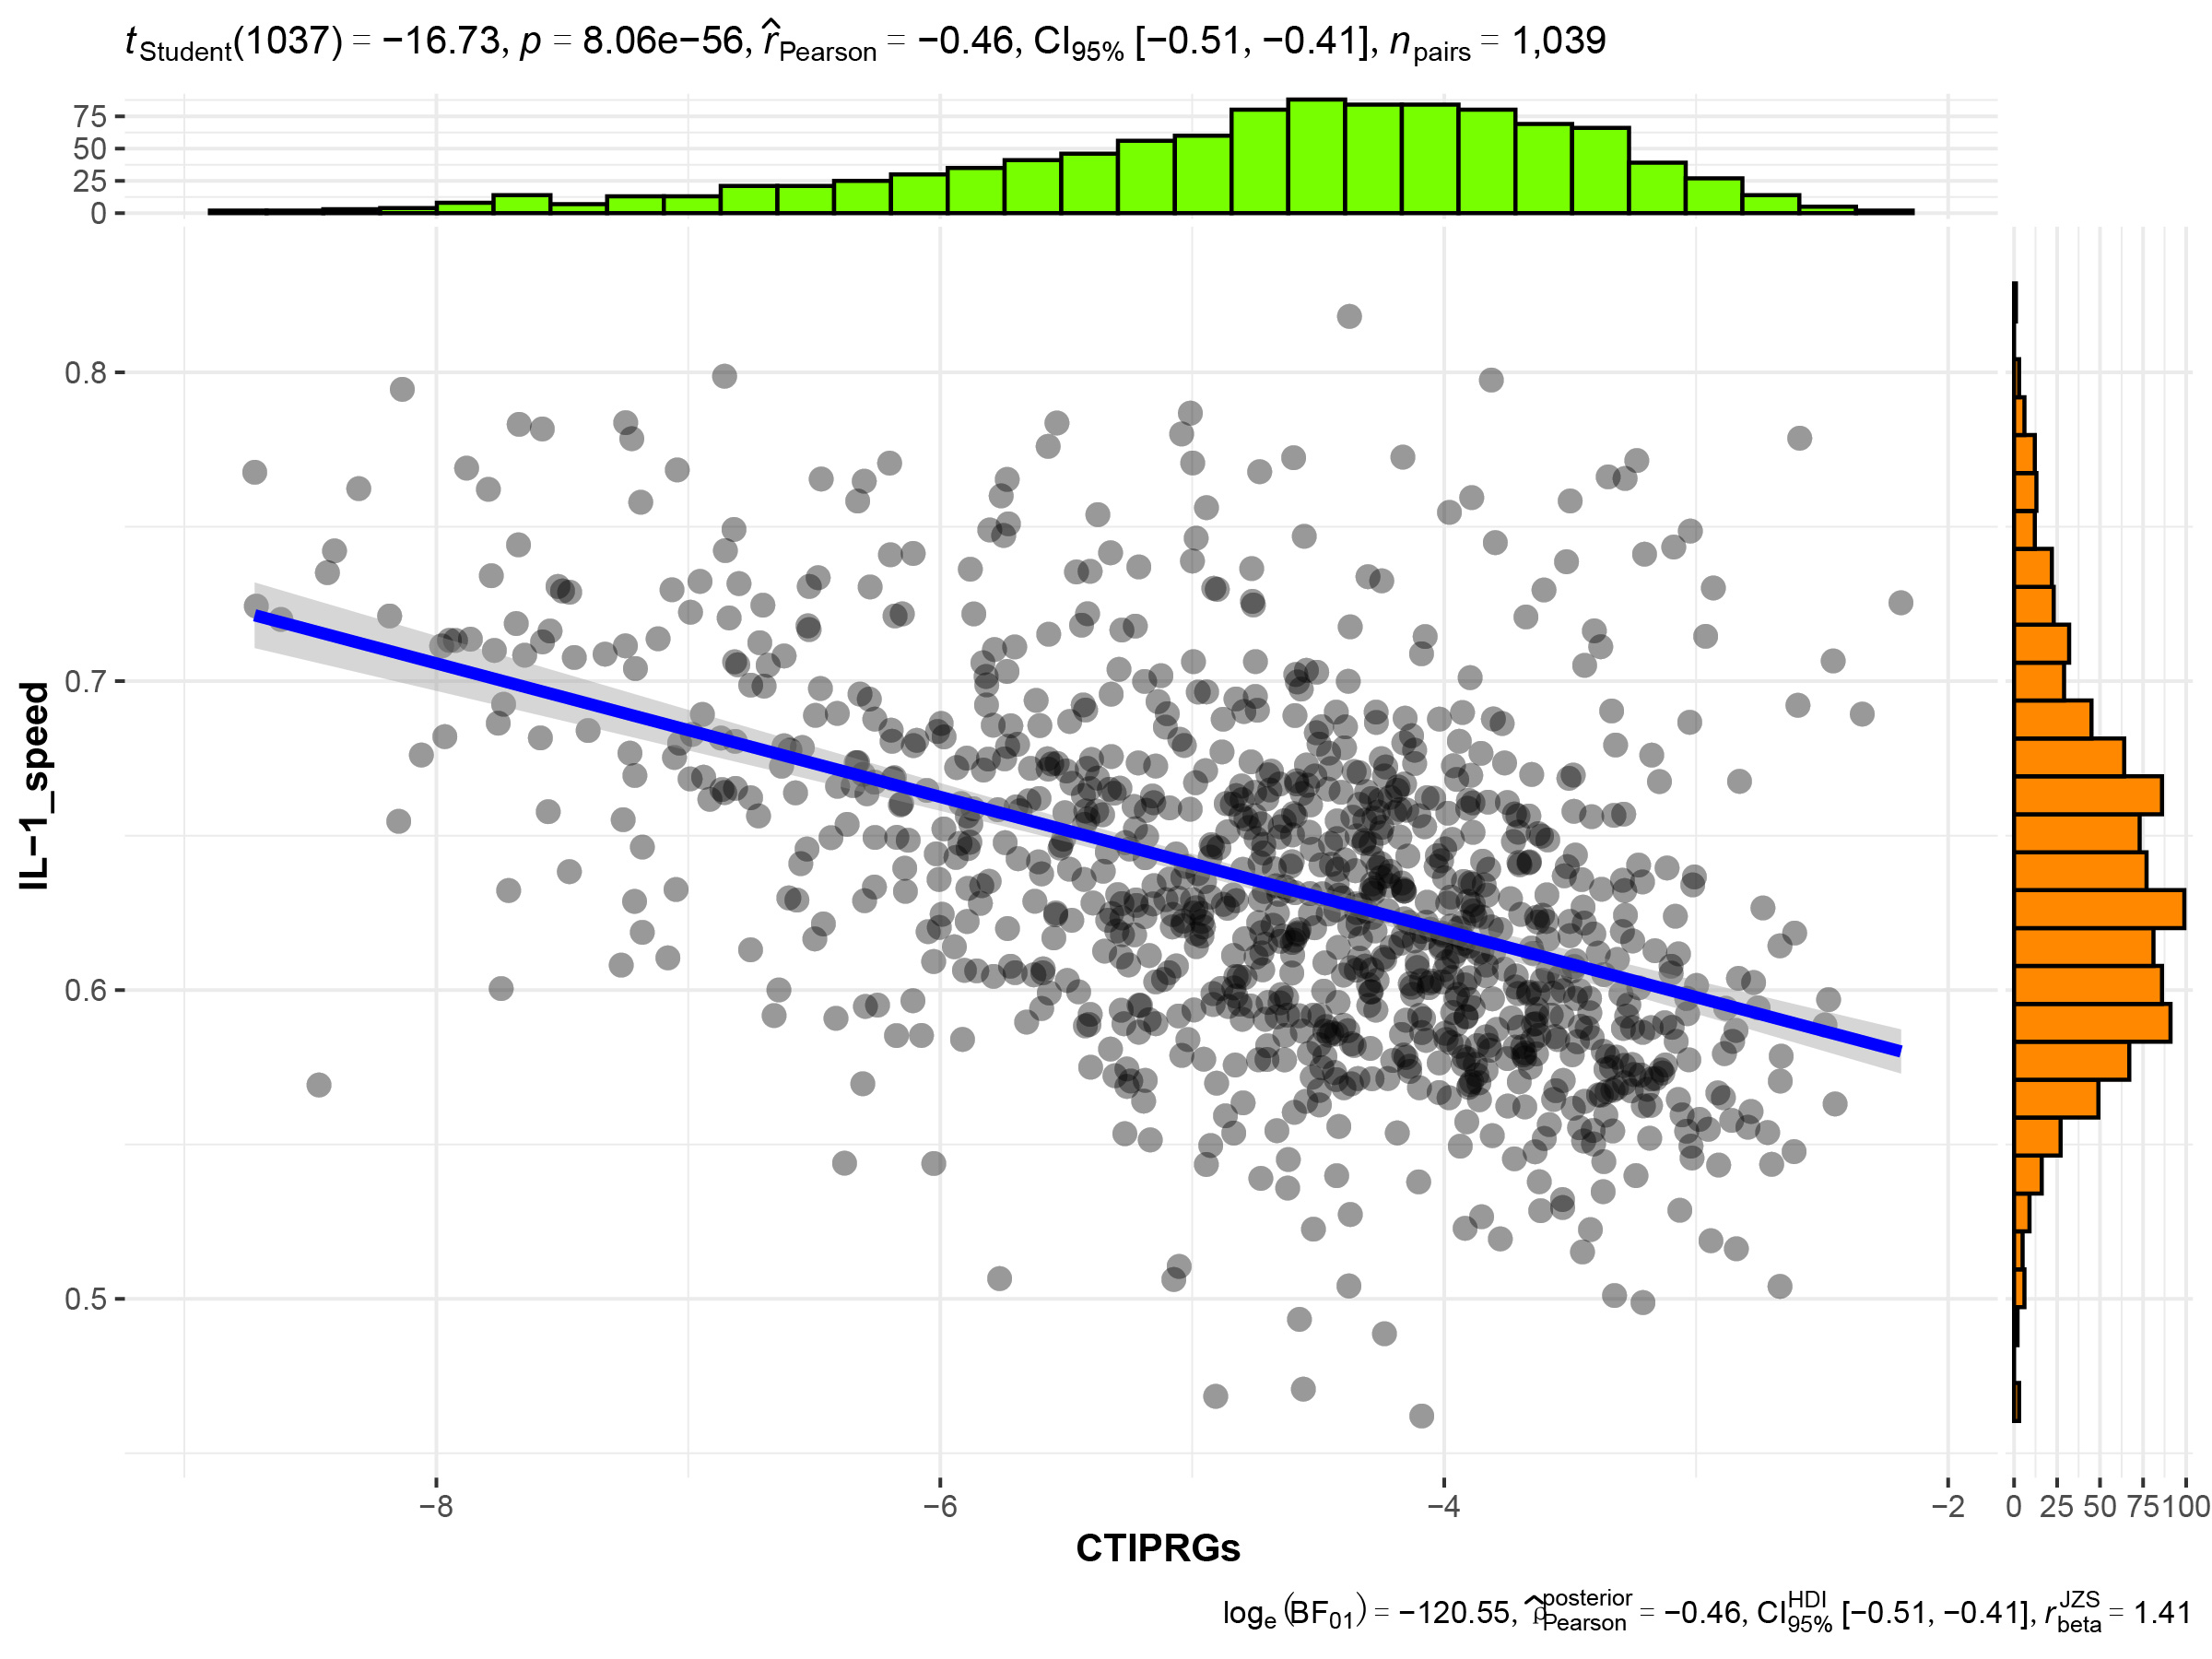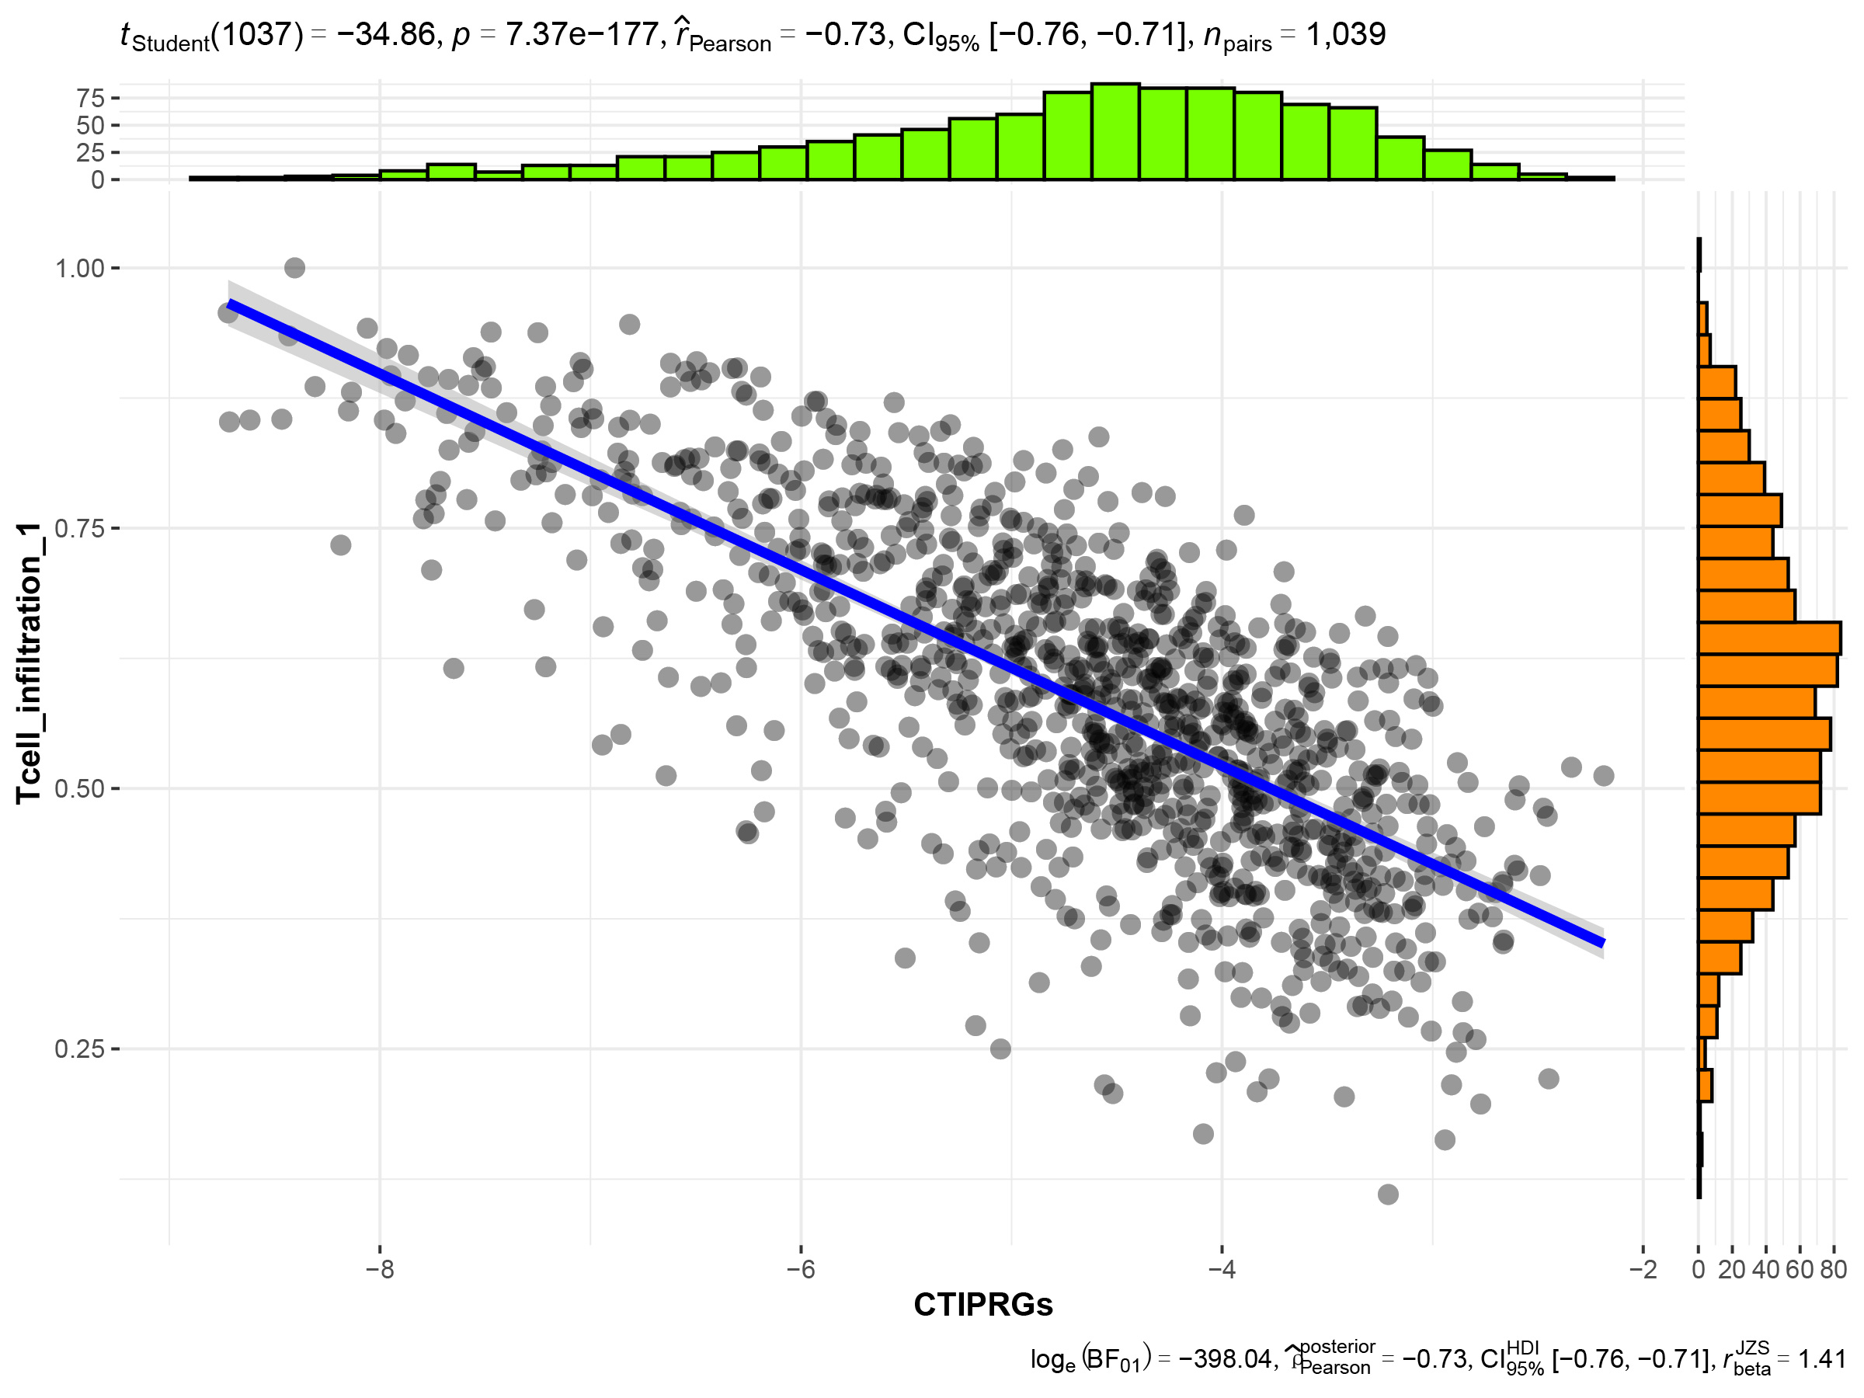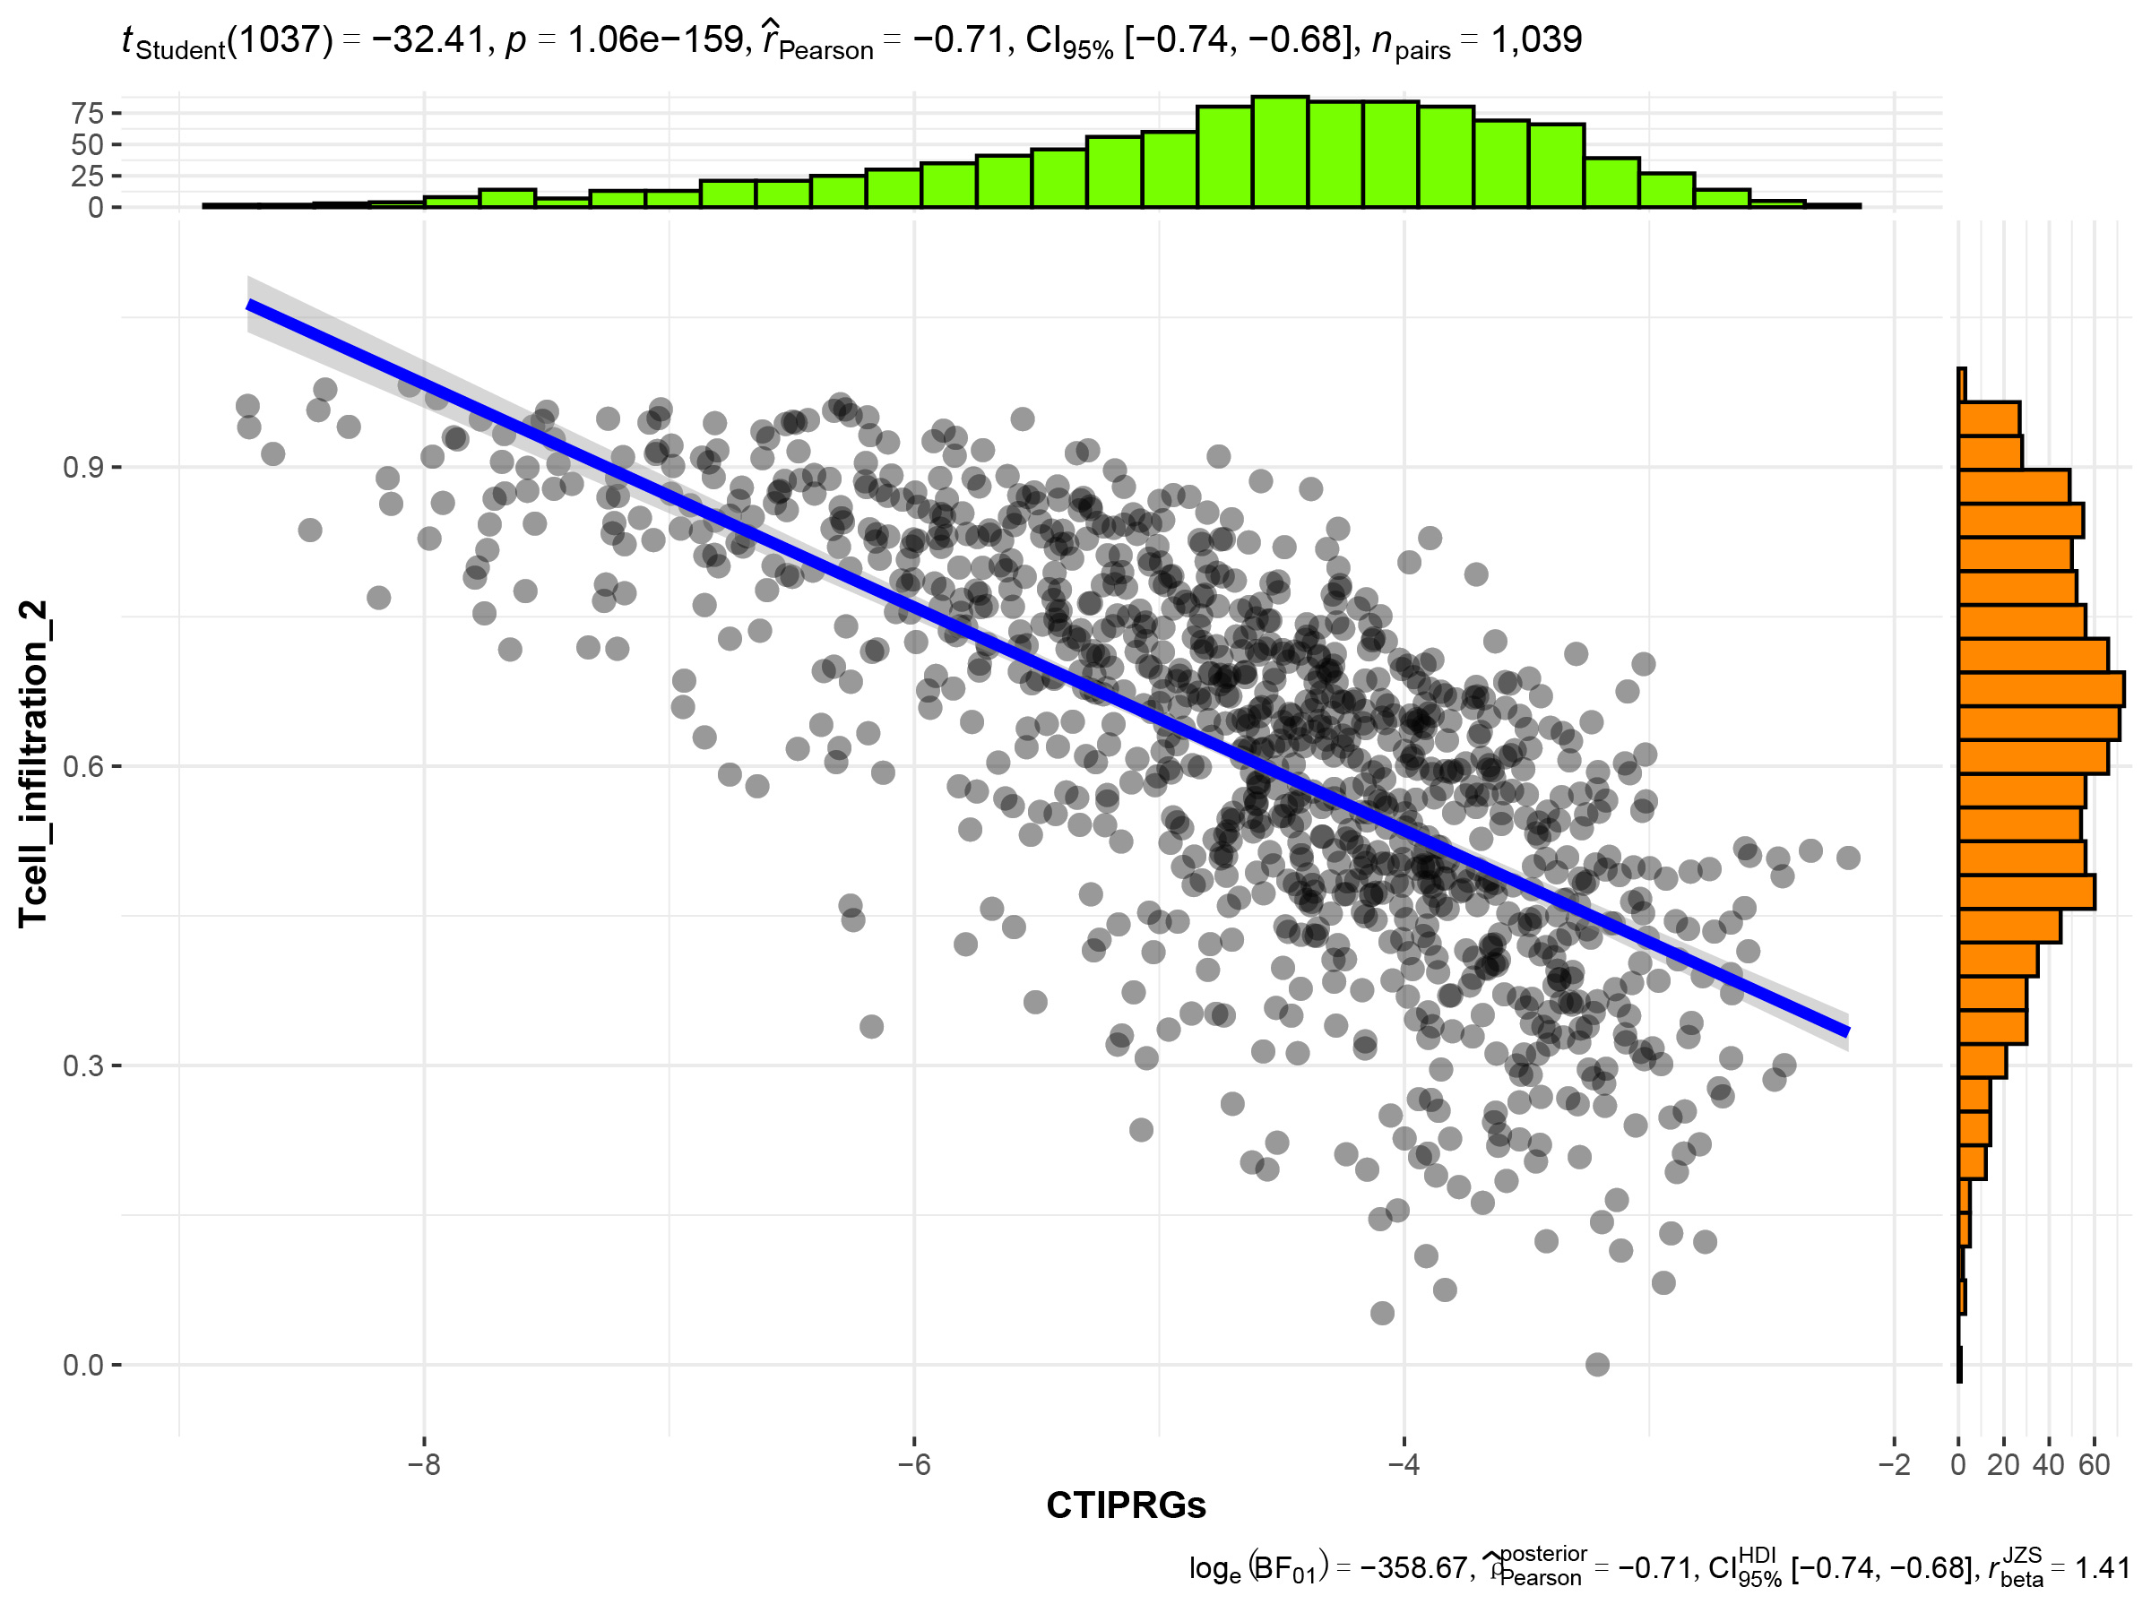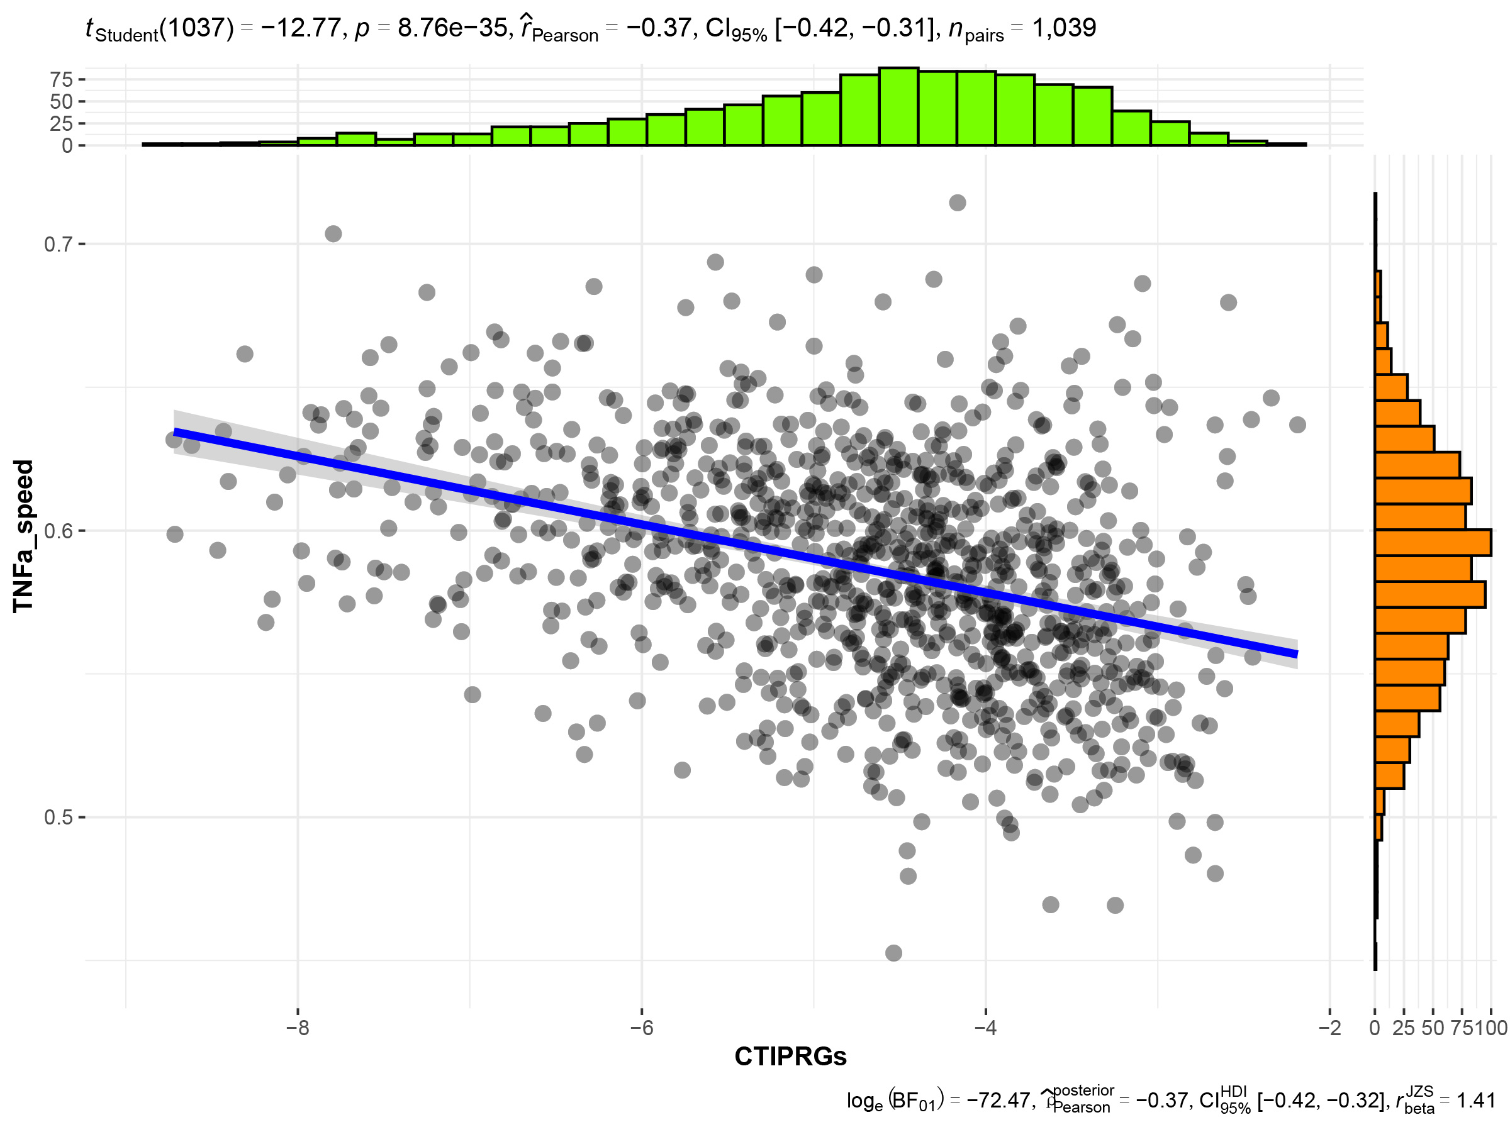
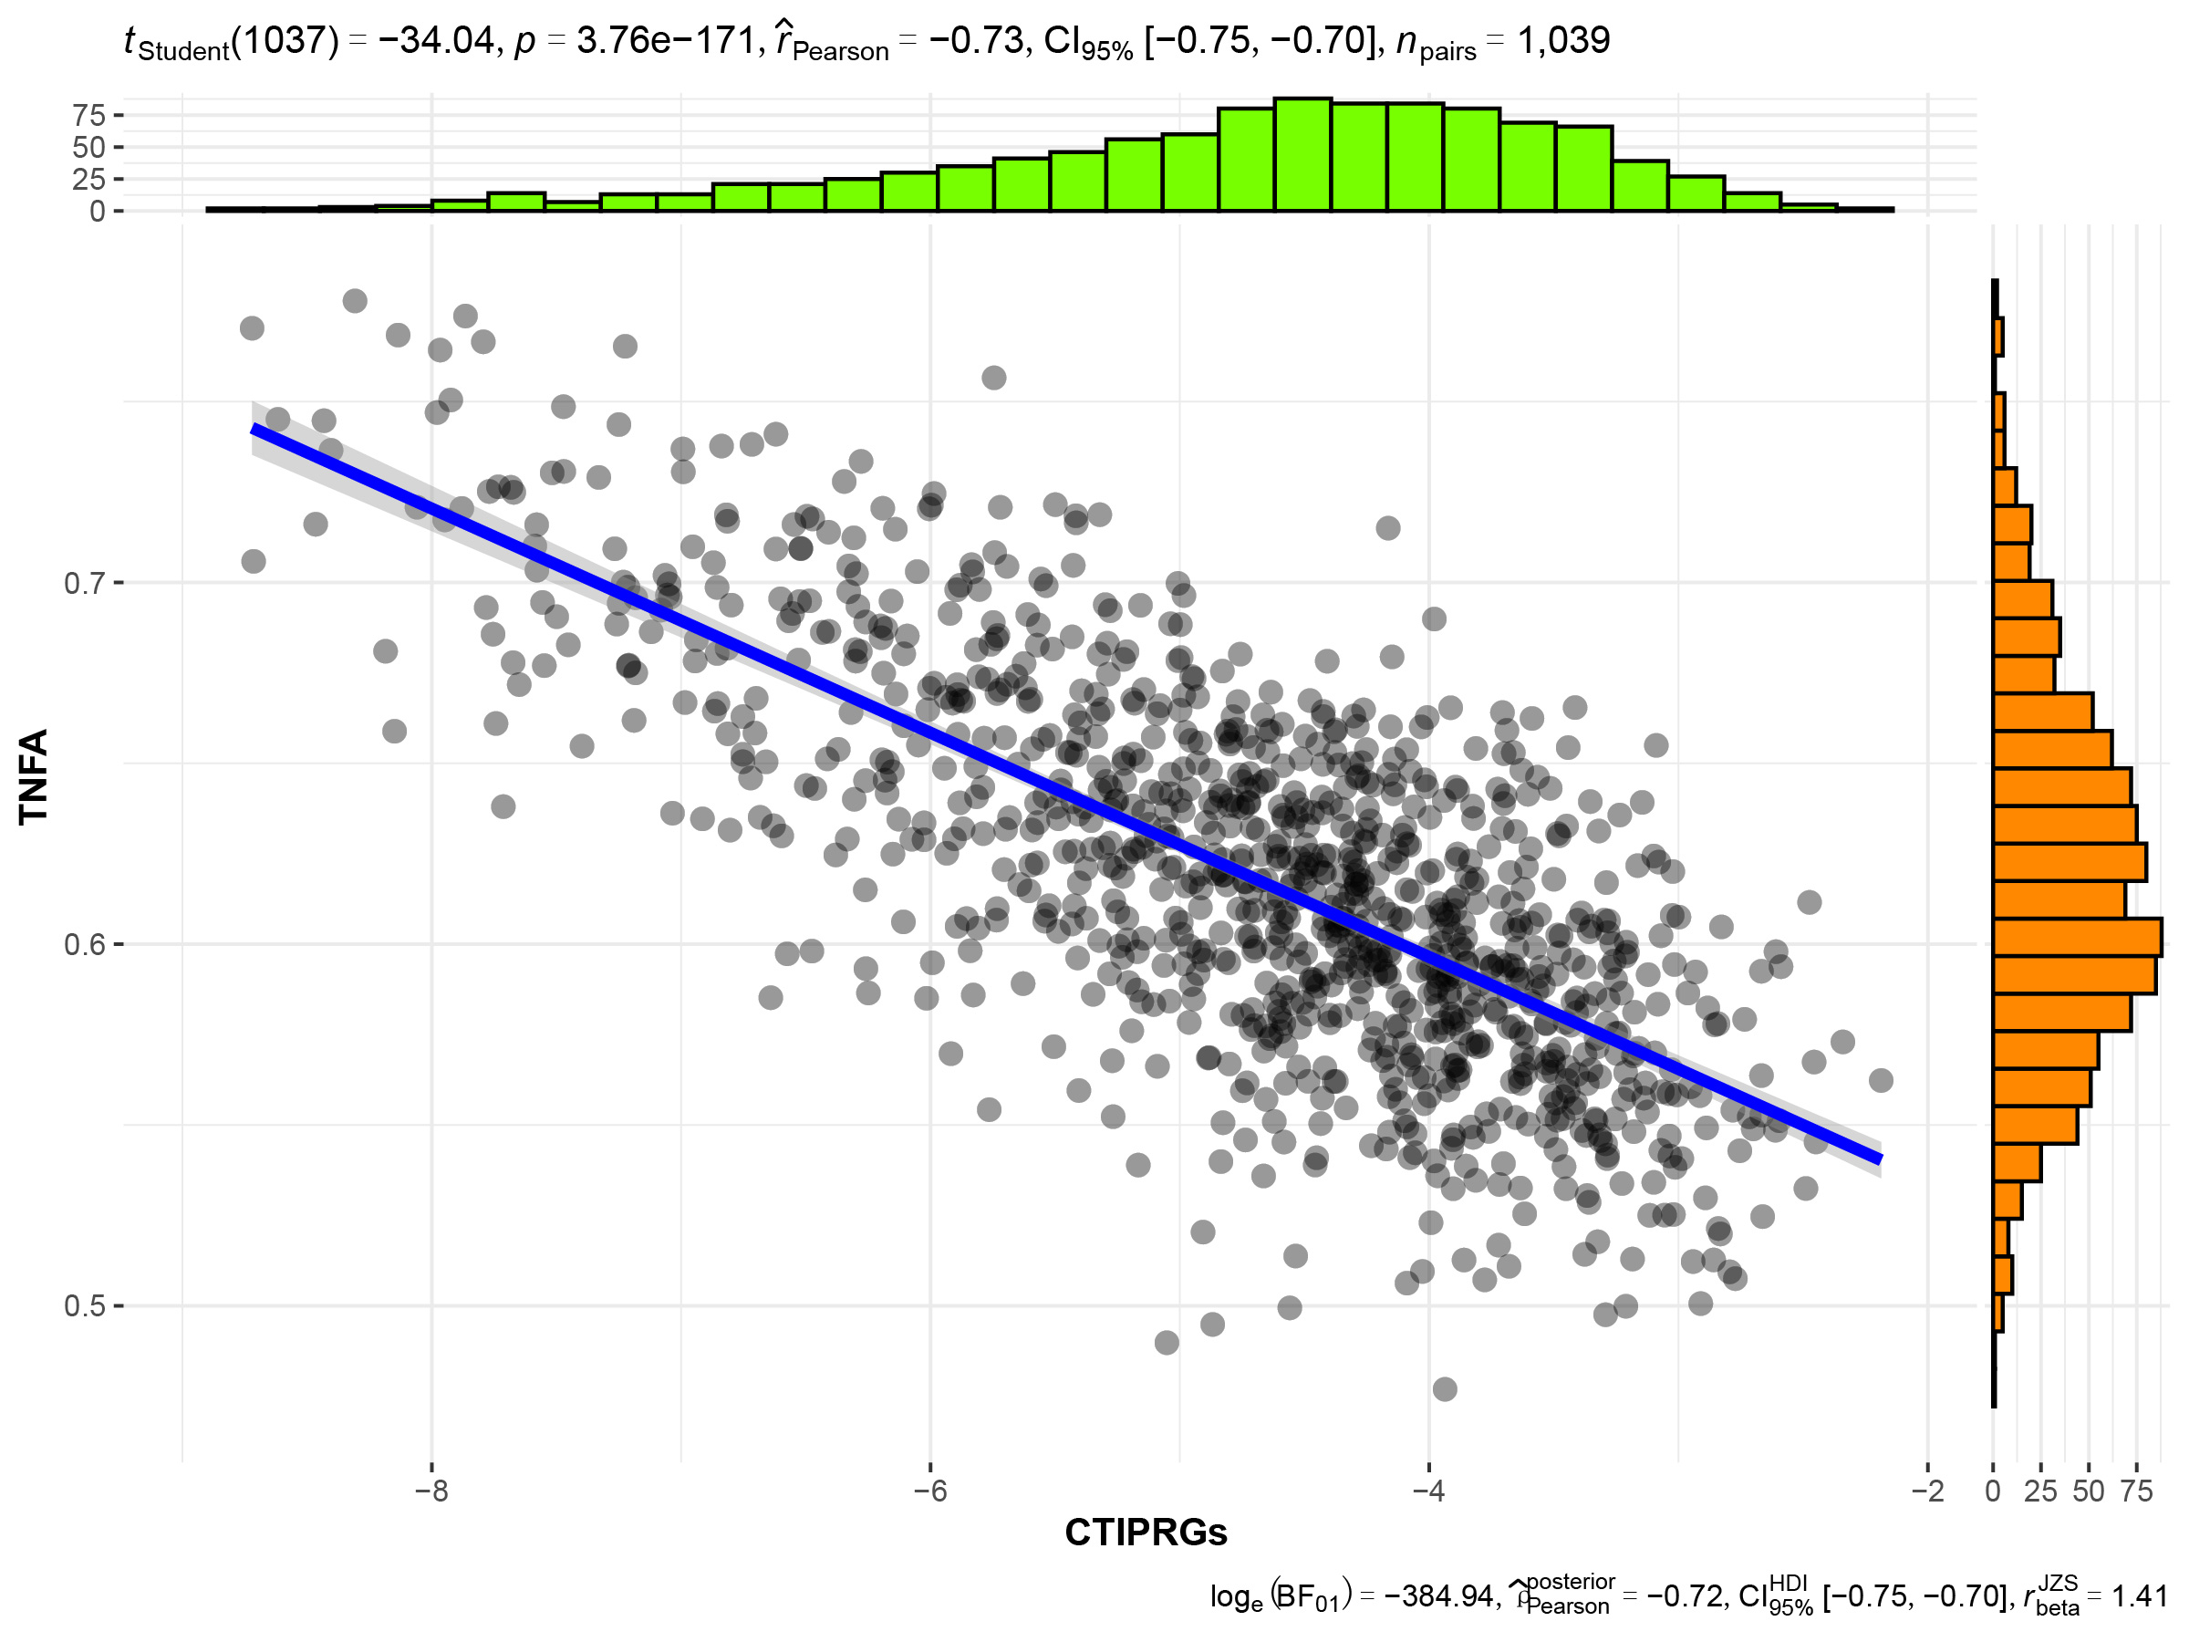

FIGURE LEGEND
Supplementary Figure 1 Construction of a scale-free network with the optimal soft-thresholding power using the CRDEGs of the TCGA-BRCA cohort. (A) Sample clustering tree with clinicopathological characteristics. (B) The use of soft threshold power selection. (C) Representative heatmap of the seven module correlations.

Supplementary Figure 2 KM survival curve illustrated the OS of the validation cohort(GSE20685、GSE42568、GSE88770).

Supplementary Figure 3 Box plot showing the differences in immune score between high-and low-CTIPRGs groups

Supplementary Figure 4 CTIPRGs correlation analysis with different indicators. (A) Association between CTIPRGs with chemokines and chemokine receptor. (B) Correlations between CTIPRGs and seven indicators.

