Table S1. Technical details of the ¹H-MRS acquisition using the experts’ consensus checklist for a single voxel ¹H-MRS study (Lin et al. 2021):
Site (Name or Number)
1. Hardware
a. Field strength [T] | 3T
b. Manufacturer | Philips
c. Model (software version if available) | Achieva with dStream Upgrade. Software Release 5.6.1.
d. RF coils: nuclei (transmit/ receive), number of channels, type, body part | 32-channel dStream receive-only phased-array head coil
e. Additional hardware | N/A
2. Acquisition
a. Pulse sequence | PRESS without saturation pulses and a voxel-based flip angle calibration performed prior to each measurement to achieve the desired flip angle and thus optimal SNR (Versluis et al. 2010).
b. Volume of Interest (VOI) locations | 1. PO: Right parieto-occipital sulcus (precuneus and cuneus)  2. pSTG: Left posterior superior temporal gyrus
c. Nominal VOI size [cm³, mm³] | 18 mm x 17 mm x 17 mm³ (anterior-posterior x left-right x foot-head) for both voxels. Volume = 5.2 cm³.
d. Repetition Time (TR), Echo Time (TE) [ms, s] | TR = 2500ms; TE = 32ms
e. Total number of Excitations or acquisitions per spectrum | 128 acquisitions per spectrum divided into 4 blocks of 32 averages each. At the beginning of each block, one scan without water suppression was performed, which was used for eddy-current correction.
f. Additional sequence parameters (spectral width in Hz, number of spectral points, frequency offsets) | 1024 data points; spectral width 2000 Hz
g. Water Suppression Method | VAriable Power radiofrequency pulses with Optimized Relaxation delays (VAPOR)
h. Shimming Method, reference peak, and thresholds for “acceptance of shim” chosen | Second-order automatic pencil-beam shimming where pencil-beam excitations were performed trough a shim volume of 27x25x24 mm³ (PB volume option). Shim volume was individually placed manually and asymmetrically regarding the measurement voxel to avoid the inclusion of surrounding heterogeneous tissues, thus reducing B₀- inhomogeneities. If necessary, some of the shim volume dimensions of the pSTG voxels were slightly adapted to prevent B₀-inhimigeneities.
i. Triggering or motion correction method | N/A
3. Data analysis methods and outputs
a. Analysis software | ReconFrame (GyroTools LLC, Zurich, Switzerland) to pre-process the spectra and LCModel version 6.3 (Provencher 1993) for analysis. For the pre-processing, code from FID-A (Simpson et al, 2017) was added to ReconFrame.
b. Processing steps deviating from quoted reference or product | Pre-processing steps were performed according to the consensus recommendations: 1) Eddy-current correction 2) combination of head coil channels, 3) frequency realignment of the 128 single acquisitions to the average of all averages using spectral registration4) filtering of residual water signal (Near et al. 2021).
c. Output measure | Ratios to total creatine were calculated.
d. Quantification references and assumptions, fitting model assumptions | For quantification a basis set was simulated using the GAMMA Simulation package (Smith et al. 1994) with the following model spectra: N-acetylaspartate (NAA), N-acetyl-aspartyl-glutamate (NAAG), glutamate (Glu), glutamine (Gln), gamma-aminobutyric acid (GABA), glutathione (GSH), glycerophosphocholine (GPC), phosphocholine (PCh), creatine (Cre), phosphocreatine (PCr), myo-Inositol (mI), ethanolamine and phosphorylethanolamine (PE), aspartate (Asp), glucose (Glc), lactate (Lac), scyllo-inositol (sI), and taurine (Tau).  Simulated contribution of macro molecules and lipid signals provided within LCModel.  The chemical shift range for the ﬁtting procedure was set to 4.0–0.2 ppm. Peak area concentrations were corrected for the number of contributing protons.
4. Data Quality
a. Reported variables  (SNR, Linewidth (with reference peaks)) | Linewidth:  - Full width at half maximum (FWHM, in Hz) of unsuppressed water peaks from the second block using the fwhm MATLAB function (version 1.0.0.0 by Patrick Egan; https://ch.mathworks.com/matlabcentral/fileexchange/10590-fwhm).  - Full width at half maximum (FWHM, in Hz) of NAA-peak provided by LCModel.  SNR:  - NAA peak height over 2 times the SD of the fit residual, provided by LCModel
b. Data exclusion criteria | First, spectra were visually inspected for artifacts. Additional criteria for spectrum exclusion from the analysis were 1) linewidth of the NAA peak of >10Hz and signal-to-noise ratio (SNR) of <15 (linewidth and SNR values from the LCModel analysis were used) in one of the four conditions (HS1, HS2, CS1, CS2). This means that if at least one of the spectra met the exclusion criterion, all four spectra were excluded. In addition, 2) data sets with differences in linewidth LW and SNR between the four conditions higher than two times of the mean intrasubject standard deviation (SD) of all subjects were excluded. The rationale for this approach is based on reported systematic quantification biases of neurochemical due to differences in spectral quality measures (Bartha 2007; Matos et al. 2016).  Neurochemicals with mean %CRLB > 20 % for all datasets were excluded from the analysis
c. Quality measures of postprocessing Model fitting | Relative % CRLBs obtained from LCModel.
d. Sample Spectrum | Figure 3, Figure 4

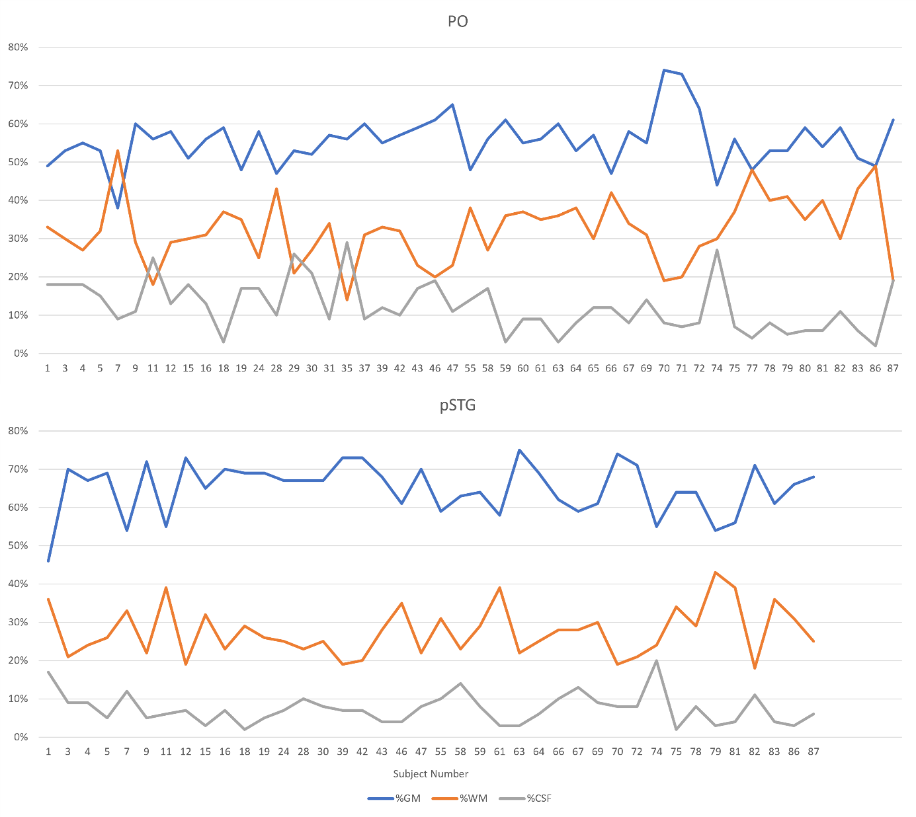
Figure S1: Illustration of the tissue fractions recorded in the PO (parieto-occipital) and pSTG (posterior superior temporal gyrus) voxels for all analyzed participants. One participant was excluded from the tissue fraction analysis due to technical issues with the anatomical image, in addition to those excluded as detailed in the results section of the main manuscript. Consequently, 49 PO and 40 pSTG voxels were included in the analysis. Overall, the PO voxel contained higher percentages of white matter (WM) and grey matter (GM) compared to the pSTG voxel. Statistics of tissue fractions are summarized in table S2.

Table S2: Mean and standard deviations (SD) of the tissue fractions in the PO and pSTG voxels across analyzed datasets. One participant was excluded from the tissue fraction analysis due to technical issues with the anatomical image, in addition to those excluded as detailed in the results section of the main manuscript.

 | PO (N=49) |  |  | pSTG (N=40)
 | Mean | SD |  | Mean | SD
GM | 55.51% | 6.40% |  | 64.98% | 6.67%
WM | 32.10% | 8.37% |  | 27.53% | 6.45%
CSF | 12.27% | 6.56% |  | 7.38% | 3.97%
GM, gray matter; WM, white matter; CSF, cerebrospinal fluid; SD, standard
deviation; PO, parieto-occipital voxel; pSTG, posterior superior temporal gyrus

References
Bartha, Robert (2007): Effect of signal-to-noise ratio and spectral linewidth on metabolite quantification at 4 T. In: NMR in biomedicine 20 (5), S. 512–521. DOI: 10.1002/nbm.1122.
Lin, Alexander; Andronesi, Ovidiu; Bogner, Wolfgang; Choi, In-Young; Coello, Eduardo; Cudalbu, Cristina et al. (2021): Minimum Reporting Standards for in vivo Magnetic Resonance Spectroscopy (MRSinMRS): Experts' consensus recommendations. In: NMR in biomedicine 34 (5), e4484. DOI: 10.1002/nbm.4484.
Matos, Nuno M. P. de; Meier, Lukas; Wyss, Michael; Meier, Dieter; Gutzeit, Andreas; Ettlin, Dominik A.; Brügger, Mike (2016): Reproducibility of Neurochemical Profile Quantification in Pregenual Cingulate, Anterior Midcingulate, and Bilateral Posterior Insular Subdivisions Measured at 3 Tesla. In: Front. Hum. Neurosci. 10, S. 300. DOI: 10.3389/fnhum.2016.00300.
Near, Jamie; Harris, Ashley D.; Juchem, Christoph; Kreis, Roland; Marjańska, Małgorzata; Öz, Gülin et al. (2021): Preprocessing, analysis and quantification in single-voxel magnetic resonance spectroscopy: experts' consensus recommendations. In: NMR in biomedicine 34 (5), e4257. DOI: 10.1002/nbm.4257.
Provencher, S. W. (1993): Estimation of metabolite concentrations from localized in vivo proton NMR spectra. In: Magnetic resonance in medicine 30 (6), S. 672–679. DOI: 10.1002/mrm.1910300604.
Smith, S. A.; Levante, T. O.; Meier, B. H.; Ernst, R. R. (1994): Computer Simulations in Magnetic Resonance. An Object-Oriented Programming Approach. In: Journal of Magnetic Resonance, Series A 106 (1), S. 75–105. DOI: 10.1006/jmra.1994.1008.
Versluis, Maarten J.; Kan, Hermien E.; van Buchem, Mark A.; Webb, Andrew G. (2010): Improved signal to noise in proton spectroscopy of the human calf muscle at 7 T using localized B1 calibration. In: Magnetic resonance in medicine 63 (1), S. 207–211. DOI: 10.1002/mrm.22195.

