supplementary Files
table S1. Clinical samples collected from Chaoyang Central Hospital.
sample | stage | T | N | M | grade | age | fustatus | futime
A1 | StageⅣ | T4 | N1 | MO | G1 | 64 | 0 | 564
A2 | StageⅣ | T4 | N0 | MO | G2 | 59 | 0 | 240
A3 | StageⅡ | T2 | N0 | MO | G1 | 79 | 1 | 624
A4 | StageⅣ | T4 | N1 | MO | G3 | 54 | 1 | 797
A5 | StageⅣ | T4 | N1 | MO | G2 | 64 | 1 | 948
A6 | StageⅣ | T4 | N2 | MO | G2 | 51 | 1 | 1049
A7 | StageⅢ | T3 | N1 | MO | G2 | 69 | 0 | 1422
A8 | StageⅢ | T3 | N1 | MO | G2 | 71 | 1 | 1782
A9 | StageⅣ | T4 | N2 | MO | G2 | 50 | 1 | 913
A10 | StageⅢ | T3 | N0 | MO | G2 | 67 | 0 | 707
A11 | StageⅣ | T3 | N2 | MO | G1 | 55 | 0 | 737
A12 | StageⅣ | T3 | N2 | MO | G2 | 65 | 1 | 167

table S2 GSE227156 of clinical information
geo | T | N | M | diff | Sex | Age | DFS | futime | fustatus
GSM44802 | 2 | 0 | 0 | 1 | 1 | 68 | 12 | 360 | 0
GSM44839 | 1 | 0 | 0 | 1 | 1 | 72 | 92 | 2730 | 0
GSM44840 | 1 | 0 | 0 | 2 | 1 | 52 | 61 | 1260 | 1
GSM44806 | 4 | 2 | 0 | 1 | 1 | 51 | 39 | 1050 | 1
GSM44822 | 3 | 3 | 0 | 2 | 1 | 58 | 77 | 1110 | 1
GSM44827 | 3 | 1 | 0 | 3 | 1 | 65 | 40 | 870 | 1
GSM44829 | 3 | 2 | 0 | 3 | 1 | 70 | 5 | 120 | 1
GSM44826 | 4 | 2 | 0 | 1 | 1 | 67 | 118 | 3540 | 0
GSM44794 | 3 | 1 | 0 | 2 | 1 | 55 | 143 | 2850 | 0
GSM44811 | 4 | 2 | 0 | 2 | 1 | 61 | 140 | 2580 | 0
GSM44837 | 1 | 2 | 0 | 1 | 1 | 70 | 63 | 1170 | 0
GSM44815 | 3 | 2 | 0 | 1 | 1 | 53 | 104 | 3120 | 0
GSM44817 | 3 | 2 | 0 | 2 | 1 | 45 | 101 | 3030 | 0
GSM44819 | 4 | 1 | 0 | 2 | 1 | 43 | 116 | 3480 | 0
GSM44821 | 2 | 2 | 0 | 2 | 1 | 64 | 83 | 2490 | 0
GSM44833 | 2 | 1 | 0 | 3 | 0 | 63 | 67 | 2010 | 0
GSM44841 | 3 | 2 | 0 | 1 | 1 | 59 | 66 | 1980 | 0
GSM44809 | 3 | 2 | 0 | 2 | 1 | 51 | 84 | 420 | 1
GSM44810 | 4 | 2 | 0 | 2 | 1 | 71 | 22 | 270 | 1
GSM44812 | 3 | 2 | 0 | 2 | 1 | 54 | 20 | 330 | 1
GSM44838 | 3 | 2 | 0 | 2 | 1 | 62 | 18 | 240 | 1
GSM44813 | 4 | 3 | 0 | 2 | 1 | 43 | 12 | 90 | 1
GSM44814 | 3 | 3 | 0 | 2 | 1 | 56 | 12 | 240 | 1
GSM44816 | 3 | 2 | 0 | 3 | 1 | 63 | 7 | 210 | 1
GSM44818 | 1 | 2 | 0 | 3 | 1 | 49 | 16 | 30 | 0
GSM44823 | 3 | 3 | 0 | 3 | 1 | 41 | 34 | 840 | 1
GSM44824 | 3 | 3 | 0 | 2 | 0 | 57 | 8 | 240 | 1
GSM44830 | 3 | 2 | 0 | 2 | 1 | 51 | 6 | 240 | 1
GSM44832 | 4 | 3 | 0 | 2 | 1 | 69 | 5 | 30 | 1
GSM44834 | 3 | 2 | 0 | 2 | 1 | 64 | 26 | 630 | 1
GSM44842 | 2 | 2 | 0 | 2 | 1 | 70 | 23 | 660 | 1

table S3 72 Immune checkpoint, chemokine factor, and receptor-related genes
CCchemokine subfamily | CXCchemokine subfamily | XCchemokine subfamily | CX3Cchemokine subfamily | CCR | CXCR | XCR | CX3CR
CCL1 | CXCL1 | XCL1 | CX3CL1 | CCR1 | CXCR1 | XCR1 | CX3CR1
CCL2 | CXCL2 | XCL2 |  | CCR2 | CXCR2
CCL3 | CXCL3 |  |  | CCR3 | CXCR3
CCL3L1 | CXCL4/PF4 |  |  | CCR4 | CXCR4
CCL4 | CXCL4L1/PF4V1 |  |  | CCR5 | CXCR5
CCL4L1 | CXCL5 |  |  | CCR6 | CXCR6
CCL5 | CXCL6
CCL7 | CXCL7/ppbp
CCL8 | CXCL8/IL-8
CCL11 | CXCL10
CCL13 | CXCL11
CCL14 | CXCL12
CCL15 | CXCL13
CCL16 | CXCL14
CCL17 | CXCL9
CCL18 | CXCL16
CCL19 | CXCL17
CCL20
CCL21
CCL22
CCL23
CCL24
CCL25
CCL26
CCL27
CCL28

table S4 79 Immune checkpoint genes and descriptions
 | Gene symbol | Descriptions
1 | ADORA2A | Adenosine A2a Receptor
2 | BTLA | B And T Lymphocyte Associated
3 | BTN2A1 | Butyrophilin Subfamily 2 Member A1
4 | BTN2A2 | Butyrophilin Subfamily 2 Member A2
5 | BTN3A1 | Butyrophilin Subfamily 3 Member A1
6 | BTNL3 | Butyrophilin Like 3
7 | BTNL9 | Butyrophilin Like 9
8 | C10orf54 | V-Set Immunoregulatory Receptor
9 | CD160 | CD160 Molecule
10 | CD209 | CD209 Molecule
11 | CD226 | CD226 Molecule
12 | CD27 | CD27 Molecule
13 | CD274 | CD274 Molecule
14 | CD276 | CD276 Molecule
15 | CD28 | CD28 Molecule
16 | CD40 | CD40 Molecule
17 | CD40LG | CD40 Ligand
18 | CD47 | CD47 Molecule
19 | CD70 | CD70 Molecule
20 | CD80 | CD80 Molecule
21 | CD86 | CD86 Molecule
22 | CD96 | CD96 Molecule
23 | CEACAM1 | CEA Cell Adhesion Molecule 1
24 | CTLA4 | Cytotoxic T-Lymphocyte Associated Protein 4
25 | HAVCR2 | Hepatitis A Virus Cellular Receptor 2
26 | HLA-A | Major Histocompatibility Complex, Class I, A
27 | HLA-B | Major Histocompatibility Complex, Class I, B
28 | HLA-C | Major Histocompatibility Complex, Class I, C
29 | HLA-DMA | Major Histocompatibility Complex, Class II, DM Alpha
30 | HLA-DMB | Major Histocompatibility Complex, Class II, DM Beta
31 | HLA-DOA | Major Histocompatibility Complex, Class II, DO Alpha
32 | HLA-DOB | Major Histocompatibility Complex, Class II, DO Beta
33 | HLA-DPA1 | Major Histocompatibility Complex, Class II, DP Alpha 1
34 | HLA-DPB1 | Major Histocompatibility Complex, Class II, DP Beta 1
35 | HLA-DQA1 | Major Histocompatibility Complex, Class II, DQ Alpha 1
36 | HLA-DQB1 | Major Histocompatibility Complex, Class II, DQ Beta 1
37 | HLA-DRA | Major Histocompatibility Complex, Class II, DR Alpha
38 | HLA-DRB1 | Major Histocompatibility Complex, Class II, DR Beta 1
39 | HLA-DRB3 | Major Histocompatibility Complex, Class II, DR Beta 3
40 | HLA-DRB4 | Major Histocompatibility Complex, Class II, DR Beta 4
41 | HLA-DRB5 | Major Histocompatibility Complex, Class II, DR Beta 5
42 | HLA-E | Major Histocompatibility Complex, Class I, E
43 | HLA-F | Major Histocompatibility Complex, Class I, F
44 | HLA-G | Major Histocompatibility Complex, Class I, G
45 | ICOS | Inducible T Cell Costimulator
46 | ICOSLG | Inducible T Cell Costimulator Ligand
47 | IDO1 | Indoleamine 2,3-Dioxygenase 1
48 | KIR2DL1 | Killer Cell Immunoglobulin Like Receptor, Two Ig Domains And Long Cytoplasmic Tail 1
49 | KIR2DL2 | Killer Cell Immunoglobulin Like Receptor, Two Ig Domains And Long Cytoplasmic Tail 2
50 | KIR2DL3 | Killer Cell Immunoglobulin Like Receptor, Two Ig Domains And Long Cytoplasmic Tail 3
51 | KIR2DL4 | Killer Cell Immunoglobulin Like Receptor, Two Ig Domains And Long Cytoplasmic Tail 4
52 | KIR2DL5A | Killer Cell Immunoglobulin Like Receptor, Two Ig Domains And Long Cytoplasmic Tail 5A
53 | KIR2DL5B | Killer Cell Immunoglobulin Like Receptor, Two Ig Domains And Long Cytoplasmic Tail 5B
54 | KIR2DS1 | Killer Cell Immunoglobulin Like Receptor, Two Ig Domains And Short Cytoplasmic Tail 1
55 | KIR2DS2 | Killer Cell Immunoglobulin Like Receptor, Two Ig Domains And Short Cytoplasmic Tail 2
56 | KIR2DS3 | Killer Cell Immunoglobulin Like Receptor, Two Ig Domains And Short Cytoplasmic Tail 3
57 | KIR2DS4 | Killer Cell Immunoglobulin Like Receptor, Two Ig Domains And Short Cytoplasmic Tail 4
58 | KIR2DS5 | Killer Cell Immunoglobulin Like Receptor, Two Ig Domains And Short Cytoplasmic Tail 5
59 | KIR3DL1 | Killer Cell Immunoglobulin Like Receptor, Three Ig Domains And Long Cytoplasmic Tail 1
60 | KIR3DL2 | Killer Cell Immunoglobulin Like Receptor, Three Ig Domains And Long Cytoplasmic Tail 2
61 | KIR3DL3 | Killer Cell Immunoglobulin Like Receptor, Three Ig Domains And Long Cytoplasmic Tail 3
62 | KIR3DS1 | Killer Cell Immunoglobulin Like Receptor, Three Ig Domains And Short Cytoplasmic Tail 1
63 | LAG3 | Lymphocyte Activating 3
64 | LGALS9 | Galectin 9
65 | PDCD1 | Programmed Cell Death 1
66 | PDCD1LG2 | Programmed Cell Death 1 Ligand 2
67 | PVR | PVR Cell Adhesion Molecule
68 | SIRPA | Signal Regulatory Protein Alpha
69 | TDO2 | Tryptophan 2,3-Dioxygenase
70 | TIGIT | T Cell Immunoreceptor With Ig And ITIM Domains
71 | TNFRSF14 | TNF Receptor Superfamily Member 14
72 | TNFRSF18 | TNF Receptor Superfamily Member 18
73 | TNFRSF4 | TNF Receptor Superfamily Member 4
74 | TNFRSF9 | TNF Receptor Superfamily Member 9
75 | TNFSF14 | TNF Superfamily Member 14
76 | TNFSF18 | TNF Superfamily Member 18
77 | TNFSF4 | TNF Superfamily Member 4
78 | TNFSF9 | TNF Superfamily Member 9
79 | VTCN1 | V-Set Domain Containing T Cell Activation Inhibitor 1

table S5 GO and KEGG enrichment tables of 195 differentially expressed genes.
ID | Description | GeneRatio | BgRatio | pvalue | p.adjust | qvalue | geneID | Count
GO:0005201 | extracellular matrix structural constituent | 10/151 | 166/18496 | 1.09E-06 | 0.000397405 | 0.000353964 | PXDN/COL5A1/LAMA3/NID1/COL2A1/LAMA1/ANOS1/LAMB1/COL4A6/LAMC1 | 10
GO:0043394 | proteoglycan binding | 4/151 | 36/18496 | 0.000205185 | 0.025142298 | 0.02239395 | COL5A1/NID1/GPNMB/COL2A1 | 4
GO:0005178 | integrin binding | 7/151 | 154/18496 | 0.000274334 | 0.025142298 | 0.02239395 | FERMT1/COL5A1/ADAM23/CXADR/GPNMB/FAP/ADAM9 | 7
GO:0042813 | Wnt receptor activity | 3/151 | 16/18496 | 0.000276289 | 0.025142298 | 0.02239395 | FZD9/NID1/FZD6 | 3

category | subcategory | ID | Description | GeneRatio | BgRatio | pvalue | p.adjust | qvalue | geneID | Count
Environmental Information Processing | Signal transduction | hsa04151 | PI3K-Akt signaling pathway | 12/65 | 359/8662 | 1.18E-05 | 0.001582272 | 0.00142939 | 1944/3909/59345/23566/7039/1280/1956/284217/3912/1288/2149/3915 | 12
Environmental Information Processing | Signaling molecules and interaction | hsa04512 | ECM-receptor interaction | 6/65 | 89/8662 | 5.04E-05 | 0.003378286 | 0.003051869 | 3909/1280/284217/3912/1288/3915 | 6
Cellular Processes | Cellular community - eukaryotes | hsa04510 | Focal adhesion | 8/65 | 203/8662 | 0.000127174 | 0.005680424 | 0.005131569 | 3909/394/1280/1956/284217/3912/1288/3915 | 8
Human Diseases | Cancer: specific types | hsa05222 | Small cell lung cancer | 5/65 | 92/8662 | 0.000605585 | 0.020183145 | 0.018233006 | 3909/284217/3912/1288/3915 | 5
Human Diseases | Infectious disease: viral | hsa05165 | Human papillomavirus infection | 9/65 | 331/8662 | 0.000753102 | 0.020183145 | 0.018233006 | 8326/3909/8323/1280/1956/284217/3912/1288/3915 | 9
Human Diseases | Infectious disease: parasitic | hsa05146 | Amoebiasis | 5/65 | 102/8662 | 0.000968369 | 0.0216269 | 0.019537262 | 3909/284217/3912/1288/3915 | 5
Human Diseases | Infectious disease: parasitic | hsa05145 | Toxoplasmosis | 5/65 | 111/8662 | 0.001414986 | 0.027086876 | 0.024469684 | 3909/2770/284217/3912/3915 | 5
Environmental Information Processing | Signal transduction | hsa04010 | MAPK signaling pathway | 8/65 | 301/8662 | 0.001745375 | 0.029235029 | 0.026410277 | 1944/1852/3556/7039/1956/23542/84451/6788 | 8
table S5 195 differentially expressed genes.
KRT16P6 | SLC28A3 | GPNMB | MYO1B | ANKUB1
RUNDC3A | KRT17 | FAP | SNAP25-AS1 | ADGRV1
SLC6A2 | RTN4RL1 | DSCAM | CARMIL1 | LNCAROD
RTN4R | MEX3A | LINC01213 | IQCH | SP9
EFNA3 | FHAD1 | NETO2 | LINC02687 | RAI14
FERMT1 | PLOD2 | EGFR-AS1 | CIBAR1 | PLS3
IGSF3 | LOX | TP63 | BVES | PCDHB9
SYT12 | LINC00491 | MSANTD3-TMEFF1 | P3H4 | DLX2-DT
CORO6 | IL1RAP | C12orf56 | ZNF391 | DLX2
LYPD5 | RASL11B | PCDHB16 | IQCA1-AS1 | KRT1
EFNA4-EFNA3 | FAM227A | LUCAT1 | DSG2 | DSG2-AS1
PERP | EXO1 | COL2A1 | DNMT3B | NBEAP5
SHANK2 | GNB4 | FNBP1L | ERC2 | STK3
KRT74 | SLC6A15 | LINC00668 | LINC01460 | CD109
PXDN | PURPL | TSLP | RPL7AP54 | LINC02893
CDH3 | C6orf141 | EPB41L4B | XRCC2 | CFAP45
SLC47A2 | CD109-AS1 | P4HA1 | LINC01518 | DNAH14
LINC02677 | ARHGAP5 | EGFR | LRP12 | ZIC4
LASTR | FNDC3B | LOC124907726 | NLN | FZD6
SRRM3 | ECT2 | XPR1 | LURAP1L | LOC105378305
NDRG4 | MARVELD1 | FBXO45 | H1-0 | TGFA
CSPG4 | CCDC8 | TMEFF1 | LAMB1 | ZNRF3
FZD9 | SLC9A3P2 | TCEAL9 | P3H2-AS1 | BVES-AS1
DYSF | MB21D2 | DLX5 | MAP3K21 | MAPK15
NDRG1 | NPR3 | OR7A5 | SPIRE1 | LCLAT1
PKP1 | MYH16 | LAMA1 | COL4A6 | SLC1A6
COL5A1 | CECR2 | MAPK8IP2 | SNAI2 | SRFBP1
FNDC10 | AKR1E2 | PRTFDC1 | SRSF12 | LAMC1
MDFI | ENAH | HDGFL3 | LOC105378798 | SCML2P1
RAB31 | GNAI1 | DCUN1D1 | F2R | CASP14
MIR6887 | NID1 | CCDC113 | RTP3 | SEMA3C
ADAM23 | GPR156 | KCNG3 | KIF13A | NEDD1
FABP4 | SQLE | TMTC3 | DLX1 | CLXN
DSG1 | MCIDAS | OPA1-AS1 | MN1 | MEST
ULBP3 | RETREG1-AS1 | PTPN14 | MYO10 | DSC1
LAMA3 | LPAR3 | MATCAP2 | CTXN1 | ADAM9
NMB | MAGEA9B | GLO1 | FAM83B | MAP7
CHST3 | MARK1 | PTPN12 | RN7SL399P | ELOVL7
DUSP9 | CXADR | ANOS1 | RNF217 | SMPD4P1

table S6 25 small molecular compounds showing significant differential responses between High-expression group and low-expression group
Compound | p_value
BI.2536_1086 | 0.000199197
MN.64_1854 | 0.001030914
Ulixertinib_2047 | 0.001300041
BPD.00008900_1998 | 0.001736152
GSK1904529A_1093 | 0.001802188
Paclitaxel_1080 | 0.002011223
MG.132_1862 | 0.002537993
IAP_5620_1428 | 0.006412159
Osimertinib_1919 | 0.006718869
Ibrutinib_1799 | 0.007730265
UMI.77_1939 | 0.008531582
Wee1.Inhibitor_1046 | 0.01946272
AZD6738_1917 | 0.019903974
Dinaciclib_1180 | 0.023684039
GDC0810_1925 | 0.023776792
MK.1775_1179 | 0.024290619
Selumetinib_1736 | 0.026769566
LCL161_1557 | 0.027243221
ERK_2440_1713 | 0.033105963
Gallibiscoquinazole_1830 | 0.038072123
Ipatasertib_1924 | 0.038715015
Docetaxel_1007 | 0.043189252
Cediranib_1922 | 0.043992758
Daporinad_1248 | 0.045667002
BMS.345541_1249 | 0.049495128

table S7 DLX5 knockdown and overexpression efficiency
group | 1 si-NC | 2 siRNA-1 | 3 siRNA-2 | 4 siRNA-3 | 5 pCDNA3.1 empty vector | 6 pCDNA3.1-DLX5 overexpression
Relative value | 1.00 | 0.20 | 1.04 | 0.33 | 1.00 | 0.17
Standard deviation | 0.07 | 0.03 | 0.04 | 0.05 | 2715.14 | 47.44

Supplementary figure1 Technical Workflow Diagram
Cohort of Chaoyang Central Hospital
(n=18)
Differential Genes in Hypopharyngeal Cancer
Scoring 22 Immune Cell Types & WGCNA Matrix
Immunology-Related Differential Gene Set
Tumor Immune Infiltration CD4+ T Cell Genes
Filtering Squamous Epithelial Cells in scRNA-seq Data
PPI Network and Clinical Prognosis

Tumor Mutation Burden
evaluating the therapeutic response
ImmuneChemokine and Receptor Correlation
Immune Checkpoint Relevance

Cellular Layer Verification
Supplementary figure2.
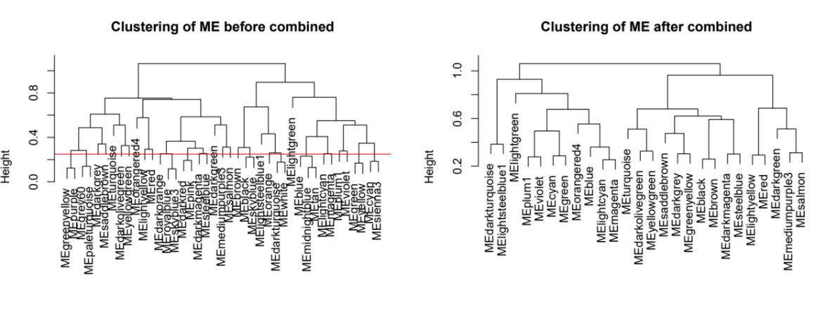
A

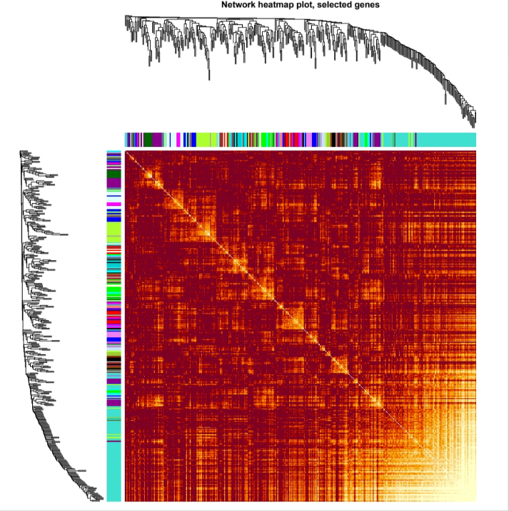
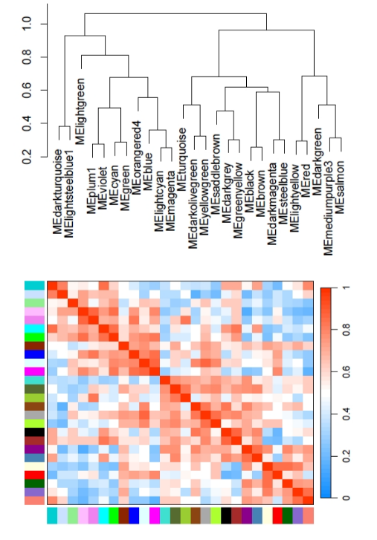
B
C

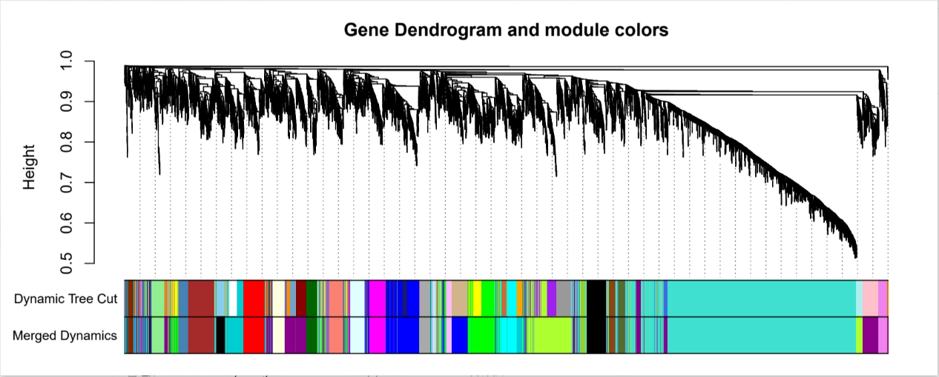
D

A Merge high-similarity dynamic modules at the 0.25 cut line.
B Correlation plot between modules
C Visualization of gene network (TOM plot)
D By aggregating genes with strong correlations in the same module, different modules were obtained and are displayed in different colors
Supplementary figure3.
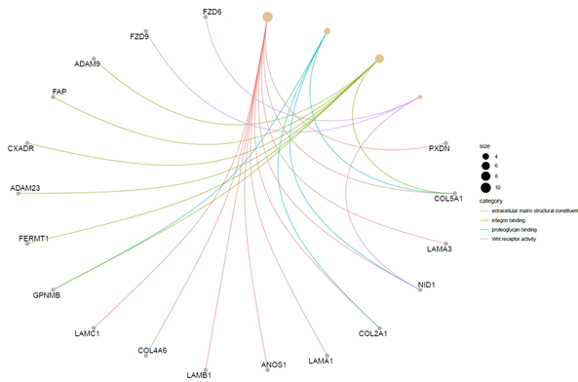

Supplementary figure4.
3000 highly variable genes
Harmony De-Batch Chart
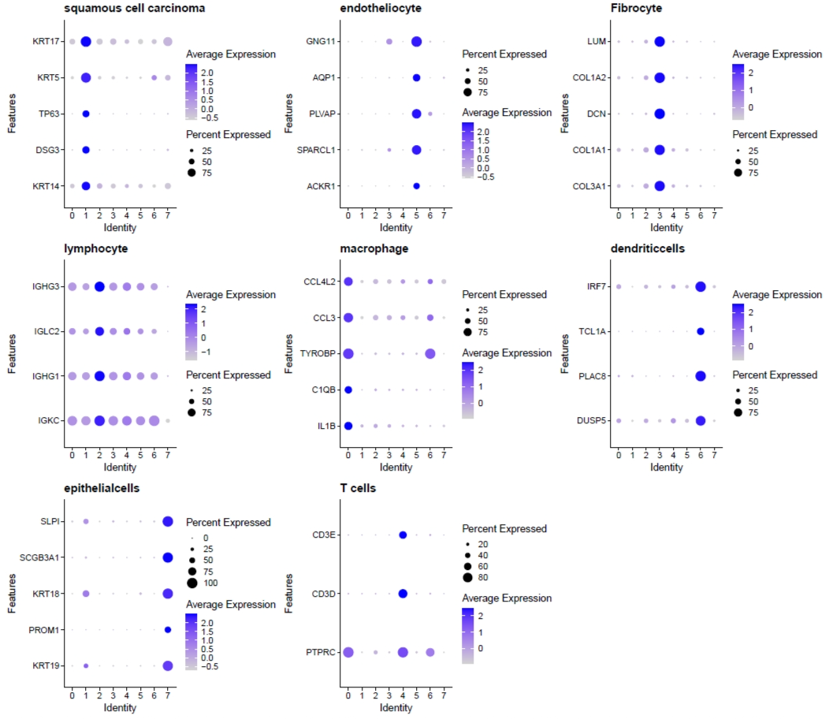
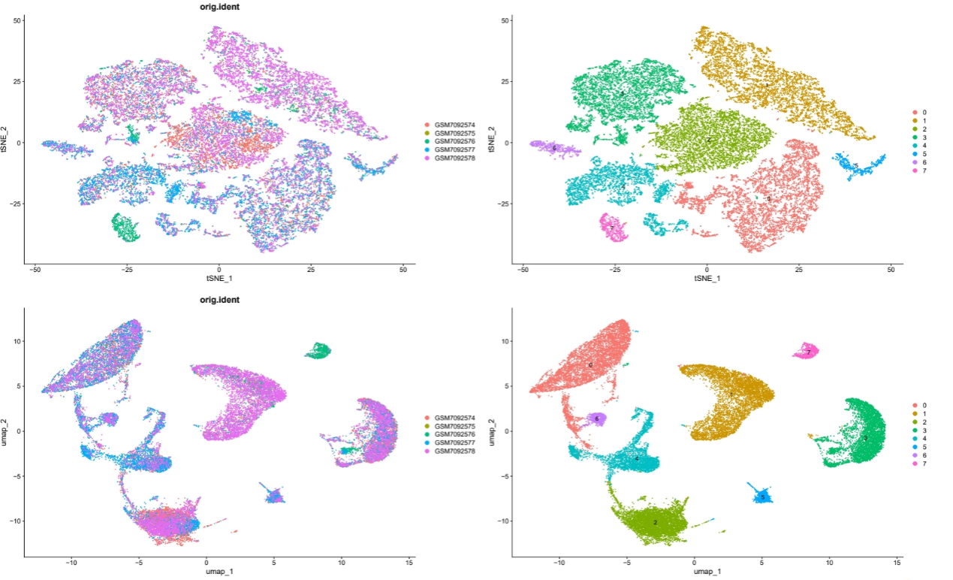
Supplementary figure5.
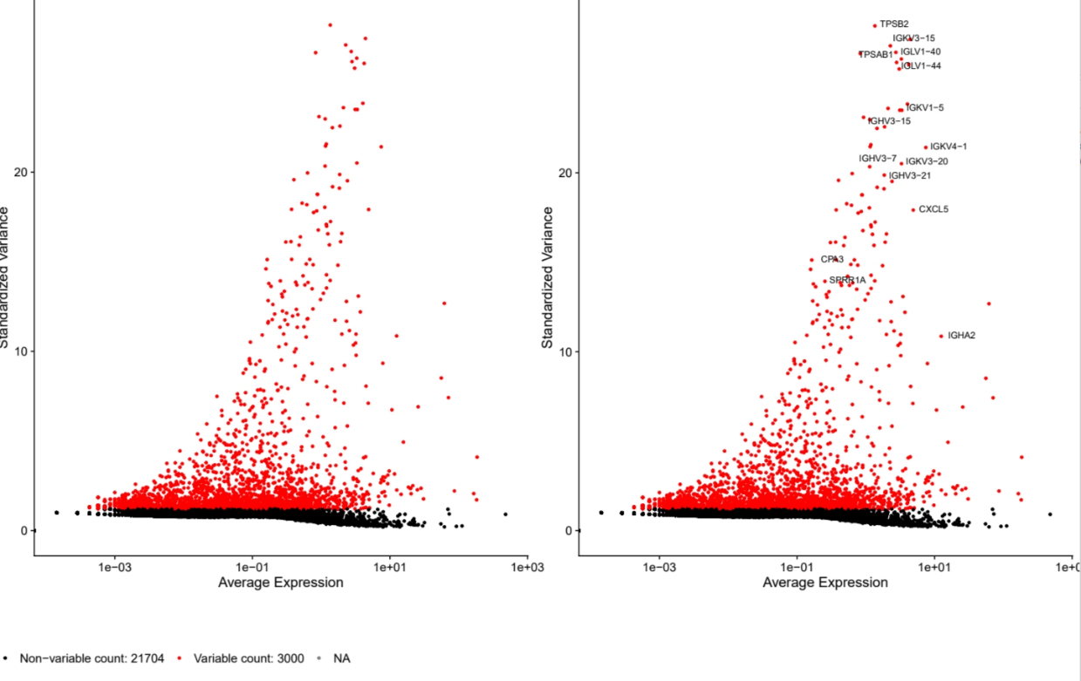
Marker genes for cell clusters

