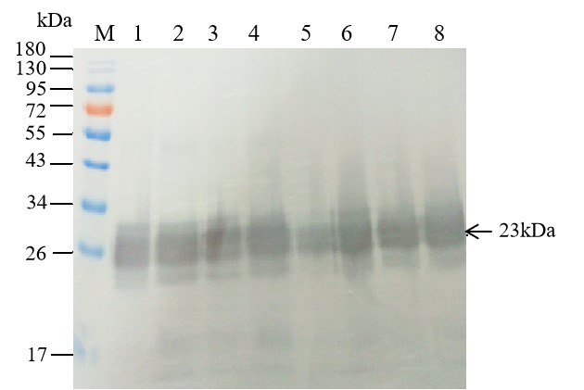

Original image of Fig 2B. Western blot analysis of S1CD expression in Sf9 cells infected with different baculoviruses at 96 h p.i. Lane M: PageRuler™ Prestained Protein Ladder, 10 to 180 kDa; Lane 1 ~ Lane 8: Samples from the Sf9 cells infected with the recombinant virus Ac-IM-p10-S1CD, Ac-IM-2p10-2S1CD, Ac-IM-3p10-3S1CD, Ac-IM-ph-S1CD, Ac-IM-2ph-2S1CD, Ac-IM-3ph-3S1CD, Ac-IM-php10-2S1CD, and Ac-IM-2ph2p10-4S1CD, respectively.

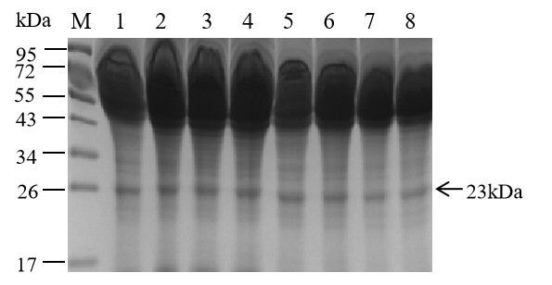
Original image of Fig 2C. SDS-PAGE analysis of S1CD expression in culture supernatant of Sf9 cells infected with different baculoviruses at 96 h p.i. Lane M: PageRuler™ Prestained Protein Ladder, 10 to 180 kDa; Lane 1 ~ Lane 8: Samples from the Sf9 cells infected with the recombinant virus Ac-IM-p10-S1CD, Ac-IM-2p10-2S1CD, Ac-IM-3p10-3S1CD, Ac-IM-ph-S1CD, Ac-IM-2ph-2S1CD, Ac-IM-3ph-
3S1CD, Ac-IM-php10-2S1CD, and Ac-IM-2ph2p10-4S1CD, respectively.

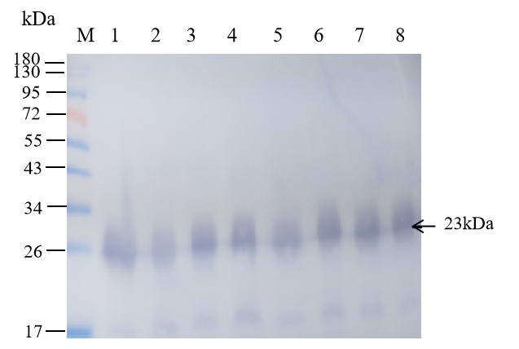
Original image of Fig 2D. Western blot analysis of S1CD expression in culture supernatant of Sf9 cells infected with different baculoviruses at 96 h p.i. Lane M: PageRuler™ Prestained Protein Ladder, 10 to 180 kDa; Lane 1 ~ Lane 8: Samples from the Sf9 cells infected with the recombinant virus Ac-IM-p10-S1CD, Ac-IM-2p10-2S1CD, Ac-IM-3p10-3S1CD, Ac-IM-ph-S1CD, Ac-IM-2ph-2S1CD, Ac-IM-3ph-
3S1CD, Ac-IM-php10-2S1CD, and Ac-IM-2ph2p10-4S1CD, respectively.

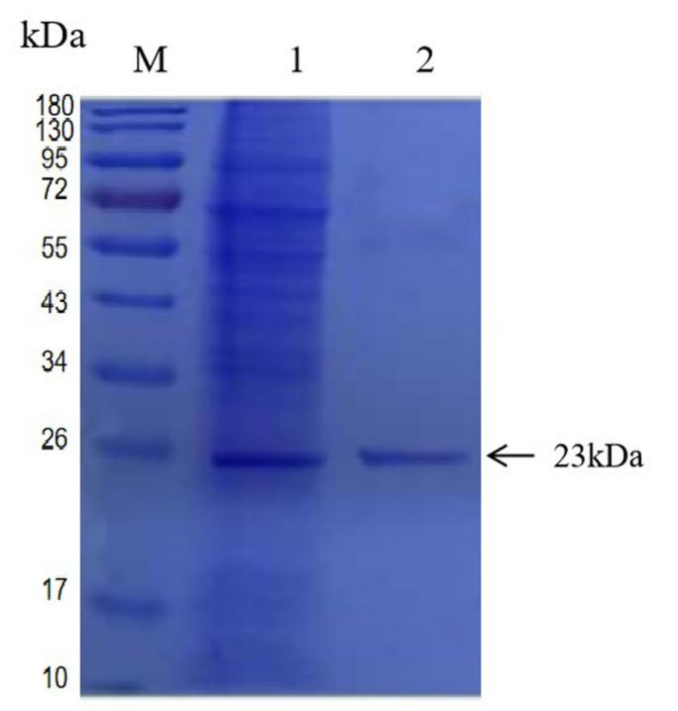
Original image of Fig 4. SDS-PAGE analysis of purified recombinant S1CD protein. Lane M: Pageruler™ Prestained Protein Ladder, 10 to 180 kDa; Lane 1: ultrasound supernatant of the recombinant baculovirus Ac-IM-3p10-3S1CD infected Sf9 cells; Lane 2: 300 mM Imidazole eluent.

