Cellular and Molecular Life Sciences
PRSS55 Regulates Energy Homeostasis and BCAA Metabolism via Interacting with BCKDK in Mouse Testes and Sperm
Haoyang Ge¹, Chunling Shen¹, Wenfeng Xiong¹, Shunyuan Lu¹, Chaojie Li¹, Lingyun Tang¹, Yan Shen¹, Hongxin Zhang¹, Jian Fei², Zhugang Wang^{1,*}
¹ State Key Laboratory of Medical Genomics, Research Center for Experimental Medicine, Rui-Jin Hospital Affiliated to Shanghai Jiao Tong University School of Medicine, Shanghai 200025, China; haoyangge@sjtu.edu.cn (H.G.); scl11868@rjh.com.cn (C.Z.); xiongwenfeng@sjtu.edu.cn (W.X.); lsy40488@rjh.com.cn (S.L.); jackyjie@sjtu.edu.cn (C.L.); tly12033@rjh.com.cn (L.T.); sy40685@rjh.com.cn (Y.S.) zhx11627@rjh.com.cn (H.Z.)
² Shanghai Engineering and Technology Research Center for Model Animals, Shanghai 201318, China; jfei@tongji.edu.cn
* Correspondence: zhugangw@shsmu.edu.cn

Supporting materials (original images of immunoblotting assays)

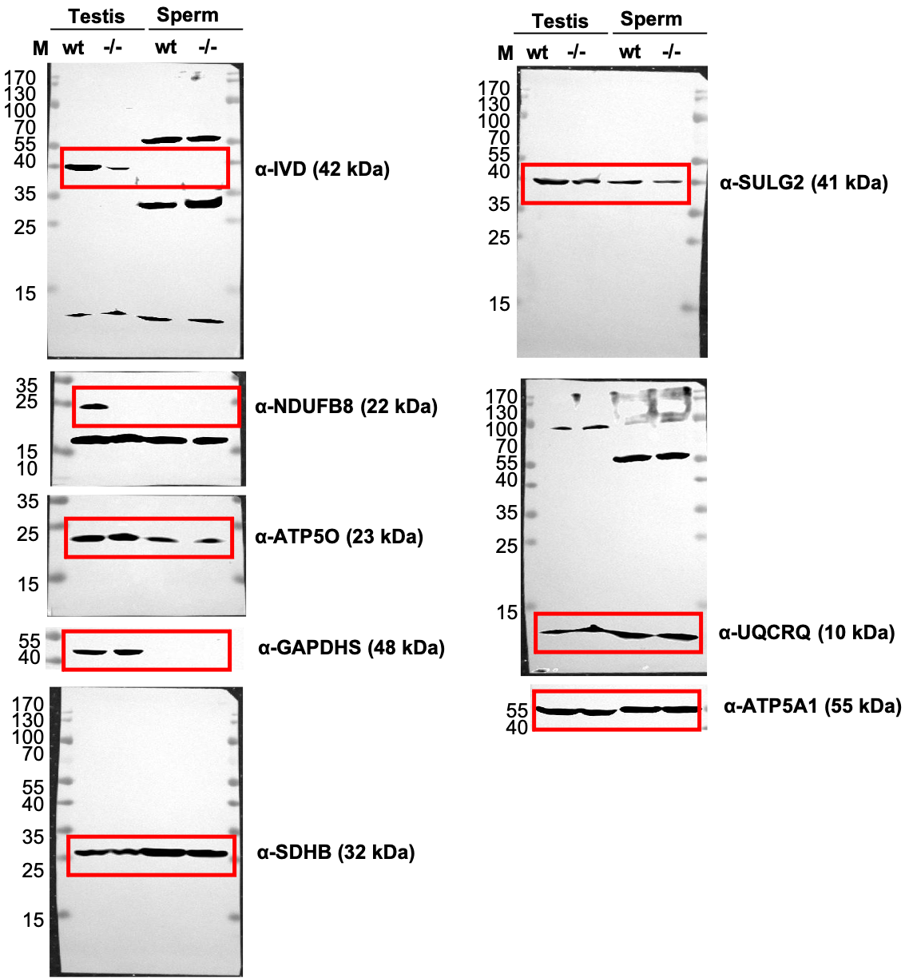
Figure 3A

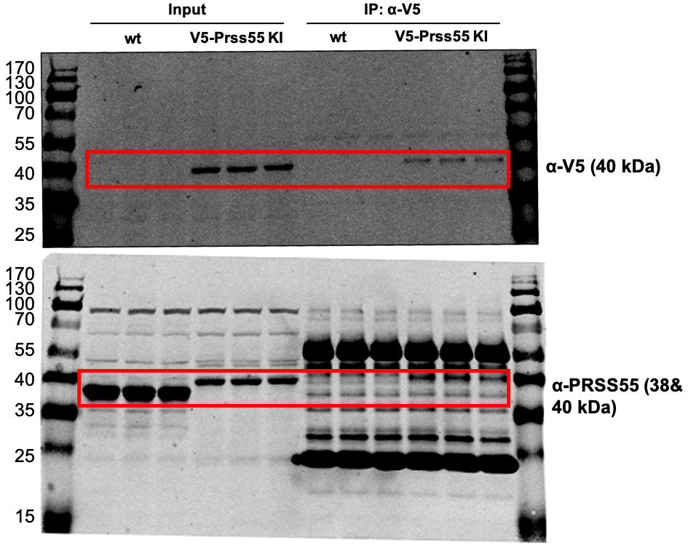
Figure 5A

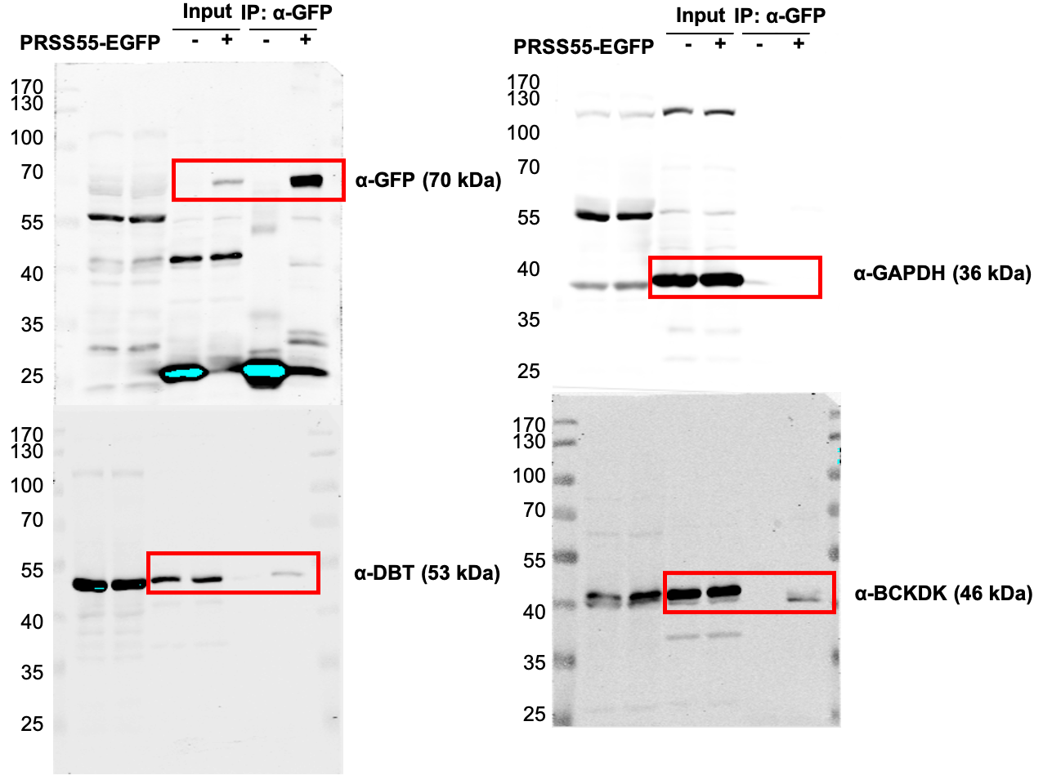
Figure 5D

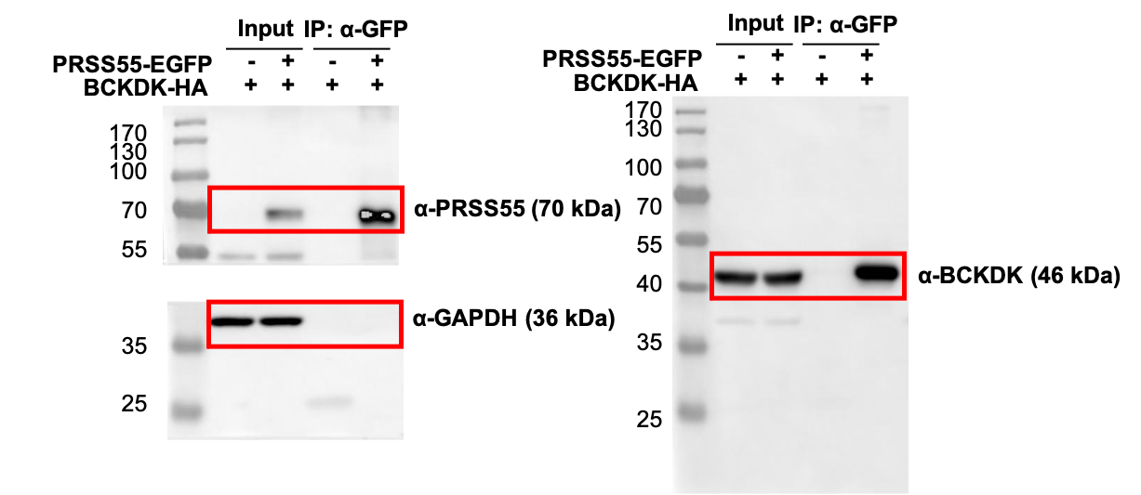
Figure 5E

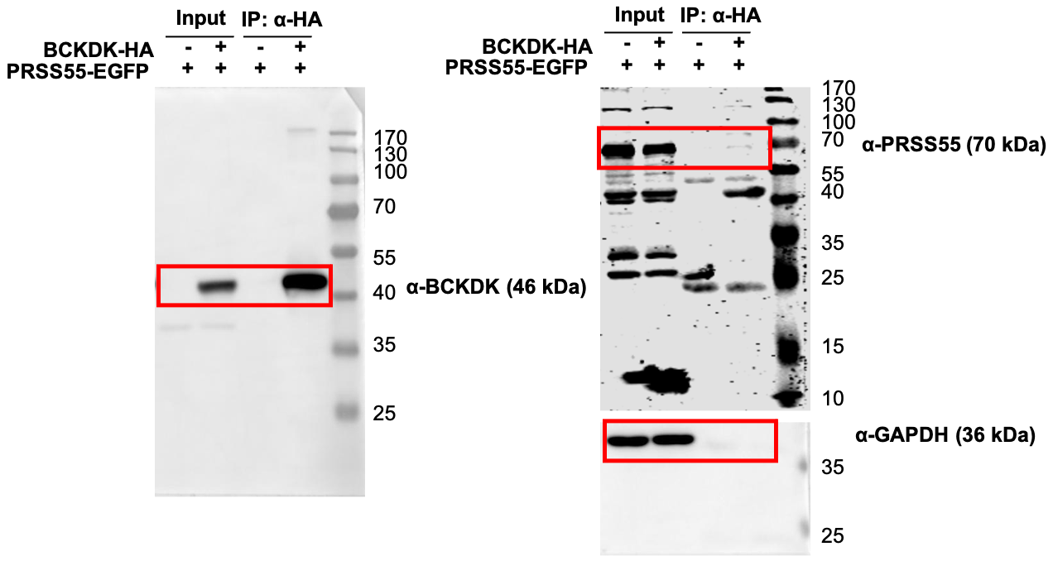
Figure 5F
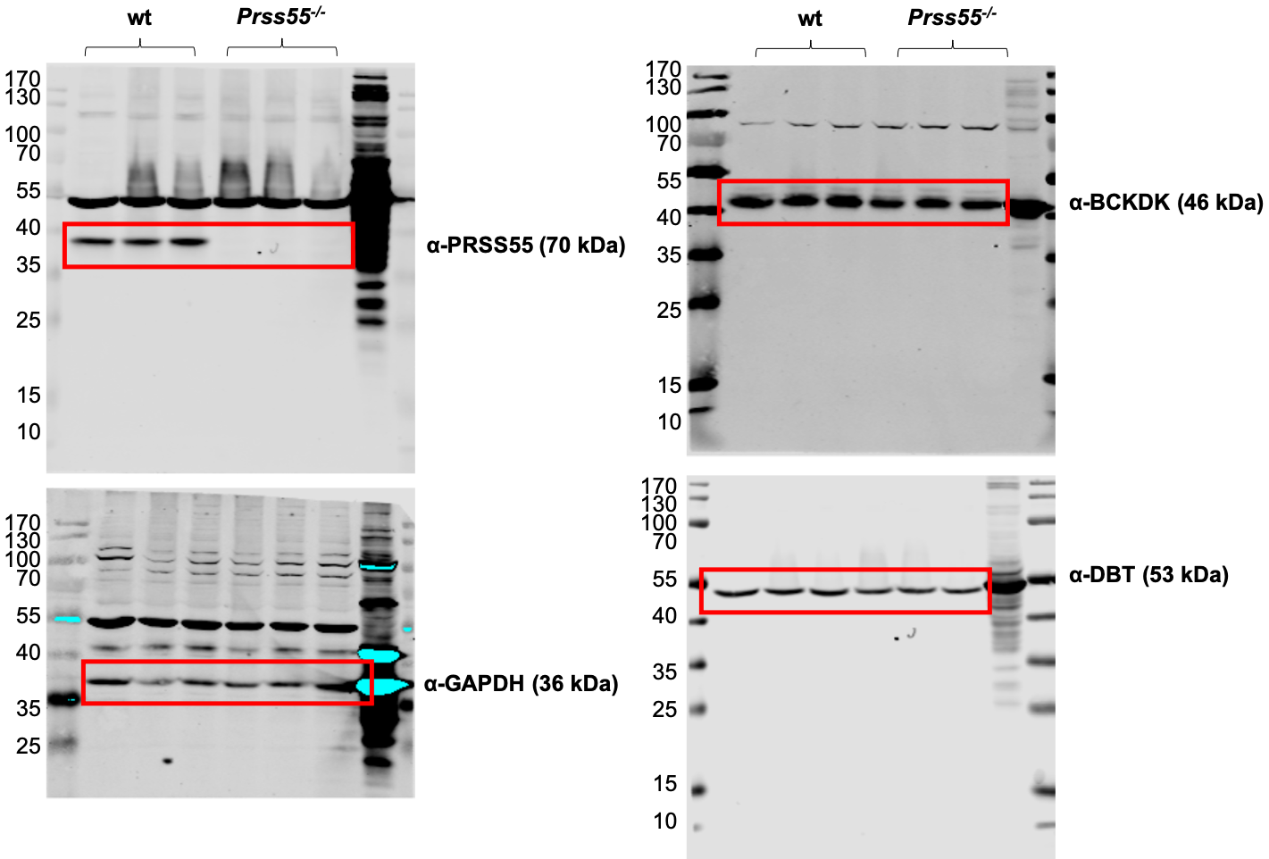
Figure 5G

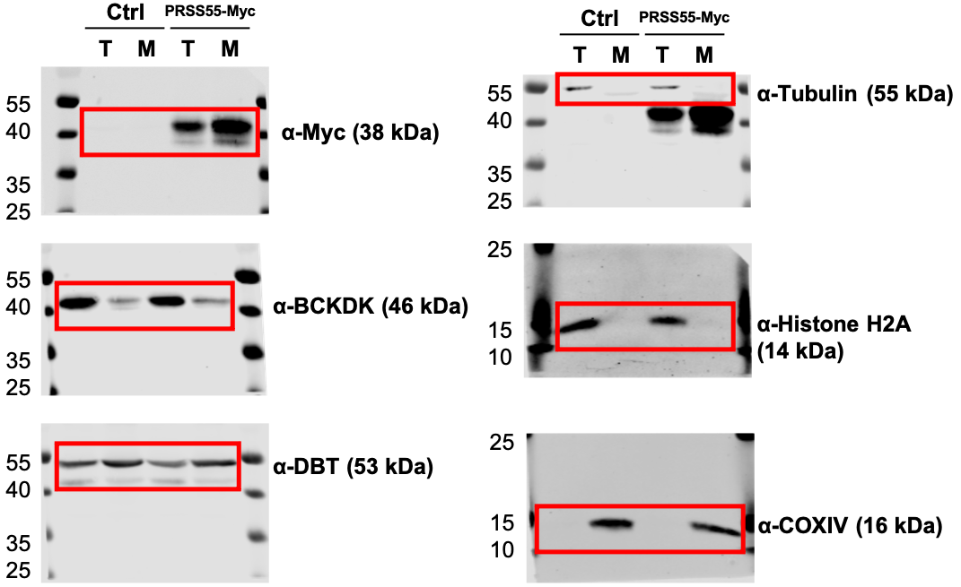
Figure 6B

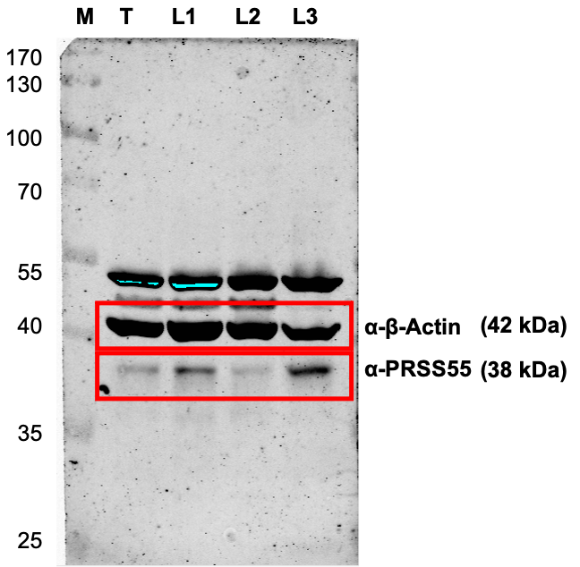
Supplementary Figure 1E

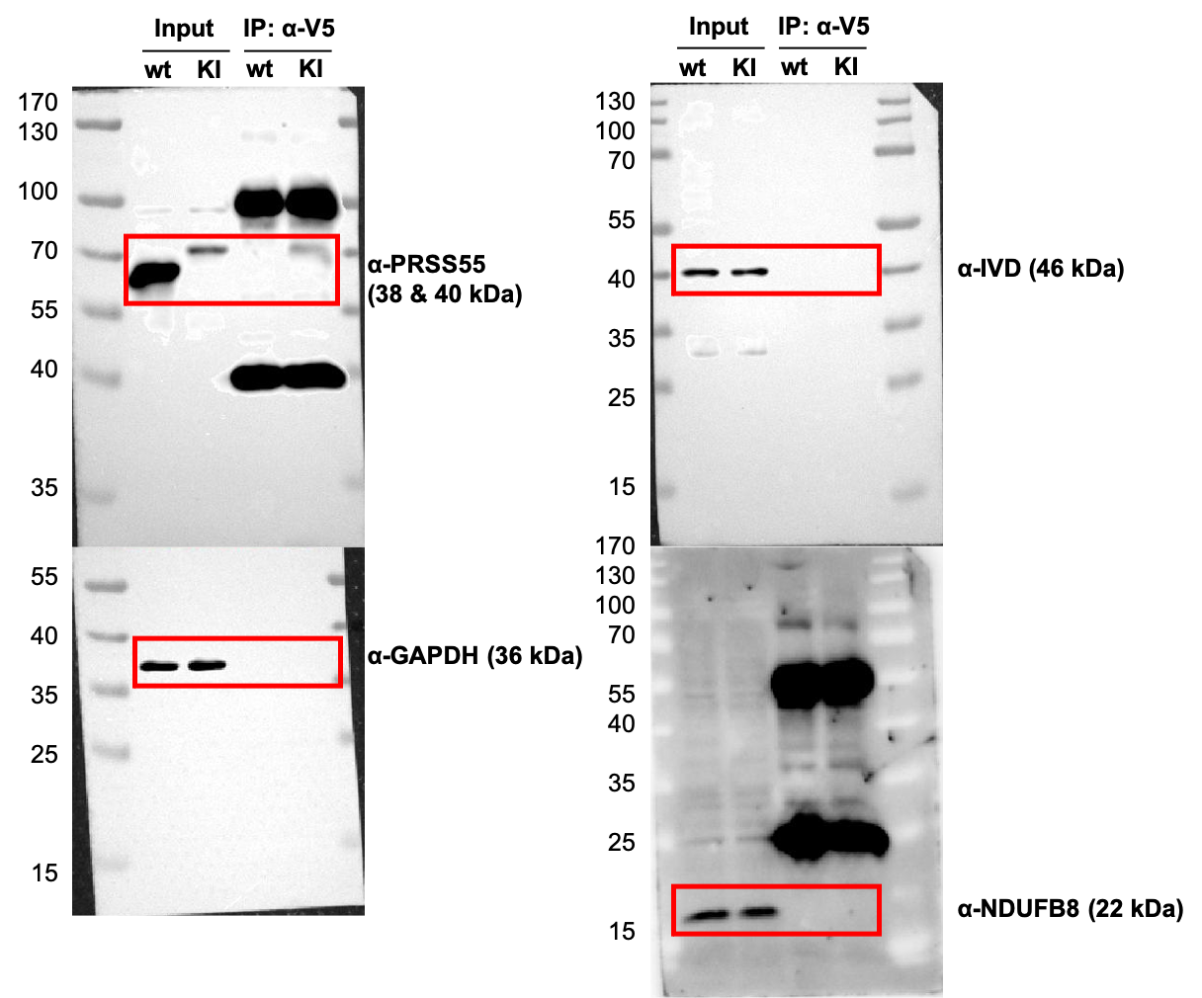
Supplementary Figure 2A

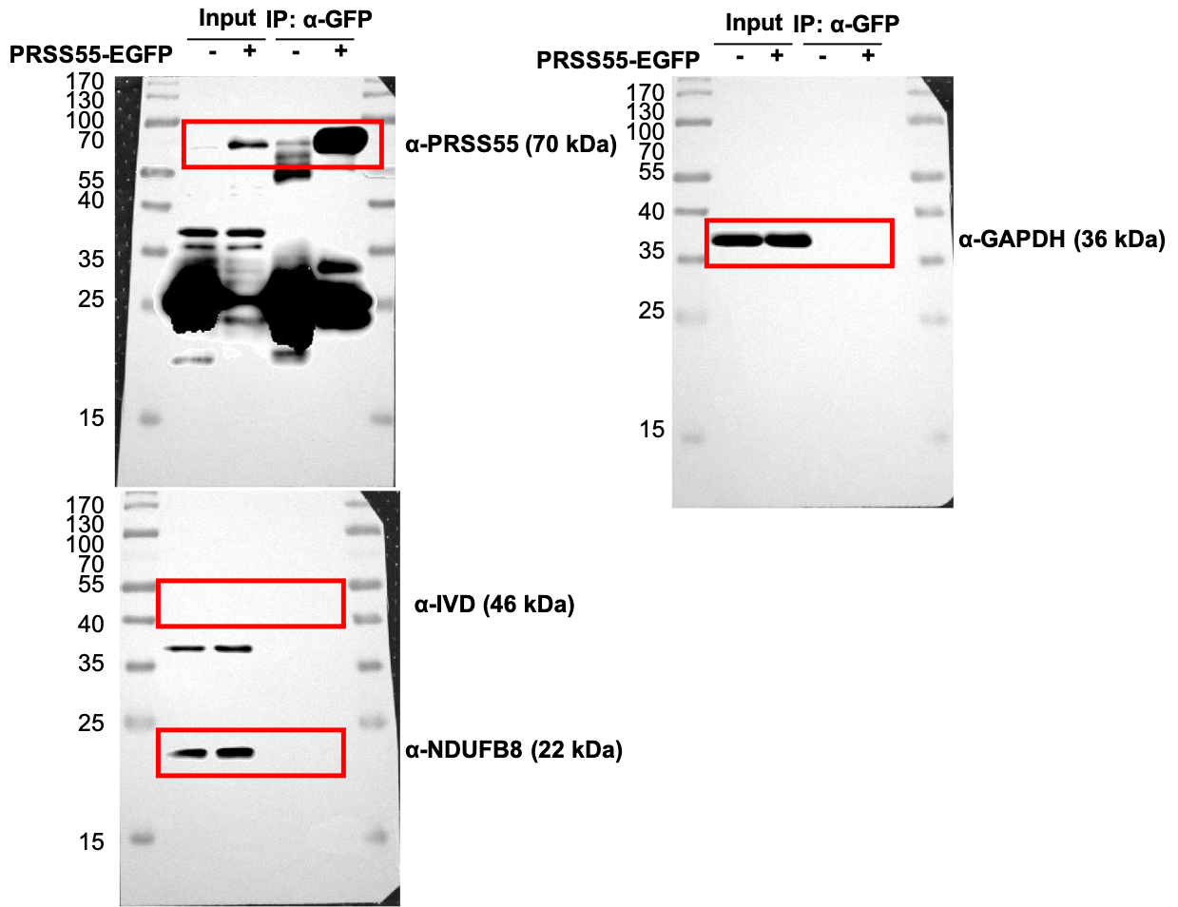
Supplementary Figure 2B

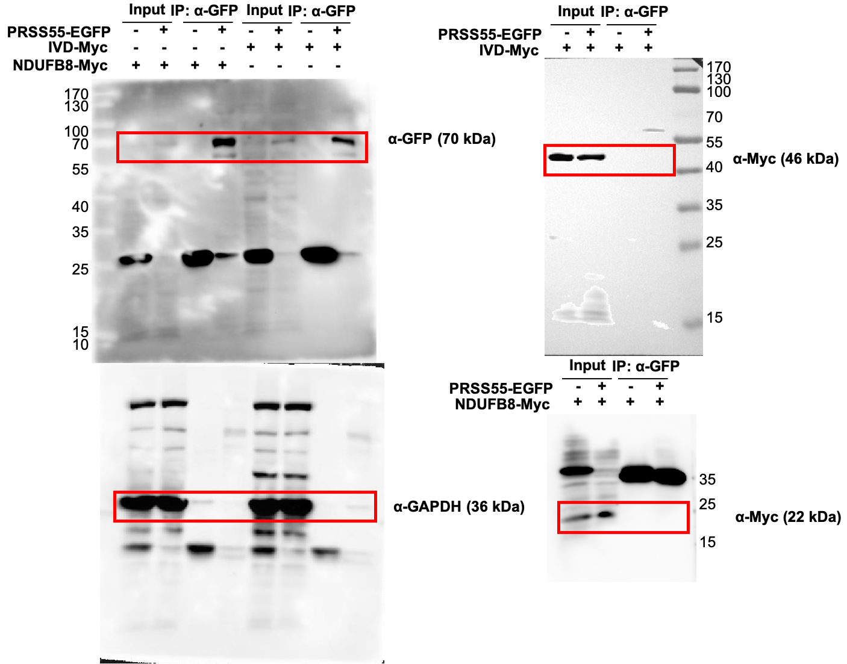
Supplementary Figure 2C & D

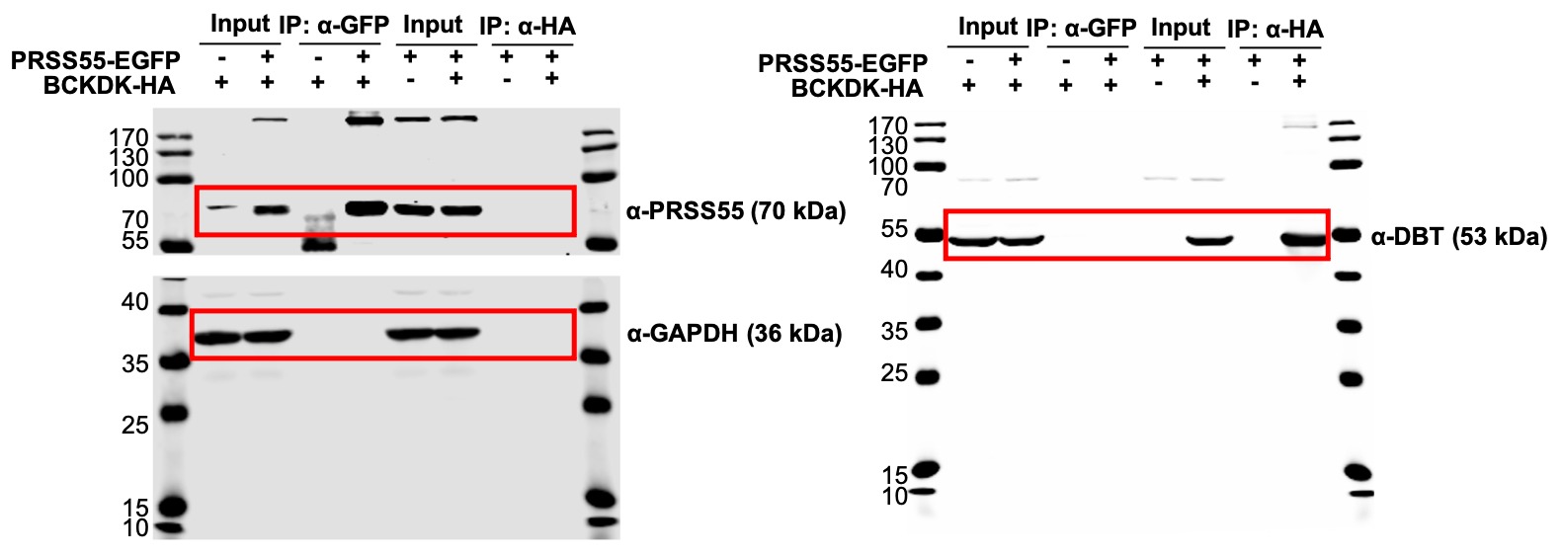
Supplementary Figure 3A & B

