Cellular and Molecular Life Sciences
PRSS55 Regulates Energy Homeostasis and BCAA Metabolism via Interacting with BCKDK in Mouse Testes and Sperm
Haoyang Ge¹, Chunling Shen¹, Wenfeng Xiong¹, Shunyuan Lu¹, Chaojie Li¹, Lingyun Tang¹, Yan Shen¹, Hongxin Zhang¹, Jian Fei², Zhugang Wang^{1,*}
¹ State Key Laboratory of Medical Genomics, Research Center for Experimental Medicine, Rui-Jin Hospital Affiliated to Shanghai Jiao Tong University School of Medicine, Shanghai 200025, China; haoyangge@sjtu.edu.cn (H.G.); scl11868@rjh.com.cn (C.Z.); xiongwenfeng@sjtu.edu.cn (W.X.); lsy40488@rjh.com.cn (S.L.); jackyjie@sjtu.edu.cn (C.L.); tly12033@rjh.com.cn (L.T.); sy40685@rjh.com.cn (Y.S.) zhx11627@rjh.com.cn (H.Z.)
² Shanghai Engineering and Technology Research Center for Model Animals, Shanghai 201318, China; jfei@tongji.edu.cn
* Correspondence: zhugangw@shsmu.edu.cn

Supplementary figures

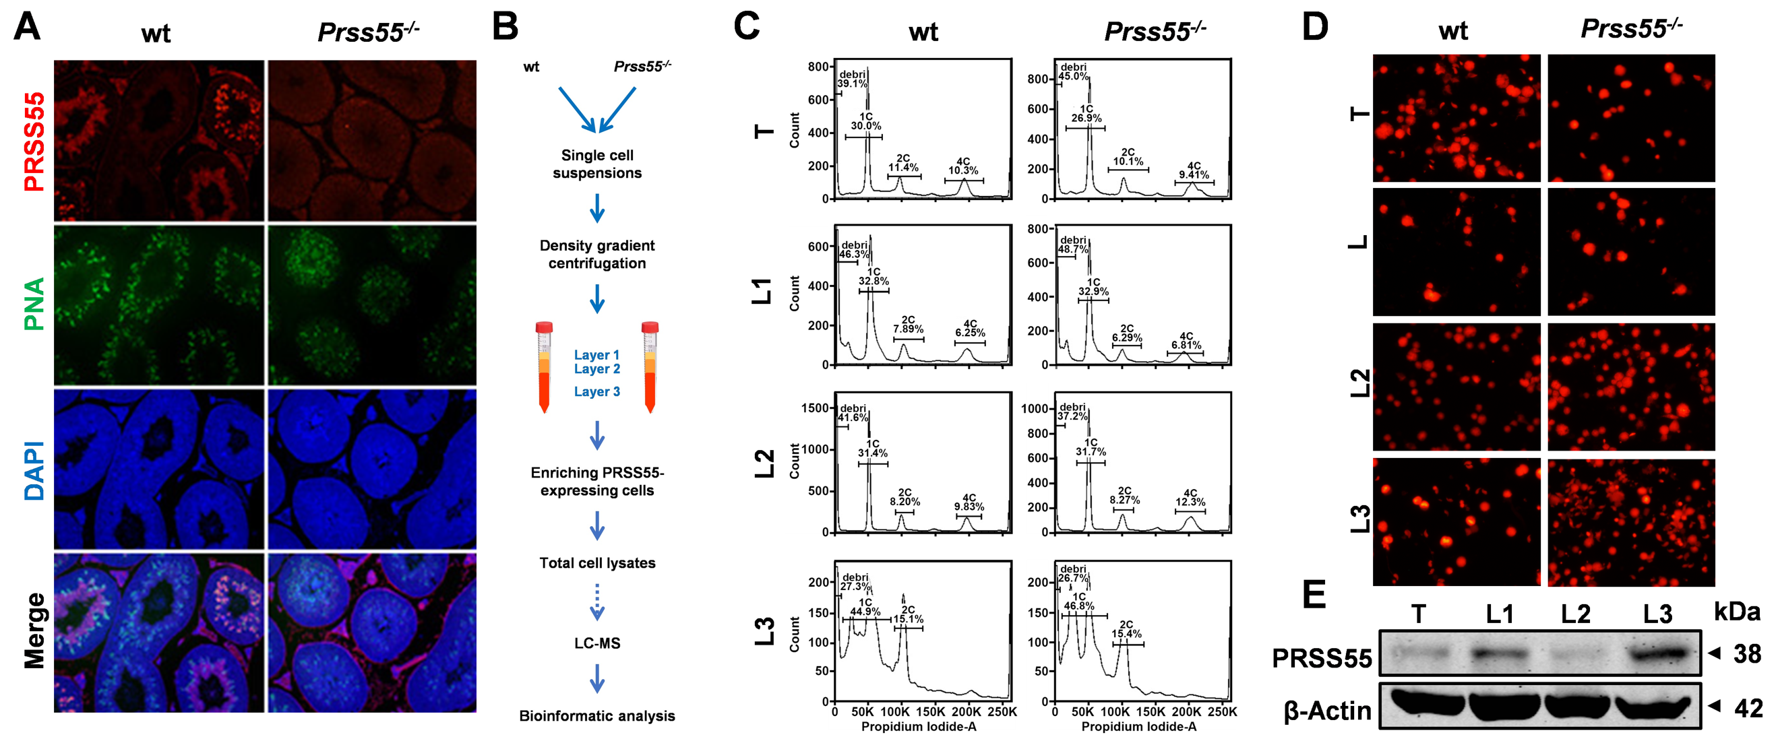
Supplementary Figure 1. PRSS55-enriched testicular single cells were isolated by Percoll density gradient centrifugation. (A) Immunofluorescence staining of PRSS55 at the luminal side of the seminiferous tubules (PRSS55: red; PNA: green; DAPI: blue). (B) Work-flow displays the strategy of PRSS55-enrichment cells for both wild-type (wt) and Prss55^{-/-} mice. (C) Propidium iodide (PI) nuclear staining (red) of total (T), layer 1 (L1), layer 2 (L2), and layer 3 (L3) cells between wt and Prss55^{-/-} mice. (D) Flow cytometry analysis of DNA ploid types of wt and Prss55^{-/-} mice T, L1, L2, and L3 cells. (E) Immunoblotting analysis of PRSS55 levels in wild-type T, L1, L2, and L3 cells. β-Actin was used as a loading control.

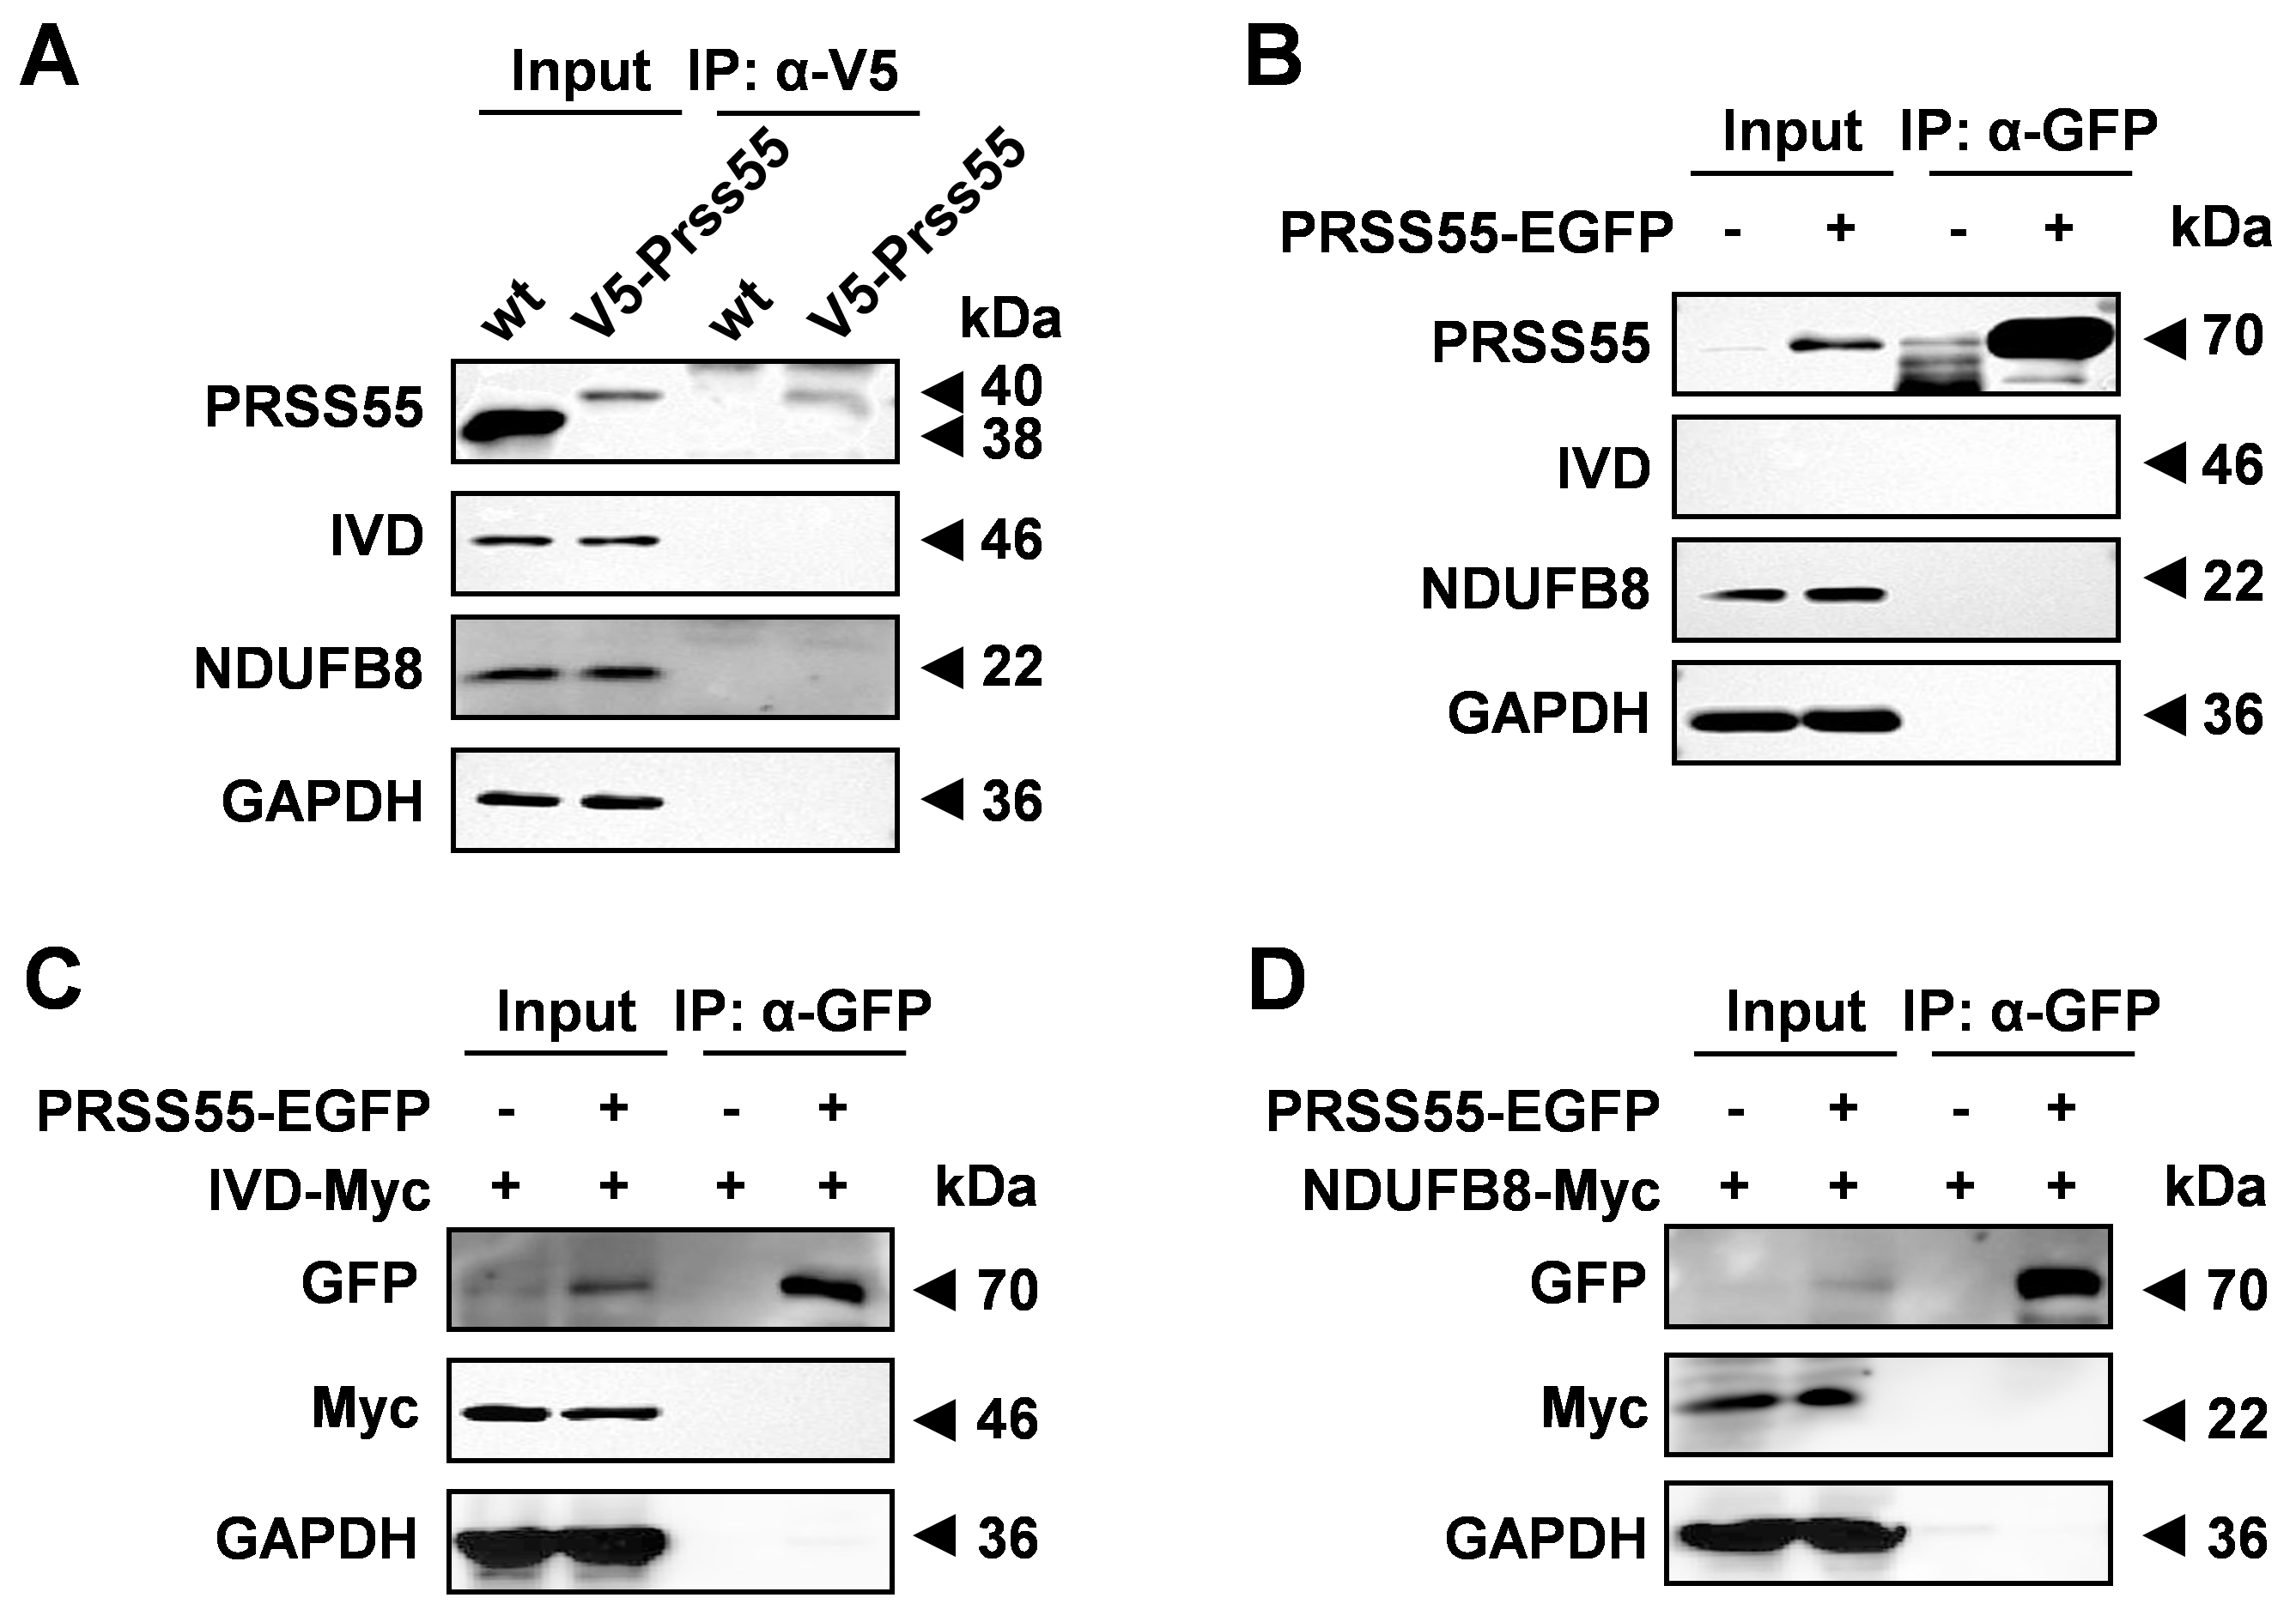
Supplementary Figure 2. IP and Co-IP experiments of PRSS55, IVD and NDUFB8. (A) The V5-PRSS55-Flag fusion protein was immunoprecipitated from the testis lysates of KI mice with an anti-V5 mAb magnetic beads. Wt mice were used as negative controls. GAPDH was shown as a loading control. (B) The PRSS55-EGFP fusion protein was immunoprecipitated from the HEK293T cell lysates. Endogenous IVD and NDUFB8 were probed with their specific antibodies, respectively. (C, D) Co-IP of PRSS55-EGFP from co-transfected HEK293T cell lysates.
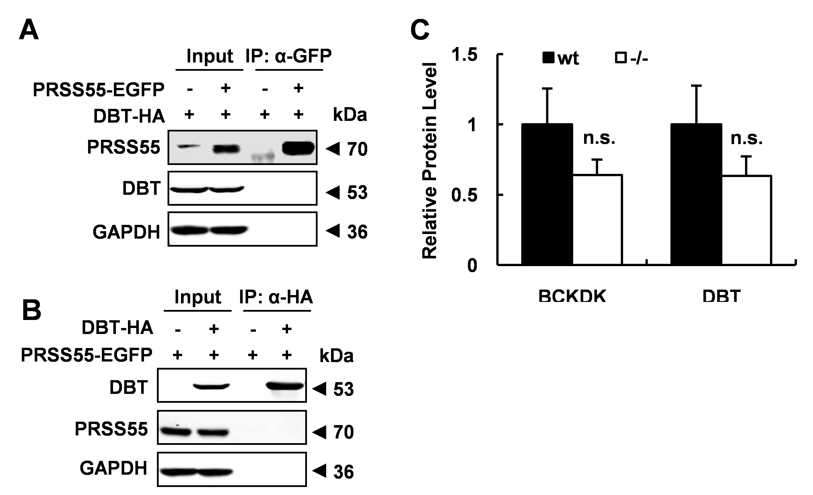
Supplementary Figure 3. Co-IP assays between PRSS55 and DBT. Co-IP of PRSS55 (A) or DBT (B) tagged as indicated with anti-tag antibodies from the cell lysates of co-transfected HEK293T cells by immunoblot. GAPDH was shown as a loading control. (C) Quantitative analysis of relative intensities of BCKDK and DBT protein levels (n = 3).

