Additional file 1:

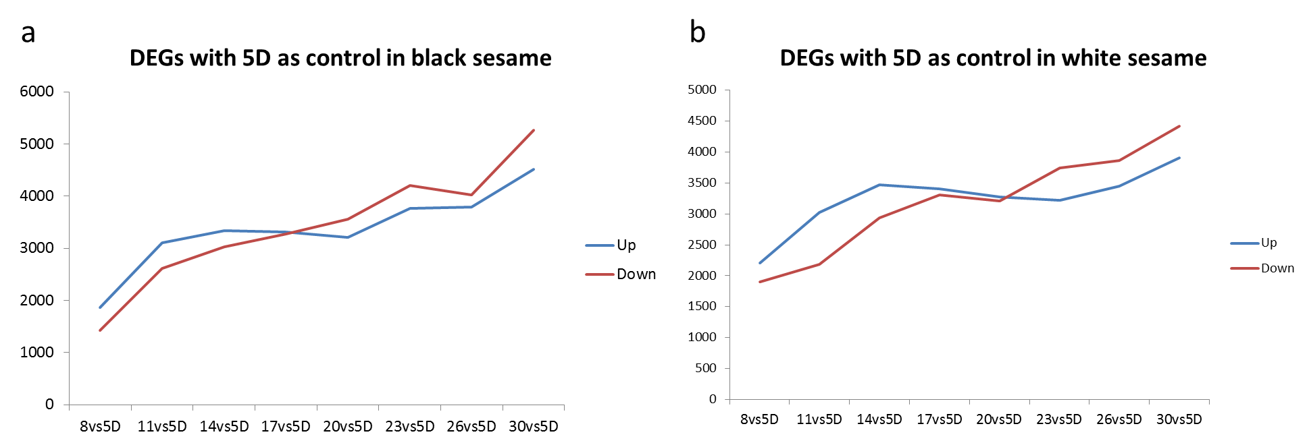

Figure S1. Dynamic change of the different expressed genes in black and white sesame with 5 DPA as the control.

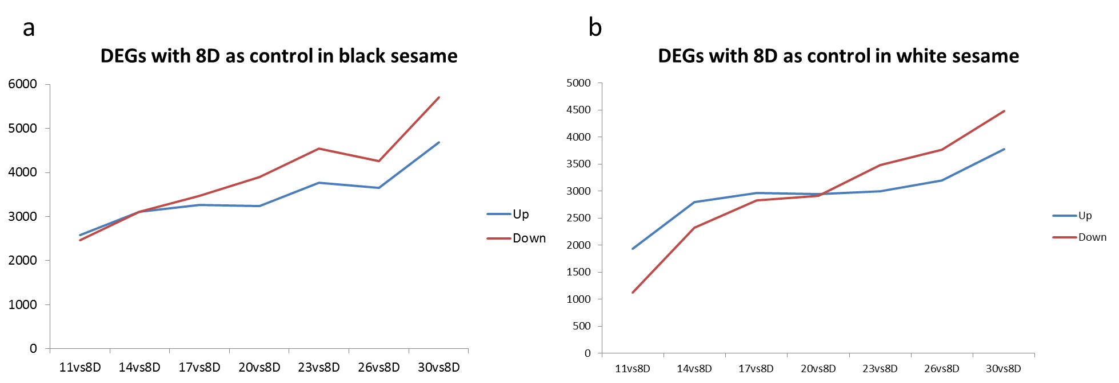

Figure S2. Dynamic change of the differentially expressed genes in black and white sesame with 8 DPA as the control

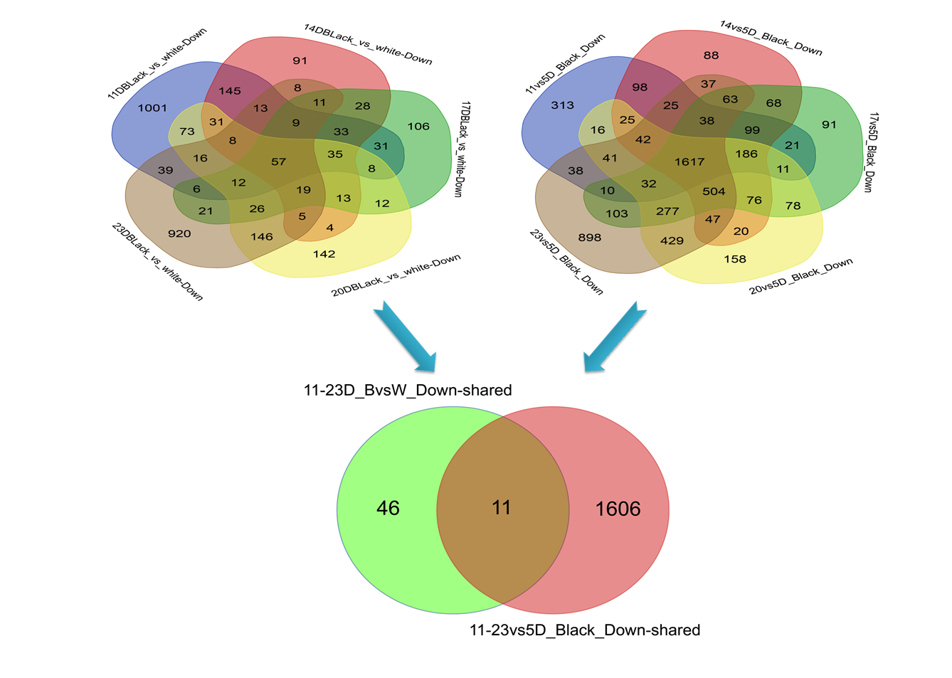
Figure S3. The common down-regulated DEGs. The gene sets were generated from the shared DEGs between black and white sesame from 11 to 23 DPA, and the shared DEGs with 5 DPA as control in black sesame from 11 to 23 DPA.

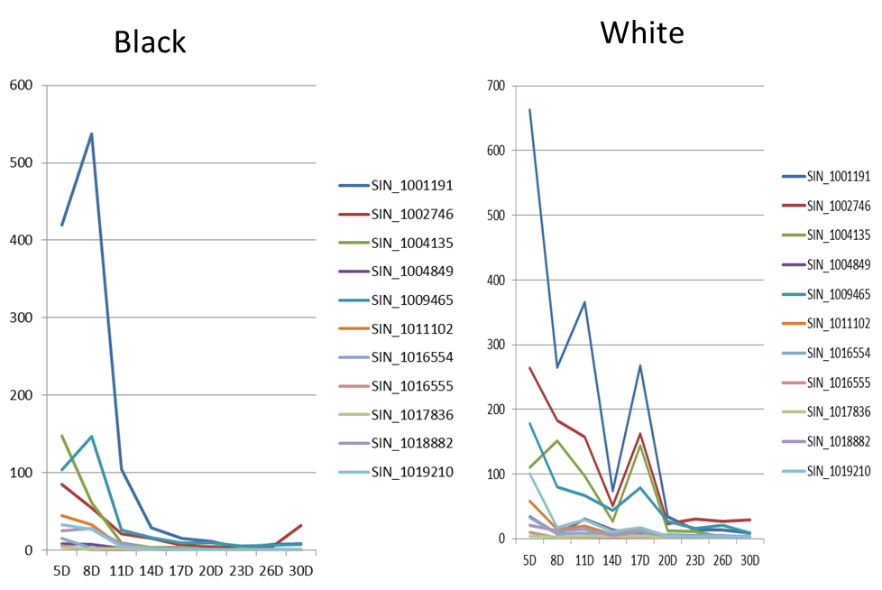

Figure S4. The expression patterns of the 11 common down-regulated DEGs in black and white sesame.

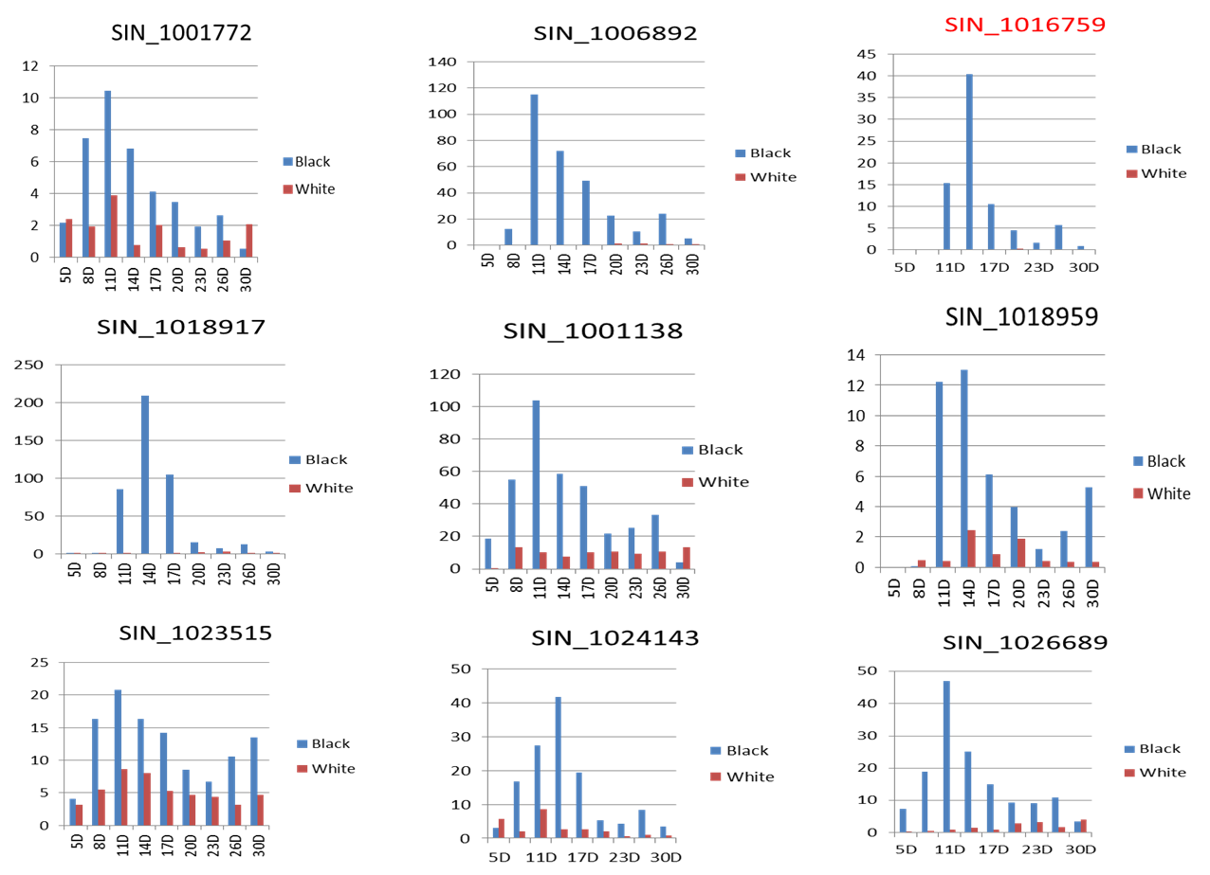

Figure S5. The expression difference of the 9 genes in subgroup 2 in the black and white sesame. SIN_1001772 and SIN_1023515 were not included in the candidate genes for their expression profiles.

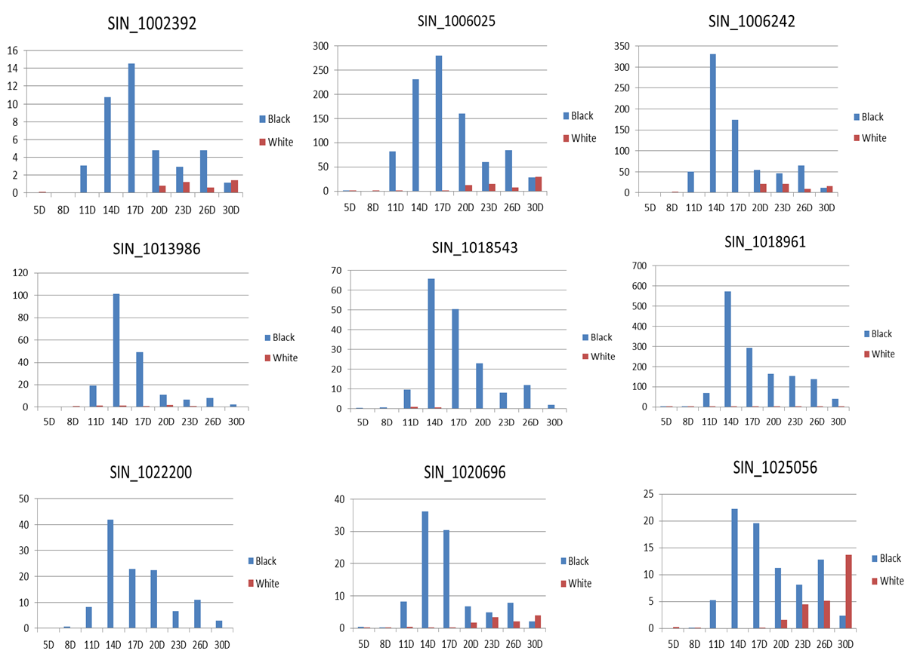

Figure S6. The expression difference of the 9 genes in subgroup 3 in the black and white sesame.

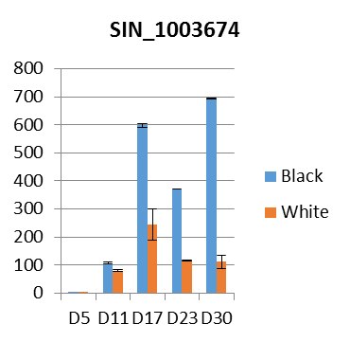
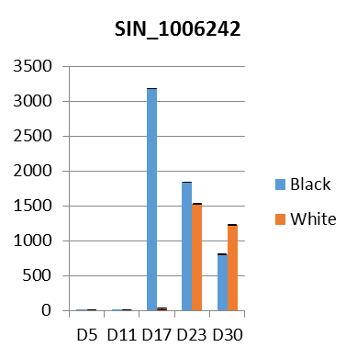
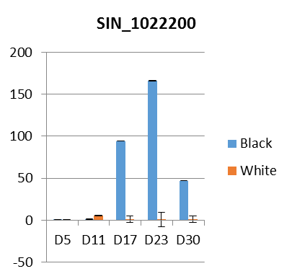
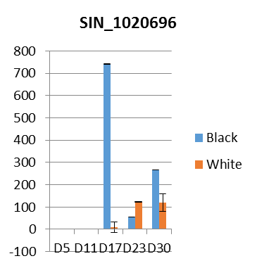
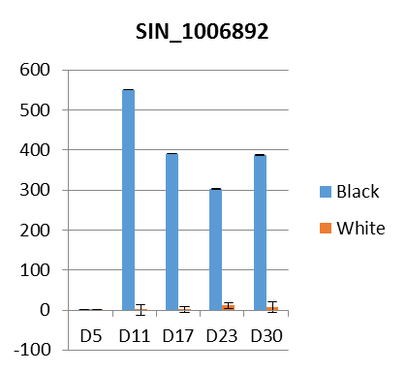
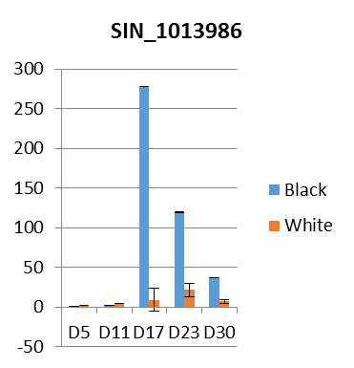
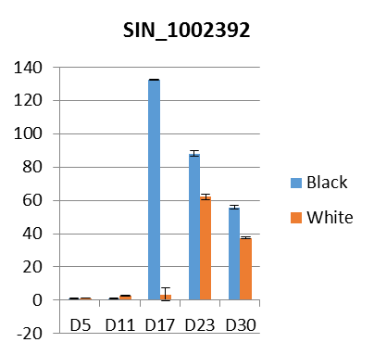
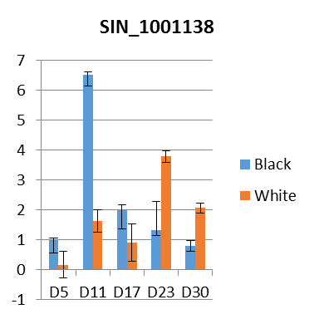
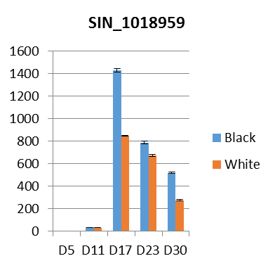
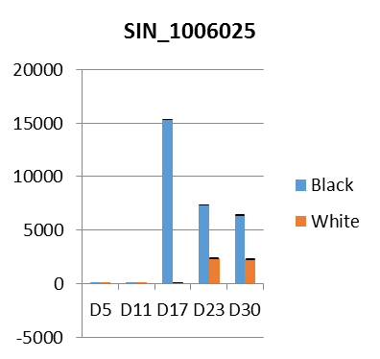
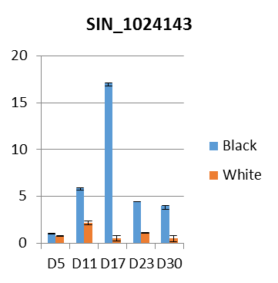
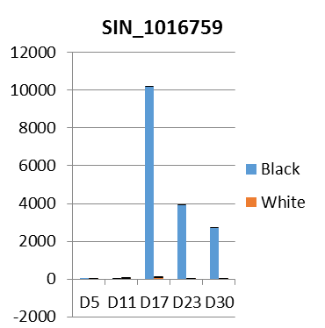
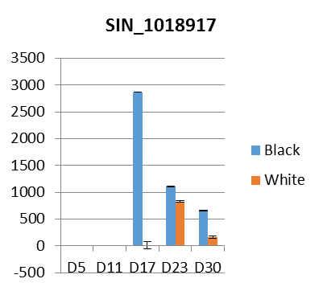
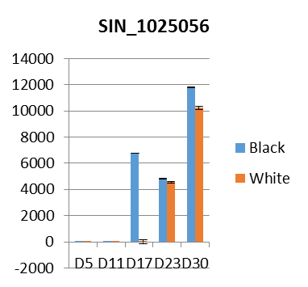
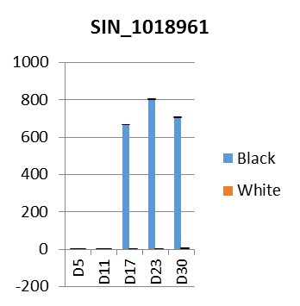
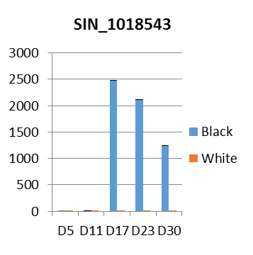
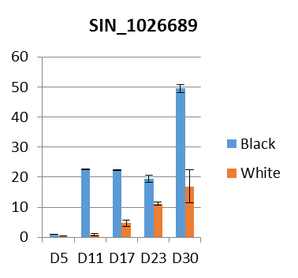

Figure S7. qRT-PCR validation of the 17 candidate genes

