Supplementary material
Supplementary Table 1. Edge weight matrix for GGMs
 | 1 | 2 | 3 | 4 | 5 | 6 | 7 | 8
1.Restrained eating | (-)
2.Emotional eating | 0.12 | (-)
3.External eating | -0.08 | 0.53 | (-)
4.Depression | 0 | 0.09 | -0.13 | (-)
5.School bullying | 0 | 0 | 0 | 0.16 | (-)
63Social anxiety | 0 | 0.01 | 0.18 | 0.33 | 0.01 | (-)
7.Weight stigma | 0 | 0.13 | 0.07 | 0 | 0.37 | 0.12 | (-)
8.Internalized stigma | 0.20 | 0 | 0 | 0.14 | 0.04 | 0.25 | 0.33 | (-)

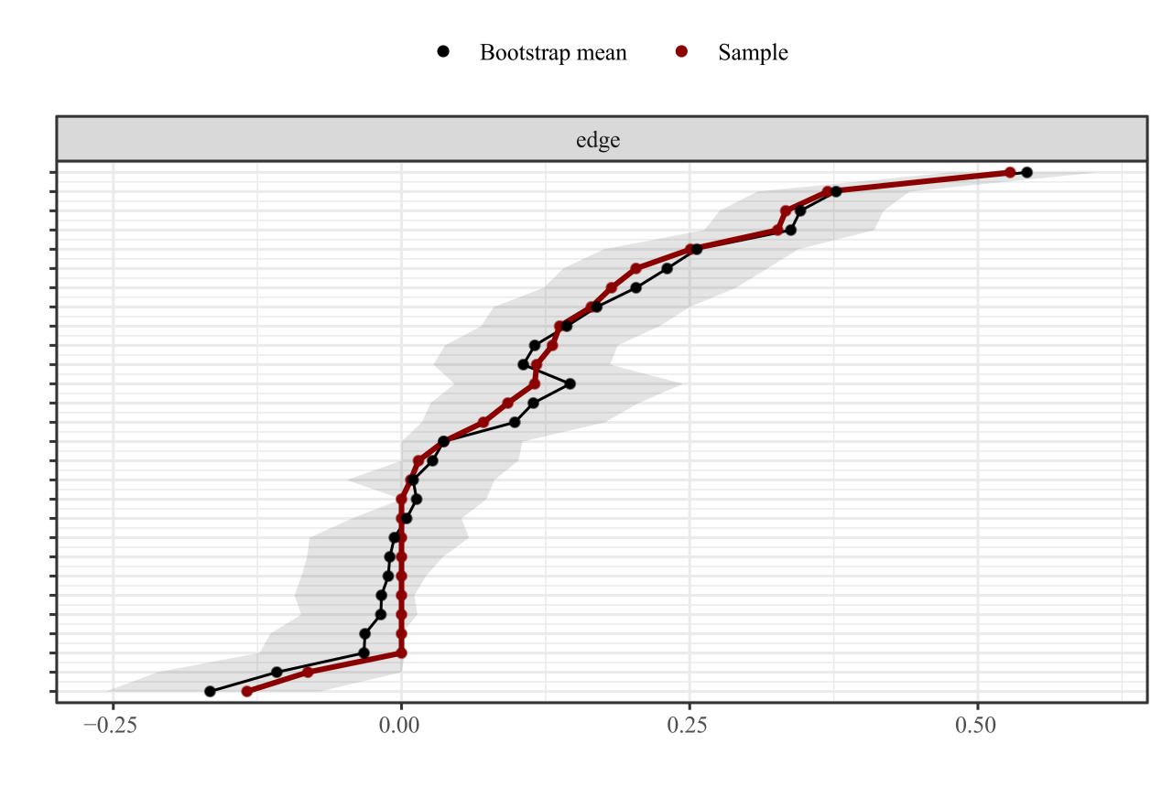
Supplementary Figure 1. Edge stability test bootstrap estimates 95% confidence interval for edge weights in GGMs. Red represents the weight of the network connection of symptoms in this study, black represents the average weight calculated by Bootstrap, and the gray area represents the 95% confidence interval.
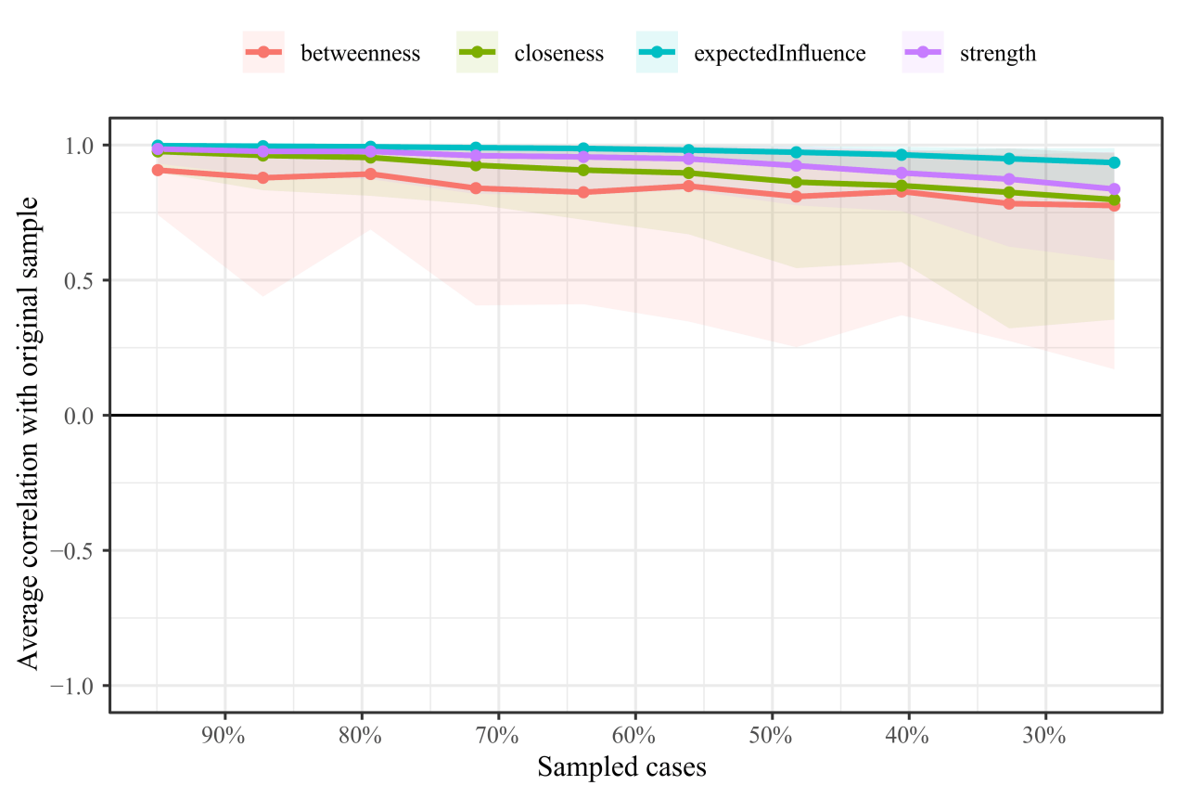
Supplementary Figure 2. Edge stability test bootstrap estimates 95% confidence interval for centrality indices in GGMs. The abscissa indicates the proportion of included samples, and the ordinate indicates the correlation between the centrality indicators of the symptom network model nodes and the centrality indicators after changing the proportion of included samples.

