Supporting information

NIR Emissive Biomimetic Ghost Nanovesicles for Site-Selective Solid Tumor Imaging
Rajendra Prasad^{1$}*, Kumari Prerna^{1$}, Mayur Temgire², Pinaki Banerjee³, Rohini Kumari¹, Gopal C Kundu^{3,4}, Simpi Kumari⁵, Jayesh Bellare², Vikash Kumar Dubey¹, Pranjal Chandra¹, Mahadeo Gorain³

¹School of Biochemical Engineering, Indian Institute of Technology (BHU) Varanasi, Uttar Pradesh, 221005, India
²Department of Chemical Engineering, Indian Institute of Technology Bombay, Powai, Mumbai, 400076, India
³National Center for Cell Science, Pune, 411008, India
⁴School of Biotechnology and Kalinga Institute of Medical Sciences (KIMS), KIIT Deemed to be University, Institute of Eminence, Bhubaneswar 751024, India
⁵Sahu BioTech Services, Utsav Society, Kirkartwadi, Nandoshi Road, Pune, 411024, Maharashtra, India

Sr. No. | Concentration  mg/mL | Absorption | Number of Nanovesicles/cm³ | Number of dye molecules/cm³ | Dye/Nanovesicle | Relative Brightness  (MESF units)
1 | 1.9 | 0.15 | 5.68 x 10¹¹ | 3.44 x 10¹⁴ | 605 | 598
2 | 2.5 | 0.25 | 7.48 x 10¹¹ | 5.74 x 10¹⁴ | 767 | 762
3 | 0.9 | 0.09 | 2.69 x 10¹¹ | 2.11 x 10¹⁴ | 784 | 779
4 | 2.4 | 0.12 | 7.18 x 10¹¹ | 2.87 x 10¹⁴ | 399 | 396
5 | 2.02 | 0.2 | 6.04 x 10¹¹ | 4.59 x 10¹⁴ | 759 | 754
6 | 1 | 0.18 | 2.99 x 10¹¹ | 4.13 x 10¹⁴ | 1381 | 1371
7 | 0.2 | 0.01 | 0.5 x 10¹¹ | 2.29 x 10¹³ | 383 | 381
8 | 2.8 | 0.13 | 8.38 x 10¹¹ | 2.98 x 10¹⁴ | 356 | 353
9 | 3.2 | 0.15 | 7.79 x 10¹¹ | 3.44 x 10¹⁴ | 442 | 414
10 | 1.02 | 0.05 | 2.48 x 10¹¹ | 1.14 x 10¹⁴ | 462 | 433
Supplementary Table 1. Physicochemical parameters and relative brightness of ICG dye J-aggregates tagged biomimetic nanovesicles.

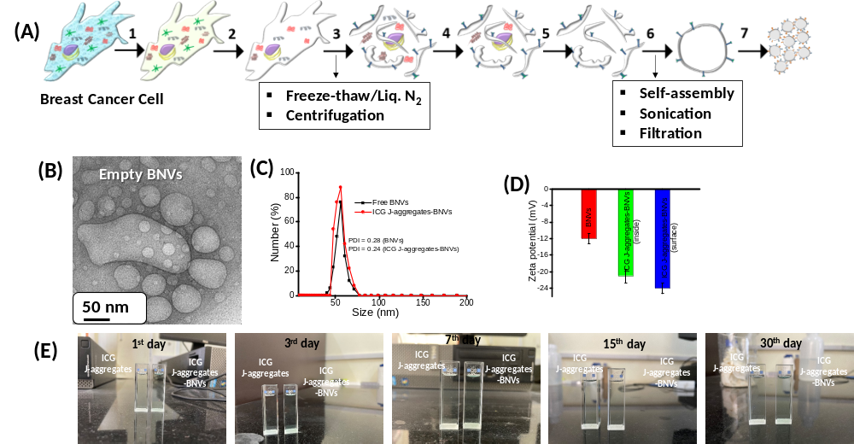
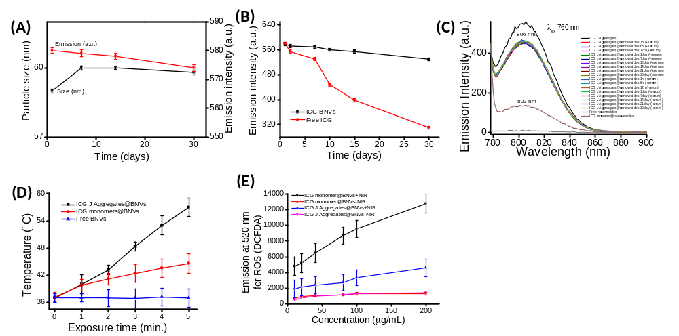
Supplementary Figure 2. Time dependent (tested up to 30 days) emission intensity and particle measurements of ICG J-aggregates-biomimetic nanovesicles (A) and time dependent (tested up to 30 days with and without serum) photostability measurement of ICG J-aggregates-biomimetic nanovesicles and compared to free dye molecules (B,C), phototransduction and photosensitizing response of ICG J-aggregates and monomers encapsulated nanovesicles (D, E).

Supplementary Figure 1. Biochemical process of biomimetic nanovesicles (A), TEM image of biomimetic nanovesicles (B), dynamic light scattering size distribution of biomimetic nanovesicles with and without ICG J-aggregates with their PDI values (C), zetapotential for surface charge measurement of biomimetic nanovesicles with and without ICG J-aggregates in their interior and exterior surfaces (D) and digital photograph showing particles dispersion in physiological environment at different time point (E).

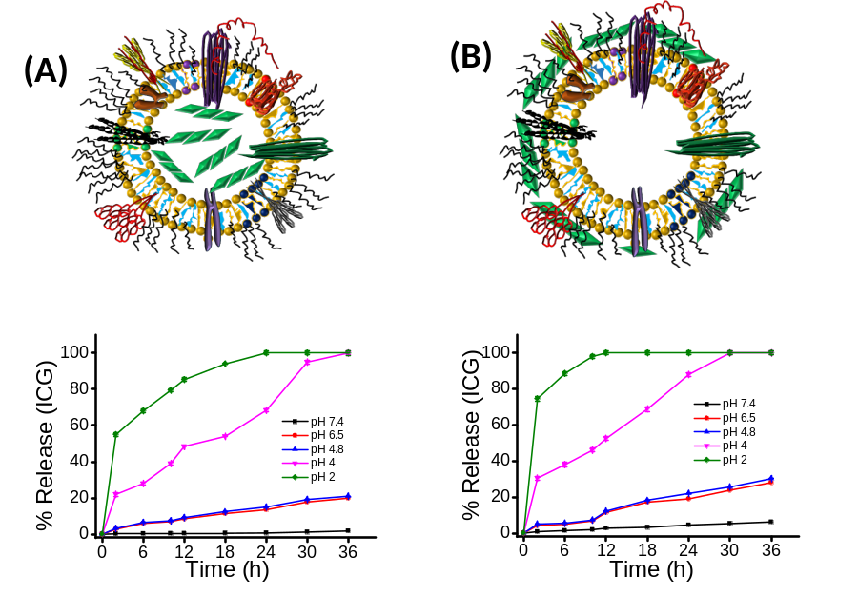
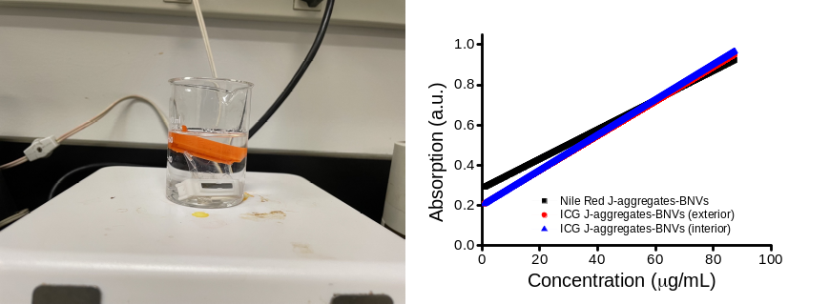
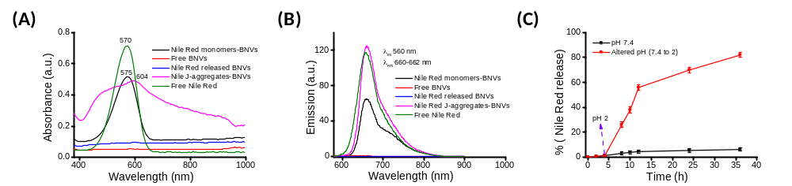
Supplementary Figure 5. pH dependent (2 to 7.4) % release kinetics of ICG dye molecules from engineered nanovesicles. J-aggregates of ICG dye are located in interior (A) and exterior surface of nanovesicles (B).

Supplementary Figure 4. A digital photograph taken during the release kinetic of J-aggregates from biomimetic nanovesicles and absorption response at various concentrations of released cargo.

Supplementary Figure 3. Absorption and emission spectra of lipophilic Nile Red J-aggregates loaded nanovesicles and comparison with their monomers (A, B) and time dependent % release kinetics of Nile Red dye molecules from engineered nanovesicles showing their cargo delivery efficacy in cancer mimicked environment (C).

Supplementary Figure 6. Cancer cell imaging (A) MDA-MB231 and (B) MCF-7 using ICG J-aggregates nanovesicles (dye in interior-top images and dye in exterior surface-bottom images).

Supplementary Figure 7. Cryo-TEM images of ICG, anticancer drug DOX and Nile Red dye loaded nanovesicles. 200 nm scale bar for all images.

Batch No. | Total Volume (mL) | Size (nm) | Concentration (mg/mL) | Dye/Nanovesicle
1 | 15 | 62 | 1.20 | 242
2 | 15 | 65 | 1.28 | 281
3 | 15 | 62 | 1.22 | 273
4 | 15 | 60 | 1.26 | 201
5 | 15 | 60 | 1.32 | 228
6 | 15 | 58 | 1.26 | 243
7 | 15 | 65 | 1.30 | 258
8 | 15 | 62 | 1.32 | 284
9 | 15 | 60 | 1.28 | 265
10 | 15 | 60 | 1.32 | 257
Largest scale | 100 | 65 | 5.0 | 215
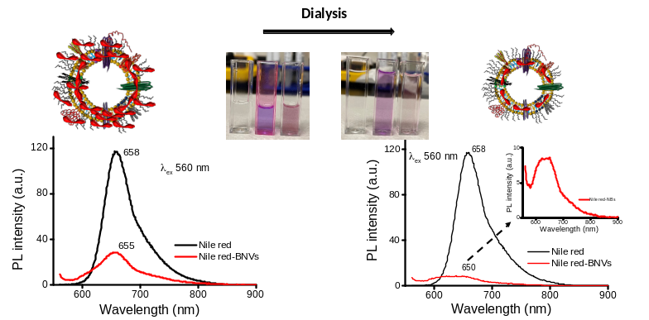
Supplementary Figure 8. Spectroscopic measurements of lipophilic Nile Red J-aggregates loaded nanovesicles and its purification followed by dialysis for 2 days. Digital photographs are showing colour distinction before and after dialysis.

Supplementary Table 2. Batch optimization for particles size, concentration, and dye per nanovesicle.

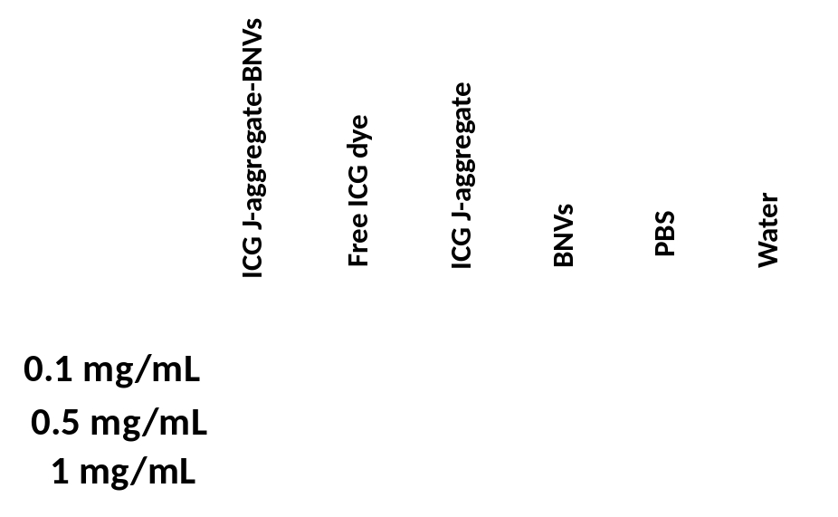
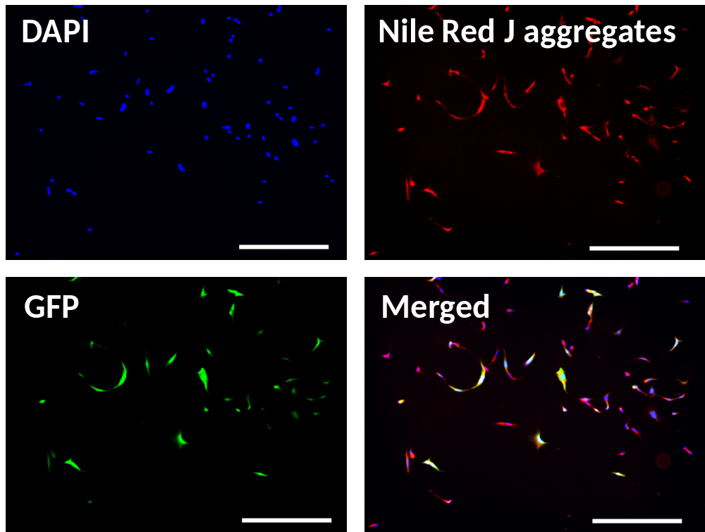
Supplementary Figure 9. Breast cancer cell imaging (MDA-MB231) using lipophilic Nile Red J-aggregates loaded nanovesicles.

Supplementary Figure 10. Contrast and brightness performance of ICG J-aggregates, ICG J-aggregates loaded nanovesicles and free ICG dye molecules at different concentrations. BNVs, PBS and water are used as control.

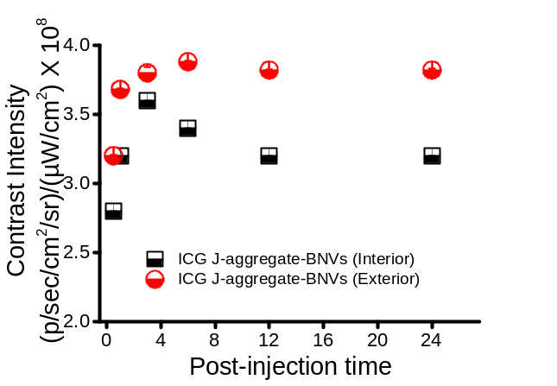
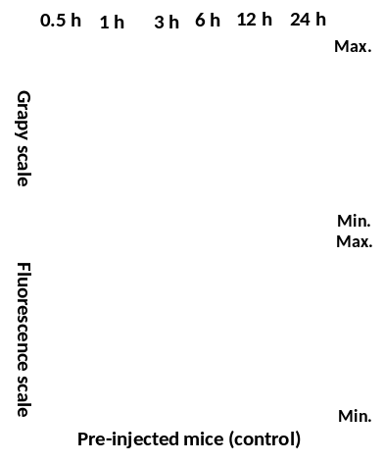
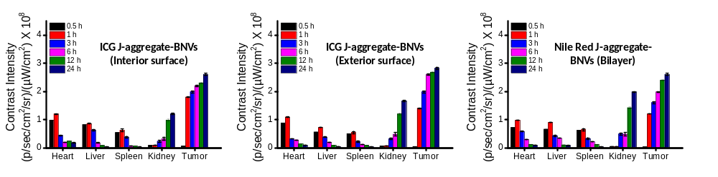
Supplementary Figure 13. Time dependent (0.5 h to 24 h) whole body scans of pre-injected animals in gray and fluorescence scale. Red dots are representing the autofluorescence.

Supplementary Figure 12. Time dependent (0.5 h to 24 h) in vivo biodistribution measurements after systemic administration of ICG J-aggregates loaded nanovesicles (dye J-aggregates are in interior and exterior surfaces) and Nile Red J-aggregates loaded nanovesicles. Fluorescent values are recorded from tumor site and tissues during whole body scans.

Supplementary Figure 11. Time dependent (0.5 h to 24 h) emission intensity from tumor area after systemic administration of ICG loaded nanovesicles (ICG J aggregates within cavity named as interior surface and ICG J aggregates on the exterior surface).

