Heart and Lung Point-of-Care Ultrasonography Tutoring in Internal Medicine: a Randomized Controlled Trial

*Antonio Leidi^{1,2}, Juliette Krauer¹, Guillaume Soret^{1,2}, Thibault Parent¹, Christophe Marti¹, Philippe Meyer³, André Juillerat¹, Stijn Bex¹, Noémie Suh⁴, Frédéric Rouyer², Nils Siegenthaler⁵, Olivier Grosgurin^{1,2}

Supplementary materials

Submission to Internal and Emergency Medicine

Antonio Leidi and Juliette Krauer contributed equally to the study

¹Division of General Internal Medicine, Geneva University Hospitals, Geneva, Switzerland
²Division of Emergency Medicine, Geneva University Hospitals, Geneva, Switzerland
³Division of Cardiology, Geneva University Hospitals, Geneva, Switzerland
⁴Division of Intensive Care, Geneva University Hospitals, Geneva, Switzerland
⁵Division of Intensive Care, La Tour Hospital, Geneva, Switzerland

Corresponding author: Antonio Leidi, General Internal Medicine, Department of Medicine, Geneva University Hospitals, Rue Gabrielle-Perret-Gentil 4, 1205 Geneva, Switzerland, tel: +41795534559, fax: +41223729202, ORCID ID 0000-0002-3934-0104

Supplementary Figure 1. Trial design
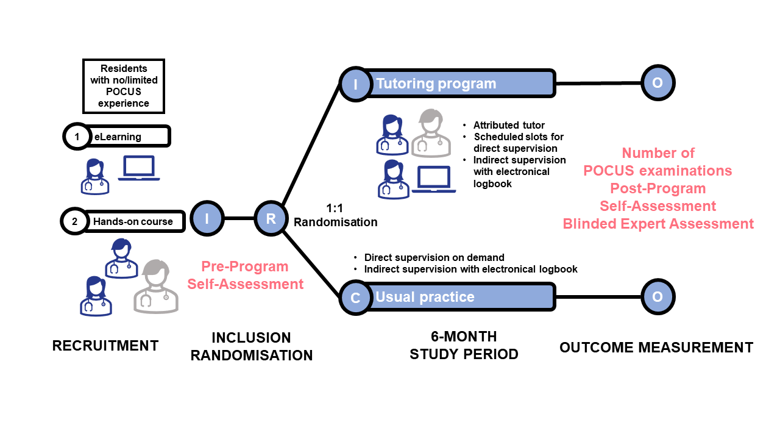
Supplementary Table 1. Self-assessment questionary

General skills and machine operations
 | Strongly  disagree | Disagree | Neutral | Agree | Strongly agree
- I am confident in general image acquisition skills  - I am confident in general image interpretation skills  - I am confident in machine operations | 1  1  1 | 2  2  2 | 3  3  3 | 4  4  4 | 5  5  5

Cardiac ultrasound

- I am confident in evaluation skills for cardiac systolic function | 1 | 2 | 3 | 4 | 5
- I am confident in evaluation skills for heart chambers size (RV/LV)  - I am confident in evaluation skills for inferior vena cava  - I am confident in evaluation skills for pericardial effusion | 1  1  1 | 2  2  2 | 3  3  3 | 4  4  4 | 5  5  5

Pulmonary ultrasound

- I am confident in evaluation skills for pleural effusion | 1 | 2 | 3 | 4 | 5
- I am confident in evaluation skills for interstitial syndrome  - I am confident in evaluation skills for pneumothorax  - I am confident in evaluation skills for consolidation | 1  1  1 | 2  2  2 | 3  3  3 | 4  4  4 | 5  5  5
Supplementary Table 2. Expert assessment tool

Generals skills
 | Skills acquired for CERTAIN criteria | Skills acquired for MOST criteria | Skills acquired for ALL criteria
Preparation  - Patient & scanner positioning  - Probe selection  - Initial pre-settings (choosing the right mode) | 1 | 2 | 3
Image acquisition  - Positioning the probe in the hand  - Identification of anatomical landmarks  - Smooth movements  - Appropriate measurements | 1 | 2 | 3
Image optimization  - Area of interest centering  - Overall image quality  - Optimization of settings (depth, gain) | 1 | 2 | 3
Clinical integration  - Appropriate interpretation | 1 | 2 | 3

 | I have to do the exam | Physical intervention would be required (probe repositioning) | Verbal intervention would be necessary | Back-up presence required | I don't need to be there
Autonomy | 1 | 2 | 3 | 4 | 5

Skills scale for pleuropulmonary ultrasonography

Image acquisition
Please note the image quality for each view according to the scale below:
 | Not obtained | Insufficient quality for interpretation |  | Suboptimal quality, but interpretation possible |  | Good quality and easy to interpret
Pleural sliding | 0 | 1 | 2 | 3 | 4 | 5
Beach sign | 0 | 1 | 2 | 3 | 4 | 5
Costo-diaphragmatic recess | 0 | 1 | 2 | 3 | 4 | 5

Cardiac ultrasound competency scale

Image acquisition
Please rate the image quality for each view according to the scale below:
 | Not obtained | Insufficient quality for interpretation |  | Suboptimal quality, but interpretation possible |  | Good quality and easy to interpret
Parasternal long axis view  - Setpum as horizontal as possible  - Apex not visible  - Aortic and mitral valves visible  - Descending aorta visible | 0 | 1 | 2 | 3 | 4 | 5
Parasternal short axis view  - Round shape of the LV  - Papillary muscles visible  - RV visible | 0 | 1 | 2 | 3 | 4 | 5
Apical four-chamber view  - 4 cavities fully visible  - Tricuspid and mitral valves visible  - Septum vertical and in the center of the image  - TAPSE measurement | 0 | 1 | 2 | 3 | 4 | 5
Apical five-chamber view  - Visible aortic valve | 0 | 1 | 2 | 3 | 4 | 5
Subcostal view  - 4 cavities visible  - Tricuspid and mitral valves visible | 0 | 1 | 2 | 3 | 4 | 5
Inferior vena cava  - Opening into RA  - As horizontal as possible  - Inspiro-expiratory diameter measurement | 0 | 1 | 2 | 3 | 4 | 5
RA : right auricule

Image interpretation
On the basis of the images produced, is it possible to interpret :
 | Image quality does not allow interpretation | Image quality enables interpretation
LV function | 0 | 1
Presence/absence of pericardial effusion | 0 | 1
Presence/absence of RVD | 0 | 1
Presence/absence of hypo/hypervolaemia | 0 | 1
RVD: right ventricular dilatation

What is the most likely diagnosis? (check the candidate's answer)
Normal LVF

Moderately reduced LVF

Severely impaired LVF

Pericardial effusion

LVF : lleft ventricular systolic function

Supplementary Table 3. Characteristics of POCUS tutors

 | Tutor 1 | Tutor 2 | Tutor 3
POCUS certification, y | 2018 | 2019 | 2022
Seniority | Attending physician | Chief resident | Chief resident
Supervised POCUS, n (%) | 180 (53%) | 83 (24%) | 70 (23%)
Trainees reaching the primary outcome (%) | 100% | 75% | 25%

Supplementary Table 4. Pre- and post-tutoring self-assessment questionary

Participants | Pre-tutoring  (N=23) | Post-tutoring  (N=22) |  | p-Valueª
 | All subjects  (N=23) | Intervention  (N=10) | Control  (N=12)
General
Acquisition, n (%)  Competent  Incompetent | 9 (39)  14 (61) | 7 (70)  3 (30) | 4 (33)  8 (67) | 0.08
Interpretation, n (%)  Competent  Incompetent | 9 (39)  14 (61) | 7 (70)  3 (30) | 5 (42)  7 (58) | 0.2
US machine use, n (%)  Competent  Incompetent | 12 (52)  11 (48) | 7 (70)  3 (30) | 7 (58)  5 (42) | 0.7
Echocardiography
LVF evaluation, n (%)  Competent  Incompetent | 14 (61)  9 (39) | 9 (90)  1 (10) | 3 (25)  9 (75) | 0.004*
RVD evaluation, n (%)  Competent  Incompetent | 10 (43)  13 (57) | 9 (90)  1 (10) | 6 (50)  6 (50) | 0.07
Volemia, n (%)  Competent  Incompetent | 8 (35)  15 (65) | 6 (60)  4 (40) | 4 (33)  8 (67) | 0.4
Pericardial evaluation, n (%)  Competent  Incompetent | 17 (74)  6 (26) | 10 (100)  0 (0) | 7 (58)  5 (42) | 0.02*
Globally competent, n (%)  Yes  No | 7 (30)  16 (70) | 6 (60)  4 (40) | 0 (0)  12 (100) | 0.003*
Lung ultrasonography
Pleural effusion  Competent  Incompetent | 19 (83)  4 (17) | 9 (90)  1 (10) | 10 (83)  2 (17) | 1.0
Interstitial syndrome  Competent  Incompetent | 16 (70)  7 (30) | 7 (70)  3 (30) | 6 (50)  6 (50) | 0.4
Pneumothorax  Competent Incompetent | 13 (57)  10 (43) | 9 (90)  1 (10) | 6 (50)  6 (50) | 0.07
Consolidation  Competent  Incompetent | 12 (48)  11 (52) | 9 (90)  1 (10) | 6 (50)  6 (50) | 0.07
Globally competent, n (%)  Yes  No | 6 (26)  17 (74) | 60 (60)  40 (40) | 3 (25)  9 (75) | 0.19
US: ultrasonography; IVC inferior vena cava; LVF: left ventricular systolic dysfunction; RVD: right ventricular dilatation

Supplementary Table 5. Blinded-expert assessment, by study group

Participants | Intervention  (N obs=18) | Control  (N obs=18) | p-Valueª
General
Preparation, n (%)  Competent  Incompetent | 15 (83)  3 (17) | 15 (83)  3 (17) | 1.0
Acquisition, n (%)  Competent  Incompetent | 15 (83)  3 (17) | 9 (50)  9 (50) | 0.034*
Optimisation, n (%)  Competent  Incompetent | 15 (83)  3 (17) | 8 (44)  10 (56) | 0.015*
Interpretation, n (%)  Competent  Incompetent | 16 (94)  1 (6) | 10 (71)  4 (29) | 0.14
Autonomy, n (%)  Yes  No | 15 (83)  3 (17) | 6 (33)  12 (67) | 0.002*
Echocardiography
Quality of acquisition
PSLA, n (%)  High  Poor | 15 (83)  3 (17) | 11 (61)  7 (39) | 0.14
PSSA, n (%)  High  Poor | 13 (72)  5 (28) | 9 (50)  9 (50) | 0.17
4C, n (%)  High  Poor | 13 (72)  5 (28) | 8 (44)  10 (56) | 0.09
5C, n (%)  High  Poor | 11 (65)  6 (35) | 2 (11)  16 (89) | 0.001*
SC, n (%)  High  Poor | 14 (78)  4 (22) | 8 (44)  10 (55) | 0.04*
IVC, n (%)  High  Poor | 14 (78)  4 (22) | 3 (26)  14 (76) | 0.001*
Meaningful interpretation
LVF evaluation, n (%)  Possible  Impossible | 15 (83)  3 (17) | 13 (72)  5 (28) | 0.69
RVD evaluation, n (%)  Possible  Impossible | 15 (83)  3 (17) | 7 (39)  11 (61) | 0.006*
Volemia, n (%)  Possible  Impossible | 13 (72)  5 (28) | 4 (22)  14 (78) | 0.003*
Pericardial evaluation, n (%)  Possible  Impossible | 18 (100)  0 (0) | 17 (94)  1 (6) | 1.0
Proportion of correct LVF evaluation, n (%)  Total  Patients  Healthy Volunteers | 17 (94)  8 (89)  9 (100) | 14 (82)  5 (62)  9 (100) | 0.34  0.29  1.0
Lung ultrasonography
Quality of acquisition
Lung sliding, n (%)  High  Poor | 16 (89)  2 (11) | 17 (94)  1 (6) | 1.0
Seashore sign, n (%)  High  Poor | 12 (67)  6 (33) | 16 (89)  2 (11) | 0.23
Costo-pleural space, n (%)  High  Poor | 13 (72)  5 (27) | 13 (72)  5 (27) | 1.0
PSLA: parasternal long axis view; PSSA: parasternal short axis view; 4C: apical four-chamber view; 5C: apical five-chamber view; SC: subcostal view; IVC inferior vena cava; LVF: left ventricular systolic dysfunction; RVD: right ventricular dilatation

