Extended Data
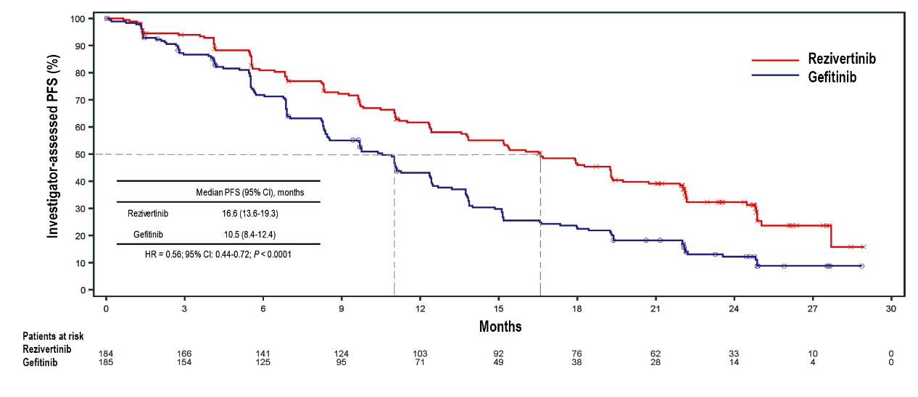
Fig. S1 Kaplan-Meier plot of investigator-assessed PFS in ITT set. PFS, progression free survival; CI, confidence interval; HR, hazard ratio.

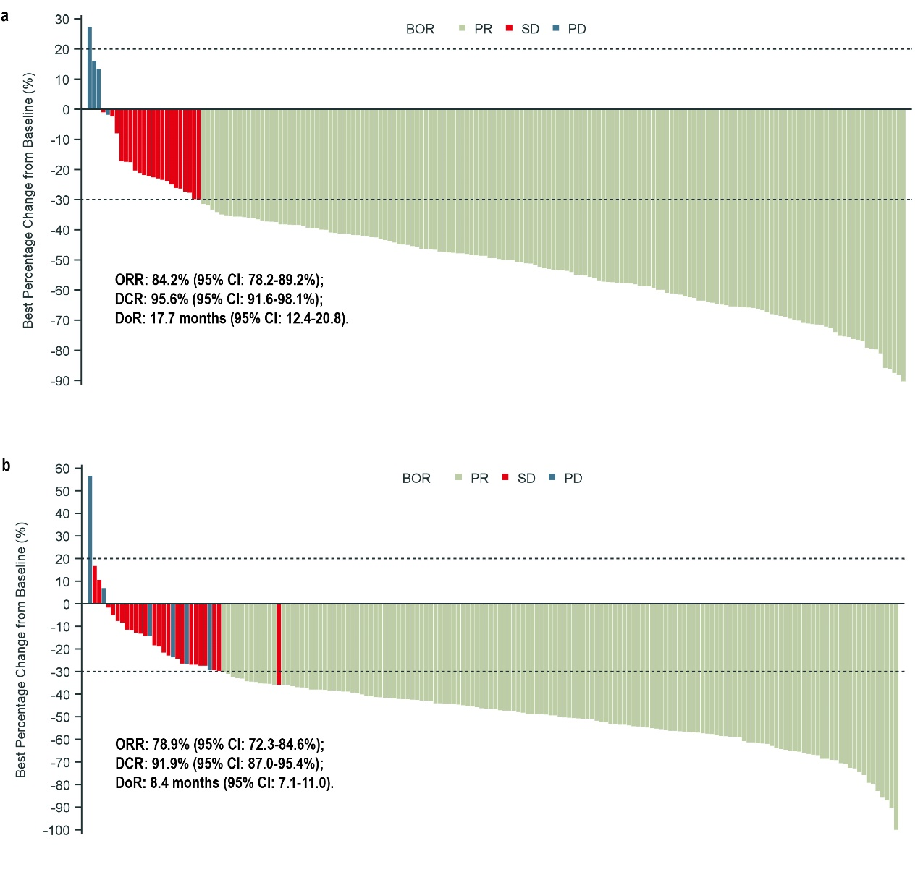
Fig. S2 Waterfall plot of best percentage change in sum of tumor size from baseline in the rezivertinib group (a) and gefitinib group (b). BOR, best overall response; PR, partial response; SD, stable disease; PD, progressive disease; ORR, objective response rate; DCR, disease control rate; DoR, duration of response; CI, confidence interval.

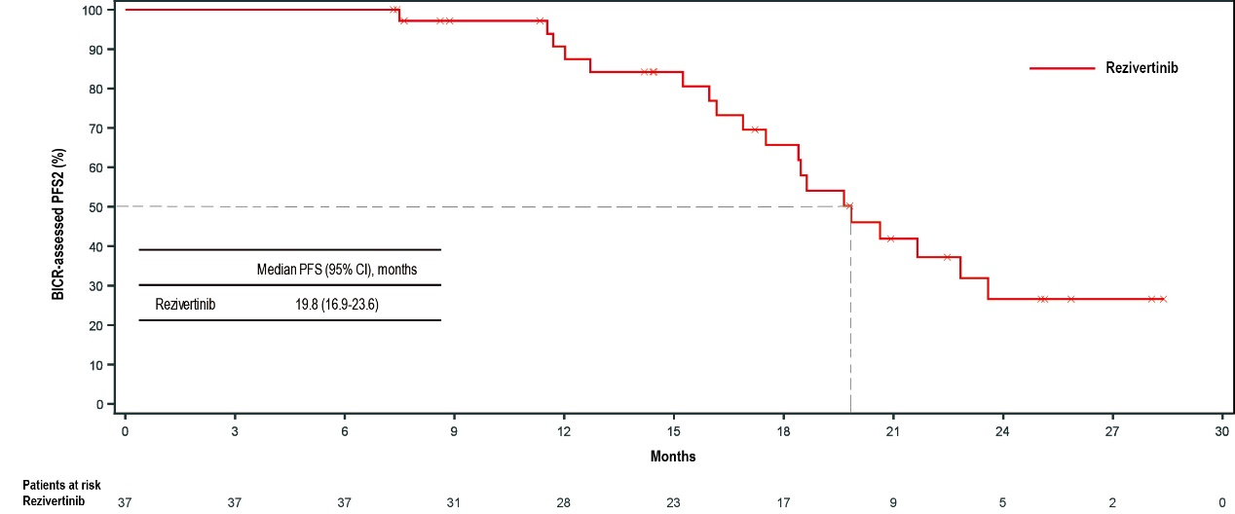
Fig. S3 Kaplan-Meier plot of BICR-assessed PFS2. PFS2 was defined as the time from randomization to the second occurrence of disease progression or death from any cause after initiating cross-over treatment with rezivertinib treatment, whichever occurred first. PFS, progression-free survival; CI, confidence interval.

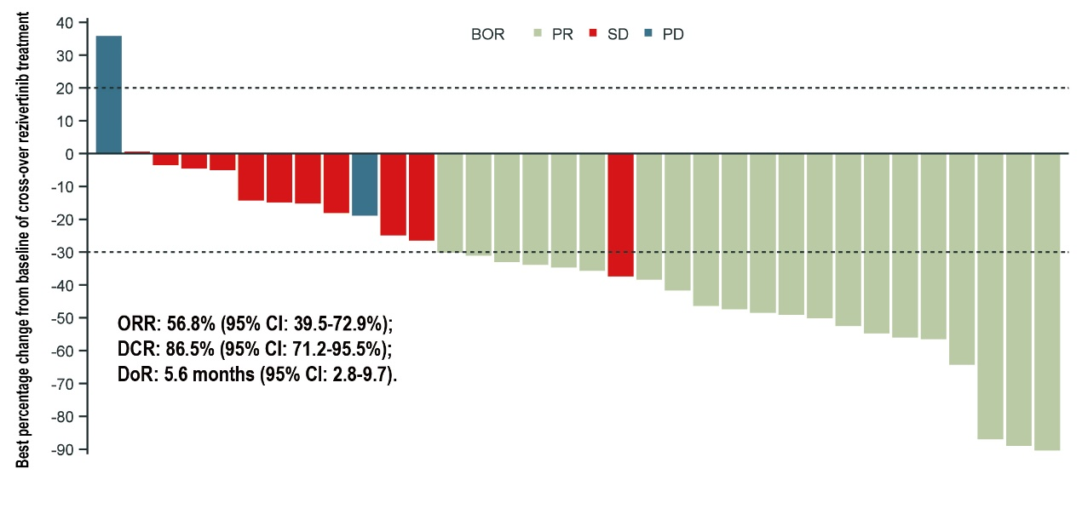
Fig.S4 Waterfall plot of best percentage change in sum of tumor size from baseline of cross-over rezivertinib treatment. BOR, best overall response; PR, partial response; SD, stable disease; PD, progressive disease; ORR, objective response rate; DCR, disease control rate; DoR, duration of response; CI, confidence interval.

Table S1. Summary of BICR-assessed objective response, TTR and DoR of ITT set
Efficacy | Rezivertinib, n (%)  (n=184) | Gefitinib, n (%)  (n=185)
Best overall response, n (%)
CR | 0 (0.0) | 0 (0.0)
PR | 155 (84.2) | 146 (78.9)
SD | 21 (11.4) | 24 (13.0)
PD | 4 (2.2) | 7 (3.8)
NE ª | 4 (2.2) | 8 (4.3)
ORR, n (%) | 155 (84.2) | 146 (78.9)
95% CI (%) | 78.2-89.2 | 72.3-84.6
P value | 0.1625
DCR, n (%) | 176 (95.7) | 170 (91.9)
95% CI (%) | 91.6-98.1 | 87.0-95.4
P value | 0.1322
TTR, months
Median | 1.4 | 1.4
95% CI (%) | 1.4-1.5 | 1.4-1.5
P value | 0.9242
DoR, months
Median | 17.7 | 8.4
95% CI (%) | 12.4-20.8 | 7.1-11.0
P value | <.0001
Note: ª Patients were classified as not evaluable if no valid post-baseline tumor assessment, new anti-tumor treatment initiated before the first post-baseline assessment, stable disease occurred within 6 weeks of starting study treatment, or overall response of all post-baseline tumor assessments was NE. In the ITT population, totally 12 patients were determined as not evaluable, while 4 in the rezivertinib group (3 had no valid post-baseline tumor assessment and 1 received new anti-cancer treatment initiated before the first post-baseline assessment) and 8 in the gefitinib group without valid post-baseline tumor assessment. BICR, Blinded Independent Center Review; ORR, objective response rate; DCR, disease control rate; TTR, time to response; DoR, duration of response; ITT, intention-to-treat; CI, confidence interval; CR, complete response; PR, partial response; SD, stable disease; PD, progressive disease; NE, not evaluable.

Table S2. Summary of BICR-assessed objective response and DoR of cross-over rezivertinib treatment
Efficacy | Cross-over rezivertinib treatment, n (%)  (N=37)
Best overall response, n (%)
CR | 0 (0.0)
PR | 21 (56.8)
SD | 11 (29.7)
PD | 2 (5.4)
NE ª | 3 (8.1)
ORR, n (%) | 21 (56.8)
95% CI (%) | 39.5-72.9
DCR, n (%) | 32 (86.5)
95% CI (%) | 71.2-95.5
DoR, months
Median | 5.6
95% CI (%) | 2.8-9.7
Note: ª Among patients received cross-over rezivertinib treatment, 3 were determined as not evaluable, while 2 had no valid post-baseline tumor assessment and 1 received new anti-cancer treatment initiated before the first post-baseline assessment. BICR, Blinded Independent Center Review; ORR, objective response rate; DCR, disease control rate; DoR, duration of response; CI, confidence interval. CR, complete response; PR, partial response; SD, stable disease; PD, progressive disease; NE, not evaluable.

Table S3. Summary of AEs of cross-over rezivertinib treatment
AEs | Cross-over rezivertinib treatment, n (%)  (N=37)
TEAE | 36 (97.3)
TEAE with Grade 3 or Higher | 10 (27.0)
Grade 3 | 10 (27.0)
Grade 4 | 0
Grade 5 | 0
TEAE Leading to Death | 0
TEAE Leading to Treatment Termination | 0
TEAE Leading to Dose Adjustment | 4 (10.8)
TEAE Leading to Dose Interruption | 2 (5.4)
TEAE Leading to Dose Reduction | 2 (5.4)
TRAE | 31 (83.8)
TRAE with Grade 3 or Higher | 4 (10.8)
Grade 3 | 4 (10.8)
Grade 4 | 0
Grade 5 | 0
TRAE Leading to Death | 0
TRAE Leading to Treatment Termination | 0
TRAE Leading to Dose Adjustment | 2 (5.4)
TRAE Leading to Dose Interruption | 0
TRAE Leading to Dose Reduction | 2 (5.4)
Serious TEAE | 5 (13.5)
Serious TRAE | 0
Serious TEAE Leading to Discontinuation of study drug | 0
Note: Safety was determined by investigator as per CTCAE Version 4.03. AE, adverse events; TEAE, treatment-emergent adverse event; TRAE, treatment-related adverse event.

