SUPPLEMENTARY MATERIALS
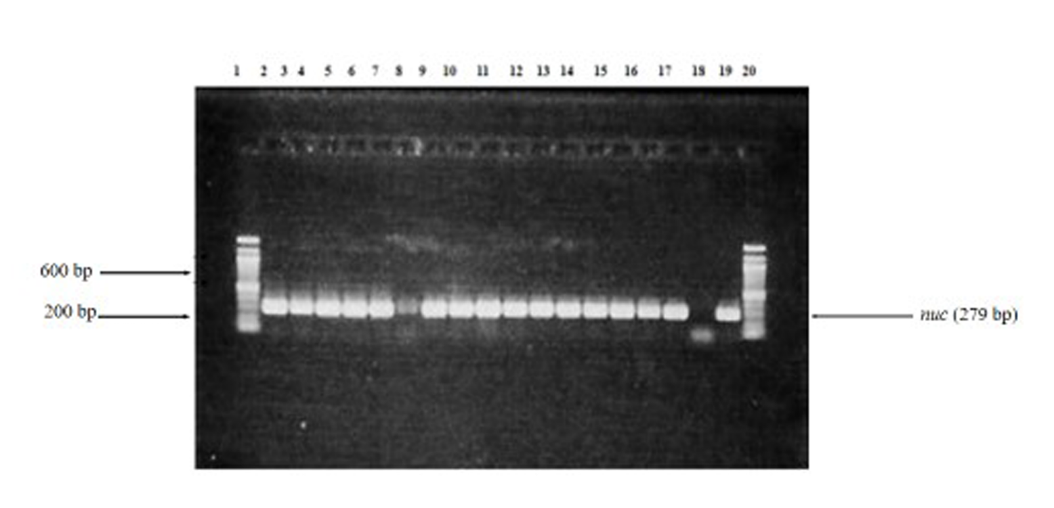
Amplification of the nuc gene
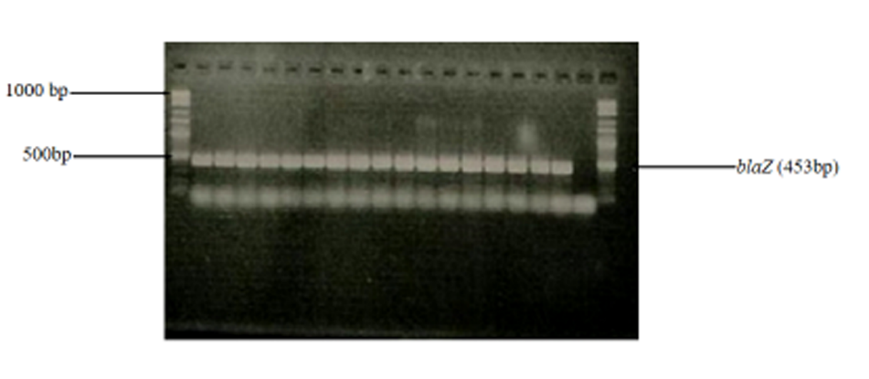
Amplification of the blaZ gene in selected MDR S.aureus strains

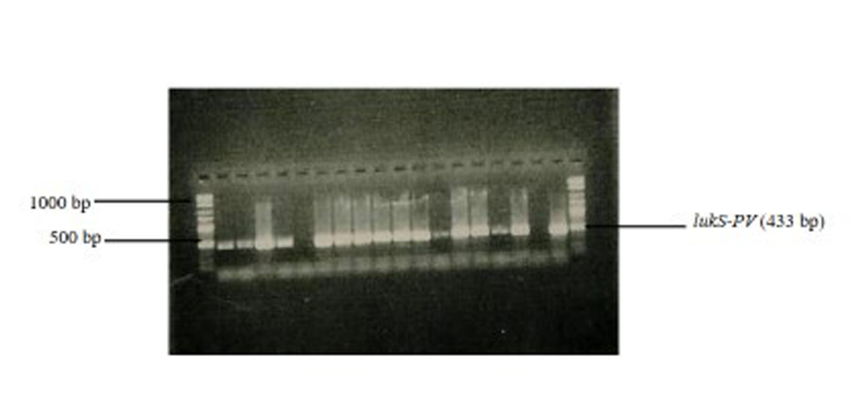
Amplification of the PVL gene
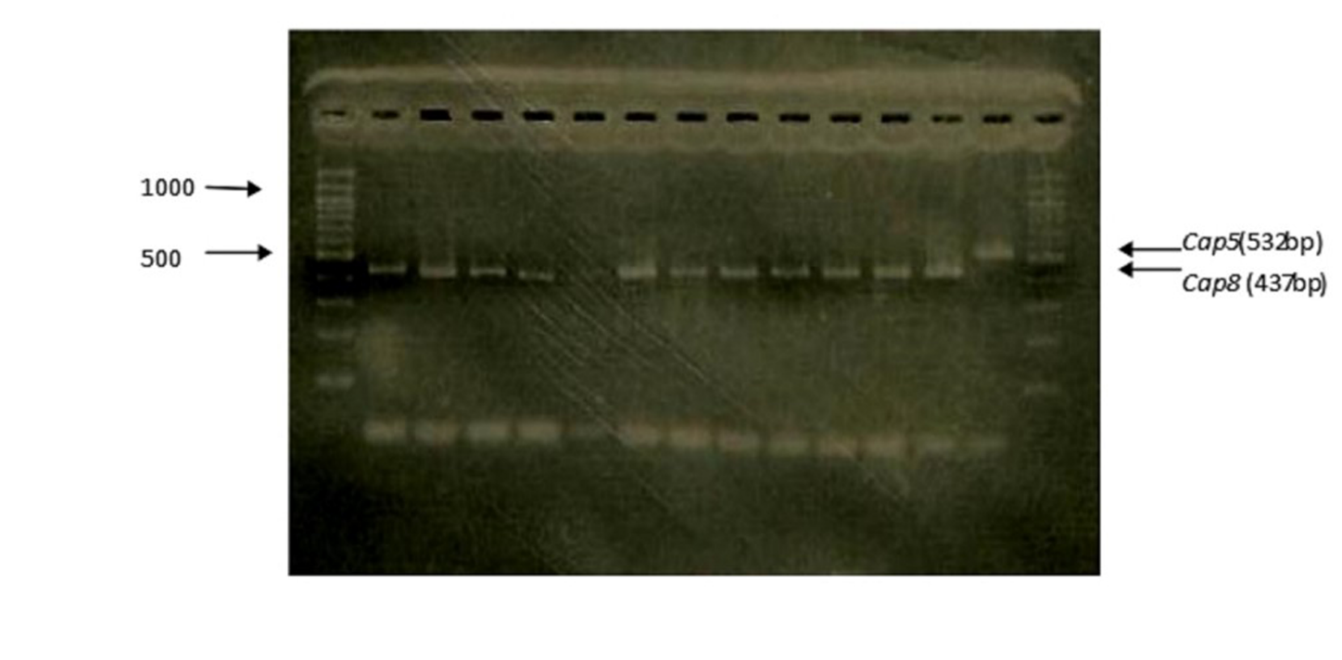
Detection of the capsular genotype in selected MDR strains of S. aureus

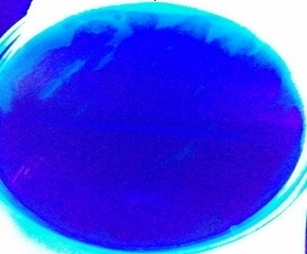
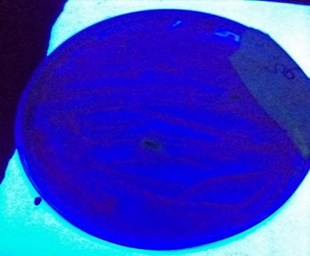
A B
A: showing biofilm formation, i.e. blackening of the Congo red agar (CRA) seen under UV light. B: no blackening of the CRA, i.e. no formation of biofilm seen under UV light.

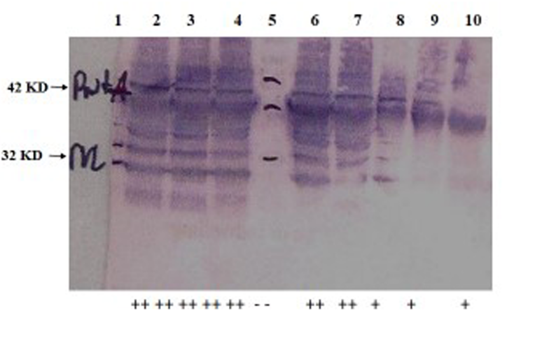
Western blot for semi-quantification of PVL proteins; Keys: no PVL production --, low PVL production +, and high PVL production ++

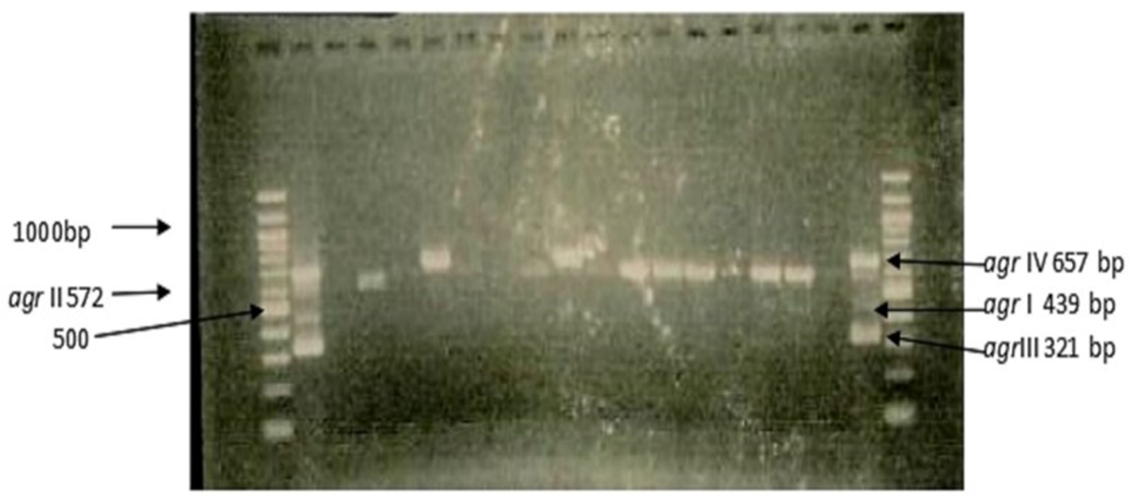
Multiplex PCR for agr typing

