Supplementary material of article Sex-mediated gene flow of grayfoot chacma baboons (Papio ursinus griseipes) in a highly seasonal habitat of Gorongosa National Park
Ferreira da Silva et al.

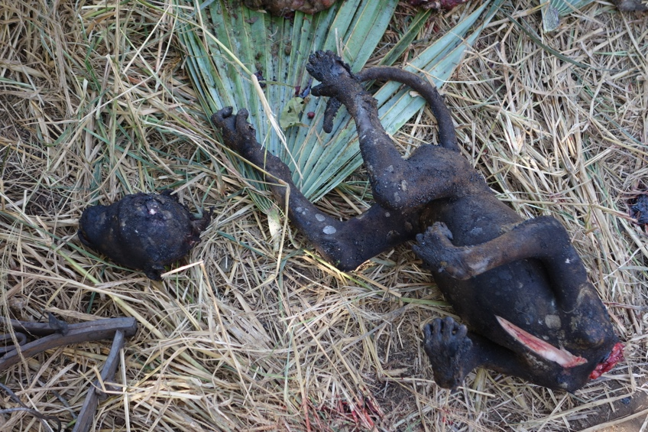
Fig. 1S Photo of a baboon carcass being prepared for consumption, credits by M. Stallmans. The meat was found by rangers in a hunters camp, in 2015, in Gorongosa National Park.

Supplementary material 1 - Details on primers and amplification by Polymerase Chain Reaction (PCR) (cycling conditions)
1.1 D-loop
A fragment of approximately 490 bp of the control region (hypervariable region I) was amplified and sequenced using the external primers published by Hapke et al. (2001): L15437: CTGGCGTTCTAACTTAAACT and H15849: GTAGTATTACCCGAGCGG. The mtDNA fragment was amplified in a 10uL volume using the 5 µl My taqTM HS Mix. The final reaction concentrations consisted of 5 µl My taqTM HS Mix, 0.2uM of each primer and 2uL of DNA extract. The PCR started with a Polymerase activation step for 15 min at 95ºC, followed by 40 cycles of denaturation step at 94ºC for 30 sec, annealing temperature at 59ºC for 90 sec and extension at 72ºC for 60 sec. The PCR ended with a final extension of 30 min at 60ºC. PCR products were purified with 10 units of Exonuclease I and five units of Antarctic Phosphatase (New England Biolabs Inc., Ipswich, UK). Samples were then sequenced bidirectionally using an ABI3730XL capillary analyzer at Centro de Testagem Molecular (CTM, CIBIO, Portugal). All PCRs were carried out in a T100TM BIO-RAD 96 Well Thermal Cycler at CTM/CIBIO.

1.2 Sex molecular determination protocol
To determine the sex of individuals, we used the molecular determination protocol developed by DiFiore et al 2005 in which a fragment of the amelogenin X gene and the SRY gene, differing in size by 35 bp, are amplified in a multiplex PCR. Males are identified by the amplification of the two fragments while females are identified by the sole amplification of the Amelogenin fragment. PCR cycling conditions were optimized for the samples used in this study using positive controls which were samples collected from visually confirmed males and females. Fragments were amplified in a 10uL volume and the final PCR reaction concentrations consisted of 2x My taqTM HS Mix, 0.2uM of each primer and 2uL of DNA extract. The touchdown PCR started with a Polymerase activation step for 15 min at 95ºC and was followed by 14 cycles of denaturation at 95ºC for 30 sec, annealing temperature starting at 66ºC for 30 sec and decreasing -0.5ºC per cycle and extension at 72ºC for 30 sec, followed by 26 cycles of an annealing temperature at 59ºC for 30 sec and extension at 72ºC for 30 sec. The PCR ended with a final extension of 10 min at 60ºC. PCR products were subjected to a 2% agarose gels electrophoresis (120V) and then visualized with NZYDNA Ladder V (NZYTech, Portugal) in an UV transilluminator (Gel Doc ™ XR + Gel Documentation System (Bio-Rad, EE. UU). All PCRs were carried out in a T100TM BIO-RAD 96 Well Thermal Cycler at CTM/CIBIO.
A minimum of three PCRs were conducted to reach the final identification of the sex of the samples. Males were identified by the presence of two bands in the agarose gel and the samples amplifying only the largest fragment were considered females. The difference of approximately 35 bp between fragments was visualized in 2% agarose gel electrophoreses (Di Fiore, 2005).
1.3 Microsatellite loci
Fourteen autosomal microsatellite loci and one Y-chromosome linked locus were amplified using five multiplex PCR systems (Table S1). Loci were human-derived and with known cross-amplification in Papio (Ferreira da Silva et al., 2014). Markers were amplified in 10uL volume using the My taqTM HS Mix, 0.2uM of each multiplex primer mixture and 2uL of DNA extract (see Table S1, for multiplex PCR conditions and primers concentrations in the final reaction). PCR cycling conditions started with a Polymerase activation step (15 min at 95ºC), followed by 40 cycles of denaturation for 30 sec at 94ºC, a 40 sec annealing step at 50º-59ºC (Table S1) and an extension step for 60 sec at 72ºC. The PCR ended with a final extension step of 30 min at 72ºC.

Supplementary material 2 - Prevention of contaminations
Several precautions were taken to avoid contamination with exogenous DNA during samples extraction. These included carrying out the protocol of DNA extraction in a dedicated lab and inside a laminar-flow hood, irradiating the material with UV for 30 minutes prior the start of the laboratory procedures and cleaning the inside of the hood with 10% bleach. Head and facial masks were always used, and nitrile gloves were frequently changed. PCR reagent mixes were prepared in a dedicated-laboratory at CIBIO facilities (Centro de Investigação em Biodiversidade e Recursos Genéticos, Universidade do Porto). PCRs were assembled in a Microflow OMNI PCR workstation (Bioquell UK Ltd, Hampshire, UK). All the material was irradiated with UV light, while sterile filter tips and face masks were used during all steps of the PCR set up. Negative controls with no added DNA were included in each set of PCR reactions.

Supplementary material 3 – Composition of multiplexes PCR
Table 1S: Details of Multiplexes PCRs (annealing temperature): loci included in each multiplex, name and GenBank code, primers sequences, repeat motif, colour of fluorescent dye, final PCR concentration, allele range found for overall dataset and the PCR cycling conditions.
MULTIPLEX | LOCUS | GC | PRIMER F  PRIMER R (5’-3’) | REPEAT MOTIF | DYE | FINAL CONC (uM) | RANGE  (bp) | PCR cycling conditions.
M1 | D13S765 | G09003 | TGTAACTTACTTCAAATGGCTCA  TTGAAACTTACAGACAGCTTGC | GATA | TAMRA | 0.15 | 193-217 | 94ºC 15 min  94ºC 30 s  57ºC 50 s  72ºC 40 s  72ºC 30 min
M1 | D12S375 | G08936 | TTGTTGAGGGTCTTTCTCCA  TCTTCTTATTTGGAAAAGTAACCC | GATA | PET | 0.1 | 169-193 | 94ºC 15 min  94ºC 30 s  57ºC 50 s  72ºC 40 s  72ºC 30 min
M1 | D3S1766 | G08269 | ACCACATGAGCCAATTCTGT  ACCCAATTATGGTGTTGTTACC | ATCT | FAM | 0.1 | 212-232 | 94ºC 15 min  94ºC 30 s  57ºC 50 s  72ºC 40 s  72ºC 30 min
M1 | D7S503 | G18277 | ATGACTTGGAGTAATGGG  AACCTTTAATCAGGATACAGAC | CA | NED | 0.6 | 138-158 | 94ºC 15 min  94ºC 30 s  57ºC 50 s  72ºC 40 s  72ºC 30 min
M2 | D2S1326 | G08136 | AGACAGTCAAGAATAACTGCCC  CTGTGGCTCAAAAGCTGAAT | CTAT | FAM | 0.3 | 234-270 | 94ºC 15 min  94ºC 30 s  55ºC 50 s  72ºC 40 s  72ºC 30 min
M2 | D14S306 | G09055 | AAAGCTACATCCAAATTAGGTAGG  TGACAAAGAAACTAAAATGTCCC | GATA | FAM | 0.2 | 163-183 | 94ºC 15 min  94ºC 30 s  55ºC 50 s  72ºC 40 s  72ºC 30 min
M2 | D1S533 | G07788 | CATCCCCCCCAAAAAATATA  TTGCTAATCAAATAACAATGGG | GATA | HEX | 0.4 | 191-207 | 94ºC 15 min  94ºC 30 s  55ºC 50 s  72ºC 40 s  72ºC 30 min
M3 | D8S1106 | G09378 | TTGTTTACCCCTGCATCACT  TTCTCAGAATTGCTCATAGTGC | GATA | VIC | 0.1 | 133-157 | 94ºC 15 min  94ºC 30 s  59ºC 40 s  72ºC 30 s  72ºC 30 min
M3 | D6S501 | G08551 | GCTGGAAACTGATAAGGGCT  GCCACCCTGGCTAAGTTACT | CTAT | FAM | 0.5 | 190-222 | 94ºC 15 min  94ºC 30 s  59ºC 40 s  72ºC 30 s  72ºC 30 min
M3 | D10S611 | G08794 | CATACAGGAAACTGTGTAGTGC  CTGTATTTATGTGTGTGGATGG | GATA | FAM | 0.1 | 200-224 | 94ºC 15 min  94ºC 30 s  59ºC 40 s  72ºC 30 s  72ºC 30 min
M4 | D5S1457 | G08431 | TAGGTTCTGGGCATGTCTGT  TGCTTGGCACACTTCAGG | GATA | PET | 0.1 | 123-137 | 94ºC 15 min  94ºC 30 s  57ºC 50 s  72ºC 40 s  72ºC 30 min
M4 | D7S2204 | G08635 | TCATGACAAAACAGAAATTAAGTG  AGTAAATGGAATTGCTTGTTACC | AGAT | FAM | 0.4 | 243-259 | 94ºC 15 min  94ºC 30 s  57ºC 50 s  72ºC 40 s  72ºC 30 min
M4 | D3S1768 | G08287 | GGTTGCTGCCAAAGATTAGA  CACTGTGATTTGCTGTTGGA | GATA | VIC | 0.1 | 186-206 | 94ºC 15 min  94ºC 30 s  57ºC 50 s  72ºC 40 s  72ºC 30 min
M5 | Sex-determination | Di Fiore 2005 | AMELF1:ACCACCAGCTTCCCAGTTTA  AMELR1:GCTGGGWTAGAACCAAGCTG  And  SRY-F1:AGTGAAGCGACCCATGAAC  SRY-R1:TGTGCCTCCTGGAAGAATG | NA | FAM | 0.1 | 200 and 165 | 94ºC 15 min  94ºC 30 s  60ºC 40 s  72ºC 30 s  72ºC 30 min
M5 | D4S243 | M87736 | AATCCCTTTTCTACCTTTCTATCAC  GAGAGGAGAGATAAAAGATGTAAATG | GATA | FAM | 0.2 | 148-180 | 94ºC 15 min  94ºC 30 s  60ºC 40 s  72ºC 30 s  72ºC 30 min
Y-linked | DYS576 |  | TTGGGCTGAGGAGTTC  GGCAGTCTCATTTCCTGGAG | CTTT | FAM | 0.2 |  | 94ºC 15 min  94ºC 30 s  55ºC 40 s  72ºC 30 s  72ºC 5 min

Supplementary material 4 - Method to estimate the number of number of repeats per locus per sample
Microsatellite loci genotyping followed a modified “multi-tube” approach based on (Taberlet et al., 1996) in which the number of repetitions across loci necessary to generate a reliable consensus genotype was estimated based on empirical data, following Ferreira da Silva et al., (2014). The maximum likelihood approach implemented in Pedant v1.0 (Johnson & Haydon, 2007b) was used to obtain preliminary allelic ropout (ADO) and false allele (FA) rates based on a dataset of 20 samples collected in Gorongosa National Park. These samples were selected to avoid the inclusion of more than one genetic population in the estimation. The ADO and FA rates estimated in Pedant were used as input in GEMINI v1.4.1 (Valiére et al., 2002) to estimate the number of repetitions across loci required to obtain 95% confidence in the consensus genotypes (using the “consensus genotype” module analysis).

Supplementary material 5 - Description of microsatellite loci dataset

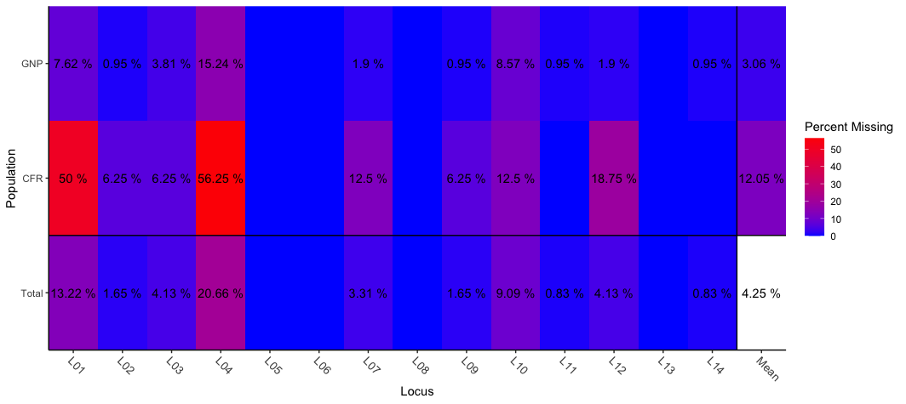
Fig. 2S Missing data plot. Plot showing the percentage of missing data per autosomes locus, for each of the sampling localities and across the whole dataset. The plot was assembled using poppr 2.9.3 R package (Kamvar et al., 2015). Blue areas represent 0% of missing data and red tones represent increasing percentages of missing data (see legend). Locus 01 to Locus 14: D12S375, D7S503, D3S1766, D13S765, D3S1768, D7S2204, D5S1457, D14S306, D1S533, D2S1326, D4S243, D6S501, D8S1106 and D10S611

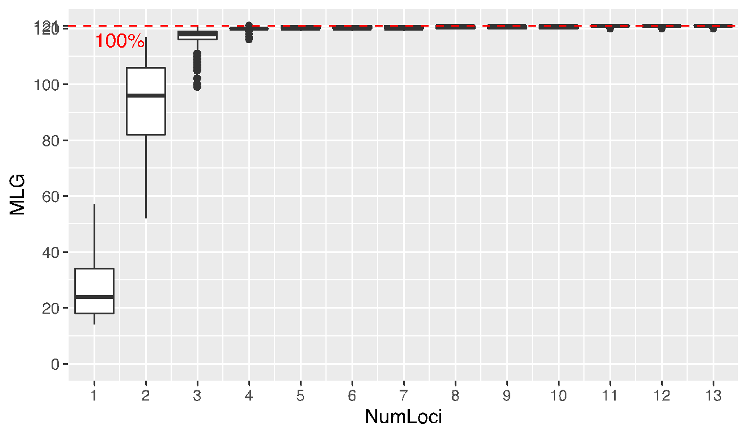

Fig. 3S Genotype accumulation curve to assess power to discriminate between unique individuals given a random sample of n loci. For each boxplot, n loci were randomly sampled 1000 times to generate the distribution. MLG - the number of multilocus genotype. The genotype accumulation curve does not increase further after n=4 loci, suggesting that four loci is sufficient to distinguish between multilocus genotype. Constructed using poppr R package (Kamvar et al. 2015).

Supplementary material 6 – Genetic Diversity

Table 2S - Autosomal microsatellite genetic diversity total number of unique genotypes: N=121; N - Sample Size, Na – number of alleles, Ne – number of effective alleles, I - Information Index, Ho - Observed Heterozygosity, He - Expected and UHe - Unbiased Expected Heterozygosity, and F - Fixation Index

Locus | N | Na | Ne | I | Ho | He | UHe | F
D12S375 | 105 | 7.000 | 5.122 | 1.729 | 0.790 | 0.805 | 0.809 | 0.018
D7S503 | 119 | 10.000 | 3.059 | 1.552 | 0.664 | 0.673 | 0.676 | 0.014
D3S1766 | 116 | 8.000 | 4.716 | 1.663 | 0.759 | 0.788 | 0.791 | 0.037
D13S765 | 96 | 7 | 4.716 | 1.663 | 0.759 | 0.788 | 0.791 | -0.096
D3S1768 | 121 | 9.000 | 5.919 | 1.892 | 0.818 | 0.831 | 0.835 | 0.015
D7S2204 | 121 | 8.000 | 6.356 | 1.932 | 0.868 | 0.843 | 0.846 | -0.030
D5S1457 | 117 | 12.000 | 5.640 | 1.925 | 0.786 | 0.823 | 0.826 | 0.044
D14S306 | 121 | 6.000 | 3.470 | 1.358 | 0.727 | 0.712 | 0.715 | -0.022
D1S533 | 119 | 5.000 | 3.281 | 1.332 | 0.647 | 0.695 | 0.698 | 0.069
D2S1326 | 110 | 11.000 | 6.906 | 2.087 | 0.773 | 0.855 | 0.859 | 0.096
D4S243 | 120 | 9.000 | 4.917 | 1.772 | 0.800 | 0.797 | 0.800 | -0.004
D6S501 | 116 | 12.000 | 6.650 | 2.129 | 0.793 | 0.850 | 0.853 | 0.067
D8S1106 | 121 | 7.000 | 2.888 | 1.275 | 0.645 | 0.654 | 0.656 | 0.014
D10S611 | 120 | 13.000 | 10.484 | 2.452 | 0.933 | 0.905 | 0.908 | -0.032
Mean | 115.857 | 8.857 | 5.256 | 1.765 | 0.774 | 0.785 | 0.788 | 0.014
SE | 1.972 | 0.653 | 0.539 | 0.089 | 0.022 | 0.020 | 0.020 | 0.013

Table 3S – Autosomal microsatellites genetic diversity for GNP and CFR (mean statistics)
N samples GNP = 101.8 (includes GNP core and BM) and N CFR = 14. Na – number of alleles, Ne – number of effective alleles, I - Information Index, Ho - Observed Heterozygosity, He - Expected and UHe - Unbiased Expected Heterozygosity, and F - Fixation Index

GNP | N | Na | Ne | I | Ho | He | UHe | F
Mean | 101.857 | 8.643 | 5.099 | 1.737 | 0.778 | 0.778 | 0.782 | -0.001
SE | 1.262 | 0.570 | 0.520 | 0.087 | 0.022 | 0.021 | 0.021 | 0.013
CFR
Mean | 14.071 | 6.500 | 4.747 | 1.638 | 0.745 | 0.767 | 0.798 | 0.033
SE | 0.788 | 0.429 | 0.439 | 0.079 | 0.041 | 0.020 | 0.021 | 0.044

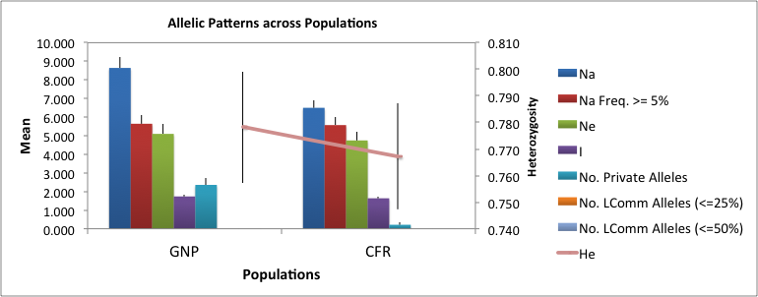

Fig. 4S – Allelic patterns across populations. Genetic diversity as estimated using 14 microsatellite loci (N=121 unique genotypes, N GNP = 101.8, includes BM locality and N CFR = 14). Mean and standard errors across loci for each population of the following statistics: Number of alleles (Na), Na with frequency >5%, effective number of alleles (Ne), information index (I), Number of private alleles, Number of Locally Common alleles (frequency >=5%) found in <=25% and <=50% of populations, expected heterozygosity (He).

Supplementary material 7 – Estimation of Population structure

Table 4S: Pairwise Fst between sampling sites using microsatellite loci and mitochondrial DNA (mtDNA) D-loop. GNP – Gorongosa National Park, CFR – Catapú Forest Reserve. Fst was estimated using number of different alleles for microsatellite loci and haplotype frequencies (Haplotype column) and pairwise differences for mitochondrial DNA (Pairwise column). * Denotes significance (p<0.05) and ** p<0.001
Pairwise Fst | Microsatellite loci | mtDNA
Pairwise Fst | CFR | CFR
Pairwise Fst | CFR | Haplotype | Pairwise
GNP | 0.017* | 0.57** | 0.52**

Table 5S - AMOVA
Table shows two-hierarchical level AMOVA (Excoffier et al., 1992) conducted in Arlequin based in mtDNA and microsatellite loci. For mtDNA, significance was calculated using 10,000 permutations. For microsatellite loci, was performed a locus-by-locus AMOVA based on the number of different alleles as recommended for genetic datasets with missing data (Excoffier & Lischer, 2015). The results of the global AMOVA are an average weighted over loci. The significance of covariance components and fixation indices was tested using 16,000 permutations.

MtDNA
Source of variation | DF | Sum of squares | Variance component | Percentage of variation
Among populations | 1 | 29.69 | 0.73 Va | 55.9
Within-populations | 96 | 55.16 | 0.57 Vb | 44.11
Total | 97 | 84.85 | 1.30
Fixation Index (FST) = | 0.56**
Microsatellite loci
Source of variation | DF | Sum of squares | Variance component | Percentage of variation
Among populations |  | 13.6 | 0.147 | 2.61
Within-populations |  | 1258.9 | 5.48 | 97.4
Total |  | 1272.5 | 5.631
Fixation Index (FST) = | 0.026

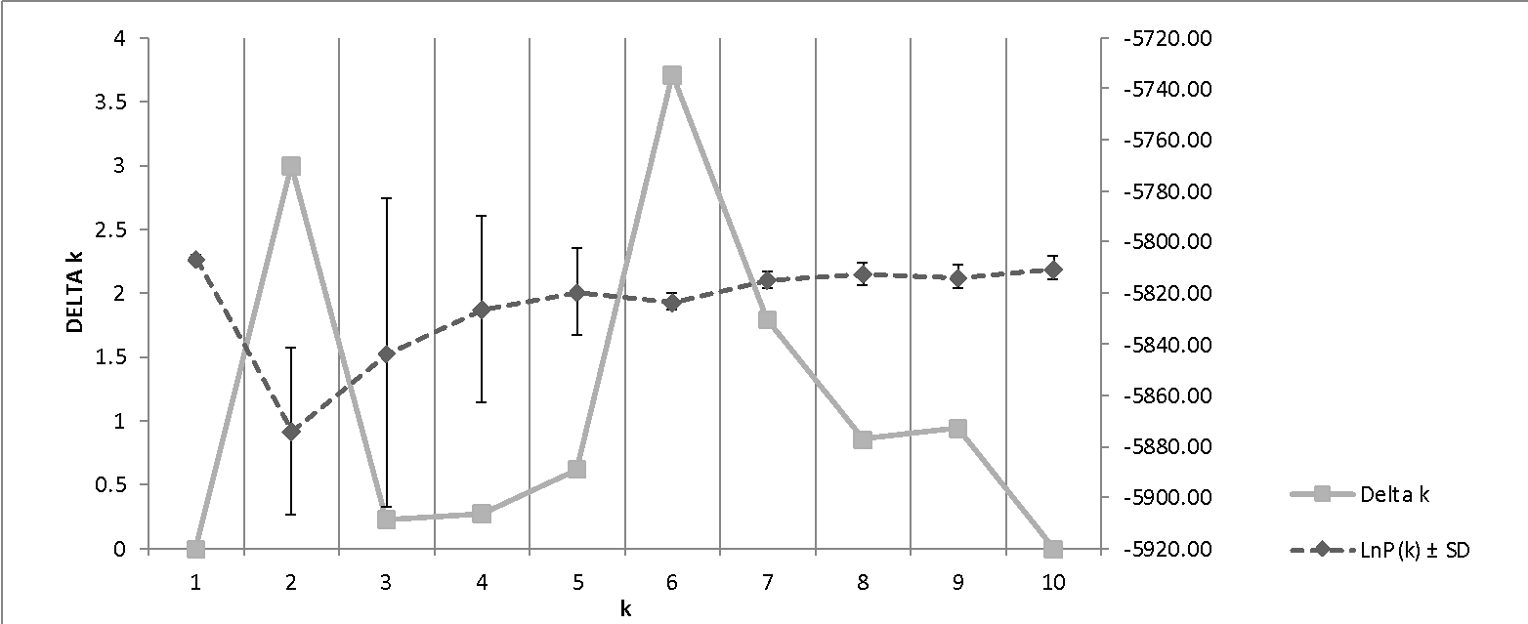

Fig. 5S: Figure shows DELTA K and Ln P(K) values as a function of the number of putative populations (K).

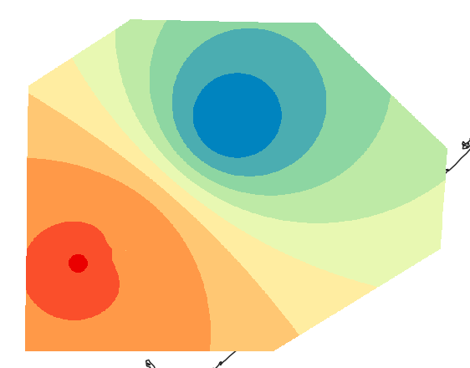
a) mtDNA D-loop - Model: Variation ~ long; explained variance = 18.14%; r2 = 0.17; p< 0.001.

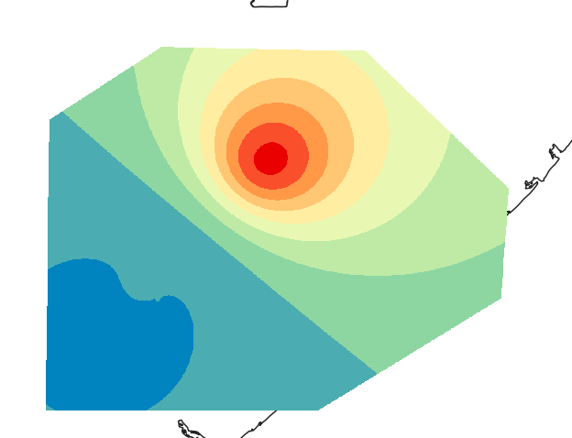
b) Microsatellite loci. Whole dataset - Model: Variation ~ lat + lat^2*long; explained variance = 3.34%; r2 = 0.017; p < 0.001.

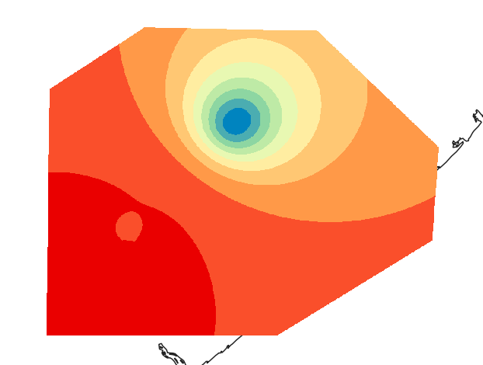
c) Microsatellite loci. Males - Model: Variation ~ lat; explained variance = 2.68%; r2 = 0.010; p< 0.01.

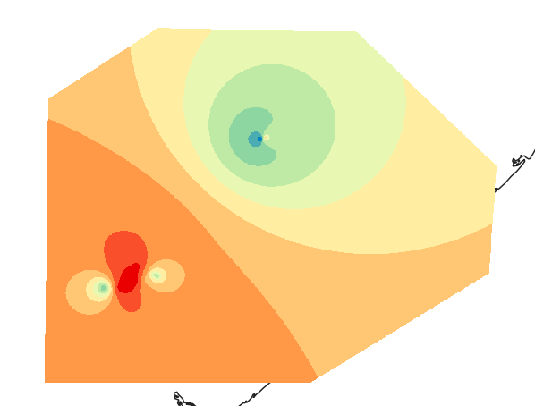
d) Microsatellite loci. Females - Model: Variation ~ long^3 + lat*long; explained variance = 6.48%; r2 = 0.027; p< 0.001.

Figure 6S. Spatial patterns of genetic variation across sampled regions. The extrapolated fitted site scores from redundancy analyses are represented in gradient of color from blue to red built using a) mtDNA D-loop, b) Microsatellite loci, Whole dataset, c) Males dataset, d) Females dataset. Darker and lighter shades represent higher and lower scores, respectively. Maps were constructed in QGIS.

Supplementary material 8 – Identification of Migrants

Table 6S: Table showing samples identified as putative migrants by analyses. ID - Sample identification code, sex identified using molecular tools M- male and F – female, Population GNP – Gorongosa National Park and CFR – Catapú Forest Reserve, Assignment to a genetic unit - the probability of assignment between brackets using results from STRUCTURE runs compensated for unequal sample size (cluster 1 mostly represented in GNP or cluster 2 mostly represented in CFR), STRUTURE - results from migrants identification using STRUCTURE run with MIGPRIOR set to 0.05 and GENSBACK set to 1, GENECLASS - results from GENECLASS analyses (Lhome/Lmax, p < 0.01), mtDNA hap - mitochondrial DNA d-loop haplotype (hap); Not Seq – a sequence was not obtained for the individual; the haplotypes are labelled as in Fig 2. NS – non-significant (p>0.05), SIG – significant (p value is indicated). The individuals highlighted in bold have been classified as migrants.

ID | Sex | Population | Assignment to a genetic unit | STRUCTURE | GENECLASS | mtDNA hap
BF09 | M | GNP | Cluster 2 (0.98) | NS | NS | Hap 1
BF12 | M | GNP | Admixed | NS | NS | Not Seq
BF13 | F | GNP | Cluster 2 (0.99) | NS | NS | Not Seq
BF16 | F | GNP | Cluster 2 (0.98) | NS | NS | Not Seq
BF27 | F | GNP | Cluster 2 (0.99) | NS | NS | Not Seq
BF35 | M | GNP | Cluster 1 (0.97) | NS | NS | Hap 1
BF43 | M | GNP | Cluster 1 (0.99) | NS | NS | Not Seq
BF45 | M | GNP | Admixed | NS | NS | Not Seq
BF47 | M | GNP | Cluster 1 (0.99) | NS | NS | Not Seq
BF63 | M | GNP | Cluster 2 (0.99) | NS | NS | Hap 1
BF90 | F | GNP | Cluster 2 (0.99) | SIG | SIG, p = 0.0005 | Hap 1
BF92 | F | GNP | Admixed | SIG | SIG, p = 0.0005 | Hap 1
BF311 | F | GNP | Cluster 2 (0.99) | NS | NS | Not Seq
BF315 | F | GNP | Cluster 2 (0.90) | NS | NS | Hap 3
BF316 | M | GNP | Cluster 2 (0.98) | NS | NS | Hap 3
BF318 | F | GNP | Cluster 2 (0.97) | NS | NS | Not Seq
BF213 | M | CFR | Cluster 1 (0.99) | NS | SIG, p = 0.0065 | Hap5
BF221 | F | CFR | Cluster 1 (0.99) | NS | NS | Hap5
BF223 | NA | CFR | NA | NA | NA | Hap6
BF228 | NA | CFR | NA | NA | NA | Hap6
BF249 | NA | CFR | NA | NA | NA | Hap6
BF241 | F | CFR | Cluster 2 (0.90) | NS | SIG, p = 0.0019 | Hap5
BF265 | NA | CFR | Cluster 2 (0.99) | NS | SIG, p = 0.0016 | NA
BF266 | NA | CFR | Admixed | NS | SIG, p = 0.0032 | Hap5
BF276 | NA | CFR | Cluster 1 (0.99) | NS | SIG, p = 0.0002 | Not Seq

Supplementary material 9 – Neutrality tests

Table 7S: Table shows the results of the neutrality tests performed in DNAsp. (Librado & Rozas, 2009). Populations CFR – Catapú Forest Reserve, GNP – Gorongosa National Park and for the overall dataset, Nseq – Number of sequences, Ns – total number of sites S - Polymorphic sites, k - Average number of pairwise differences, Pi - Nucleotide diversity, Theta (k) – theta average of k, Theta (eta) per sequence, N h - N haplotypes, Hd - haplotype diversity, Tajima's D’s, Fu and Li's F*, Fu's Fs, Strobeck's S – significant p-value highlighted in bold, *p < 0.05, ** p< 0.001

Populations | Nseq | Ns | S | k | Pi | Theta (k) | Theta (eta) | N h | Hd | Tajima's D | Fu and Li's D* | Fu and Li's F* test | Fu's Fs | Strobeck's S | Prob Nhap <=4 | Prob Nhap = 4
CFR | 32 | 442 | 17 | 3.399 | 0.0078 | 3.399 | 4.221 | 4 | 0.472 | -0.65 | 1.59** | 1.02 | 4.987* | 0.028 |  | 0.022*
CFR_without_Hap6 | 29 | 442 | 4 | 0.768 | 0.0018 | 1.019 | 1.019 | 3 | 0.362 | -0.63 | 1.062 | 0.66 | 0.945 | 0.564 | prob Nhap = 3 | 0.284
GNP | 71 | 442 | 3 | 0.51 | 0.0012 | 0.512 | 0.621 | 4 | 0.343 | -0.33 | -0.504 | -0.529 | -0.547 | 0.839 |  | 0.205
Overall | 103 | 442 | 18 | 1.978 | 0.0047 | 1.978 | 3.457 | 7 | 0.61 | -1.21 | 1.2 | 0.3446 | 1.248 | 0.373 |  | 0.15

Supplementary material 10 – Comparing the GNP baboon genetic diversity with available data for other populations of baboons
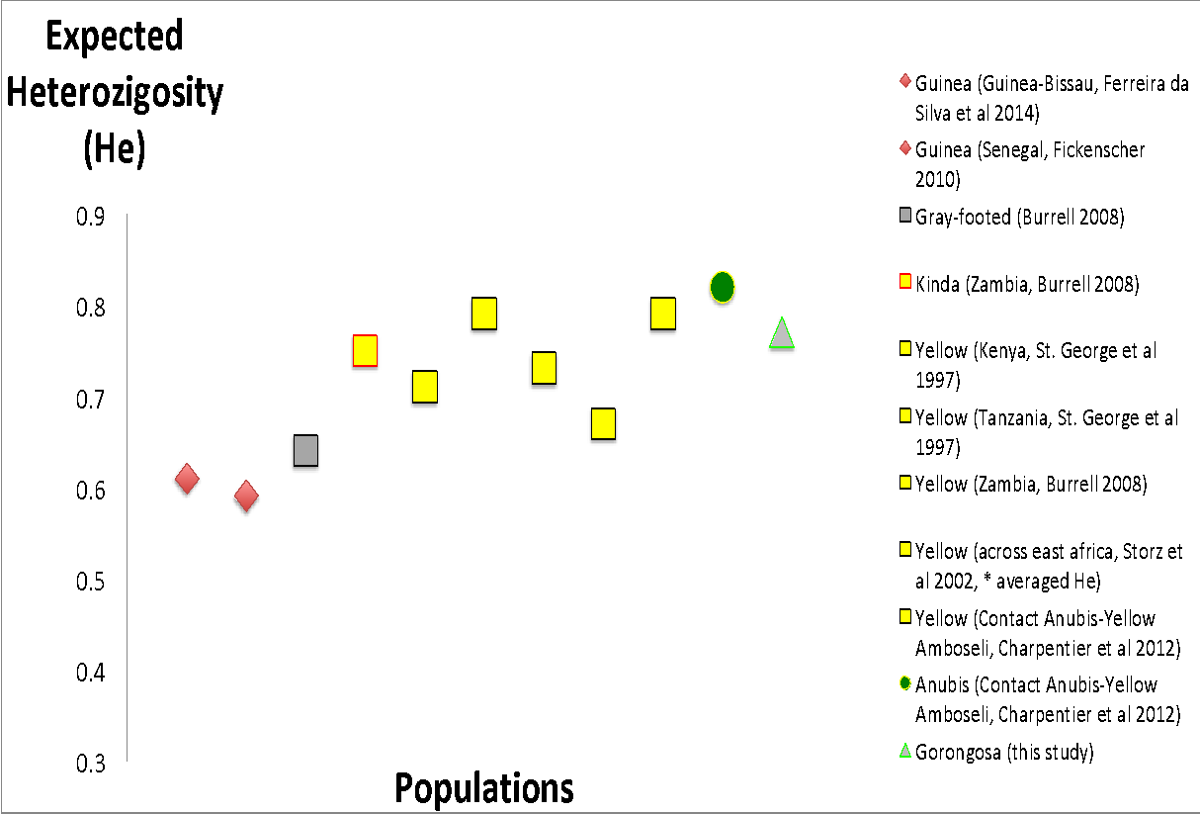
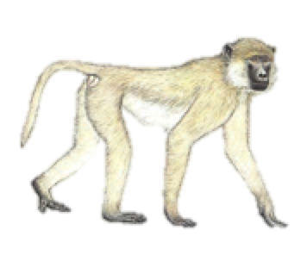
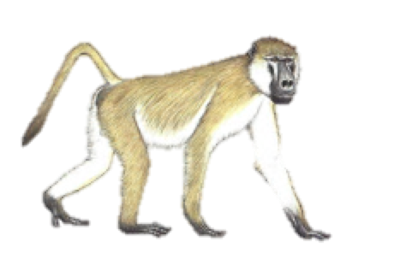
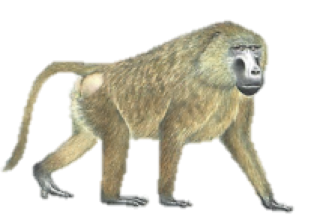
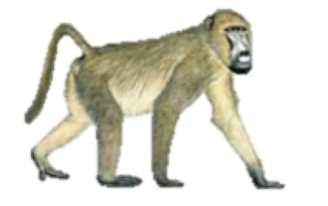
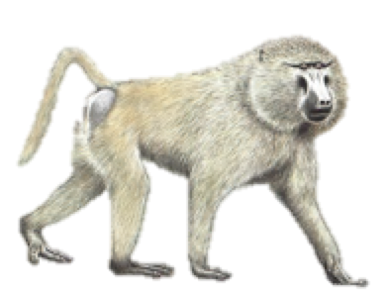

yellow
Kinda
Guinea
Gray-foot
0.77
Anubis/yellow

GNP

Figure 7S. The figure shows the expected heterozygosity (He) estimated for the Gorongosa baboons and by this study and the expected heterozygosity (He) estimated for other populations/species by several works (data points, from left to right, Guinea baboons, Ferreira da Silva et al., 2014, Fickenscher, 2010, Gray-foot chacma baboon and Kinda baboon, Burrell, 2008, yellow St.George et al., 1996 and Storz et al., 2002, Anubis/yellow, Charpentier et al., 2012)

Supplementary material 11 – Contextualization of dimensions of home ranges and dispersal distances estimated using genetic data and GPS collars by Baker-Lewis in prep.

The results published by this work suggest that genetically similar females are clustered at a scale of approximately 10 km Euclidean distance whereas males tend to be significantly similar between 10 to 20 kms intervals. In principle, the estimated distances could be good approximations to the dimensions of social group’s home ranges and dispersal distances in GNP, respectively. We used ranging data from two troops in the park collected by elements of the PPP in parallel to our study, to discuss and contextualize the order of magnitude of home-range’s sizes and dispersal distances estimated using genetic data.
A woodland-dwelling baboon troop and a floodplain-dwelling troop inhabiting the south-central area of the park were followed during eight months of a habituation process to the collection of behavioural data (Hammond et al., 2006). This is the area where troops are in higher density and that was substantially more sampled for genetic data by our study (Fig. 1). During this period, the troops were observed to range over a total area of 8.7 km² and 15.6 km², respectively (Hammond et al., 2022). After the habituation process ended, GPS collars were deployed on two females from each of these troops. From the collars recordings of location at 15-minute intervals, the home range was calculated using the minimum convex polygon of the 95% most central points from each troop. When calculated by season, the average home-range size for the woodland-dwelling troop ranged from approximately 6.0 km² in the dry season to approximately 3.4 km² in the wet season, while the floodplain-dwelling troop ranged from 6.2 km² in the dry season to 11 km² in the wet season.
The floodplain troop also underwent seasonal displacement, moving approximately 2 km south of their dry-season range to their wet-season home range. During the study, it was observed a great level of overlap between home-ranges of neighboring troops (and at least three troops shared the space with the troops under study).
The overlapping troops tended to be large (i.e., up to 120 individuals) and largely spread in space. A maximum of 8 km in average between seasons could be estimated between the most distant edges of the two focal troops' home ranges and this measurement included 800m of overlap in the center of the home ranges.
According to the estimation of home-range sizes (which are approximately 3 to 5 km across), the estimation by genetic data of a maximum of 10 km distance between significantly related females is not implausible. Moreover, despite variability in their home range sizes and locations, both troops returned to the same ranging areas each season, supporting molecular-based results that female movements are restricted.
On the other hand, concerning male movements, the estimation of 10 to 20 km for male-dispersal distance seems to be an unreliable measurement of male movements into neighboring troops, since the inter-groups distance tend to be small (around 5 km) given the high density of troops in GNP, that the home-ranges of neighboring groups greatly overlap and that there is tendency for individuals of the same social group to spread in space. However, if males are moving exclusively from their natal groups into neighboring groups, the estimation of 10 to 20 km for male-dispersal distances seems to be an unreliable measurement. The inter-group distance of the two groups under study may be approximately of 5 km because of a high density of groups in GNP. Nevertheless, given the low number of predators in the area, the risk of mortality from predation during male dispersal is probably low and males may be dispersing further away from his natal group’s neighboring troops. Other causes, such as the ratio of males and females in troops (Clarke et al., 2008) and mating competition (Alberts & Altmann, 1995) may be playing a role in the dispersal distance of males in GNP and the influence of such factors could be further assessed.

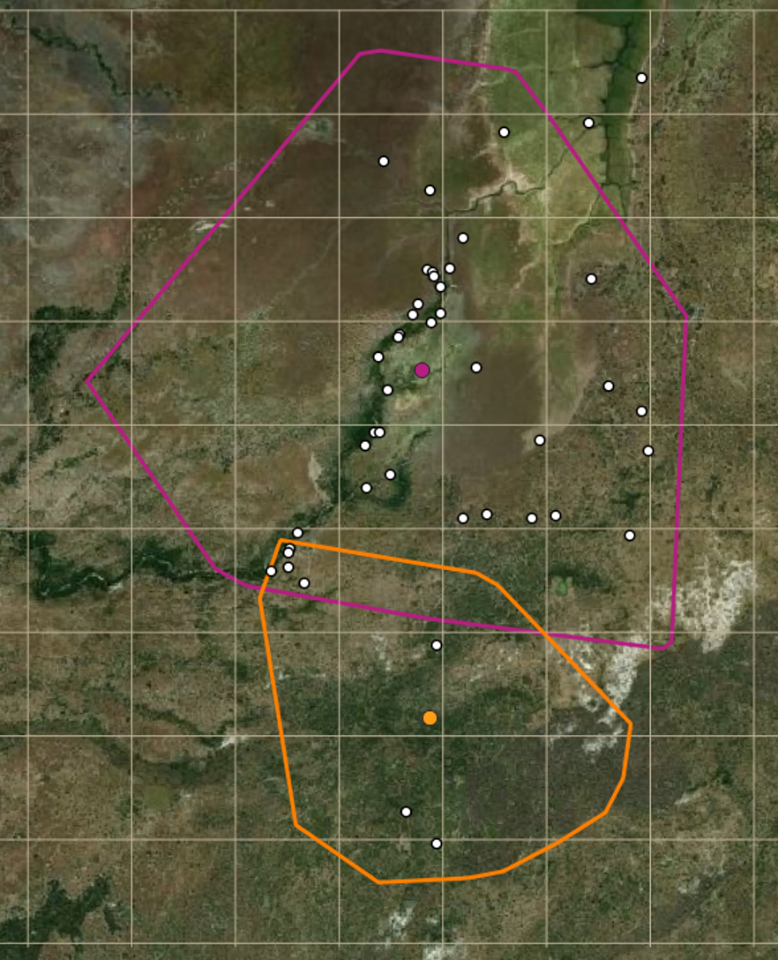
Fig. 8S The figure shows the minimum bounding polygon of the floodplain troop and the woodland troop (WT) home-range estimation. The geographic centroids are represented by pink and orange points. The grid squares are 1x1km. The white points are places where other troops (not investigated) were encountered while following one of the study troops.

References

Alberts, S., & Altmann, J. (1995). Balancing costs and opportunities: dispersal in male baboons American Naturalist, 145 279–306
Burrell, A. (2008). Phylogenetics and Population Genetics of Central African Baboons. In PhD thesis. New York University.
Charpentier, M. J., Fontaine, M. C., Cherel, E., Renoult, J. P., Jenkins, T., Benoit, L., . . . Tung, J. (2012). Genetic structure in a dynamic baboon hybrid zone corroborates behavioural observations in a hybrid population. Molecular Ecology, 21(3), 715-731. https://doi.org/10.1111/j.1365-294X.2011.05302.x
Clarke, P. M. R., Henzi, S. P., Barrett, L., & Rendall, D. (2008). On the road again: competitive effects and condition-dependent dispersal in male baboons. Animal Behaviour, 76, 55-63. https://doi.org/doi:10.1016/j.anbehav.2008.01.009
Di Fiore, A. (2005). A rapid genetic method for sex assignment in non-human primates. Conservation Genetics, 6, 1053–1058 https://doi.org/10.1007/s10592-005-9086-5
Ferreira da Silva, M. J., Godinho, R., Casanova, C., Minhós, T., Sá, R., & Bruford, M. W. (2014). Assessing the impact of hunting pressure on population structure of Guinea baboons (Papio papio) in Guinea-Bissau. Conservation Genetics, 15(6), 1339-1355. https://doi.org/10.1007/s10592-014-0621-0
Fickenscher, G. H. (2010). Genetic Population Structure of Free-Ranging Guinea Baboons (Papio papio) in the Niokolo-Koba Nationa Park, Senegal Gottingen University]. Gottingen.
Hammond, R. L., Handley, L. J., Winney, B. J., Bruford, M. W., & Perrin, N. P. (2006). Genetic evidence for female-biased dispersal and gene ﬂow in a polygynous primate. Proceedings of the Royal Society of London B Biological Sciences, 273, 479–484.
Kamvar, Z. N., Tabima, J. F., & Grünwald, N. J. (2015). Poppr: An R package for genetic analysis of populations with clonal, partially clonal, and/or sexual reproduction. PeerJ 2:e281. http://dx.doi.org/10.7717/peerj.281
Librado, P., & Rozas, J. (2009). DnaSP v5: A software for comprehensive analysis of DNA polymorphism data. . Bioinformatics, 25(1451-1452 ). https://doi.org/doi: 10.1093/bioinformatics/btp187
St.George, D., Witte, S. M., Turner, T. R., Weiss, M. L., Phillips-Conroy, J., Smith, E. O., & Rogers, J. (1996). Microsatellite Variation in Two Populations of Free-Ranging Yellow Baboons (Papio hamadryas cynocephalus). International Journal of Primatology, 19(2), 273-285.
Storz, J. F., Beaumont, M. A., & Alberts, S. C. (2002). Genetic evidence for long-term population decline in a savannah-dwelling primate: Inferences from a hierarchical Bayesian model. Molecular Biology and Evolution, 19.
Taberlet, P., Griffin, S., Goossens, B., Questiau, S., Manceau, V., Escaravage, N., . . . Bouvet, J. (1996). Reliable genotyping of samples with very low DNA quantities using PCR. Nucleic Acids Research, 26 (16), 3189-3194.

