Additional file for the paper:
Dynamically triggered seismicity in Japan following the 2024 M_{w}7.5 Noto earthquake

Like An¹, Bogdan Enescu^{1,2}, Zhigang Peng³, Masatoshi Miyazawa⁴, Hector Gonzalez-Huizar⁵, Yoshihiro Ito⁴

¹Department of Geophysics, Graduate School of Science, Kyoto University, Kyoto, Japan
²National Institute for Earth Physics, Bucharest, Romania
³School of Earth and Atmospheric Sciences, Georgia Institute of Technology, Atlanta, Georgia, U.S.A.
⁴Disaster Prevention Research Institute, Kyoto University, Uji, Kyoto, Japan
⁵Departamento de Sismología, División Ciencias de la Tierra, Centro de Investigación Científica y de Educación Superior de Ensenada (CICESE), Ensenada, Baja California, 22860, México

Corresponding Author: Like An, like.an.65h@st.kyoto-u.ac.jp

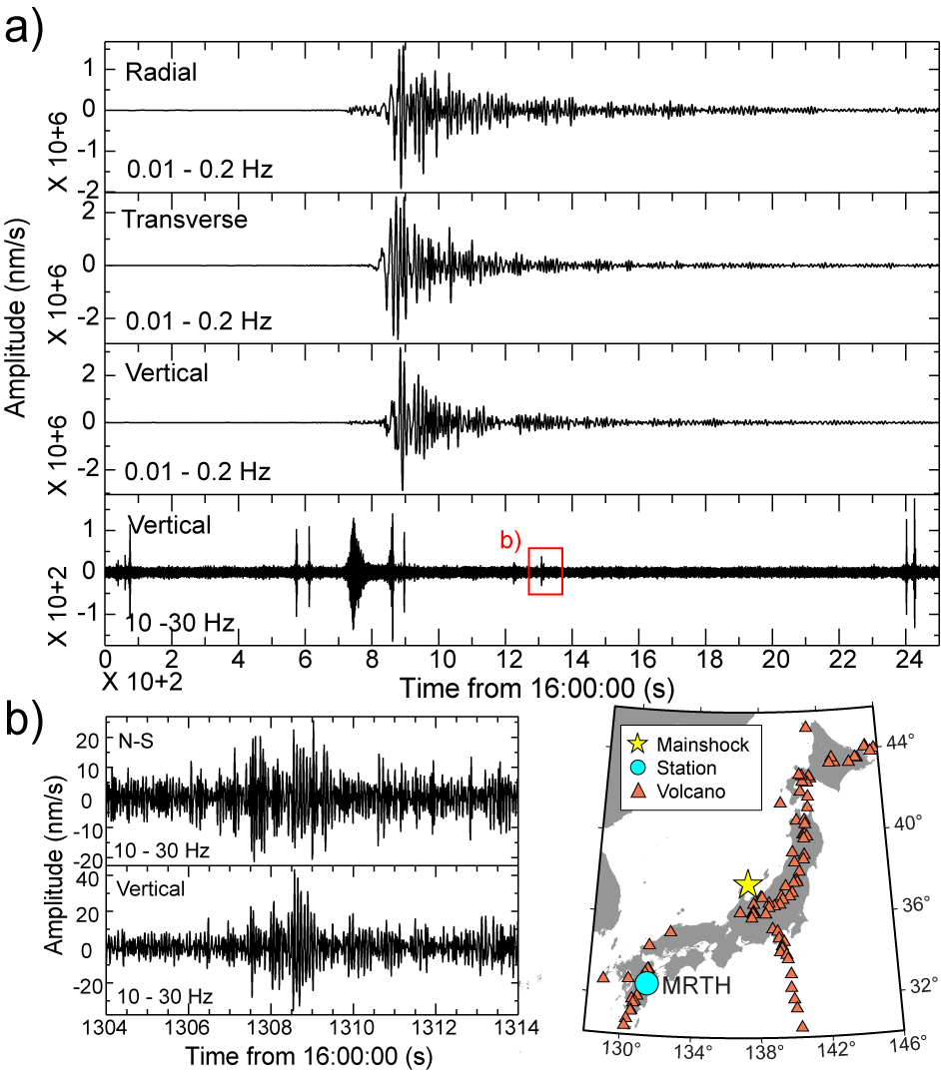
Figure S1. Example of triggered earthquakes with less confidence observations. Due to the background seismicity and low signal-noise-ratio, the P and S arrivals are less clear and the identification of triggering difficult. a) from top to bottom, the top three figures are the radial, transverse and vertical components which are bandpass filtered at 0.01 – 0.2 Hz. The lowest bottom figures are the vertical component filtered with 10 – 30 Hz. The inset map indicates the mainshock and investigated station, MRTH, in Kyushu.

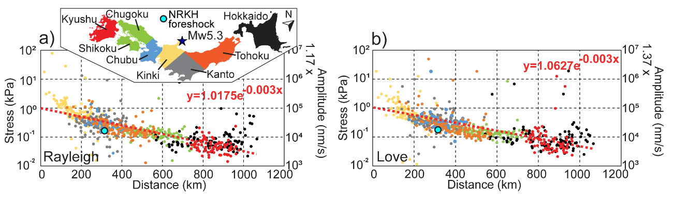Figure S2. Dynamic stress changes as a function of distance from the foreshock epicenter, obtained at 754 Hi-net stations (that have recorded clear surface waves of the foreshock). a) The dynamic stress change associated with the Rayleigh waves (vertical component seismogram) and b) associated with the Love waves (transverse component seismogram). Color of dots indicates which area the stations belong to (e.g., red dots indicate the dynamic stress change calculated from the waveforms recorded at the stations in Kyushu). Dashed red lines show the trend of stress change and the fitted equation is given at the top right corner of each graph. To the left of each graph, the y-axis indicates stress (kPa), while to the right, the y-axis indicates the peak ground velocity (PGV) (nm/s). For example, in a), a stress change of 0.1 kPa corresponds to a Rayleigh wave amplitude of around 1.17 x 10⁴ nm/s. The blue dot indicates the stress/PGV calculated at the station NRKH, where a potential foreshock-triggered earthquake has been observed.

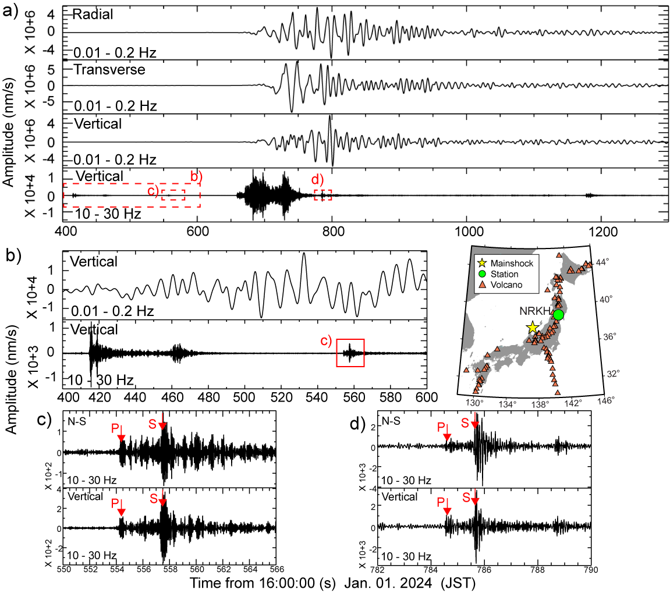Figure S3. Potentially triggered earthquake by the Noto foreshock, observed at the Hi-net station NRKH, in Tohoku region (inset map to the right of the figure). The Mw5.3 foreshock and the Mw7.5 mainshock occurred at 16:06:53 (413 s) and 16:10:58 (658 s), respectively. a) From top to bottom, the top three figures are the radial, transverse and vertical component seismograms bandpass filtered from 0.01 – 0.2 Hz. The lowest bottom figure is the vertical component seismogram filtered from 10 – 30 Hz. The dotted rectangles and associated symbols indicate the zoom-in waveforms shown at (b), (c) and (d). b) A zoom-in of a) from around 16:06:30 to 16:10:30 to show the foreshock (~413 s) and the possible foreshock-triggered earthquake (~554 s). c) The waveform of the foreshock-triggered earthquake filtered from 10 – 30 Hz. d) The waveform of the mainshock-triggered earthquake filtered with 10 – 30 Hz.

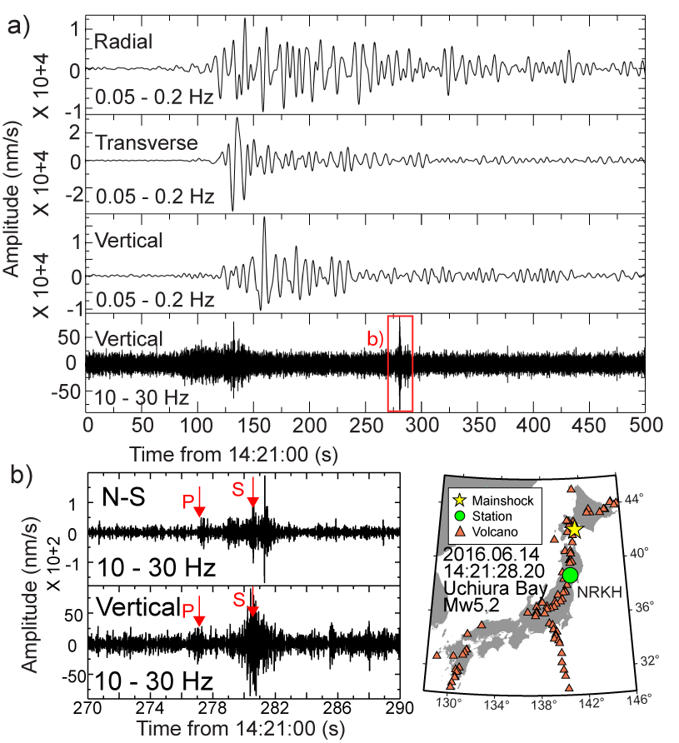
Figure S4. Possible triggered earthquake by the passage of the surface waves associated with the 2016 Mw5.2 earthquake occurred near Uchiura Bay, Hokkaido, observed at station NRKH (same station at which a potentially triggered earthquake has been observed for the Noto foreshock). a) From top to bottom, the top three figures are the radial, transverse and vertical components filtered from 0.05 – 0.2 Hz. The lowest bottom seismogram is the vertical component filtered from 10 – 30 Hz. b) A zoom-in of a) at 265 – 290 seconds to show the possibly triggered earthquake. The inset map shows the time and location of the Mw5.2 earthquake and the location of the station NRKH.
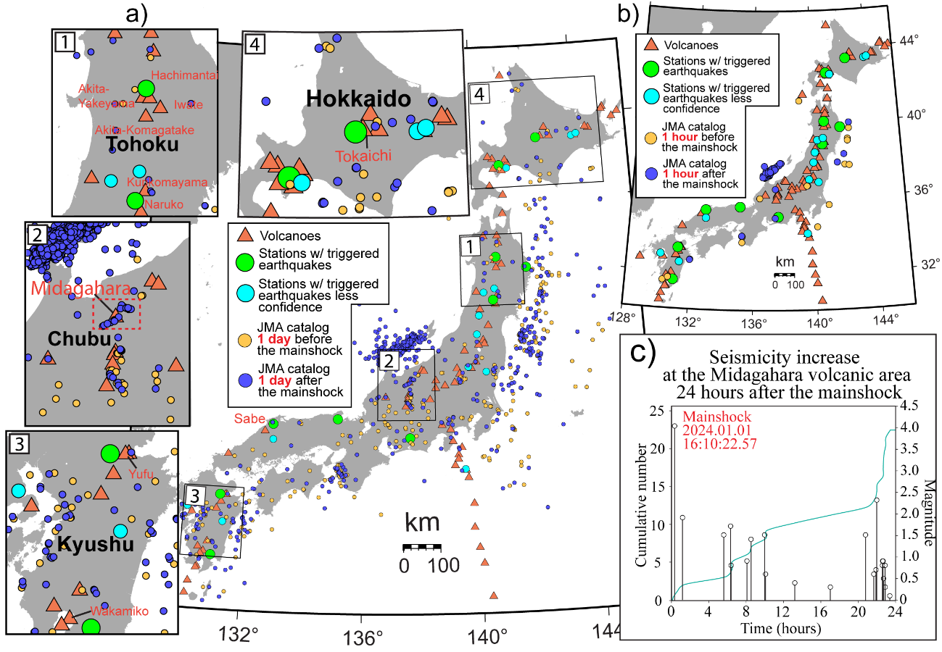Figure S5. a) Epicentral maps of earthquakes (JMA catalog) occurred one day before and after the 2024 Noto earthquake mainshock. Green and light blue circles are the stations with detected triggered earthquakes and red triangles show volcanoes. Yellow and dark blue circles are the earthquakes recorded by the JMA earthquake catalog 1 day before and after the mainshock, respectively.) Regions indicated as rectangles (1) to (4) in the whole-Japan map are zoomed-in the (1) – (4) inset maps for Tohoku, Chubu. Kyushu and Hokkaido regions. The dotted rectangle in (2) shows the Midagahara region that was activated after the Noto earthquake (as discussed in the main text and shown in Figure S5c). b) Epicentral map showing the earthquake occurred one hour before and after the mainshock, according to the JMA catalog (most earthquakes are aftershocks of the 2024 Noto earthquake). c) Graph showing the cumulative number of earthquakes and magnitude versus time (according to the JMA catalog) in the Midagahara volcanic area, 24 hours after the Noto mainshock. Note that no earthquakes occurred in this region before Noto earthquake.

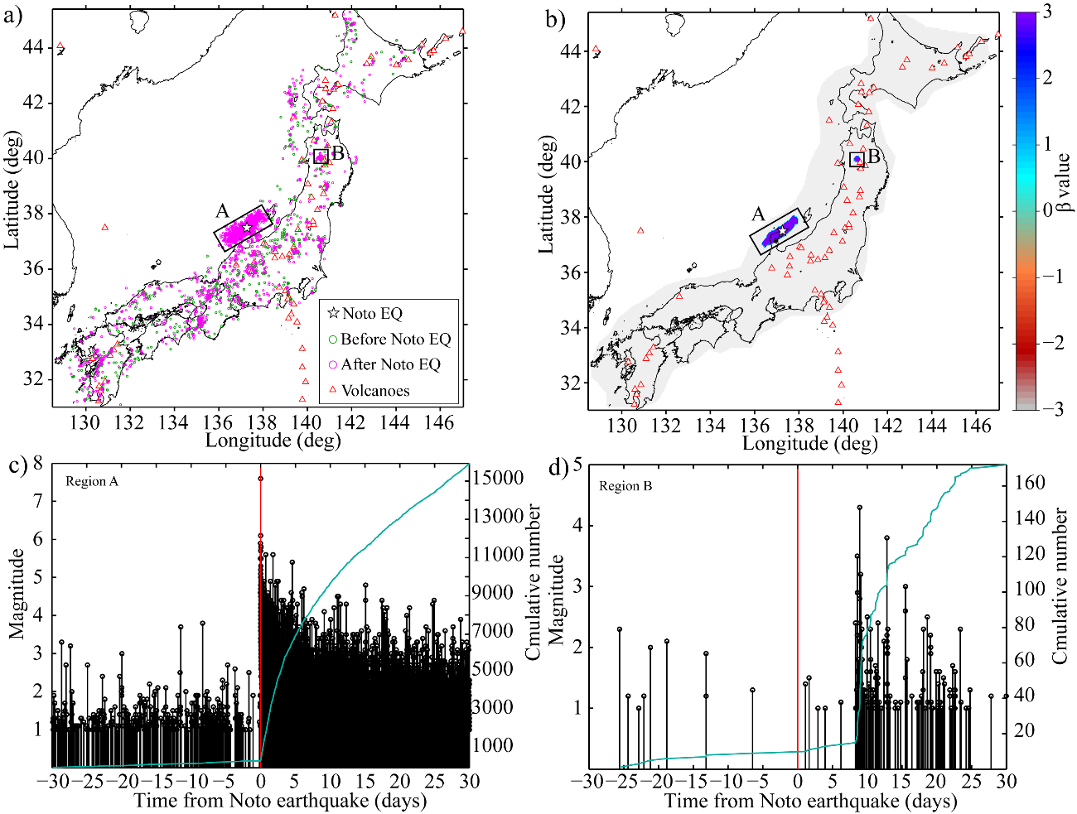
Figure S6. a) Epicentral distribution of inland earthquakes occurred 30 days before and after the 2024 Noto earthquake, which have depth ≤ 20 km and magnitude ≥ 1.0 and shallow offshore earthquakes (depth ≤ 20) on the side of Japan Sea (JMA catalog). b) β-value calculated using the same earthquakes shown in a) and the relation of Reasenberg and Simpson (1992), for a grid spacing of 0.05 degrees. For each grid node, we searched for the 50 closest nearby events and computed the β-value statistics. The maximum radius at each grid point is limited to 10 km. Gray areas represent regions where the β-value cannot be calculated, using the indicated conditions. c) Cumulative number of earthquakes occurred 30 days before and after the 2024 Noto mainshock in region A, Noto peninsula. d) Cumulative number of earthquakes occurred 30 days before and after the 2024 Noto earthquake mainshock in region B, northern Tohoku.

Table S1. Dynamic stress changes and PGVs calculated from Rayleigh and Love wave amplitudes, measured on vertical and transverse component seismograms, respectively, at 10 Hi-net stations. The distance from each station to the Noto mainshock is also indicated.

Station name | Distance to mainshock (km) | Rayleigh wave PGV (nm/s) | Stress change corresponding to Rayleigh waves (kPa) | Love wave PGV (nm/s) | Stress change corresponding to Love waves (kPa)
NFRH | 791 | 2.3 * 10⁶ | 19.4 | 1.7 * 10⁶ | 12.8
OHTH | 761 | 3.4 * 10⁶ | 29.4 | 2.2 * 10⁶ | 16.5
TROH | 474 | 4.1 * 10⁶ | 35.3 | 4.9 * 10⁶ | 36.1
KZNH | 419 | 6.1 * 10⁶ | 52.7 | 6.5 * 10⁶ | 47.9
NRKH | 332 | 5.7 * 10⁶ | 48.8 | 7.2 * 10⁶ | 52.7
HOUH | 279 | 5.1 * 10⁶ | 43.5 | 6.4 * 10⁶ | 47.1
NDGH | 291 | 7.1 * 10⁶ | 60.8 | 5.1 * 10⁶ | 37.6
KACH | 458 | 5.0 * 10⁶ | 42.4 | 5.1 * 10⁶ | 37.2
KKEH | 721 | 2.6 * 10⁶ | 22.6 | 3.6 * 10⁶ | 26.4
OSUH | 874 | 1.9 * 10⁶ | 16.1 | 3.1 * 10⁶ | 22.5

