Supplementary Material

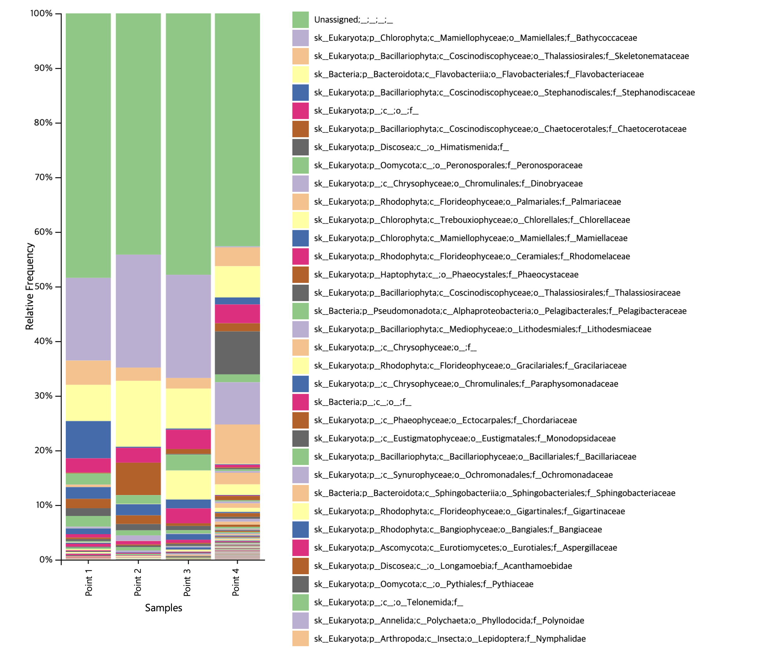
Supplementary Figure 1. Taxonomic composition using a stacked bar plot generated with community level 5.

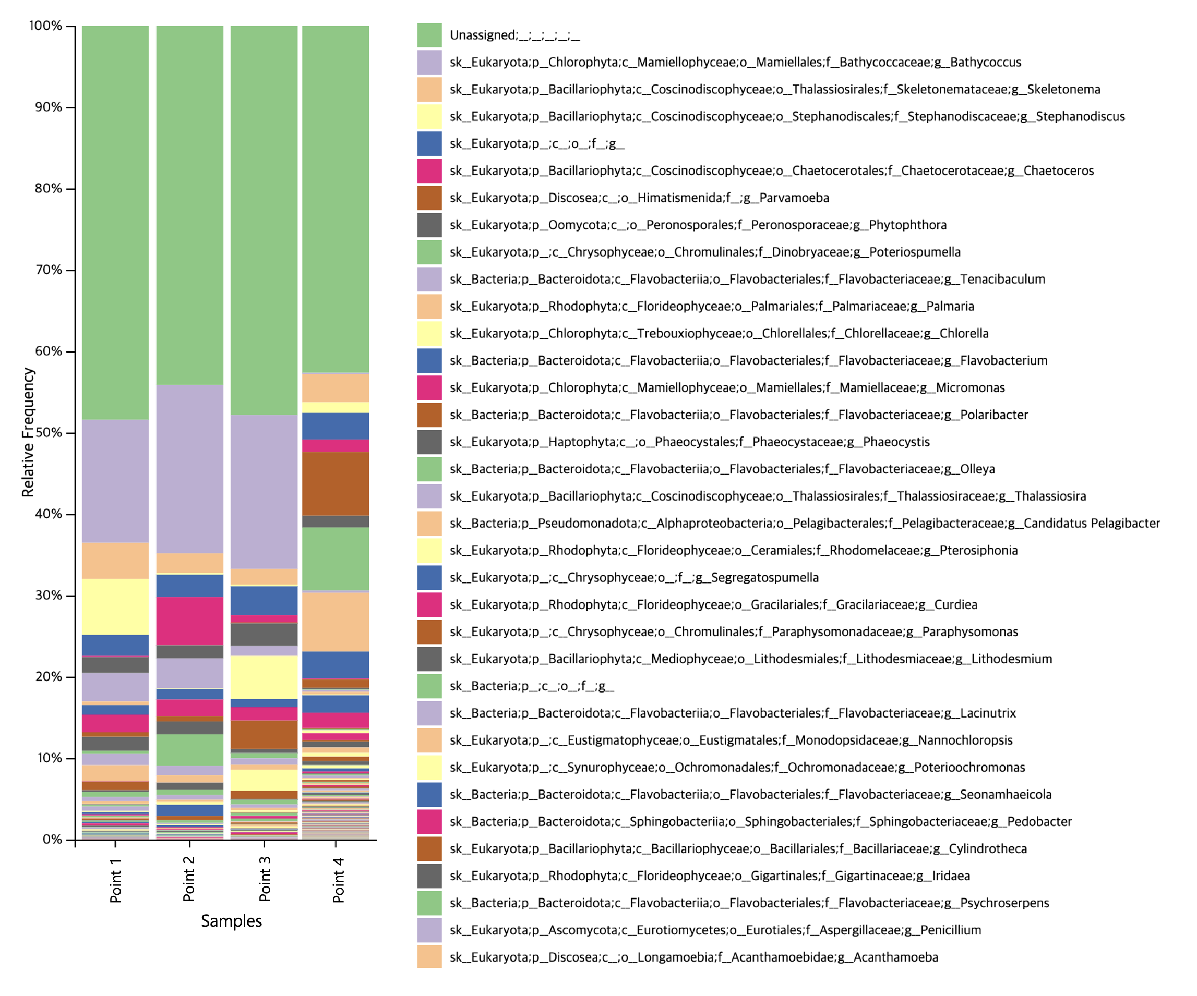Supplementary Figure 2. Taxonomic composition using a stacked bar plot generated with community level 6.

