Extended Data

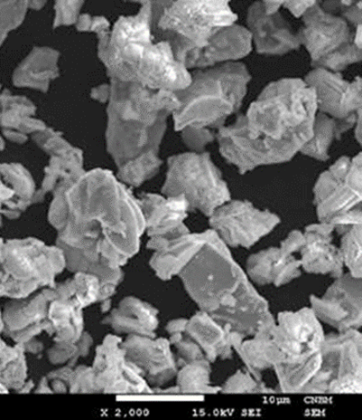

Extended Data Fig. 1. SEM image of YBCO-123 micro-sized powder. The image was obtained with Jeol 7001TTLS scanning electron microscope, at 15 kV accelerating voltage with the use of a secondary electron detector. For better visibility YBCO-123 granules were dispersed on a silicon substrate.

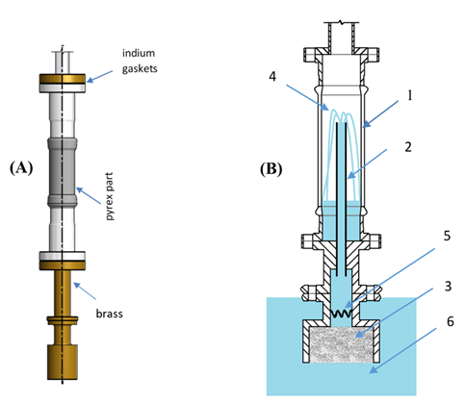
a
b

Extended Data Fig. 2. Construction of the glass cryostat insert for efficiency measurements. a) – external view of the device with an indication of the materials used. b) – schematic representation of the device’s interior. Pyrex part 1 of known volume allows direct observation of superfluid component transfer through the capillary 2 and measures the efficiency of YBCO-123 filter 3 via the fountain effect 4 generated by the heater 5 immersed in superfluid helium 6. The heater is the resistor:
128 ohm at RT and 124 ohms at 4.2 K, placed in a downstream direction.

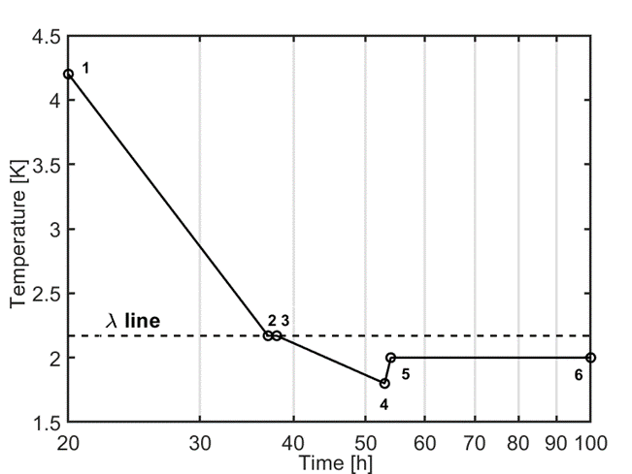

Extended Data Fig. 3. Cooling process below 4.2 K. Regions 1-4 show the almost monotonous temperature decreases down to about 1.7 K with a short flattening at 2-3 which is called the lambda front – described in detail in¹⁹. Region 4-5 shows the start of the fountain effect. The extremely high thermal conductivity of superfluid helium²¹ allows us to assume that heat transfer from the heater to the YBCO-123 entropy filter is lossless. Finally, region 5-6 shows temperature stabilization as thermomechanical pumping (the fountain effect) continues. The initial power of the heater was stabilized at 70 mW.

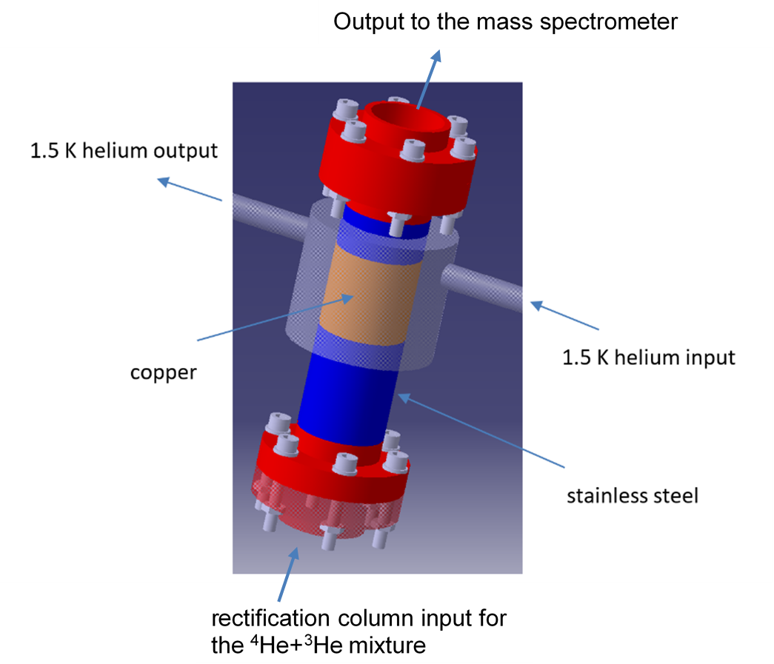

Extended Data Fig. 4. Schematic presentation of the rectification column. The temperature of the copper part is stabilized by the flowing liquid helium with the temperature at the level of 1.5 K.

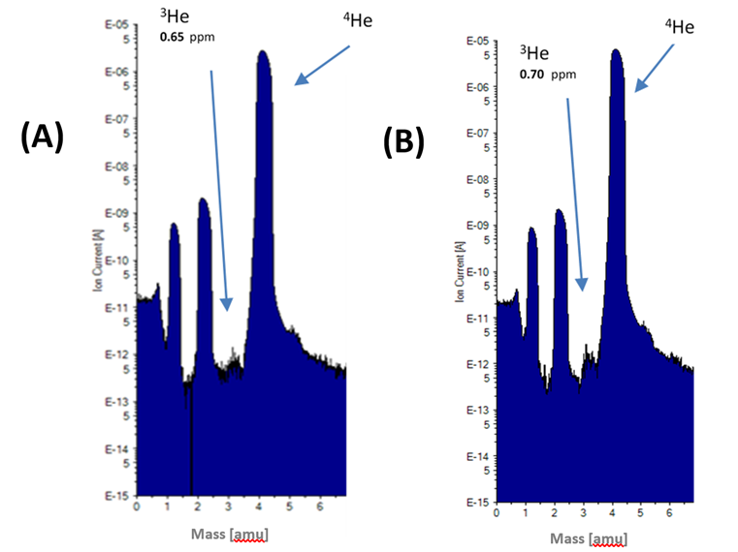
a
b

Extended Data Fig. 5. Mass spectra below (a) and above (b) λ-transition. Spectra were registered for the rectification column from figure Extended Data Fig. 4. a) mass spectrum for 1.93 K at the bottom of column and b) mass spectrum for 3.3 K at the bottom of the column. The separation efficiency depends little on whether the rectification is below or above λ-transition. The presence of hydrogen peaks at masses 1 and 2 are explained in our previous paper¹⁹.

