Direct long-read RNA sequencing uncovers functional variation affecting transcript production and RNA modifications.

Supplementary figures:
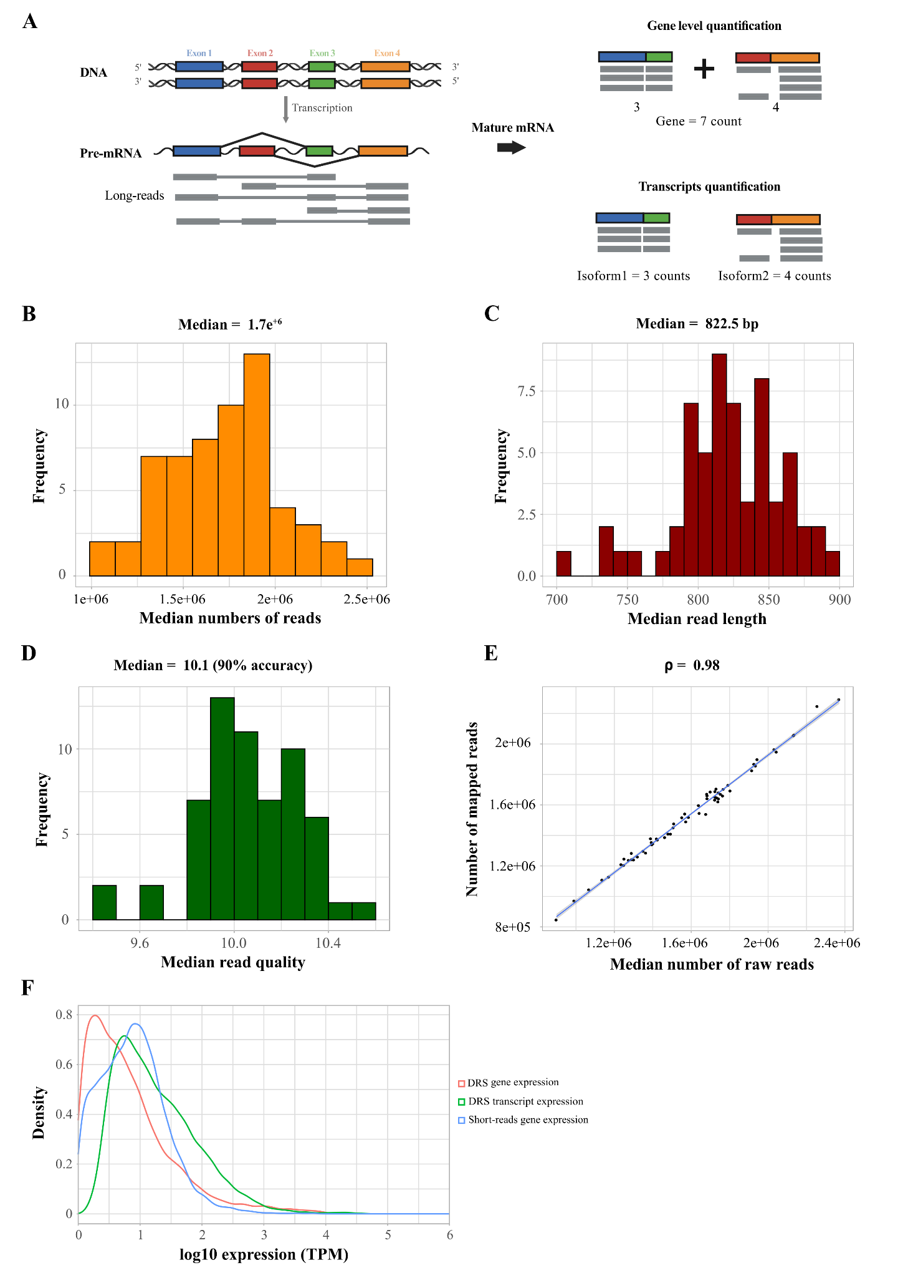
S1: Quality control and summary statistics of the DRS data.
(A) Schematic representation of the RNA splicing steps (left) and the two layers of phenotypes produced by sequencing methods such as gene-level quantification and transcript quantification (right). Every box represents a different exon, where grey boxes represent sequencing reads. (B) Histograms with the median number of reads (orange), (C) median read length (red), and (D) median read quality (green) across the DRS data from all 60 LCL samples. (E) Scatter-plot comparing the number of raw and aligned reads in the 60 LCL samples. A median of 96.3% of raw reads was mapped correctly to the Reference Genome (GRCh37) with a Spearman correlation of ⍴ = 0.98. (F) Density plot comparing the log₁₀ gene and transcript expression detected with DRS and short-reads technology.

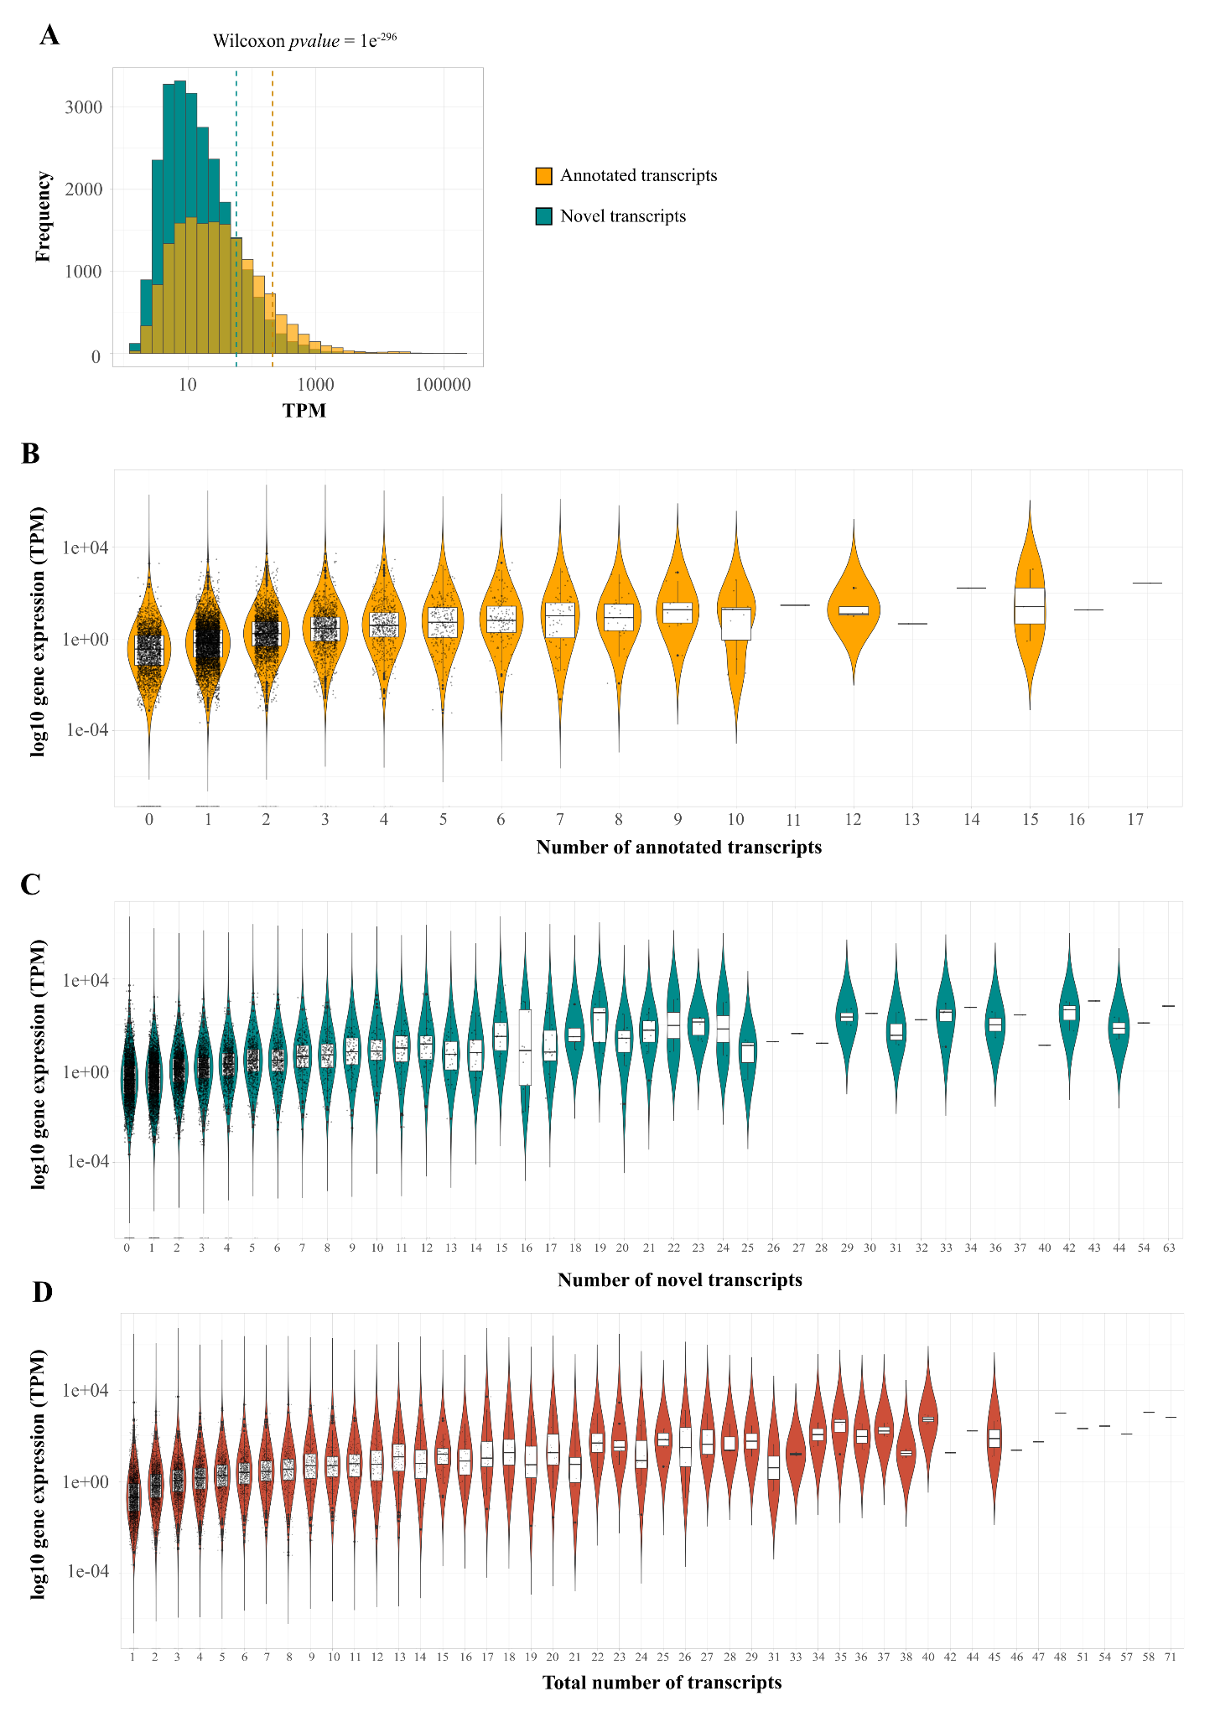
S2: Distribution of annotated and novel transcripts across the LCL population.
(A) Histogram comparing the expression of annotated (orange) and novel (green) transcripts in the 60 LCLs samples sequence with DRS (Wilcoxon pvalue=1e⁻²⁹⁶). (B-D) Violin plots showing the log₁₀ transcripts per million (TPM) gene expression values versus the number of (B) annotated transcripts (orange), (C) novel transcripts (dark green), and (D) total transcripts (red) per each gene; every black dot is a gene.

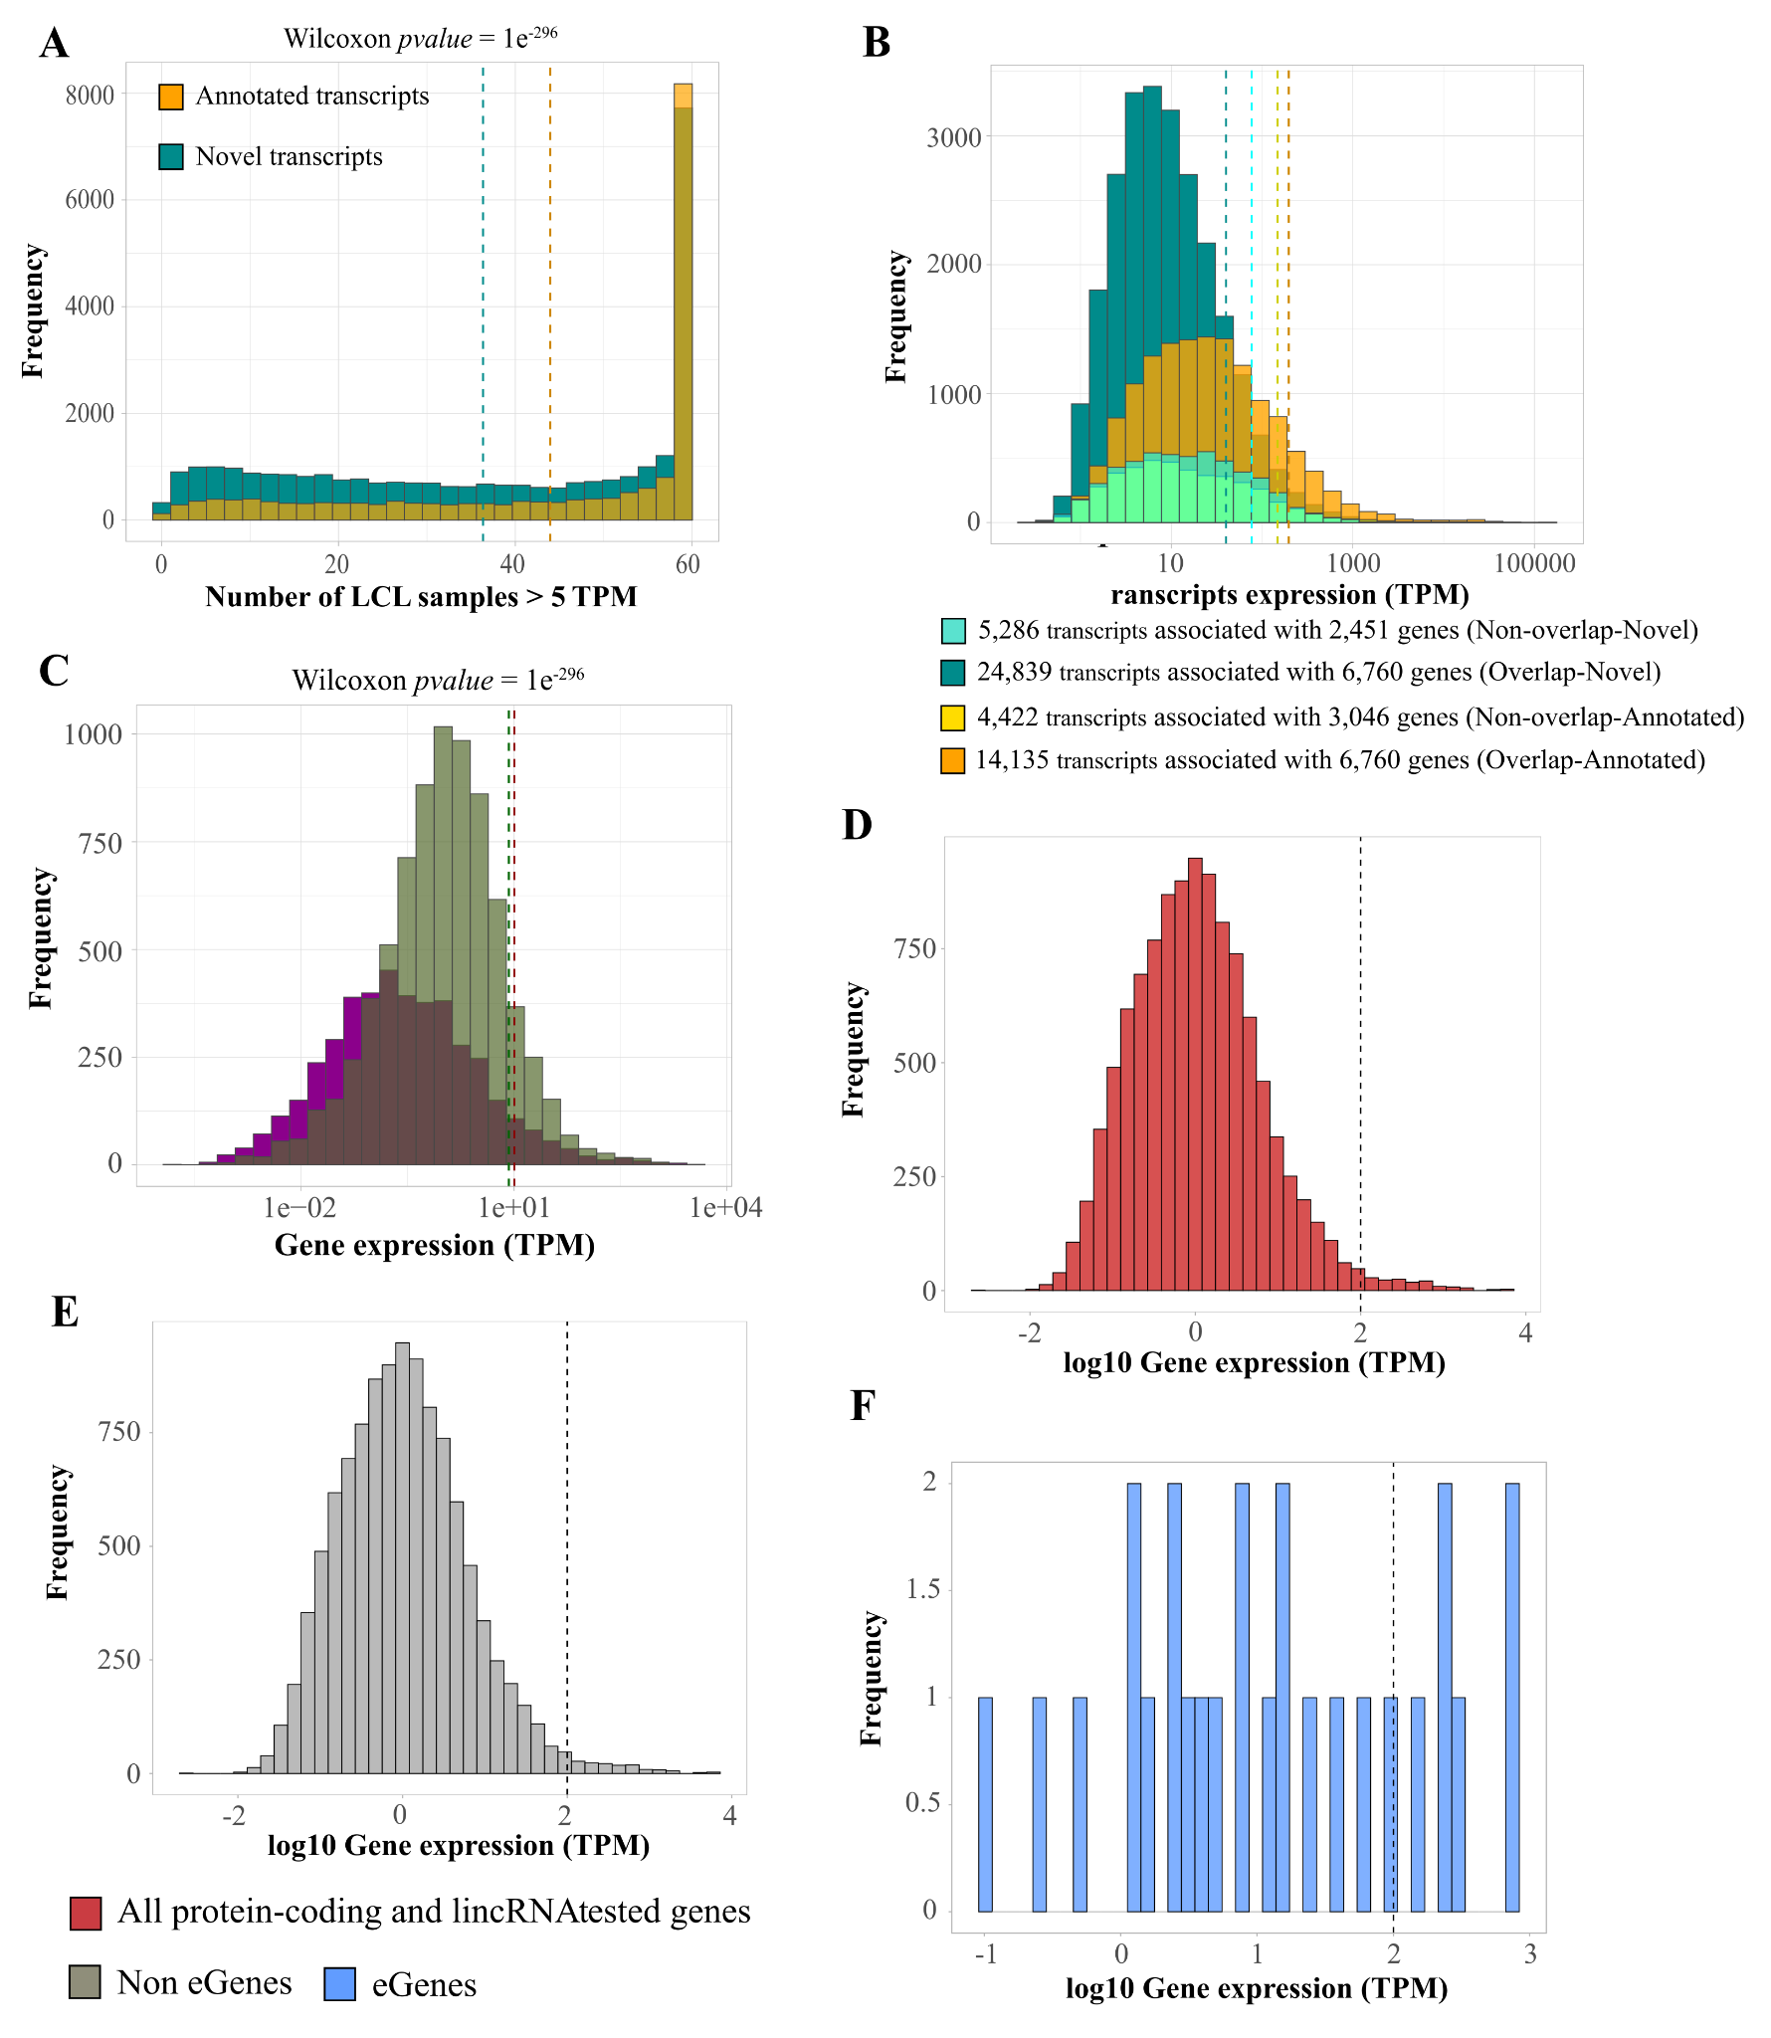

S3: Characteristics of transcripts on protein-coding and lincRNA genes tested for eQTL analysis.
(A) Histogram showing the difference in distribution of annotated (orange) and novel (green) isoforms expressing at least five transcripts per million (TPM) in at least one sample in the LCLs population (Wilcoxon pvalue= 1e⁻²⁹⁶). (B) Histogram for transcripts expression (TPMs) grouped by gene categories: in yellow, 4,422 transcripts expressed by genes with no novel transcripts detected; in azure, 5,285 transcripts expressed by genes that have only novel transcripts detected; in orange, 14,135 transcripts expressed by genes with both annotated and novel transcripts; and in dark blue, 24,839 transcripts expressed by the same gene as the orange category (C) Histogram showing the different expression of genes (in TPM) with a dominant transcript (dark green) compared to genes without a dominant transcript (purple) (Wilcoxon pvalue = 1e⁻²⁹⁶). (D-F) Histograms showing the distribution of the log₁₀ gene expression in TPMs detected with DRS for all the protein-coding and lincRNAs tested in (D) genes tested for eQTL (red), (E) for genes not significant for eQTLs (non eGene, grey), and (F) for eGenes significantly associated with a SNP at FDR 5% (light Blue).

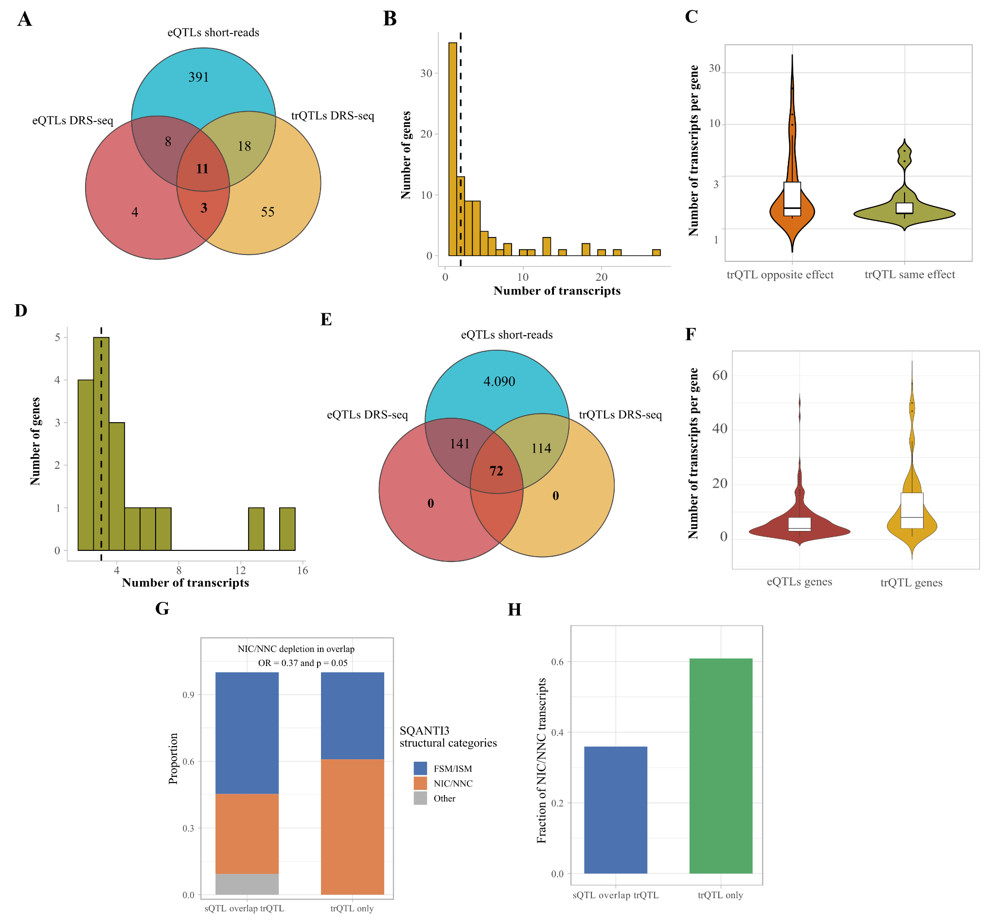
S4: SNP-gene overlap between datasets obtained with different technologies and QTLs characteristics.
(A) Venn diagram reporting the number of genes with significant eQTLs (eGene) that overlap between the datasets generated with DRS (red), short-reads (light blue), and genes including transcripts with significant trQTLs in the DRS dataset (yellow). (B) Histogram with the number of transcripts per gene on genes with a significant trQTLs. (C) Violin-plot comparing the number of transcripts per gene between the 52 genes with two or more trQTLs with opposite direction of effect (orange) and trQTLs with the same direction of effect (dark yellow). (D) Histogram for the distribution of the number of transcripts per gene for trQTL affecting two or more transcripts with the same direction of effect. (E) Venn diagram showing the overlap between genes with eQTLs detected in the short-read dataset with a bigger sample size (n = 317, light blue), eQTLs detected with DRS replicated in the short-read dataset with the bigger sample size (n = 317, red), and the trQTL replicated in the short-read dataset (n = 317, yellow). (F) Violin-plot showing the number of transcripts per gene for the genes with an eQTL (red) and genes with a trQTL (yellow) detected with DRS and significantly replicated with the short-read dataset with a sample size n = 317. (G) Stacked bar plot showing the proportion of SQANTI3 structural categories, FSM/ISM (annotated splice forms, blue), NIC/NNC (novel internal splice junctions, orange), and Other (gray) ,for transcripts involved in both sQTL and trQTL associations (sQTL overlap trQTL) compared to transcripts with trQTL associations only (trQTL only). NIC/NNC transcripts are depleted in the overlap group (Fisher's exact test, OR = 0.37, p = 0.05). (H) Bar plot showing the fraction of NIC/NNC transcripts in the sQTL-trQTL overlap group (blue) compared to trQTL-only transcripts (green), highlighting the lower proportion of novel splice junction transcripts among those with convergent sQTL and trQTL signals.

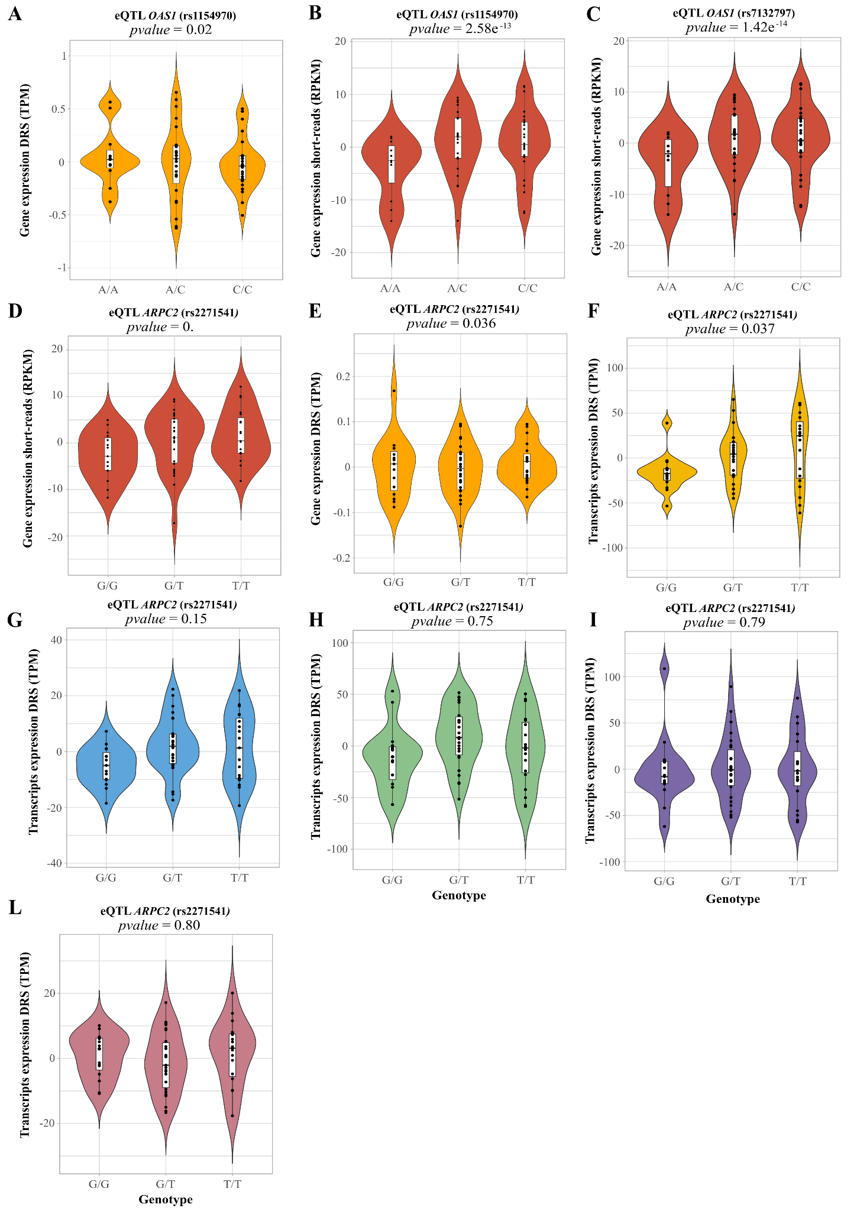
S5: Comparison of eQTL detected using DRS and short-reads data for the OAS1 and ARPC2 genes. Violin plots showing gene or transcript expression stratified by genotype, with individual samples shown as black dots and embedded boxplots indicating median and interquartile range. Expression values correspond to covariate-adjusted normalized residuals derived from TPM for DRS data and RPKM for short-read measurements; therefore values are centered around zero. (A-C) eQTL effects at the OAS1 locus. (A) Gene-level expression measured using DRS (rs1154970; p = 0.02). (B) Gene-level expression measured using short-read for the same variant (rs1154970; p = 2.58 × 10⁻¹³). (C) Gene-level expression measured using short-read for rs7132797 (p = 1.42 × 10⁻¹⁴). (D-L) eQTL and transcript-level QTL effects at the ARPC2 locus (rs2271541). (D) Gene-level expression from short-read (p ≈ 0). (E-L) Transcript-level expression quantified using DRS for individual isoforms, showing variable levels of association across isoforms (p values indicated in each panel).
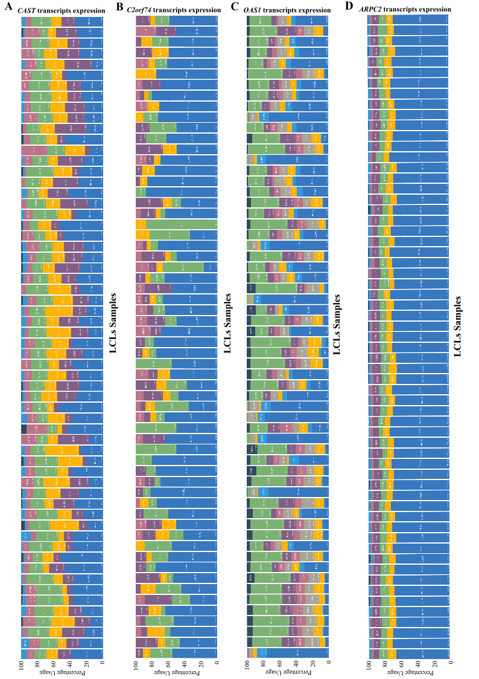
S6: Transcripts usages across the 60 LCL samples for genes with significant trQTLs
(A-D) Each stacked bar plots show the proportion of each isoform (color-coded) within each individual sample. The x-axis reflects the relative isoform usage (from 0 to 1 per sample). This panel highlights inter-individual variability in transcript composition at this locus. The genes included are CAST (A), C2orf74 (B), OAS1 (C), and ARPC2 gene (D)

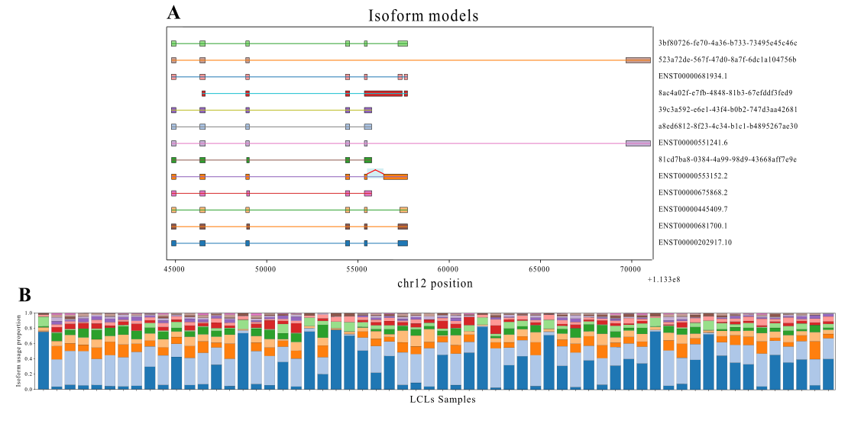

S7: Isoform architecture of OAS1 gene and relative transcript usage across LCL samples.
(A) Schematic representation of transcript isoforms detected for the OAS1 gene. Colored boxes represent exons and connecting lines represent introns. Each row corresponds to an individual isoform model identified from DRS data. The y-axis (right) indicates genomic position (chr12), and isoforms are vertically separated for visualization. Distinct colors denote different transcript structures, highlighting alternative exon usage and transcript diversity within the locus. (B) Relative isoform usage across the 60 LCL samples. Stacked bar plots represent the proportion of each isoform (color-matched to panel A) within individual samples. Each horizontal bar corresponds to one sample, and the x-axis indicates isoform usage proportion (sum = 1 per sample). This panel illustrates inter-individual variability in transcript composition at the locus.

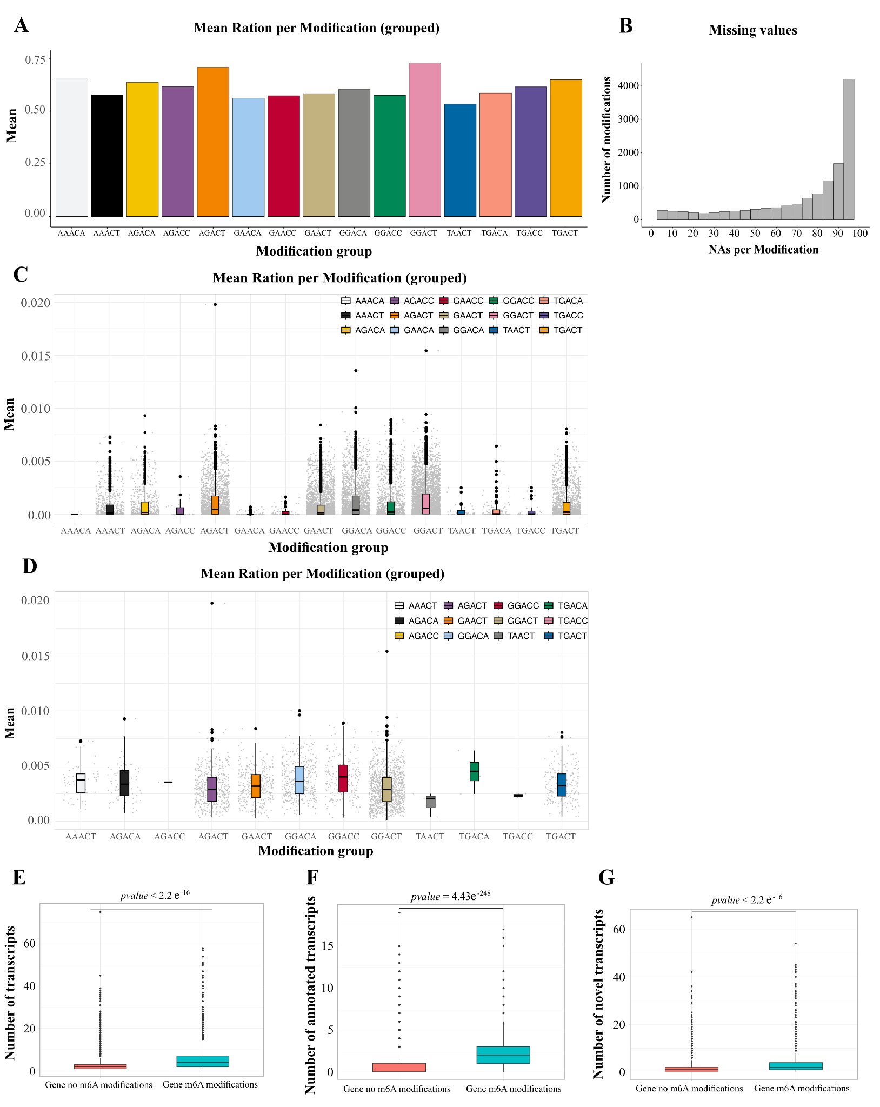
S8: m6A RNA modifications group and m6A-QTL gene description.
(A) Of the 18 motifs that would be evaluated to identify m6A modifications, some were more commonly found than others. The bar-plot shows the number of modifications identified per motif by m6Anet, using the 17,491 unfiltered modifications reported. (B) Histogram showing the number of missing values (NAs) per modification across the 60 samples and from the 17,491 modifications annotated to known genes in Gencode v46 and reported by m6Anet. We filtered any modifications missing in more than 30 samples (50%). (C-D) Boxplots show the variance in the ratio of modified versus unmodified reads for each m⁶A modification across samples. Values are grouped by the 18 sequence motifs associated with m⁶A. (C) includes all 17,491 modification events identified after quality filtering (detected in at least one transcript and one individual), while (D) shows the top 30% most variable modifications (n = 2,761) selected for m⁶A-QTL mapping. Most modifications exhibit low variability, with variance typically ranging from 0 to 0.02. (E-G) Box-plots showing the overall number of transcripts produced by genes for which no m6AQTL were found in their transcripts (pink) and genes that produce transcripts affected by m6AQTL (light blue). Wilcoxon pvalues are 8.49e⁻¹⁵⁸ for all the transcripts together (E), 6.19e⁻¹⁰⁶ for only the annotated transcripts (F) and 4.21e⁻⁸⁴ for only the novel transcripts (G).

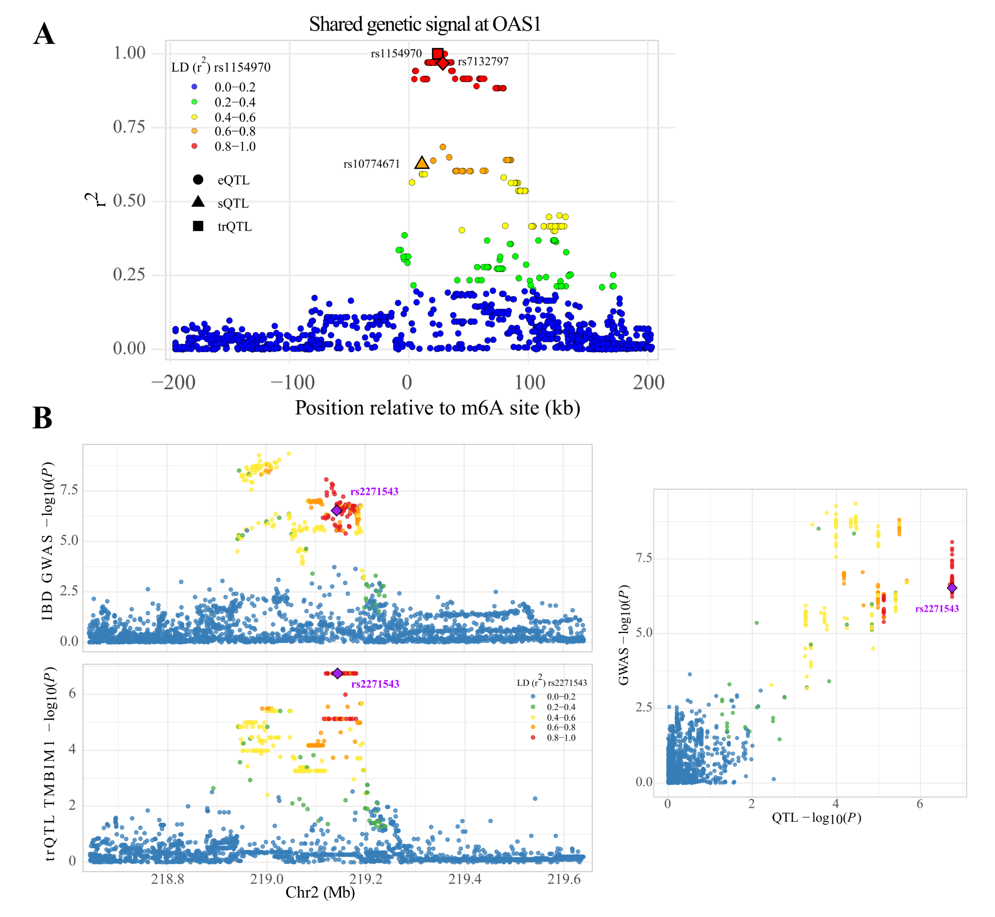
S9: Colocalization between trQTL and GWAS signals
(A) Variants within ±200 kb of the m⁶A site at the OAS1 locus, colored by LD (r²) with rs1154970. Symbols denote lead trQTL (square), eQTL (circle), and sQTL (triangle) variants. Strong LD and attenuation of associations upon conditioning indicate a shared genetic signal across molecular phenotypes. (B) (right) LocusZoom-style plots showing a ~1 Mb region centered on the lead trQTL SNP (rs2271543) for the gene TMBIM1, which colocalizes with a GWAS signal for inflammatory bowel disease (IBD) [de Lange KM et al., Nat. Genetics, 2017]. The top panel shows GWAS association statistics and the bottom panel shows trQTL association statistics. The x-axis represents genomic position on chromosome 2 (Mb), and the y-axis shows –log10(P) values. Each point corresponds to a SNP, colored according to linkage disequilibrium (r²) with the lead SNP (rs2271543), which is highlighted in purple. (left) Scatter plot comparing GWAS and trQTL association signals across shared variants at the locus. Each point represents a SNP, with the x-axis showing trQTL –log10(P) values and the y-axis showing GWAS –log10(P) values. Points are colored according to linkage disequilibrium (r²) with the lead SNP, illustrating concordance between regulatory and disease association signals.

