SUPPLEMENTAL MATERIALS

Impact of Primary Health Care data quality on their use for infectious disease surveillance
Pilar T. V. Florentino¹, Juracy Bertoldo-Junior¹, George C. G. Barbosa¹, Thiago Cerqueira-Silva^{1,2}, Vinicius de A. Oliveira^{1,3}, Kate T. de Souza³, Márcio H. O. Garcia⁴, Gerson O Penna⁵, Viviane Boaventura⁶, Pablo Ivan P. Ramos¹, Manoel Barral-Netto^{1,6}*, Izabel Marcilio^{1,7}*;

¹ Centro de Integração de Dados e Conhecimentos para Saúde (CIDACS), Instituto Gonçalo Moniz, Fundação Oswaldo Cruz (Fiocruz), Salvador, Brazil;
² Department of Medical Statistics, Faculty of Epidemiology and Population Health, London School of Hygiene & Tropical Medicine, London, United Kingdom;
³ Secretaria de Atenção Primária à Saúde, Ministério da Saúde, Brasília, Brazil;
⁴ Secretaria de Vigilância em Saúde, Ministério da Saúde, Brasília, Brazil;
⁵ Escola Fiocruz de Governo, Fundação Oswaldo Cruz (Fiocruz), Brasília, Brazil;
⁶ Laboratório de Medicina e Saúde Pública de Precisão (MeSP2),Instituto Gonçalo Moniz, Fundação Oswaldo Cruz (Fiocruz), Salvador, Brazil;
⁷ Escola Bahiana de Medicina e Saúde Pública, Salvador, Bahia,Brazil;

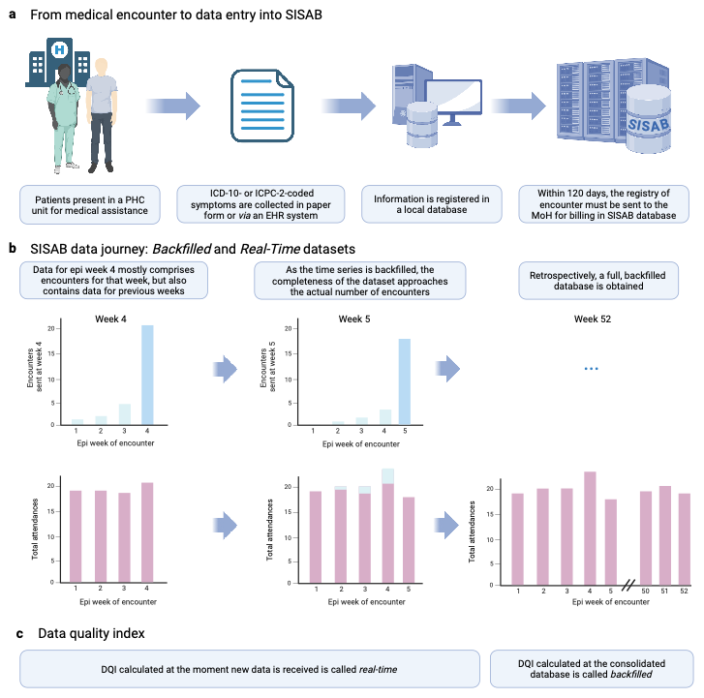

Figure S1. Schematic diagram of the methodology used in the study.

Table S1. Distribution of detected outbreak warnings according to concordance between backfilled and real-time Primary Health Care datasets, and to levels of completeness and timeliness of the real-time dataset, in the study period.

 | Concordant  n (%) | Non-concordant  n (%)
Overall | 12,538 (65.0) | 6,737 (35.0)
Completeness (%)
0.0 | 0 (0.0) | 70 (100.0)
12.5 | 0 (0.0) | 31 (100.0)
25.0 | 1 (1.2) | 81 (98.8)
37.5 | 3 (2.4) | 120 (97.6)
50.0 | 4 (0.6) | 672 (99.4)
62.5 | 9 (1.3) | 696 (98.7)
75.0 | 85 (16.2) | 441 (83.8)
87.5 | 337 (26.2) | 947 (73.8)
100.0 | 12,099 (76.7) | 3,679 (23.3)
Timeliness* | 99 (96-100)* | 83 (39-98)*
*Median (IQR)

Table S2. Distribution of detected outbreak warnings according to concordance between backfilled and real-time Primary Health Care datasets, and to the Data Quality Index in the study period (comprising a total of 23 epidemiological weeks)

 | Concordant  n (%) | Non-Concordant  n (%)
Overall | 12,538 (65.0) | 6,737 (35.0)
Suitable DQI | 11,656 (80.4) | 2,845 (19.6)
Unsuitable DQI | 882 (18.5) | 3,892 (81.5)
Weeks with suitable DQI (%)
≤20 | 276 (8.1) | 3,114 (91.9)
20-40 | 259 (34.8) | 486 (65.2)
40-60 | 462 (48.9) | 482 (51.1)
60-80 | 2,276 (78.4) | 628 (21.6)
80-100 | 9,265 (82.0) | 2,027 (18.0)

