Supplementary Information

Figure A1 contains four subplots. Each subplot corresponds to a marginalized version of the 4D posterior in Figure 3. The 4D posterior was marginalized over each of the model inputs. For each of the marginalized distributions, the MAP model was extracted for each along with the underlying model parameters for each MAP model. Figure A1a corresponds to the 4D posterior marginalized over $K_{S}$ with axes of $K_{F}$, $μ$, and $α$. The color in the joint probability of the model inputs present on the axes. The eight clusters present in Figure 3 collapse to five clusters in Figure A1a. After marginalizing over $K_{F}$, (Figure A1b), the eight clusters collapse to four with various numbers of points. In Figure A1c, where the marginalization is over $μ$, only two clusters remain. Lastly, when marginalized over $α$, all the points collapse to one large cluster.

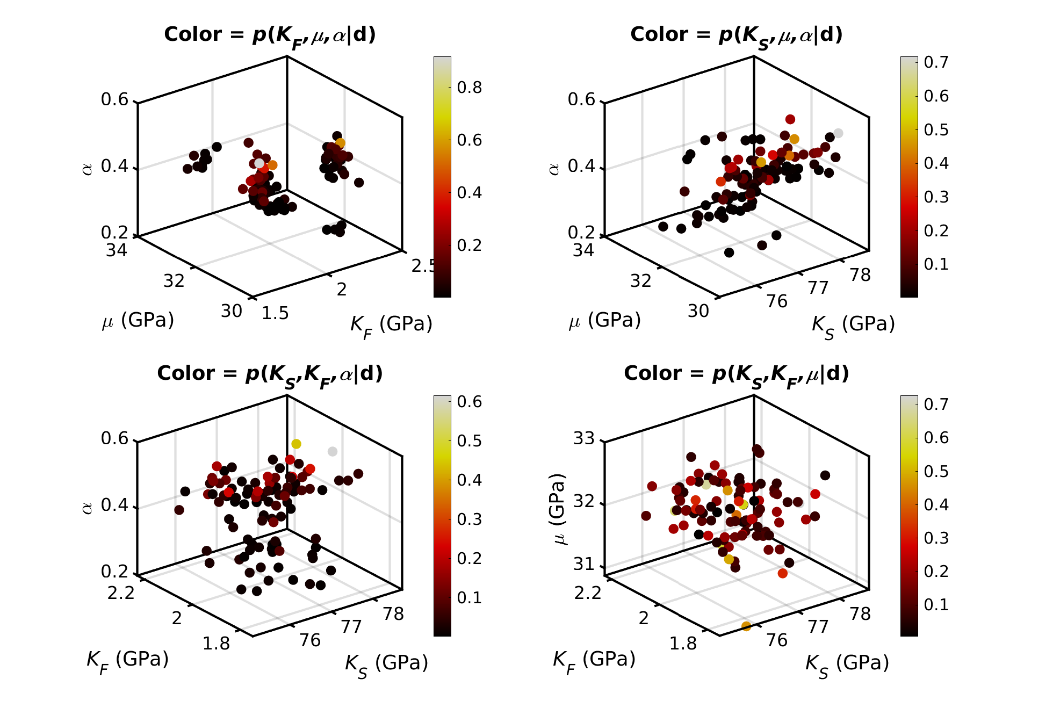

Figure S1. Each subplot corresponds to the 4D posterior values that have been marginalized over one of the model parameters. From each of the 3D distributions, the MAP values were determined from each ensemble. Color in each case is the joint probability of the model inputs present. MAP values come from the 3D distributions marginalized over a) $K_{S}$, b) $K_{F}$, c) $μ$, and d) $α$. These plots show that marginalizing over a given model input tends to collapse the clear clusters shown in Figure 3.

Each 4D posterior for the DEM ensembles was marginalized along each of the dimensions, resulting in four 3D scatter plots (Figure S2). After marginalization, the MAP was extracted for each 3D distribution and the underlying model parameters extracted. Figure S2a is the plot of $μ$, $α$, and $ϕ_{c}$ (marginalized over $K_{F}$) where the color is the joint probability of those three model inputs occurring together. Relative to Figure 8, the eight clusters collapse to four. Higher probabilities (blue points) tend to be correlated with larger values of $ϕ_{c}$, but much scatter is present. Marginalizing over $μ$ (Figure S2b) or $α$ (Figure S2c) reduces the original eight clusters to two. Lastly, only one cluster is present (Figure S2d) after the marginalization over $ϕ_{c}$.

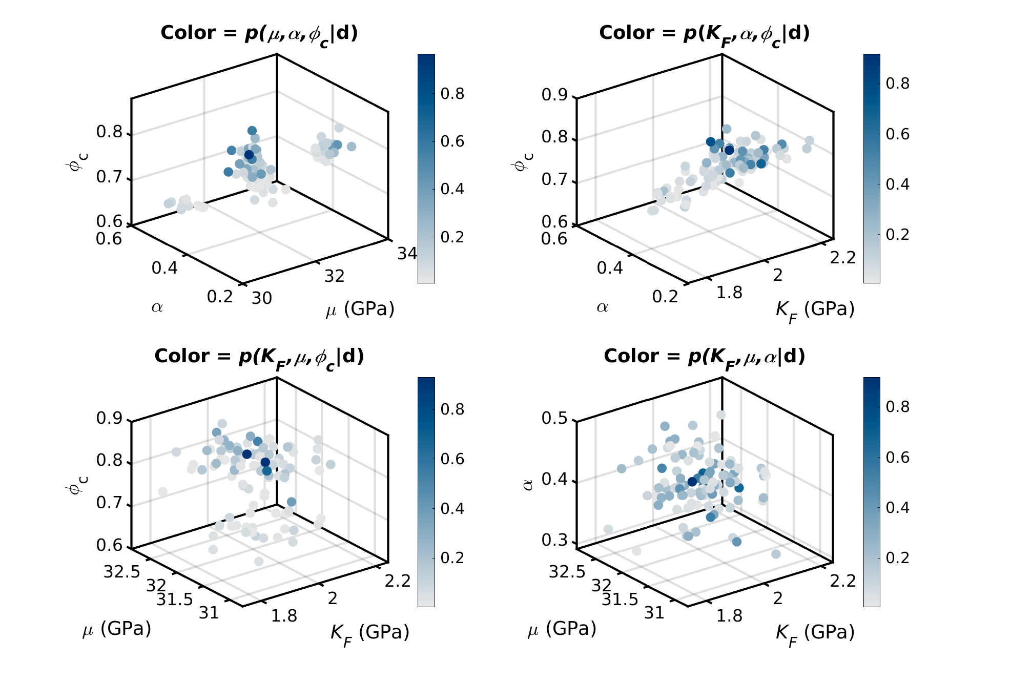

Figure S2. Values of the MAP model parameters for the 3D marginalized posteriors. a) is the plot $μ$, $α$, and $ϕ_{c}$, colored by their joint probability P($μ$, $α$, $ϕ_{c}$). b) displays the values of $K_{F}$, $α$, and $ϕ_{c}$ colored by their joint probability. Last in c) and d) are the plots of $K_{F}$–$μ$–$ϕ_{c}$ and $K_{F}$–$μ$–$α$, respectively, each colored by their respective joint probabilities. Only in a) is some indication present of the clusters shown observed in Figure 8.

