SUPPLEMENT

Table S1. MGB Full Cohort PAD Patient Demographics
Predominantly antibody deficiency, n | 525
Average age (years, [std]) | 55.46 [19.44]
Sex
Male (% [n]) | 33.53 (169)
Female (% [n]) | 66.67 (335)
Race (% [n])
Non-Hispanic White | 93 (458)
Black/African American | 1 (5)
Asian | 1 (4)
American Indian/Alaska | 0.2 (1)
Native Hawaiian Other Pacific Islander | 0 (0)
Declined/Two or more/Other/Unknown | 6 (28)
Predominantly antibody deficiency type (% [n])
Complicated CVID | 26 (137)
Common variable immunodeficiency (CVID) | 39 (203)
Primary Hypogammaglobulinemia | 18 (95)
Secondary Hypogammaglobulinemia | 3 (18)
Specific antibody deficiency | 8 (43)
IgG subclass deficiency | 6 (29)

Figure S1: Percentage of poor self-rated health status, mental health, and physical health among primary PAD patients by immunoglobin replacement therapy status.

Figure S1. The figure represents the distribution of self-rated health status: A) Fair or poor self-rated health status, B) Mental health not good for ≥14 days, and C) Physical health not good for ≥14 days, comparing patients who received IgRT (blue bar; n=48) and those who did not (orange bar; n=18). Each bar indicates the proportion of individuals who reported their health status. Error bars represent the 95% confidence interval of the proportion of respondents.

Figure S2: Percentage of poor self-rated health status, mental health, and physical health among primary PAD patients by immunomodulator therapy status.

Figure S2. The figure represents the distribution of self-rated health status: A) Fair or poor self-rated health status, B) Mental health not good for ≥14 days, and C) Physical health not good for ≥14 days, comparing patients who received immunomodulator therapy (blue bar; n=55) and those who did not (orange bar; n=21). Each bar indicates the proportion of individuals who reported their health status. Error bars represent the 95% confidence interval of the proportion of respondents.

Figure S3: Percentage of poor self-rated health status, mental health, and physical health among primary PAD patients by genetic etiology status.

Figure S3. The figure represents the distribution of self-rated health status: A) Fair or poor self-rated health status, B) Mental health not good for ≥14 days, and C) Physical health not good for ≥14 days, comparing patients with identified genetic etiology (blue bar; n=10) and those with not identified genetic etiology (orange bar; n=66). Each bar indicates the proportion of individuals who reported their health status. Error bars represent the 95% confidence interval of the proportion of respondents.

Figure S1.
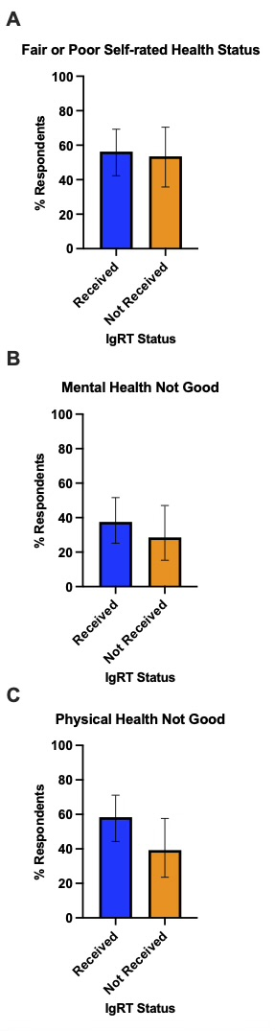
Figure S2.
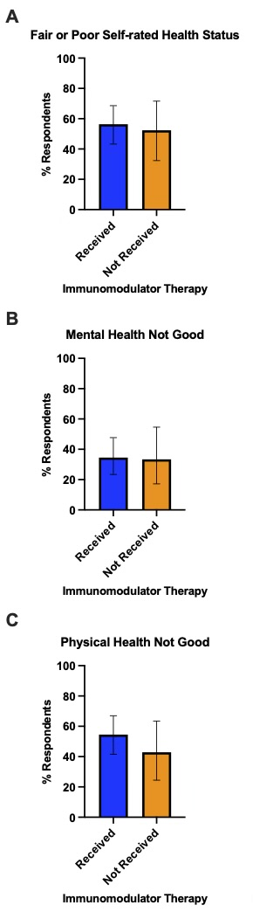

Figure S3.
