SUPPORTING INFORMATION
OPTIMIZED MECHANCAL AND IMPACT PERFORMANCE OF HIGH STRENGTH TEMPO OXIDIZED CELLULOSE NANOFIBRIL (TOCNF) - EPOXY LAMINATES
ENDRINA S. FORTI1, DANIELA B. JIMENEZ1, GREGORY T. SCHUENEMAN2, ROBERT J. MOON2, JEFFREY P. YOUNGBLOOD*,1

*(Corresponding Author: Phone: +1 765 496 2294, Fax: +1 765 494 1204, Email address: jpyoungb@purdue.edu, ORCID: 0000-0002-8720-8642)

¹ School of Materials Engineering, Purdue University, West Lafayette, Indiana 47907, United States of America.

² Forest Product Laboratory, Madison, Wisconsin 53726, United States of America.

Endrina S. Forti ORCID iD: 0000-0002-3825-6883
Daniela B. Jimenez ORCID iD: 0000-0003-0816-0191
Gregory T. Schueneman ORCID iD: 0000-0002-6390-5240
Robert J. Moon ORCID iD: 0000-0001-9526-0953
Jeffrey P. Youngblood ORCID iD: 0000-0002-8720-8642

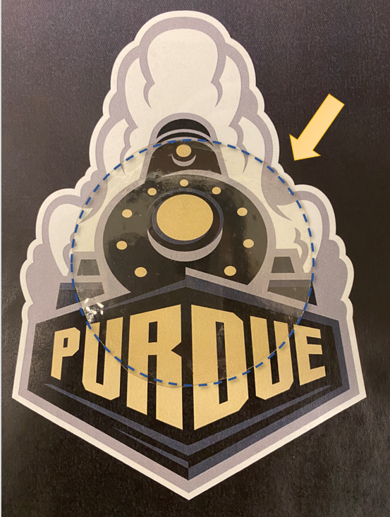
Fig SI1 Picture of a 10-layer TOCNF + PVA – epoxy A laminate, showing high transparency and low haziness.
To account for the transparency of the laminates, UV-Vis measurements were performed in air and compared against borosilicate glass (Fig SI2 ). Results showed differences in the behavior of the three laminates. TOCNF + PVA laminates with epoxy A as interlayer seemed to have a diminished transparency (~6 %) when compared with other laminates. The results also indicated that adding a silane coupling agent (APTES) seem to reduce this effect, making the TOCNF + PVA + APTES laminates comparable with the original laminate (Neat TOCNF laminate), therefore increasing its transparency. The decreased transparency of TOCNF + PVA laminates can find an explanation in the reflection between layers or destructive interferences. The increased adhesion, or better wettability of the epoxy when APTES was applied could have reduced the reflection, making for better interfaces and increasing the transparency. In general, the APTES and the neat TOCNF laminate showed a decrease of around 6% when compared to borosilicate glass while the TOCNF + PVA laminate showed around 17% difference. Even when the loss in transparency, laminates show great transparency and low haziness to the naked eye.
Fig SI2 Visible transmittance via UV-Vis spectroscopy of TOCNF laminates, and borosilicate glass. Thickness was normalized using the borosilicate glass as reference (0.9mm)
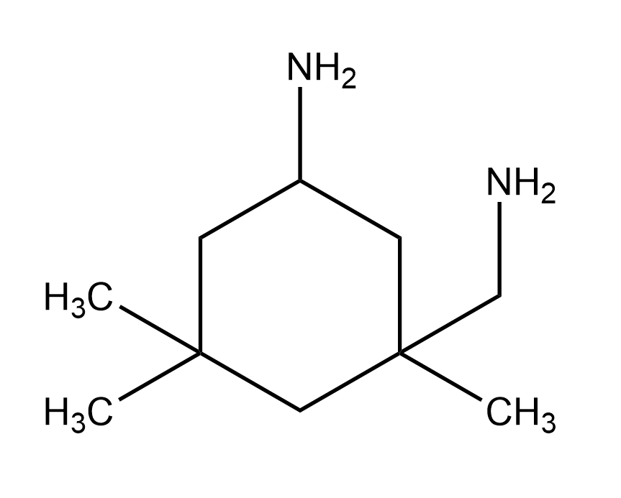
Fig SI3 Molecular structure of 5- Amino 1,3,3-trimethylcyclohexanemethy- amine. Introduced to formulation B
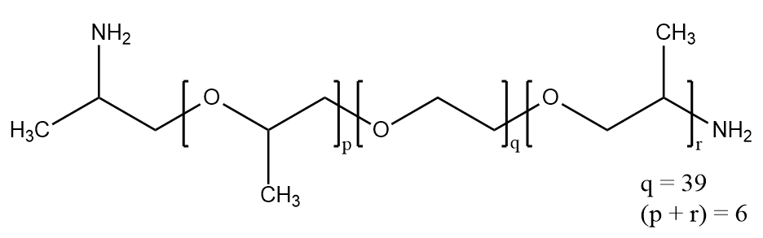
Fig SI4 Molecular structure for hardener O,O’-Bis(2-aminopropyl) polypropylene glycol-block-polyethylene glycol-block-polypropylene glycol used on formulation C and D.

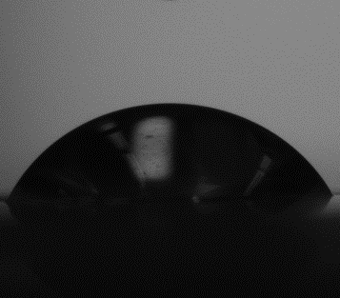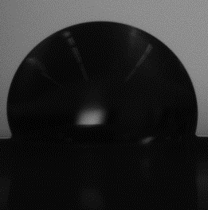
(b)
(a)
Fig SI5 Static contact angle photographs of water droplets in different substrates. (a). TOCNF + PVA (b) TOCNF + PVA + APTES
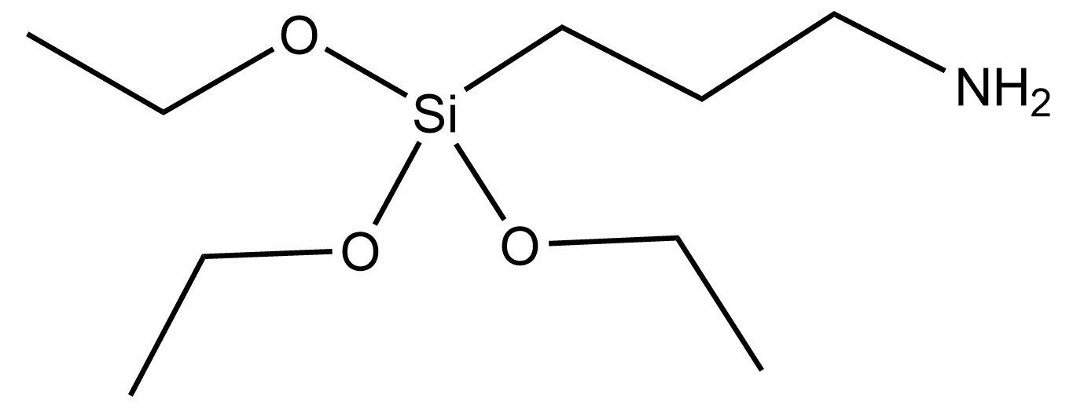
Fig SI6 Molecular structure for APTES (3-Aminopropyl)triethoxysilane

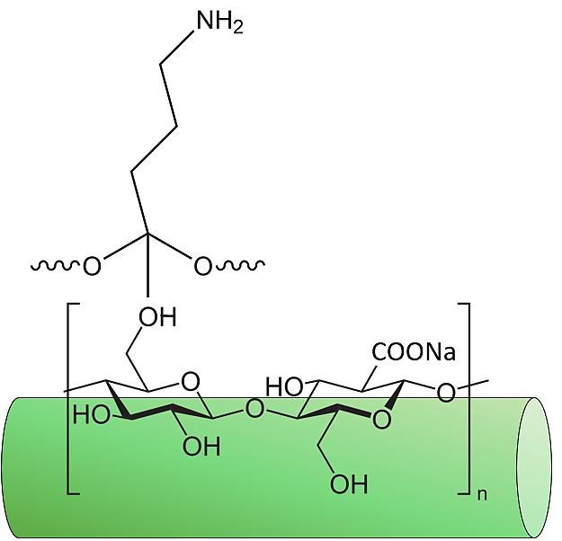
Fig SI7 Schematic of the surface modification achieved of TOCNF with APTES

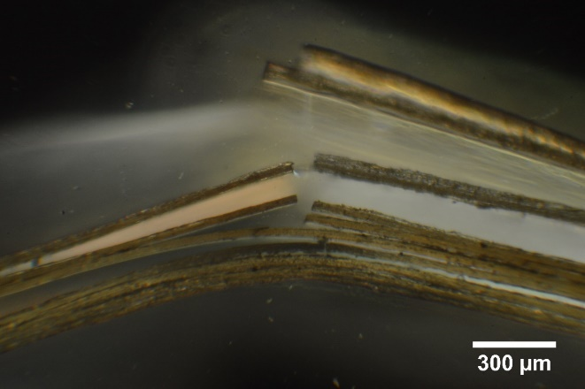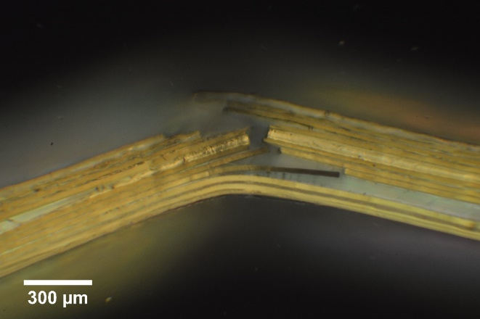
(b)
(a)
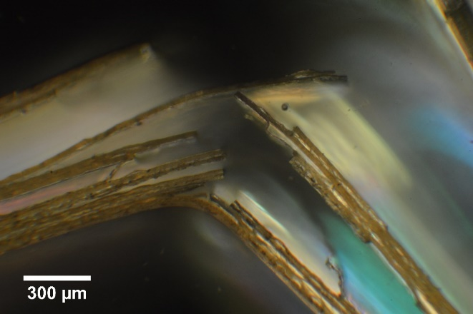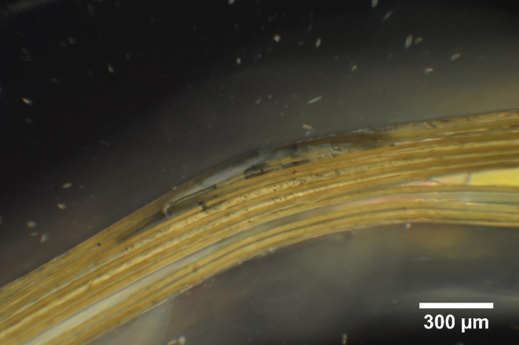
(c)
(d)
Fig SI8 Polarized microscopy images of 10-layer TOCNF or TOCNF + PVA composite laminates after 3-point bending fracture. (a). Neat TOCNF -epoxy A laminate, (b) TOCNF + PVA – epoxy A, (c) TOCNF + PVA – epoxy b, (d) TOCNF + PVA – epoxy d
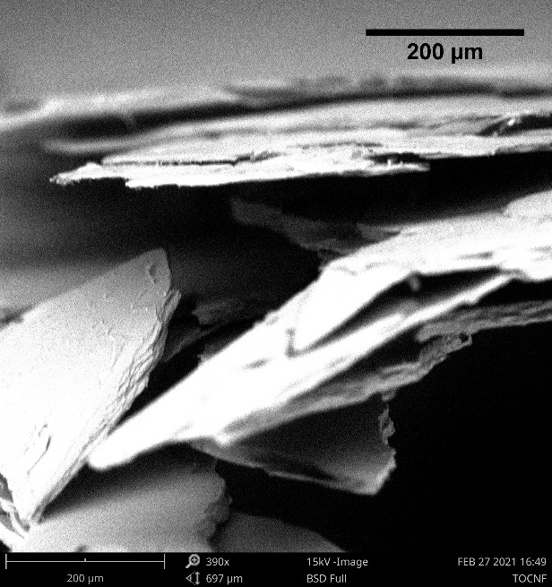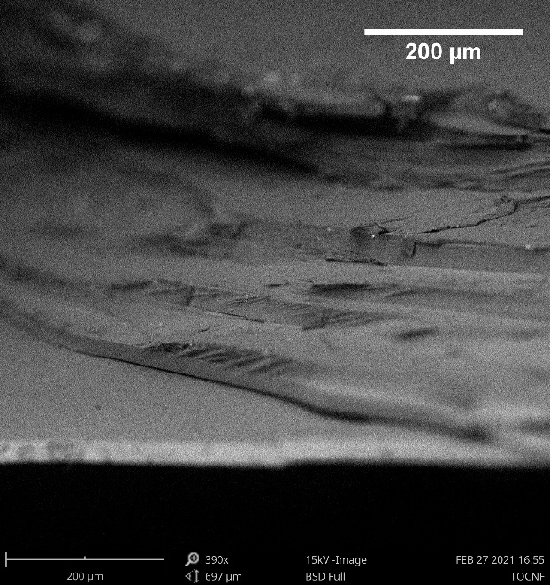
(a.1)
(a.2)
(b.2)
(b.1)
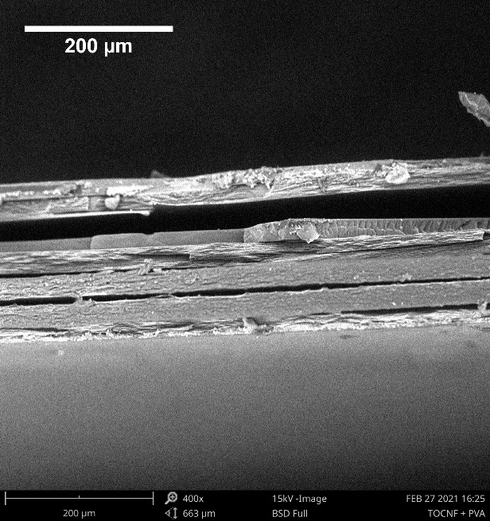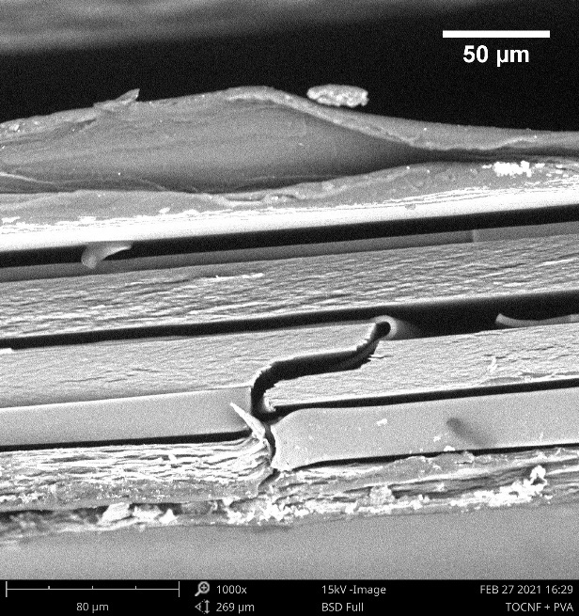
(c.2)
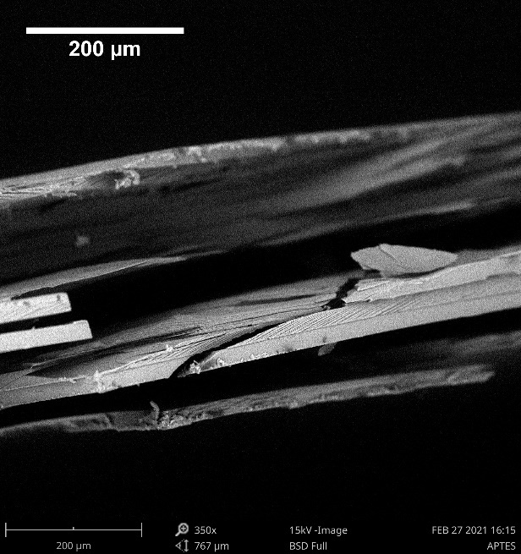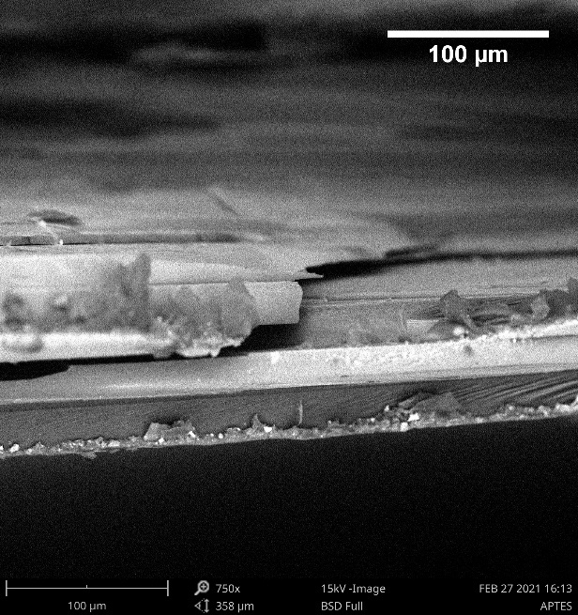
(c.1)
Fig SI9 SEM images of fracture behavior after free dart impact of 10-layer laminates. (a) Neat TOCNF – epoxy A (b) TOCN + PVA – epoxy A, (c) TOCNF + PVA + APTES – epoxy A.

