Electronic Supplementary Materials
How to search for and reveal a hidden intermediate? The ELF topological description of non-synchronicity in double proton transfer reactions under oriented external electric field
Vanessa Labet, Antoine Geoffroy-Neveux, and Mohammad Esmaïl Alikhani

OEEF (×10⁻⁴) ua | r1 (Å) | r2 (Å) | r3 (Å) | r4 (Å) | R1 (Å) | R2 (Å) | Barrier Height
Reactant
0 | 0.995 | 1.665 | 0.995 | 1.665 | 2.660 | 2.660 | 7.4
40 | 0.989 | 1.718 | 1.003 | 1.618 | 2.706 | 2.621 | 6.9
80 | 0.984 | 1.772 | 1.013 | 1.567 | 2.755 | 2.579 | 5.5
120 | 0.979 | 1.832 | 1.025 | 1.517 | 2.811 | 2.542 | 3.5
160 React | 0.976 | 1.924 | 1.042 | 1.466 | 2.897 | 2.507 | 1.4
160 RI | 1.042 | 1.484 | 1.484 | 1.042 | 2.525 | 2.525
200 React | 0.974 | 1.969 | 1.077 | 1.386 | 2.939 | 2.460 | 0.0
200 RI | 1.024 | 1.555 | 1.555 | 1.024 | 2.578 | 2.578
Transition state
0 | 1.202 | 1.202 | 1.202 | 1.202 | 2.404 | 2.404
40 | 1.138 | 1.279 | 1.279 | 1.138 | 2.417 | 2.417
80 | 1.094 | 1.352 | 1.352 | 1.094 | 2.445 | 2.445
120 | 1,063 | 1,419 | 1,419 | 1,063 | 2,482 | 2,482
160 | 1.002 | 1.646 | 1.269 | 1,419 | 2.649 | 2.417
200 | 0.981 | 1.850 | 1.162 | 1.253 | 2.830 | 2.411

Table 1: The most relevant geometrical parameters of the reactants and transition states for the DPT reaction of FAD under an external oriented electric field. The isomerization barrier heights are given in kcal/mol.

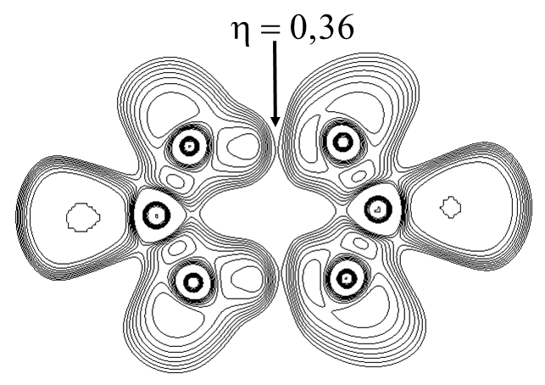
Figure 1. The reaction intermediate ELF isocurve (0.36 ≤ η ≤ 1) of the formic acid dimer under influence of an electric field F_{z} = 160 × 10⁻⁴ au.

