Supporting information
Relationships between Crosslinking Behavior and Morphological Development in PLA/ENR Blends Using Maleic Anhydride as a Coupling and TPV Agent
Muhamad Al-Haqqem Abdul Hadi¹, Nor Azura Abdul Rahim ^{1,2*†}, Roshasnorlyza Hazan³ and Yeoh Cheow Keat^{1,2}
¹ Faculty of Chemical Engineering Technology, Universiti Malaysia Perlis (UniMAP), Pusat Pengajian Jejawi 2, 02600 Arau, Perlis, Malaysia.
² Institute of Nano Electronic Engineering (INEE), Universiti Malaysia Perlis (UniMAP), Jalan Kangar-Alor Setar, Seriab, 01000 Kangar, Perlis, Malaysia.
³ Materials Technology Group, Industrial Technology Division, Malaysian Nuclear Agency, Bangi, 43000, Kajang, Selangor Darul Ehsan, Malaysia

* Correspondence: norazura@unimap.edu.my

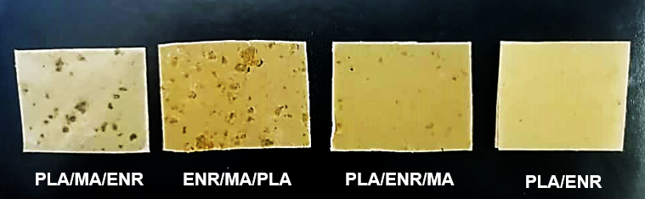
Figure 1s. Surface appearance of PLA/ENR at different MA compounding sequent

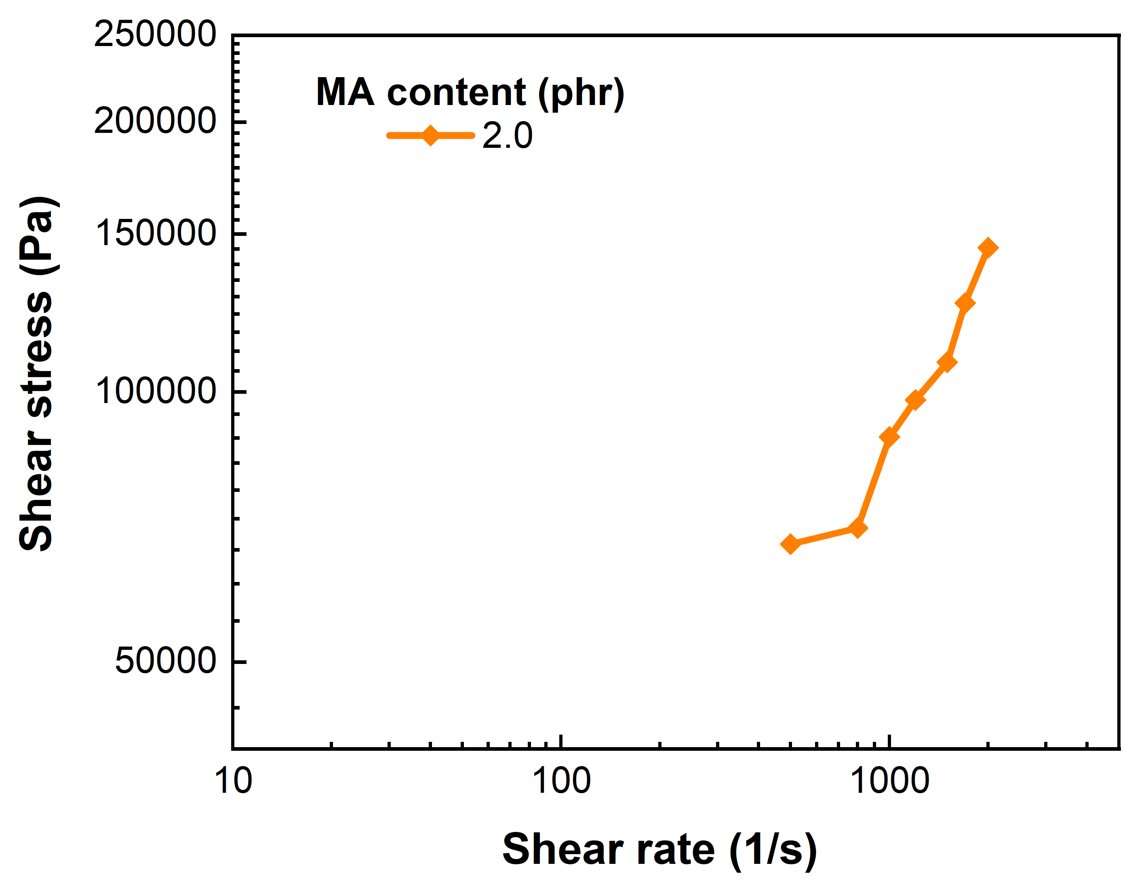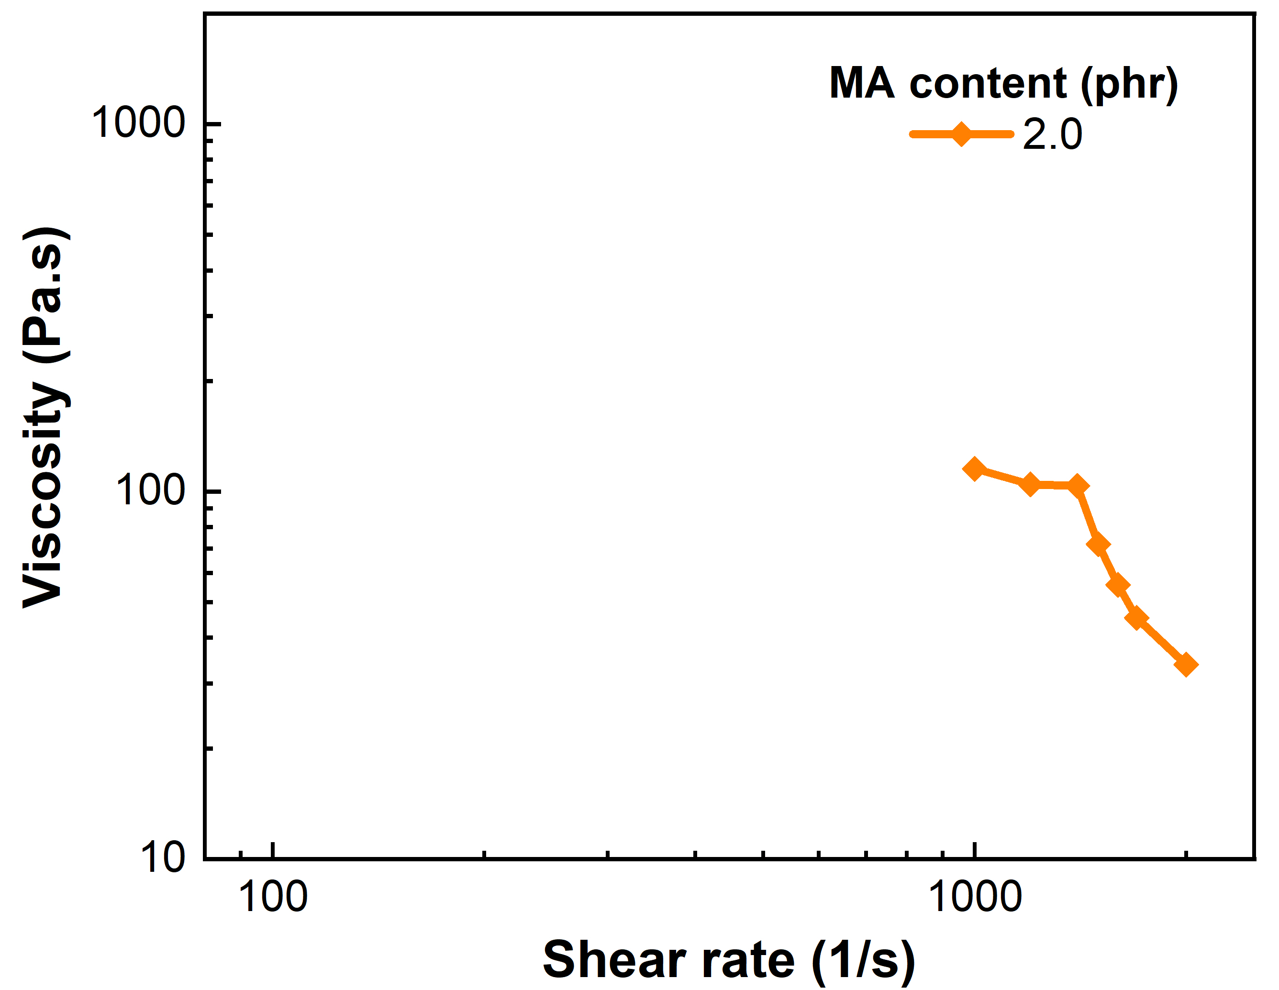
Figure 2s. Capillary rheometer (a) shear stress and (b) viscosity against shear rate for PLA/ENR blend with 2.0 phr MA content.

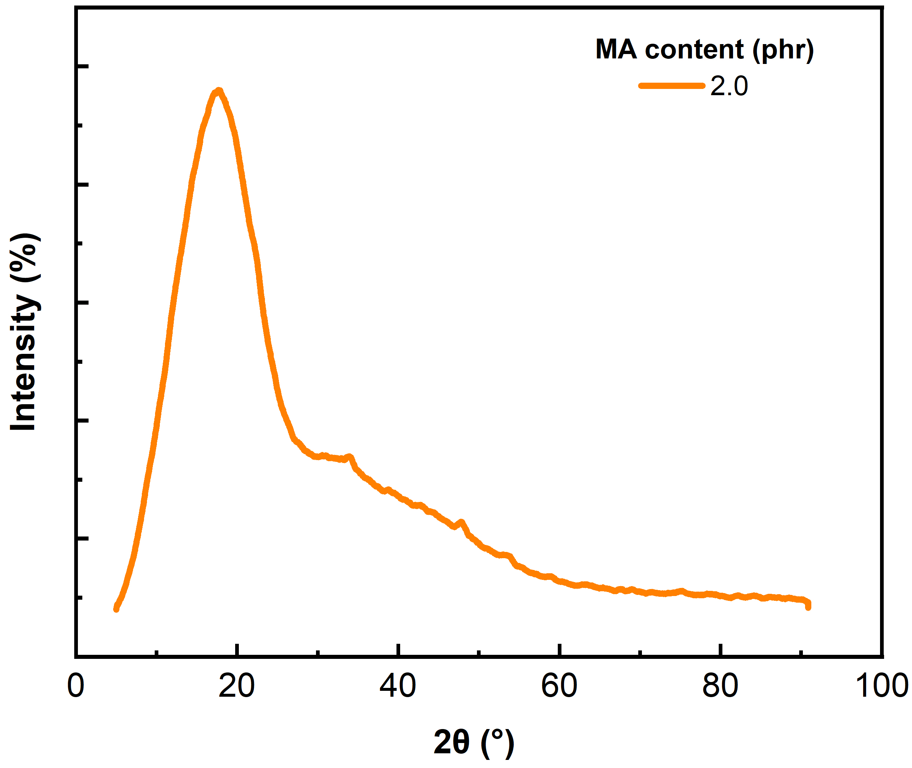
Figure 2s. XRD curve for PLA/ENR blend with 2 phr MA content.

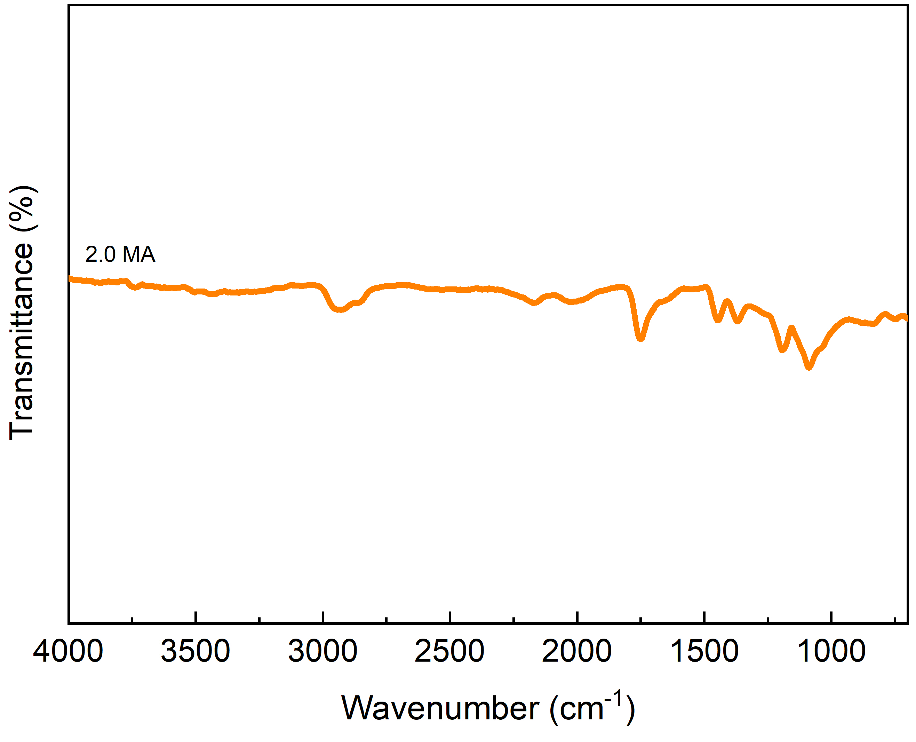
Figure 3s. FTIR spectra recorded for PLA/ENR blend with 2 phr MA content.

