Validation set |  | DSC  (without augmentation) | DSC  (with augmentation) | △DSC
1st | BD | 0.774 | 0.758 | -1.6%p
1st | AW | 0.471 | 0.513 | +4.2%p
2nd | BD | 0.726 | 0.728 | +0.2%p
2nd | AW | 0.397 | 0.424 | +2.7%p
3rd | BD | 0.702 | 0.726 | +2.4%p
3rd | AW | 0.356 | 0.397 | +4.1%p
4th | BD | 0.704 | 0.723 | +1.9%p
4th | AW | 0.366 | 0.339 | -2.7%p
5th | BD | 0.683 | 0.706 | +2.3%p
5th | AW | 0.470 | 0.475 | +0.5%p
Mean (SD) | BD | 0.718 (0.03) | 0.728 (0.01) | +1.0%p
Mean (SD) | AW | 0.412 (0.05) | 0.429 (0.06) | +1.7%p
Mean (SD) | Avg. | 0.565 (0.03) | 0.579 (0.03) | +1.4%p
Supplementary Table 1 Comparison of performance of deep learning model according to the data augmentation
Items | Value
Network Architecture | DeepLabv3+
Backbone Network | ResNet-50 (pretrained with ImageNet)
Image Size | 256 x 256 x 3
Batch Size | 12
Learning Rate | 1e-04
Learning Rate Scheduler | Cosine Annealing (Tmax:10, EtaMin:1e-7)
Number of Epochs | 100
Optimizer | AdamW
Loss Function | Combination of Dice Loss and Cross-entropy Loss:  Dice loss + Cross-entropy loss (without background)
Number of Classes | 3 (Activation Layer: Softmax Function)
Augmentation | At Training  # Normalization  - Normal distribution (mean, std)  - Resize (256 x 256)  # Geometric transformation  - RandomRotate90  - Flip  - Transpose  - ShiftScaleRotate  # Appearence transformation  - ColorJitter  - HueSaturationValue  - RandomBrightnessContrast  - GaussianBlur  - ToGray  - CLAHE  - ChannelShuffle  # Noising & Masking transformation  - CoarseDropout  - GaussNoise  - Posterize | At Test (Inference)  # Normalization  - Normal distribution (mean, std)  - Resize (256 x 256)
Supplementary Table 2 Hyperparameter details
Supplementary Figure 1. This figure presents four examples to demonstrate the interpretability of the proposed deep learning model.
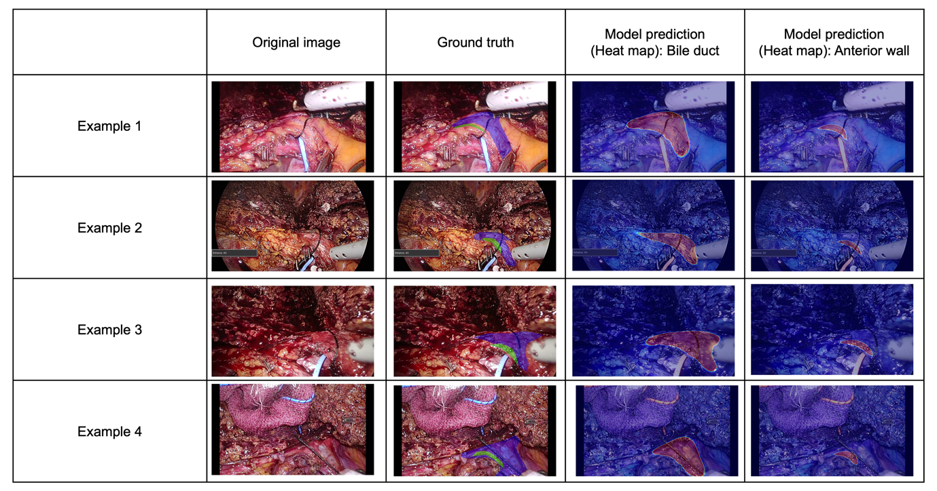

1. Original Image: This is the actual intraoperative image captured during the surgery. It serves as the baseline for comparison against the ground truth and model predictions.
2. Ground Truth: This image provides a manual segmentation of the biliary structures, which represents the target that the deep learning model is expected to predict.
3. Model Prediction (Heat Map: Bile Duct): The model's prediction for the bile duct is overlaid on the original image as a heat map. The heat map likely indicates the model's confidence in predicting the location and shape of the bile duct, with warmer colors (like reds and yellows) signify higher confidence or stronger activation, while cooler colors (like blues) indicate lower confidence or weaker activation.
4. Model Prediction (Heat Map: Anterior Wall): Similar to the previous column, this heat map overlays the model's prediction for the anterior wall of the biliary structure on the original image.

