Supplementary Information

Disorder-driven Sintering-free Garnet-type Solid Electrolytes
Giyun Kwon^{1*}, Hyeokjo Gwon^{1*}, Youngjoon Bae¹, Changhoon Jung¹, Dong-Su Ko¹, Min Gyu Kim², Kyungho Yoon¹, Gabin Yoon¹, Sewon Kim¹, In-Sun Jung¹, Sangjun Lee¹, Taehee Kim¹, Ju-Sik Kim¹, Tae Young Kim¹

¹Battery Material Techincal Unit, Material Research Center, Samsung Advanced Institute of Technology (SAIT), Samsung Electronics Co., Ltd., 130 Samsung-ro, Yeongtong-gu, Suwon-si, Gyeonggi-do, 16678 Republic of Korea
²Beamline Research Division, Pohang Accelerator Laboratory, Pohang University of Science and Technology, Pohang, Gyeongbuk, 37673 Republic of Korea

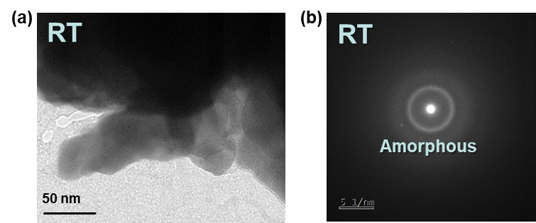

Figure S1. a) Bright-field TEM and b) SAED images of a-LLZTO at ambient temperature.

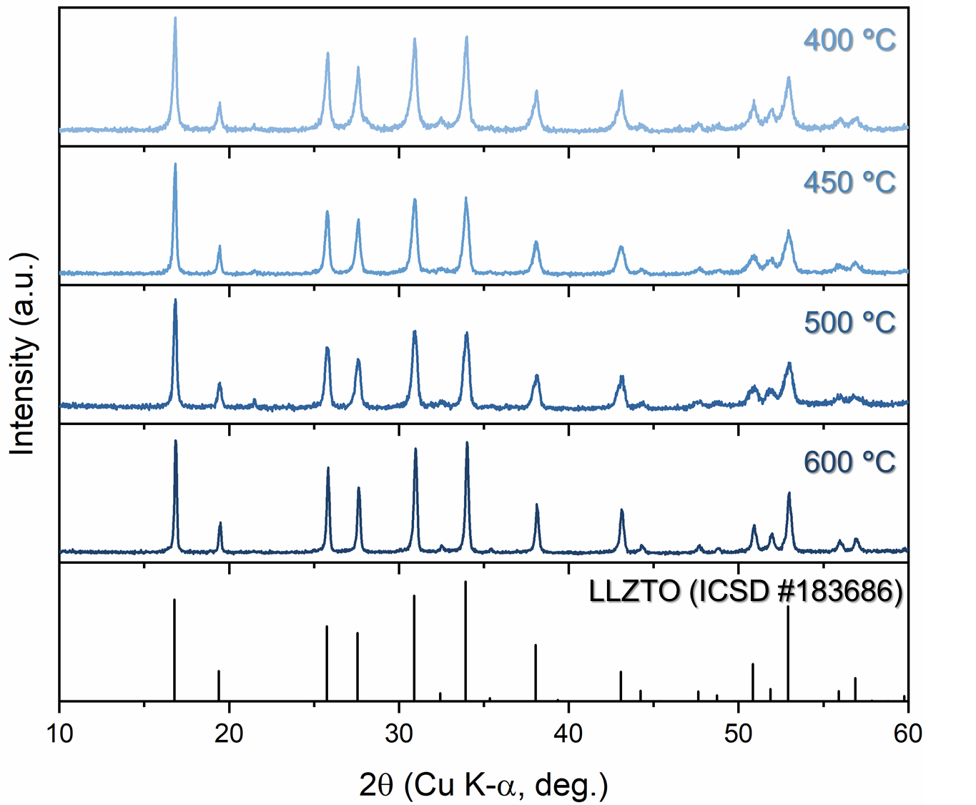

Figure S2. XRD patterns of D-garnet solid electrolyte (with 50% excess lithium) with respect to the heat-treatment temperature.
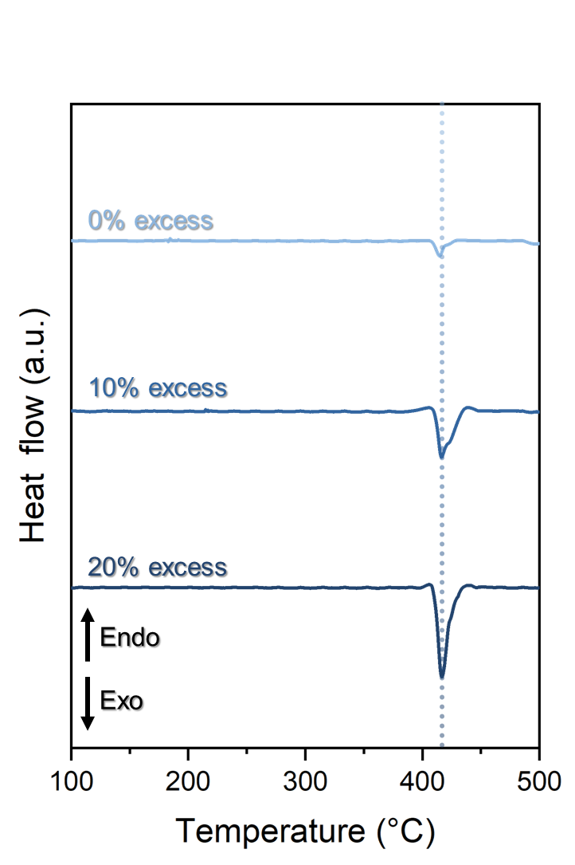

Figure S3. DSC curves of a-LLZTO with 0, 10, and 20% excess lithium.

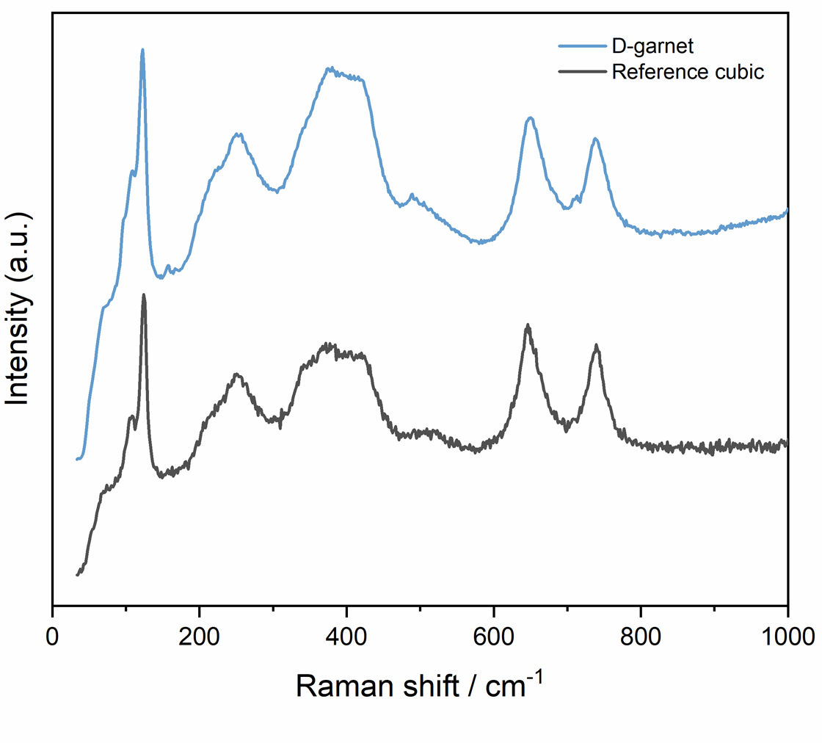

Figure S4. Raman spectra of D-garnet and reference cubic-phase garnet solid electrolytes.

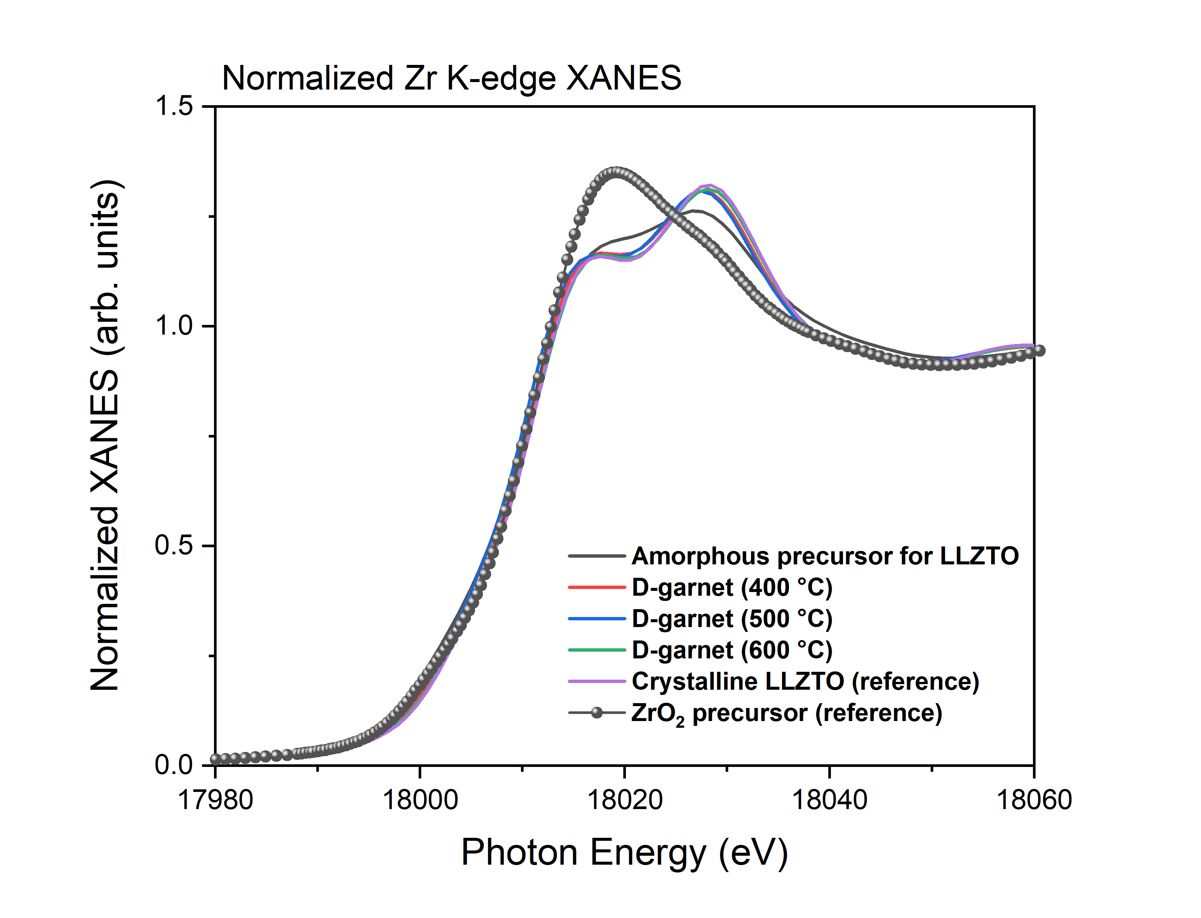

Figure S5. Zr K-edge XAS spectra of the initial amorphous state (a-LLZTO), the D-garnet solid electrolytes formed at varied temperature, and conventional cubic-phase garnet as reference.

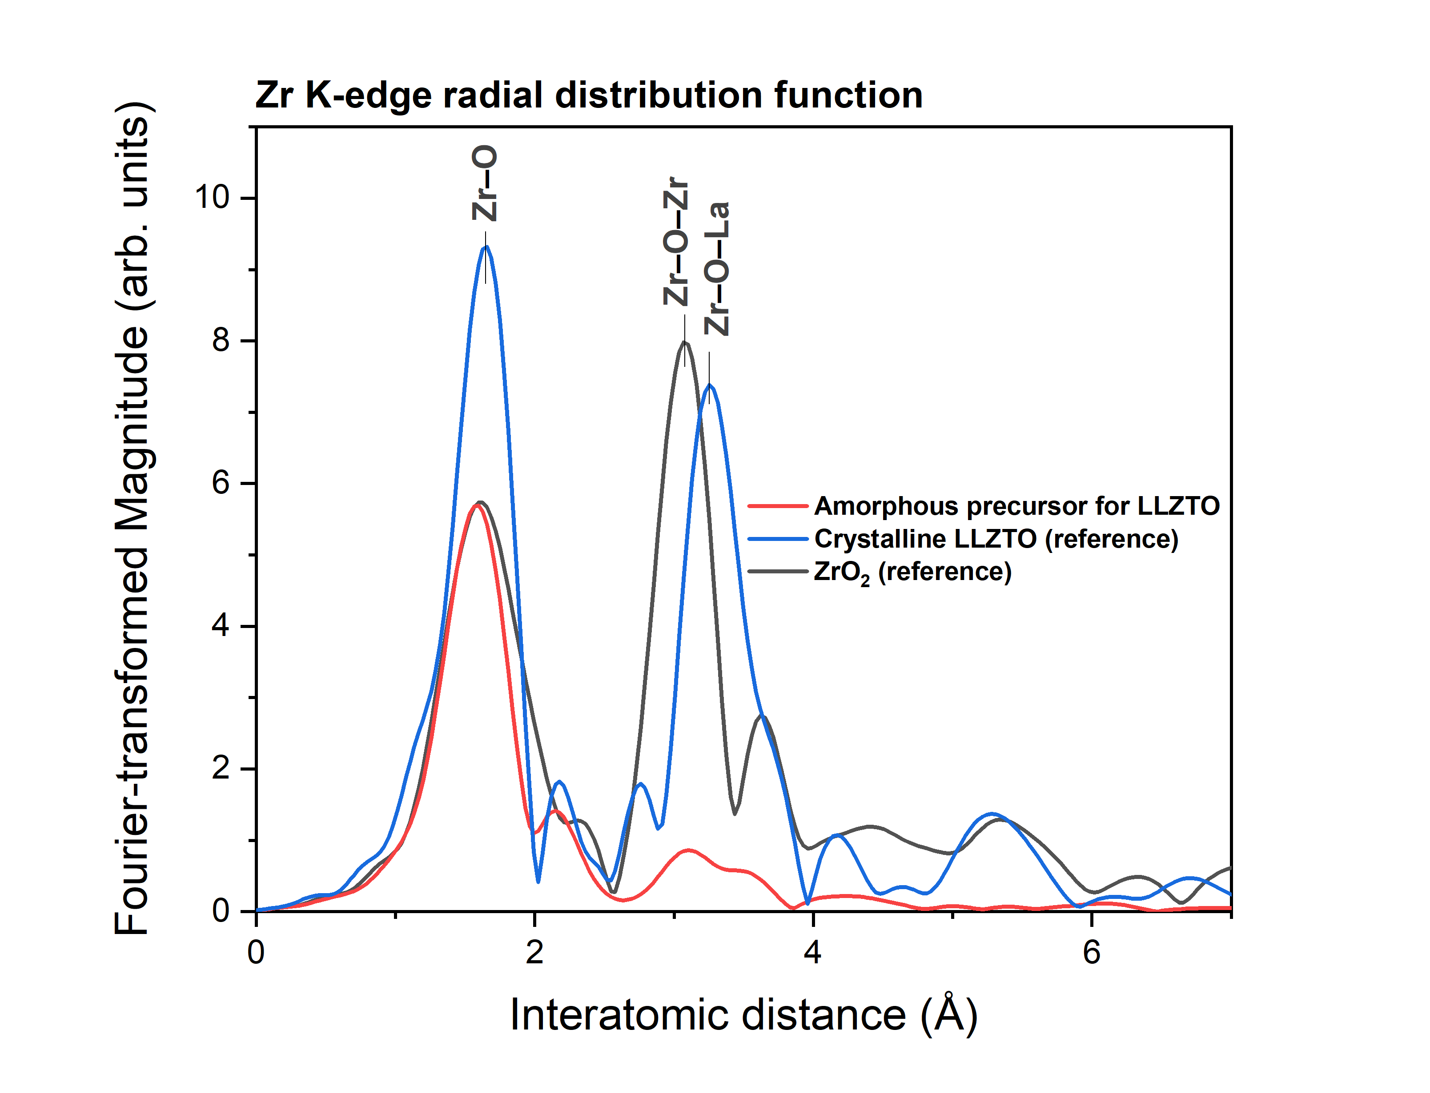

Figure S6. Zr K-edge EXAFS radial distribution function spectra of the amorphous precursor (a-LLZTO) and conventional cubic-phase garnet as reference.

Figure S7. EIS spectra of D-garnet solid electrolyte prepared at 500 °C for 2 h at various temperatures.

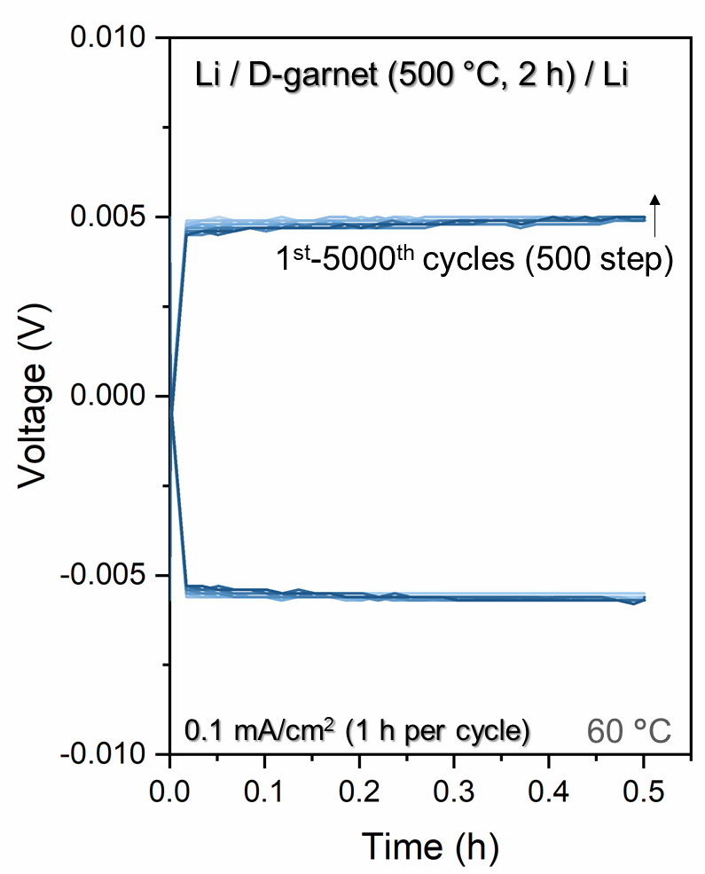

Figure S8. Voltage profiles during lithium stripping and plating of D-garnet solid electrolyte prepared at 500 °C for 2 h.

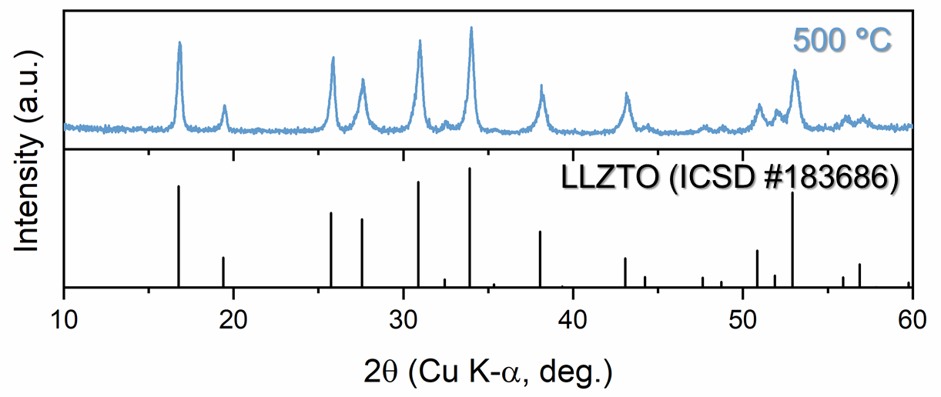

Figure S9. XRD pattern of the D-garnet solid electrolyte hot-pressed under 375 MPa at 500 °C for 2 h.

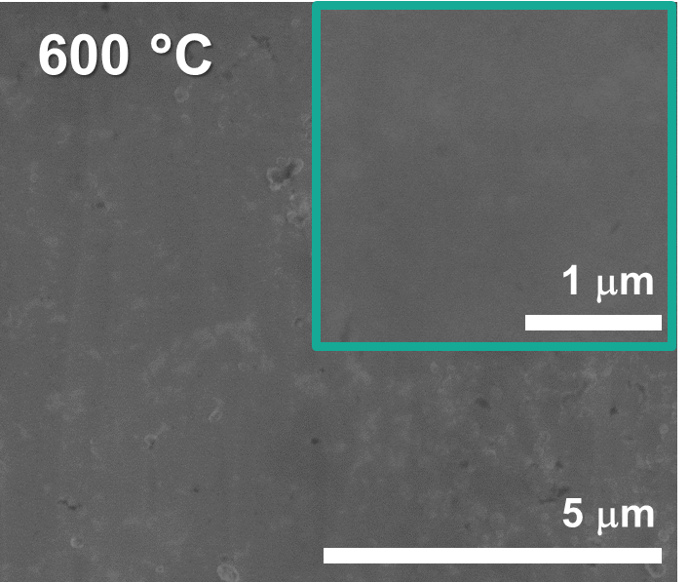

Figure S10. SEM images of the D-garnet solid electrolyte hot-pressed at 600 °C for 2 h.

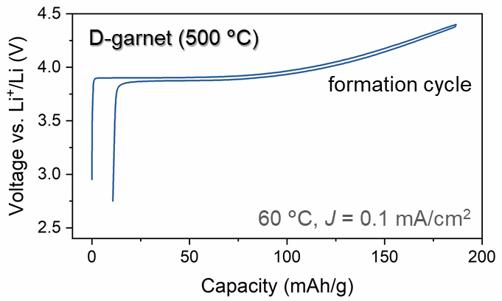

Figure S11. Electrochemical profile for the formation cycle of hybrid full-cell exploiting D-garnet electrolyte and LCO cathode at 60 °C with a current density of 0.1 mA/cm² (corresponding to ~0.29 C-rate).

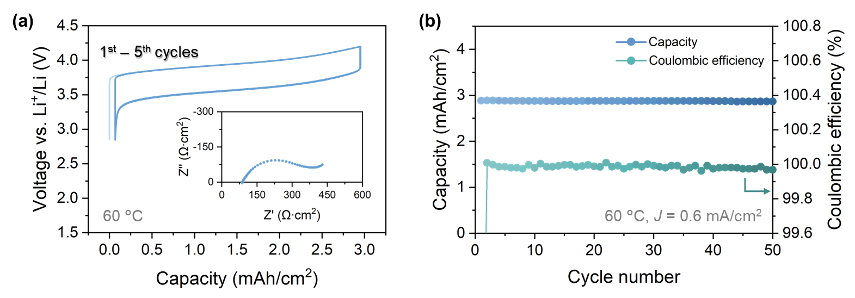

Figure S12. a) Electrochemical profiles for the initial five cycles (including formation cycle) (inset: Nyquist plot of the cell at 25 °C before cycling), and b) cycling performance of hybrid full-cell exploiting D-garnet electrolyte and NCM111 cathode at 60 °C with a current density of 0.6 mA/cm² (~0.19 C).

Table S1. SAED pattern indexing of D-garnet solid electrolytes formed at various temperature.
Temperature  (°C) | Spot number | Dimeter  (nm^{–1}) | d-spacing  (Å) | Phase | Miller indices (hkl)
350 | 1 | 3.774 | 5.299 | LLZTO | (211)
350 | 2 | 5.311 | 3.766 | Li₂CO₃ | (200)
350 | 3 | 5.923 | 3.377 | LLZTO | (400)
350 | 4 | 7.474 | 2.676 | LLZTO | (422)
500 | 1 | 5.721 | 3.496 | LLZTO | (400)
500 | 2 | 7.245 | 2.761 | LLZTO | (422)
800 | 1 | 3.752 | 5.330 | LLZTO | (211)
800 | 2 | 5.994 | 3.337 | LLZTO | (400)
800 | 3 | 7.211 | 2.774 | LLZTO | (422)

Table S2. Structural parameters calculated from EXAFS curve-fitting process for Zr K-edge k³-weighted EXAFS spectra.
Sample | Path | Energy shift (eV) | Coordination number | Interatomic distance (Å) | Debye–Waller factor (10⁻³ Å²) | r-factor of fit**
Amorphous precursor | Zr–O | −4.76 (±1.83)* | 5.22 (±0.43) | 2.076 (±0.012) | 7.61 (±1.38) | 0.030
D-garnet (500 °C) | Zr–O | −1.64 (±0.94) | 5.82 (±0.25) | 2.094 (±0.003) | 5.76 (±0.38) | 0.015
D-garnet (500 °C) | Zr–O–La | −1.64 (±0.94) | 2.44 (±0.19) | 3.591 (±0.004) | 4.22 (±0.54) | 0.015
D-garnet  (600 °C) | Zr–O | 0.00 (Fixed) | 5.65 (±0.23) | 2.099 (±0.002) | 5.02 (±0.55) | 0.013
D-garnet  (600 °C) | Zr–O–La | 0.00 (Fixed) | 2.76 (±0.25) | 3.601 (±0.003) | 4.21 (±0.47) | 0.013
Crystalline LLZTO | Zr–O | 0.00 (Fixed) | 5.68 (±0.16) | 2.099 (±0.002) | 4.63 (±0.26) | 0.014
Crystalline LLZTO | Zr–O–La | 0.00 (Fixed) | 3.49 (±0.21) | 3.601 (±0.003) | 4.34 (±0.35) | 0.014
* Each value in parentheses means the uncertainty obtained from EXAFS fitting process.
** R-factor value which is quality of the fit determined with {ReΔχ_{k}²+ImΔχ_{k}²}/{Re(χ_{kdata})²+Im(χ_{kdata})²}, where χ(k) is EXAFS-function and Δχ(k) means χ(k)_{data} - χ(k)_{best-fitted}.

Supplementary Note 1
Thermodynamic driving force comparison for amorphous precursor and crystalline precursors.
(amorphous) Li_{6.5}La₃Zr_{1.5}Ta_{0.5}O₁₂ → (crystalline) Li_{6.5}La₃Zr_{1.5}Ta_{0.5}O₁₂ (∆H₁= –3.48 eV / f.u.)
(crystalline) 3.25Li₂O + 1.5La₂O₃ + 1.5ZrO₂ + 0.25Ta₂O₅ → (crystalline) Li_{6.5}La₃Zr_{1.5}Ta_{0.5}O₁₂ (∆H₂= –2.08 eV / f.u.)

Supplementary Note 2
Reference for performance comparison of ionic conductivity with respect to the processing temperature for garnet-based solid electrolytes reported previously (Figure 4d in the manuscript).¹⁻³²

Reference
1 Park, J. S. et al. Effects of crystallinity and impurities on the electrical conductivity of Li–La–Zr–O thin films. Thin Solid Films 576, 55-60 (2015).
2 Chen, R.-J. et al. Sol–gel derived Li–La–Zr–O thin films as solid electrolytes for lithium-ion batteries. J. Mater. Chem. A 2, 13277-13282 (2014).
3 Pfenninger, R., Struzik, M., Garbayo, I., Stilp, E. & Rupp, J. L. A low ride on processing temperature for fast lithium conduction in garnet solid-state battery films. Nat. Energy 4, 475-483 (2019).
4 Kim, S., Hirayama, M., Taminato, S. & Kanno, R. Epitaxial growth and lithium ion conductivity of lithium-oxide garnet for an all solid-state battery electrolyte. Dalton Transactions 42, 13112-13117 (2013).
5 Rawlence, M. et al. Effect of gallium substitution on lithium-ion conductivity and phase evolution in sputtered Li7–3 x Ga x La3Zr2O12 thin films. ACS Appl. Mater. Interfaces 10, 13720-13728 (2018).
6 Bitzer, M., Van Gestel, T. & Uhlenbruck, S. Sol-gel synthesis of thin solid Li7La3Zr2O12 electrolyte films for Li-ion batteries. Thin Solid Films 615, 128-134 (2016).
7 Tan, J. & Tiwari, A. Fabrication and characterization of Li7La3Zr2O12 thin films for lithium ion battery. ECS Solid State Letters 1, Q57 (2012).
8 Tadanaga, K. et al. Preparation of lithium ion conductive Al-doped Li7La3Zr2O12 thin films by a sol–gel process. J. Power Sources 273, 844-847 (2015).
9 Jonson, R. A. & McGinn, P. J. Tape casting and sintering of Li7La3Zr1. 75Nb0. 25Al0. 1O12 with Li3BO3 additions. Solid State Ion. 323, 49-55 (2018).
10 Huang, L.-H. & Li, C.-C. Liquid metallic Ga as sintering aid to promote the densification of garnet electrolytes for all-solid-state Li-ion batteries. J. Power Sources 556, 232527 (2023).
11 Yi, E., Wang, W., Kieffer, J. & Laine, R. M. Flame made nanoparticles permit processing of dense, flexible, Li+ conducting ceramic electrolyte thin films of cubic-Li 7 La 3 Zr 2 O 12 (c-LLZO). J. Mater. Chem. A 4, 12947-12954 (2016).
12 Yi, E., Wang, W., Kieffer, J. & Laine, R. M. Key parameters governing the densification of cubic-Li7La3Zr2O12 Li+ conductors. J. Power Sources 352, 156-164 (2017).
13 Ohta, S. et al. Co-sinterable lithium garnet-type oxide electrolyte with cathode for all-solid-state lithium ion battery. J. Power Sources 265, 40-44 (2014).
14 Rosero-Navarro, N., Yamashita, T., Miura, A., Higuchi, M. & Tadanaga, K. Preparation of Li7La3 (Zr2− x, Nbx) O12 (x= 0–1.5) and Li3BO3/LiBO2 composites at low temperatures using a sol–gel process. Solid State Ion. 285, 6-12 (2016).
15 Rosero‐Navarro, N. C., Yamashita, T., Miura, A., Higuchi, M. & Tadanaga, K. Effect of sintering additives on relative density and Li‐ion conductivity of Nb‐doped Li7La3ZrO12 solid electrolyte. J. Am. Ceram. Soc. 100, 276-285 (2017).
16 Tadanaga, K. et al. Low temperature synthesis of highly ion conductive Li7La3Zr2O12–Li3BO3 composites. Electrochem. Commun. 33, 51-54 (2013).
17 Chen, S. et al. Low-sintering-temperature garnet oxides by conformal sintering-aid coating. Cell Rep. Phys. Sci. 2 (2021).
18 El Shinawi, H. & Janek, J. Stabilization of cubic lithium-stuffed garnets of the type “Li7La3Zr2O12” by addition of gallium. J. Power Sources 225, 13-19 (2013).
19 Murugan, R., Thangadurai, V. & Weppner, W. Lattice parameter and sintering temperature dependence of bulk and grain-boundary conduction of garnet-like solid Li-electrolytes. J. Electrochem. Soc. 155, A90 (2007).
20 Li, C., Liu, Y., He, J. & Brinkman, K. S. Ga-substituted Li7La3Zr2O12: An investigation based on grain coarsening in garnet-type lithium ion conductors. J. All. Compd. 695, 3744-3752 (2017).
21 Afyon, S., Krumeich, F. & Rupp, J. L. A shortcut to garnet-type fast Li-ion conductors for all-solid state batteries. J. Mater. Chem. A 3, 18636-18648 (2015).
22 Matsuda, Y. et al. Sintering behavior and electrochemical properties of garnet-like lithium conductor Li6. 25M0. 25La3Zr2O12 (M: Al3+ and Ga3+). Solid State Ion. 311, 69-74 (2017).
23 Djenadic, R. et al. Nebulized spray pyrolysis of Al-doped Li7La3Zr2O12 solid electrolyte for battery applications. Solid State Ion. 263, 49-56 (2014).
24 Van Den Broek, J., Afyon, S. & Rupp, J. L. Interface‐engineered all‐solid‐state Li‐ion batteries based on garnet‐type fast Li+ conductors. Adv. Energy Mater. 6, 1600736 (2016).
25 Cheng, L. et al. Effect of microstructure and surface impurity segregation on the electrical and electrochemical properties of dense Al-substituted Li 7 La 3 Zr 2 O 12. J. Mater. Chem. A 2, 172-181 (2014).
26 Wu, J.-F. et al. Gallium-doped Li7La3Zr2O12 garnet-type electrolytes with high lithium-ion conductivity. ACS Appl. Mater. Interfaces 9, 1542-1552 (2017).
27 Zhang, Y. et al. Effect of lithium ion concentration on the microstructure evolution and its association with the ionic conductivity of cubic garnet-type nominal Li7Al0. 25La3Zr2O12 solid electrolytes. Solid State Ion. 284, 53-60 (2016).
28 Shin, D. O. et al. Synergistic multi-doping effects on the Li7La3Zr2O12 solid electrolyte for fast lithium ion conduction. Sci. Rep. 5, 18053 (2015).
29 Ohta, S., Kobayashi, T. & Asaoka, T. High lithium ionic conductivity in the garnet-type oxide Li7− X La3 (Zr2− X, NbX) O12 (X= 0–2). J. Power Sources 196, 3342-3345 (2011).
30 Kumazaki, S. et al. High lithium ion conductive Li7La3Zr2O12 by inclusion of both Al and Si. Electrochem. Commun. 13, 509-512 (2011).
31 Huang, X., Xiu, T., Badding, M. E. & Wen, Z. Two-step sintering strategy to prepare dense Li-Garnet electrolyte ceramics with high Li+ conductivity. Ceram. Int. 44, 5660-5667 (2018).
32 Matsuda, Y. et al. Phase formation of a garnet-type lithium-ion conductor Li7− 3xAlxLa3Zr2O12. Solid State Ion. 277, 23-29 (2015).

