Table of Contents
1 General methods 3
1.1 Materials 3
1.2 Instrumentation 3
2 Development orthogonal procedure 6
2.1 Optimization orthogonal reactions 6
2.2 Starting molecule 9
3 Synthesis 11
3.1 Monomer synthesis 11
3.1.1 Octyl side chain phenyl monomers 11
3.1.2 Racemic 2-methyl butyl side chain phenyl monomers 16
3.1.3 S-chiral 2-methylbutyl side chain phenyl monomers 21
3.1.4 Phenanthrene monomers 24
3.1.5 Starting molecule (S), branching molecule (V₂) and endcap molecule (E) 30
3.2 Oligomer synthesis 33
4 Characterizations 64
4.1 NMR 64
4.1.1 Monomers 64
4.1.2 Racemic oligomers 98
4.1.3 Chiral linear oligomers 107
4.1.4 Chiral branched oligomers 115
4.1.5 Phenanthrene containing oligomers 124
4.1.6 Modulair developed oligomers 131
4.2 Size Exclusion Chromatography (SEC) 135
4.2.1 Racemic oligomers 135
4.2.2 Chiral linear oligomers 136
4.2.3 Chiral branched oligomers 136
4.2.4 Phenanthrene containing oligomers 137
4.2.5 Modular developed oligomers 138
4.3 HRMS 139
4.3.1 Racemic oligomers 139
4.3.2 Chiral linear oligomers 140
4.3.3 Chiral branched oligomers 142
4.3.4 Phenanthrene oligomers 144
4.3.5 Modular developed oligomers 145
4.4 UV-vis spectroscopy 146
4.4.1 Racemic oligomers 146
4.4.2 Chiral linear oligomers 148
4.4.3 Chiral branched oligomers 148
4.4.4 Phenanthrene containing oligomers 149
4.4.5 Modular developed oligomers 149
4.5 Fluorescence spectroscopy 150
4.5.1 Racemic oligomers 156
4.5.2 Chiral linear oligomers 156
4.5.3 Chiral branched oligomers 157
4.5.4 Phenanthrene containing oligomers 157
4.5.5 Modular developed oligomers 158
4.5.6 Tables with Stokes shift and FWHM 158
4.6 CD and corresponding UV-vis results 159
5 References 164

- General methods
  - Materials
All reagents were purchased either from Acros Organics, BLDpharm, Fluorochem, Sigma-Aldrich, TCI or Thermo Scientific and used without further purification. Dry solvents were bought from Sigma-Aldrich. Solvents for reactions and purifications were bought from Fisher Scientific or Chem-Lab.
  - Instrumentation
Melting point apparatus
Melting point measurements of new monomers are carried out with a Stuart SMP11 melting point apparatus. To estimate the melting point of the different structures, initial heating rates were 6 °C/min. In a second run, the heating rate is changed to 1 °C/min within 10 °C of the melting point.
NMR
High-field nuclear magnetic resonance (NMR) spectra are recorded on a Bruker Avance III HD 400 spectrometer with a Bruker AscendTM 400 magnet system (¹H basic frequency of 400.17 MHz) and a 5 mm PABBO BB/19F-1H/D probe with z-gradients and on a Bruker Avance II+ 600 spectrometer with a Bruker 600 UltraShieldTM magnet system (¹H basic frequency of 600.13 MHz) and a 5 mm PABBO BB-1H/D probe with z-gradients. ¹³C-detected experiments are ¹H-decoupled using power-gated decoupling. All samples are dissolved in deuterated chloroform (CDCl₃), deuterated dichloromethane (CD₂Cl₂) or deuterated tetrahydrofuran (THF-d₈). Data are recorded at room temperature using Bruker TopSpin 3.6.x (Bruker Avance III HD 400 and Bruker Avance II+ 600 spectrometers) and processed and analyzed using Bruker TopSpin 4.2.x. ¹H data are calibrated using tetramethylsilane (TMS) as an internal calibration reference while ¹³C data are calibrated using the deuterated solvents as internal calibration reference (for CDCl₃ a 1:1:1 triplet at 77.16 ppm). The δ-values are expressed in parts per million (ppm). The following acronyms are used: s (singlet), d (doublet), t (triplet), q (quartet), m (multiplet), brd (broadened). The prefix app. can denote the apparent multiplicity of a signal or the theoretically expected multiplicity based on the molecular structure of the compound.

Size Exclusion Chromatography
Size exclusion chromatography (SEC) measurements for determining the purity of the developed oligomer and the molar mass properties of the structures is carried out on a Shimadzu LC20 apparatus (PLgel 3 μm MIXED-E column, LC-20AT pump, CBM-20A controller, SPD-20A and RID-20A detectors) using tetrahydrofuran (THF) as the eluent. The SEC apparatus is calibrated towards a series of polystyrene standards (Polymer Laboratories) in THF. Before the measurements, all samples are fully dissolved/diluted in THF (concentration ≈ 1 mg/mL) and filtered (pore size 0.2 μm).
UV-vis spectrometer
The absorbance of the synthesized oligomers are determined using a Agilent Cary 60 UV-Vis spectrometer. The spectra are recorded within the wavelength range of 250 nm to 800 nm, with a resolution of 0.5 nm and a scanning speed of 600 nm/min, a data interval of 1 nm and an ave. time of 0.1 second. To compensate for the signal originating from the cuvette and solvent, a blank measurement is conducted. The samples For UV-vis and fluorescence spectroscopy are conducted in quartz cuvettes 10x10 mm, while the measurements prior to CD analysis are performed with 1x10 mm quartz cuvettes.
Fluoresce spectrometer
The fluorescence of the synthesized oligomers is measured using an Edinburgh FLS980 spectrofluorometer. The spectrum is recorded within the wavelength range of 350 nm to 800 nm, with a specified interval of 1 nm and a dwell time of 0.2. The excitation wavelength is set between 350 nm to 370 nm with different slit openings as mentioned in the relevant section.
Circular Dichroism spectrometer
CD spectra are acquired at room temperature using a JASCO J-1500 Spectrometer to measure the ellipticity of the dissolved and aggregation induced oligomer samples. The apparatus is configured with settings spanning a wavelength range of 250 nm to 800 nm, utilizing an interval of 0.1 nm and a scanning speed of 100 nm/min. To account for the signals originating from the solvent and the cuvette, a blank measurement is taken prior to each scan. Initial measurements are conducted in quartz cuvettes 10x10 mm, while in a later stage quartz cuvettes 1x10 mm are used (see relevant section).
Aggregation is induced by the addition of a non-solvent to a solution of the oligomer in a good solvent. The addition of the non-solvent is been done in a time span of 5 minutes with a automated syringe pump and the solution is stirred at 400 RPM. After the addition, the sample is transferred to a quartz vial and measured on the UV-vis spectrometer and CD spectrometer as soon as possible.
Chromatography
Thin layer chromatography (TLC) plates used to monitor reactions consisted of 0.2 mm thick pre-coated silica gel 60 with fluorescent indicator UV₂₅₄ on aluminium bought from Machery-Nagel. The UV lamp used to analyze the TLC is a CAMAG UV Lamp 4 able to illuminate UV 254 nm and UV 366 nm, each with 8W. Silica used for column chromatography or filtrations through a plug of silica were 0.060-0.200 mm in size with 60 Å pores, purchased from Thermo Scientific.
- Development orthogonal procedure
  - Optimization orthogonal reactions
Key in orthogonal sequence-defined polymers are the reactions applied. In non-conjugated systems, multiple examples exist which typically make use of reactions with characteristics of click reactions. However, these reaction are not able to be used in conjugated systems as these would disrupt the conjugation along the oligomer backbone. Therefore, reactions with high yields, simple and mild reaction conditions, and regio- and stereo-control that do maintain the conjugation are envisioned. The choice for a cross-coupling reaction as one of the two orthogonal reactions is clear and discussed in the article. As a second coupling reaction, different options were investigated which are discussed below.
Imine
A first possibility studied is the formation of an imine between two consecutive aromatic units which is done by reacting an aniline-based compound with an benzaldehyde derivative. The biggest drawback in this condensation type reaction is the fact that it is a reversible reaction in contact with water, reverting in the starting compounds. Due to this instability, it is no longer being investigated.
Mills
The second option is the Mills reaction, which involves the combination of an aniline derivative with a nitroso compound to develop azobenzene-like structures. This reaction is often used in chromophore design and meets all the requirements. Reactions with small molecules, such as aniline and nitrosobenzene, yields almost 100 % azobenzene with exclusively the trans conformation. Additionally, azo groups are known to be convertible at wish under UV light. Unfortunately, during the step-by-step modification of the compounds towards the desired monomers (with alkoxy side chains on both the aniline and nitroso compound), difficulties arise. First, small quantities of azoxy side products emerged. As we aim to obtain total control regarding the primary structure, this is highly undesirable. Second, yields start decreasing significantly. A potential hypothesis is that with alkoxy side chains ortho to the nitroso function, the electrophilicity is greatly reduced towards a reaction with aniline. To overcome this issue, multiple catalyst are tested to complexate with oxygen of the nitroso function in order to increase the electrophilicity again. Unfortunately, yields remained low and formation of azoxy products could not be prevented.

Horner-Wadsworth-Emmons (HWE)
The decision to use the HWE reaction instead of a standard Wittig reaction is well-founded due to several advantages. In the Wittig reaction phosphonium ylides are involved, while the modified HWE reactions uses phosphonates. The latter can be used with a wider variety of reagents, and the corresponding anion possesses greater nucleophilicity, allowing for milder reaction conditions. In addition, the by-product of the HWE reaction is a water-soluble dialkylphophate salt, which can be easily removed through aqueous extractions. In sequence-defined oligomers, not only the monomer sequence is important, but we also strive to control the stereochemistry to achieve absolute control. The HWE is well-known to predominantly synthesize the preferred E configuration, making this its most crucial advantage.
The most common procedure is performed in THF and with KOtBu as a base, and was chosen as the starting point. Step-by-Step, variables such as base, solvent, and temperature were modified to enhance the stereoselectivity and reaction rate. In the fist, classic procedure, the conversion was 100 % after only 30 minutes and an E configuration of roughly 92 % was achieved (based on ¹H-NMR). To further optimize the protocol, LiOtBu and NaOtBu were used as alternative bases since the counterions interact differently during the synthesis, rendering different E/Z ratios. LiOtBu did not give any conversion after multiple hours, while NaOtBu only gave a moderate conversion. Therefore, we continued working with KOtBu and conducted the next experiments in toluene and DMF to study the optimal solvent. In toluene, the conversion was incomplete, likely due to the lower solubility of KOtBu, while DMF yielded a complete conversion but resulted in a higher number of cis product (approximately 20 %). Finally, temperatures were varied as higher temperatures favors the thermodynamic and more stable E configuration. 0 °C, RT and 70 °C were evaluated and gave comparable E/Z ratios. However, at 70 °C, both starting products did not react completely favoring procedures at lower temperatures. As a result, the starting conditions generated the best outcome related to conversion rate and stereocontrol.
As expected, full exclusion of the Z configuration is not achieved during the oligomer synthesis with O and M(rac). Surprisingly, the reaction with monomers P and V₂ rendered no cis product. Since crystallizations or precipitations are used to purify the different sequences, the Z configuration is removed due to the more favorable crystallization of the desired E configuration. Unfortunately, it is not always possible to separate both via these purifications making it necessary to convert the Z enantiomer. This is done by dissolving the oligomers in CHCl₃ at 50 °C with a catalytic amount of I₂, protected from light with Al-foil. The protection from light is needed as we noticed that the favorable trans conformation converts to the unwanted cis enantiomer.
Suzuki-Miyaura cross coupling (SMCC)
The initial SMCC reaction was performed according to the procedure as described by Xu et al.¹ First, a mixture of Pd(OAc)₂ and RuPhos was activated upon heating at 65 °C for 20 minutes. Then, the base and starting molecule S were added. The monomer containing the boronic ester group was added dropwise over 2.5 hours using an automatic syringe in order to diminish protodeborylation. However, this procedure resulted in variable yields of dimer in repeatedly performed synthesizes. Extensive research towards the most optimal reaction conditions was needed and emerged in a fast and well-controlled reaction. An overview of the tested reaction conditions and the associated issues is presented in Table 1.
First, the reaction time was increased, which did not improve the yield (entry 1). There was still starting product left and protodeborylation occurred to a large extent. The amount of palladium catalyst was doubled, however, the same problems were still observed (2). Because in the referring article boronic acids were used, while we use boronic esters, the water content might be the critical element to control. Boronic esters are known to be more stable and need an extra activation by means of hydroxide anions originating from water. Nonetheless, since the presence of the hydroxide anions is the cause of the protodeborylation, it is necessary to find the appropriate balance. Enough water should be added to provide activation of the boronic ester, whilst keeping the amount as low as possible to prevent side reactions such as protodeborylation and deprotection of the hydroxyl group.
As a result, the influence of water to the reaction was investigated next. Upon the addition of a droplet of water, the reaction rate was increased and the conversion improved (3). As expected, the presence of water did lead to the removal of a small fraction of the protecting group and protodeborylation still occurred to a large extent. However, the reaction rate improved significantly. In order to maintain the improved reaction rate while protodeborylation is minimized, the reaction was performed using a controlled 50-to-1 THF/water ratio (4). Deprotection of the hydroxylgroup was diminished and protodeborylation happened only to a moderate extent while the conversion was nearly 100 %. To overcome this final issue, the number of boronic ester equivalents was slightly increased and the conversion improved (5).

Table 1. Conditions to finetune the SMCC reactions.
No. of experiment | Eq. boronic ester | Water added | Dropwise or simultaneous addition | % Pd(OAc)₂ | Deprotection | Reaction time | Starting product left?
Initial procedure | 1.1 | No | Dropwise (2.5h) | 5 % | No | 2.5 h | Yes
1 | 1.1 | No | Dropwise (2.5h) | 5 % | No | 22 h | yes
2 | 1.1 | No | Dropwise (2.5h) | 10 % | No | 2.5h | yes
3 | 1.1 | droplet | Simultaneous | 5 % | Moderate to extensive | 20 min | yes
4 | 1.1 | 2 % | Simultaneous | 5 % | little | 20 min | yes
5 | 1.2 | 2 % | Simultaneous | 5 % | little | 20 min | no

To facilitate the synthesis of the hexamer from the pentamer, double the usual amount of palladium catalyst was used. During preliminary tests, incomplete conversions were noticed despite employing the same reaction conditions as before. One potential hypothesis attributes this to the pentamer possessing two vinylene bonds enabling palladium to ring-walk. To address this issue, double the amount of catalyst was used. Besides with the synthesis of these hexamers, also double the amount of palladium is used when a SMCC reaction is applied subsequent to incorporating branching molecule V₂. This adjustment compensates for the enlargement of the oligomer with two monomer building blocks or oligomer sequences instead of one (SO//V₂M//(S), SM//OO//V₂M//(S), SO//OM//V₂M//(S) and SO//V₂E//OO//OS).
  - Starting molecule
To keep the goal of developing a modular approach in mind, a starting molecule with more than one functional group is desired. Besides the functionality required to develop the oligomer, also one for post-polymerization transitions is necessary. For this purpose, a hydroxyl group was chosen because it offers numerous post-polymerization possibilities. This hydroxyl group must be protected in the first reaction step to prevent precipitation and deactivation of the anionic intermediate formed when it comes into contact with the bases required in both syntheses. The aim of the protective group is to be resistant to the conditions of the reaction applied and to be removed easily.

Aldehyde monomers
Because the hydroxyl group actually is a masked pseudohalide, the modular approach will rely on the SMCC reaction. Therefore we initially tested 4-hydroxybenzaldhyde as starting molecule to maintain the alternation of SMCC and HWE reactions. With this starting molecule, the protective group envision should be stable to the conditions of the HWE reaction.
The first protective group we considered was 2-tetrahydropyranyl (THP). Synthesizing this protected compound was simple but, unfortunately, complications arose during the purification. After the reaction, purifications were needed and were performed with column chromatography. However, the silica appeared to be too acidic and deprotected the wanted molecule.
The second protective group studied is a methoxymethyl ether with chloromethyl methyl ether (CMME) as reagent. Following the extremely hazardous properties of this compound and the difficulties we faced to deprotect the hydroxyl, CMME was no longer investigated.
Bromine monomers
Since the previous two methods did not succeed, we shifted to using 4-bromophenol as starting molecule. The first chain elongation will now be performed via a SMCC reaction, which uses less basic conditions compared to the HWE reaction. This opens the opportunity to study different protective groups than those previously considered. With the easy deprotection in mind, silyl ethers are excellent alternatives as these are very easy to remove with fluorinated compounds, such as tetrabutylammonium fluoride (TBAF). Although SMCC reactions in combination with silyl ether products are described in literature before, it resulted in a mixture of various compounds of which the origin is unclear.
The next option investigated is protecting the hydroxyl as an acetate with acetyl chloride. SMCC reaction with this protective group did lead to small quantity of deprotected dimer. However, deprotection is necessary next anyway, since the acetate group would be unstable in contact with KOtBu used in the HWE reaction. This removal is accomplished by dissolving the crude product mixture in THF with a 1 M NaOH solution. Therefore, acetate esters ended up to be the ideal group to use for protecting the hydroxyl functionality.

- Synthesis
  - Monomer synthesis
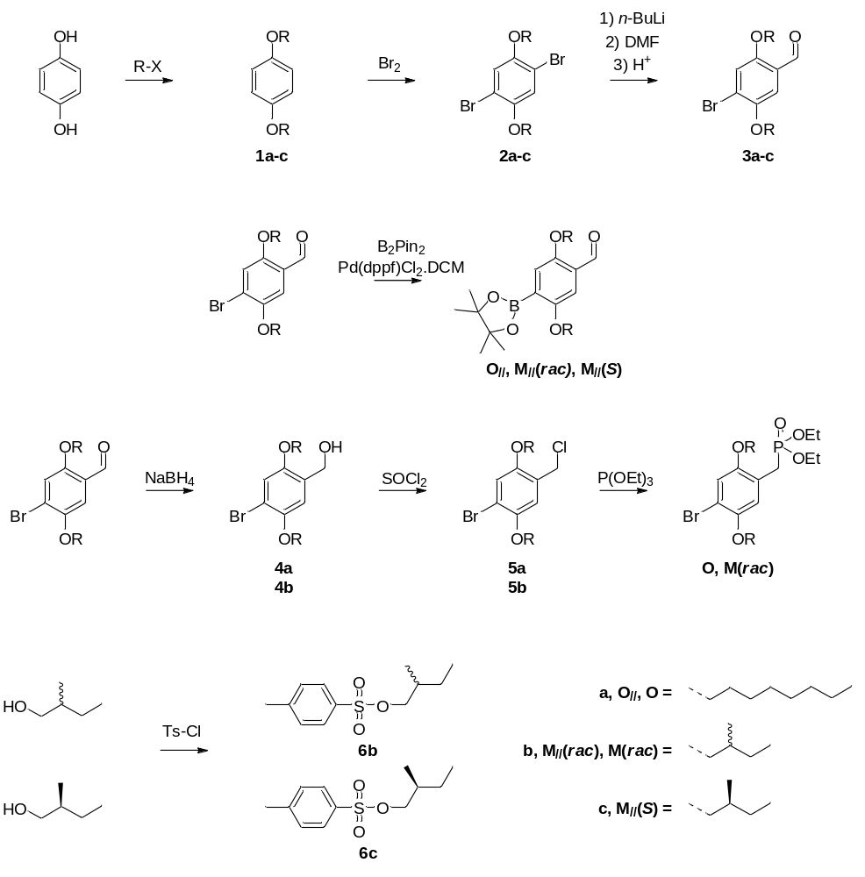

    - Octyl side chain phenyl monomers
1,4-di(octyloxy)benzene (1a)
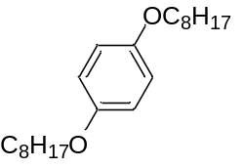
In a multi-neck flask, hydroquinone (150 mmol, 16.5 g) is dissolved in degassed ethanol (500 ml) under an inert atmosphere. Next, K₂CO₃ (600 mmol, 82.9 g) and KI (4.50 mmol, 744 mg) are added and the mixture is refluxed for 30 minutes. 1-Bromooctane (330 mmol, 63.7 g) is added dropwise to the mixture via an addition funnel and the reaction is stirred overnight at reflux temperature. The warm reaction mixture is filtered and the remaining salts are washed with ethyl acetate (EA). The filtrate is cooled to recrystallize the product and filtered with a Büchner filter to obtain the pure product as white flakes.
Quantity: 39.3 g
Yield: 79%
¹H-NMR (400 MHz, CDCl₃): δ6.81 (s, 4H), 3.89 (t, J = 6.61 Hz, 4H), 1.74 (m, 4H), 1.44 (m, 4H), 1.29 (m, 16H), 0.88 (t, J = 6.86 Hz, 6H)
¹³C-NMR (100 MHz, CDCl₃): δ153.20, 115.40, 68.68, 31.83, 29.41, 29.39, 29.26, 26.07, 22.67, 14.11

1,4-dibromo-2,5-di(octyloxy)benzene (2a)
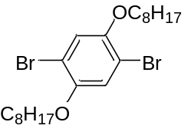
In a multi-neck flask, 1,4-di(octyloxy)benzene (1a) (118 mmol, 39.3 g) is dissolved in DCM (200 mL) under an inert atmosphere and cooled to 0 °C. Bromine (235 mmol, 37.6 g) is added dropwise to the solution via an addition funnel and stirred for two hours. The reaction mixture is quenched with a saturated NaHSO₃ solution and extracted with DCM. The organic phase is consecutively washed with a saturated NaHSO₃ solution, a saturated NaHCO₃ solution, and a saturated NaCl solution and dried over MgSO₄. After filtration, the solvent is removed under reduced pressure to obtain the crude product which is purified by recrystallization from cold ethanol. The product is filtered using a Büchner filter to obtain the pure product as white crystals with a faint yellow shade.
Quantity: 50.2 g
Yield: 87 %
¹H-NMR (400 MHz, CDCl₃): δ7.08 (s, 2H), 3.94 (t, J = 6.58 Hz, 4H), 1.79 (m, 4H), 1.48 (m, 4H), 1.23-1.40 (m, 16H), 0.88 (t, J = 6.87 Hz, 6H)
¹³C-NMR (100 MHz, CDCl₃): δ150.09, 118.49, 111.14, 70.33, 31.80, 29.26, 29.21, 29.12, 25.94, 22.66, 14.11

4-bromo-2,5-di(octyloxy)benzaldehyde (3a)²
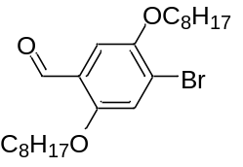
In an oven dried multi-neck flask, 1,4-dibromo-2,5-di(octyloxy)benzene (2a) (102 mmol, 50.1 g) is dissolved in dry diethyl ether (Et₂O) (500 ml) under an inert atmosphere and cooled to 0 °C. n-BuLi (2.5 M in hexane) (103 mmol, 41.3 mL) is added dropwise the solution via a syringe and stirred for one hour. Next, dry DMF (135 mmol, 10.5 mL) is added at room temperature and stirred for one additional hour. The reaction is quenched by the addition of a 1 M solution of HCl and extracted with Et₂O. The combined organic phase is consecutively washed with a saturated NaHCO₃ solution, and a saturated NaCl solution and dried over MgSO₄. After filtration, the solvent is evaporated under reduced pressure to obtain the crude product which is purified by column chromatography (SiO₂, n-heptane (Hep)/DCM 5.5/2.5). The pure product is obtained as a yellow solid.
Quantity: 32.4 g
Yield: 72 %
¹H-NMR (400 MHz, CDCl₃): δ10.41 (s, 1H), 7.31 (s, 1H), 7.22 (s, 1H), 4.02 (t, J = 6.51 Hz, 2H), 4.00 (t, J = 6.51 Hz, 2H), 1.81 (m, 4H), 1.46 (m, 4H), 1.31 (m, 16H), 0.86 (m, 6H)
¹³C-NMR (100 MHz, CDCl₃): δ188.99, 155.80, 149.88, 124.30, 120.99, 118.50, 110.66, 77.33, 77.02, 76.70, 69.88, 69.50, 31.80, 31.78, 29.27, 29.22, 29.20, 29.08, 29.03, 26.01, 25.95, 22.66, 22.65, 14.11, 14.09
2,5-di(octyloxy)-4-(4,4,5,5-tetramethyl-1,3,2-dioxaborolan-2-yl)benzaldehyde (O//)
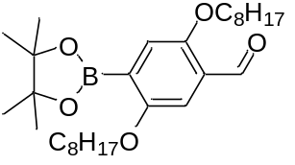
In an oven dried flask, 4-bromo-2,5-di(octyloxy)benzaldehyde (3a) (11.7 mmol, 5.18 g), potassium acetate (35.2 mmol, 3.46 g), Pd(dppf)Cl₂.DCM (0.23 mmol, 192 mg) and bis(pinacolato)diboron (B₂Pin₂) (12.9 mmol, 3.28 g) are dissolved in dry 1,4-dioxane (50 ml) under an inert atmosphere. The reaction mixture is stirred overnight at reflux temperature. Next, Et₂O is added and the organic phase is washed with brine and dried over MgSO₄. After filtration, the solvent is evaporated under reduced pressure to obtain the crude product which is purified by crystallization from cold MeOH. The pure product is obtained as a brown solid with a yellow shade.
Quantity: 5.62g
Yield: 98 %
Melting point range 45-47 °C
¹H-NMR (600 MHz, CDCl₃): δ10.48 (s, 1H), 7.24 (s, 1H), 7.20 (s, 1H), 4.08 (t, J = 6.45 Hz, 2H), 3.95 (t, J = 6.31 Hz, 2H), 1.78 (m, 4H), 1.48 (m, 4H), 1.36 (s, 12H), 1.24-1.38 (m, 16H), 0.89 (t, J = 6.87 Hz, 3H), 0.88 (t, J = 6.76Hz, 3H)
¹³C-NMR (150 MHz, CDCl₃): δ190.14, 157.27, 155.61, 126.80, 120.33, 109.25, 84.01, 69.24, 69.02, 31.87, 31.80, 29.44, 29.36, 29.33, 29.30, 29.23, 26.09, 26.03, 24.86, 22.69, 22.66, 14.10
HRMS (m/z): [M]+ calcd. For C₂₉H₄₉B₁O₅, 487.3709; found 487.3732

4-bromo-2,5-di(octyloxy)benzyl alcohol (4a)
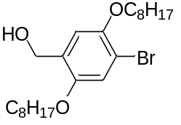
In an oven dried multi-neck flask, NaBH₄ (60.0 mmol, 2.26 g) is dissolved in a mixture of dry ethanol (5 ml) and diethyl ether (10 ml) under inert an atmosphere and cooled to 0 °C. Next, 4-bromo-2,5- di(octyloxy)benzaldehyde (3a) (30.0 mmol, 13.2 g) is dissolved in diethyl ether (200 ml) and added dropwise to the mixture via an addition funnel. The reaction is monitored by TLC and quenched with HCl (1 M) after which it is extracted with DCM. The combined organic phase is consecutively washed with a saturated NaHCO₃ solution, and a saturated NaCl solution and dried over MgSO₄. After filtration, the solvent is evaporated under reduced pressure to obtain the crude product which is purified by column chromatography (SiO₂, Hep/EA: 7/1). The pure product is obtained as a white solid.
Quantity: 9.62 g
Yield: 72 %
¹H-NMR (400 MHz, CDCl₃): δ7.05 (s, 1H), 6.90 (s, 1H), 4.63 (d, J = 6.34 Hz, 2H), 3.97 (t, J = 6.50Hz, 2H), 3.94 (t, J = 6.46 Hz, 2H), 2.24 (t, J = 6.42 Hz, 1H), 1.79 (m, 4H), 1.46 (m, 4H), 1.31 (m, 16H), 0.88 (m, 6H)
¹³C-NMR (100 MHz, CDCl₃): δ151.04, 149.60, 129.30, 116.52, 114.56, 111.25, 70.33, 68.89, 61.82, 31.82, 31.80, 29.30, 29.25, 29.22, 26.11, 25.99, 22.66, 14.10

4-bromo-2,5-di(octyloxy)benzyl chloride (5a)
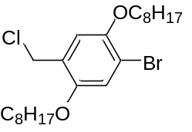
In a multi-neck flask, 4-bromo-2,5-di(octyloxy)benzyl alcohol (4a) (21.7 mmol, 9.62 g) and a catalytic amount of DMF are dissolved in toluene (150 ml) and cooled to 0 °C closed by a CaCl₂ tube. Next, thionyl chloride (SOCl₂) (65.1 mmol, 4.72 ml) is added dropwise to the solution via an addition funnel and the reaction is monitored by TLC. After the reactions, toluene and SOCl₂ are evaporated under reduced pressure to obtain the crude product which is purified by column chromatography (SiO₂, Hep). The pure product is obtained as white crystals.
Quantity: 7.19 g
Yield: 72 %
Melting point range 46-48 °C
¹H-NMR (400 MHz, CDCl₃): δ7.06 (s, 1H), 6.93 (s, 1H), 4.59 (s, 2H), 3.97 (t, J = 6.66 Hz, 2H), 3.94 (t, J = 6.48 Hz, 2H), 1.79 (m, 4H), 1.48 (m, 4H), 1.31 (m, 16H), 0.88 (m, 6H)
¹³C-NMR (100 MHz, CDCl₃): δ151.08, 149.54, 125.86, 117.30, 115.86, 112.91, 70.27, 69.27, 41.19, 31.81, 29.31, 29.28, 29.24, 29.22, 26.01, 25.99, 22.67, 14.11
HRMS (m/z): [M]+ calcd. For C₂₃H₃₈O₂Cl₁Br₁, 460.1744; found 460.1758

Diethyl (4-bromo-2,5-di(octyloxy))benzyl phosphonate (O)
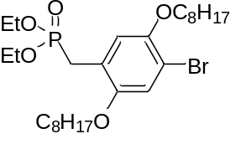
4-bromo-2,5-di(octyloxy)benzyl chloride (5a) (15.6 mmol, 7.19 g) is dissolved in triethyl phosphite (77.8 mmol, 13.3 ml) and refluxed for five hours. The crude product is purified by short path vacuum distillation to obtain the pure product as faint yellow oil.
Quantity: 7.45 g
Yield: 85 %
¹H-NMR (400 MHz, CDCl₃): δ7.03 (d, J = 0.83 Hz, 1H), 6.97 (d, J = 2.78 Hz, 1H), 4.03 (m, 4H), 3.96 (t, J = 6.56 Hz, 2H), 3.89 (t, J = 6.55 Hz, 2H), 3.19 (d, J = 21.79 Hz, 2H), 1.78 (m, 4H), 1.46 (m, 4H, 1.30 (m, 16H), 1.25 (t, J = Hz, 6H), 0.88 (m, 6H)
¹³C-NMR (100 MHz, CDCl₃): δ151.13, 151.05, 149.35, 149.32, 120.43, 120.33, 116.94, 116.91, 116.74, 116.69, 110.71, 110.66, 70.10, 69.28, 62.00, 61.93, 31.81, 29.34, 29.33, 29.24, 27.03, 26.08, 25.99, 25.64, 22.66, 16.41, 16.35, 14.11, 14.10
³¹P-NMR (162 MHz, CDCl₃): δ26.42 (s, 1P)

    - Racemic 2-methyl butyl side chain phenyl monomers
2-methylbutyl p-toluenesulfonate (6b)³
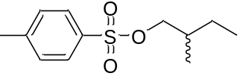
In a multi-neck flask, 2-methylbutanol (150 mmol, 13.2 g) and triethylamine (Et₃N) (188 mmol, 26.1 mL) are dissolved in DCM (200 mL) under an inert atmosphere and cooled to a temperature of 0 °C. Next, 4-toluenesulfonyl chloride (TsCl) (188 mmol, 35.8 g) diluted in DCM (100 mL) is added dropwise to the reaction mixture via an addition funnel and the reaction is monitored by TLC. The reaction is quenched with HCl (1 M) and the mixture is extracted with DCM afterwards. The combined organic phase is consecutively washed with a saturated NaHCO₃ solution, and a saturated NaCl solution and dried over MgSO₄. After filtration, the solvent is evaporated under reduced pressure to obtain the crude product which is purified by column chromatography (SiO₂, Hep/EA: 7.8/0.2). The pure product is obtained as clear oil.
Quantity: 31.1 g
Yield: 86 %
¹H-NMR (400 MHz, CDCl₃): δ7.79 (d, J = 8.38 Hz, 2H), 7.34 (d, J = 8.38 Hz, 2H), 3.85 (m, 2H), 2.45 (s, 3H), 1.71 (m, 1H), 1.39 (m, 1H), 1.15 (m, 1H), 0.88 (d, J = 6.73 Hz, 3H), 0.83 (t, J = 7.59 Hz, 3H)
¹³C-NMR (100 MHz, CDCl₃): δ144.60, 133.19, 129.79, 127.90, ,74.83, 34.35, 25.43, 21.64, 15.96, 10.96

1,4-di(2-methylbutyloxy)benzene (1b)
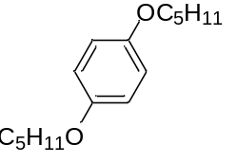
In a multi-neck flask, Potassium hydroxide (KOH) (219 mmol, 12.3 g) is dissolved in degassed ethanol (300 ml), and hydroquinone (84.3 mmol, 9.28 g) is subsequently added. The mixture is flushed with nitrogen and heated to reflux temperature. 2-Methylbutyl-p-toluenesulfonate (6b) (185 mmol, 45.0 g) is added dropwise via an addition funnel and the mixture is refluxed overnight. The solvent is removed via rotary evaporation and the product is dissolved in ethyl acetate. The organic phase is washed with brine and dried over MgSO4. After filtration, the solvent is evaporated under reduced pressure to obtain the crude product which is purified by column chromatography (SiO2, Hep/EA: 7.5/0.5). The pure product is obtained as faint yellow oil.
Quantity: 16.7 g
Yield: 79 %
¹H-NMR (400 MHz, CDCl₃): δ6.82 (s, 4H), 3.72 (m, 4H), 1.83 (m, 2H), 1.56 (m, 2H), 1.25 (m, 2H), 1.00 (d, J = 6.77 Hz, 2H), 0.94 (t, J = 7.48 Hz, 6H)
¹³C-NMR (100 MHz, CDCl₃): δ153.38, 115.41, 73.64, 34.80, 26.17, 16.55, 11.32
1,4-dibromo-2,5-di(2-methylbutyloxy)benzene (2b)
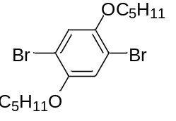
The synthesis is performed analogously to the synthesis of 1,4-dibromo-2,5-di(octyloxy)benzene (2a) with 1,4-di(2-methylbutyl)benzene (1b) (66.7 mmol, 16.7 g) in DCM (200 mL) and bromine (133 mmol, 21.3 g). The product did not require any purification and is obtained as a clear oil.
Quantity: 23.0 g
Yield: 84.4 %
¹H-NMR (400 MHz, CDCl₃): δ7.07 (s, 2H), 3.77 (m, 4H), 1.89 (m, 2H), 1.59 (m, 2H), 1.30 (m, 2H), 1.04 (d, J = 6.76 Hz, 6H), 0.95 (t, J = 7.45 Hz, 6H)
¹³C-NMR (100 MHz, CDCl₃): δ150.14, 118.28, 111.08, 74.94, 34.78, 26.05, 16.54, 11.33

4-bromo-2,5-di(2-methylbutyloxy)benzaldehyde (3b)
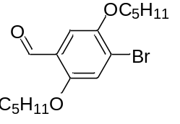
The synthesis is performed analogously to the synthesis of 4-bromo-2,5-di(octyloxy)benzaldehyde (3a) with 1,4-dibromo-2,5-di(2-methylbutyloxy)benzene (2b) (56.3 mmol, 23.0 g) in Et₂O (200 mL), n-BuLi (2.5 M in hexanes) (56.9 mmol, 22.7 mL) and, DMF (74.9 mmol, 5.80 mL). The purified product is obtained as viscous yellow oil.
Quantity: 14.9 g
Yield: 74 %
¹H-NMR (400 MHz, CDCl₃): δ10.43 (s, 1H), 7.30 (s, 1H), 7.22 (s, 1H), 3.76-3.92 (m, 4H), 1.91 (m, 2H), 1.51-1.65 (m, 2H), 1.24-1.38 (m, 2H), 1.05 (d, J = 6.76 Hz, 3H), 1.04 (d, J = 6.76 Hz, 2H), 0.96 (t, J = 7.48 Hz, 3H), 0.95 (t, J = 7.58 Hz, 3H)
¹³C-NMR (100 MHz, CDCl₃): δ188.90, 155.90, 149.99, 124.29, 121.04, 118.41, 110.45, 74.50, 74.11, 34.77, 34.71, 26.10, 26.07, 16.57, 16.55, 11.33, 11.30
HRMS (m/z): [M]+ calcd. For C₁₇H₂₅O₃Br₁, 356.0987; found 356.0978

2,5-di(2-methylbutyloxy)-4-(4,4,5,5-tetramethyl-1,3,2-dioxaborolan-2-yl)benzaldehyde (M//(rac))
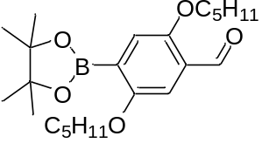
The synthesis is performed analogously to the synthesis of 2,5-di(octyloxy)-4-(4,4,5,5-tetramethyl- 1,3,2-dioxaborolan-2-yl)benzaldehyde (O//) with 4-bromo-2,5-di(2-methylbutyloxy)benzaldehyde (3b) (41.3 mmol, 14.7 g), B₂Pin₂ (49.5 mmol, 12.6 g), KOAc (124 mmol, 12.2 g) and Pd(dppf)Cl₂.DCM (825 µmol, 674 mg) in 1,4-dioxane (100 mL). The purified product is obtained as brown solid with a yellow shade.
Quantity: 12.7 g
Yield: 76 %
Melting point range 45-49 °C
¹H-NMR (400 MHz, CDCl₃): δ10.50 (s, 1H), 7.24 (s, 1H), 7.21 (s, 1H), 3.85-3.97 (m, 2H), 3.70-3.85 (m, 2H), 1.88 (m, 2H), 1.53-1.67 (m, 2H), 1.36 (s, 12H), 1.29 (m, 2H), 1.04 (d, J = 6.81 Hz, 3H), 1.03 (d, J = 6.81 Hz, 3H), 0.96 (t, J = 7.57 Hz, 3H), 0.94 (t, J = 7.50 Hz, 3H)
¹³C-NMR (100 MHz, CDCl₃): δ190.10, 157.42, 155.66, 126.82, 120.34, 108.89, 83.97, 73.81, 73.63, 34.97, 29.71, 26.17, 25.99, 24.91, 24.87, 16.68, 16.42, 11.38
HRMS (m/z): [M]+ calcd. For C₂₃H₃₇B₁O₅, 403.2770; found 403.2776

4-bromo-2,5-di(2-methylbutyloxy)benzyl alcohol (4b)
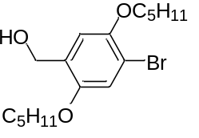
The synthesis is performed analogously to the synthesis of 4-bromo-2,5-di(octyloxy)benzyl alcohol (4a) with NaBH₄ (11.1 mmol, 420 mg) in Et₂O (15 mL) and EtOH (10 mL) and 4-bromo-2,5-di(2-methylbutyloxy)benzaldehyde (3b) (5.54 mmol, 1.98 g) in Et₂O (10 mL). The purified product is obtained as faint yellow oil.
Quantity: 1.75 g
Yield: 88 %
¹H-NMR (400 MHz, CDCl₃): δ7.04 (s, 1H), 6.90 (s, 1H), 4.64 (d, J = 6.24 Hz, 2H), 3.70-3.87 (m, 4H), 2.21 (t, J = 6.24 Hz, 1H), 1.88 (m, 2H), 1.48-1.66 (m, 2H), 1.29 (m, 2H), 1.05 (d, J = 6.76 Hz, 3H), 1.02 (d, J = 6.76 Hz, 3H), 0.95 (2xt, J = 7.34 Hz, 6H)
¹³C-NMR (100 MHz, CDCl₃): δ150.98, 149.72, 129.27, 116.42, 114.21, 111.14, 74.94, 73.58, 61.71, 34.86, 34.76, 26.20, 26.09, 16.66, 16.57, 11.34, 11.31
HRMS (m/z): [M]+ calcd. For C₁₇H₂₇O₃Br₁, 358.1144; found 358.1155

4-bromo-2,5-di(2-methylbutyloxy)benzyl chloride (5b)
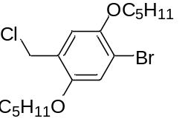
The synthesis is performed analogously to the synthesis of 4-bromo-2,5-di(octyloxy)benzyl chloride (5a) with 4-bromo-2,5-di(2-methylbutyl)benzyl alcohol (4b) (4.86 mmol, 1.75 g) in toluene (15 mL), SOCl₂ (24.3 mmol, 1.80 mL) and a catalytic amount of DMF. The purified product is obtained as a clear oil.
Quantity: 1.45 g
Yield: 79 %
¹H-NMR (600 MHz, CDCl₃): δ7.06 (s, 1H), 6.92 (s, 1H), 4.60 (s, 2H), 3.72-3.86 (m, 4H), 1.89 (m, 2H), 1.54-1.64 (m, 2H), 1.30 (m, 2H), 1.05 (d, J = 7.02 Hz, 3H), 1.04 (d, J = 7.14 Hz, 3H), 0.96 (t, J = 7.50 Hz, 3H), 0.95 (t, J = 7.50 Hz, 3H)
¹³C-NMR (150 MHz, CDCl₃): δ151.11, 149.61, 125.74, 117.10, 115.61, 112.88, 74.88, 73.83, 41.24, 34.87, 34.82, 26.11, 26.09, 16.62, 16.58, 11.37, 11.34
HRMS (m/z): [M]+ calcd. For C₁₇H₂₆O₂Cl₁Br₁, 376.0805; found 376.0821

Diethyl 4-bromo-2,5-di(2-methylbutyloxy)benzyl phosphonate (M(rac))
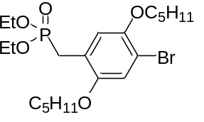
The synthesis is performed analogously to the synthesis of Diethyl (4-bromo-2,5-di(octyloxy))benzyl phosphonate (O) with 4-bromo-2,5-di(2-methylbutyloxy)benzyl chloride (5b) (7.95 mmol, 3.00 g) in P(OEt)₃ (39.8 mmol, 6.80 mL). The purified product is obtained as clear oil.
Quantity: 3.27 g
Yield: 88 %
¹H-NMR (600 MHz, CDCl₃): δ7.03 (s, 1H), 6.97 (d, J = 2.70 Hz, 1H), 4.03 (m, 4H), 3.66-3.85 (m, 4H), 3.19 (d, J = 21.77 Hz, 2H), 1.87 (m, 2H), 1.58 (m, 2H), 1.29 (m, 2H), 1.25 (t, J = 7.09 Hz, 6H), 1.04 (d , J = 6.67 Hz, 3H), 1.03 (d, J = 6.67 Hz, 3H), 0.95 (t, J = 7.47 Hz, 6H)
¹³C-NMR (150 MHz, CDCl₃): δ151.10, 151.05, 149.45, 149.43, 120.30, 120.24, 116.79, 116.77, 116.53, 116.49, 110.65, 110.62, 74.74, 73.95, 61.98, 61.93, 34.89, 34.85, 26.77, 26.14, 26.09, 25.85, 16.67, 16.56, 16.40, 16.36, 11.35, 11.34
³¹P-NMR (243 MHz, CDCl₃): δ26.44 (s, 1P)
HRMS (m/z): [M]+ calcd. For C₂₁H₃₆O₅Br₁P₁, 478.1484; found 478.1466

    - S-chiral 2-methylbutyl side chain phenyl monomers
(S)-2-methylbutyl-p-toluenesulfonate (6c)
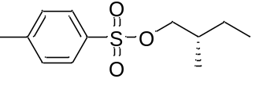
The synthesis is performed analogously to the synthesis of 2-methylbutyl-p-toluenesulfonate (6b) with (S)-2-methylbutanol (200 mmol, 17.6 g) and triethylamine (250 mmol, 25.3 g) in DCM (200 mL) and TsCl (300 mmol, 57.1 g) in DCM (150 mL). The purified product is obtained as clear oil.
Quantity: 34.6 g
Yield: 72%
¹H-NMR (400 MHz, CDCl₃): δ7.79 (d, J = 8.42Hz, 2H), 7.34 (d, J=8.42 Hz, 2H), 3.85 (m, 2H), 2.45 (s, 3H), 1.70 (m, 1H), 1.39 (m, 1H), 1.14 (m, 1H), 0.88 (d, J = 6.80 Hz, 3H), 0.83 (t, J = 7.52 Hz, 3H)
¹³C-NMR (100 MHz, CDCl₃): δ144.61, 133.18, 129.79, 127.90, 74.83, 34.35, 25.43, 21.65, 15.96, 10.96

1,4-di((S)-2-methylbutyloxy)benzene (1c)
The synthesis is performed analogously to the synthesis of 1,4-di(2-methylbutyl)benzene (1b) with potassium hydroxide (149 mmol, 10.8 g), hydroquinone (64.9 mmol, 7.15 g) dissolved in EtOH (200 mL) and (S)-2-methylbutyl-p-toluenesulfonate (6c) (143 mmol, 34.6 g). The purified product is obtained as light yellow oil.
Quantity: 13.5 g
Yield: 83 %
¹H-NMR (400 MHz, CDCl₃): δ6.81 (s, 4H), 3.72 (m, 4H), 1.83 (m, 2H), 1.53 (m, 2H), 1.25 (m, 2H), 1.01 (d, J = 6.83 Hz, 2H), 0.93 (t, J = 7.46 Hz, 6H)
¹³C-NMR (100 MHz, CDCl₃): δ153.39, 115.41, 73.65, 34.80, 26.17, 16.55, 11.32

1,4-dibromo-2,5-di((S)-2-methylbutyloxy)benzene (2c)
The synthesis is performed analogously to the synthesis of 1,4-dibromo-2,5-di(octyloxy)benzene (2a) with 1,4-di((S)-2-methylbutyl)benzene (1c) (53.9 mmol, 13.5 g) in DCM (150 mL) and bromine (108 mmol, 17.2 g). The product did not require any purification and is obtained as white crystals.
Quantity: 18.5 g
Yield: 85 %
¹H-NMR (400 MHz, CDCl₃): δ7.07 (s, 2H), 3.77 (m, 4H), 1.89 (m, 2H), 1.59 (m, 2H), 1.30 (m, 2H), 1.05 (d, J = 6.74 Hz, 6H), 0.95 (t, J = 7.45 Hz, 6H)
¹³C-NMR (100 MHz, CDCl₃): δ150.14, 118.28, 111.08, 74.95, 34.79, 26.05, 16.55, 11.34

4-bromo-2,5-di((S)-2-methylbutyloxy)benzaldehyde (3c)
The synthesis is performed analogously to the synthesis of 4-bromo-2,5-di(octyloxy)benzaldehyde (3a) with 1,4-dibromo-2,5-di((S)-2-methylbutyloxy)benzene (2c) (40.9 mmol, 16.7 g) in Et₂O (250 mL), n-BuLi (2.5 M in hexanes) (41.3 mmol, 16.5 mL) and, DMF (54.4 mmol, 4.25 mL). The pure product is obtained as viscous yellow oil.
Quantity: 10.5 g
Yield: 98 %
¹H-NMR (400 MHz, CDCl₃): δ10.43 (s, 1H), 7.30 (s, 1H), 7.22 (s, 1H), 3.76-3.91 (m, 4H), 1.92 (m, 2H), 1.51-1.65 (m, 2H), 1.25-1.38 (m, 2H), 1.05 (d, J = 6.76 Hz, 3H), 1.04 (d, J = 6.76 Hz, 2H), 0.96 (t, J = 7.46 Hz, 3H), 0.95 (t, J = 7.46 Hz, 3H)
¹³C-NMR (100 MHz, CDCl₃): δ188.91, 155.90, 149.99, 124.29, 121.05, 118.42, 110.45, 74.51, 74.12, 34.77, 34.72, 26.10, 26.08, 16.57, 16.55, 11.33, 11.31
HRMS (m/z): [M]+ calcd. For C₁₇H₂₅O₃Br₁, 356.0987; found 356.0999

2,5-di((S)-2-methylbutyloxy)-4-(4,4,5,5-tetramethyl-1,3,2-dioxaborolan-2-yl)benzaldehyde (M//(S))
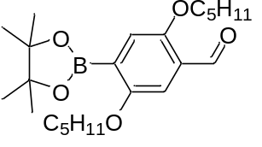
The synthesis is performed analogously to the synthesis of 2,5-di(octyloxy)-4-(4,4,5,5-tetramethyl- 1,3,2-dioxaborolan-2-yl)benzaldehyde (M//(rac) with 4-bromo-2,5-di((S)-2-methylbutoxy)benzaldehyde (3c) (31.3 mmol, 11.2 g), B₂Pin₂ (47.0 mmol, 11.9 g), KOAc (93.9 mmol, 9.22 g) and Pd(dppf)Cl₂.DCM (626 µmol, 511 mg) in 1,4-dioxane (100 mL). The purified product is obtained as brown solid with yellow shade.
Quantity: 9.50 g
Yield: 87 %
Melting point range 35-39 °C
¹H-NMR (600 MHz, CDCl₃): δ10.50 (s, 1H), 7.24 (s, 1H), 7.21 (s, 1H), 3.85-3.96 (m, 2H), 3.72-3.84 (m, 2H), 1.82-1.94 (m, 2H), 1.53-1.67 (m, 2H), 1.36 (s, 12H), 1.30 (m, 2H), 1.04 (d, J = 6.83 Hz, 3H), 1.03 (d, J = 6.61 Hz, 3H), 0.96 (t, J = 7.51 Hz, 3H), 0.94 (t, J = 7.51 Hz, 3H)
¹³C-NMR (150 MHz, CDCl₃): δ190.10, 157.42, 155.66, 126.82, 120.34, 108.89, 83.97, 73.81, 73.63, 34.97, 29.71, 26.17, 25.99, 24.91, 24.87, 16.68, 16.42, 11.38
HRMS (m/z): [M]+ calcd. For C₂₃H₃₇B₁O₅, 403.2770; found 403.2776
    - Phenanthrene monomers
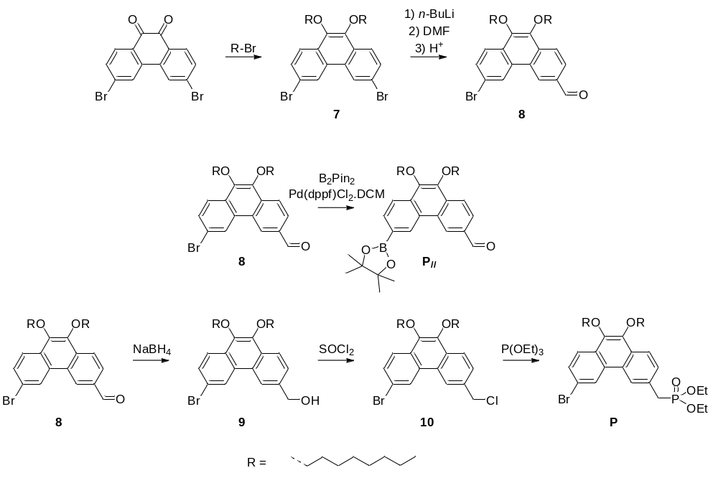
3,6-dibromo-9,10-di(octyloxy)phenanthrene (7)⁴
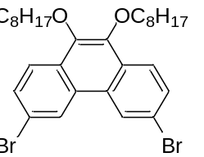
In a multi-neck flask, 3,6-dibromophenanthrene-9,10-dione (10.0 mmol, 3.66 g) and tetrabutylammonium bromide (3.30 mmol, 1.06 g) are dissolved in a mixture of 40 mL H₂O and 60 mL THF. Next, Na₂S₂O₄ (33.3 mmol, 5.80 g) is added stepwise and the resulting mixture was stirred for 15 min followed by the addition of KOH (76.0 mmol, 4.26 g). The solution is purged with nitrogen and heated to reflux temperature. Afterwards, 1-bromooctane (40 mmol, 7.7252 g) is added dropwise via an addition funnel and stirred for 16 hours. The solution is extracted with Et₂O and the combined organic phase is consecutively washed with a saturated NaHCO₃ solution, and a saturated NaCl solution and dried over MgSO₄. After filtration, the solvent is evaporated under reduced pressure to obtain the crude product which is purified by column chromatography (SiO₂, H). The pure product is obtained as white solid.

Quantity: 3.91 g
Yield: 66 %
¹H-NMR (400 MHz, CDCl3): δ8.64 (d, J = 1.87 Hz, 2H), 8.09 (d, J = 8.74 Hz, 2H), 7.70 (dd, J = 1.87 Hz, J = 8.74 Hz, 2H), 4.17 (t, J = 6.78 Hz, 4H), 1.88 (m, 4H), 1.53 (m, 4H), 1.43-1.23 (m, 16H), 0.89 (t, J = 6.83 Hz, 6H)
¹³C-NMR (100 MHz, CDCl₃): δ143.16, 130.46, 128.87, 128.76, 125.39, 124.22, 120.31, 73.76, 31.84, 30.43, 29.47, 29.30, 26.22, 22.67, 14.11

6-bromo-9,10-di(octyloxy)phenanthrene-3-carbaldehyde (8)
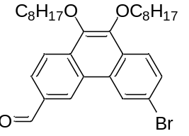
The synthesis is performed analogously to the synthesis of 4-bromo-2,5-di(octyloxy)benzaldehyde (3a) with 3,6-dibromo-9,10-di(octyloxy)phenanthrene (7) (22.7 mmol, 13.5 g) in Et₂O (90 mL), n-BuLi (2.5 M in hexanes) (22.7 mmol, 9.08 mL) and, DMF (29.5 mmol, 2.29 mL). The purified product is obtained as a white solid with a yellow shade.
Quantity: 7.62 g
Yield: 62 %
Melting point range 55-57 °C
¹H-NMR (600 MHz, CDCl₃): δ10.25 (s, 1H), 9.03 (d, J = 1.56 Hz, 1H), 8.84 (d, J = 1.83 Hz, 1H), 8.35 (d, J = 8.52 Hz, 1H), 8.15 (d, J = 8.61 Hz, 1H), 8.10 (dd, J = 1.56 Hz, J = 8.52 Hz, 1H), 7.76 (dd, J = 1.83 Hz, J = 8.61 Hz, 1H), 4.26 (t, J = 6.73 Hz, 2H), 4.18 (t, J = 6.76 Hz, 2H), 1.90 (m, 4H), 1.55 (m, 4H), 1.43-1.25 (m, 16H), 0.89 (t, J = 6.85 Hz, 6H)
¹³C-NMR (100 MHz, CDCl₃): δ192.10, 145.96, 142.94, 134.36, 133.62, 130.66, 130.22, 128.61, 127.08, 126.90, 125.98, 125.46, 124.51, 123.33, 121.09, 73.93, 73.87, 31.84, 30.45, 30.42, 29.48, 29.46, 29.30, 26.22, 26.20, 22.67, 14.11 ,14.11
HRMS (m/z): [M]+ calcd. For C₃₁H₄₁O₃Br₁, 540.2239; found 540.2228

3-bromo-6-(hydroxymethyl)-9,10-di(octyloxy)phenanthrene (9)
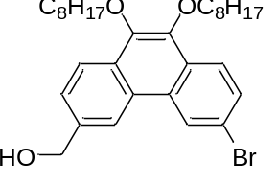
The synthesis is performed analogously to the synthesis of 4-bromo-2,5-di(octyloxy)benzyl alcohol (4a) with NaBH₄ (11.0 mmol, 414 mg) in Et₂O (15 mL) and EtOH (5 mL) and 6-bromo-9,10-di(octyloxy)phenanthrene-3-carbaldehyde (8) (3.65 mmol, 1.98 g) in Et2O (20 mL). The purified product is obtained as white crystal.
Quantity:
Yield: 80.9%
Melting point range 72-73 °C
¹H-NMR (600 MHz, CDCl₃): δ8.77 (d, J = 1.88 Hz, 1H), 8.52 (brd, s, 1H), 8.23 (d, J = 8.40 Hz, 1H), 8.10 (d, J = 8.74 Hz, 1H), 7.69 (dd, J = 1.88 Hz, J = 8.74 Hz, 1H), 7.63 (dd, J = 1.38 Hz, J = 8.40 Hz, 1H), 4.96 (d, J = 5.80 Hz, 2H), 4.19 (t, J = 6.80 Hz, 2H), 4.18 (t, J = 6.68 Hz, 2H), 1.89 (m, 4H), 1.83 (t, J = 5.96 Hz, 1H), 1.54 (m, 4H), 1.42-1.26 (m, 16H), 0.89 (t, J = 6.84 Hz, 6H)
¹³C-NMR (150 MHz, CDCl₃): δ143.41, 142.93, 138.49, 129.90, 129.57, 128.49, 127.56, 126.39, 125.41, 124.19, 122.84, 120.76, 120.03, 73.76, 73.70, 65.60, 31.85, 30.47, 29.50, 29.31, 26.24, 22.68, 14.11
HRMS (m/z): [M]+ calcd. For C₃₁H₄₃O₃Br₁, 542.2396; found 542.2415

3-bromo-6-(chloromethyl)-9,10-di(octyloxy)phenanthrene (10)
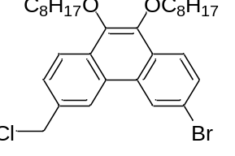
The synthesis is performed analogously to the synthesis of 4-bromo-2,5-di(octyloxy)benzyl chloride (5a) with 3-bromo-6-(hydroxymethyl)-9,10-di(octyloxy)phenanthrene (9) (2.95 mmol, 1.61 g) in toluene (90 mL), SOCl₂ (8.86 mmol, 643 µL) and a catalytic amount of DMF. The purified product is obtained as a clear oil.
Quantity: 1.66 g
Yield: 100 %
¹H-NMR (600 MHz, CDCl₃): δ8.73 (d, J = 1.63 Hz, 1H), 8.51 (brd, s, 1H), 8.23 (d, J = 8.40 Hz, 1H), 8.10 (d, J = 8.80 Hz, 1H), 7.69 (dd, J = 1.63, 8.80 Hz, 1H), 7.65 (dd, J = 1.37, 8.40 Hz, 1H), 4.84 (s, 2H), 4.19 (t, J = 6. 82 Hz, 2H), 4.18 (t, J = 6.66 Hz, 2H), 1.89 (m, 4H), 1.54 (m, 4H), 1.42-1.27 (m, 16H), 0.89 (t, J = 6..87 Hz, 6H)
¹³C-NMR (150 MHz, CDCl₃): δ143.44, 143.27, 135.00, 130.09, 130.00, 129.73, 128.57, 127.69, 127.44, 125.35, 124.25, 123.19, 122.76, 120.21, 73.78, 73.73, 46.69, 31.93, 31.85, 30.45, 29.71, 29.66, 29.49, 29.37, 29.31, 26.24, 22.68, 14.11
HRMS (m/z): [M]+ calcd. For C₃₁H₄₂O₂Cl₁Br₁, 560.2057; found 560.2062

Diethyl ((6-bromo-9,10-di(octyloxy)phenanthrene-3-yl)methyl)phosphonate (P)
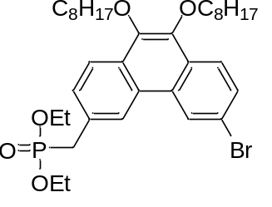
The synthesis is performed analogously to the synthesis of diethyl (4-bromo-2,5-di(octyloxy))benzyl phosphonate (O) with 3-bromo-6-(chloromethyl)-9,10-di(octyloxy)phenanthrene (10) (2.95 mmol, 1.66 g) in P(OEt)₃ (14.8 mmol, 2.53 mL). The purified product is obtained as a brownish viscous oil.
Quantity: 1.94 g
Yield: 99 %
¹H-NMR (600 MHz, CDCl₃): δ8.73 (d, J = 1.87 Hz, 1H), 8.44 (brd, s, 1H), 8.18 (d, J = 8.50 Hz, 1H), 8.09 (d, J = 8.74 Hz, 1H), 7.68 (dd, J = 1.87 Hz, J = 8.74 Hz, 1H), 7.59 (dt , J = 1.67 Hz, 8.50 Hz, 1H), 4.18 (t, J = 6.84 Hz, 2H), 4.17 (t, J = 6.84 Hz, 2H), 4.04 (m, 4H), 3.40 (d, J = 21.63 Hz, 2H), 1.89 (m, 4H), 1.55 (m, 4H), 1.42-1.27 (m, 16H), 1.26 (t, J = 7.09 Hz, 6H), 0.89 (t, J = 6.82 Hz, 6H)
¹³C-NMR (150 MHz, CDCl₃): δ143.39, 142.78, 129.91, 129.69, 129.46, 129.40, 129.18, 129.14, 128.93, 128.51, 127.62, 125.38, 124.14, 123.70, 123.64, 122.75, 120.01, 73.74, 73.67, 62.27, 62.23, 34.63, 33.72, 31.85, 30.48, 30.46, 29.71, 29.51, 29.50, 29.32, 26.24, 22.68, 16.46, 16.42, 14.11
³¹P-NMR (243 MHz, CDCl₃): δ26.13 (s, 1P)
HRMS (m/z): [M]+ calcd. For C₃₅H₅₂O₅P₁Br₁, 662.2736; found 662.2766

9,10-di(octyloxy)-6-(4,4,5,5-tetramethyl-1,3,2-dioxaborolan-2-yl)phenanthrene-3-carbaldehyde (P//)
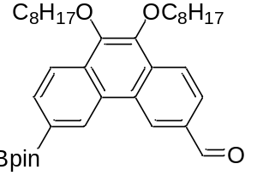
The synthesis is performed analogously to the synthesis of 2,5-di(octyloxy)-4-(4,4,5,5-tetramethyl- 1,3,2-dioxaborolan-2-yl)benzaldehyde (O//) with 6-bromo-9,10-di(octyloxy)phenanthrene-3-carbaldehyde (8) (5.98 mmol, 3.24 g), B₂Pin₂ (7.77 mmol, 1.97 g), KOAc (17.9 mmol, 1.76 g) and Pd(dppf)Cl₂.DCM (120 µmol, 97.6 mg) in 1,4-dioxane (50 mL). The purified product is obtained as clear viscous oil.
Quantity: 2.18 g
Yield: 62 %
¹H-NMR (600 MHz, CDCl3): δ10.29 (s, 1H), 9.27 (brd, s, 1H), 9.18 (brd, s, 1H), 8.35 (d, J = 8.28 Hz, 1H), 8.26 (d, J = 8.28 Hz, 1H), 8.09 (d, J = 8.28 Hz, 1H), 8.07 (d, J = 8.28 Hz, 1H), 4.25 (t, J = 6.68 Hz, 2H), 4.21 (t, J = 6.68 Hz, 2H), 1.91 (m, 4H), 1.56 (m, 4H), 1.43 (s, 14H), 1.25-1.42 (m, 16H), 0.89 (t, J = 6.81 Hz, 6H)
¹³C-NMR (150 MHz, CDCl₃): δ192.58, 146.14, 143.77, 133.86, 133.57, 132.83, 131.96, 129.94, 128.54, 128.07, 127.43, 125.27, 123.19, 121.75, 84.17, 73.85, 31.85, 30.45, 29.49, 29.47, 29.31, 26.23, 24.96, 22.68, 14.11
HRMS (m/z): [M]+ calcd. For C₃₇H₅₃O₅B₁, 587.4022; found 587.4022

    - Starting molecule (S), branching molecule (V₂) and endcap molecule (E)
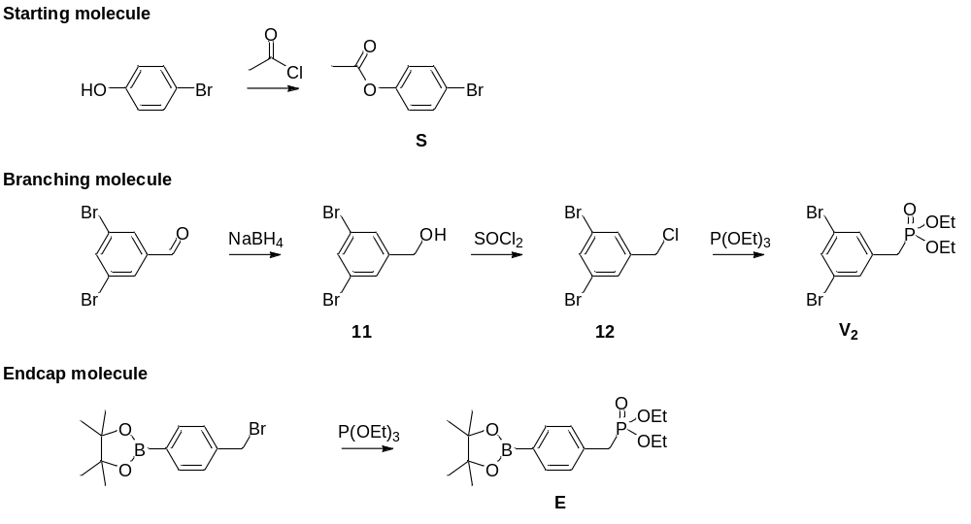
4-Bromophenyl acetate (S)⁵
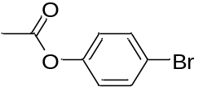
An oven dried flask is loaded with 4-bromophenol (5.00 mmol, 865 mg) dissolved in DCM (6.5 mL, 1.3 M) and cooled to 0 °C. Pyridine (6.50 mmol, 542 µL) was added to the solution immediately followed by acetyl chloride (6.00 mmol, 424 µL). The reaction mixture was allowed to warm to room temperature and monitored by TLC. The reaction mixture was washed with water, HCl solution (1 M), a saturated NaHCO₃ solution, and a saturated NaCl solution and dried over MgSO₄. After filtration, the solvent is evaporated under reduced pressure to obtain the crude product which is purified by column chromatography (SiO₂, Hep/EA: 6/2).
Quantity: 1.00 g
Yield: 93 %
¹H-NMR (400 MHz, CDCl₃): δ7.49 (d, J = 8.96 Hz, 2H), 6.98 (d, J = 8.96 Hz, 2H), 2.29 (s, 3H)

3,5-dibromobenzyl alcohol (11)
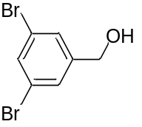
The synthesis is performed analogously to the synthesis of 4-bromo-2,5-di(octyloxy)benzyl alcohol (4a) with NaBH₄ (39.5 mmol, 1.50 g) in Et₂O (20 mL) and EtOH (5 mL) and 3,5-dibromobenzaldehyde (19.8 mmol, 5.22 g) in Et₂O (50 mL). The purified product is obtained as peached colored solid.
Quantity: 4.86 g
Yield: 93 %
¹H-NMR (400 MHz, CDCl₃): δ7.58 (m, 1H), 7.45 (m, 2H), 4.67 (s, 2H)
¹³C-NMR (100 MHz, CDCl₃): δ144.68, 133.08, 128.42, 123.07, 63.75

3,5-dibromobenzyl chloride (12)⁶
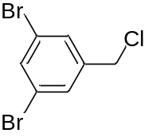
The synthesis is performed analogously as described in literature with 3,5-dibromobenzyl alcohol (11) (18.3 mmol, 4.86 g) in DCM (20 mL), SOCl₂ (54.9 mmol, 3.98 mL) and a catalytic amount of DMF. The crude product is purified by filtration through a plug of silica (SiO₂ Hep/EA: 6/2). The purified product is obtained as a clear oil.
Quantity: 5.20 g
Yield: 100 %
¹H-NMR (400 MHz, CDCl₃): δ7.63 (t, J = 1.68 Hz, 1H), 7.48 (d, J = 1.68 Hz, 2H), 4.49 (s, 1H)
¹³C-NMR (100 MHz, CDCl₃): δ140.98, 134.04, 130.32, 123.09, 44.24

Diethyl 3,5-dibromobenzylphosphonate (V₂)
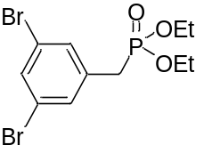
The synthesis is performed analogously to the synthesis of diethyl (4-bromo-2,5-di(octyloxy))benzyl phosphonate (O) with 3,5-dibromobenzyl chloride (12) (18.3 mmol, 5.20 g) in P(OEt)₃ (91.5 mmol, 1.68 mL). The purified product is obtained as colorless liquid.
Quantity: 5.41 g
Yield:76.6 %
¹H-NMR (300 MHz, CDCl₃): δ7.56 (m, 1H), 7.39 (m, 2H), 4.06 (m, 4H), 3.06 (d, J = 21.84 Hz, 2H), 1.28 (t, J = 714 Hz, 6H)

Diethyl 4-(4,4,5,5-tetramethyl-1,3,2-dioxaborolan-2-yl)benzylphosphonate (E)⁷
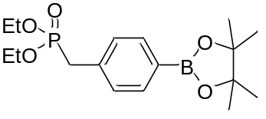
The synthesis is performed analogously to the synthesis of diethyl (4-bromo-2,5-di(octyloxy))benzyl phosphonate (O) with 2-(4-(bromomethyl)phenyl)-4,4,5,5-tetramethyl-1,3,2-dioxaborolane (5.00 mmol, 1.49 g) in P(OEt)₃ (25 mmol, 429 µL). The purified product is obtained as colorless oil.
Quantity: 1.77 g
Yield: 100 %
¹H-NMR (600 MHz, CDCl₃): δ7.50 (d, J = 7.94 Hz, 2H), 7.30 (dd, J = 2.48, 7.94 Hz, 2H), 4.00 (m, 4H), 3.17 (d, J = 21.95 Hz, 2H), 1.34 (s, 12H), 1.24 (t, J = 7.10 Hz, 6H)
¹³C-NMR (150 MHz, CDCl₃): δ134.97, 134.96, 134.87, 129.20, 129.16, 83.79, 62.19, 62.14, 34.56, 33.65, 24.88, 16.40, 16.36

  - Oligomer synthesis
General procedure A (Suzuki-Miyaura cross coupling)
An oven dried multi-neck flask is loaded with the growing macromolecule (1 eq.), the monomer (1.2 eq.), palladium(II)acetate (0.05 eq), RuPhos (0.25 eq.) and K₃PO₄ (3 eq.) and purged with N₂. Anhydrous degassed THF is added to establish a concentration of 0.2 M and water is added to a ratio of 50/1 relative to THF. Next, the reaction mixture is placed in a preheated oil bath of 65 °C and stirred for 30 minutes. Afterwards, the reaction is quenched with a saturated NH₄Cl solution and extracted with Et₂O. The combined organic phase is consecutively washed with a saturated NH₄Cl solution, a saturated NaHCO₃ solution, and a saturated NaCl solution and dried over Na₂SO₄. After filtration, the solvent is evaporated under reduced pressure to obtain the crude product which is purified as explained in the relevant section.
General procedure B (Horner-Wadsworth-Emmons coupling)
An oven dried flask is loaded with the growing macromolecule (1 eq.), and the monomer (1.1 eq.) under N₂ atmosphere and dissolved in anhydrous THF. Another dried flask is loaded with KOtBu (3 eq.) under N₂ atmosphere and suspended in anhydrous THF as well. The solution with both components is dropwise added to the base suspension through a canula and the reaction is stirred for 20 minutes and protected from light with Al-foil. A saturated solution of NH₄Cl is added to quench the reaction and extracted with Et₂O. The combined organic phase is consecutively washed with a saturated NH₄Cl solution, a saturated NaHCO₃ solution, and a saturated NaCl solution and dried over Na₂SO₄. After filtration, the solvent is evaporated under reduced pressure to obtain the crude product which is purified as explained in the relevant section.
SO//
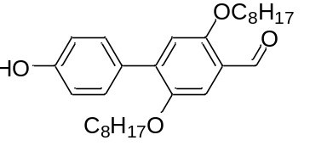
The synthesis is performed as described in general procedure A with 4-bromophenyl acetate (S) (2.00 mmol, 430 mg), 2,5-di(octyloxy)-4-(4,4,5,5-tetramethyl-1,3,2-dioxaborolan-2-yl)benzaldehyde (O//) (2.40 mmol, 1.17 g), Pd(OAc)₂ (100 µmol, 22.5 mg), RuPhos (500 µmol, 233 mg) and K₃PO₄ (6.00 mmol, 1.27 g) dissolved in a mixture of THF (10 mL) and water (0.2 mL). After quenching and work-up of the reaction, the crude product is dissolved in THF and a few mL of NaOH solution (1 M) is added to deprotect the hydroxyl group. The reaction is neutralized with HCl (1 M) and extracted with Et₂O. The combined organic phase is consecutively washed with a saturated NaHCO₃ solution, and a saturated NaCl solution and dried over Na₂SO₄. After filtration, the solvent is evaporated under reduced pressure to obtain the crude product which is purified by a filtration through a plug of silica (SiO₂, hep/EA 7.8/0.2). The pure product is obtained as a yellow solid.
Quantity: 884 mg
Yield: 97 %
¹H-NMR (600 MHz, CDCl₃): δ10.47 (s, 1H), 7.47 (d, J = 8.39 Hz, 2H), 7.38 (s, 1H), 6.93 (s, 1H), 6.89 (d, J = 8.58Hz, 2H), 5.08 (s, 1H), 4.06 (t, J = 6.55 Hz, 2H), 3.94 (t, J = 6.55 Hz, 2H), 1.83 (m, 2H), 1.69 (m, 2H), 1.47 (m, 2H), 1.20-1.39 (m, 18H), 0.88 (m, 6H)
¹³C-NMR (150 MHz, CDCl₃): δ189.49, 156.33, 155.48, 150.12, 138.60, 130.92, 130.09, 123.70, 115.39, 114.94, 110.53, 69.27, 69.09, 31.80, 31.78, 29.31, 29.25, 29.23, 29.21, 29.11, 26.08, 26.05, 22.66, 14.12, 14.10
HRMS (m/z): [M]+ calcd. For C₂₉H₄₂O₄, 454.3083; found 454.3099

SO//O
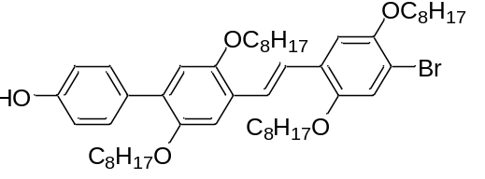
The synthesis is performed as described in general procedure B with SO// (4.00 mmol, 1.82 g) and diethyl (4-bromo-2,5-di(octyloxy))benzyl phosphonate (O) (4.40 mmol, 2.45 g) dissolved in THF ( 20 mL) and KOtBu (12.0 mmol, 1.35 g) suspended in THF (10 mL). The crude product is dissolved in a minimal amount of DCM and added to EtOH at room temperature to precipitate the product. The purified product is obtained as fluffy light yellow solid.
Quantity: 2.83 g
Yield: 82 %
¹H-NMR (600 MHz, CDCl₃): δ7.47 (d, J = 8.94 Hz, 2H), 7.45 (d, J = 16.60 Hz, 1H), 7.39 (d, J = 16.60 Hz, 1H), 7.18 (s, 1H), 7.15 (s,1H), 7.08 (s, 1H), 6.87 (d, J = 8.80 Hz, 2H), 6.86 (s, 1H), 4.71 (s, 1H), 4.03 (t, J = 6.35 Hz, 2H), 4.00 (t, J = 6.35 Hz, 2H), 3.96 (t, J = 6.35 Hz, 2H), 3.92 (t, J = 6.35 Hz, 2H), 1.83, (m, 6H), 1.69 (m, 2H), 1.50 (m, 6H), 1.21-1.40 (m, 34H), 0.88 (m, 12H)

¹³C-NMR (150 MHz, CDCl₃): δ154.63, 151.05, 150.24, 149.84, 131.08, 130.91, 130.76, 127.40, 124.18, 123.06, 117.87, 115.44, 114.81, 111.73, 111.55, 111.50, 70.27, 69.63, 69.59, 69.53, 31.87, 31.85, 31.81, 29.51, 29.42, 29.36, 29.34, 29.32, 29.30, 29.27, 26.22, 26.17, 26.15, 26.08, 22.67, 14.12, 14.09
HRMS (m/z): [M]+ calcd. For C₅₂H₇₉O₅Br₁, 862.5111; found 862.5132

SO//OO//
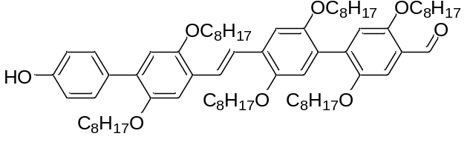
The synthesis is performed as described in general procedure A with (SO//O) (500 µmol, 432 mg), 2,5-di(octyloxy)-4-(4,4,5,5-tetramethyl-1,3,2-dioxaborolan-2-yl)benzaldehyde (O//) (600 µmol, 293 mg), Pd(OAc)₂ (25.0 µmol, 5.60 mg), RuPhos (150 µmol, 70.0 mg) and K₃PO₄ (1.50 mmol, 318 mg) dissolved in a mixture of THF (2.50 mL) and water (50.0 µL). The crude product is purified by recrystallization from MeOH. The purified product is obtained as yellow solid.
Quantity: 571 mg
Yield: 100 %
¹H-NMR (600 MHz, CDCl₃): δ10.50 (s, 1H), 7.53 (d, J = 16.90 Hz, 1H), 7.50 (d, J = 16.90 Hz, 1H), 7.48 (d, 8.60 Hz, 2H), 7.38 (s, 1H), 7.23 (s, 1H), 7.03 (s, 1H), 6.90 (s, 1H), 6.88 (s, 1H), 6.88 (d, J = 8.53 Hz, 2H), 4.88 (s, 1H), 4.03 (t, J = 6.37 Hz, 2H), 4.02 (t, J = 6.47 Hz, 2H), 3.97 (t, J = 6.58 Hz, 2H), 3.90-3.95 (m, 6H), 1.83 (m, 6H), 1.1 7(m, 2H), 1.64 (m, 4H), 1.49 (m, 6H), 1.17-1.42 (m, 54H), 084-0.91 (m, 18H)
¹³C-NMR (150 MHz, CDCl₃): δ 189.59, 155.69, 154.66, 151.08, 150.65, 150.45, 150.35, 150.26, 136.18, 131.09 , 130.77, 127.82, 126.89, 126.63, 123.98, 123.83, 123.48, 117.02, 116.30, 115.48, 114.82, 111.49, 111.09, 110.17, 69.62, 69.54, 69.18, 31.89, 31.82, 29.55, 29.51, 29.47, 29.44, 29.40, 29.36, 29.34, 29.30, 29.28, 29.26, 26.27, 26.22, 26.17, 26.13, 26.06, 22.67, 14.13, 14.10
HRMS (m/z): [M]+ calcd. For C₇₅H₁₁₆O₈, 1144.8670; found 1144.8680

SM// (rac)
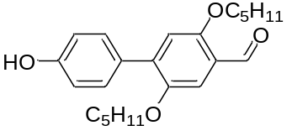
The synthesis is performed as described in general procedure A with 4-bromophenyl acetate (S) (200 µmol, 43.0 mg), 2,5-di(2-methylbutyloxy)-4-(4,4,5,5-tetramethyl-1,3,2-dioxaborolan-2-yl)benzaldehyde (M//(rac)) (240 µmol, 97.0 mg), Pd(OAc)₂ (10.0 µmol, 2.25 mg), RuPhos (50.0 µmol, 23.3 mg) and K₃PO₄ (600 µmol, 127 mg) dissolved in a mixture of THF (1.00 mL) and water (20.0 µL). After quenching and work-up of the reaction, the crude product is dissolved in THF and a few mL of NaOH solution (1 M) is added to deprotect the hydroxyl group. The reaction is neutralized with HCl (1 M) and extracted with Et₂O. The combined organic phase is consecutively washed with a saturated NaHCO₃ solution, and a saturated NaCl solution and dried over Na₂SO₄. After filtration, the solvent is evaporated under reduced pressure to obtain the crude product which is purified by a filtration through a plug of silica (SiO₂, hep/EA 7.8/0.2). The pure product is obtained as a yellow solid.
Quantity: 527 mg
Yield: 71 %
¹H-NMR (400 MHz, CDCl₃): δ10.49 (s, 1H), 7.47 (d, J = 8.72 Hz, 2H), 7.37 (s, 1H), 6.93 (s, 1H), 6.89 (d, J = 8.72 Hz, 2H), 4.91 (s, 1H), 3.98 (m, 2H), 3.77 (m, 2H), 1.93 (m, 1H), 1.78 (m, 1H), 1.58 (m, 1H), 1.44(m, 1H), 1.13-1.38 (m, 2H), 1.05 (d, J = 6.79 Hz, 3H), 0.96 (t, J = 7.43 Hz, 3H), 0.92 (d, J = 6.70 Hz, 3H), 0.87 (t, J = 7.48 Hz, 3H)
¹³C-NMR (100 MHz, CDCl₃): δ189.36, 156.42, 155.39, 150.25, 138.65, 130.95, 130.15, 123.71, 115.29, 114.87, 110.29, 73.91, 73.87, 34.89, 34.73, 26.16, 26.10, 16.69, 16.64, 11.34, 11.26
HRMS (m/z): [M]+ calcd. For C₂₃H₃₀O₄, 370.2144; found 370.2148

SM//O (rac)
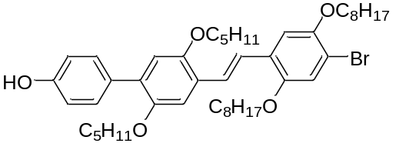
The synthesis is performed as described in general procedure B with SM//(rac) (114 µmol, 42.1 mg) and diethyl (4-bromo-2,5-di(octyloxy))benzyl phosphonate (O) (125 µmol, 70.4 mg) dissolved in THF (550 µL) and KOtBu (341 µmol, 38.2 mg) suspended in THF (550 µL). The crude product is purified by recrystallization from MeOH. The pure product is obtained as yellow solid.
Quantity: 56.7 mg
Yield: 64 %
¹H-NMR (400 MHz, CDCl₃): δ7.48 (d, J = 16.54 Hz, 1H), 7.47 (d, J = 8.71 Hz, 2H), 7.40 (d, J = 16.54 Hz, 1H), 7.18 (s, 1H), 7.17 (s,1H), 7.08 (s, 1H), 6.87 (d, J = 8.71 Hz, 2H), 6.86 (s, 1H), 4.74 (s, 1H), 4.03 (t, J = 6.59 Hz, 2H), 3.96 (t, J = 6.53 Hz, 2H), 3.87 (m, 1H), 3.80 (m, 2H), 3.71 (m, 1H), 1.93, (m, 1H), 1.88-1.72 (m, 5H), 1.62 (m, 1H), 1.48 (m, 5H), 1.14-1.42 (m, 18H), 1.07 (d, J = 6.79 Hz, 3H), 0.96 (t, J = 7.57 Hz, 3H), 0.94 (d, J = 6.73 Hz, 3H), 0.88 (m, 9H)
¹³C-NMR (100 MHz, CDCl₃): δ154.58, 151.09, 150.95, 150.39, 149.83, 131.11, 130.97, 130.82, 127.44, 126.25, 124.00, 122.67, 117.95, 115.39, 114.74, 111.41, 111.33, 111.07, 74.40, 74.28, 70.14, 69.66, 35.06, 34.92, 31.84, 29.37, 29.34, 29.32, 29.29, 29.27, 26.35, 26.13, 26.03, 22.68, 22.65, 16.83, 16.73, 14.12, 14.09, 11.45, 11.31
HRMS (m/z): [M]+ calcd. For C₄₆H₆₇O₅Br₁, 778.4172; found 778.4188

SM//OO// (rac)
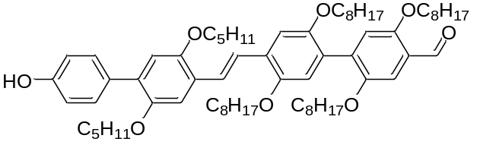
The synthesis is performed as described in general procedure A with (SM//O(rac)) (72.6 µmol, 56.7 mg), 2,5-di(octyloxy)-4-(4,4,5,5-tetramethyl-1,3,2-dioxaborolan-2-yl)benzaldehyde (O//) (87.2 µmol, 42.6 mg), Pd(OAc)₂ (3.63 µmol, 815 ng), RuPhos (18.2 µmol, 8.47 mg) and K₃PO₄ (218 µmol, 46.3 mg) dissolved in a mixture of THF (363 µL) and water (7.26 µL). The crude product is purified by recrystallization from MeOH followed by filtration through a plug of silica (SiO₂, Hep/EA 7.8/0.2). The purified product is obtained as yellow solid.
Quantity: 58.1 mg
Yield: 76 %
¹H-NMR (400 MHz, CDCl₃): δ10.50 (s, 1H), 7.56 (d, J = 16.48 Hz, 1H), 7.51 (d, J = 16.48 Hz, 1H), 7.48 (d, J = 8.64 Hz, 2H), 7.39 (s, 1H), 7.25 (s, 1H), 7.23 (s, 1H), 7.03 (s, 1H), 6.90 (s, 1H), 6.88 (d, J = 8.64 Hz, 1 H), 6.88 (s, 1H), 4.92 (s, 1H), 4.04 (t, J = 6.46 Hz, 2H), 3.98 (t, J = 6.52 Hz, 2H), 3.90 (m, 5H), 3.82 (m, 2H), 3.73 (m, 1H), 1.95 (m, 1H), 1.82 (m, 5H), 1.64 (m, 5H), 1.48 (m, 5H), 1.15-1.41 (m, 38H), 1.09 (d, J = 6.72 Hz, 3H), 0.98 (t, J = 7.66 Hz, 3H), 0.95 (d, J = 6.80 Hz, 3H), 0.87 (m, 15H)
¹³C-NMR (100 MHz, CDCl₃): δ189.83, 155.80, 154.88, 151.12, 150.67, 150.46, 150.43, 150.26, 136.33, 130.97, 130.93, 130.81, 127.92, 126.78, 126.49, 123.93, 123.70, 123.03 , 117.04, 116.42, 115.46, 114.80, 111.05, 110.67, 110.23, 74.46, 74.33, 69.62, 69.50, 69.20, 35.12, 34.95, 31.83, 29.54, 29.48, 29.47, 29.36, 29.31, 29.28, 29.27, 26.38, 26.25, 26.18, 26.14, 26.09, 22.68, 16.86, 16.76, 14.11, 11.48, 11.34
HRMS (m/z): [M]+ calcd. For C₆₉H₁₀₄O₈, 1060.7731; found 1060.7737

SO//M (rac)
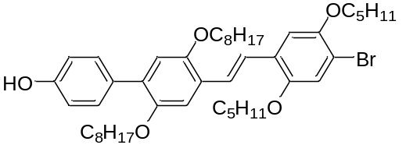
The synthesis is performed as described in general procedure B with SO// (900 µmol, 409.2 mg) and diethyl (4-bromo-2,5-di(octyloxy))benzyl phosphonate (M//(rac)) (990 µmol, 475 mg) dissolved in THF ( 2.5 mL) and KOtBu (0.27 mmol, 0.303 g) suspended in THF (2.5 mL). The crude product is dissolved in 20 mL of CHCl₃ and a catalytic amount of I₂ at 50 °C. The reaction was monitored by ¹H-NMR to follow the conversion until 100 %. The crude product was purified filtered through a plug of silica (SiO₂, hep/EA 7/1) followed by a recrystallization from MeOH. The pure product is obtained as yellow solid.
Quantity: 504 mg
Yield: 72 %
¹H-NMR (600 MHz, CDCl₃): δ7.48 (d, J = 8.58 Hz, 2H), 7.47 (d, J = 16.80 Hz, 1H), 7.41 (d, J = 16.80 Hz, 1H), 7.20 (s, 1H), 7.15 (s, 1H), 7.08 (s, 1H), 6.87 (s, 1H), 6.87 (d, J = 8.58 Hz, 2H), 4.77 (s, 1H), 4.01 (t, J = 6.51 Hz, 2H), 3.93 (t, J = 6.42 Hz, 2H), 3.91 (m, 1H), 3.83 (m, 2H), 3.76 (m, 1H), 1.93 (m, 2H), 1.83 (m, 2H), 1.70 (m, 2H), 1.63 (m, 2H), 1.49 (m, 2H), 1.21-1.41 (m, 20H), 1.08 (d, J = 6.72 Hz, 3H), 1.07 (d, J = 6.78 Hz, 3H), 0.98 (t, J = 7.47 Hz, 3H), 0.97 (t, J = 7.29 Hz, 3H), 0.88 (t, J = 6.99 Hz, 3H), 0.86 (t, J = 6.84 Hz, 3H)
¹³C-NMR (150 MHz, CDCl₃): δ154.62, 151.05, 150.97, 150.24, 149.94, 131.06, 130.84, 130.76, 127.28, 126.37, 123.77, 122.85, 117.85, 115.52, 114.81, 111.47, 111.27, 111.11, 74.88, 74.40, 69.62, 69.39, 34.95, 34.91, 31.85, 31.80, 29.47, 29.40, 29.37, 29.31, 29.26, 26.30, 26.17, 26.15, 26.11 , 22.67, 22.65, 16.77, 16.62, 14.12, 14.08, 11.42, 11.40
HRMS (m/z): [M]+ calcd. For C₄₆H₆₇O₅Br₁, 778.4172; found 778.4161

SO//MO// rac
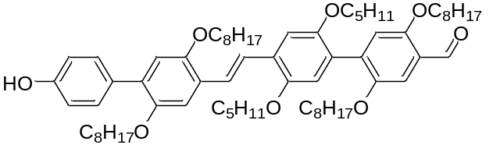
The synthesis is performed as described in general procedure A with (SO//M(rac)) (621 µmol, 485 mg), 2,5-di(octyloxy)-4-(4,4,5,5-tetramethyl-1,3,2-dioxaborolan-2-yl)benzaldehyde (O//) (745 µmol, 364 mg), Pd(OAc)₂ (31.0 µmol, 6.96 mg), RuPhos (150 µmol, 69.9 mg) and K₃PO₄ (1.86 mmol, 395 mg) dissolved in a mixture of THF (3.105 mL) and water (62 µL). The crude product is purified by filtration through a plug of silica (SiO₂, hep/EA 7.8/0.2) followed by recrystallization from EtOH. The purified product is obtained as yellow solid.
Quantity: 228 mg
Yield: 35 %
¹H-NMR (600 MHz, CDCl₃): δ10.50 (s, 1H), 7.55 (d, J = 17.10 Hz, 1H), 7.52 (d, J = 17.10 Hz, 1H), 7.49 (d, J = 8.64 Hz, 2H), 7.38 (s, 1H), 7.25 (s, 1H), 7.23 (s, 1H), 7.02 (s, 1H), 6.88 (s, 2H), 6.88 (d, J = 8.64 Hz, 2H), 4.92 (s, 1H), 4.03 (t, J = 6.51 Hz, 2H), 4.02 (t, J = 6.63 Hz, 2H), 3.94 (t, J = 6.51 Hz, 2H), 3.91 (t, J = 6.69 Hz, 2H), 3.85 (m, 1H), 3.78 (m, 2H), 3.70 (m, 1H), 1.94 (m, 1H), 1.83 (m, 4H), 1.71 (m, 3H), 1.64 (m, 3H), 1.49 (m, 4H), 1.09-1.42 (m, 39H), 1.08 (d, J = 6.78 Hz, 3H), 0.97 (t, J = 7.44 Hz, 3H), 0.86 (m, 18H)
¹³C-NMR (150 MHz, CDCl₃): δ189.67, 155.69, 154.67, 150.97, 150.68, 150.55, 150.38, 150.26, 136.32, 131.07, 130.77, 130.71, 127.69, 126.92, 126.67, 124.00, 123.41, 123.29 , 117.08, 116.19, 115.56, 114.82, 111.05, 110.67, 110.16, 74.36, 74.25, 69.66, 69.39, 69.19, 35.08, 34.90, 31.87, 31.81, 29.51, 29.41, 29.39, 29.31, 29.28, 29.24, 29.21, 26.36, 26.19, 26.12, 26.09, 26.03, 22.68, 22.66, 16.83, 16.61, 14.12, 14.10, 11.46, 11.29
HRMS (m/z): [M]+ calcd. For C₆₉H₁₀₄O₈, 1060.7731; found 1060.7731

SO//OM// (rac)
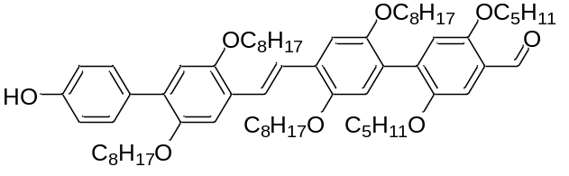
The synthesis is performed as described in general procedure A with (SO//O) (380 µmol, 334 mg), 2,5-di(2-methylbutyloxy)-4-(4,4,5,5-tetramethyl-1,3,2-dioxaborolan-2-yl)benzaldehyde (M//(rac)) (460 µmol, 186 mg), Pd(OAc)₂ (19.0 µmol, 4.20 mg), RuPhos (97.0 µmol, 45.2 mg) and K₃PO₄ (1.16 mmol, 246 mg) dissolved in a mixture of THF (1.9 mL) and water (38 µL). The crude product is purified by column chromatography (SiO₂, Hep/EA: 7.8/0.2). The purified product is obtained as yellow solid.
Quantity: 327 mg
Yield: 81 %
¹H-NMR (600 MHz, CDCl₃): δ10.52 (s, 1H), 7.53 (d, J = 16.86 Hz, 1H), 7.51 (d, J = 16.86 Hz, 1H), 7.49 (d, J = 8.64 Hz, 2H), 7.38 (s, 1H), 7.23 (2s, 1H), 7.02 (s, 1H), 6.90 (s, 1H), 6.88 (s, 1H), 6.88 (d, J = 8.64 Hz, 2H), 4.84 (s, 1H), 4.02 (t, J = 6.69 Hz, 2H), 3.97 (t, J = 6.51 Hz, 2H), 3.94 (t, J = 6.33 Hz, 2H), 3.90 (m, 3H), 3.81 (m, 2H), 3.70 (m, 1H), 1.92 (m, 1H), 1.84 (m, 4H), 1.71 (m, 3H), 1.62 (m, 2H), 1.51 (m, 4H), 1.10-1.44 (m, 40H), 1.04 (d, J = 6.60 Hz, 3H), 0.96 (t, J = 7.41 Hz, 3H), 0.86 (m, 18H)
¹³C-NMR (150 MHz, CDCl₃): δ189.51, 155.79, 154.64, 151.07, 150.76, 150.45, 150.34, 150.26, 136.21, 131.10, 130.77, 127.78, 127.02, 126.61, 123.97, 123.77, 123.48, 116.94, 116.37, 115.47, 114.81, 111.46, 111.11, 109.92, 77.23, 77.01, 76.80, 73.85, 69.65, 69.62, 69.58, 69.53, 34.87, 34.72, 31.87, 31.81, 29.54, 29.47, 29.43, 29.42, 29.37, 29.34, 29.31, 29.26, 26.23, 26.16, 26.13, 26.07, 22.68, 22.66, 22.65, 16.62, 14.12, 14.08, 11.33, 11.23
HRMS (m/z): [M]+ calcd. For C₆₉H₁₀₄O₈, 1060.7731; found 1060.7767

SO//OM// (S)
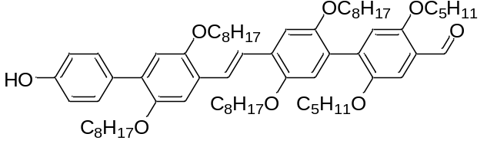
The synthesis is performed as described in general procedure A with (SO//O (1.08 mmol, 1.05 g), 2,5-di((S)-2-methylbutyloxy)-4-(4,4,5,5-tetramethyl-1,3,2-dioxaborolan-2-yl)benzaldehyde (M//(S)) (1.45 mmol, 586 mg), Pd(OAc)₂ (60.0 µmol, 13.4 mg), RuPhos (300 µmol, 140 mg) and K₃PO₄ (3.63 mmol, 771 mg) dissolved in a mixture of THF (5.4 mL) and water (108 µL). The crude product is purified by filtration through a plug of silica (SiO₂, Hep/EA: 7.8/0.2) followed by a recrystallization from MeOH. The purified product is obtained as yellow solid.
Quantity: 1.08 g
Yield: 94 %
¹H-NMR (600 MHz, CDCl₃): δ10.52 (s, 1H), 7.52 (s, 2H), 7.49 (d, 8.59 Hz, 2H), 7.38 (s, 1H), 7.23 (2s, 2H), 7.02 (s, 1H), 6.89 (s, 1H), 6.88 (s, 1H), 6.87 (d, J = 8.60 Hz, 2H), 4.82 (s, 1H), 4.02 (t, J = 6.39 Hz, 2H), 3.97 (t, J = 6.39 Hz, 2H), 3.94 (t, J = 6.39 Hz, 2H), 3.90 (m, 3H), 3.83 (m, 1H), 3.80 (m, 1H), 3.70 (m, 1H), 1.92 (m, 2H), 1.84 (m, 4H), 1.71 (m, 3H), 1.62 (m, 2H), 1.50 (m, 4H), 1.17-1.43 (m, 40H), 1.04 (d, J = 6.82 Hz, 3H), 0.96 (t, J = 7.44 Hz, 3H), 0.86 (m, 18H)
¹³C-NMR (150 MHz, CDCl₃): δ 189.52, 155.80, 154.64, 151.07, 150.76, 150.45, 150.35, 150.27, 136.22, 131.12, 130.78, 127.79, 127.03, 126.62, 123.98, 123.78, 123.49, 116.94, 116.37, 115.47, 114.81, 111.46, 111.12, 109.93, 73.85, 69.65, 69.62, 69.59, 69.54, 34.87, 34.72, 31.88, 31.81, 29.54, 29.47, 29.44, 29.42, 29.37, 29.34, 29.31, 29.28, 29.27, 26.23, 26.18, 26.17, 26.13, 26.07, 22.69, 22.67, 22.65, 16.62, 14.13, 14.09, 11.34, 11.23
HRMS (m/z): [M]+ calcd. For C₆₉H₁₀₄O₈, 1060.7731; found 1060.7747

SO//OM//O (S)
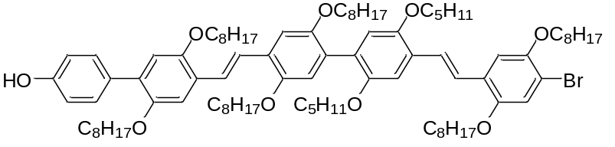
The synthesis is performed as described in general procedure B with SO//OM//(S) (530 µmol, 563 mg) and diethyl (4-bromo-2,5-di(octyloxy))benzyl phosphonate (O) (580 µmol, 327 mg) dissolved in THF (2 mL) and KOtBu (1.59 mmol, 178 mg) suspended in THF (2 mL). The crude product is purified by precipitation in MeOH at room temperature. The pure product is obtained as dark yellow solid.
Quantity: 406 mg
Yield: 52 %
¹H-NMR (600 MHz, CDCl₃): δ7.51 (s, 2H), 7.50 (d, J = 16.67 Hz, 1H), 7.49 (d, J = 8.35 Hz, 2H), 7.42 (d, J = 16.67 Hz, 1H), 7.24 (s, 1H), 7.23 (s, 1H), 7.20 (s, 1H), 7.19 (s, 1H), 7.09 (s, 1H), 6.95 (2s, 2H), 6.88 (s, 1H), 6.87 (d, J = 8.35 Hz, 2H), 4.72 (brd, s, 1H), 4.03 (t, J = 6.53 Hz, 2H), 4.01 (t, J = 6.53 Hz, 2H), 3.98 (t, J = 6.53 Hz, 2H), 3.97 (t, J = 6.53 Hz, 2H), 3.94 (t, J = 6.53 Hz, 2H), 3.90 (t, J = 6.53 Hz, 2H), 3.85 (m, 1H), 3.78 (m, 2H), 3.96 (m, 1H), 1.93 (m, 1H), 1.84 (m, 8H) 1.71 (m, 3 H), 1.63 (m, 3H), 1.51 (m, 8H), 1.11-1.46 (m, 55H), 1.07 (d, J = 6.81 Hz, 3H), 0.96 (t, J = 7.34 Hz, 3H), 0.87 (m, 24H)
¹³C-NMR (150 MHz, CDCl₃): δ154.56, 151.03, 150.94, 150.78, 150.67, 150.47, 150.42, 150.27, 149.82, 131.21, 130.79, 130.56, 127.55, 126.95, 126.84, 124.27, 123.27, 122.47, 117.92, 116.81, 115.51, 114.79, 111.40, 111.31, 110.99, 77.23, 74.23, 70.12, 69.79, 69.65, 69.52, 35.05, 34.91, 31.89, 31.87, 31.84, 31.82, 29.56, 29.54, 29.44, 29.43, 29.38, 29.35, 29.34, 29.32, 29.28, 26.37, 26.23, 26.17, 26.12, 26.04, 22.68, 22.67, 16.83, 16.67, 14.13, 14.10, 11.45, 11.29
HRMS (m/z): [M]+ calcd. For C₉₂H₁₄₁O₉Br₁, 1468.9759; found 1468.9788

SO//OM//OM// (S)
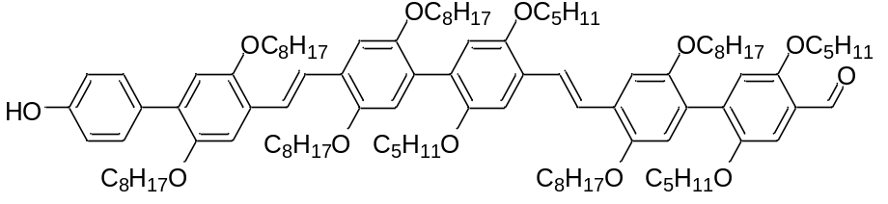
The synthesis is performed as described in general procedure A with (SO//OM//O(S) (280 µmol, 406 mg), 2,5-di((S)-2-methylbutyloxy)-4-(4,4,5,5-tetramethyl-1,3,2-dioxaborolan-2-yl)benzaldehyde (M//(S)) (340 µmol, 138 mg), Pd(OAc)₂ (28.0 µmol, 6.29 mg), RuPhos (70.0 µmol, 32.7 mg) and K₃PO₄ (840 µmol, 178 mg) dissolved in a mixture of THF (1.4 mL) and water (28 µL). The crude product is purified by filtration through a plug of silica (SiO₂, Hep/EA: 7.5/0.5) followed by a liquid-liquid extraction with EtOH which is decanted. The purified product is obtained as dark viscous yellow oil.
Quantity: 209 mg
Yield: 45 %
¹H-NMR (400 MHz, THF-d₈): δ10.49 (s, 1H) 8.25 (s, 1H), 7.62 (d, J = 16.61 Hz, 1H), 7.57 (d, J = 16.61 Hz, 1H), 7.55 (s, 2H), 7.42 (d, J = 8.56 Hz, 2H), 7.36 (s, 1H), 7.29 (s, 1H), 7.27 (s, 1H), 7.25 (s, 2H), 7.10 (s, 1H), 6.97 (s, 1H), 6.96 (s, 1H), 6.93 (s, 1H), 6.91( s, 1H), 6.76 (d, J = 8.56 Hz, 2H), 3.86-4.08 (m, 15H), 3.83 (m, 3H), 3.74 (m, 2H), 1.81-2.01 (m, 8H), 1.15-1.70 (m, 76 H),1.12 (d, J = 6.72 Hz, 3H), 1.07 (d, J = 6.72 Hz, 3H), 1.01 (t, J = 7.52, 3H), 0.98 (t, J = 7.52, 3H), 0.89 (m, 30H)
¹³C-NMR (150 MHz, CDCl₃): δ189.53, 155.82, 154.63, 151.04, 150.78, 150.70, 150.46, 150.28, 150.22, 136.26, 130.78, 130.59, 128.17, 127.94, 126.94, 126.84, 126.67, 123.97, 123.87, 123.71, 122.89, 116.94, 116.86, 116.45, 115.52, 114.81, 111.46, 111.41, 110.88, 110.61, 109.96, 74.41, 74.29, 73.87, 69.80, 69.67, 69.63, 69.53, 69.47, 35.08, 34.92, 34.88, 34.73, 31.94, 31.89, 31.86, 31.82, 31.81, 29.71, 29.56, 29.52, 29.43, 29.41, 29.34, 29.32, 29.29, 26.39, 26.24, 26.19, 26.15, 26.14, 26.09, 26.08, 22.68, 22.66, 16.83, 16.68, 16.64, 16.61, 14.13, 14.09, 11.46, 11.34, 11.30, 11.24
HRMS (m/z): [M]+ calcd. For C₁₀₉H₁₆₆O₁₂, 1667.2379; found 1667.2378

SM// (S)
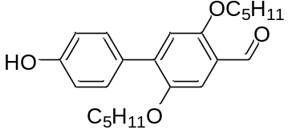
The synthesis is performed as described in general procedure A with 4-bromophenyl acetate (S) (500 µmol, 108 mg), 2,5-di((S)-2-methylbutyloxy)-4-(4,4,5,5-tetramethyl-1,3,2-dioxaborolan-2-yl)benzaldehyde (M//(S)) (600 µmol, 222 mg), Pd(OAc)₂ (25.0 µmol, 5.60 mg), RuPhos (125 µmol, 58.3 mg) and K₃PO₄ (1.50 mmol, 318 mg) dissolved in a mixture of THF (2.5 mL) and water (0.05 mL). After quenching and work-up of the reaction, the crude product is dissolved in THF and a few mL of NaOH solution (1 M) is added to deprotect the hydroxyl group. The reaction is neutralized with HCl (1 M) and extracted with Et₂O. The combined organic phase is consecutively washed with a saturated NaHCO₃ solution, and a saturated NaCl solution and dried over Na₂SO₄. After filtration, the solvent is evaporated under reduced pressure to obtain the crude product which is purified by column chromatography (SiO₂, Hep/EA: 7.8/0.2). The pure product is obtained as a yellow solid.
Quantity: 141 mg
Yield: 76 %
¹H-NMR (600 MHz, CDCl₃): δ10.49 (s, 1H), 7.47 (d, J = 8.58 Hz, 2H), 7.37 (s, 1H), 6.93 (s, 1H), 6.89 (d, J = 8.58 Hz, 2H), 4.87 (s, 1H), 3.89 (m, 2H), 3.77 (m, 2H), 1.93 (m, 1H), 1.78 (m, 1H), 1.58 (m, 1H), 1.44(m, 1H), 1.32 (m, 1H), 1.20 (m, 1H), 1.05 (d, J = 6.94 Hz, 3H), 0.96 (t, J = 7.36 Hz, 3H), 0.92 (d, J = 6.74 Hz, 3H), 0.87 (t, J = 7.36 Hz, 3H)
¹³C-NMR (150 MHz, CDCl₃): δ189.37, 156.42, 155.40, 150.25, 138.66, 130.94, 130.14, 123.71, 115.29, 114.87, 110.29, 73.91, 73.87, 34.89, 34.73, 26.16, 26.10, 16.69, 16.64, 11.34, 11.26
HRMS (m/z): [M]+ calcd. For C₂₃H₃₀O₄, 370.2144; found 370.2144

SM//O (S)
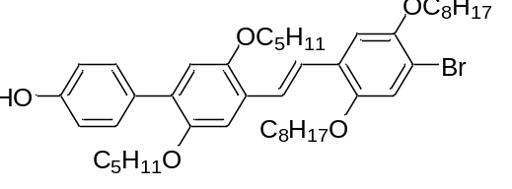
The synthesis is performed as described in general procedure B with SM//(S) (380 µmol, 14.1 mg) and diethyl (4-bromo-2,5-di(octyloxy))benzyl phosphonate (O) (418 µmol, 236 mg) dissolved in THF (1.5 mL) and KOtBu (1.14 mmol, 128 mg) suspended in THF (1 mL). The crude product is purified by filtration through a plug of silica (SiO₂, Hep/EA: 7/1) followed by precipitation in MeOH at 0 °C. The pure product is obtained as yellow solid.
Quantity: 207 mg
Yield: 70 %
¹H-NMR (600 MHz, CDCl₃): δ7.48 (d, J = 16.67 Hz, 1H), 7.47 (d, J = 8.39 Hz, 2H), 7.40 (d, J = 16.67 Hz, 1H), 7.18 (s, 1H), 7.17 (s,1H), 7.08 (s, 1H), 6.87 (d, J = 8.39 Hz, 2H), 6.86 (s, 1H), 4.76 (brd, s, 1H), 4.03 (t, J = 6.54 Hz, 2H), 3.96 (t, J = 6.56 Hz, 2H), 3.87 (m, 1H), 3.80 (m, 2H), 3.71 (m, 1H), 1.93, (m, 1H), 1.87-1.75 (m, 5H), 1.62 (m, 1H), 1.42-1.54 (m, 5H), 1.42-1.16 (m, 18H), 1.07 (d, J = 6.86 Hz, 3H), 0.97 (t, J = 7.57 Hz, 3H), 0.94 (d, J = 6.62 Hz, 3H), 0.88 (m, 9H)
¹³C-NMR (150 MHz, CDCl₃): δ154.58, 151.09, 150.95, 150.39, 149.83, 131.11, 130.98, 130.82, 127.44, 126.25, 124.00, 122.67, 117.96, 115.39, 114.74, 111.41, 111.34, 111.07, 74.40, 74.29, 70.14, 69.66, 35.06, 34.92, 31.86, 31.84, 29.38, 29.35, 29.32, 29.30, 29.27, 26.35, 26.15, 26.13, 26.04, 22.69, 22.66, 16.84, 16.73, 14.12, 14.09, 11.45, 11.32
HRMS (m/z): [M]+ calcd. For C₄₆H₆₇O₅Br₁, 778.4172; found 778.4171

SM//OO// (S)
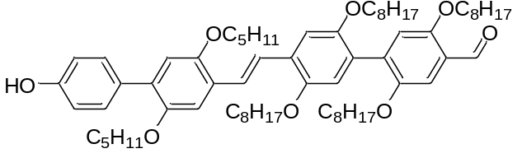
The synthesis is performed as described in general procedure A with (SM//O(S) (510 µmol, 402 mg), 2,5-di(oxtyloxy)-4-(4,4,5,5-tetramethyl-1,3,2-dioxaborolan-2-yl)benzaldehyde (O//) (560 µmol, 274 mg), Pd(OAc)₂ (26.0 µmol, 5.80 mg), RuPhos (128 µmol, 59.5 mg) and K₃PO₄ (1.53 mmol, 325 mg) dissolved in a mixture of THF (2.55 mL) and water (0.051 mL). The crude product is purified by filtration through a plug of silica (SiO₂, Hep/EA: 7.8/0.2) followed by a recrystallization from MeOH. The purified product is obtained as yellow solid
Quantity: 469 mg
Yield 87 %
¹H-NMR (600 MHz, CDCl₃): δ10.49 (s, 1H), 7.55 (d, J = 16.36 Hz, 1H), 7.51 (d, J = 16.36 Hz, 1H), 7.48 (d, 8.68 Hz, 2H), 7.38 (s, 1H), 7.24 (s, 1H), 7.23 (s, 1H), 7.03 (s, 1H), 6.90 (s, 1H), 6.88 (s, 1H), 6.88 (d, J = 8.68 Hz, 2H), 4.77 (s, 1H), 4.03 (t, J = 6.44 Hz, 2H), 3.98 (t, J = 6.47 Hz, 2H), 3.94 (t, J = 6.39 Hz, 2H), 3.92 (2t, J = 6.46, 6.53 Hz, 4H), 3.89 (m, 1H), 3.81 (m, 2H), 3.73 (m, 1H), 1.95 (m, 1H), 1.81 (m, 5H), 1.64 (m, 5H), 1.43-1.53 (m, 5H), 1.17-1.39 (m, 38H), 1.08 (d, J = 6.80Hz, 3H), 0.98 (t, J = 7.56 Hz, 3H), 0.95 (d, J = 6.66 Hz, 3H), 0.84-0.91 (m, 15H)
¹³C-NMR (150 MHz, CDCl₃): δ189.57, 155.69, 154.59, 151.09, 150.65, 150.45, 150.41, 150.24, 136.14, 131.15, 130.83, 127.84, 126.80, 126.54, 123.99, 123.63, 123.07, 117.02, 116.39, 115.42, 114.75, 111.00, 110.63, 110.18, 74.43, 74.29, 69.57, 69.45, 69.18, 35.10, 34.94, 31.88, 31.82, 29.53, 29.47, 29.45, 29.34, 29.30, 29.26, 26.37, 26.23, 26.17, 26.13, 26.07, 22.67, 16.85, 16.74, 14.10, 11.47, 11.33
HRMS (m/z): [M]+ calcd. For C₆₉H₁₀₄O₈, 1060.7731; found 1060.7772

SM//OO//O (S)
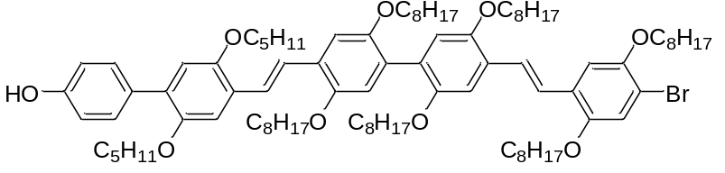
The synthesis is performed as described in general procedure B with SM//OO//(S) (220 µmol, 237 mg) and diethyl (4-bromo-2,5-di(octyloxy))benzyl phosphonate (O) (250 µmol, 141 mg) dissolved in THF (2 mL) and KOtBu (670 µmol, 75.2 mg) suspended in THF (1 mL). The crude product is purified by precipitation in MeOH at room temperature. The pure product is obtained as yellow solid.
Quantity: 219 mg
Yield: 68 %
¹H-NMR (600 MHz, CDCl₃): δ7.55 (d, J = 17.18 Hz, 1H), 7.51 (d, J = 17.18 Hz, 1H), 7.48 (d, J = 16.50 Hz, 1H), 7.48 (d, J = 8.49 Hz, 2H), 7.41 (d, J = 16.50 Hz, 1H), 7.25 (s, 1H), 7.24 (s, 1H), 7.20 (s, 1H), 7.17 (s, 1H), 7.08 (s, 1H), 6.96 (s, 2H), 6.88 (s, 1H), 6.87 (d, J = 8.49 Hz, 2H), 4.76 (brd, s, 1H), 4.04 (t, J = 6.53 Hz, 2H), 3.98 (m,6H), 3.92 (t, J = 6.53 Hz, 2H), 3.90 (t, J = 6.53 Hz, 2H), 3.88 (m, 1H), 3.82 (m, 2H), 3.73 (m, 1H), 1.95 (m, 1H), 1.82 (m, 9H), 1.65 (m, 5H), 1.50 (m, 9H) 1.17-1.41 (m, 54H), 1.09 (d, J = 6.79 Hz, 3H), 0.98 (t, J = 6.67 Hz, 3H), 0.95 (d, J = Hz, 3H), 0.83-0.91 (m, 21H)
¹³C-NMR (150 MHz, CDCl₃): δ151.05, 150.66, 150.45, 150.41, 150.30, 149.83, 130.84, 130.63, 128.34, 127.51, 126.76, 124.44, 123.28, 123.12, 122.87, 117.85, 116.92, 116.81, 115.44, 114.73, 111.71, 111.48, 111.41, 110.95, 110.89, 74.47, 74.28, 70.27, 69.75, 69.62, 69.56, 69.51, 69.39, 35.11, 34.94, 33.72, 31.94, 31.89, 31.87, 31.85, 29.71, 29.56, 29.46, 29.43, 29.40, 29.38, 29.35, 29.32, 29.28, 26.37, 26.27, 26.25, 26.16, 26.15, 26.09, 22.69, 16.85, 16.74, 14.11, 14.09, 11.47, 11.33
HRMS (m/z): [M]+ calcd. For C₉₂H₁₄₁O₉Br, 1468.9759; found 1468.9741

SM//OO//OM// (S)
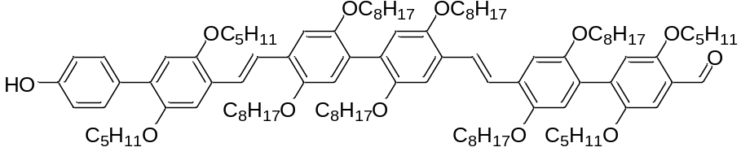
The synthesis is performed as described in general procedure A with (SM//OO//O(S) (260 µmol, 382 mg), 2,5-di((S)-2-methylbutyloxy)-4-(4,4,5,5-tetramethyl-1,3,2-dioxaborolan-2-yl)benzaldehyde (M//(S)) (310 µmol, 125 mg), Pd(OAc)₂ (26.0 µmol, 5.80 mg), RuPhos (65.0 mmol, 30.3 mg) and K₃PO₄ (78.0 µmol, 166 mg) dissolved in a mixture of THF (1.3 mL) and water (26 µL). The crude product is purified by filtration through a plug of silica (SiO₂, Hep/EA: 9/1) followed by liquid-liquid extraction with IPA which is decanted. The purified product is obtained as dark viscous yellow oil.
Quantity: 243 mg
Yield: 56 %
¹H-NMR (400 MHz, CD₂Cl₂): δ10.52 (s, 1H), 7.57 (s, 4H), 7.50 (d, J = 8.68 Hz, 2H), 7.38 (s, 1H), 7.26 (s, 4H), 7.06 (s, 1H), 6.97 (2s, 2H), 6.93 (s, 1H), 6.91 (s, 1H), 6.89 (d, J = 8.68 Hz, 2H), 3.70-4.06 (m, 20H), 1.13-2.03 (m, 84H), 1.12 (d, J = 6.96 Hz, 3H), 1.07 (d, J = 6.72 Hz, 3H), 1.00 (t, J = 7.52 Hz, 3H), 0.98 (d, J = 6.82 Hz, 3H), 0.97 (t, J = 7.46 Hz, 3H), 0.82-0.95 (m, 27H)
¹³C-NMR (150 MHz, CDCl₃): δ189.52, 155.81, 154.58, 151.05, 150.77, 150.67, 150.45, 150.42, 150.34, 131.19, 130.83, 130.64, 128.18, 127.90, 126.95, 126.76, 123.97, 123.32, 123.11, 116.96, 116.83, 116.35, 115.45, 114.73, 111.40, 110.95, 109.94, 74.47, 74.28, 73.86, 69.75, 69.65, 69.58, 69.51, 69.42, 35.11, 34.94, 34.88, 34.73, 31.89, 31.86, 31.81, 29.58, 29.54, 29.48, 29.45, 29.42, 29.37, 29.32, 29.27, 26.37, 26.28, 26.25, 26.22, 26.18, 26.15, 26.14, 26.08, 22.69, 22.67, 16.86, 16.74, 16.62, 14.11, 14.09, 11.48, 11.33, 11.24
HRMS (m/z): [M]+ calcd. For C₁₀₉H₁₆₆O₁₂, 1667.2379; found 1667.2435

SO//OM//V₂ (S)
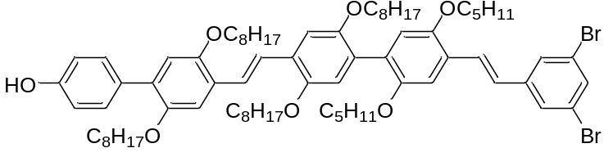
The synthesis is performed as described in general procedure B with SO//OM//V₂(S) (519 µmol, 551 mg) and diethyl 3,5-dibromobenzylphosphonate (V₂) (571 µmol, 220 mg) dissolved in THF (3 mL) and KOtBu (1.56 mmol, 175 mg) suspended in THF (2 mL). The crude product is purified by precipitation in MeOH at – 78 °C. The pure product is obtained as yellow solid.
Quantity: 596 mg
Yield: 89 %
¹H-NMR (600 MHz, CDCl₃): δ7.58 (d, J = 1.59 Hz, 2H), 7.52 (brd, s, 3H), 7.49 (d, J = 8.47 Hz, 2H), 7.48 (d, J = 16.42 Hz, 1H), 7.24 (2s, 2H), 7.10 (s, 1H), 7.04 (d, J = 16.42 Hz, 1H), 6.96 (s, 1H), 6.94 (s, 1H), 6.88 (s, 1H), 6.87 (d, J = 8.47 Hz, 2H), 4.83 (brd, s, 1H), 4.02 (t, J = 6.44 Hz, 2H), 3.98 (t, J = 6.44 Hz, 2H), 3.94 (t, J = 6.44 Hz, 2H), 3.91 (t, J = 6.44 Hz, 2H), 3.87 (m, 1H), 3.78 (m, 2H), 3.68 (m, 1H), 1.96 (m, 1H), 1.84 (m, 4H), 1.71 (m, 3H), 1.12-1.70 (m, 46H), 1.08 (d, J = 6.80 Hz, 3H), 0.99 ( t, J = 7.60 Hz, 3H), 0.82-0.91 (m, 18H)
¹³C-NMR (150 MHz, CDCl₃): δ154.59, 151.03, 150.82, 150.72, 150.65, 150.41, 150.26, 141.96, 132.19, 131.15, 130.77, 130.61, 129.28, 127.98, 127.84, 127.13, 126.93, 126.77, 125.64, 124.83, 123.63, 123.38, 123.17, 116.84, 116.75, 115.49, 114.79, 111.41, 111.37, 74.38, 74.24, 69.77, 69.65, 69.53, 34.94, 34.91, 31.88, 31.85, 31.81, 29.70, 29.55, 29.53, 29.43, 29.42, 29.34, 29.33, 29.31, 29.27, 26.38, 26.23, 26.15, 26.14, 26.10, 22.68, 22.67, 16.83, 16.67, 14.12, 14.09, 11.38, 11.28
HRMS (m/z): [M]+ calcd. For C₇₆H₁₀₈O₇Br₂, 1290.6462; found 1290.6481

SO//OM//V₂M// (S)
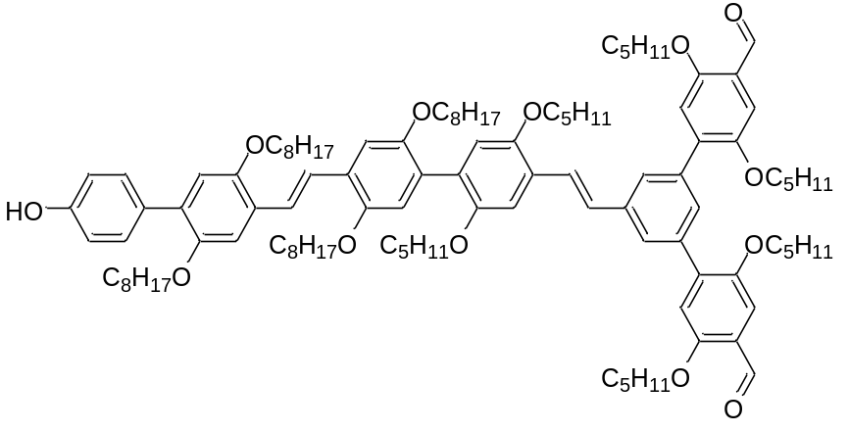
The synthesis is performed as described in general procedure A with (SO//OM//V₂(S) (448 µmol, 571 mg), 2,5-di((S)-2-methylbutyloxy)-4-(4,4,5,5-tetramethyl-1,3,2-dioxaborolan-2-yl)benzaldehyde (M//(S)) (987 µmol, 399 mg), Pd(OAc)₂ (44.8 µmol, 10.1 mg), RuPhos (224 µmol, 105 mg) and K₃PO₄ (1.35 mmol, 286 mg) dissolved in a mixture of THF (2.242 mL) and water (44.8 µL). The crude product is purified by liquid-liquid extraction with EtOH which is decanted. The purified product is obtained as viscous yellow oil.
Quantity: 652 mg
Yield: 86 %
¹H-NMR (600 MHz, CD₂Cl₂): δ10.53 (s, 2H), 7.78 (d, J = 1.20 Hz, 2H), 7.63 (s, 1H), 7.61 (d, J = 16.48 Hz, 1H), 7.54 (s, 2H), 7.48 (d, J = 8.64 Hz, 2H), 7.43 (s, 2H), 7.32 (d, J = 16.48 Hz, 1H), 7.24 (s, 2H), 7.21 (s, 1H), 7.12 (s, 2H), 6.96 (s, 1H), 6.95 (s, 1H), 6.90 (s, 1H), 6.88 (d, J = 8.64 Hz, 2H), 5.18 (brd, s, 1H), 3.69-4.07 (m, 20H), 1.12-2.00 (m, 66H), 1.07 (d, J = 6.73 Hz, 8H), 0.79-1.01 (m, 40H) (chloroform in signal)
¹H-NMR (600 MHz, CDCl₃): δ10.54 (s, 2H), 7.74 (d, J = 1.44 Hz, 2H), 7.58 (d, J = 16.86 Hz, 1H), 7.57 (s, 1H), 7.52 (s, 2H), 7.49 (d, J = Hz, 2H), 7.44 (s, 2H), 7.28 (d, J = 16.86 Hz, 1H), 7.24 (s, 2H), 7.18 (s, 1H), 7.06 (s, 2H), 6.97 (s, 1H), 6.96 (s, 1H), 6.88 (d, J = Hz, 2H), 6.88 (s, 1H), 4.86 (brd, s, 1H), 4.02 (t, J = 6.51 Hz, 2H), 3.98 (t, J = 6.60 Hz, 2H), 3.83-3.93 (m, 11H), 3.77 (m, 4H), 3.69 (m, 1H), 1.94 (m, 3H), 1.27-1.89 (m, 81H), 1.07 (d, 6.81 Hz, 3H), 1.06 (m, 9H), 0.97 (t, J = 7.42 Hz, 6H), 0.94 (t, J = 7.50 Hz, 3H), 0.80-0.91 (m, 30H)
¹³C-NMR (150 MHz, CDCl₃): δ189.38, 156.43, 154.66, 151.03, 150.72, 150.67, 150.60, 150.40, 150.36, 150.27, 138.86, 137.67, 137.50, 131.11, 130.77, 130.63, 129.32, 128.50, 128.28, 127.91, 127.14, 127.05, 126.78, 125.80, 124.48, 124.24, 123.65, 123.34, 116.95, 116.70, 115.52, 114.81, 111.41, 111.29, 110.54, 74.45, 74.15, 74.00, 73.96, 69.71, 69.65, 69.53, 34.95, 34.92, 34.73, 31.88, 31.85, 31.82, 29.71, 29.56, 29.53, 29.44, 29.42, 29.35, 29.34, 29.31, 29.29, 29.28, 26.35, 26.24, 26.23, 26.16, 26.13, 26.11, 22.67, 16.89, 16.67, 16.64, 14.12, 14.10, 11.38, 11.35, 11.27, 11.21
HRMS (m/z): [M]+ calcd. For C₁₁₀H₁₅₈O₁₃, 1687.1702; found 1687.1744

SM//OO//V₂ (S)
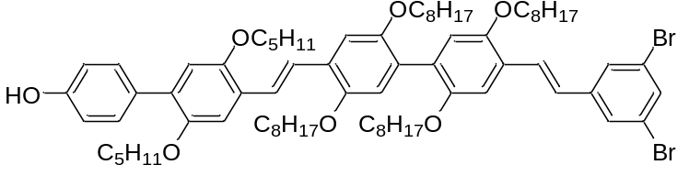
The synthesis is performed as described in general procedure B with SM//OO//V₂(S) (309 µmol, 328 mg) and diethyl 3,5-dibromobenzylphosphonate (V₂) (340 µmol, 131 mg) dissolved in THF (3 mL) and KOtBu (928 µmol, 104 mg) suspended in THF (2 mL). The crude product is purified by precipitation in MeOH at room temperature . The pure product is obtained as yellow solid.
Quantity: 357 mg
Yield: 89 %
¹H-NMR (600 MHz, CDCl₃): δ7.59 (d, J = 1.73 Hz, 2H), 7.55 (d, J = 16.53 Hz, 1H), 7.52 (d, J = 16.53 Hz, 1H), 7.52 (t, J = 1.73 Hz, 1H), 7.48 (d, J = 8.53 Hz, 2H), 7.46 (d, J = 16.39 Hz, 1H), 7.25 (s, 1H), 7.24 (s, 1H), 7.12 (s, 1H), 7.03 (d, J = 16.39 Hz, 1H), 6.97 (s, 1H), 6.94 (s, 1H), 6.88 (s, 1H), 6.87 (d, J = 8.53 Hz, 2H), 4.76 (brd, s, 1H), 4.00 (t, J = 6.75 Hz, 2H), 3.98 (t, J = 6.58 Hz, 2H), 3.92 (t, J = 6.54 Hz, 2H), 3.90 (t, J = 6.22 Hz, 2H), 3.89 (m, 1H), 3.82 (m, 2H), 3.73 (m, 1H), 1.95 (m, 1H), 1.75-1.88 (m, 5H), 1.65 (m, 5H), 1.49 (m, 5H), 1.18-1.42 (m, 38H), 1.09 (d, J = 6.77 Hz, 3H), 0.98 ( t, J = 7.45 Hz, 3H), 0.95 (d, J = 6.77 Hz, 3H), 0.83-0.91 (m, 15H)
¹³C-NMR (150 MHz, CDCl₃): δ154.55, 151.06, 150.78, 150.63, 150.41, 150.31, 141.93, 132.22, 131.20, 130.84, 130.67, 129.34, 128.02, 127.18, 126.91, 126.70, 125.69, 124.87, 123.24, 123.16, 116.80, 116.74, 115.44, 114.73, 111.76, 110.97, 110.85, 74.46, 74.28, 69.76, 69.56, 69.52, 69.39, 35.11, 34.94, 31.89, 31.85, 29.71, 29.54, 29.53, 29.50, 29.47, 29.42, 29.40, 29.37, 29.35, 29.30, 26.38, 26.24, 26.16, 26.12, 22.72, 22.69, 16.85, 16.74, 14.12, 14.09, 11.47, 11.33
HRMS (m/z): [M]+ calcd. For C₇₆H₁₀₈O₇Br₂, 1290.6462; found 1290.6484

SM//OO//V₂M// (S)
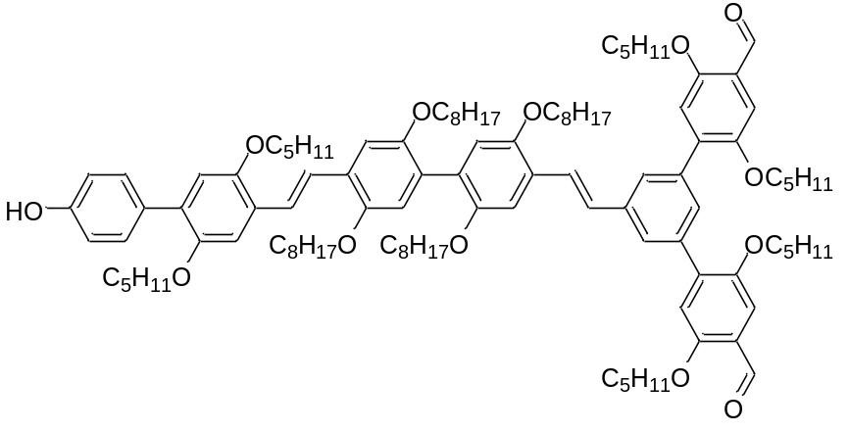
The synthesis is performed as described in general procedure A with (SM//OO//V₂(S) (276 µmol, 357 mg), 2,5-di((S)-2-methylbutyloxy)-4-(4,4,5,5-tetramethyl-1,3,2-dioxaborolan-2-yl)benzaldehyde (M//(S)) (608 µmol, 246 mg), Pd(OAc)₂ (27.6 µmol, 6.20 mg), RuPhos (138 µmol, 64.5 mg) and K₃PO₄ (829 µmol, 176 mg) dissolved in a mixture of THF (1.38 mL) and water (27.6 µL). The crude product is purified by liquid-liquid extraction with EtOH which is decanted. The purified product is obtained as viscous yellow oil.
Quantity: 384 mg
Yield: 82 %
¹H-NMR (600 MHz, CDCl₃): δ10.54 (s, 2H), 7.75 (d, J = 1.50 Hz, 2H), 7.57 (d, J = 16.68 Hz, 1H), 7.55 (d, J = 16.50 Hz, 1H), 7.54 (t, J = 1.50 Hz, 1H), 7.52 (d, J = 16.50 Hz, 1H), 7.48 (d, J = 8.64 Hz, 2H), 7.44 (s, 2H), 7.26 (d, J = 16.68 Hz, 1H), 7.25 (s, 1H), 7.24 (s, 1H), 7.19 (s, 1H), 7.05 (s, 2H), 6.98 (s, 1H), 6.96 (s, 1H), 6.88 (d, J = 8.64 Hz, 2H), 6.88 (s, 1H), 4.92 (s, 1H), 3.99 (t, J = 6.69 Hz, 2H), 3.98 (t, J = 6.51 Hz, 2H), 3.76-3.97 (m, 15H), 3.74 (m, 1H), 1.95 (m, 3H), 1.75-1.87 (m, 7H), 1.56-1.70 (m, 7H), 1.40-1.53 (m, 7H), 1.14-1.39 (m, H), 1.09 (d, J = 6.78 Hz, 3H), 1.06 (d, J = 6.78 Hz, 6H), 0.98 (t, J = 7.44 Hz, 3H), 0.97 (t, J = 7.41 Hz, 6H), 0.95 (d, J = 6.60 Hz, 3H), 0.79-0.93 (m, 27H)
¹³C-NMR (150 MHz, CDCl₃): δ189.36, 156.42, 154.62, 151.05, 150.64, 150.56, 150.41, 150.35, 150.29, 138.82, 137.68, 137.44, 131.15, 130.82, 130.69, 128.29, 127.69, 127.21, 127.09, 126.70, 125.84, 124.48, 124.24, 123.19, 116.90, 116.72, 115.55, 115.44, 114.74, 111.71, 110.96, 110.78, 110.48, 74.45, 74.28, 74.02, 73.93, 69.80, 69.53, 69.50, 69.33, 35.11, 34.94, 34.74, 31.89, 31.85, 31.79, 29.55, 29.52, 29.49, 29.46, 29.43, 29.41, 29.35, 29.32, 29.31, 26.37, 26.24, 26.17, 26.14, 26.12, 22.69, 22.66, 22.60, 16.85, 16.74, 16.67, 16.65, 14.11, 14.09, 14.06, 11.47, 11.36, 11.33, 11.22
HRMS (m/z): [M]+ calcd. For C₁₁₀H₁₅₈O₁₃, 1687.1702; found 1687.1737
SO//V₂
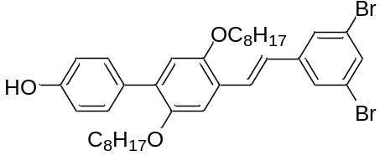
The synthesis is performed as described in general procedure B with SO// (575 µmol, 261 mg) and diethyl 3,5-dibromobenzylphosphonate (V₂) (632 µmol, 244 mg) dissolved in THF (3 mL) and KOtBu (1.73 mmol, 194 mg) suspended in THF (1 mL). The crude product is purified by recrystallisation from pentane. The pure product is obtained as bright yellow solid.
Quantity: 303 mg
Yield: 77 %
¹H-NMR (600 MHz, CDCl₃): δ7.58 (d, J = 1.70 Hz, 2H), 7.52 (t, J = 1.70 Hz, 1H), 7.47 (d, J = 8.71 Hz, 2H), 7.44 (d, J = 16.35 Hz, 1H), 7.11 (s, 1H), 7.01 (d, J = 16.35 Hz, 1H), 6.88 (s, 1H), 6.87 (d, J = 8.71 Hz, 2H), 4.78 (s, 1H), 4.02 (t, J = 6.54 Hz, 2H), 3.91 (t, J = 6.55 Hz, 2H), 1.85 (m, 2H), 1.70 (m, 2H), 1.51 (m, 2H), 1.20-1.42 (m, 18H), 0.89 (t, J = 6.97 = 3H), 0.87 (t, J = 6.92 Hz, 3H)
¹³C-NMR (150 MHz, CDCl₃): δ154.76, 151.41, 150.17, 141.82, 132.27, 131.87, 130.85, 130.78, 128.03, 126.59, 125.80, 124.71, 123.17, 115.32, 114.85, 111.88, 69.60, 69.55, 31.83, 31.81, 29.71, 29.46, 29.43, 29.35, 29.27, 26.34, 26.10, 22.68, 14.14, 14.11
HRMS (m/z): [M]+ calcd. For C₃₆H₄₆O₃Br₂, 684.18314; found 684.1834

SO//V₂M// (S)
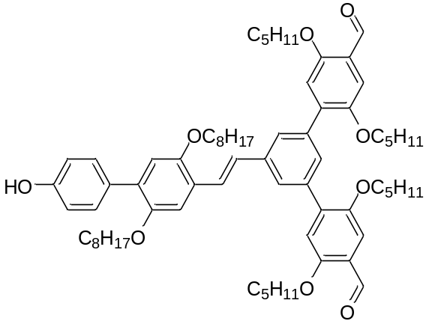
The synthesis is performed as described in general procedure A with (SO//V₂(S) (430 µmol, 297 mg), 2,5-di((S)-2-methylbutyloxy)-4-(4,4,5,5-tetramethyl-1,3,2-dioxaborolan-2-yl)benzaldehyde (M//(S)) (946 µmol, 382 mg), Pd(OAc)₂ (43.0 µmol, 9.65 mg), RuPhos (108 µmol, 50.4 mg) and K₃PO₄ (1.30 mmol, 274 mg) dissolved in a mixture of THF (2.15 mL) and water (0.043 mL). The crude product is purified by column chromatography (SiO₂, Hep/EA: 7.8/02). The purified product is obtained as viscous yellow oil.
Quantity: 384 mg
Yield: 82 %
¹H-NMR (400 MHz, CD₂Cl₂): δ10.52 (s, 2H), 7.78 (d, J = 1.36 Hz, 2H), 7.61 (t, J = 1.36 Hz, 1H), 7.57 (d, J = 16.49 Hz, 1H), 7.48 (d, J = 8.68 Hz, 2H), 7.43 (s, 2H), 7.29 (d, J = 16.49 Hz, 1H), 7.20 (s, 1H), 7.11 (s, 1H), 6.90 (s, 1H), 6.88 (d, J = 8.68 Hz, 2H), 5.22 (brd, s, 1H), 4.03 (t, J = 6.60, 2H), 3.96 (m, 4H), 3.91 (m, 2H), 3.86 (m, 2H), 3.80 (m, 2H), 1.94 (m, 2H), 1.66-1.88 (m, 6H), 1.11-1.66 (m, 28H), 1.06 (d, J = 6.72, 6H), 0.97 (t, J = 7.38 Hz, 6H), 0.92 (d, J = 6.72 Hz, 6H), 0.77-0.90 (m, 12H)
¹H-NMR (600 MHz, CDCl₃): δ10.53 (s, 2H), 7.74 (d, J = 1.51 Hz,2H), 7.54 (d, J = 16.41 Hz, 1H), 7.54 (t, J = 1.51 Hz, 1H), 7.48 (d, J = 8.68 Hz, 2H), 7.44 (s, 2H), 7.25 (d, J = 16.41 Hz, 1H), 7.18 (s, 1H), 7.05 (s, 2H), 6.88 (s, 1H), 6.88 (d, J = 8.68 Hz, 2H), 5.05 (s, 1H), 4.01 (t, J = 6.73 Hz, 2H), 3.95 (m, 2H), 3.92 (t, J = 6.64 Hz, 2H), 3.88 (m, 2H), 3.85 (m, 2H), 3.78 (m, 2H), 1.94 (m, 2H), 1.73-1.86 (m, 4H), 1.71 (m, 2H), 1.59 (m, 2H), 1.13-1.51 (m, 26H), 1.06 (d, J = 6.67 Hz, 6H), 0.97 (t, J = 7.43 = 3H), 0.91 (d, J = 6.95 Hz, 6H), 0.88 (t, J = 7.17 Hz, 3H), 0.81 (m, 9H)
¹³C-NMR (150 MHz, CDCl₃): δ189.38, 156.43, 154.80, 151.20, 150.34, 150.19, 138.80, 137.69, 137.33, 131.18, 130.90, 130.75, 129.29, 128.40, 127.23, 125.67, 124.24, 124.17, 115.54, 115.34, 114.86, 111.81, 110.48, 74.02, 73.92, 69.63, 69.50, 34.94, 34.73, 31.81, 31.77, 29.46, 29.39, 29.27, 26.22, 26.17, 26.11, 22.68, 22.59, 16.66, 16.65, 14.12, 14.06, 11.36, 11.23
HRMS (m/z): [M]+ calcd. For C₇₀H₉₆O₉, 1080.7054; found 1080.7035

SO//V₂M//O (S)
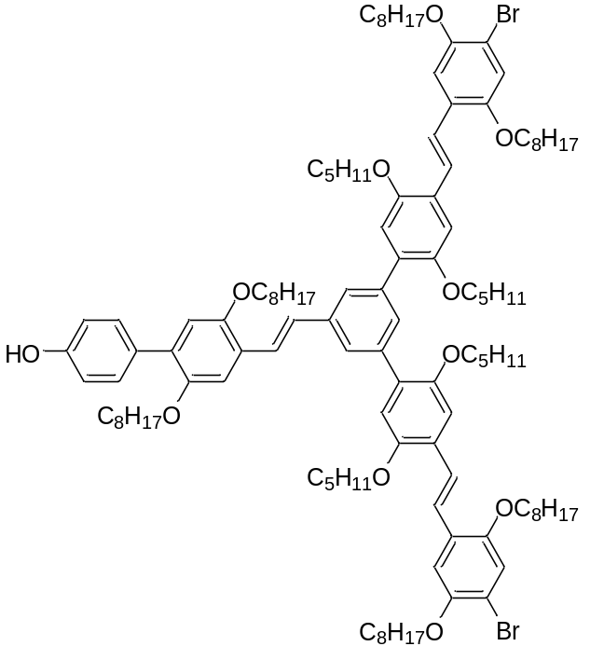
The synthesis is performed as described in general procedure B with (SO//V₂M//(S) (220 µmol, 239 mg) and diethyl (4-bromo-2,5-di(octyloxy))benzyl phosphonate (O) (486 µmol, 274 mg) dissolved in THF (1.5 mL) and KOtBu (1.10 mmol, 123 mg) suspended in THF (1 mL). The crude product is dissolved in 20 mL of CHCl₃ and a catalytic amount of I₂ at 50 °C. The reaction was monitored by ¹H-NMR to follow the conversion until 100 %. The crude product is purified by column chromatography (SiO₂, Hep/EA: 7.5/0.5). The pure product is obtained as yellow oil.
Quantity: 203 mg
Yield: 49 %
¹H-NMR (400 MHz, CDCl₃): δ7.75 (d, J = 1.46 Hz, 2H), 7.59 (t, J = 1.46 Hz, 1H), 7.54 (d, J = 16.48 Hz, 1H), 7.52 (d, J = 16.53 Hz, 2H), 7.48 (d, J = 8.56 Hz, 2H), 7.44 (d, J = 16.53 Hz, 2H), 7.26 (d, J = 16.48 Hz, 1H), 7.24 (s, 2H), 7.20 (s, 1H), 7.19 (s, 2H), 7.09 (s, 2H), 7.00 (s, 2H), 6.88 (s, 1H), 6.87 (d, J = 8.56 Hz, 2H), 3.86-4.08 (m, 14H), 3.83 (m, 4H), 3.76 (m, 2H), 1.95 (m, 2H), 1.75-1.90 (m, 12H), 1.57-1.75 (m, 4H), 1.12-1.54 (m, 66H), 1.08 (d, J = 6.72 Hz, 6H), 0.97 (t, J = 7.46 Hz, 6H), 0.93 (d, J = 6.72 Hz, 6H), 0.78-0.92 (m, 24H)
¹³C-NMR (100 MHz, CDCl₃): δ151.20, 150.97, 150.53, 149.84, 138.38, 136.95, 131.55, 130.78, 127.41, 126.69, 124.02, 122.86, 117.95, 115.54, 115.40, 114.82, 111.47, 111.35, 74.45, 70.14, 69.65, 69.58, 35.12, 34.94, 31.86, 31.84, 31.81, 29.47, 29.38, 29.35, 29.32, 29.28, 26.37, 26.19, 26.13, 26.04, 22.69, 22.66, 22.61, 16.85, 16.75, 14.12, 14.10, 11.47, 11.30
HRMS (m/z): [M]+ calcd. For C₁₁₆H₁₇₀O₁₁Br₂, 1897.1100; found 1897.1099

SP//
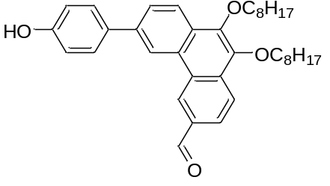
The synthesis is performed as described in general procedure A with 4-bromophenyl acetate (S) (93.0 µmol, 20.0 mg), 9,10-di(octyloxy)-6-(4,4,5,5-tetramethyl-1,3,2-dioxaborolan-2-yl)phenanthrene-3-carbaldehyde (P//) (112 µmol, 65.7 mg), Pd(OAc)₂ (4.65 µmol, 1.04 mg), RuPhos (23.3 µmol, 10.8 mg) and K₃PO₄ (279 µmol, 59.2 mg) dissolved in a mixture of THF (0.465 mL) and water (0.0093 mL). After quenching and work-up of the reaction, the crude product is dissolved in THF and a few droplets of NaOH solution (1 M) are added to deprotect the hydroxyl group. The reaction is neutralized with HCl (1 M) and extracted with Et₂O. The combined organic phase is consecutively washed with a saturated NaHCO₃ solution, and a saturated NaCl solution and dried over Na₂SO₄. After filtration, the solvent is evaporated under reduced pressure to obtain the crude product which is purified by a filtration through a plug of silica (SiO₂, Hep/EA: 7/1). The pure product is obtained as a yellow solid.
Quantity: 42.0 mg
Yield: 81 %
¹H-NMR (400 MHz, CDCl3): δ10.26 (s, 1H), 9.19 (d, J = 1.42 Hz, 1H), 8.83 (d, J = 1.68 Hz, 1H), 8.36 (d, J = 8.46 Hz, 1H), 8.33 (d, J = 8.52 Hz, 1H), 8.09 (dd, J = 1.42, 8.46 Hz, 1H), 7.87 (dd, J = 1.68, 8.52 Hz, 1H), 7.69 (d, J = 8.64 Hz, 2H), 7.02 (d, J = 8.64 Hz, 2H), 5.02 (brd, s, 1H), 4.29 (t, J = 6.70 Hz, 2H), 4.20 (t, J = 6.70 Hz, 2H), 1.93 (m, 4H), 1.58 (m, 4H), 1.24-1.46 (m, 16H), 0.90 (m, 6H)
¹³C-NMR (100 MHz, CDCl₃): δ192.49, 155.53, 146.39, 142.55, 139.14, 134.36, 133.75, 133.32, 129.25, 128.87, 128.58, 128.21, 126.78, 126.68, 125.72, 123.28, 120.42, 115.94, 76.70, 73.89, 31.86, 30.52, 30.46, 29.51, 29.50, 29.32, 26.26, 26.25, 22.69, 14.12
HRMS (m/z): [M]+ calcd. For C₃₇H₄₆O₄, 554.3396; found 554.3391

SP//O
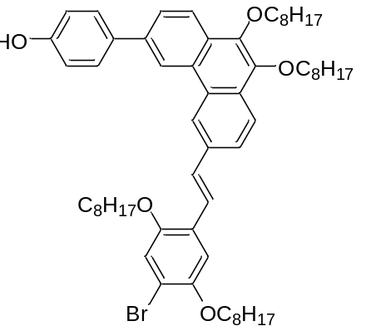
The synthesis is performed as described in general procedure B with SP// (67.1 µmol, 37.2 mg) and diethyl (4-bromo-2,5-di(octyloxy))benzyl phosphonate (O) (80.5 µmol, 45.3 mg) dissolved in THF (0.335 mL) and KOtBu (201 µmol, 22.6 g) suspended in THF (0.335 mL). The crude product is purified by precipitation in MeOH at room temperature. The purified product is obtained as yellow solid.
Quantity: 35.3 g
Yield: 55 %
¹H-NMR (400 MHz, CDCl3): δ8.78 (d, J = 1.66 Hz, 1H), 8.69 (d, J = 1.26 Hz, 1H), 8.28 (d, J = 8.50 Hz, 1H), 8.23 (d, J = 8.62 Hz, 1H), 7.89 (dd, J = 1.26, 8.62 Hz, 1H), 7.81 (dd, J = 1.66, 8.50 Hz, 1H), 7.89 (d, J = 8.68 Hz, 2H), 7.58 (d, J = 16.37 Hz, 1H), 7.38 (d, J = 16.37 Hz, 1H), 7.23 (s, 1H), 7.11 (s, 1H), 7.00 (d, J = 8.68 Hz, 2H), 4.82 (s, 1H), 4.24 (t, J = 6.24 Hz, 2H), 4.22 (t, J = 6.30 Hz, 2H), 4.08 (t, J = 6.48 Hz, 2H), 4.00 (t, J = 6.54 Hz, 2H), 1.90 (m, 8H), 1.56 (m, 8H), 1.20-1.45 (m, 32H), 0.90 (m, 9H), 0.84 (t, J = 7.04 Hz, 3H)
¹³C-NMR (100 MHz, CDCl₃): δ155.22, 151.12, 149.92, 143.40, 138.14, 134.37, 129.61, 128.81, 128.65, 126.71, 126.03, 124.15, 123.12, 122.85, 121.90, 117.98, 115.81, 111.92, 73.77, 70.37, 69.70, 31.88, 31.85, 31.78, 30.55, 29.55, 29.38, 29.34, 29.28, 26.30, 26.21, 26.08, 22.70, 22.65, 14.13, 14.08
HRMS (m/z): [M]+ calcd. For C₆₀H₈₃O₅Br₁, 962.5424; found 962.5450
SP//OO//
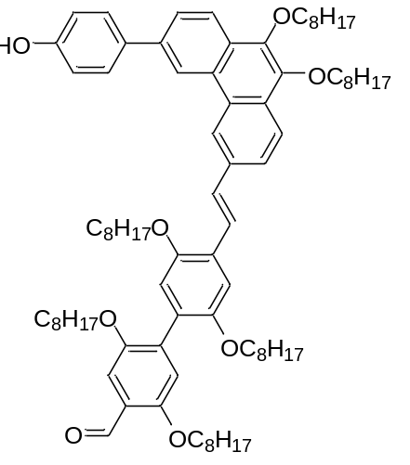
The synthesis is performed as described in general procedure A with (SP//O) (34.2 µmol, 33.0 mg), 2,5-di(octyloxy)-4-(4,4,5,5-tetramethyl-1,3,2-dioxaborolan-2-yl)benzaldehyde (O//) (41.1 µmol, 20.1 mg), Pd(OAc)₂ (1.71 µmol, 384 µg), RuPhos (8.55 µmol, 39.9 mg) and K₃PO₄ (103 µmol, 21.8 g) dissolved in a mixture of THF (0.171 mL) and water (0.00342 mL). The crude product is purified by filtration through a plug of silica (SiO₂, Hep/EA: 7.5/0.5). The purified product is obtained as yellow solid.
Quantity: 31.2 mg
Yield: 73 %
¹H-NMR (400 MHz, CDCl3): δ10.51 (s, 1H), 8.80 (d, J = 1.60 Hz, 1H), 8.71 (d, J = 1.20 Hz, 1H), 8.28 (d, J = 8.68 Hz, 1H), 8.24 (d, J = 8.52 Hz, 1H), 7.93 (dd, J = 1.20, 8.52 Hz, 1H), 7.82 (dd, J = 1.60, 8.68 Hz, 1H), 7.71 (d, J = 16.37 Hz, 1H), 7.69 (d, J = 8.44 Hz, 2H), 7.44 (d, J = 16.37 Hz, 1H), 7.39 (s, 1H), 7.30 (s, 1H), 7.04 (s, 1H), 7.00 (d, J = 8.44 Hz, 2H), 6.93 (s, 1H), 4.92 (s, 1H), 4.24 (t, J = 6.60 Hz, 2H), 4.23 (t, J = 6.72 Hz, 2H), 4.05 (t, J = 6.48 Hz, 2H), 4.02 (t, J = 6.60 Hz, 2H), 3.97 (t, J = 6.46 Hz, 2H), 3.93 (t, J = 6.52 Hz, 2H), 1.89 (m, 8H), 1.15-1.70 (m, 64H), 0.79-0.94 (m, 18H)
¹³C-NMR (100 MHz, CDCl₃): δ189.63, 155.74, 155.31, 150.68, 150.55,150.44, 143.35, 143.26, 138.14, 136.18, 135.29, 134.33, 129.31, 128.88 128.86, 128.80, 128.64, 127.27, 127.10, 126.02 124.20, 124.04, 123.64, 122.94, 122.82, 121.84, 120.44, 116.96, 116.33, 115.82, 110.79, 110.20, 73.77, 69.66, 69.60, 69.21, 31.89, 31.82, 30.56, 29.56, 29.53, 29.42, 29.40, 29.36, 29.32, 29.30, 29.27, 26.31, 26.17, 26.14, 26.08, 22.70, 22.68, 14.14, 14.11, 14.08
HRMS (m/z): [M]+ calcd. For C₈₃H₁₂₀O₈,1244.8983; found 1244.9021
SO//P
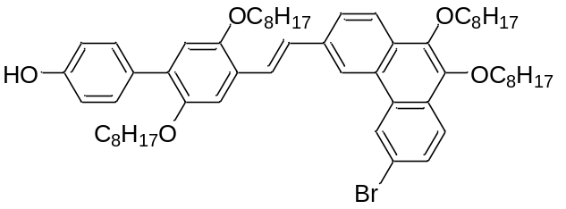
The synthesis is performed as described in general procedure B with SO// (108 µmol, 49.3 mg) and diethyl ((6-bromo-9,10-di(octyloxy)phenanthrene-3-yl)methyl)phosphonate (P) (119 µmol, 79.0 mg) dissolved in THF ( 0.250 mL) and KOtBu (325 µmol, 36.5 mg) suspended in THF (0.250 mL). The crude product is purified by recrystallization from EtOH. The purified product is obtained as yellow solid.
Quantity: 90.4 mg
Yield: 87 %
¹H-NMR (600 MHz, CDCl₃): δ8.79 (d, J = 1.62 Hz, 1H), 8.55 (brd, s, 1H), 8.21 (d, J = 8.40 Hz, 1H), 8.10 (d, J = 8.73 Hz, 1H), 7.92 (dd, J = 1.47, 8.40 Hz, 1H), 7.69 (d, J = 16.32 Hz, 1H), 7.69 (dd, J = 1.62, 8.73 Hz, 1H), 7.50 (d, J = 8.46 Hz, 2H), 7.40 (d, J = 16.32 Hz, 1H), 7.28 (s, 1H), 6.91 (s, 1H), 6.88 (d, J = 8.46 Hz, 2H), 4.80 (brd, s, 1H), 4.21 (t, J = 6.66 Hz, 2H), 4.19 (t, J = 6.66 Hz, 2H), 4.06 (t, J = 6.55 Hz, 2H), 4.00 (t, J = 6.44 Hz, 2H), 1.90 (m, 6H), 1.74 (m, 2H), 1.56 (m, 6H), 1.23-1.46 (m, 34H), 0.90 (m, 9H), 0.84 (t, J = 6.96 Hz, 3H)
¹³C-NMR (150 MHz, CDCl₃): δ154.65, 151.16, 150.32, 143.64, 142.93, 135.76, 131.08, 131.06, 130.80, 129.97, 129.84, 129.29, 128.61, 128.59, 127.78, 125.86, 125.36, 124.81, 124.22, 123.98, 122.78, 121.56, 119.99, 115.53, 114.82, 111.23, 73.80, 73.73, 69.69, 69.58, 31.86, 31.82, 30.50, 30.48, 29.53, 29.51, 29.42, 29.32, 29.31, 29.28, 26.31, 26.26, 26.16, 22.69, 22.67,14.14, 14.12, 14.09
HRMS (m/z): [M]+ calcd. For C₆₀H₈₃O₅Br₁, 962.5424; found 962.5461

SO//PO//
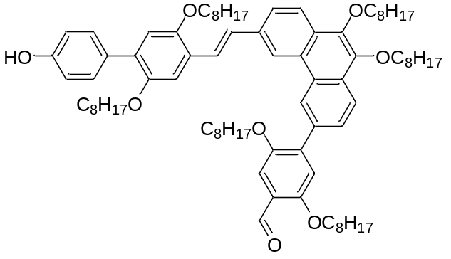
The synthesis is performed as described in general procedure A with (SO//P) (91.5 µmol, 88.3 mg), 2,5-di(octyloxy)-4-(4,4,5,5-tetramethyl-1,3,2-dioxaborolan-2-yl)benzaldehyde (O//) (110 µmol, 53.6 mg), Pd(OAc)₂ (4.57 µmol, 1.03 mg), RuPhos (22.9 µmol, 10.7 mg) and K₃PO₄ (275 µmol, 58.3 mg) dissolved in a mixture of THF (0.4575 mL) and water (0.00915 mL). The crude product is purified by filtration through a plug of silica (SiO₂, Hep/EA: 7.5/0.5). The purified product is obtained as yellow solid.
Quantity: 99.7 mg
Yield: 87 %
¹H-NMR (400 MHz, CDCl3): δ10.54 (s, 1H), 8.89 (d, J = 1.54 Hz, 1H), 8.65 (d, J = 1.24 Hz, 1H), 8.28 (d, J = 8.50 Hz, 1H), 8.25 (d, J = 8.56 Hz, 1H), 7.93 (dd, J = 1.24, 8.56 Hz, 1H), 7.79 (dd, J = 1.54, 8.50 Hz, 1H), 7.68 (d, J = 16.37 Hz, 1H), 7.50 (s, 1H), 7.49 (d, J = 8.56 Hz, 2H), 7.39 (d, J = 16.37 Hz, 1H), 7.26 (s, 1H), 7.14 (s, 1H), 6.90 (s, 1H), 6.88 (d, J = 8.56 Hz, 2H), 5.01 (s, 1H), 4.25 (t, J = 6.66 Hz, 4H), 4.14 (t, J = 6.42 Hz, 2H), 4.04 (t, J = 5.74 Hz, 2H), 4.01 (t, J = 5.62 Hz, 2H), 3.96 (t, J = 6.42 Hz, 2H). 1.95 (m, 4H), 1.86 (m, 4H), 1.71 (m, 4H), 1.00-1.64 (m, 60H), 0.88 (m, 15H), 0.74 (t, J = 6.96 Hz, 3H)
¹³C-NMR (100 MHz, CDCl₃): δ 189.49, 156.44, 154.76, 151.17, 150.46, 150.32, 143.86, 143.19, 139.34, 135.56, 134.82, 131.10, 130.99, 130.78, 129.37, 129.13, 128.98, 128.88, 128.23, 128.10, 125.97, 124.20, 123.77, 123.67, 122.83, 122.03, 121.77, 116.07, 115.53, 114.85, 111.31, 110.92, 77.23, 73.79, 69.67, 69.63, 69.47, 69.40, 31.90, 31.82, 31.80, 31.78, 31.70, 30.57, 29.56, 29.53, 29.44, 29.37, 29.30, 29.27, 29.25, 29.09, 26.31, 26.27, 26.15, 22.71, 22.69, 22.66, 22.53, 14.14, 14.09, 14.03
HRMS (m/z): [M]+ calcd. For C₈₃H₁₂₀O₈,1244.8983; found 1244.9004

SO//OP//
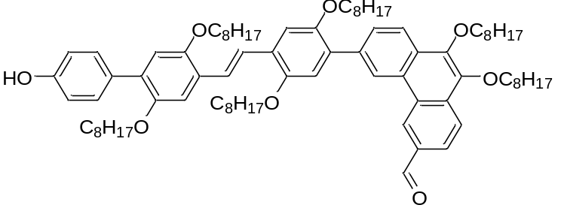
The synthesis is performed as described in general procedure A with (SO//O) (87.7 µmol, 75.8 mg), 9,10-di(octyloxy)-6-(4,4,5,5-tetramethyl-1,3,2-dioxaborolan-2-yl)phenanthrene-3-carbaldehyde (P//) (105 µmol, 62.0 mg), Pd(OAc)₂ (4.38 µmol, 980 µg), RuPhos (21.9 µmol, 10.2 mg) and K₃PO₄ (263 µmol, 55.8 mg) dissolved in a mixture of THF (0.439 mL) and water (0.00877 mL). The crude product is purified by filtration through a plug of silica (SiO₂, Hep/EA: 7.5/0.5). The purified product is obtained as yellow solid.

Quantity: 82.8 g
Yield: 76 %
¹H-NMR (400 MHz, CD₂Cl₂): δ10.28 (s, 1H), 9.20 (d, J = 1.42 Hz, 1H), 9.03 (d, J = 1.50 Hz, 1H), 8.42 (d, J = 8.50 Hz, 1H), 8.37 (d, J = 8.50 Hz, 1H), 8.13 (dd, J = 1.42, 8.50 Hz, 1H), 7.96 (dd, J = 1.50, 8.50 Hz, 1H), 7.63 (s, 2H), 7.53 (d, J = 8.80 Hz, 2H), 7.39 (s, 1H), 7.30 (s, 1H), 7.16 (s, 1H), 6.95 (s, 1H), 6.92 (d, J = 8.80 Hz, 1H), 5.12 (s, 1H), 4.35 (t, J = 6.72 Hz, 2H), 4.26 (t, J = 6.68 Hz, 2H), 4.14 (t, J = 6.54 Hz, 2H), 4.09 (m, 4H), 4.03 (t, J = 6.42 Hz, 2H), 1.96 (m, 8H), 1.77 (m, 4H), 1.62 (m, 4H), 1.09-1.52 (m, 56H), 0.93 (m, 15H), 0.80 (t, J = 7.04 Hz, 3H)
¹H-NMR (400 MHz, CDCl₃): δ10.24 (s, 1H), 9.15 (d, J = 1.36 Hz, 1H), 8.96 (d, J = 1.52 Hz, 1H), 8.37 (d, J = 8.56 Hz, 1H), 8.32 (d, J = 8.56 Hz, 1H), 8.10 (dd, J = 1.36, 8.56 Hz, 1H), 7.90 (dd, J = 1.52, 8.56 Hz, 1H), 7.56 (s, 2H), 7.50 (d, J = 8.56 Hz, 2H), 7.33 (s, 1H), 7.26 (s, 1H), 7.07 (s, 1H), 6.90 (s, 1H), 6.88 (d, J = 8.56 Hz, 2H), 4.80 (brd, s, 1H), 4.30 (t, J = 6.60 Hz, 2H), 4.21 (t, J = 6.66 Hz, 2H), 4.08 (t, J = 6.54 Hz, 2H), 4.04 (t, J = 6.56 Hz, 2H), 4.02 (t, J = 6.32 Hz, 2H), 3.96 (t, J = 6.48 Hz, 2H), 1.82-2.00 (m, 8H), 1.72 (m, 4H), 1.56 (m, 4H), 1.04-4.47 (m, 56H), 0.88 (m, 15H), 0.76 (t, J = 7.02 Hz, 3H)
¹³C-NMR (100 MHz, CDCl₃): δ192.32, 154.63, 151.24, 151.12, 150.56, 150.30, 146.45, 142.71, 136.93, 134.17, 133.42, 131.15, 130.82, 130.79, 130.60, 129.23, 128.67, 128.63, 128.36, 127.83, 126.63, 125.11, 123.98, 123.45, 123.35, 123.25, 122.19, 116.04, 115.53, 114.82, 111.53, 111.49, 73.88, 69.88, 69.65, 69.56, 31.88, 31.83, 31.70, 30.55, 30.47, 29.56, 29.52, 29.45, 29.34, 29.30, 29.13, 26.26, 26.22, 26.18, 22.69, 22.54, 14.13, 14.09, 14.02
HRMS (m/z): [M]+ calcd. For C₈₃H₁₂₀O₈,1244.8983; found 1244.8973

TfSO//OO//
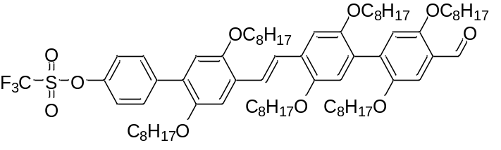
An oven dried flask was loaded with SO//OO// (100 µmol, 115 mg), PhNTf₂ (150 µmol, 58.4 mg), DMAP (10.0 µmol, 1.22 mg) and flushed with N₂. Next, DCM (1 mL) and Et₃N (200 µmol, 27.9 mL) were added to the mixture and the reaction was monitored by TLC. The reaction was terminated by the addition of HCl (1 M) and extracted with Et₂O. The combined organic phase is consecutively washed with a saturated NaHCO₃ solution, and a saturated NaCl and dried over Na₂SO₄. After filtration, the solvent is evaporated under reduced pressure to obtain the crude product with is purified by filtration through a plug of silica (SiO₂, Hep/EA: 7.5/0.5) and followed by recrystallization from EtOH. The pure product is obtained as lime green solid.
Quantity: 933 mg
Yield: 74 %
¹H-NMR (400 MHz, CDCl₃): δ10.50 (s, 1H), 7.66 (d, J = 8.80 Hz, 2H), 7.55 (d, J = 16.65 Hz, 1H), 7.51 (d, J = 16.65 Hz, 1H), 7.39 (s, 1H), 7.30 (d, J = 8.80 Hz, 2H), 7.24 (s, 1H), 7.23 (s, 1H), 7.02 (s, 1H), 6.90 (s, 1H), 6.87 (s, 1H), 4.03 (t, J = 6.72 Hz, 2H), 4.02 (t, J = 6.72 Hz, 2H), 3.98 (t, J = 6.60 Hz, 2H), 3.96 (t, J = 6.36 Hz, 2H), 3.93 (t, J = 6.60 Hz, 2H), 3.92 (t, J = 6.42 Hz, 2H), 1.84 (m, 6H), 1.58-1.75 (m, 6H), 1.50 (m, 6H), 1.17-1.41 (m, 54H), 0.87 (m, 18H)
¹³C-NMR (100 MHz, CDCl₃): δ 189.52, 151.04, 150.63, 150.43, 150.15, 148.44, 138.95, 136.04, 131.25, 128.76, 127.99, 127.50, 124.29, 124.05, 123.52, 120.71, 116.99, 116.25, 115.40, 111.21, 110.17, 69.66, 69.49, 69.17, 31.88, 31.82, 29.51, 29.47, 29.42, 29.40, 29.36, 29.30, 29.27, 29.26, 26.27, 26.21, 26.15, 26.13, 26.06, 22.67,14.09
HRMS (m/z): [M]+ calcd. For C₇₆H₁₁₅O₁₀S₁F₃, 1276.8163; found 1276.8140

SO//OO//E
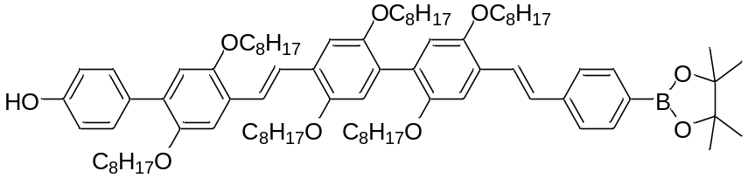
The synthesis is performed as described in general procedure B with SO//OO// (100 µmol, 115 mg) and diethyl 4-(4,4,5,5-tetramethyl-1,3,2-dioxaborolan-2-yl)benzylphosphonate (E) (1.5 eq., 150 µmol, 53.5 mg) dissolved in THF ( 0.5 mL) and KOtBu (0.3 mmol, 0.0336 g) suspended in THF (0.5 mL). We did not succeed in separating the unwanted cis product by recrystallisation nor precipitation. The crude product is dissolved in 20 mL of CHCl₃ and a catalytic amount of I₂ at 50 °C. The reaction was monitored by ¹H-NMR to follow the conversion until 100 %. The crude product is purified by column chromatography (SiO₂, Hep -> EA) and followed by precipitation in MeOH at room temperature. The purified product is obtained as yellow solid.
Quantity: 94.0 mg
Yield: 70 %
¹H-NMR (600 MHz, CDCl3): δ7.81 (d, J = 8.07 Hz, 2H), 7.57 (d, J = 16.39 Hz, 1H), 7.54 (d, J = 8.07 Hz, 2H), 7.52 (s, 2H), 7.48 (d, 8.64 Hz, 2H), 7.24 (s, 2H), 7.19 (1s, 1H), 7.18 (d, J = 16.39 Hz, 1H), 6.96 (s, 1H), 6.95 (s, 1H), 6.88 (s, 1H), 6.87 (d, J = 8.64 Hz, 2H), 4.92 (s, 1H), 4.00 (m, 6H), 3.92 (m, 6H), 1.84 (m, 6H), 1.71 (m, 2H), 1.65 (m, 4H), 1.50 (m, 6H), 1.18-1.42 (m, 66H), 0.87 (m, 18H)
¹³C-NMR (150 MHz, CDCl₃): δ154.64, 151.05, 150.69, 150.67, 150.62, 150.45, 150.28, 140.91, 135.14, 131.14, 130.78, 130.60, 128.61, 128.58, 128.02, 127.01, 126.87, 125.96, 125.80, 124.89, 123.70, 123.33, 116.87, 116.80, 115.54, 114.82, 111.44, 83.78, 69.79, 69.77, 69.68, 69.53, 69.49, 31.91, 31.90, 31.86, 31.83, 29.59, 29.57, 29.54, 29.49, 29.46, 29.41, 29.38, 29.35, 29.32, 29.29, 26.34, 26.29, 26.24, 26.20, 26.18, 26.14, 24.90, 22.81, 22.70, 14.13, 14.12
HRMS (m/z): [M]+ calcd. For C₈₈H₁₃₃O₉B₁, 1344.0079; found 1344.0128

SO//OO//ESO//OO//
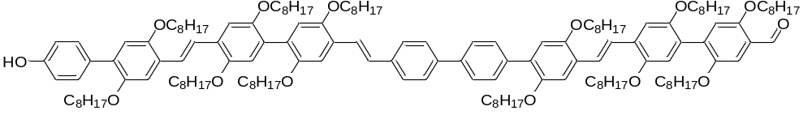
The synthesis is performed as described in general procedure A with TfSO//OO// (19.5 µmol, 25.0 mg), SO//OO//E (19.5 µmol, 26.3 mg), Pd(OAc)₂ (977 nmol, 219 µg), RuPhos (4.89 µmol, 2.27 mg) and K₃PO₄ (58.6 µmol, 12.4 mg) dissolved in a mixture of THF (0.2 mL) and water (0.004 mL). The crude product is purified by precipitation in EtOH at room temperature. The purified product is obtained as yellow solid.
Quantity: 28.5 mg
Yield: 62 %
¹H-NMR (600 MHz, CD₂Cl₂): δ10,4 (s, 1H), 7.63 (m, 6H), 7.59 (m, 2H), 7.52 (d, J = 16.32 Hz, 1H), 7.49 (s, 2H) , 7.46 (s, 2H), 7.41 (d, J = 8.64 Hz, 2H), 7.28 (s, 1H), 7.21 (s, 1H), 7.17 (d, J = 16.32 Hz, 1H), 7.17 (s, 1H), 7.16 (s, 3H), 6.98 (s, 1H), 6.92 (s, 1H), 6.89 (s, 1H), 6.88 (s, 1H), 6.84 (s, 1H), 6.82 (s, 1H), 6.79 (d, J = 8.64 Hz, 2H), 5.01 (brd, s, 1H), 3.84-4.01 (m, 24H), 1.78 (m, 12H), 1.53-1.72 (m, 12H),1.11-1.50 (m, 120H), 0.79 (m, 36H)
¹H-NMR (600 MHz, CDCl₃): δ10.50 (s, 1H), 7.69 (m, 6H), 7.64 (m, 2H), 7.58 (d, J = 16.50 Hz, 1H), 7.55 (s, 2H), 7.52 (s, 2H), 7.49 (d, J = 8.40 Hz, 2H), 7.39 (s, 1H), 7.27 (s, 1H), 7.24 (brd, s, 3H), 7.22 (s, 1H), 7.22 (d, J = 16.50 Hz, 1H), 7.03 (s, 1H), 6.98 (2s, 2H), 6.96 (s, 1H), 6.91 (s, 1H), 6.88 (s, 1H), 6.88 (d, J = 8.40 Hz, 2H), 4.78 (s, 1H), 3.97-4.07 (m, 14H), 3.93 (m, 10H), 1.85 (m, 12H), 1.73 (m, 3H), 1.65 (m, 6H), 1.50 (m, 12H), 1.17-1.45 (m, 111H), 0.88 (m, 36H),
HRMS (m/z): [M]+ calcd. For C₁₅₇H₂₃₆O₁₄, 2345.7755; found 2345.7856

SO//V₂E//OO//OS
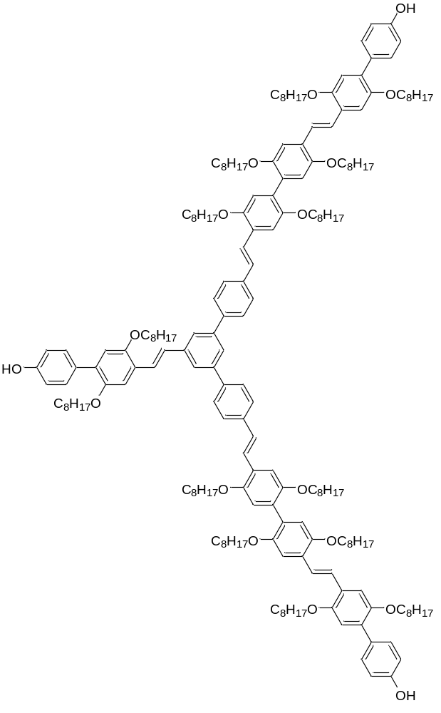
The synthesis is performed as described in general procedure A with SO//V₂ (16.9 µmol, 11.6 mg), SO//OO//E (37.2 µmol, 50.0 mg), Pd(OAc)₂ (1.69 µmol, 379 µg), RuPhos (8.44 µmol, 3.94 mg) and K₃PO₄ (50.6 µmol, 10.7 mg) dissolved in a mixture of THF (0.2 mL) and water (0.004 mL). The crude product is purified by column chromatography (SiO₂, Hep/EA: 7/1.5). The purified product is obtained as yellow solid.
Quantity: 14.4 g
Yield: 29 %
¹H-NMR (600 MHz, CDCl₃): δ7.78 (s, 2H), 7.77 (s, 1H), 7.30 (d, J = 8.28 Hz, 4H), 7.67 (d, J = 8.28 Hz, 4H), 7.63 (d, J = 16.68 Hz, 1H), 7.60 (d, J = 16.68 Hz, 2H), 7.52 (s, 4H), 7.50 (d, J = 8.46 Hz, 2H), 7.49 (d, J = 8.46 Hz, 4H), 7.32 (d, J = 16.68 Hz, 1H), 7.23 (m, 9H), 6.98 (s, 2H), 6.97 (s, 2H), 6.91 (s,1H), 6.88 (m, 8H), 4.78 (brd, s, 3H), 4.05 (t, J = 6.42 Hz, 2H), 3.89-4.03 (m, 26H), 1.86 (m, 12H), 1.62-1.77 (m, 12H), 1.54 (m, 14H), 1.18-1.45 (m, 130H), 0.87 (m, 42H)
HRMS (m/z): [M]+ calcd. For C₂₀₀H₂₈₈O₁₇, 2962.1672; found 2962.1729

- Characterizations
  - NMR
    - Monomers
1a

2a

3a

O//

4a

5a

O

6b

1b

2b

3b

M//(rac)

4b

5b

M(rac)

6c

1c

2c

3c
M//(S)

7

8

P//

9

10

P

    - Racemic oligomers
SO//
SO//O

SO//OO//

SO//OM//(rac)

SM// (rac)

SM//O(rac)

SM//OO//(rac)

SO//M(rac)

SO//MO//(rac)

    - Chiral linear oligomers
SO//OM//(S)
SO//OM//O(S)

SO//OM//OM//(S)

SM//(S)

SM//O(S)

SM//OO//(S)

SM//OO//O(S)

SM//OO//OM//(S)

    - Chiral branched oligomers
SO//OM//V₂(S)
SO//OM//V₂M//(S)

SM//OO//V₂(S)

SM//OO//V₂M//(S)

SO//V₂

SO//V₂M//(S)

SO//V₂M//O(S)

    - Phenanthrene containing oligomers
SP//
SP//O

SP//OO//

SO//P

SO//PO//

SO//OP//

    - Modulair developed oligomers
TfSO//OO//

SO//OO//E
SO//OO//ESO//OO//

SO//V₂E//OO//OS

  - Size Exclusion Chromatography (SEC)
    - Racemic oligomers

    - Chiral linear oligomers

    - Chiral branched oligomers

    - Phenanthrene containing oligomers

    - Modular developed oligomers

  - HRMS
    - Racemic oligomers

    - Chiral linear oligomers

    - Chiral branched oligomers

    - Phenanthrene containing oligomers

    - Modular developed oligomers

  - UV-vis spectroscopy
    - Racemic oligomers

    - Chiral linear oligomers

    - Chiral branched oligomers

    - Phenanthrene containing oligomers

    - Modular developed oligomers

  - Fluorescence spectroscopy
During the fluorescence measurements, the same samples used in the UV-vis experiments were measured immediately afterwards in the fluorospectrometer. However, different sequences resulted in different maximal absorbances, necessitating a change in the excitation wavelength. Moreover, not all the sequences proved to be equally fluorescent, and the best results would be obtained if the data was below 1 000 000 counts. Therefore, the scan slits and offset slits were adjusted where necessary.
SO//
Excitation wavelength: 350 nm
Scan slit: 1.70
Offset slit: 1.70

SO//O
Excitation wavelength: 350 nm
Scan slit: 2.00
Offset slit: 2.00

SO//OO//
Excitation wavelength: 370 nm
Scan slit: 1.50
Offset slit: 2.00

SO//OM//(rac)
Excitation wavelength: 370 nm
Scan slit: 1.70
Offset slit: 2.00

SO//M(rac)
Excitation wavelength: 350 nm
Scan slit: 1.20
Offset slit: 2.00

SO//MO//(rac)
Excitation wavelength: 350 nm
Scan slit: 1.70
Offset slit: 2.00

SM//(rac)
Excitation wavelength: 350 nm
Scan slit: 1.80
Offset slit: 2.00

SM//O(rac)
Excitation wavelength: 350 nm
Scan slit: 1.20
Offset slit: 2.00

SM//OO// (rac)
Excitation wavelength: 370 nm
Scan slit: 1.40
Offset slit: 2.00

SO//OM//(S)
Excitation wavelength: 370 nm
Scan slit: 1.80
Offset slit: 1.80

SO//OM//O(S)
Excitation wavelength: 365 nm
Scan slit: 1.50
Offset slit: 1.50

SO//OM//OM//(S)
Excitation wavelength: 365 nm
Scan slit: 2.00
Offset slit: 2.00

SM// (S)
Excitation wavelength: 350 nm
Scan slit: 2.00
Offset slit: 2.00
SM//(S)
Excitation wavelength: 350 nm
Scan slit: 1.70
Offset slit: 1.70
SM//OO// (S)
Excitation wavelength: 350 nm
Scan slit: 2.00
Offset slit: 2.00

SM//OO//O(S)
Excitation wavelength: 365 nm
Scan slit: 1.30
Offset slit: 1.30

SM//OO//OM//(S)
Excitation wavelength: 365 nm
Scan slit: 2.00
Offset slit: 2.00

SM//OO//V₂(S)
Excitation wavelength: 365 nm
Scan slit: 1.30
Offset slit: 1.30

SM//OO//V₂M//(S)
Excitation wavelength: 370 nm
Scan slit: 1.80
Offset slit: 1.80

SO//OM//V₂(S)
Excitation wavelength: 365 nm
Scan slit: 1.70
Offset slit: 1.70

SO//OM//V₂M//(S)
Excitation wavelength: 365 nm
Scan slit: 1.70
Offset slit: 1.70
SO//OP//
Excitation wavelength: 350 nm
Scan slit: 2.00
Offset slit: 2.20

SP//
Excitation wavelength: 330 nm
Scan slit: 2.00
Offset slit: 1.10

SP//O
Excitation wavelength: 350 nm
Scan slit: 2.00
Offset slit: 1.50

SP//OO//
Excitation wavelength: 350 nm
Scan slit: 2.00
Offset slit: 1.70

SO//P
Excitation wavelength: 365 nm
Scan slit: 1.40
Offset slit: 1.40

SO//PO//
Excitation wavelength: 350 nm
Scan slit: 2.00
Offset slit: 2.40
SO//OO//ESO//OO//
Excitation wavelength: 370 nm
Scan slit: 1.10
Offset slit: 2.00

SO//V₂E//OO//OS
Excitation wavelength: 370 nm
Scan slit: 0.70
Offset slit: 2.00

    - Racemic oligomers

    - Chiral linear oligomers

    - Chiral branched oligomers
    - Phenanthrene containing oligomers
    - Modular developed oligomers

    - Tables with Stokes shift and FWHM
Sequence | Stokes shift (cm⁻¹) | FWHM (cm⁻¹)
SO// | 4722 | 3248
SO//O | 4018 | 3277
SO//OO// | 6439 | 4077
SO//OM//(rac) | 6327 | 4135
SO//M(rac) | 3840 | 3133
SO//MO//(rac) | 6393 | 4135
SM//(rac) | 4491 | 3190
SM//O(rac) | 3787 | 3133
SM//OO// (rac) | 6261 | 4135

Sequence | Stokes shift (cm⁻¹) | FWHM (cm⁻¹)
SO//OM//(S) | 6579 | 4135
SO//OM//O(S) | 3949 | 3106
SO//OM//OM//(S) | 5205 | 4611
SM//(S) | 4595 | 3248
SM//O(S) | 3893 | 3177
SM//OO//(S) | 6630 | 4258
SM//OO//O(S) | 3818 | 3017
SM//OO//OM//(S) | 5607 | 4475

Sequence | Stokes shift (cm⁻¹) | FWHM (cm⁻¹)
SO//V | 5199 | 3439
SO//VM(S) | 4624 | 6104
SO//VM//O(S) | 3519 | 2990
SO//OM//V₂(S) | 4587 | 3583
SO//OM//V₂M//(S) | 4303 | 3183
SM//OO//V₂(S) | 4567 | 3489
SM//OO//V₂M//(S) | 4418 | 2978

Sequence | Stokes shift (cm⁻¹) | FWHM (cm⁻¹)
SO//OP// | 6632 | 5740
SP// | 7445 | 4087
SP//O | 4154 | 3399
SP//OO// | 5219 | 3945
SO//P | 4374 | 3413
SO//PO// | 8049 | 5024

Sequence | Stokes shift (cm⁻¹) | FWHM (cm⁻¹)
SO//OO//ESO//OO// | 4798 | 4137
SO//V₂E//OO//OS | 4248 | 3042

  - CD and corresponding UV-vis results
Circular dichroism (CD) is a widely applied technique in conjugated systems and offers the possibility to analyze the accompanying aggregation process. This aggregation can be induced in several ways of which the most frequently used method is a stepwise addition of a non-solvent to an oligomer solution. Classically, a combination of chloroform and methanol is used in conjugated polymer systems, but did not succeed in our case. Initial tests conducted in 10x10 quartz cuvettes did not result in any redshift originating from aggregation of the oligomer chains nor in a clear CD signal. Even ratios of 90 % non-solvent did not resulted in aggregation of the macromolecules. The blue shift noted in the UV-Vis spectra is attributed to the significant change in solvent properties (Fig. 1A and B).
As chloroform appeared to be a too good solvent for the rather short oligomers, following modifications were investigated to achieve aggregation. First, acetone as good solvent was investigated in combination with MeOH as non-solvent. Adding 70 % of MeOH did not produce a redshift, while an addition of 90 % non-solvent, again, resulted in a shift towards lower wavelengths (C). Next, isopropanol (IPA) was investigated as good solvent (D). MeOH was again added as non-solvent to an extend of 70 % but still no aggregation was observed. To perform the measurements in a more concentrated context, cuvettes with 1x10 mm dimensions instead of common 10x10 mm cuvettes were used next (E). Due to using these cuvettes, the concentration of the solution can be increased with a factor 10, facilitating an easier aggregation of the oligomers. Unfortunately, addition of MeOH as non-solvent to 70 % still did not result in aggregate formation. As a result, a mixture of MeOH and water in different ratios was examined as non-solvent. This emerged as the optimal good and non-solvent combination with the results describe in the article as outcome.
Figure 1. A) Initial aggregation test with chloroform as good solvent and MeOH as non-solvent with SM//OO//OM//(S). Upon addition up to 90% MeOH, only a blue shift is observed. B) initial test with chloroform and MeOH as non-solvent with SM//OO//(S). C) Aggregation test with Acetone as good solvent and MeOH as bad solvent with SO//OM//(S). D) Aggregation test with IPA as good solvent and MeOH as non-solvent with SO//OM//(S). E) UV-vis (left) and CD (right) results with IPA as good solvent and a mixture of MeOH and water as non-solvent with SO//OM//(S) in a 1 mm cuvette.

SM//OO//OM//(S)
Figure 2. UV-vis (left) and CD (right) results of SM//OO//OM//(S) with IPA as good solvent and 70 % of non-solvent with different ratios of MeOH/water.

SO//OM//OM//(S)
Figure 3. UV-vis (left) and CD (right) results of SO//OM//OM//(S) with IPA as good solvent and 70 % of non-solvent with different ratios of MeOH/water.

SM//OO//V₂M//(S)
Figure 4. UV-vis (left) and CD (right) results of SM//OO//V₂M//(S) with IPA as good solvent and 70 % of non-solvent with different ratios of MeOH/water

SO//OM//V₂M//(S)
Figure 5. UV-vis (left) and CD (right) results of SO//OM//V₂M//(S) with IPA as good solvent and 70 % of non-solvent with different ratios of MeOH/water.

- References
1. Xu, C. et al. Regio- and sequence-controlled conjugated topological oligomers and polymers via boronate-tag assisted solution-phase strategy. Nature Communications 12, 5853 (2021).
2. Egbe, D. A. M., Cornelia, B., Nowotny, J., Günther, W. & Klemm, E. Investigation of the photophysical and electrochemical properties of alkoxy-substituted arylene-ethynylene/arylene-vinylene hybrid polymers. Macromolecules 36, 5459–5469 (2003).
3. Zhao, X. et al. Spontaneous helielectric nematic liquid crystals: Electric analog to helimagnets. Proceedings of the National Academy of Sciences of the United States of America 118, e2111101118 (2021).
4. Li, J. et al. Oligo(3,6-phenanthrene ethynylenes): Synthesis, characterization, and photoluminescence. Journal of Organic Chemistry 78, 3001–3008 (2013).
5. Ding, C. et al. NIS/TBHP Induced Regioselective Selenation of (Hetero)Arenes via Direct C−H Functionalization. ChemCatChem 10, 5397–5401 (2018).
6. Yan, Y. H. et al. Structure-guided optimization of 1H-imidazole-2-carboxylic acid derivatives affording potent VIM-Type metallo-β-lactamase inhibitors. European Journal of Medicinal Chemistry 228, 113965 (2022).
7. García-Rodríguez, A. et al. Swivel-Cruciform Stilbenes Based on Bithiophene. European Journal of Organic Chemistry 2015, 2394–2404 (2015).

