Supplemental material
Polypyrrole deposited on the core-shell structured nitrogen doped porous carbon@Ag-MOF for signal amplification detection of chloride ions

Xiurong Zhai ^{a, *}, Qian Li ^{b}, Yang Cao ^{c}, Mengjie Han ª, Hailian Sun ª , Lelin Du, Xiyun Yang ª, Yuxin Wei ª, Congcong Yu ª

ª College of Chemistry, Chemical Engineer and Materials, Jining University, Qufu City, Shandong Province, 273155, PR China
^{b} School of Chemistry and Chemical Engineering, Yangzhou University, Yangzhou, Jiangsu, 225009, P. R. China
^{c} Ecological and Environmental Affairs Center of Jining City, Jining City, Shandong Province, 272000 PR China

* Corresponding Authors, E-mail addresses: zhaixiurong@163.com

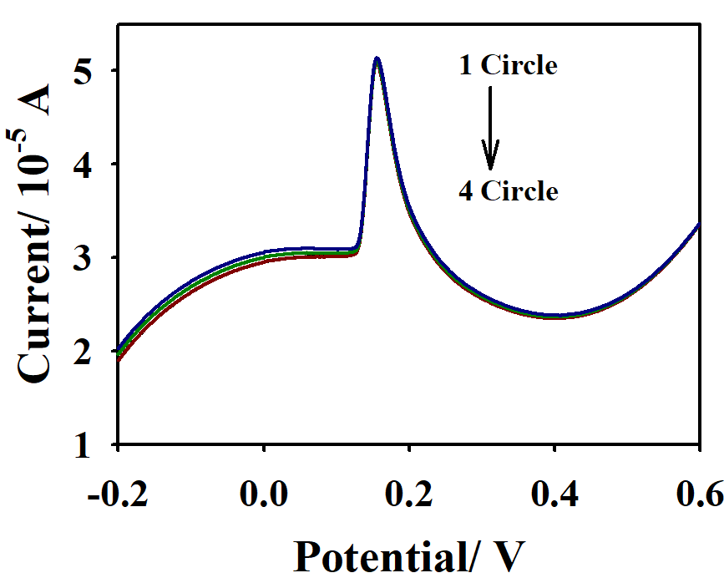

Fig. S1. The stability of NC@Ag-MOF-PPy-modified electrodes upon continuous LSV scanning for four times in buffer solution (0.1 M, pH 7.0) at the scan rate of 100 mV/ s.

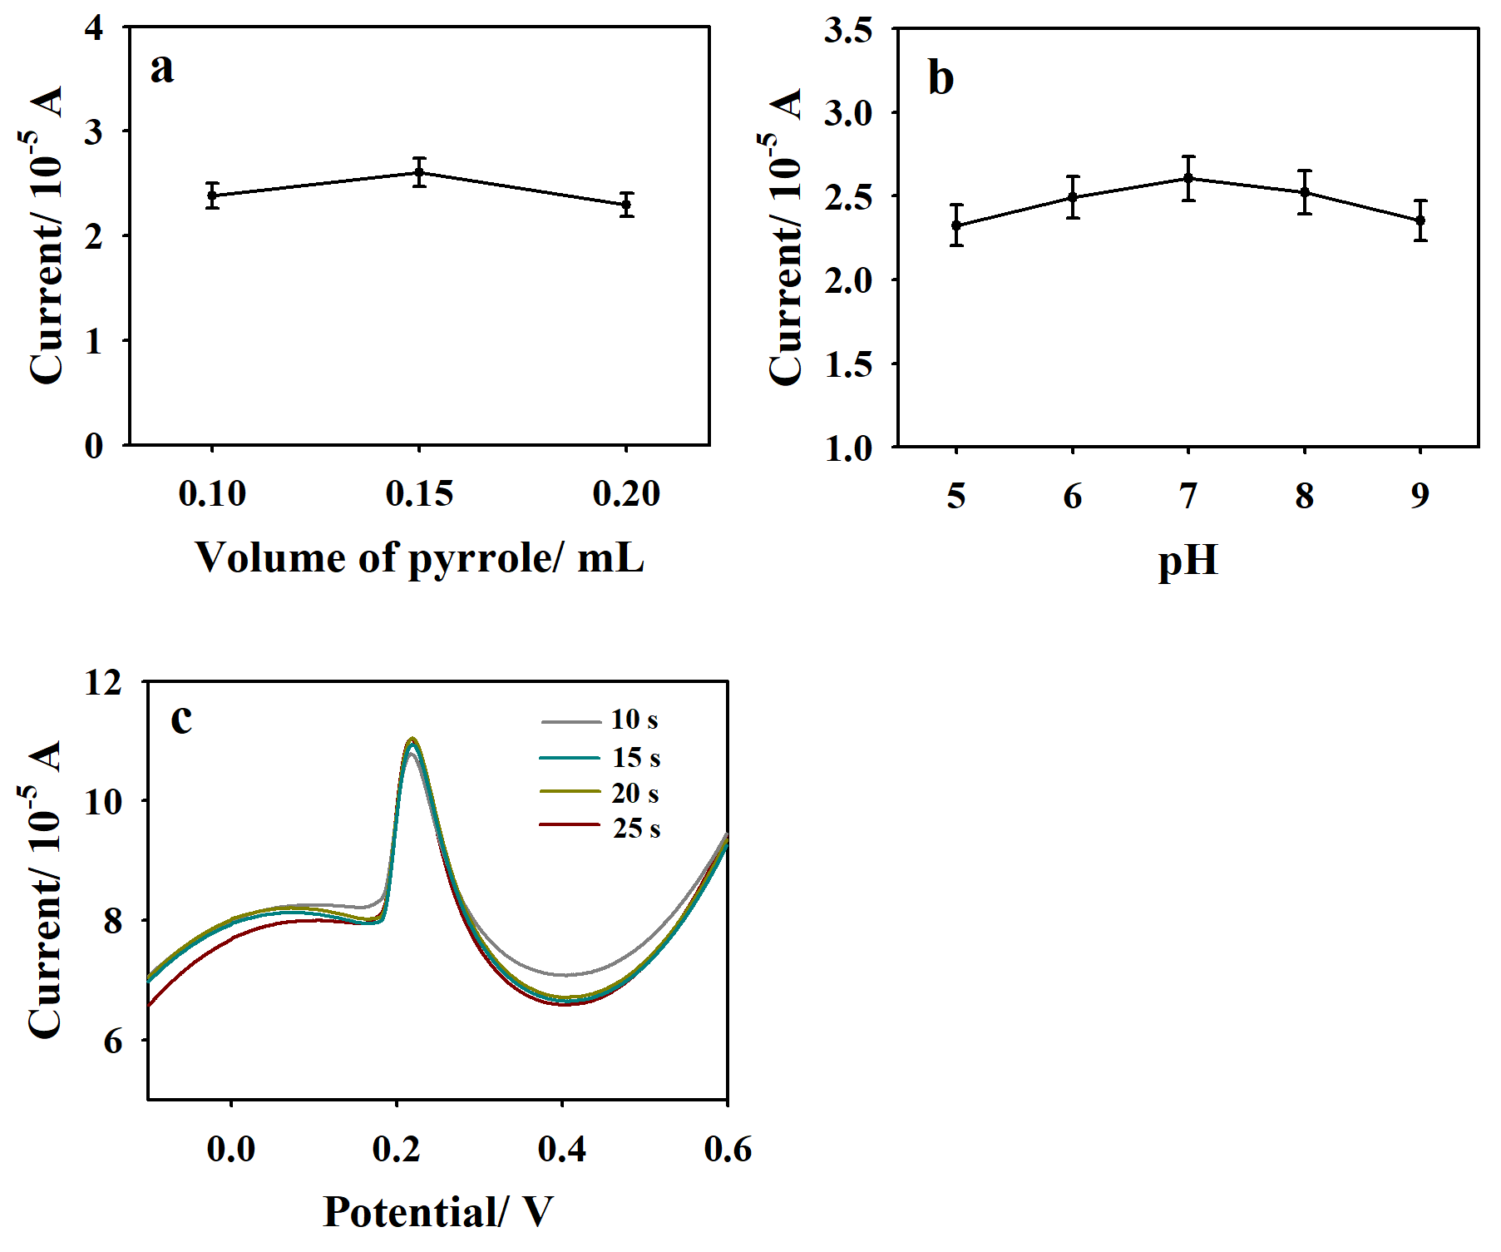
Fig. S2 The electrochemical LSV responses of NC@Ag-MOF-PPy-modified electrodes to Cl⁻ ions (10 mM) depending on (a) the volumes of pyrrole, (b) pH values, and (c) reaction time for the signal outputs of solid-state AgCl.

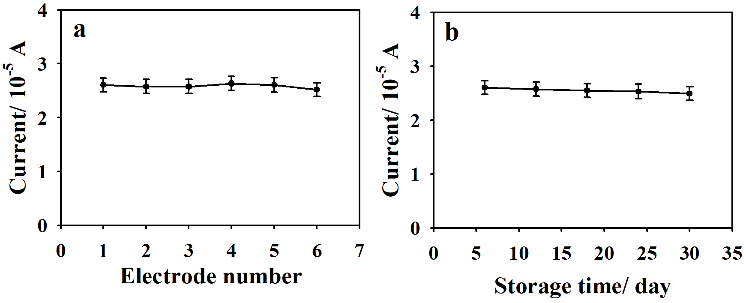
Fig. S3 (a) The electroanalytical reproducibility of six different NC@Ag-MOF-PPy-modified electrodes for detecting 10 mM Cl⁻ ions. (b) Stability tests of NC@Ag-MOF-PPy-modified electrodes stored over 30 days.
Fe
N
Ag

Table S1 Recovery test results of the developed electroanalysis method in sensing Cl⁻ ions in the samples of human serum and urine (n=3).
Sample | Spiked Cl⁻ ions  (mM) | Founded Cl⁻ ions  (mM) | Recovery  (%)
Human serum | 0 | 102 | ----
Human serum | 30 | 130 | 93.3
Human serum | 60 | 159 | 95.0
Human urine | 0 | 175 | ---
Human urine | 30 | 208 | 110.0
Human urine | 60 | 232 | 95.0

