Appendix A: Original Developed 23 items for the HEALTHPIC (Boy/ Girl Version)
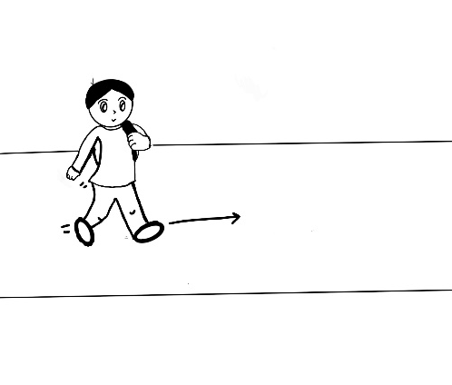 | 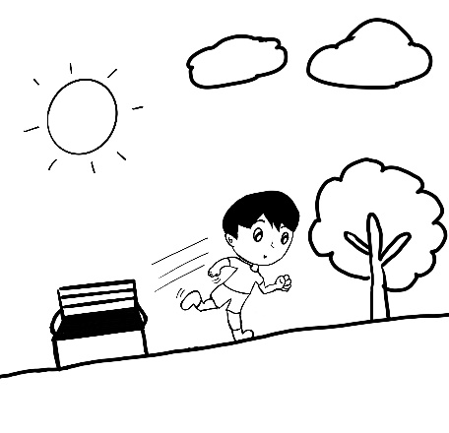 | 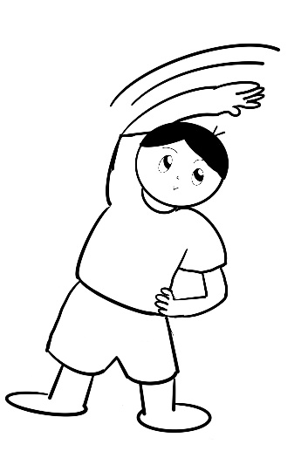
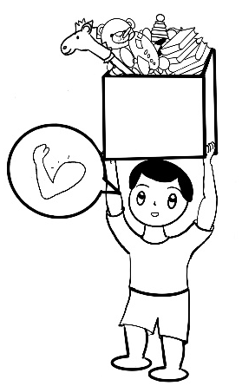 | 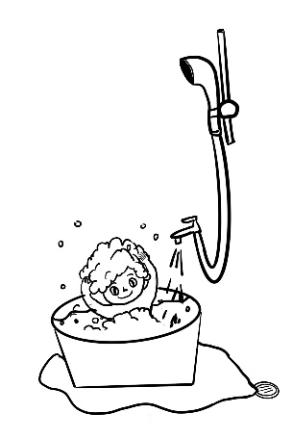 | 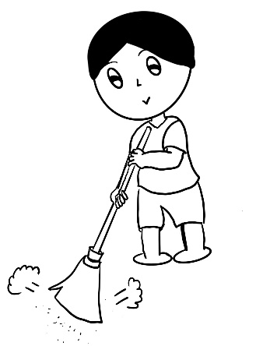
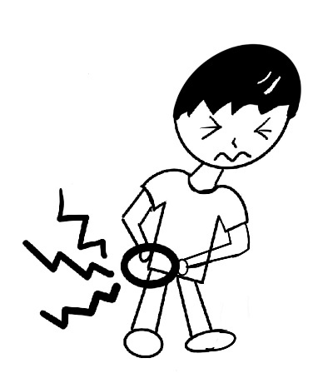 | 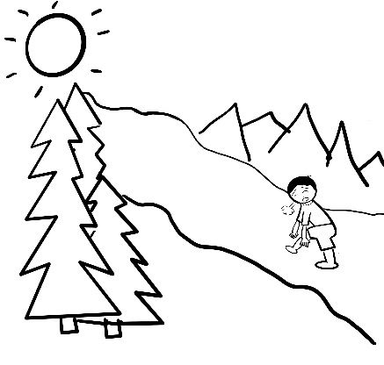 | 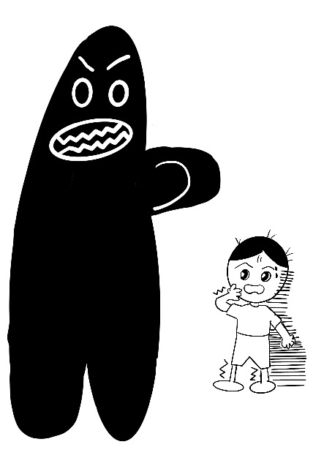
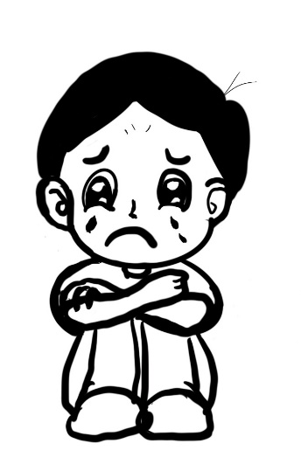 | 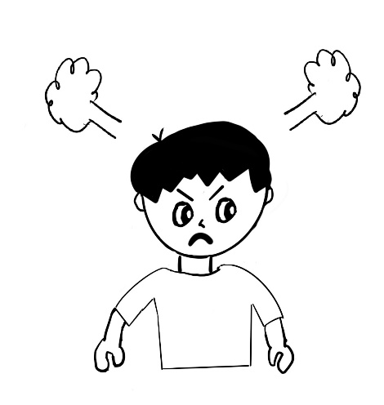 | 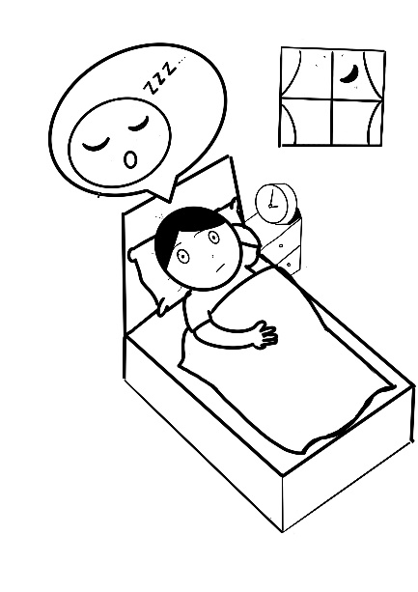
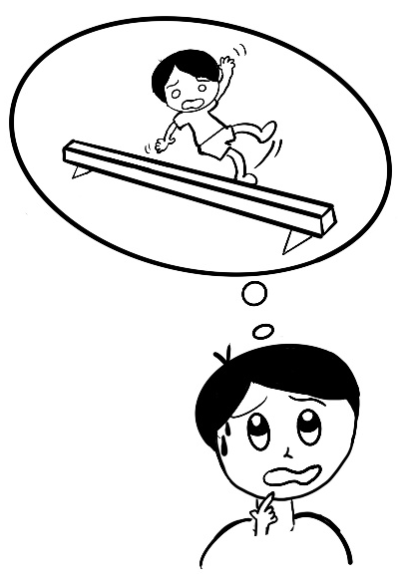 | 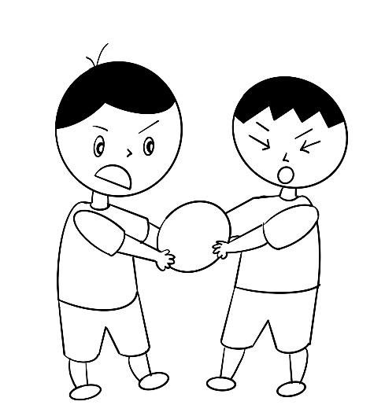 | 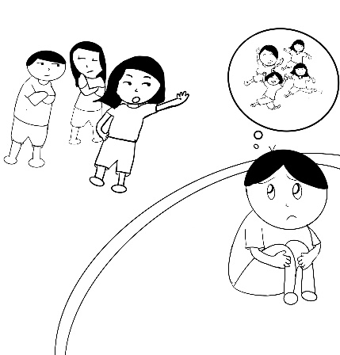
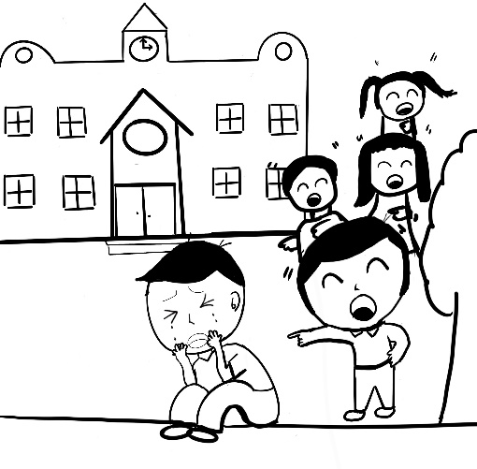 | 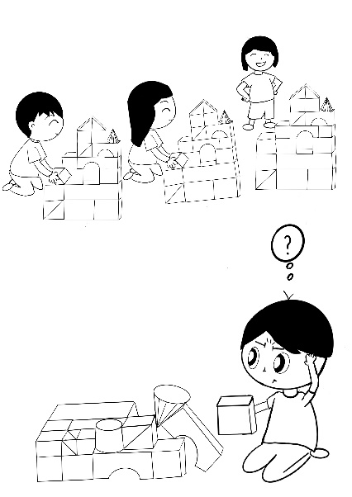 | 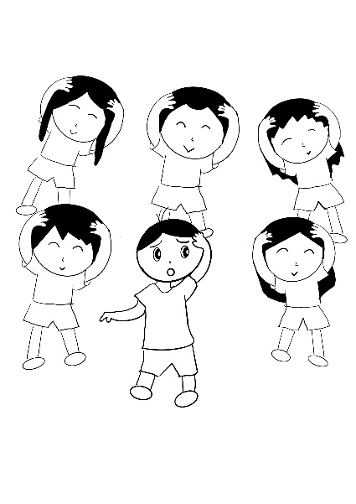
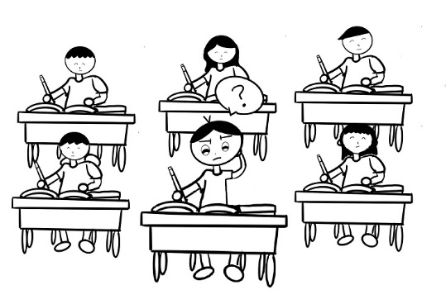 | 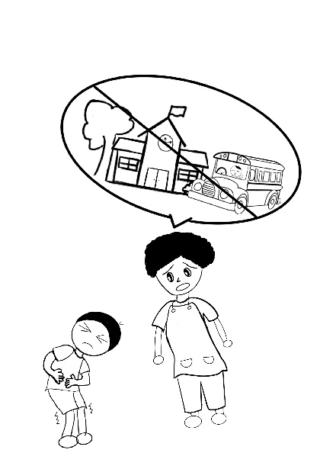 | 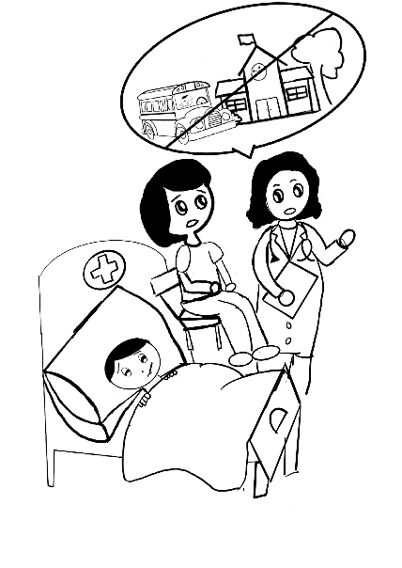
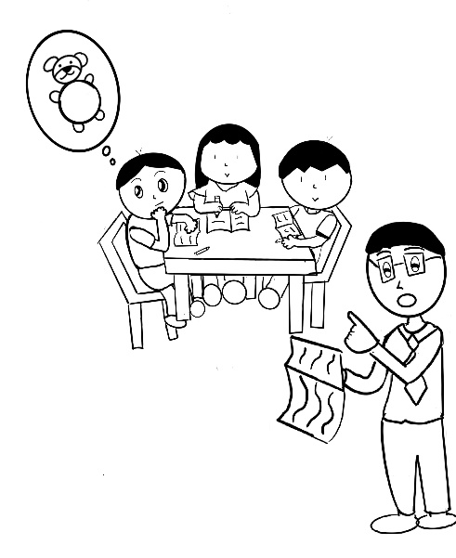 | 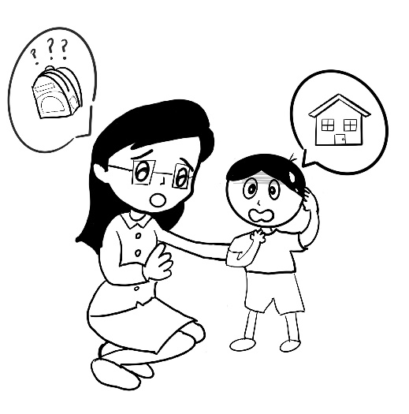

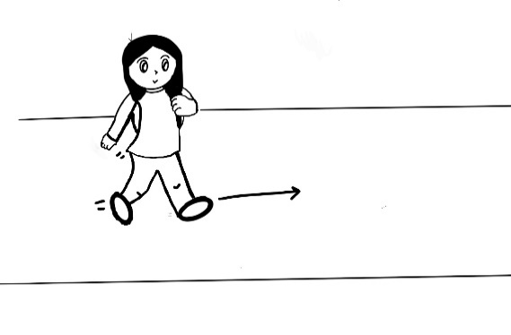 | 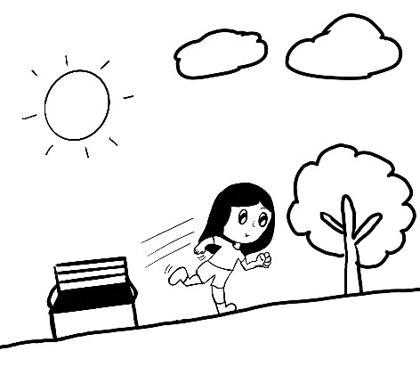 | 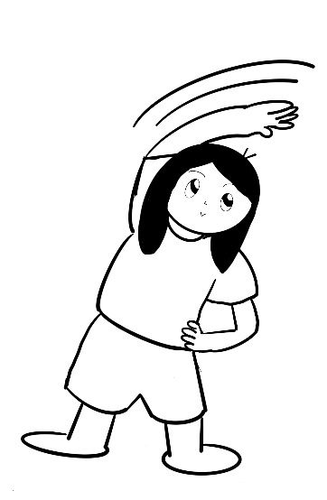
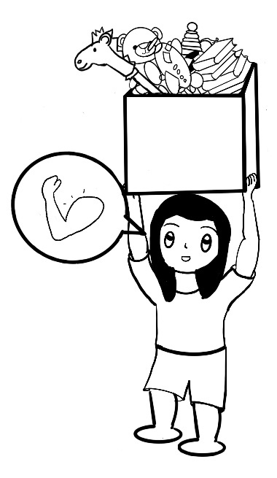 | 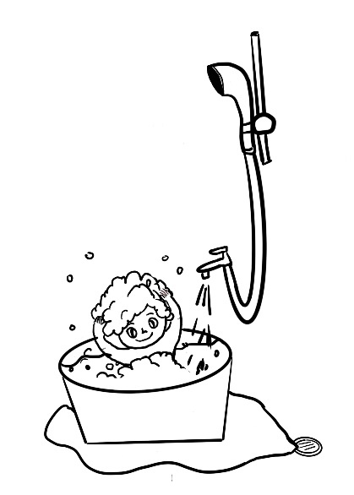 | 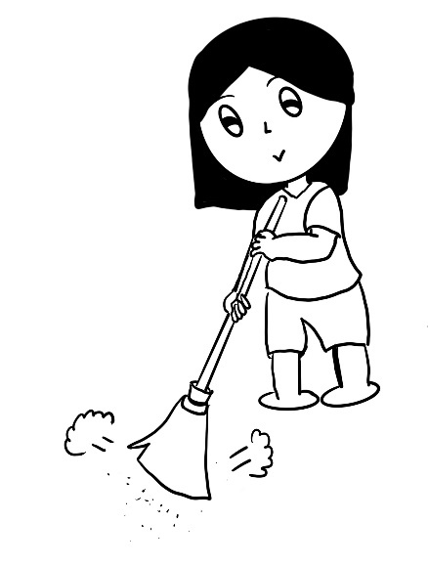
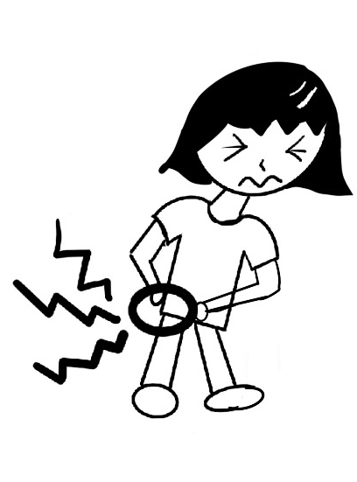 | 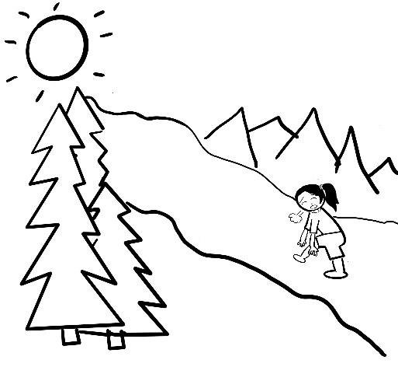 | 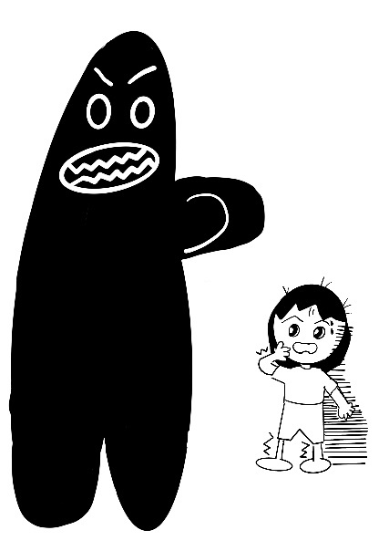
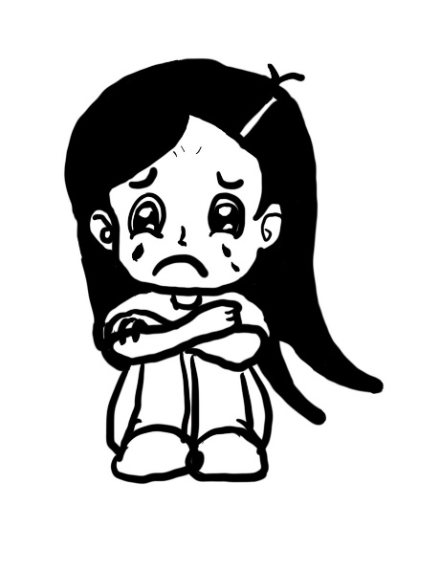 | 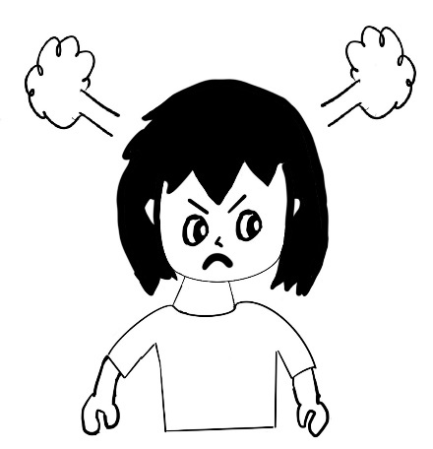 | 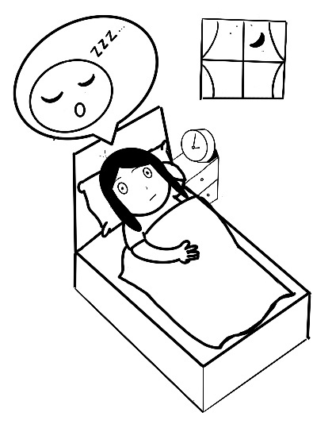
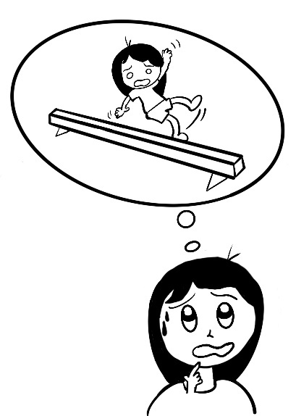 | 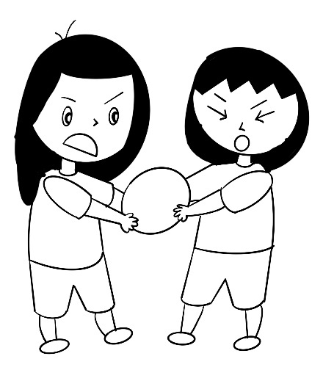 | 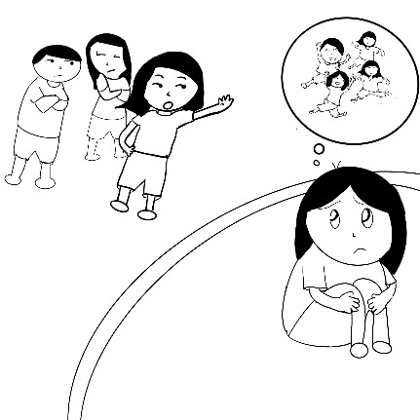
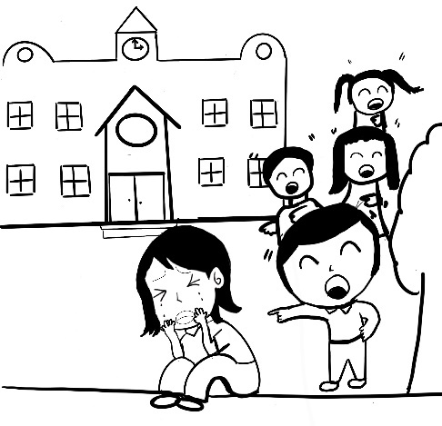 | 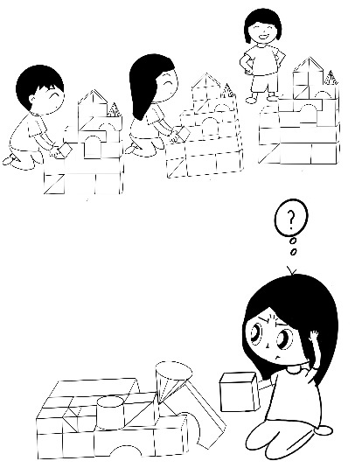 | 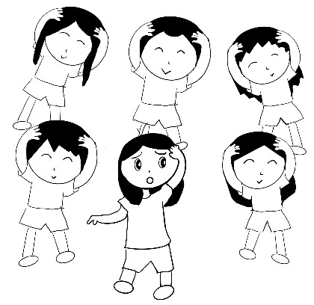
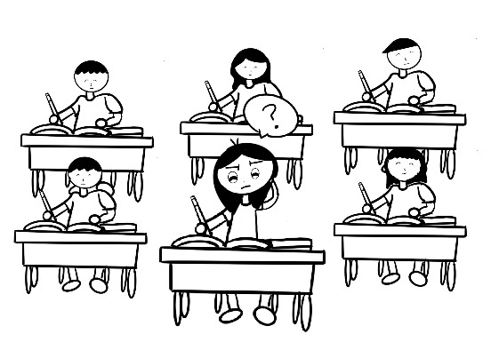 | 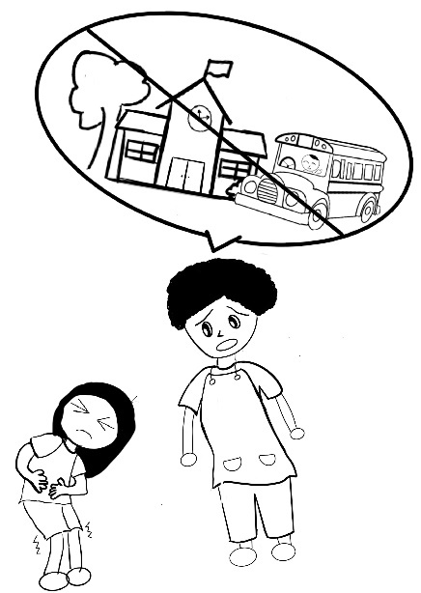 | 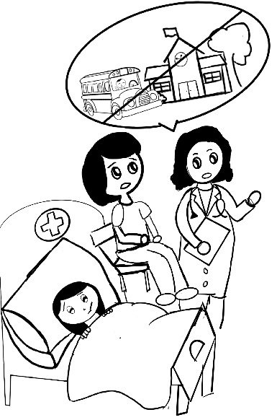
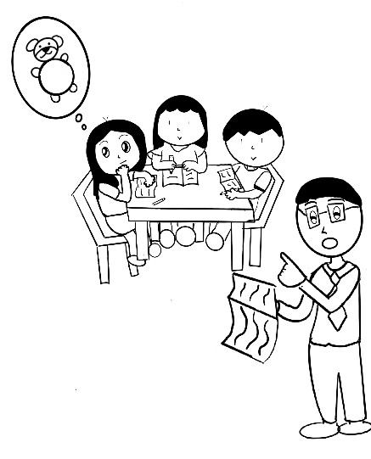 | 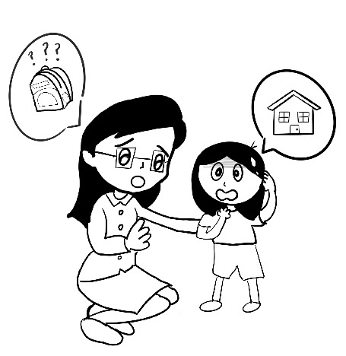
Appendix B: HEALTH-PIC Questionnaire (Boy/Girl Version)
HEALTH-PIC Boy Version (Children complete with the assistance of their parents)
Parents please read aloud the following for your child.
We are now going to look at some pictures. Within the past month, please see whether you can do the same actions/movements as the following. Please circle the most appropriate answer.
1.
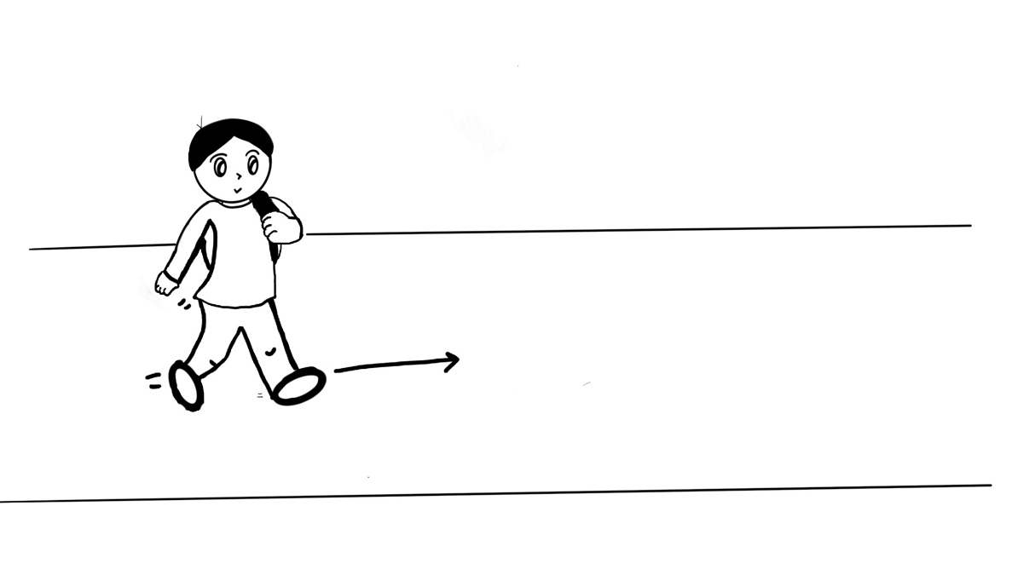
The boy in the picture is walking. For example walking to school.
In the past month, could you do the same action as the boy in the picture?

If you can, please choose the smiley face, "Yes".
If you cannot please choose the unhappy face, "No".
If you don't know, please choose the neutral face in the middle.
No | I don’t know | Yes


2.
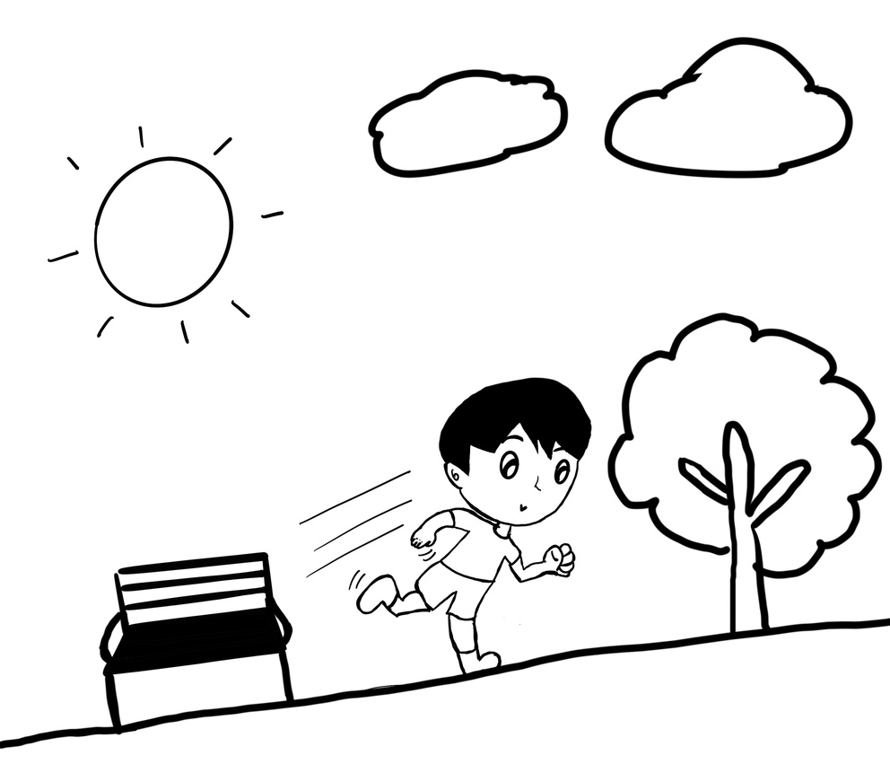
The boy in the picture is running. For example running in the park.
In the past month, could you do the same action as the boy in the picture?

If you can, please choose the smiley face, "Yes".
If you cannot please choose the unhappy face, "No".
If you don't know, please choose the neutral face in the middle.
No | I don’t know | Yes

3.
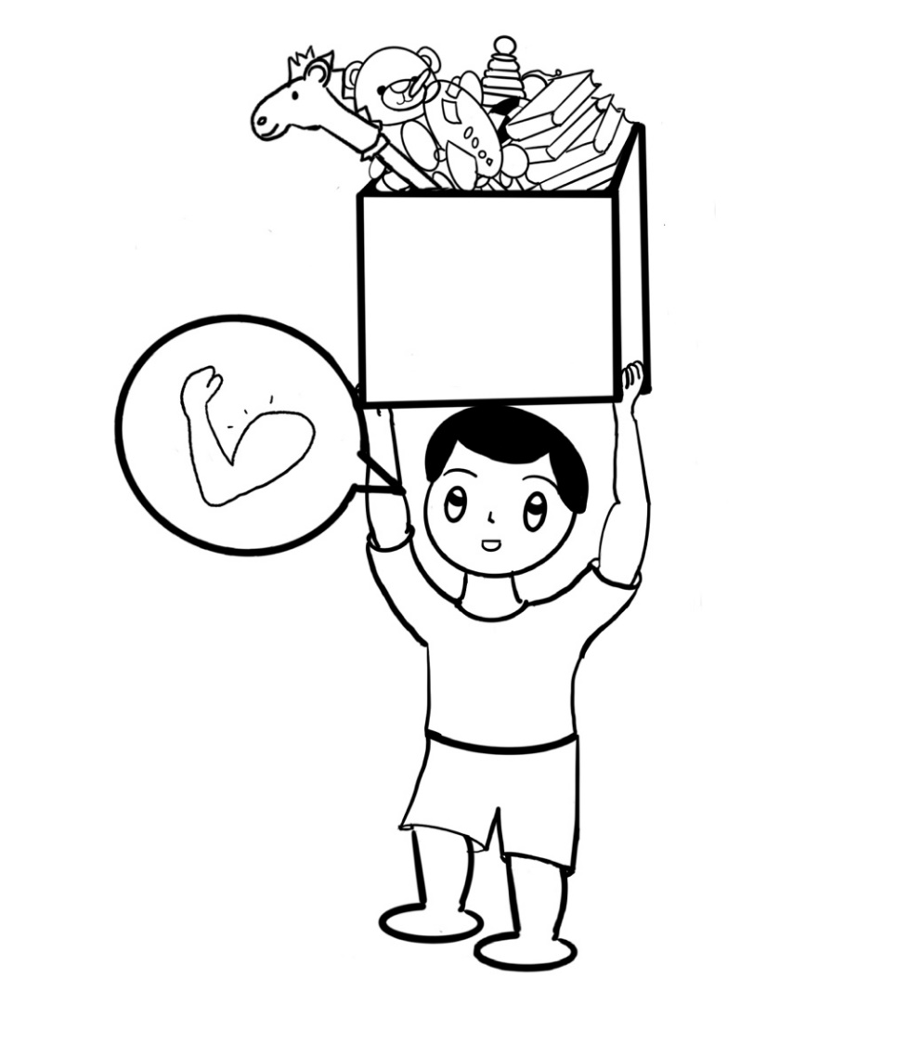
The boy in the picture is lifting heavy things. For example lifting a full box of toys.
In the past month, could you do the same action as the boy in the picture?

If you can, please choose the smiley face, "Yes".
If you cannot please choose the unhappy face, "No".
If you don't know, please choose the neutral face in the middle.
No | I don’t know | Yes

4.
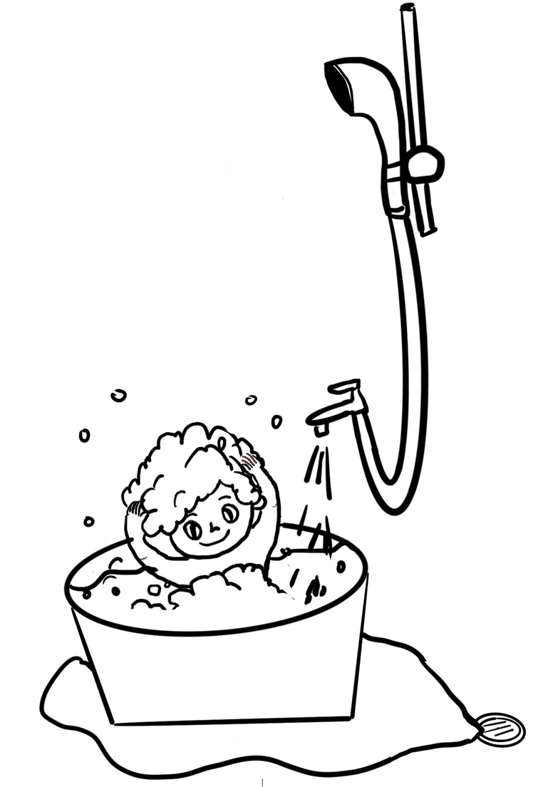
The boy in the picture is showering. For example putting on shampoo.
In the past month, could you do the same action as the boy in the picture?

If you can, please choose the smiley face, "Yes".
If you cannot please choose the unhappy face, "No".
If you don't know, please choose the neutral face in the middle.
No | I don’t know | Yes

5.
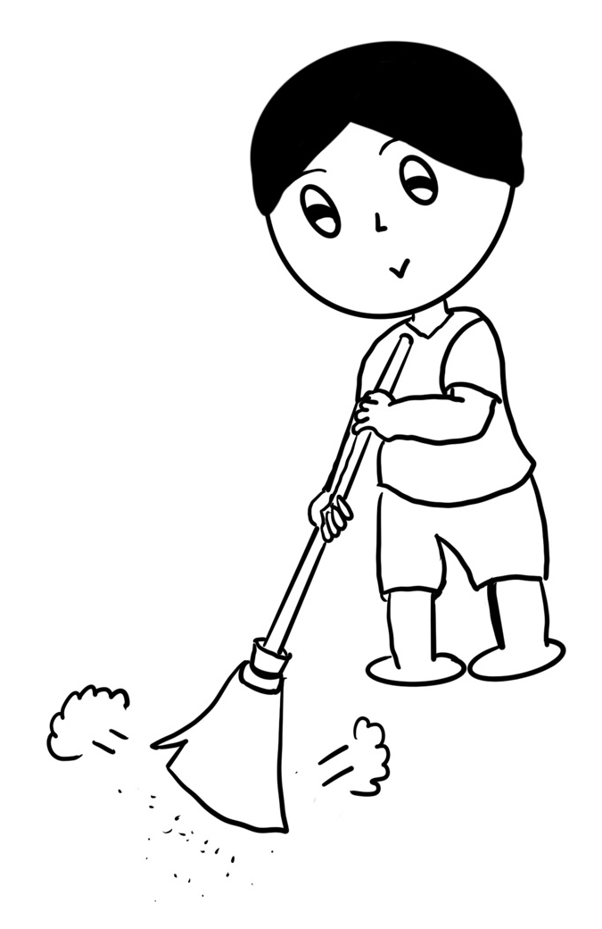
The boy in the picture is doing chores. For example sweeping the floor.
In the past month, could you do the same action as the boy in the picture?

If you can, please choose the smiley face, "Yes".
If you cannot please choose the unhappy face, "No".
If you don't know, please choose the neutral face in the middle.
No | I don’t know | Yes

We are now going to look at another group of pictures and again, I am going to ask you a few questions about these pictures.
Think about whether the following has happened to you in the past month.
Also pay attention to the smiley face, the response to the smiley face has now changed
6.
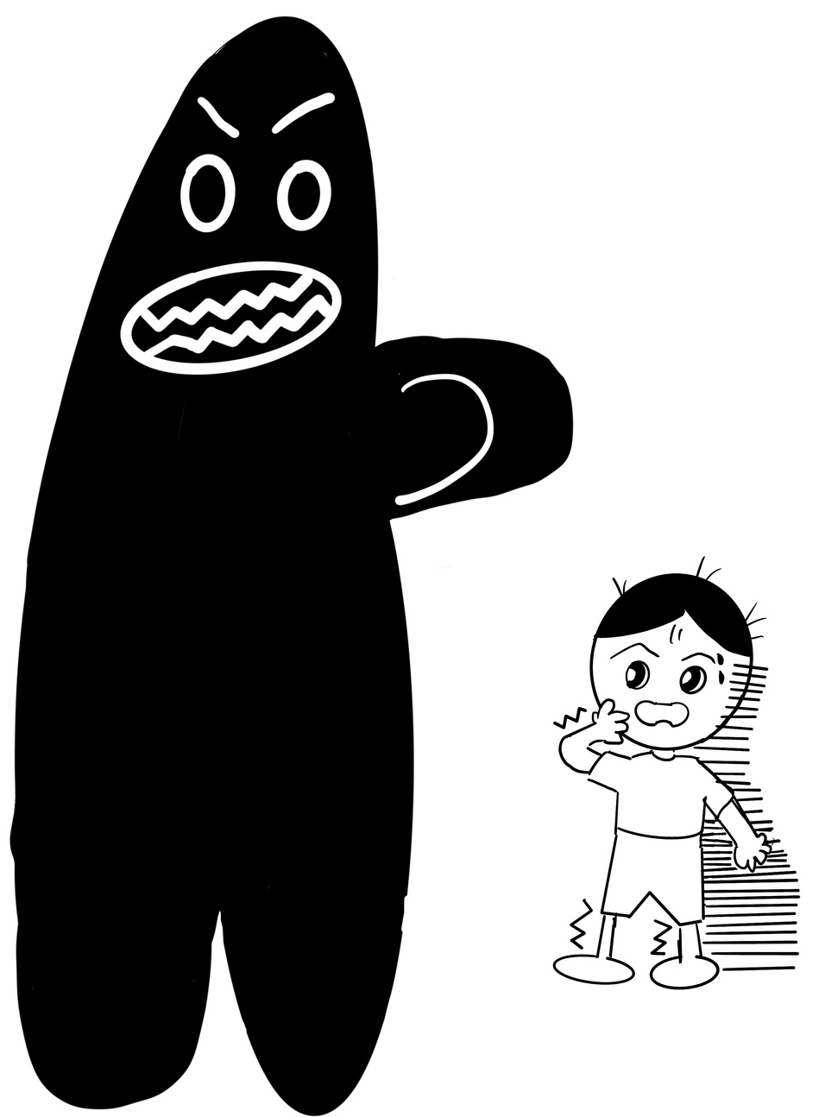
The boy in the picture feels scared or surprised. For example scared when seeing a monster
In the past month, have you felt the same way as the boy in the picture?
If you have, please choose the sad face, "Yes".
If you have not, please choose the happy face, "No".
If you don't know, please choose the neutral face in the middle.
Yes | I don’t know | No

7.
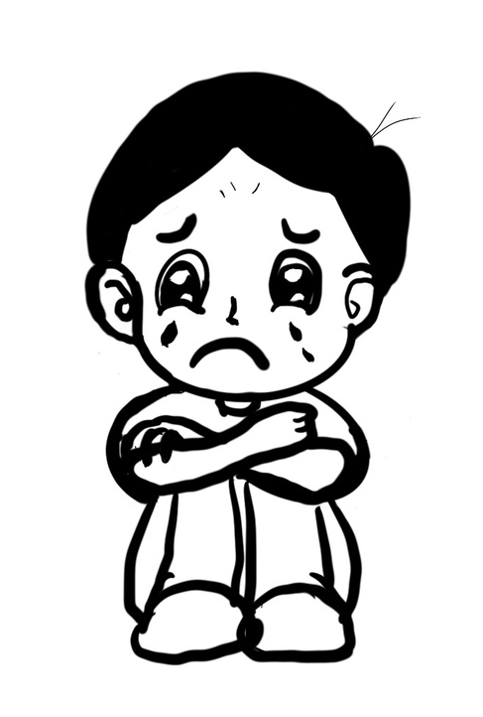
The boy in the picture feels sad or depressed. For example crying because he is unhappy
In the past month, have you felt the same way as the boy in the picture?
If you have, please choose the sad face, "Yes".
If you have not, please choose the happy face, "No".
If you don't know, please choose the neutral face in the middle.
Yes | I don’t know | No

8.
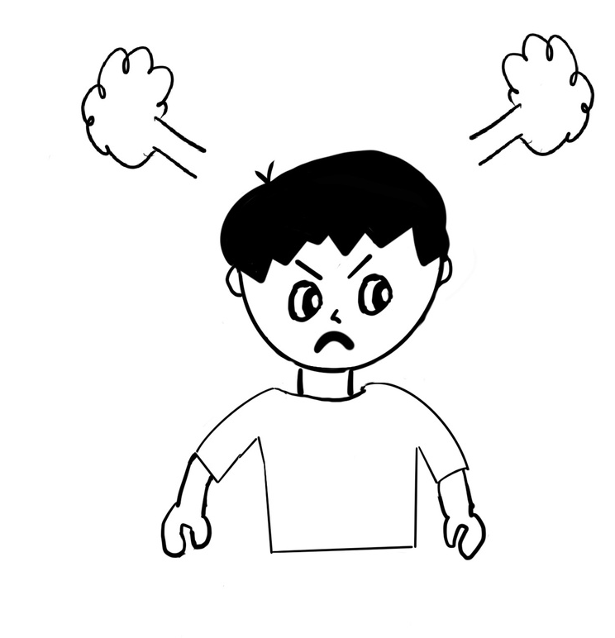
The boy in the picture feels angry or frustrated. For example angry at someone.
In the past month, have you felt the same way as the boy in the picture?
If you have, please choose the sad face, "Yes".
If you have not, please choose the happy face, "No".
If you don't know, please choose the neutral face in the middle.
Yes | I don’t know | No

9.
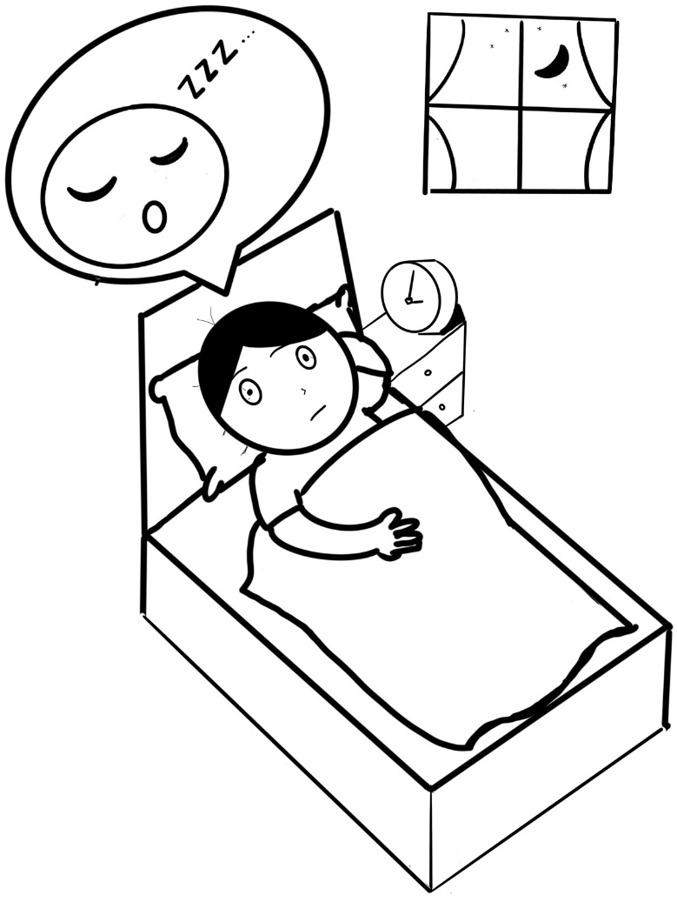
The boy in the picture can’t sleep or has trouble sleeping. For example cannot fall asleep
In the past month, have you felt the same way as the boy in the picture?
If you have, please choose the sad face, "Yes".
If you have not, please choose the happy face, "No".
If you don't know, please choose the neutral face in the middle.
Yes | I don’t know | No

10.
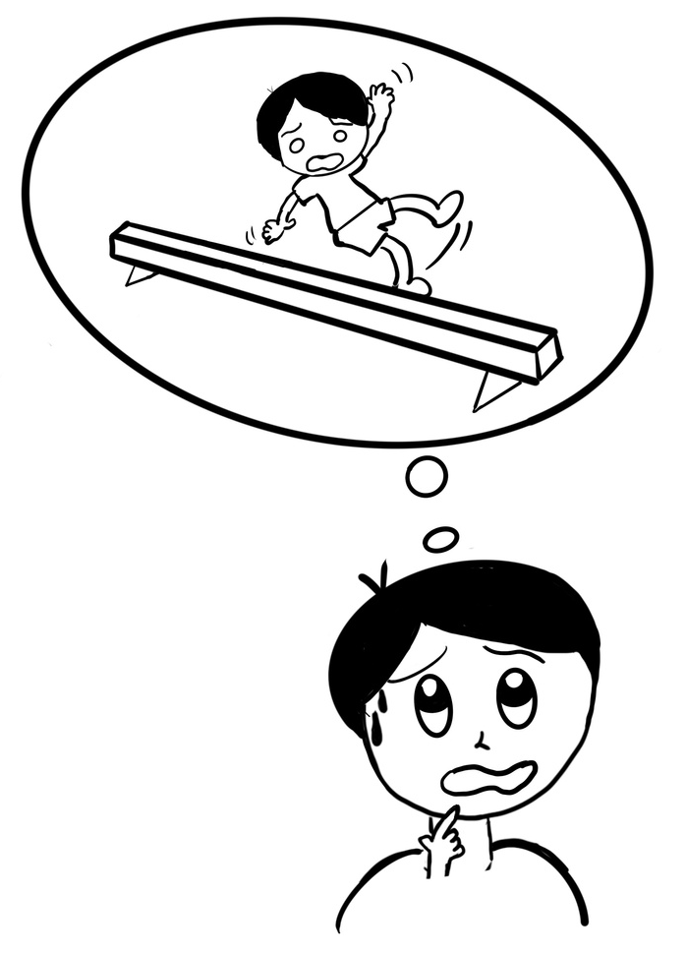
The boy in the picture is worried. For example worried that he will fall down when he is playing.

In the past month, have you felt the same way as the boy in the picture?
If you have, please choose the sad face, "Yes".
If you have not, please choose the happy face, "No".
If you don't know, please choose the neutral face in the middle.
Yes | I don’t know | No

11.
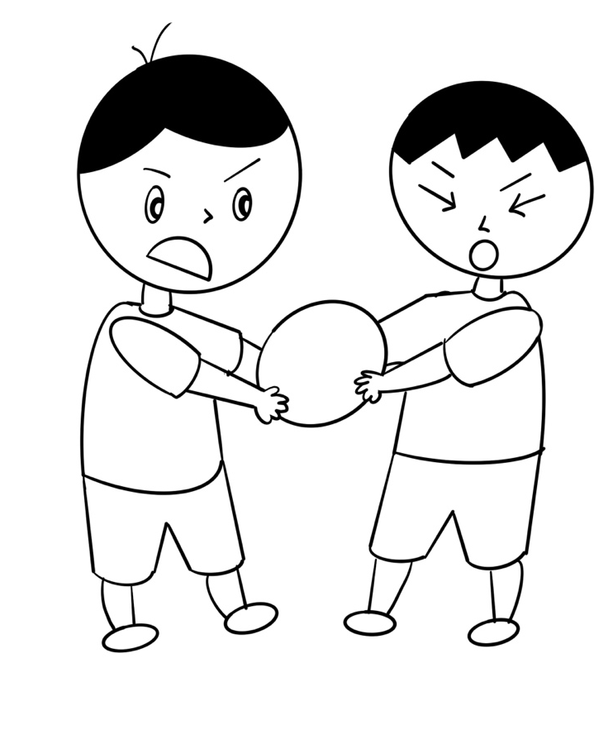
The boy in the picture has problems when playing with other children. For example fighting over toys or not sharing their toys.

In the past month, have you felt the same way as the boy in the picture?
If you have, please choose the sad face, "Yes".
If you have not, please choose the happy face, "No".
If you don't know, please choose the neutral face in the middle.
Yes | I don’t know | No

12.
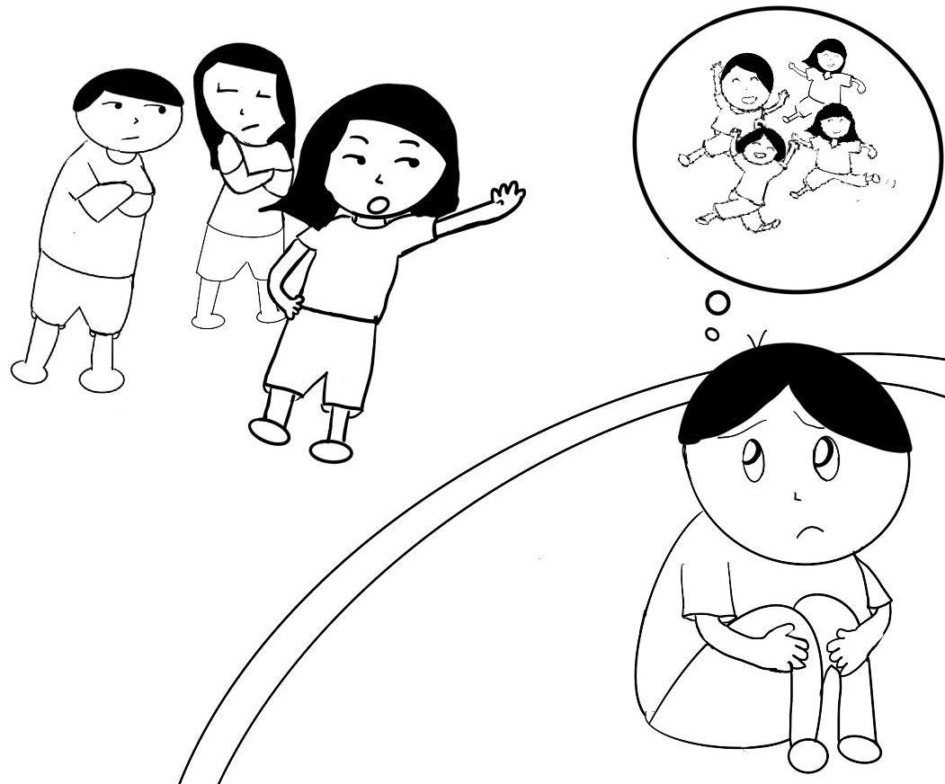
The picture shows that others do not want to play together with the boy. For example not letting him play with them.

In the past month, have you felt the same way as the boy in the picture?
If you have, please choose the sad face, "Yes".
If you have not, please choose the happy face, "No".
If you don't know, please choose the neutral face in the middle.
Yes | I don’t know | No

13.
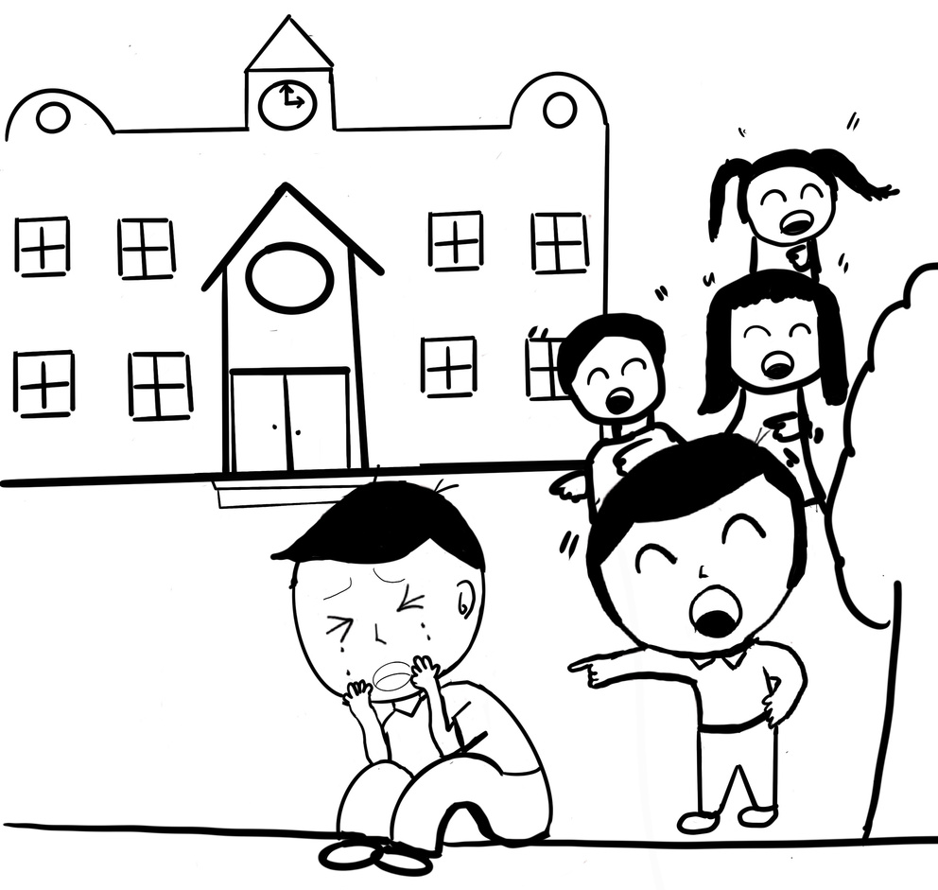
The picture shows the boy getting teased by other children. For example others are laughing at him.
In the past month, have you felt the same way as the boy in the picture?
If you have, please choose the sad face, "Yes".
If you have not, please choose the happy face, "No".
If you don't know, please choose the neutral face in the middle.
Yes | I don’t know | No

14.
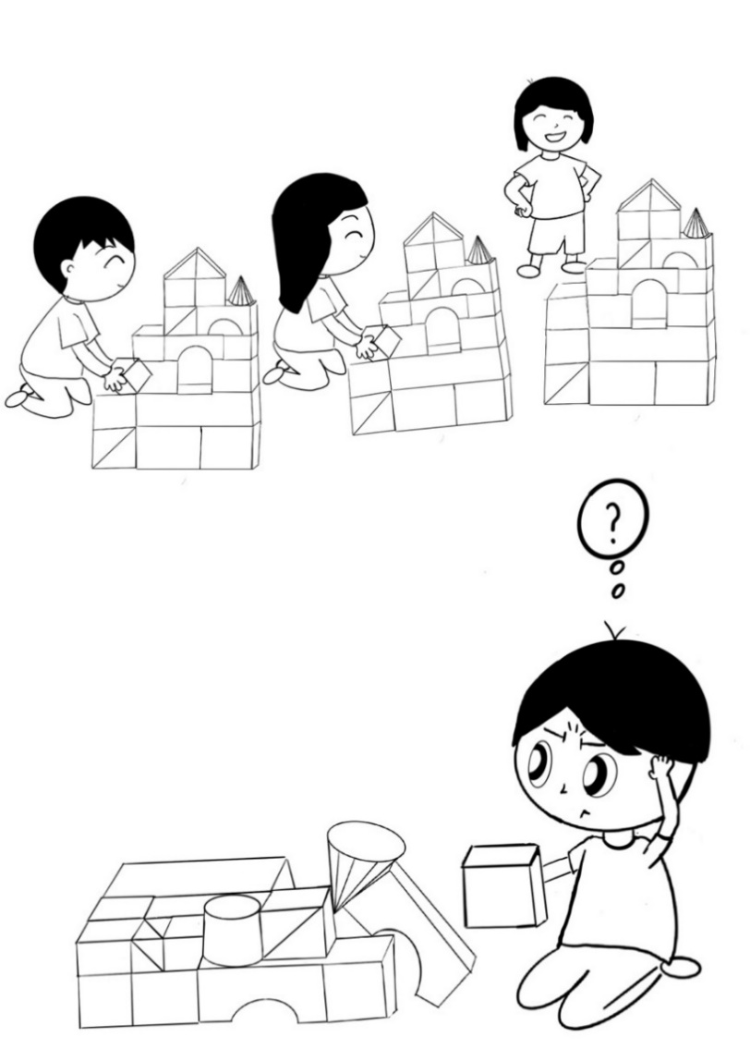
The boy in the picture shows that he cannot do things that others can do. For example other can build a castle with blocks, but he doesn’t know how.
In the past month, have you felt the same way as the boy in the picture?
If you have, please choose the sad face, "Yes".
If you have not, please choose the happy face, "No".
If you don't know, please choose the neutral face in the middle.
Yes | I don’t know | No

15.
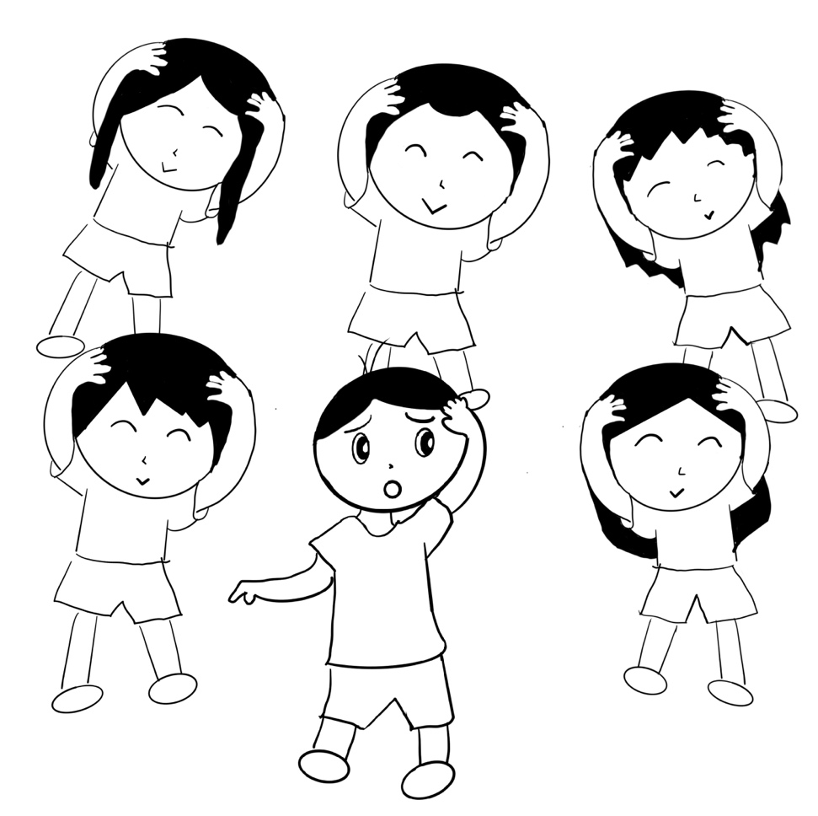
The boy in the picture shows that he cannot keep up when playing with his friends. For example cannot keep up when doing heads, shoudlers, knees and toes.
In the past month, have you felt the same way as the boy in the picture?
If you have, please choose the sad face, "Yes".
If you have not, please choose the happy face, "No".
If you don't know, please choose the neutral face in the middle.
Yes | I don’t know | No

16.
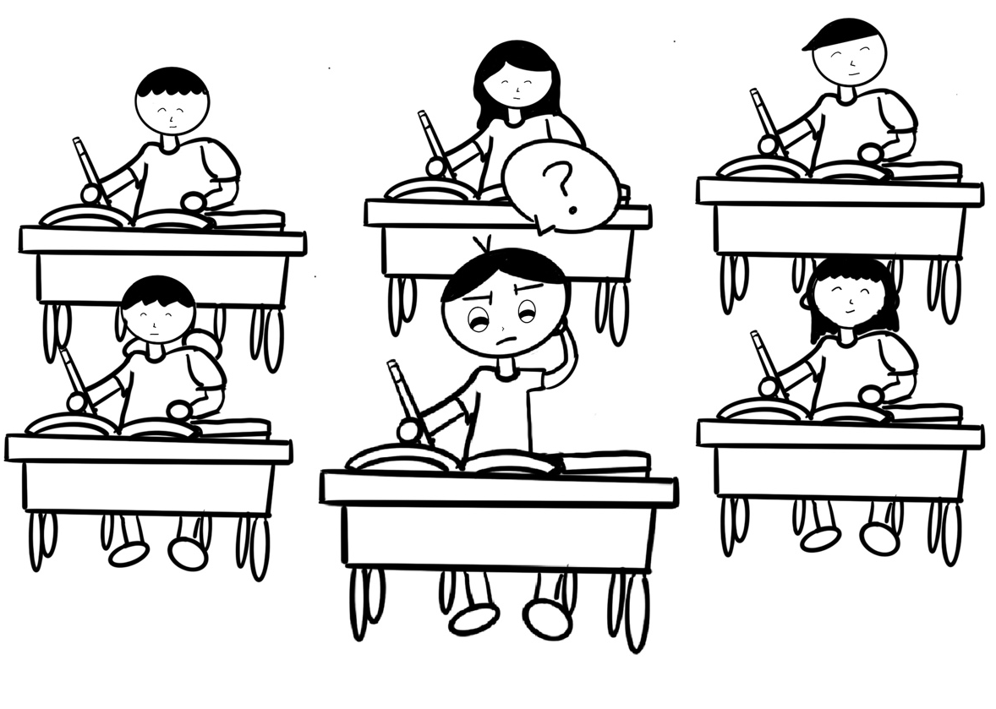
The boy in the picture shows that he cannot keep up in class. For example, he is the only one that doesn’t know how to answer the assignment/school work.
In the past month, have you felt the same way as the boy in the picture?
If you have, please choose the sad face, "Yes".
If you have not, please choose the happy face, "No".
If you don't know, please choose the neutral face in the middle.
Yes | I don’t know | No

17.
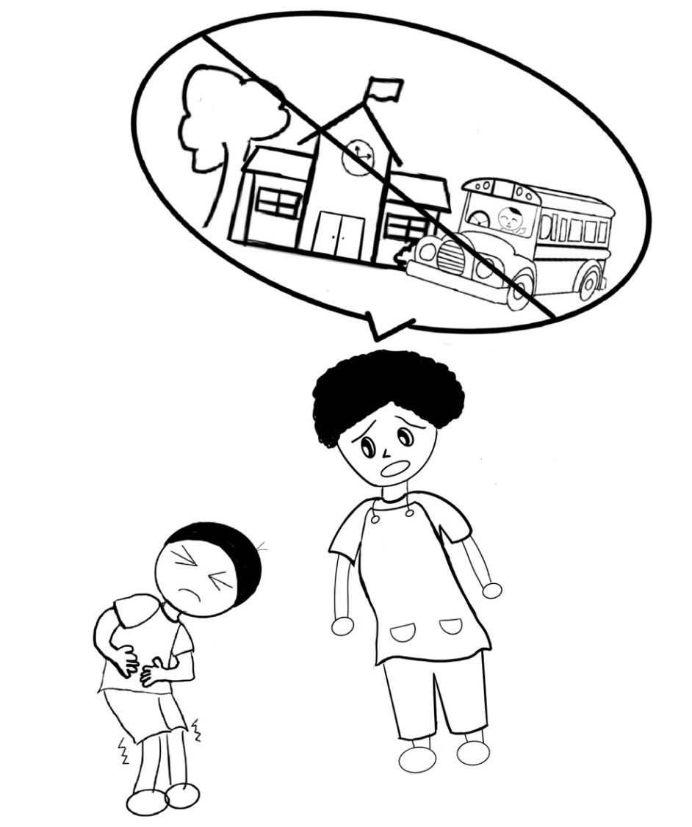
The boy in the picture shows that he is sick, and cannot go to school. For example when his mother sees that he has a tummy ache, she tells him not to go to school.
In the past month, have you felt the same way as the boy in the picture?
If you have, please choose the sad face, "Yes".
If you have not, please choose the happy face, "No".
If you don't know, please choose the neutral face in the middle.
Yes | I don’t know | No

18.
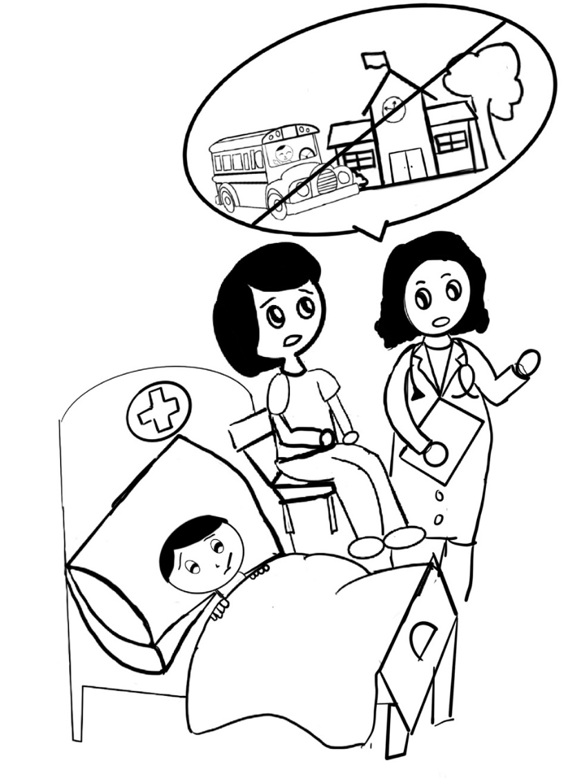

The boy in the picture shows that he is sick in the hospital and cannot go to school. For example the doctor says he is sick and cannot go to school.
In the past month, have you felt the same way as the boy in the picture?
If you have, please choose the sad face, "Yes".
If you have not, please choose the happy face, "No".
If you don't know, please choose the neutral face in the middle.
Yes | I don’t know | No

19.
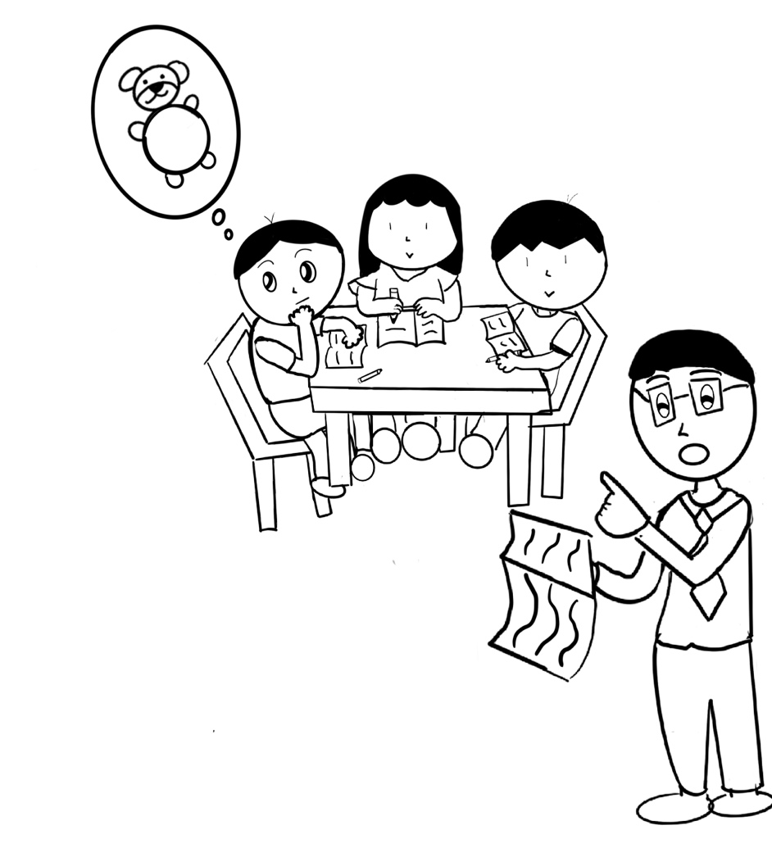
The picture shows that the boy is not focusing in class. For example the boy is thinking about his teddy bear and does not pay attention to his school work or the teacher.

In the past month, have you felt the same way as the boy in the picture?
If you have, please choose the sad face, "Yes".
If you have not, please choose the happy face, "No".
If you don't know, please choose the neutral face in the middle.
Yes | I don’t know | No

20.
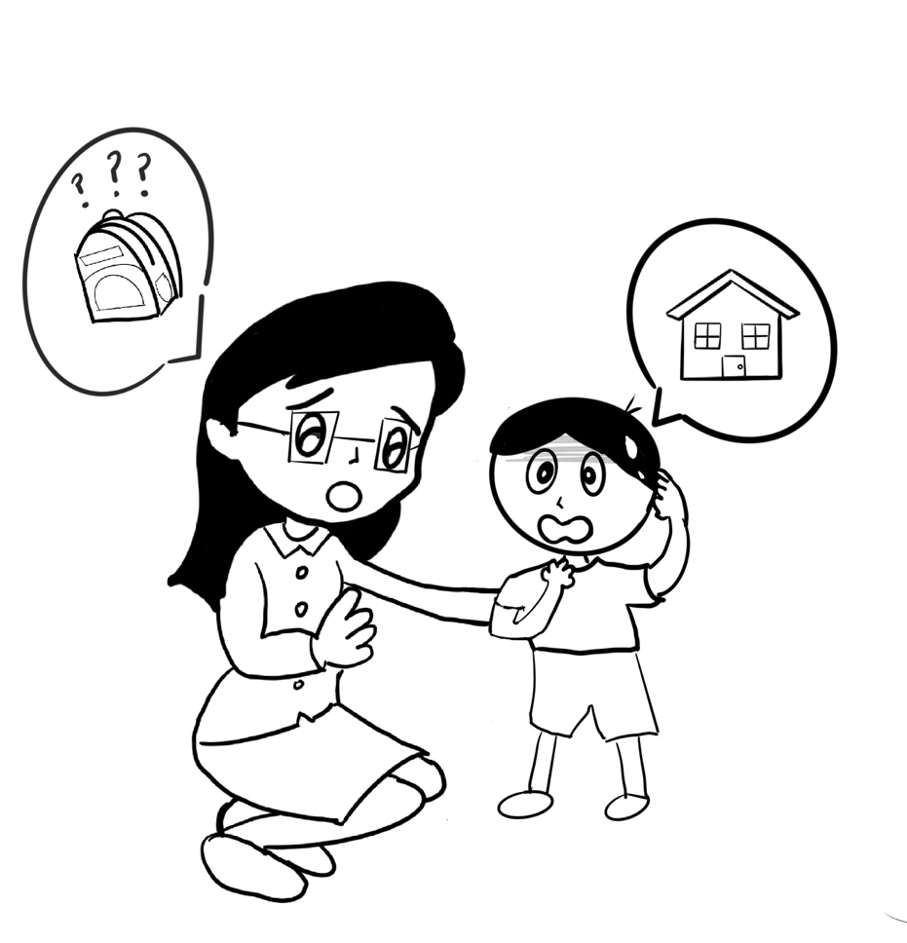
The boy in the picture shows that he is forgetful. For example forgetting his school bag at home.

In the past month, have you felt the same way as the boy in the picture?
If you have, please choose the sad face, "Yes".
If you have not, please choose the happy face, "No".
If you don't know, please choose the neutral face in the middle.
Yes | I don’t know | No

HEALTH-PIC Girl version (Children complete with the assistance of their parents)
Parents please read aloud the following for your child.
We are now going to look at some pictures. Within the past month, please see whether you can do the same actions/movements as the following. Please circle the most appropriate answer.
1.
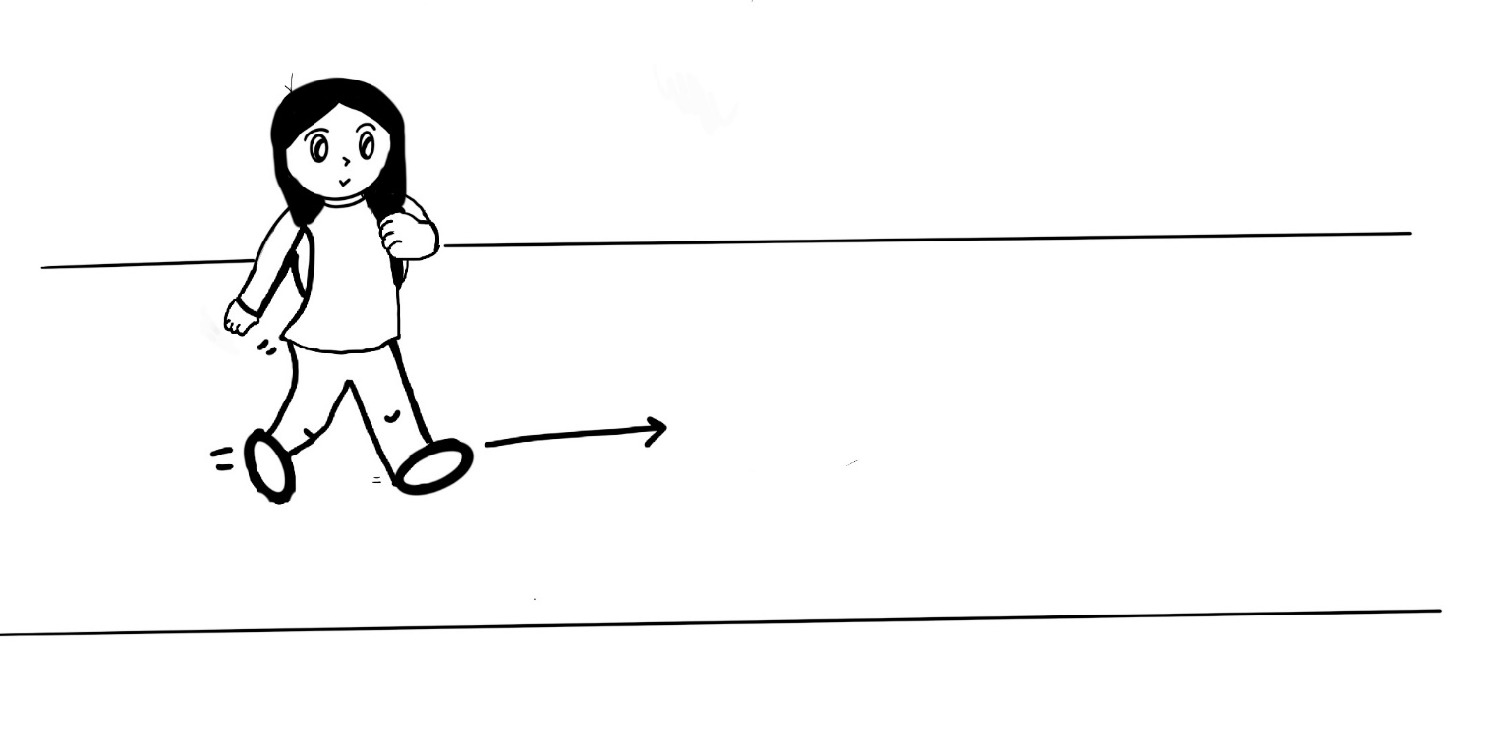
The boy in the picture is walking. For example walking to school.
In the past month, could you do the same action as the boy in the picture?

If you can, please choose the smiley face, "Yes".
If you cannot please choose the unhappy face, "No".
If you don't know, please choose the neutral face in the middle.
No | I don’t know | Yes

2.
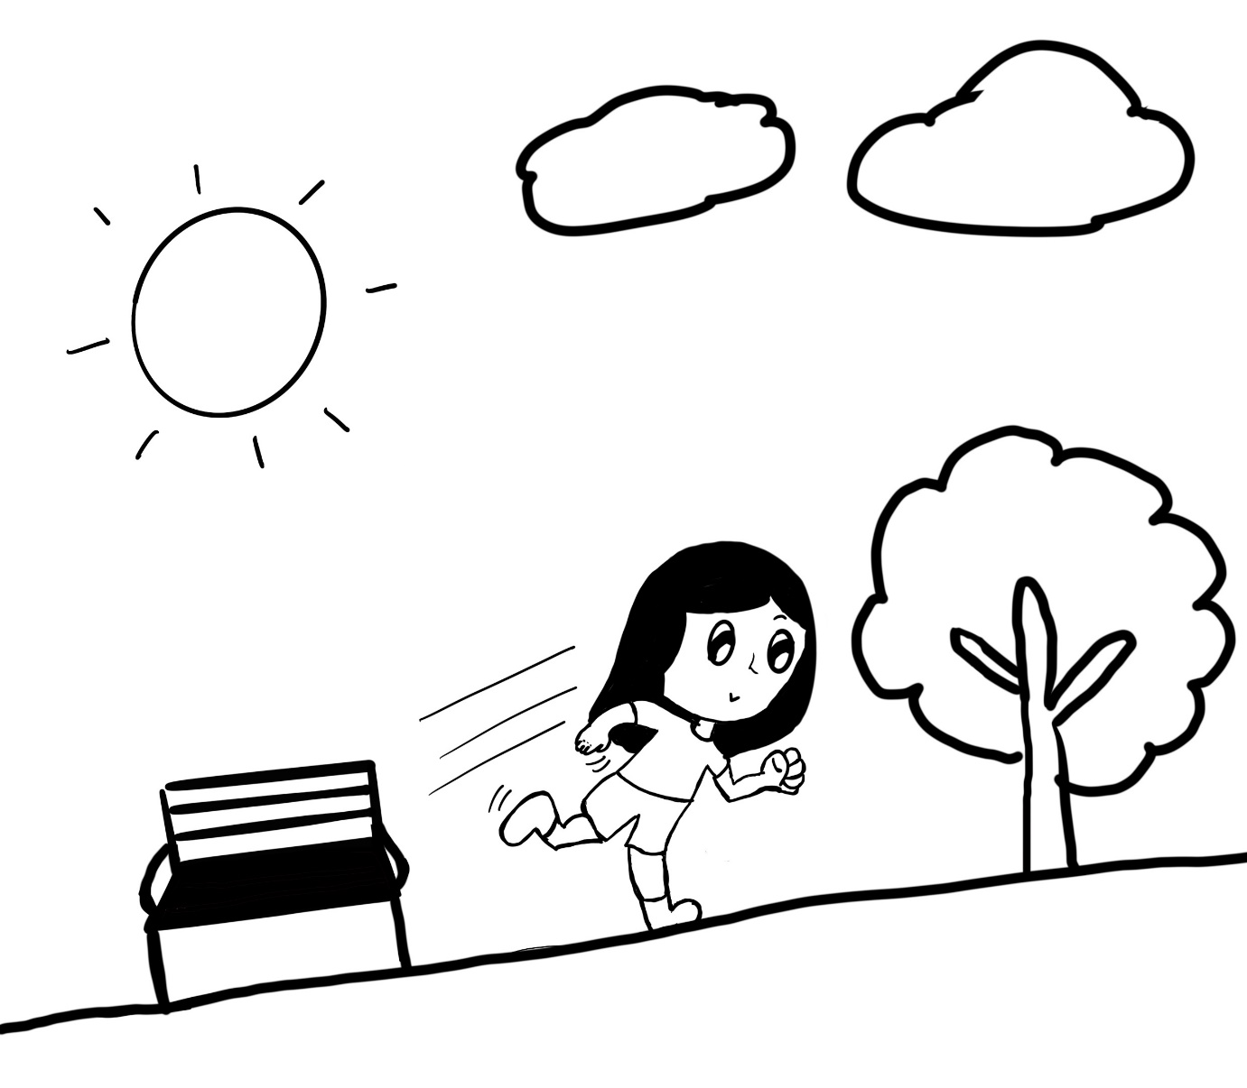
The boy in the picture is running. For example running in the park.
In the past month, could you do the same action as the boy in the picture?

If you can, please choose the smiley face, "Yes".
If you cannot please choose the unhappy face, "No".
If you don't know, please choose the neutral face in the middle.
No | I don’t know | Yes

3.
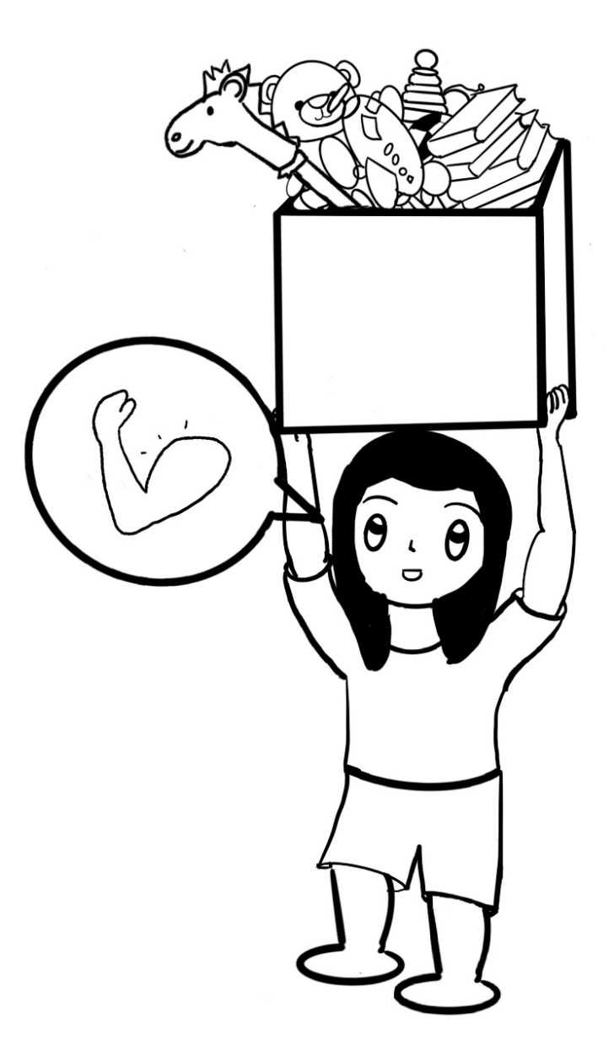
The boy in the picture is lifting heavy things. For example lifting a full box of toys.
In the past month, could you do the same action as the boy in the picture?

If you can, please choose the smiley face, "Yes".
If you cannot please choose the unhappy face, "No".
If you don't know, please choose the neutral face in the middle.
No | I don’t know | Yes

4.
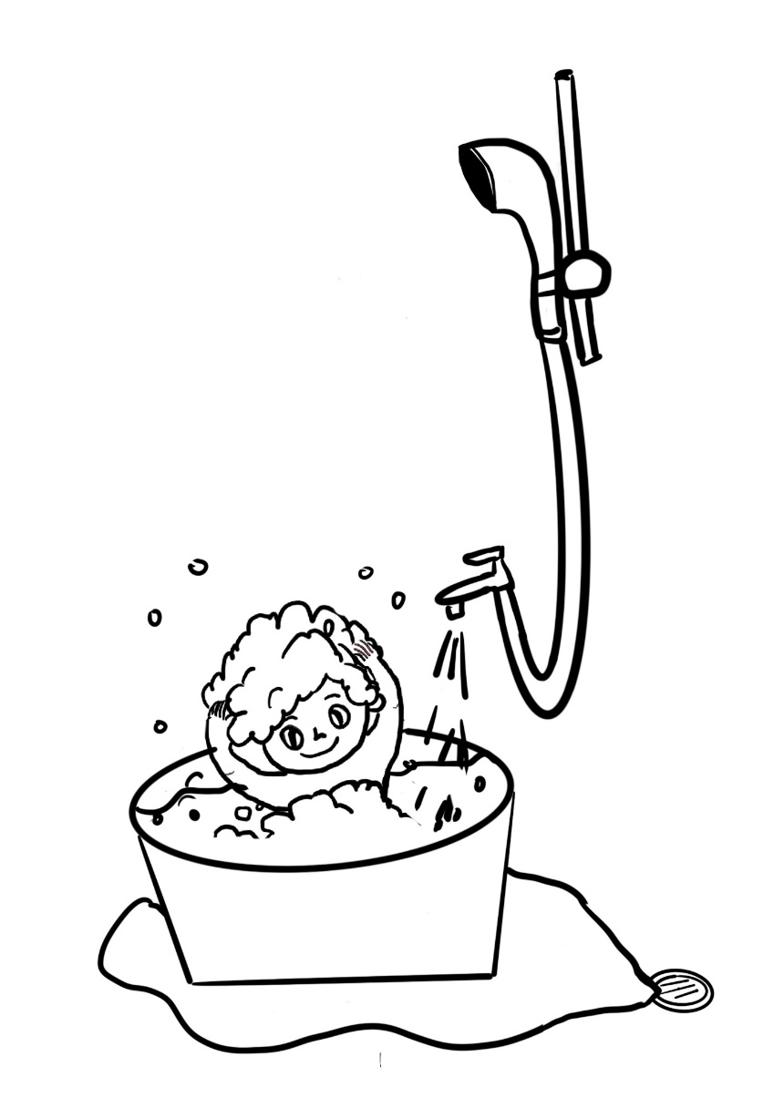
The boy in the picture is showering. For example putting on shampoo.
In the past month, could you do the same action as the boy in the picture?

If you can, please choose the smiley face, "Yes".
If you cannot please choose the unhappy face, "No".
If you don't know, please choose the neutral face in the middle.
No | I don’t know | Yes

5.
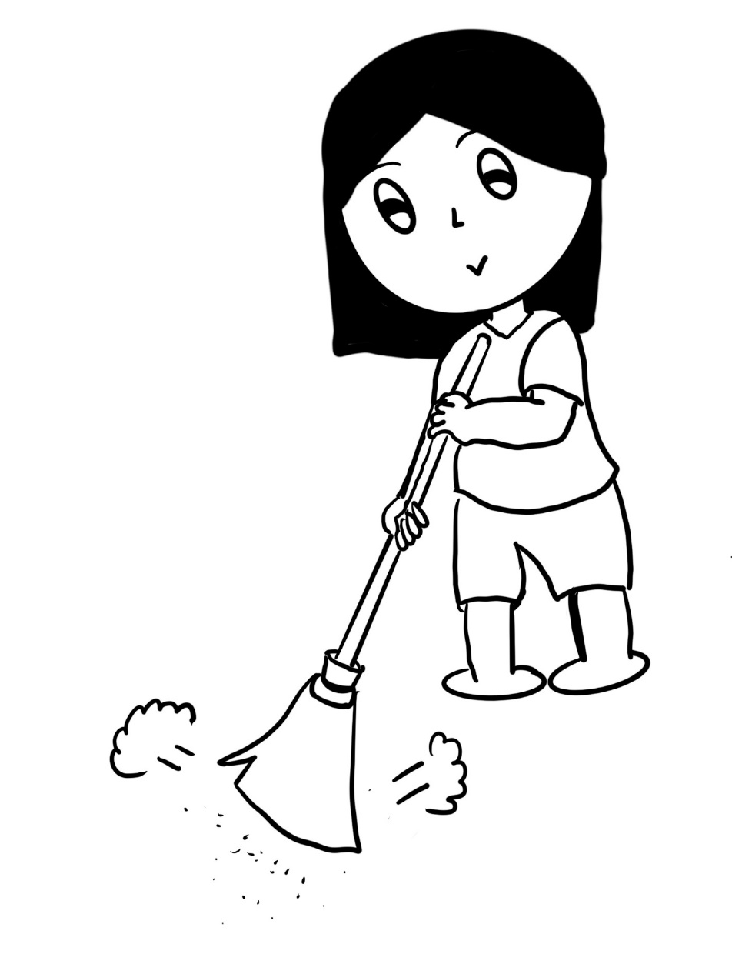
The boy in the picture is doing chores. For example sweeping the floor.
In the past month, could you do the same action as the boy in the picture?

If you can, please choose the smiley face, "Yes".
If you cannot please choose the unhappy face, "No".
If you don't know, please choose the neutral face in the middle.
No | I don’t know | Yes

We are now going to look at another group of pictures and again, I am going to ask you a few questions about these pictures.
Think about whether the following has happened to you in the past month.
Also pay attention to the smiley face, the response to the smiley face has now changed
6.
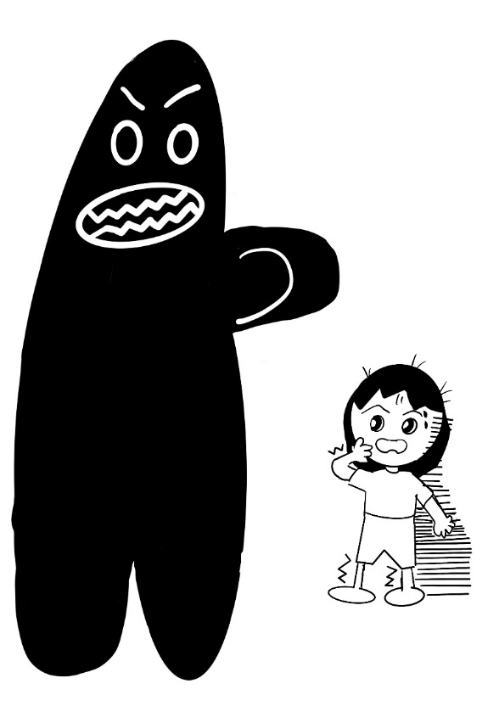
The boy in the picture feels scared or surprised. For example scared when seeing a monster
In the past month, have you felt the same way as the boy in the picture?
If you have, please choose the sad face, "Yes".
If you have not, please choose the happy face, "No".
If you don't know, please choose the neutral face in the middle.
Yes | I don’t know | No

7.
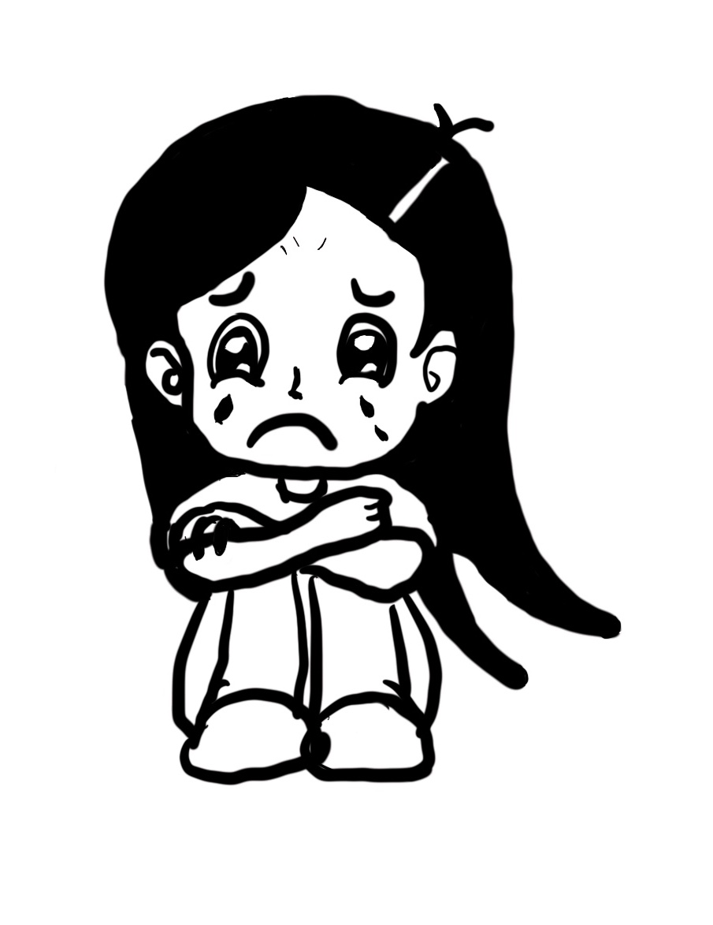
The boy in the picture feels sad or depressed. For example crying because he is unhappy
In the past month, have you felt the same way as the boy in the picture?
If you have, please choose the sad face, "Yes".
If you have not, please choose the happy face, "No".
If you don't know, please choose the neutral face in the middle.
Yes | I don’t know | No

8.
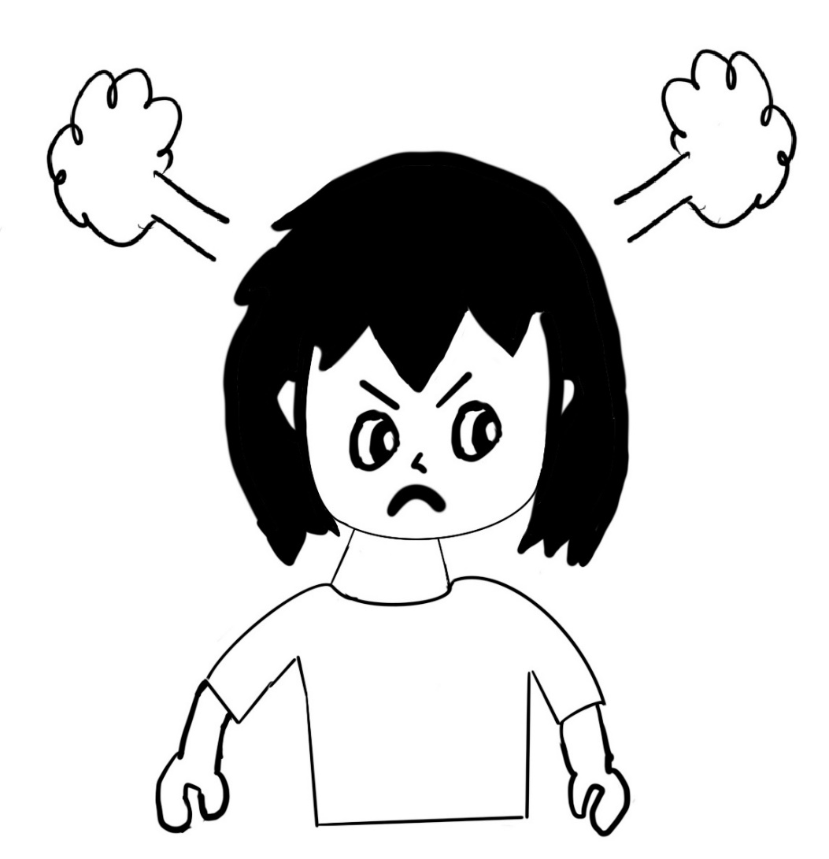
The boy in the picture feels angry or frustrated. For example angry at someone.
In the past month, have you felt the same way as the boy in the picture?
If you have, please choose the sad face, "Yes".
If you have not, please choose the happy face, "No".
If you don't know, please choose the neutral face in the middle.
Yes | I don’t know | No

9.
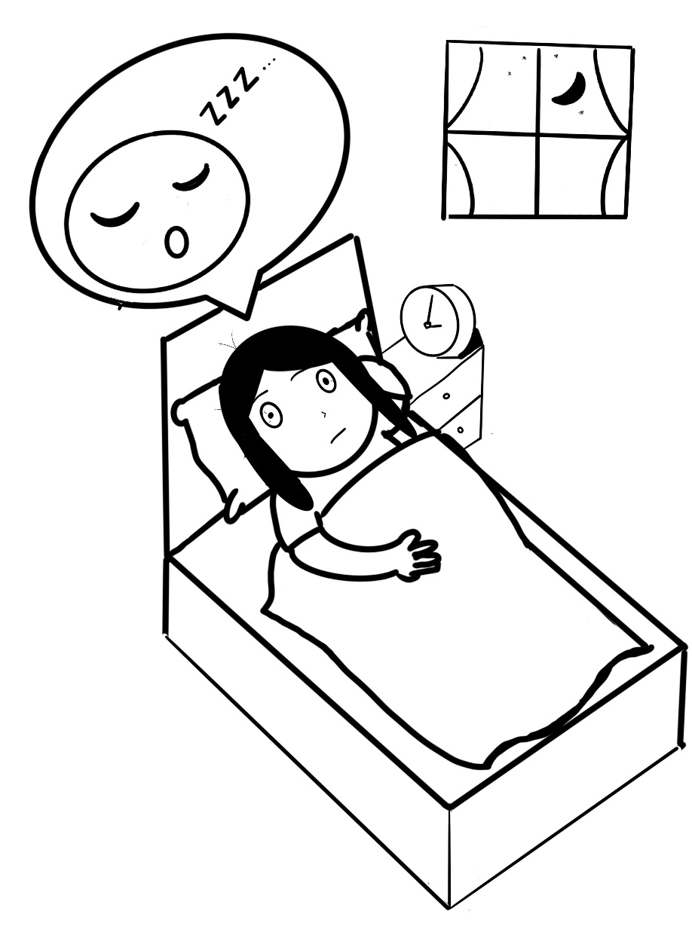
The boy in the picture can’t sleep or has trouble sleeping. For example cannot fall asleep
In the past month, have you felt the same way as the boy in the picture?
If you have, please choose the sad face, "Yes".
If you have not, please choose the happy face, "No".
If you don't know, please choose the neutral face in the middle.
Yes | I don’t know | No

10.
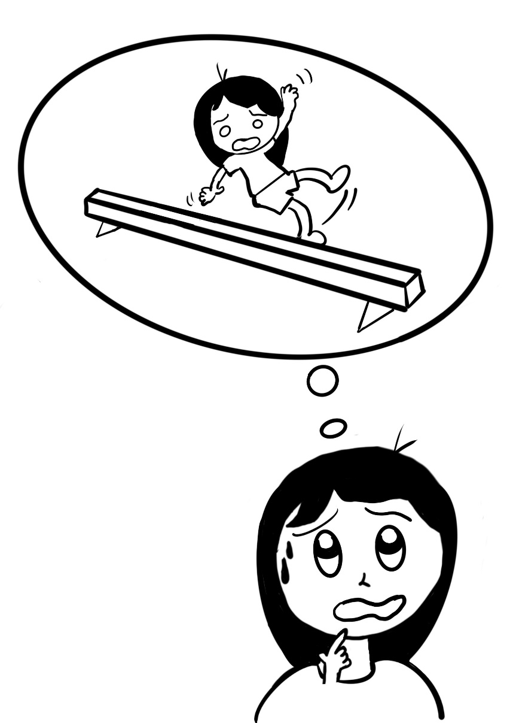
The boy in the picture is worried. For example worried that he will fall down when he is playing.

In the past month, have you felt the same way as the boy in the picture?
If you have, please choose the sad face, "Yes".
If you have not, please choose the happy face, "No".
If you don't know, please choose the neutral face in the middle.
Yes | I don’t know | No

11.
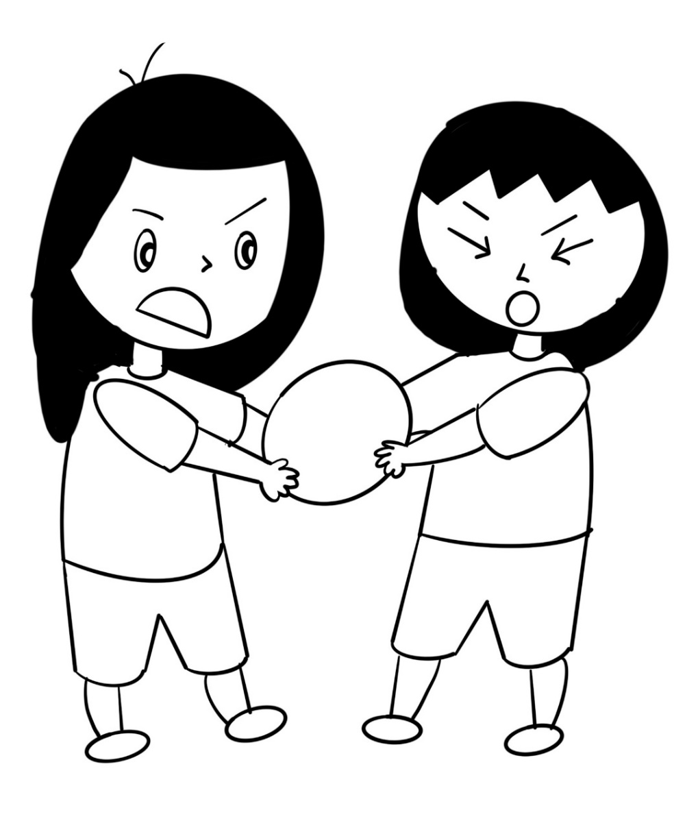
The boy in the picture has problems when playing with other children. For example fighting over toys or not sharing their toys.

In the past month, have you felt the same way as the boy in the picture?
If you have, please choose the sad face, "Yes".
If you have not, please choose the happy face, "No".
If you don't know, please choose the neutral face in the middle.
Yes | I don’t know | No

12.
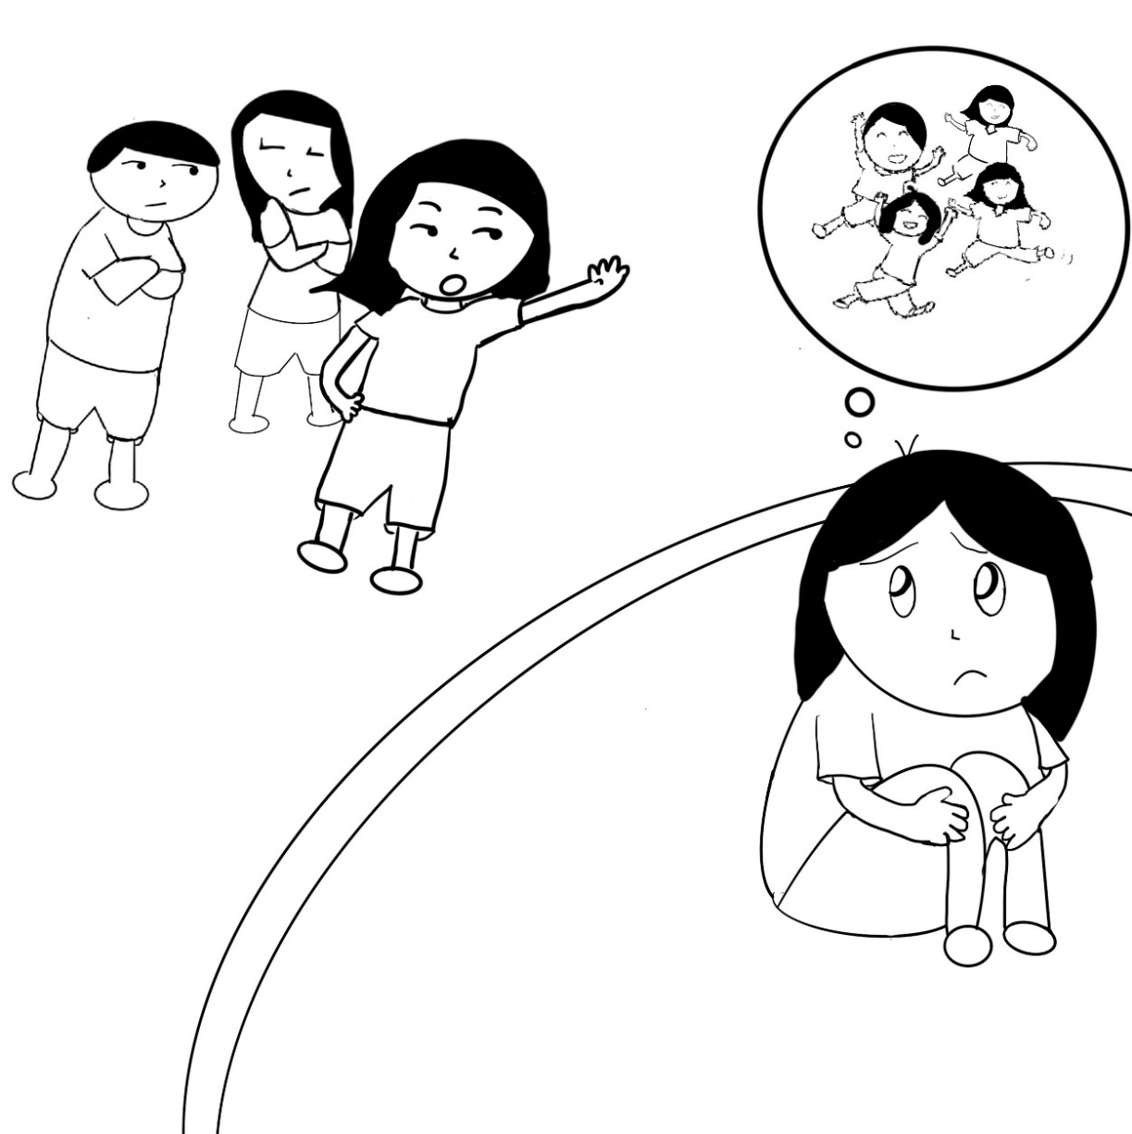
The picture shows that others do not want to play together with the boy. For example not letting him play with them.

In the past month, have you felt the same way as the boy in the picture?
If you have, please choose the sad face, "Yes".
If you have not, please choose the happy face, "No".
If you don't know, please choose the neutral face in the middle.
Yes | I don’t know | No

13.
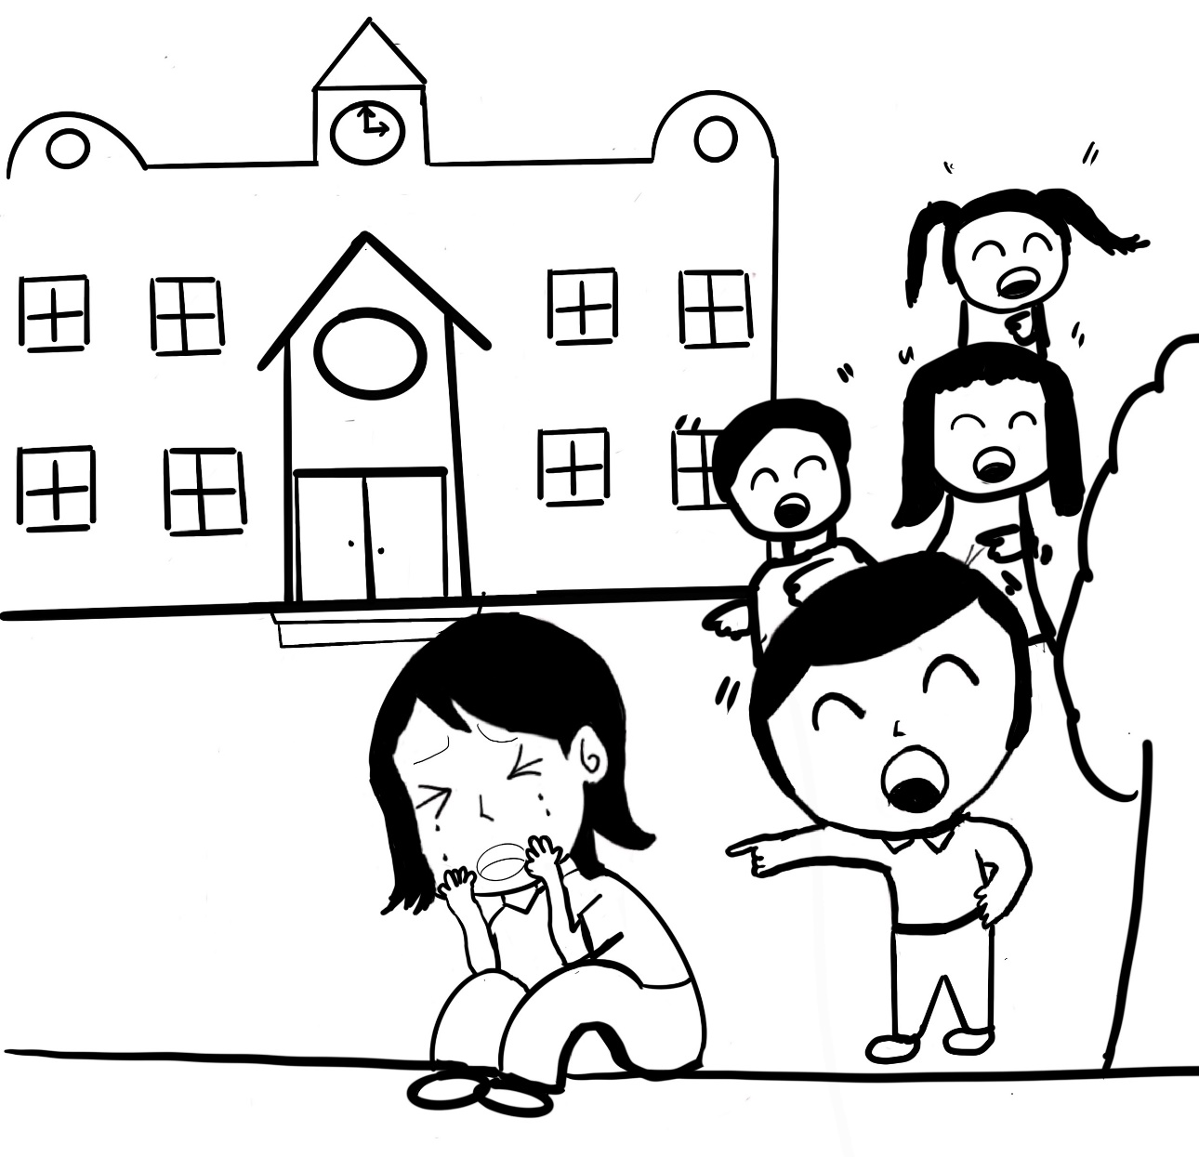
The picture shows the boy getting teased by other children. For example others are laughing at him.
In the past month, have you felt the same way as the boy in the picture?
If you have, please choose the sad face, "Yes".
If you have not, please choose the happy face, "No".
If you don't know, please choose the neutral face in the middle.
Yes | I don’t know | No

14.
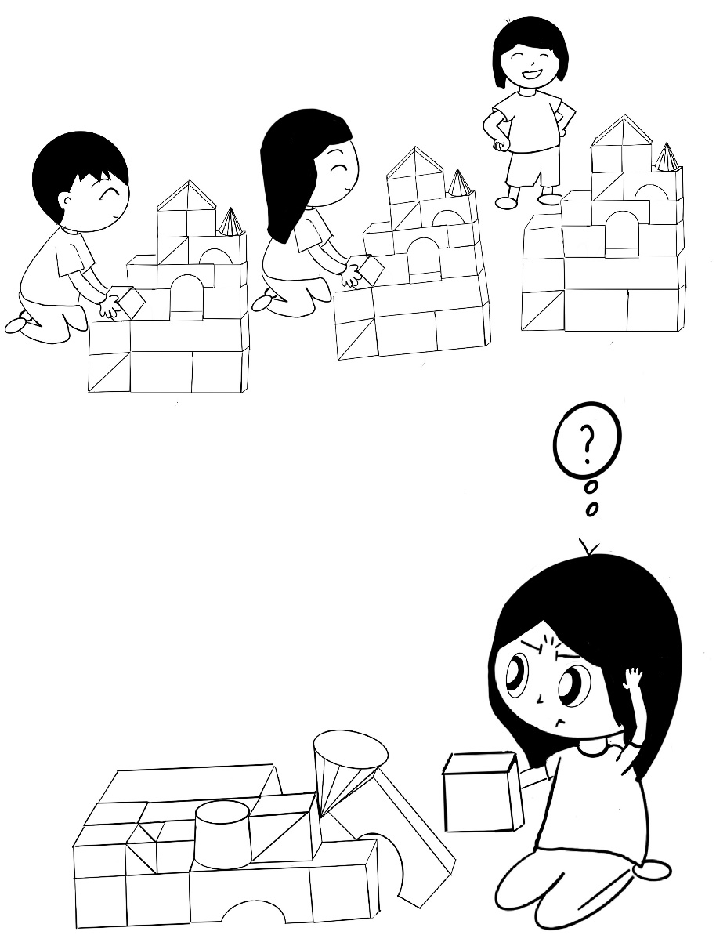
The boy in the picture shows that he cannot do things that others can do. For example other can build a castle with blocks, but he doesn’t know how.
In the past month, have you felt the same way as the boy in the picture?
If you have, please choose the sad face, "Yes".
If you have not, please choose the happy face, "No".
If you don't know, please choose the neutral face in the middle.
Yes | I don’t know | No

15.
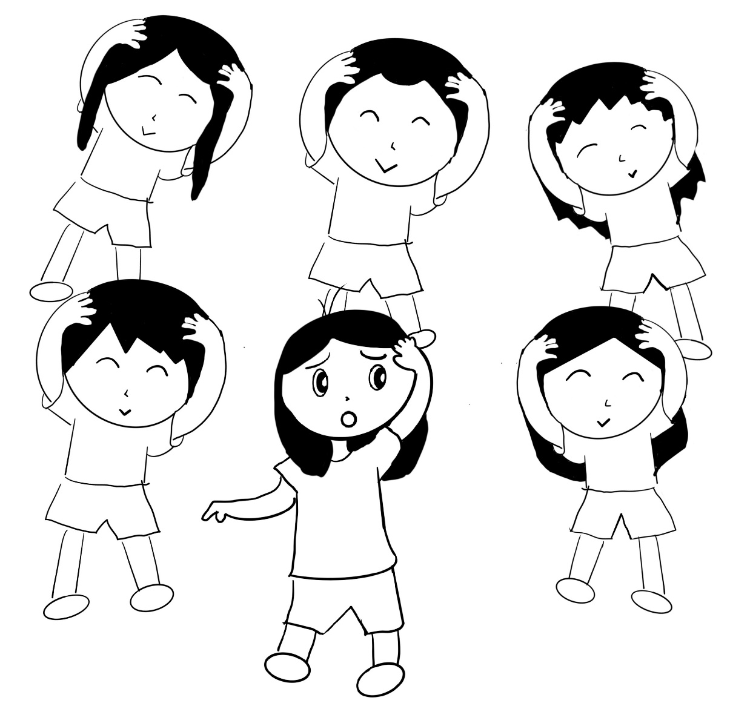
The boy in the picture shows that he cannot keep up when playing with his friends. For example cannot keep up when doing heads, shoudlers, knees and toes.
In the past month, have you felt the same way as the boy in the picture?
If you have, please choose the sad face, "Yes".
If you have not, please choose the happy face, "No".
If you don't know, please choose the neutral face in the middle.
Yes | I don’t know | No

16.
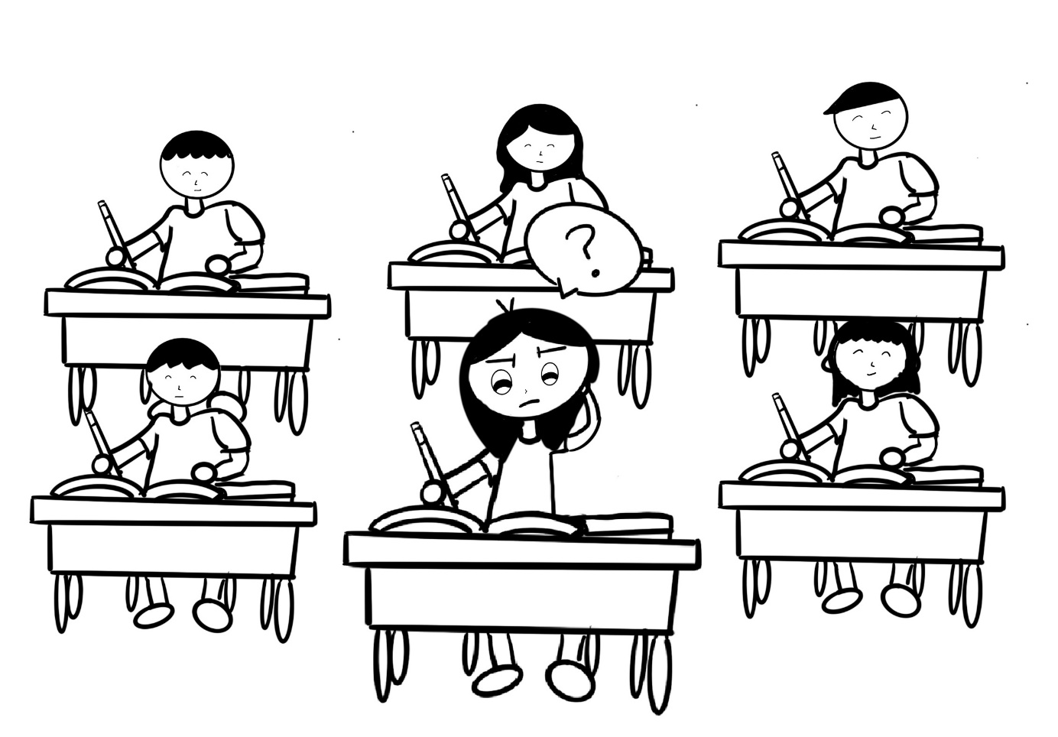
The boy in the picture shows that he cannot keep up in class. For example, he is the only one that doesn’t know how to answer the assignment/school work.
In the past month, have you felt the same way as the boy in the picture?
If you have, please choose the sad face, "Yes".
If you have not, please choose the happy face, "No".
If you don't know, please choose the neutral face in the middle.
Yes | I don’t know | No

17.
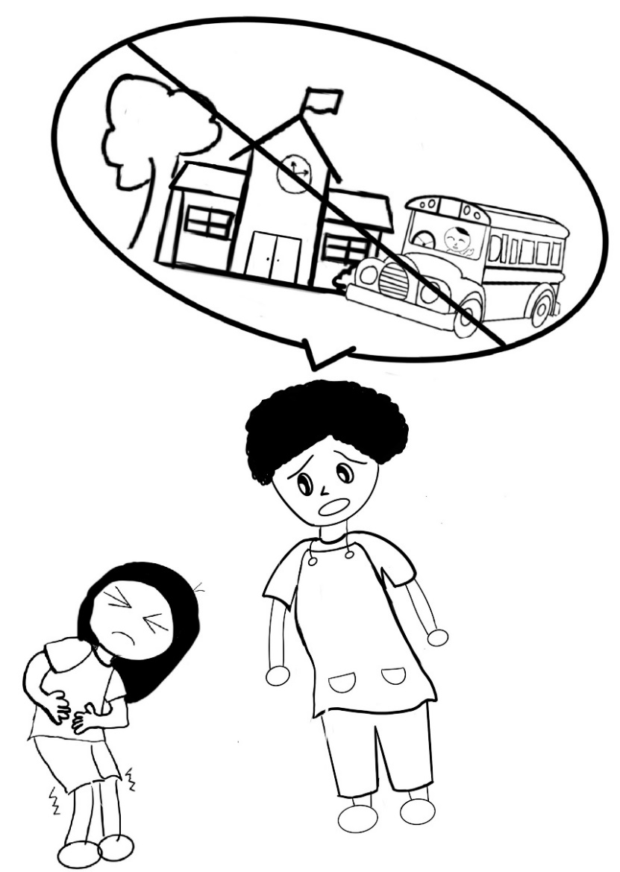
The boy in the picture shows that he is sick, and cannot go to school. For example when his mother sees that he has a tummy ache, she tells him not to go to school.
In the past month, have you felt the same way as the boy in the picture?
If you have, please choose the sad face, "Yes".
If you have not, please choose the happy face, "No".
If you don't know, please choose the neutral face in the middle.
Yes | I don’t know | No

18.
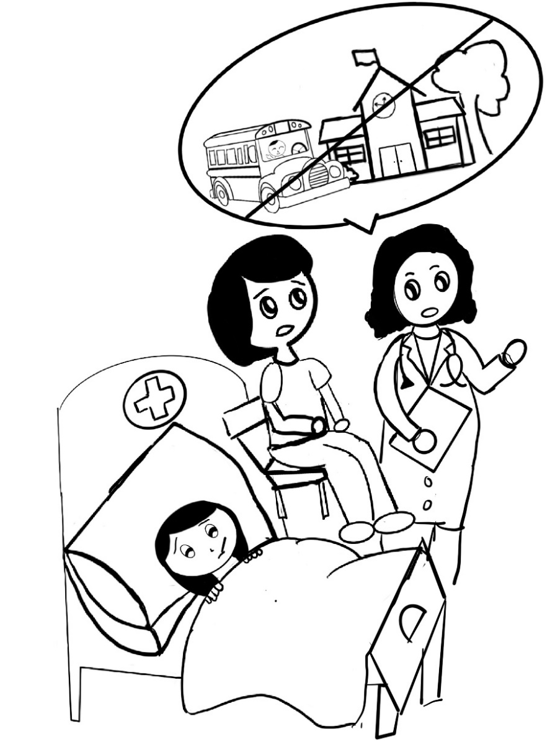

The boy in the picture shows that he is sick in the hospital and cannot go to school. For example the doctor says he is sick and cannot go to school.
In the past month, have you felt the same way as the boy in the picture?
If you have, please choose the sad face, "Yes".
If you have not, please choose the happy face, "No".
If you don't know, please choose the neutral face in the middle.
Yes | I don’t know | No

19.
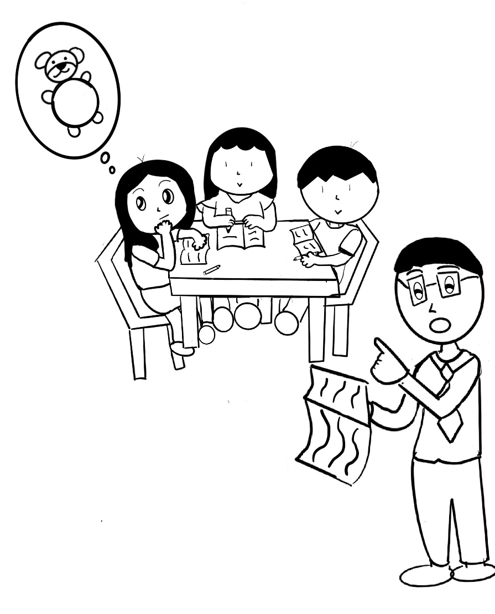
The picture shows that the boy is not focusing in class. For example the boy is thinking about his teddy bear and does not pay attention to his school work or the teacher.

In the past month, have you felt the same way as the boy in the picture?
If you have, please choose the sad face, "Yes".
If you have not, please choose the happy face, "No".
If you don't know, please choose the neutral face in the middle.
Yes | I don’t know | No

20.
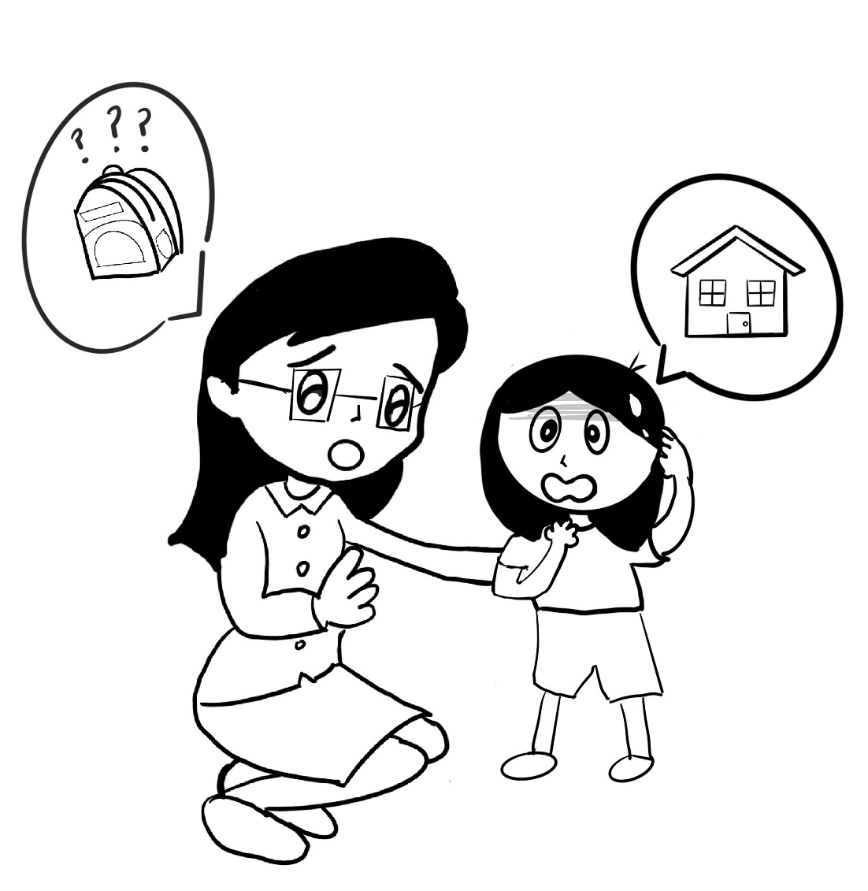
The boy in the picture shows that he is forgetful. For example forgetting his school bag at home.

In the past month, have you felt the same way as the boy in the picture?
If you have, please choose the sad face, "Yes".
If you have not, please choose the happy face, "No".
If you don't know, please choose the neutral face in the middle.
Yes | I don’t know | No

