Supplementary Information
Table S1: Annual mean concentrations of elements present in PM_{2.5} (µg m⁻³) in Faridabad, Haryana, India
Elements | Site 1 | Site 2
B | 0.039 ± 0.014 | 0.051 ± 0.022
Na | 0.130 ± 0.024 | 0.117 ± 0.030
Mg | 0.080 ± 0.006 | 0.262 ± 0.030
Al | 0.432 ± 0.035 | 1.703 ± 0.277
P | 0.037 ± 0.003 | 0.067 ± 0.008
S | 2.058 ± 0.184 | 2.430 ± 0.290
Cl | 2.929 ± 0.392 | 2.428 ± 0.433
K | 2.496 ± 0.191 | 3.282 ± 0.649
Ca | 0.504 ± 0.032 | 2.018 ± 0.226
Ti | 0.020 ± 0.004 | 0.094 ± 0.014
Cr | 0.244 ± 0.016 | 0.622 ± 0.083
Mn | 0.187 ± 0.017 | 0.128 ± 0.017
Fe | 2.191 ± 0.135 | 2.899 ± 0.212
Ni | 0.073 ± 0.007 | 0.112 ± 0.018
Cu | 0.253 ± 0.030 | 0.162 ± 0.029
Zn | 0.952 ± 0.070 | 0.850 ± 0.076
Ga | 0.301 ± 0.053 | 0.188 ± 0.048
Zr | 0.219 ± 0.049 | 0.206 ± 0.051
Mo | 0.106 ± 0.011 | 0.289 ± 0.050
Br | 0.062 ± 0.013 | 0.053 ± 0.012
Nb | 0.077 ± 0.036 | 0.117 ± 0.047
Ag | 0.349 ± 0.103 | 1.017 ± 0.299
Pb | 0.145 ± 0.020 | 0.120 ± 0.022
Ba | 0.065 ± 0.061 | 0.088 ± 0.088
Sr | 0.016 ± 0.005 | 0.060 ± 0.023
Pm | 0.114 ± 0.034 | 0.168 ± 0.065
Y | 0.053 ± 0.025 | 0.099 ± 0.036
Rb | 0.005 ± 0.002 | 0.040 ± 0.033
F | NA | 0.004 ± 0.004
Pd | 0.428 ± 0.132 | 1.022 ± 0.314
Fr | 0.027 ± 0.010 | 0.006 ± 0.004
U | 0.012 ± 0.005 | 0.033 ± 0.014
In | 0.084 ± 0.043 | 0.315 ± 0.219
As | 0.011 ± 0.004 | 0.017 ± 0.007
Sn | 0.040 ± 0.028 | 0.236 ± 0.110
Th | 0.006 ± 0.004 | 0.016 ± 0.008
La | 0.292 ± 0.233 | 0.199 ± 0.199
Cs | 0.030 ± 0.030 | NA
Sb | 0.065 ± 0.049 | NA
Po | 0.002 ± 0.002 | NA
Se | 0.001 ± 0.001 | NA
Pu | NA | 0.011 ± 0.007
Os | NA | 0.002 ± 0.002
Tl | NA | 0.007 ± 0.007
Cd | NA | 0.177 ± 0.177
Te | NA | 0.153 ± 0.108
Si | 1.079 ± 0.088 | 4.256 ± 0.692
∑ El | 16.213 ± 2.205 | 26.124 ± 5.060
PM_{2.5} | 108.436 ± 16.0 | 154.414 ± 11.1
% of ∑El in PM_{2.5} | 14.95% | 16.91%
± standard deviation; NA: not available

Table S2: Signal-to-noise ratio and R² values of PMF
 | Site 1 |  | Site 2
Elements | R² | S/N | R² | S/N
B | 0.09 | 1.41 | ------ | ------
Na | 0.42 | 4.44 | 0.09 | 4.82
Mg | 0.94 | 9.24 | 0.08 | 8.59
Al | 0.94 | 9.89 | 0.97 | 8.94
P | 0.86 | 9.67 | 0.48 | 8.52
S | 0.78 | 9.02 | 0.81 | 8.47
Cl | 0.87 | 9.60 | 0.59 | 7.96
K | 0.85 | 9.57 | 0.92 | 9.06
Ca | 0.85 | 9.67 | 0.75 | 9.06
Ti | 0.08 | 2.61 | 0.14 | 3.76
Cr | 0.18 | 7.28 | 0.39 | 8.47
Mn | 0.70 | 7.93 | 0.40 | 4.71
Fe | 0.80 | 9.67 | 0.85 | 9.18
Ni | 0.45 | 7.07 | 0.00 | 5.29
Cu | 0.82 | 7.37 | 0.53 | 4.24
Zn | 0.89 | 9.67 | 0.73 | 8.47
Ga | 0.79 | 5.87 | 0.64 | 3.41
Zr | 0.40 | 4.46 | 0.39 | 3.53
Mo | 0.20 | 6.30 | 0.39 | 7.53
Br | 0.18 | 3.04 | 0.01 | 2.00
Pb | 0.28 | 3.91 | 0.00 | 3.06
Si | 0.93 | 9.78 | 0.97 | 8.92

Table S3: PMF input summary
Parameters | Site 1 | Site 2
N-species | 22 | 21
N-samples | 92 | 85
Q_{expected} | 1449.00 | 1250.03
Q_{true} | 1993.08 | 2070.68
Q_{robust} | 1993.11 | 2070.67
Q_{true/}/Q_{expected} | 1.37 | 1.65
Robust Mode | - | -
Modelling Uncertainty | 12 | 13
No. of iterations | 100 | 100
No. of Factors | 5 | 5
Seed no. | 29 | 29
Selected base run | 39 | 20
No. of base runs | 100 | 100
Corr. R² | > 0.6 | > 0.6
DISP Swap | 0 | 0
DISP active | Yes | Yes
DISP dQ (max) | -2.27 | -1.77
% of accepted cases | 84 | 94

Table S4: Source profiles and % source contribution of the PMF analysis applied to the elemental composition of PM_{2.5} speciation datasets of site 1
Elements | Factor 1 | Factor 2 | Factor 3 | Factor 4 | Factor 5
B | 30 | 18 | 11 |  | 41
Na |  | 30 |  | 52 | 18
Mg | 16 |  | 4 | 81
Al | 15 | 3 | 5 | 71 | 5
P | 20 | 8 | 4 | 41 | 26
S | 32 | 27 |  | 6 | 35
Cl | 4 |  | 3 | 6 | 88
K | 25 | 14 | 1 | 13 | 47
Ca | 22 | 6 | 5 | 64 | 4
Ti | 16 | 67 |  | 4 | 12
Cr | 7 | 42 | 14 | 22 | 14
Mn | 12 | 29 | 36 | 5 | 18
Fe | 17 | 20 | 29 | 9 | 24
Ni | 8 | 43 | 23 | 11 | 15
Cu | 5 | 9 | 73 | 1 | 12
Zn | 19 | 15 | 37 |  | 29
Ga |  |  | 100
Zr | 5 | 26 | 54 | 5 | 9
Mo | 100
Br | 6 | 94
Pb | 14 | 26 | 22 | 20 | 18
Si | 15 | 4 | 5 | 70 | 5
Sources  % Contribution | Fossil Fuel Combustion  18% | Industrial  22% | Mixed (VE + IE +CD)  19% | Crustal Dust  22% | Biomass Burning  19%

Table S5: Source profiles and % source contribution of the PMF analysis applied to the Elemental composition of PM_{2.5} speciation datasets of site 2
Elements | Factor 1 | Factor 2 | Factor 3 | Factor 4 | Factor 5
Na |  |  |  |  | 100
Mg | 52 |  | 6 | 4 | 38
Al | 71 | 7 | 5 | 16
P | 6 |  |  | 75 | 18
S |  | 64 | 5 | 31 | 1
Cl | 22 | 72 |  |  | 6
K | 10 | 58 | 3 | 29
Ca | 69 | 10 | 4 | 17
Ti | 48 | 11 | 12 | 24 | 5
Cr |  | 9 | 56 | 18 | 17
Mn | 10 | 18 | 35 | 24 | 13
Fe | 32 | 17 | 23 | 24 | 4
Ni | 9 | 8 | 15 | 42 | 26
Cu | 7 | 3 | 55 | 15 | 20
Zn | 11 | 39 | 35 | 11 | 5
Ga | 7 |  | 74 | 10 | 9
Zr | 8 | 8 | 63 | 21
Mo | 5 | 2 | 73 | 11 | 9
Br | 9 | 17 | 44 | 18 | 12
Pb | 3 | 12 | 52 | 17 | 16
Si | 71 | 7 | 5 | 16
Sources  %  Contribution | Crustal Dust  22% | Fossil Fuel Combustion  17% | Industrial  27% | Biomass Burning  20% | Mixed (VE + CD)  14%

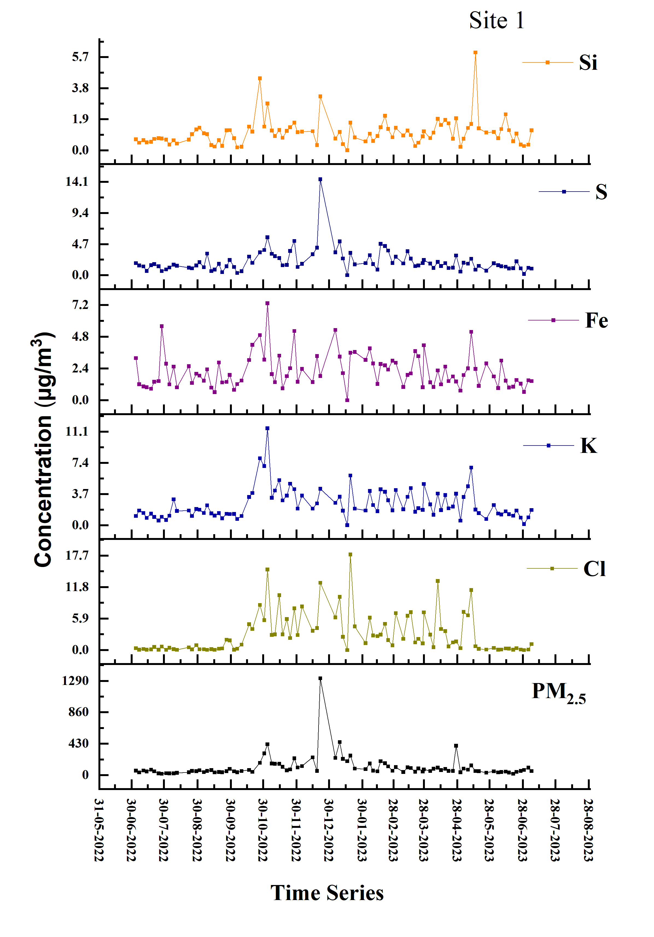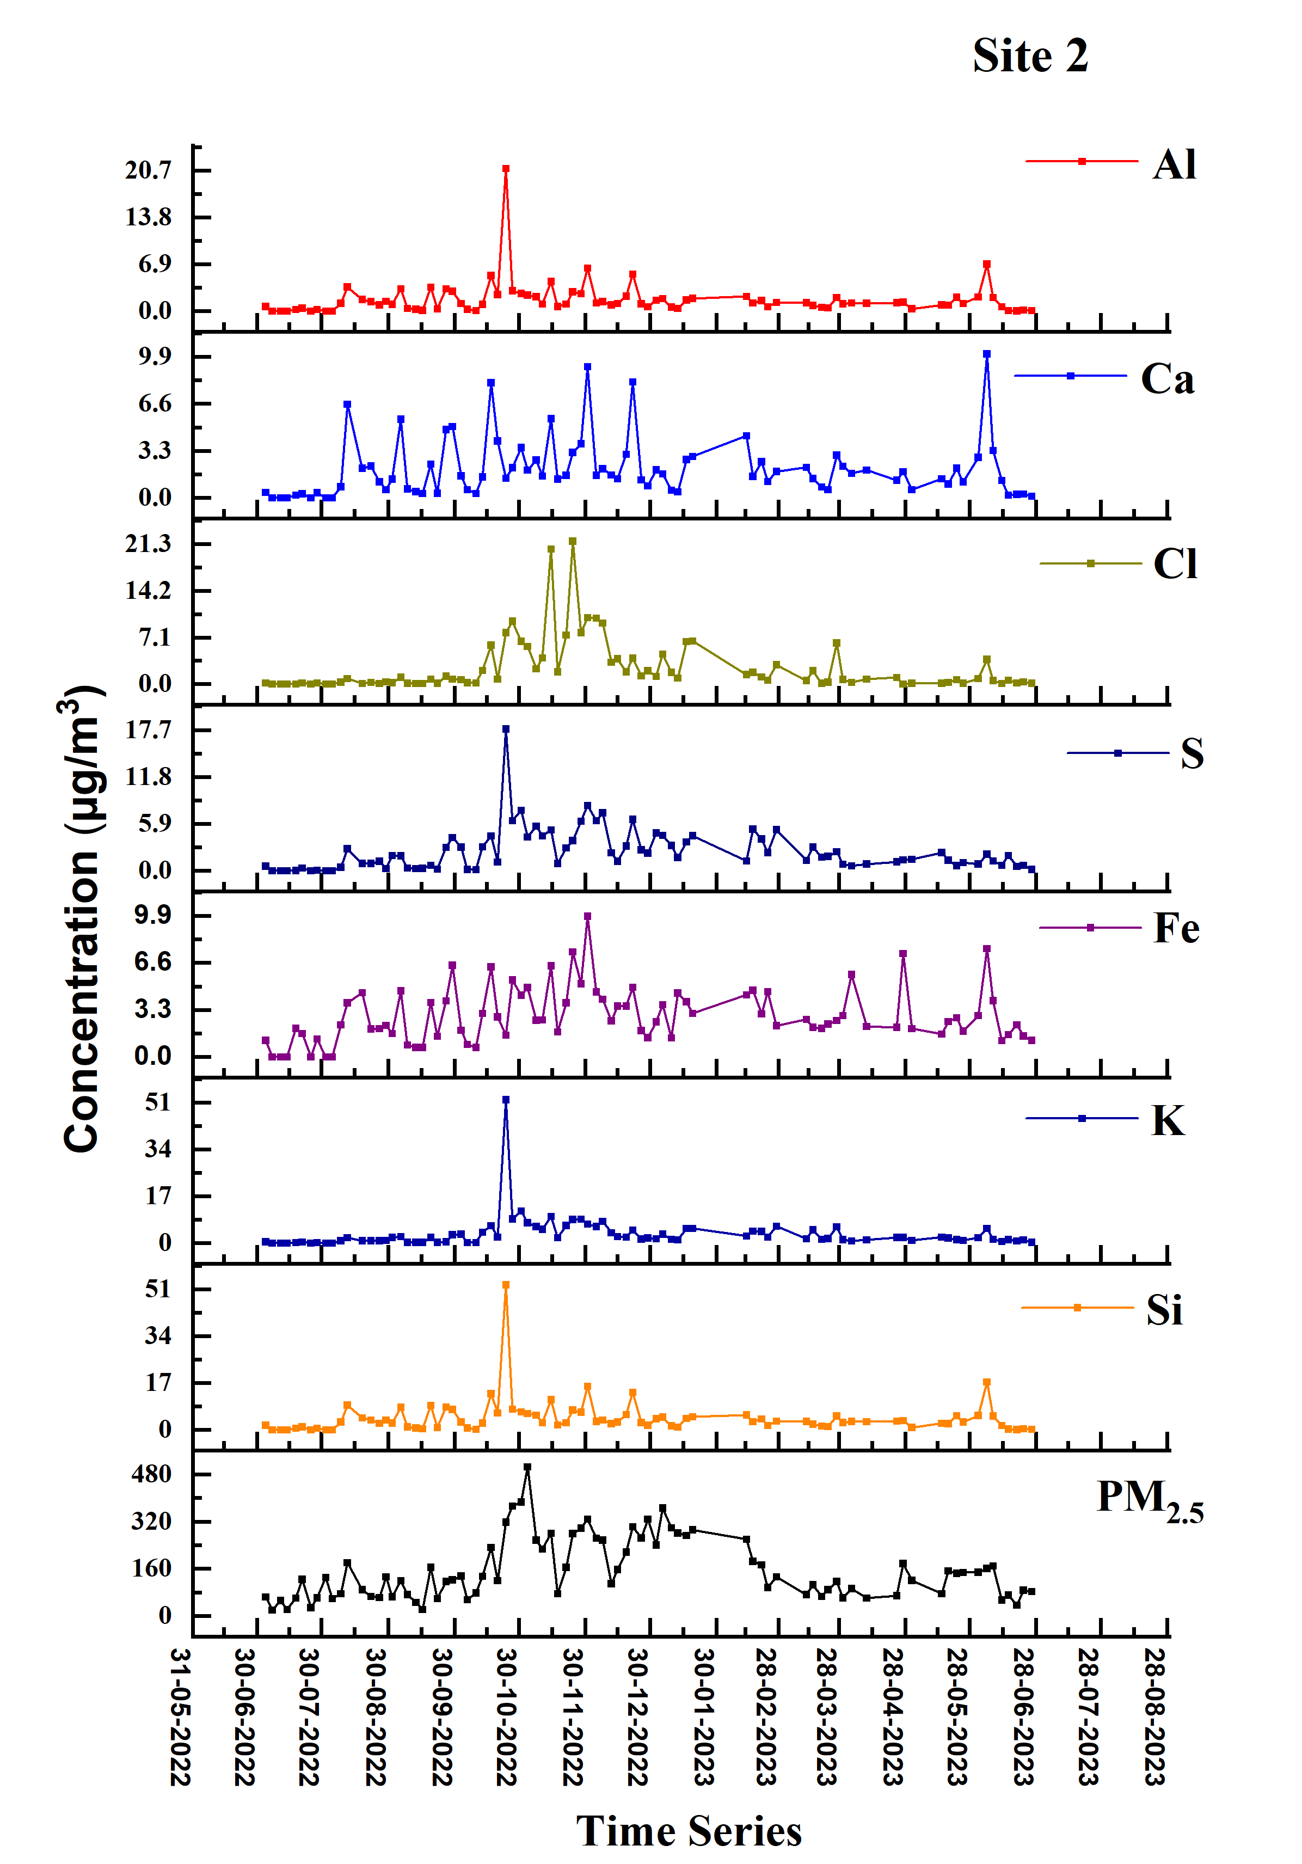
Fig S1: Time series plot of PM_{2.5} and major elements associated with PM_{2.5} concentrations in Faridabad, Haryana, India, at both sites (1&2).

