Supplementary Material – Carbon fluxes (Preliminary CO₂ and CH₄ data from chambers and eddy covariance measurement)

Methods
Carbon fluxes – chamber-based method (Sites BHP-2 – BHP-8)
Greenhouse gas (GHG) measurements were made in a single sampling period at seven of the eight sites during daylight hours, between 08:00 and 17:00. GHG measurements were not taken at BHP-1, as sampling at that site was carried out at dusk. Carbon dioxide (CO₂) and methane (CH₄) diffusive emissions were recorded in replicates of four at each site. GHG recordings were made for a minimum of 300 seconds at each station, using opaque (dark) cylindrical PVC chambers measuring 30 cm D x 55 cm H, with battery operated fans installed for mixing gases during measurement, attached to an ultraportable greenhouse gas analyzer (UGGA; Los Gatos Research, San Jose, California, USA). GHG emissions, reported here in umol m⁻² min⁻¹, were calculated using a standard diffusive flux equation (see Lambert & Fréchette, 2005) based on the best fit linear regression of emissions over time. Resulting data underwent a visual quality control check to ensure that each regression did not indicate either (a) poor sealing of the chamber; (b) saturation of the gas within the chamber; and/or (c) had an R² value <0.7. Through this QC step, one chamber measurement of each CH₄ and CO₂ was excluded (n = 27 per gas).

Carbon fluxes – eddy covariance method (Alpine Peatland)
As our gas sampling method using opaque (dark) chambers at sites BHP2–8 prevented photosynthesis from occurring during measurement, our directly measured CO₂ data represent ecosystem respiration (ER), i.e., the amount of CO₂ lost from the peatland to the atmosphere through both autotrophic and heterotrophic respiration. Net Ecosystem Exchange (NEE) is the net CO₂ flux between the ecosystem and the atmosphere, representing the net balance of CO₂ uptake (gross primary productivity, GPP) and ER, i.e., NEE = GPP – ER. Thus, for the purpose of understanding peatland global warming and/or climate mitigation potential, NEE can be considered a more informative indicator of CO₂ emissions/cycling than ER alone. We used high-frequency Eddy Covariance (EC) data from the nearby Alpine Peatland flux tower to understand relative rates of peatland ER, NEE, and GPP over the same 2-day sampling period (Table S1).

The EC flux tower configuration of AU-APL at Heathy Spur-1, a sub-catchment of Watchbed Creek peatland, is described in detail by Gunawardhana et al. (2021), but in brief: the tower measures CO₂ via a fast-response, three-dimensional, entirely integrated sonic anemometer and open path infrared gas analyser (IRGASON, Campbell Scientific, Logan, Utah, USA) installed at 2.7 m aboveground. Data, sampled at 10 Hz frequency with a solar-powered datalogger (CR3000, Campbell Scientific, USA), were collected remotely via a modem connected to the local 3G network. Data were processed to 30-min averages and quality control checks were performed in EddyProTM open–source software (v6.2.0; LI–COR, Inc., Lincoln, NE, USA) and half-hourly fluxes were subject to post-processing using Tovi software (LI-COR Inc., Lincoln, NE, USA). Following standard quality control approaches, the night-time flux method was applied to partition NEE into the individual components of gross primary productivity (GPP) and ecosystem respiration (ER), including autotrophic and heterotrophic respiration (Reichstein et al., 2005). All available ER data were modelled from air or soil temperature using the exponential regression model from Lloyd & Taylor, (1994). From the resulting 30-min data set, values of GPP, ER, and NEE from the same dates and times as the chamber gas sampling (May 23–24, 2018) were extracted and are presented here. Average daytime ER:GPP ratios from the Alpine Peatland site were then calculated for comparison against the chamber-based CO₂ (ER) data from sites BHP2–8.

Statistical Analysis
Two separate GLMs were used to compare fluxes of CH₄ and CO₂ (ER), with site as a fixed factor. Prior to analysis, CH₄ data were transformed as there were many values below zero in the data set. To do so we added, to all data points, a constant of 0.0001 + the minimum CH₄ value in the data set, so that all values were pushed above zero, while differences between values were unchanged (McDonald, 2009). Hereafter, untransformed CH₄ data are presented.

Results
Carbon fluxes
Note that we use the following convention for reporting data from both carbon flux methods: negative values (<0) describe a net uptake of atmospheric carbon into the peatland, and positive values (>0) describe a net loss of carbon from the peatland to the atmosphere. We also note that, given the single sampling period for each site, chamber-based carbon fluxes reported here are preliminary in nature.

Carbon fluxes – chamber-based method (Sites BHP2–8)
Daytime fluxes of CH₄ ranged from -0.053 to 0.26 umol m² min⁻¹ and averaged 0.001 ± 0.06 umol m² min⁻¹ across all sites. Daytime fluxes of ER ranged from 9.1 to 227.9 umol m² min⁻¹ and averaged 74.6 ± 50.9 umol CO₂ m² min⁻¹. There was no significant effect of site on daytime fluxes of either CH₄ (F = 1.67, df = 20, p = 0.18) or ER (F = 2.36, df = 20, p = 0.07) (Figure S1).

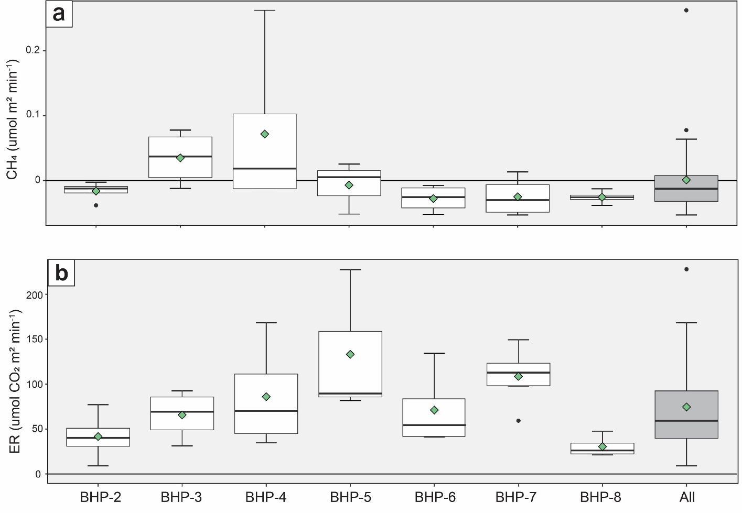
Figure S1. Measured carbon fluxes from peatland sites on the Bogong High Plains, Victoria. (a) Methane (CH₄); and (b) Ecosystem Respiration (ER; CO₂). Each box shows the interquartile range, whiskers show 95% confidence intervals, and lines within boxes show median values. Green diamonds show mean values. Differences between sites for both gases are non-significant.

Carbon fluxes – eddy covariance method
NEE measured at the Alpine Peatland flux tower averaged -43.21 and -50.18 umol m² min⁻¹ on May 23rd and May 24th, 2018, respectively (Table S1). For the same two days, partitioned ER was estimated at 106.99 and 98.47 umol m² min⁻¹ and GPP was estimated at 150.2 and 148.65 umol m² min⁻¹, respectively (Figure S2; Table S1). A diel pattern in the CO₂ fluxes measured by EC was evident, whereby rates of ER, GPP, and NEE were higher during the daylight hours, corresponding to light availability and photosynthetic activity at this time (Figure S2). In the periods during which chamber measurements of CH₄ and ER were made at sites BHP2–8 (between 10:30 and 16:30 on May 23, 2018 and between 08:30 and 15:30 on May 24, 2018), ER at the Alpine Peatland flux tower averaged 44.5% of GPP (Figure S2).

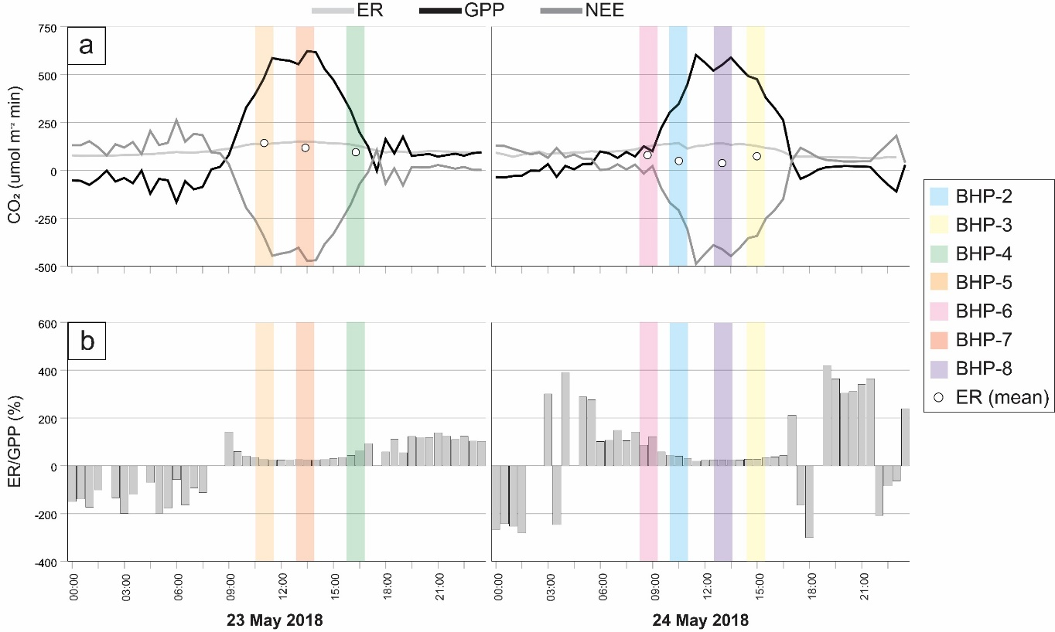
Figure S2. Sampling times of chamber-based flux measurements, and mean site ER values for sites BHP-2 – BHP-8 (open circles) transposed over data from the Alpine Peatland Flux Tower data from May 2018, as follows: (a) measured 30-min net ecosystem exchange (NEE) and partitioned (estimated) fluxes of ecosystem respiration (ER) and gross primary productivity (GPP); and (b) calculated 30-min ER/GPP.

Table S1. Fluxes of CO₂ from the Alpine Peatland eddy covariance tower: measured NEE (net ecosystem exchange) and partitioned ER (ecosystem respiration) and GPP (gross primary productivity).
Date | Diel Period | NEE | ER | GPP | ER/GPP (%)
Date | Diel Period | (umol m² min⁻¹) |  |  | ER/GPP (%)
May 23 2018 | Whole day (0000-2330) | -43.21 | 106.99 | 150.20 | -266.27
May 23 2018 | Day time (0700–1900) | -171.52 | 125.53 | 297.05 | -31.66
May 24 2018 | Whole day (0000-2330) | -50.18 | 98.47 | 148.65 | -53.37
May 24 2018 | Day time (0700–1900) | -177.37 | 116.56 | 293.93 | 114.75
Average  (23–24 May 2018) | Whole day (0000-2330) | -46.69 | 102.73 | 149.43 | -159.82
Average  (23–24 May 2018) | Day time (0700–1900) | -174.44 | 121.05 | 295.49 | 41.55

References
Lambert, M., & Fréchette, J.-L. (2005). Analytical Techniques for Measuring Fluxes of CO2 and CH4 from Hydroelectric Reservoirs and Natural Water Bodies. 37–60. https://doi.org/10.1007/978-3-540-26643-3_3
Lloyd, J., & Taylor, J. A. (1994). On the Temperature Dependence of Soil Respiration. Functional Ecology, 8(3), 315. https://doi.org/10.2307/2389824
McDonald, J. H. (2009). Handbook of Biological Statistics. Sparky House Publishing.
Reichstein, M., Falge, E., Baldocchi, D., Papale, D., Aubinet, M., Berbigier, P., Bernhofer, C., Buchmann, N., Gilmanov, T., Granier, A., Grünwald, T., Havránková, K., Ilvesniemi, H., Janous, D., Knohl, A., Laurila, T., Lohila, A., Loustau, D., Matteucci, G., … Valentini, R. (2005). On the separation of net ecosystem exchange into assimilation and ecosystem respiration: review and improved algorithm. Global Change Biology, 11(9), 1424–1439. https://doi.org/10.1111/J.1365-2486.2005.001002.X

