Supporting Information

Improvements of Antibacterial and Cell Growth Activities for Hydroxyapatite Rods Modified Polyetheretherketone (PEEK) Implants with Direct Absorption of Antibiotics

Dave W. Chen^{1,2}, Ming-Kuang Chou³, Ngi-Chiong Lau^{1,2,3}, Kong-Wei Cheng^{1,3,4,5*}

¹ Department of Orthopaedic Surgery, Chang Gung Memorial Hospital, Keelung Branch, Keelung, Taiwan
² College of Medicine, Chang Gung University, Taoyuan, Taiwan
³ Department of Chemical and Materials Engineering, Chang Gung University, Taoyuan, Taiwan
⁴ College of Environmental and Resource, Ming Chi University of Technology, New Taipei City, Taiwan
⁵ Center for Sustainability and Energy Technologies (CSET), Chang Gung University, Taoyuan, Taiwan

*Corresponding author
Address: No. 259 Wen-Hwa 1st Rd., Kwei-Shan, Taoyuan, 333, Taiwan
E-mail : kwcheng@mail.cgu.edu.tw
Tel: +886-3-2118800-3353; Fax: +886-3-2118668

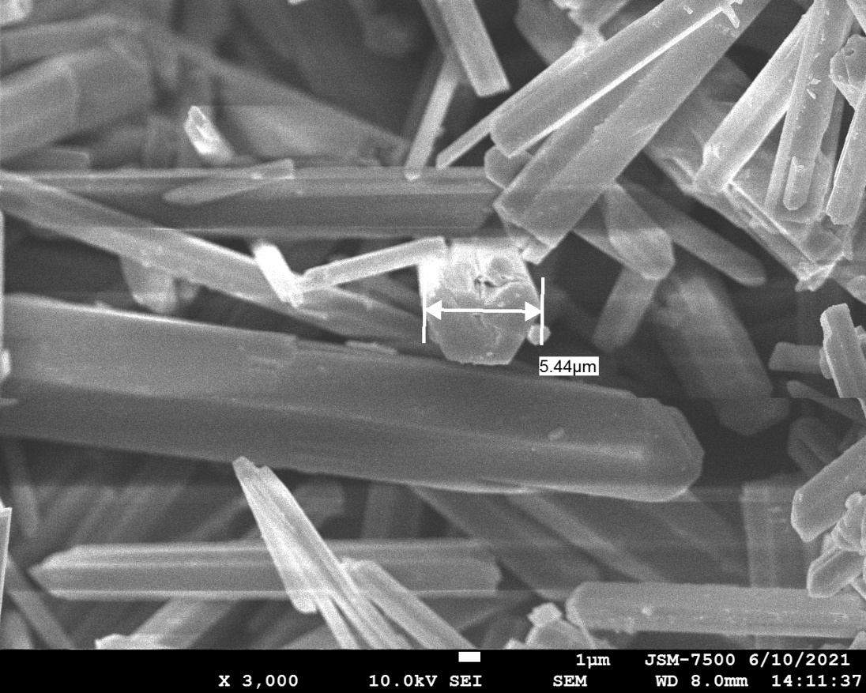

Figure S1 SEM image for sample (ii) at 3 k(X).

Figure S2 The change of OD values for pristine PEEK and PEEK/HA samples in solution containing S. aureus and E. coil as a function of time.

(I)
(II)

(III)

Figure S3 Antibacterial properties on E. coil using (I) sample (A), (II) sample (B) and (III) sample (C) with testing time of 1 day using diffusion method, respectively.

(I)
(II)

(III)

Figure S4 Antibacterial properties on S. aureus using (I) sample (A), (II) sample (B) and (III) sample (C) with testing time of 1 day using diffusion method, respectively.

