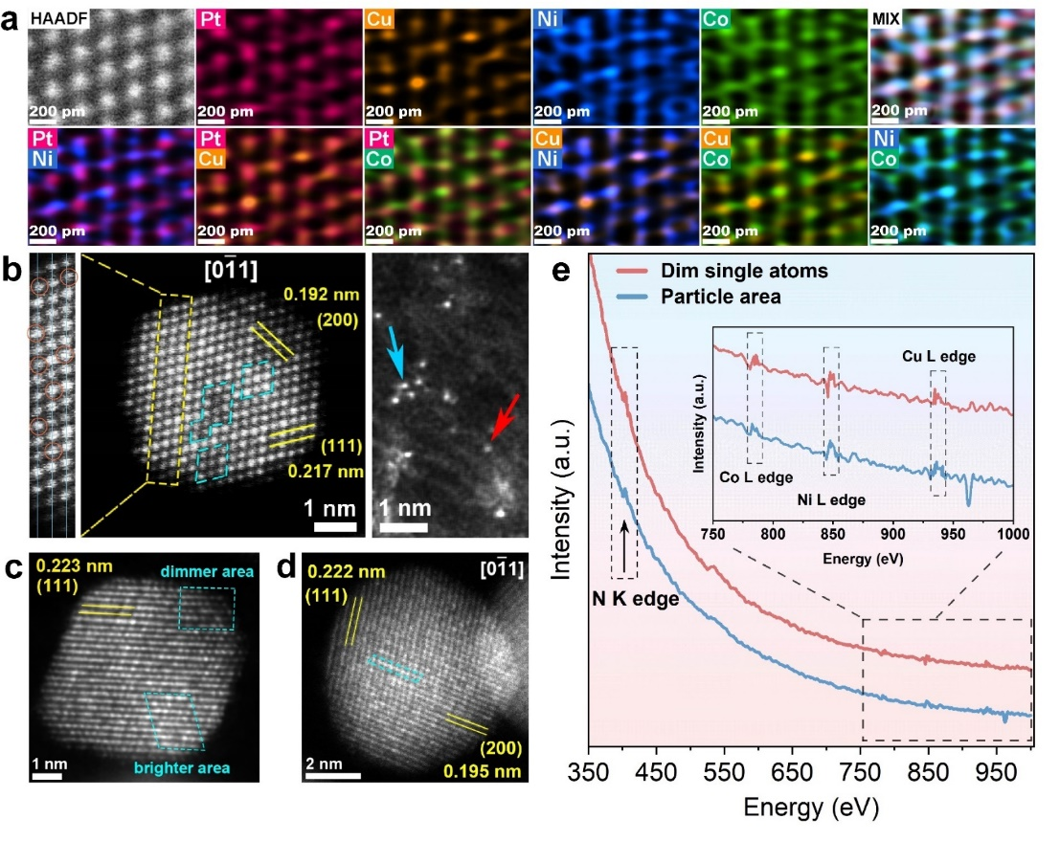
Extended Data Fig. 1 | Further characterization of nonmetal-hybridized interstitial Pt HEAs. a, High-resolution STEM image and EDS mappings of PtCuNiCoN, indicating local enrichment of certain elements along atomic columns. b-d, HAADF-STEM images of an individual nanoparticle of PtCuNiCoN (b), PtCuNiCoF (c) and PtCuNiCoB (d). The enlarged view (b) of the image in the yellow dotted box shows that some of the atomic columns are off center in opposite directions (orange circles), implying the heterogeneity of local lattice distortion. e, EELS acquired at small areas of a PtCuNiCoN nanoparticle (blue) and dim single-atom sites (red) from samples after electrochemical activation. The fact that N K-edge signals was observed via probing small areas on PtCuNiCoN particles, again confirming the presence of N within the bulk of PtCuNiCoN.
Extended Data Fig. 2 | Compositional analysis of nonmetal-hybridized interstitial Pt HEA catalysts without the carbon support. a, EDS mappings of PtCuNiCoN, PtCuNiCoF and PtCuNiCoB. b, 3D-APT reconstruction of PtCuNiCoN. c, HAADF-STEM images of individual nanoparticles and their EDS line-scanning analysis. It is worth noting that the substrate had significant impact on the morphology and composition of the synthesized catalyst. After removing the CaCO₃ substrate by acid wash, severe agglomeration of the catalyst particles occurred and the compositions of these catalysts were also found to be different from those made on KB carbon. Nevertheless, clear N, B and F signals could still be distinguished in these unsupported catalysts. These results thus further corroborate that the non-metal elements have been successfully incorporated into the bulk of these platinum alloys via the facile hydrothermal synthesis.

Extended Data Fig. 3 | Additional evidence for the interstitial positions of nonmetals. a, XPS spectra of N 1s for PtCuNiCoN and PtCuNiCo. b-f, EXAFS and the fitted scattering paths of Pt L₃-edge for PtCuNiCoN Pt L₃-edge (b), Cu K-edge (c), Ni K-edge (d), Pt foil (e) and PtO₂ (f). g, Structural parameters of Pt foil, PtCuNiCoN, and PtO₂ extracted from the EXAFS fittings; Note: CN, coordination number; R, the distance to the neighboring atom; iDPC-STEM images of PtCuNiCoB (h) and PtCuNiCoF (i). FT-EXAFS at the Pt L₃-edge, Cu and Ni K-edge all show shoulder peaks signifying metal-nitrogen coordination at 1.5-1.6 Å. Fittings of the EXAFS results (g) showed that N coordination with metal constitutes of the alloy occurred. These metal-nitrogen coordination, particularly Pt-N and Ni-N bonding, have also been confirmed by DFT calculations (Fig. 5b). These metal-nitrogen interactions could induce anchoring effect on the metal atoms, inhibiting the diffusion and corrosion of these metals during catalytic reactions^{27,28}. Of note, the total Pt-M and Ni-M coordination numbers are ~9.2 and 9.64, lower than that expected in an fcc lattice (CN=12). We ascribed this phenomenon to relatively small particle size of the catalyst, where large proportions of under-coordinated surface atoms exist. From both zone axes of [100] and [1$\overline{1}$0], clear atomic columns for boron in the PtCuNiCoB sample (indicated by arrows in (h)) could be observed at the central positions of the corresponding unit meshes, indicating that boron could occupy both the tetrahedral and the octahedral interstitial positions in the lattice. In terms of the fluorine atoms in PtCuNiCoF (i), iDPC-STEM results suggested that they might take the octahedral interstitial sites. Due to the small particle size of the samples, electron-beam damage and position drifts sometimes occurred while acquiring the data.
Extended Data Fig. 4 | XPS Analysis of the oxidation states and chemical environments of the PtCuNiCoN samples at various stages during the synthesis. a-d, XPS spectra of N 1s (a), Pt 4f (b), Cu 2p_{3/2} (c) and Ni 2p_{3/2} (d) at the different noted stages. N 1s spectra showed that as the solvothermal reaction proceeded, more M-N single-atom sites and interstitial N formed. Pyridinic nitrogen could readily react with metal via its lone pair of electrons to form M-N. Some M-N formed single-atom sites in the carbon substrate, and the others became a part of the particles. After the two-hour annealing, the amount of M-N single-atom sites were slightly reduced, probably due to H₂ reduction. As for the Pt 4f, Cu 2p_{3/2} and Ni XPS spectra, they showed a similar trend that oxidation states of metal species on the carbon support became gradually reduced, i.e., increasingly more metallic state formed as the reaction proceeded. Notably, the reduction of metal ions appeared to follow a sequence of Pt²⁺, Cu²⁺, Ni²⁺, consistent with their respective reductio potentials. These observations are consistent with the EXAFS results and STEM images presented in figure 2.

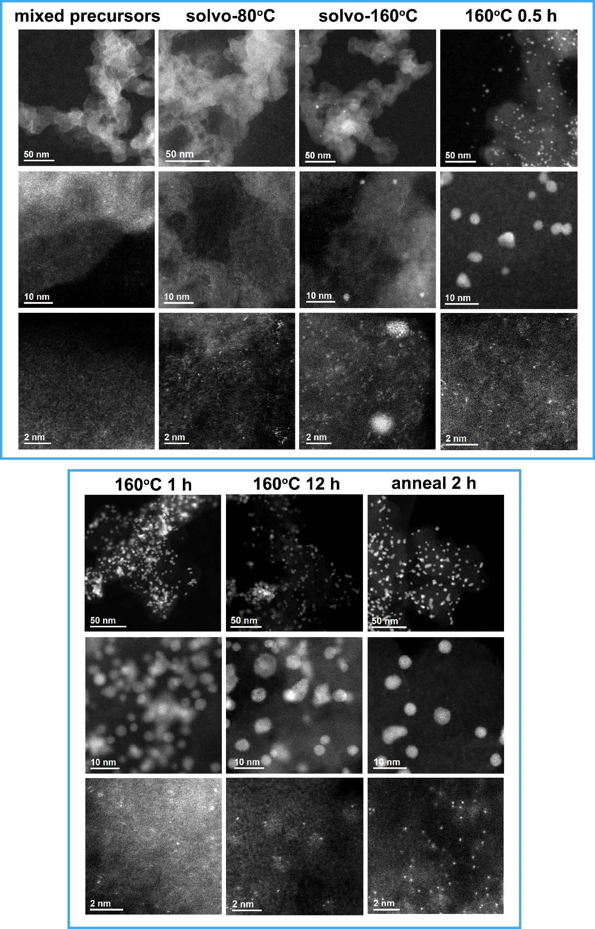
Extended Data Fig. 5 | HAADF-STEM images of the PtCuNiCoN sample at the different noted stages during synthesis.

Extended Data Fig. 6 | Electrocatalytic performance of the catalysts developed in this work. a, LSVs of the all nitrogen-incorporated catalysts tested at a rate of 10 mV s⁻¹ and 1600 rotations per minute in O₂-saturated 0.1 M HClO₄, Pt/C as a comparison. b, LSVs of the nitrogen/boron/fluorine-incorporated catalysts. c, Comparison of specific activity (SA) and mass activity (MA) of the representative catalysts from this work at 0.9 V_{RHE} to the other 50 best Pt-based ORR catalysts reported in the field2,7-11,13-15,17,27-30,38-48,69-93. It is worth noting that our PtCuNiCoN catalyst exhibits the highest specific activity. d, Electrochemical impedance curves for PtCuNiCoN, PtCuNiCo and Pt/C in RDE. e, Cyclic voltammetry (CV) curves of PtCuNiCoN at the initial, 10k, 20k, 30k cycles. f-i, LSV curves for PtCuNiCoN, PtCuNiCoFeN, PtCuNiCo and Pt/C before and after 30k cycles.

Extended Data Fig. 7 | Polarization (POL) curves of MEAs at beginning and the end of the standard 30k AST under H₂/O₂ flow at 80°C, 150 kPa_{abs} at a cathode loading of 0.05 mg_{Pt} cm⁻². a, c, MEA performance at BOT (a) and EOT (c) under H₂-O₂ with different flow rates. b, d, high frequency resistance curves of the corresponding POLs at the BOT (b) and EOT (d). e, The enlarged regions (0.8-0.95 V) of the polarization curves from (a) and (c) f, Chronoamperometric measurements of an MEA at different current densities up to 1.4 A/cm² under H₂-air, each lasting for 20 hours. At all current densities, the MEA showed excellent stability with no sign of decaying. The slight fluctuation at 1.2 A/cm² was due to the automatic refilling of water in the fuel cell tester.

Extended Data Fig. 8 | Electrochemical Impedance spectra and fitted data of fuel cells at different current densities. a-d, Nyquist plots and the fitted data of H₂-Air fuel cell with PtCuNiCoN (a), PtCuNiCo (b), Pt/KB (c) and TKK Pt/C (d), respectively. Note that the Pt loadings in anodes/cathodes for these MEAs were the same. e, Histogram of R_{ct} and R_{Ox} for the four catalysts. f, The Randles cell equivalent circuit used for fitting the spectra. R_{ohm} is mainly caused by the conduction of ions in the electrolyte. R_{ct} is related to the charge transfer of electrochemical reaction occurring near the electrodes, which is mainly controlled by the hysteretic kinetics of cathode. R_{mass} represents the diffusion impedance due to the partial pressure of oxygen in air under H₂-Air test condition, and R_{Ox} is caused by the concentration polarization of oxygen in the process of transfer to active sites, as well as the resistance through the barrier of ionomer and product water. According to the fitted data in Supplementary Table 4, the impedance associated with oxygen transmission (R_{mass}+R_{Ox}) dominated the total impedance at large current, and this phenomenon was exacerbated by vast quantities of reactant transport as the current increased. It is worth noting that compared with the other three catalysts, the use of PtCuNiCoN catalyst (e) had significantly reduced the R_{ct} and R_{mass}+R_{Ox}, which is likely due to the high activity of the catalyst improving the ORR kinetics, and the heteroatom-doping in the substrate facilitating a uniform distribution of ionomer. The porous structure of KB does not seem to be a dominant factor here, as the impedance of Pt/KB was observed to be similar to the TKK Pt/C (e).
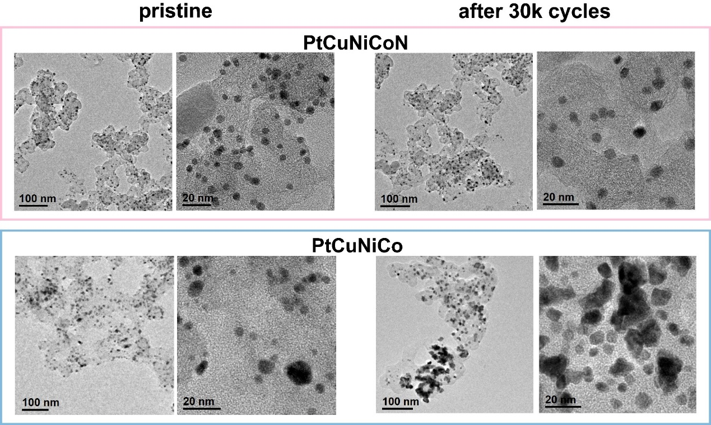
Extended Data Fig. 9 | Morphology of PtCuNiCoN and PtCuNiCo before and after 30k CV cycles. TEM images of the catalysts before and after cycling.

Extended Data Fig. 10 | The formation energies and structure snapshots of different surface metal vacancies. a, ΔGf of Pt, PtCuNiCo and PtCuNiCoN surfaces with the presence of surface O under equilibrium O coverage at 0.9 V. b, The structure snapshots of different surface metal vacancies on PtCuNiCoN (up panel) and PtCuNiCo (bottom panel). To assess the effect of nitrogen on the stability of local structures, we calculated the formation energies of surface single-atom vacancy (ΔGf) to evaluate the initial step of surface corrosion. Interestingly, surface Pt was the element most susceptible to dissolution among the three surfaces (a), which can be attributed to our utilization of slightly Pt-richer surface models (unstable surface compositions already removed during CV activation). The stabilities decreased in the order of PtCuNiCoN, PtCuNiCo and Pt, which was found closely related to the presence/absence of adjacent nitrogens preventing further surface oxidation. As depicted by the vacancy structure of Pt on PtCuNiCoN (b), once the surface Pt atom is removed, the subsurface nitrogen draws closer a nearby surface Pt (highlighted by arrows) to maintain its four-fold coordination, effectively blocking surface oxygen and preventing further metal corrosion. In the cases of PtCuNiCo, adsorbed O atoms tend to spontaneously fall into the surface vacancy (Cu, Co, Ni), causing further oxidation of the surface. On PtCuNiCo(111), the newly formed vacancies (Pt, Cu, Ni, Co) left larger spaces for additional O adsorption compared to PtCuNiCoN surfaces, rendering PtCuNiCo easier for corrosion.
Extended table 1 | Comparison of fuel cell performance of PtCuNiCoN with representative Pt-based catalysts in literature.
Catalyst | Cathode loading (mg_{Pt}/cm²) | Total loading (mg_{Pt}/cm²) | Pressure (kPa_{abs}) | Air flow (mL/min) | H₂ flow (mL/min) | MA  (A mg_{Pt}⁻¹) |  | MA  retention  （%） | Rated power  normalized  by area  (W/cm²) | Rated power  normalized  by mass  (kW/g_{Pt}) | Peak Power |  | Ref.
 |  |  |  |  |  | BOT | EOT | MA  retention  （%） | Rated power  normalized  by area  (W/cm²) | Rated power  normalized  by mass  (kW/g_{Pt}) | Normalized by area (W/cm²) | Normalized by mass (kW/g_{Pt}) | Ref.
DOE 2025 Target | NA | ≤0.1 | N/A | N/A | N/A | >0.44 | >0.264 | >60 | >1.8 | >18 | N/A | N/A | US DOE
PtCuNiCoN | 0.05 | 0.06 | 250 | 1000 | 500 | N/A | N/A | N/A | 0.85 | 14.1 | 1.03 | 17.08 | This work
PtCuNiCoN | 0.07 | 0.1 | 250 | 1000 | 500 | N/A | N/A | N/A | 1.11 | 11.0 | 1.3 | 13.0 | This work
PtCuNiCoN | 0.05 | 0.1 | 150 | 500（O₂） | 200 | 1.15 | 0.81 | 70 | N/A | N/A | N/A | N/A | This work
PtCo/C3 | 0.1 | 0.15 | 250 | 2000 | 835 | 0.72 | 0.45 | 63 | 1.16 | 7.7 | 1.24 | 8.3 | 2
sub-Pt₃Co-MC | 0.2 | 0.4 | 250 | Stoi. 2.0 | Stoi. 2.0 | 0.92 | 0.75 | 82 | 0.34 | 0.84 | 0.8 | 2 | 10
PtNi-BNCs | 0.15 | 0.25 | 250 | 300 | 150 | N/A | N/A | N/A | N/A | N/A | 0.92 | 3.68 | 11
LP@PF-2 | 0.035 | 0.385 | 250 | 520 | 200 | 1.77 | 0.26 | 15 | 0.72 | 1.9 | 1.04 | 2.7 | 14
PtCo@Gnp | 0.09 | 0.1 | 250 | 400 | 126 | 1.14 | 0.75 | 66 | 1.01 | 10.1 | 1.08 | 10.8 | 15
PtCo@Gnp | 0.06 | 0.07 | 250 | 400 | 126 | 1.21 | 0.89 | 73 | 0.92 | 13.2 | 1.01 | 14.4 | 15
N-Pt/HEA/C | 0.2 | 0.3 | 250 | 2000 | 500 | 0.26 | 0.24 | 92 | N/A | N/A | 1.48 | 4.9 | 29
Pt-Fe-N-C | 0.015 | 0.115 | 250 | 520 | 300 | 0.77 | 0.75 | 97 | 0.2 | 1.74 | 0.55 | 4.78 | 30
L1₀-Cr-PtFe/C | 0.025 | 0.125 | 250 | 2000 | 500 | 1.02 | 0.76 | 75 | 1.15 | 9.2 | 1.31 | 10.48 | 48
L1₀-Cr-PtFe/C | 0.025 | 0.05 | 250 | 2000 | 500 | 1.41 | N/A | N/A | 1.05 | 14 | 1.21 | 16.13 | 48
Pt/N-KB | 0.11 | 0.26 | 230 | 2000 | 1000 | 0.35 | N/A | N/A | 0.99 | 3.8 | 1.39 | 5.35 | 49
PtCo/KB-NH₂ | 0.1 | 0.2 | 150 | 1000 | 500 | 0.69 | 0.38 | 55 | 1.02 | 4.8 | 1.1 | 5.5 | 50
Gd-O-Pt₃Ni | 0.1 | 0.18 | 200 | 1000 | 500 | 1.58 | 1.04 | 66 | 0.93 | 5.2 | 1.04 | 5.8 | 51
Pt₃Co/FeN₄–C | 0.1 | 0.2 | 150 | 1000 | 500 | 0.72 | 0.44 | 62 | 0.82 | 4.1 | 0.91 | 4.6 | 52
PtCuCo@Co-N-C | 0.2 | 0.3 | 250 | 600 | 400 | N/A | N/A | N/A | 0.66 | 2.2 | 0.96 | 3.2 | 53
Pt1Co1-  IMC@Pt/C | 0.2 | 0.3 | 200 | 1500 | 400 | 0.46 | N/A | N/A | <0.8 | N/A | 1.23 | 4.1 | 72
Pt_{1.5}Ni_{1_x}/Ni-N-C | 0.05 | 0.15 | 250 | N/A | N/A | 0.70 | 0.51 | 74 | <0.7 | N/A | 0.91 | 6.07 | 74
PtNi(Mo) Oh | 0.1 | 0.2 | 150 | Stoi. 2.0 | Stoi. 1.5 | 0.45 | N/A | N/A | N/A | N/A | 0.7 | 3.5 | 93
L1₀-Pt₂CuGa/C | 0.1 | 0.125 | 150 | 1000 | 500 | 0.57 | 0.37 | 65 | ~900 | N/A | 1.24 | 9.92 | 94
Pt₂CoCu IMCs | 0.056 | 0.076 | 150 | 2000 | 500 | 1.24 | 0.93 | 75 | <0.85 | N/A | 1.1 | 14.47 | 95
PtMoNiAu | 0.1 | 0.15 | 150 | 500 | 200 | 0.93 | 0.72 | 77 | <0.75 | NA | 0.93 | 6.3 | 96
L1₀-Pt₅₀Ni₃₅Ga₁₅/C | 0.1 | 0.15 | 150 | 2000 | 500 | 0.7 | 0.5 | 71 | 1.15 | 7.7 | 1.1 | 7.3 | 97
L1₂-Pt₃Co@Mn_{SA}-NC | 0.1 | N/A | 150 | 2000 | 500 | 0.63 | 0.49 | 78 | N/A | N/A | 1.2 | N/A | 98
Note: Stoi. represents stoichiometric flow rate.

