Supplementary Information to
Nonmetal-Hybridized Interstitial High-Entropy Platinum Alloys for Oxygen Electrocatalysis in Practical Fuel Cells

Pengyu Gao^{1†}, Junjian Li^{1†}, Xuyao Li^{1†}, De Zhang^{1†}, Li Zhong^{2*}, Min Liu², Carlo Franke³, Zongyan Gao¹, Lina Zhou¹, Tong Li³, Hao Liu⁴, Yongxin Cheng⁵, Lihan Zhang⁶, Pengfei Yan⁶, Zhan Shi⁷, Tao Liu^{1*}
¹Shanghai Key Laboratory of Chemical Assessment and Sustainability, Department of Chemistry, Tongji University, Shanghai, 200092, China.
²SEU-FEI Nano-Pico Center, Key Laboratory of MEMS of Ministry of Education, Southeast University, Nanjing, 210096, China.
³Institute for Materials, Ruhr-University Bochum, Universitätsstraße 150, 44801 Bochum, Germany.
⁴Chemistry Department, Binghamton University, Binghamton, NY 13902-6000, USA.
⁵Institute of Chemistry, Chinese Academy of Sciences, Beijing, 100190, China.
⁶Beijing Key Lab of Microstructure and Property of Advanced Materials, College of Materials Science & Engineering, Beijing University of Technology, Beijing 100124, China.
⁷Southwest Headquarters, China Railway Construction Corporation Limited, Chengdu, China.

†These authors contributed equally.
*Email: tliu@tongji.edu.cn, lizhong@seu.edu.cn

The PDF file includes:

Supplementary Figure 1 to 10
Supplementary Table 1 to 4

Supplementary Figure 1 | SEM images showing the sample preparation process for atom probe tomography analysis.

Supplementary Figure 2 | Morphology and size distribution of PtCuNiCoF, PtCuNiCoB, PtCuNiCoN, PtCuNiCoFeN, PtCuNiFeMnN, PtCuNiCoFN, PtCuNiCoFBN catalysts. In general, the particles in all samples are uniformly distributed on the carbon support, with an average size distribution centered at 3.8-4.3 nm (PtCuNiCoF being slightly larger).

Supplementary Figure 3 | Structural changes of the PtCuNiCoN samples at various stages during the synthesis. a-d, XANES spectra of Pt L-edge (a), Cu K-edge (b), Ni K-edge (c) and Co K-edge (d). e, Fourier-transformed R-space of the Co K-edge. f, XRD patterns of PtCuNiCoN/M-N in different periods of synthesis. The decreased white line intensities (Pt L-edge) and negatively shifted leading edges of 3d-metal K-edges (a-d) suggested that they were graduated reduced during the solvothermal and annealing processes. XRD measurements did not capture any long-range ordering, i.e., detectable formation of Pt alloys, until the solvothermal reaction proceeded for 0.5 hour. As the reaction carried on, the weak and broad diffraction peak (111) intensified and shifted towards higher angles, implying increased levels of 3d-metal alloying and growth of particle sizes.

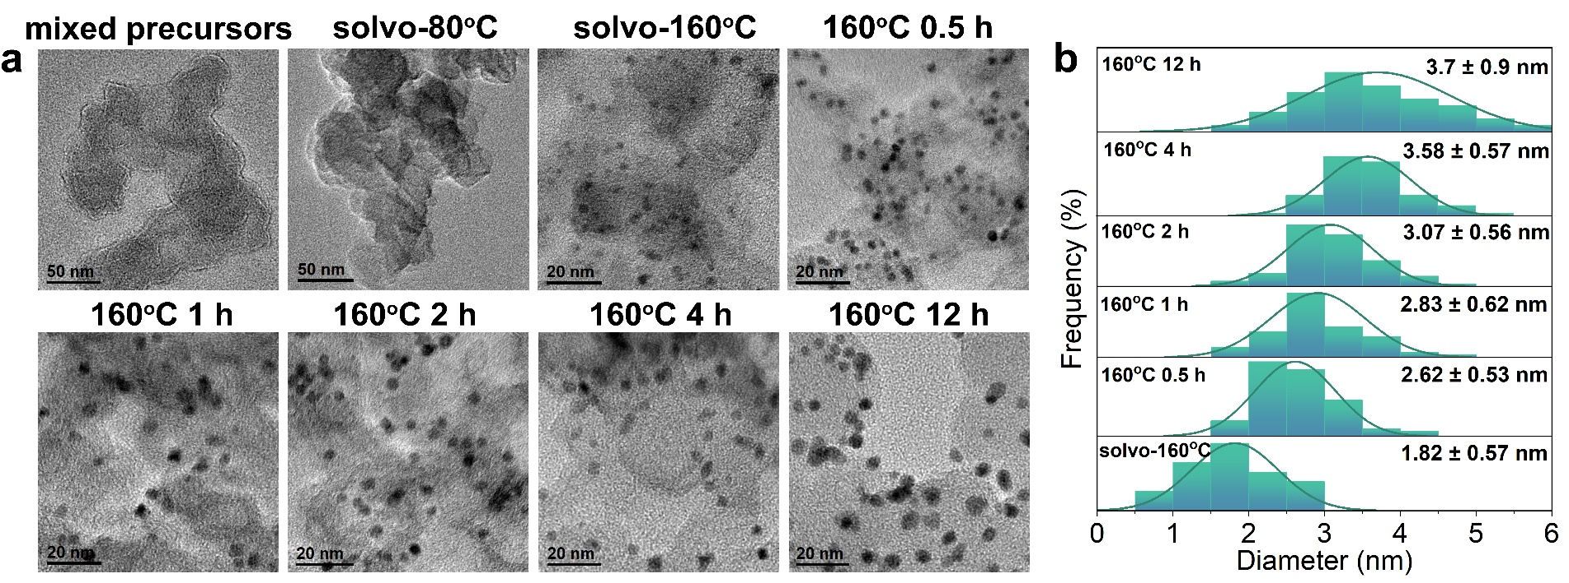
Supplementary Figure 4 | Morphology and size changes of the PtCuNiCoN catalyst during the synthetic process. TEM images (a) and the statistics of particle size distributions (b) of PtCuNiCoN in different synthetic processes.

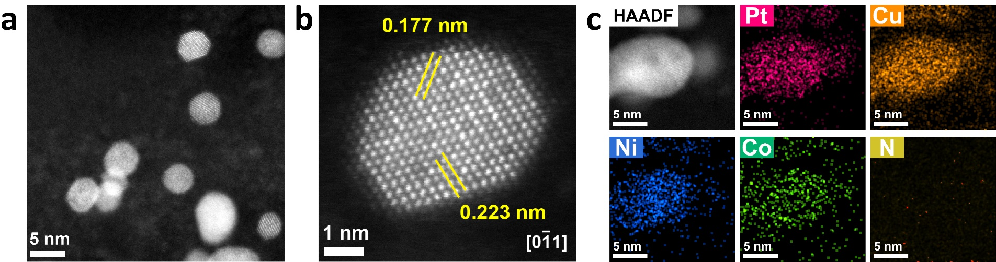

Supplementary Figure 5 | Morphology and structural analysis of PtCuNiCo. HAADF-STEM images of carbon support (a) and individual nanoparticles (b) of the PtCuNiCo electrocatalyst. No single-atom sites were observed in the carbon substrate of the sample, which was due to the absence of nitrogen sources. Comparison of EDS mappings of PtCuNiCo (c) with PtCuNiCoN (Fig. 1), the enriched N signals on particles were clearly absent, this difference further supporting that those samples in figure 1 indeed contained appreciable amount of nitrogen within the particles.

Supplementary Figure 6 | Comparison of single atoms of PtCuNiCoN before and after 30,000 CV cycles. a, TEM images of single-atoms on carbon support of PtCuNiCoN after activation (a1-4, 150 CV cycles) and prolonged cycling (a 5-8, 30,000 CV cycles). From the statistical data in the table (b), we can see that after 30,000 cycles of CV, the proportion of dimmer atoms decreases, indicating that 3d-transition metal single atoms exhibit poorer stability compared to Pt single atoms. Therefore, the reduction of 3d-transition metal single atom sites is a possible reason for the observed decrease in the activity of PtCuNiCoN (Fig. 4 in the main text).

Supplementary Figure 7 | Theoretical models and the determination of surface O coverage under ORR environment. (a) Theoretical models of PtCuNiCo and PtCuNiCoN. By comparing the energy of the system with N-doping at different sites, we found that the N atoms prefer to sit at the interstitial tetrahedral sites, which are more stable than N situating at interstitial octahedral sites and metal substitute sites. (b) The surface phase diagram of O on PtCuNiCo (111) and PtCuNiCoN (111). By only considering the O/H₂O equilibrium, the lowest limit of atomic O coverage under electrochemical conditions could be evaluated. As we are interested in the highest possible O atom coverage (θ_{O}) when the O₂ can still adsorb, it is convenient to utilize this equilibrium as a simple tool to search for the lowest limit of the O coverage at the high potentials. At 0.9 V, the equilibrium θ_{O} is 0.38 ML (monolayer) on PtCuNiCo, which is lower than that of 0.50 ML on PtCuNiCoN. The insets depict the optimized O covered surface at 0.9 V. It shows that the surface adsorbed O tend to adsorb at the three-fold hollow sites. c, Theoretical models for single metal atom anchored nitrogen doped graphene (C-N₄-M₁, M = Pt, Cu, Ni, Co).

Supplementary Figure 8 | Reaction profiles of C-N₄-M (M=Pt, Cu, Ni or Co single atom) and structural snapshots of ORR intermediates. a, ORR reaction profiles on C-N₄-M (M = Pt, Cu, Ni or Co single atom) at U = 0.9 V vs. SHE. b, Structural snapshots of the key reaction intermediates on C-N₄-Co, PtCuNiCo and Pt(111) surface. Among the elementary steps of ORR, the *OOH formation step (*O₂ + H⁺ + e⁻ → *OOH) has the highest free energy cost on all C-N₄-M. C-N₄-Co has the lowest free energy cost (0.58 eV) at this step. However, this energy cost is still 0.20 eV larger than that of PtCuNiCoN (0.38 eV). The H₂O₂ formation route on C-N₄-M, which corresponding to 2e⁻/O₂ ORR mechanism, were also considered. Consistent with previous studies, the 2e⁻/O₂ ORR is more likely to occur on Pt, Cu and Ni single atom sites but less likely to occur on Co site. The generated H₂O₂ could be further decomposed to H₂O on the surfaces of HEA nanoparticles.

Supplementary Figure 9 | Projected density of states (PDOS) onto the surface reacting O species (including *OOH (a), *O (b) and *OH (c)) on PtCuNiCo and PtCuNiCoN surfaces. Clearly, compared with PtCuNiCo, the primary bonding peaks of *OOH and *OH of PtCuNiCoN in the energy window between -6.4 to -8.5 eV are observed to shift downwards to lower energy levels. This observation indicates the significant interaction between N atoms and surface OOH/OH species, which contributes to the stabilization of the OOH and OH states. In contrast, although a small group of peaks corresponding to N-O coupling appeared near -8.1eV in the case of PtCuNiCoN, the main peaks of *O experience a shift towards higher energy regions due to the competition between surface metal-N bond and metal-O bond.

Supplementary Figure 10 | Reaction profiles of ORR on surfaces of pure Pt, PtCuNiCo and PtCuNiCoN at U = 1.0 V vs. SHE. Although the higher potential induced large drops in the free energies of *O on all three catalytic surfaces, the energy cost at the potential RDS on PtCuNiCoN remained the minimal of the three cases, primarily due to its distinctly destabilized *O and much stabilized *OH.

Supplementary Table 1 | The metal content (at%) of all catalysts tested by ICP-OES. X represents the other metallic elements (Mn, Cr, W, Al, Ir, Mo).
Catalyst | Pt | Cu | Ni | Co | Fe | X
PtCuN | 25.0 | 75.0 | / | / | / | /
PtNiN | 42.5 | / | 57.5 | / | / | /
PtCoN | 58.4 | / | / | 41.6 | / | /
PtFeN | 78.2 | / | / | / | 21.8 | /
PtCuNiN | 35.6 | 39.7 | 24.7 | / | / | /
PtCuCoN | 39.2 | 42.5 | / | 18.3 | / | /
PtCuFeN | 42.6 | 47.8 | / | / | 9.6 | /
PtNiCoN | 45.3 | / | 44.7 | 10.0 | / | /
PtNiFeN | 46.3 | / | 44.2 | / | 9.5 | /
PtCoFeN | 68.5 | / | / | 20.6 | 10.9 | /
PtCuMnN | 40.8 | 45.5 | / | / | / | 13.7
PtCuCrN | 44.1 | 46.9 | / | / | / | 9.0
PtCuNiCoN | 29.4 | 31.2 | 28.8 | 10.6 | / | /
PtCuNiFeN | 34.0 | 57.8 | 5.7 | / | 2.5 | /
PtCuNiCrN | 33.5 | 56.3 | 6.5 | / | / | 3.7
PtCuNiMnN | 32.7 | 55.5 | 6.9 | / | / | 4.9
PtCuCoFeN | 40.5 | 55.6 | / | 2.4 | 1.5 | /
PtNiCoFeN | 62.7 | / | 19.1 | 12.0 | 6.2 | /
PtNiCoMnN | 61.5 | / | 20.3 | 11.4 | / | 6.8
PtNiCoCrN | 62.1 | / | 19.8 | 10.7 | / | 7.4
PtCuNiCoFeN | 29.1 | 37.0 | 29.7 | 3.4 | 0.8 | /
PtCuNiFeMnN | 36.7 | 33.1 | 26.1 | / | 2.4 | 1.7
PtCuNiCoCrN | 32.6 | 35.5 | 27.0 | 3.6 | / | 1.3
PtCuNiFeCrN | 35.0 | 34.7 | 26.7 | / | 1.9 | 1.7
PtCuNiCoCrN | 32.6 | 35.5 | 27.0 | 3.6 | / | 1.3
PtCuNiCoMnN | 30.1 | 32.3 | 28.5 | 4.5 | / | 3.6
PtCuNiCoWN | 34.7 | 37.2 | 23.8 | 3.9 | / | 0.4
PtCuNiCoAlN | 31.5 | 36.9 | 25.7 | 2.4 | / | 4.5
PtCuNiCoMoN | 33.0 | 34.6 | 17.6 | 5.5 | / | 9.3
PtCuNiCoN-1* | 52.3 | 16.0 | 27.0 | 4.7 | / | /
PtCuNiCoN-2* | 31.8 | 20.2 | 39.6 | 8.4 | / | /
PtCuNiCoN-3* | 31.5 | 36.3 | 28.4 | 3.8 | / | /
PtCuNiCoN-4* | 21.5 | 65.5 | 10.1 | 2.9 | / | /
PtCuNiCoN-5* | 38.0 | 44.5 | 12.1 | 5.4 | / | /
PtCuNiCoN-6* | 32.2 | 34.8 | 28.3 | 4.7 | / | /
PtCuNiCoN-7* | 30.9 | 32.9 | 33.3 | 2.9 | / | /
PtCuNiCoB | 40.9 | 35.0 | 14.9 | 9.2 | / | /
PtCuNiCoF | 40.5 | 45.8 | 7.5 | 6.2 | / | /
*Note: PtCuNiCoN-X represents a series of catalysts of tunable compositions synthesized by varying the ratios of precursors during the solvothermal reaction.

Supplementary Table 2 | The Pt loadings and ECSAs for nitrogen-incorporated high-entropy platinum alloy catalysts.
Catalyst | Pt loading (wt.%) | ECSA (m² g_{Pt}⁻¹)
PtCuNiCoN | 23.8 | 64.3
PtCuNiCoF | 13.6 | 65.6
PtCuNiCoB | 24.2 | 61.2
PtCuNiCoFeN | 22.0 | 59.6
PtCuNiFeMnN | 17.3 | 60.8
PtCuNiFeN | 19.3 | 66.7
PtCuNiFeCrN | 18.3 | 57.9
PtCuCoFeN | 17.9 | 65.0
PtCuNiCoCrN | 13.4 | 62.0
PtNiCoFeN | 15.6 | 59.7

Supplementary Table 3 | MA and SA of the catalysts explored in this work.
Catalyst | MA (A mg_{Pt}⁻¹) | SA (mA cm⁻²)
PtCuNiCoF | 2.94 | 4.48
PtCuNiCoB | 2.00 | 3.27
PtCuNiCoN | 7.78 | 12.10
PtCuNiCoFN | 4.60 | 7.02
PtCuNiCoFeN | 6.67 | 11.19
PtCuNiFeMnN | 6.01 | 9.88
PtCuNiFeN | 5.58 | 8.37
PtCuCoFeN | 4.93 | 7.58
PtCuNiCoCrN | 4.90 | 7.90
PtCuNiFeCrN | 4.72 | 8.15
PtNiCoFeN | 4.10 | 6.87
PtCuNiN | 4.47 | 6.57
PtCuCoN | 4.04 | 6.31
PtCuFeN | 3.34 | 4.77
PtCuMnN | 2.30 | 3.90
PtCuN | 2.73 | 4.71
PtNiN | 2.69 | 4.10
PtFeN | 2.13 | 3.39
PtCoN | 2.00 | 3.20
PtCuNiCo | 3.60 | 5.50
PtCuNiFeCr | 2.94 | 4.92
PtCuNiCoFe | 2.80 | 4.30
PtCuNiFeMn | 2.44 | 4.06
PtCuNiFe | 1.65 | 2.76

Supplementary Table 4 | Fitting parameters of Nyquist plots.
 | R_{ohm}  (mohm) | C1  (F) | R_{ct}  (mohm) | CPE1  (S*s^a) | R_{mass}  (mohm) | CPE2  (S*s^a) | R_{Ox}  (mohm) | R_{total}  (mohm) | R_{mass+Ox}  (mohm)
PtCuNiCoN-9 A | 5.80 | 0.03 | 19.83 | 1.32×10³ | 4.02 | 0.44 | 2.04 | 31.69 | 6.06
PtCuNiCoN-11 A | 5.78 | 0.03 | 18.37 | 2.28×10³ | 3.42 | 0.36 | 4.78 | 32.35 | 8.20
PtCuNiCoN-13 A | 5.70 | 0.04 | 21.40 | 4.58×10² | 4.78 | 0.11 | 4.44 | 36.32 | 9.22
PtCuNiCo-9 A | 9.06 | 0.03 | 27.57 | 1.77×10³ | 2.08 | 0.48 | 12.29 | 51.00 | 14.37
PtCuNiCo-11 A | 9.09 | 0.17 | 26.72 | 5.58×10³ | 2.19 | 0.04 | 17.88 | 55.88 | 20.07
PtCuNiCo-13 A | 9.18 | 0.05 | 28.26 | 1.86×10³ | 13.34 | 0.16 | 22.97 | 73.75 | 36.31
Pt/KB-9 A | 6.06 | 0.08 | 49.38 | 2.13×10³ | 1.99 | 0.91 | 18.80 | 76.23 | 20.79
Pt/KB-11 A | 5.80 | 0.06 | 58.97 | 1.09×10³ | 1.91 | 5.59 | 31.82 | 98.50 | 33.73
Pt/KB-13 A | 6.07 | 0.06 | 56.81 | 2.20×10³ | 2.84 | 3.01 | 51.36 | 117.08 | 54.20
Pt/C-9 A | 5.86 | 0.17 | 50.24 | 4.07×10³ | 0.91 | 0.07 | 18.33 | 75.34 | 19.24
Pt/C-11 A | 5.95 | 0.11 | 60.23 | 9.94×10² | 0.66 | 0.10 | 34.24 | 101.08 | 34.90
Pt/C-13 A | 6.12 | 1.51 | 73.20 | 2.08×10³ | 0.07 | 0.07 | 43.63 | 123.02 | 43.70

