Supplementary Material
Appendix 1
EXTRACTS
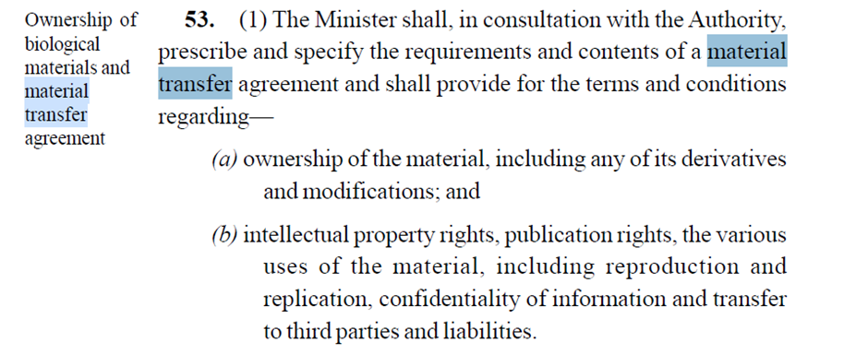
Appendix 2
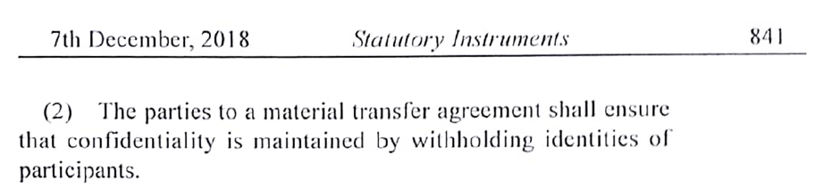
Appendix 3
