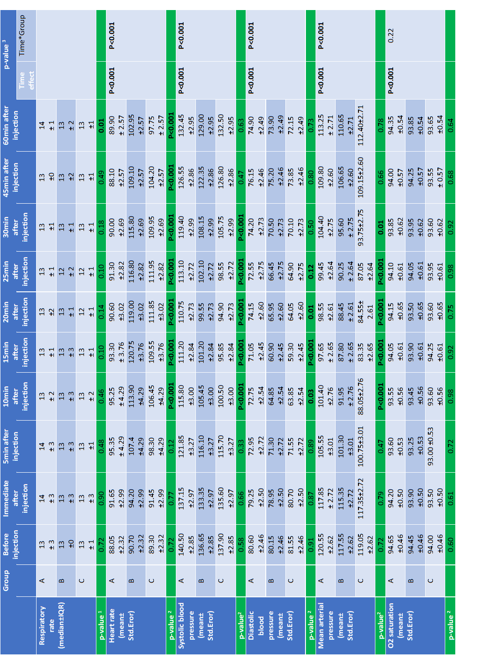
Table 4. Detailed date of the variables/group during the study (1:Kruskal-Wallis test / 2: one-way ANOVA test / 3: repeated measured ANOVA test)

