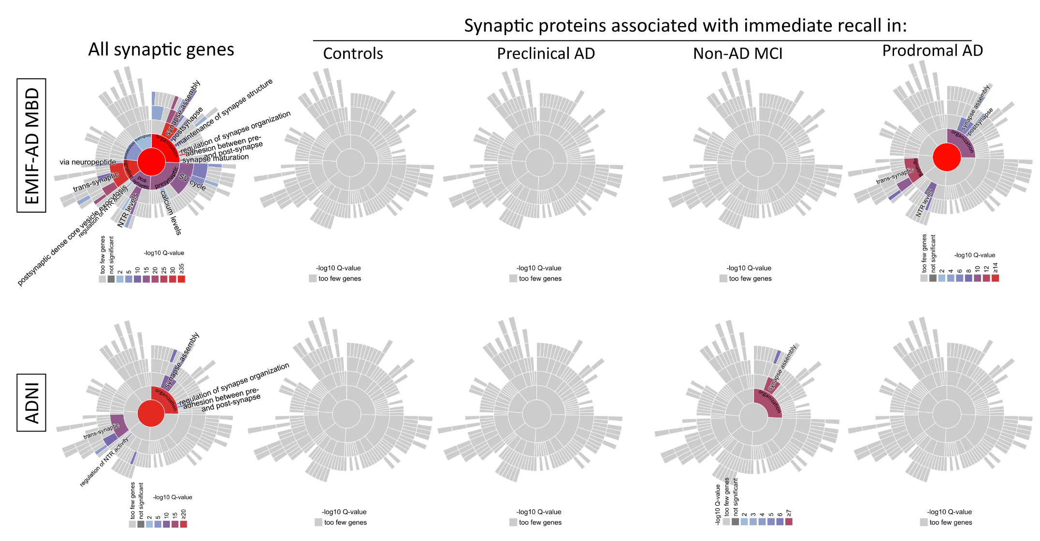
Supplementary Figure 2: Relation of immediate recall-associated proteins with synaptic processes. Enrichment analysis of synaptic processes, tested using the SynGO website (see Methods for further details). The enrichment analyses were conducted separately in each diagnostic group, selecting proteins of which the interaction between protein level and diagnostic group had a p-value < 0.1 and which additionally were related to immediate recall in that diagnostic group (p-value < 0.05). Enrichment analysis of all synaptic genes is shown for an overview of synaptic proteins included in each dataset.

