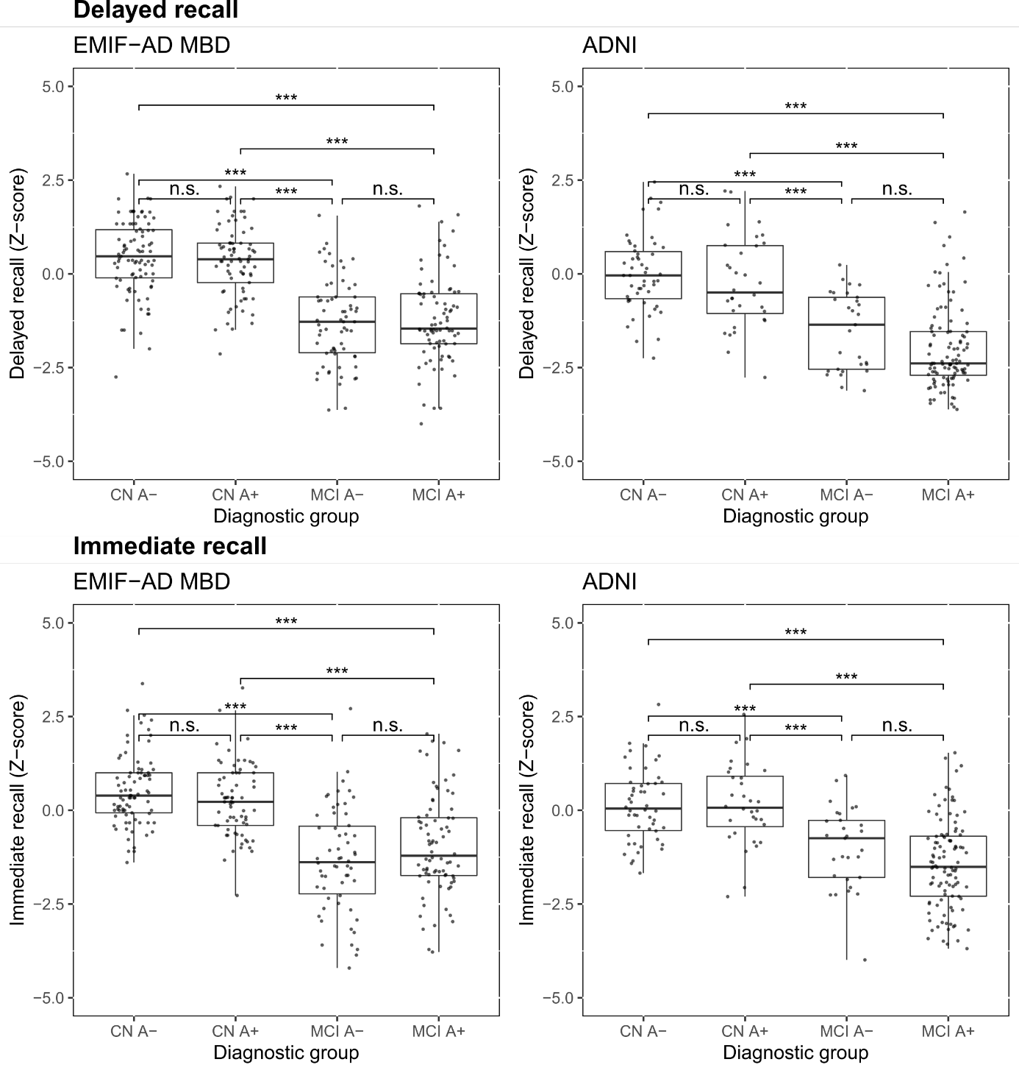
Supplementary Figure 1: Immediate and delayed recall scores in EMIF-AD MBD and ADNI. Immediate and delayed recall scores on word learning tests are Z-scores adjusted for age, sex and education (further details provided in the Methods). The box of the boxplot indicates 25th percentile, median and 75th percentile, whiskers indicate 1.5x interquartile range. N.s., not significant; *, P-value < 0.05; **, P-value < 0.01; ***, P-value < 0.001. CN A-, controls; CN A+, preclinical AD, MCI A-, Non-AD MCI, MCI A+, prodromal AD.

