Supporting Information
Experimental and theoretical study on the transformation behavior of bisphenol S by radicals driven persulfate oxidation
Junyan Wei¹, Linning Yin¹, Ruijuan Qu¹, Gadah Al-Basher², Xiaoxue Pan^{1, 3*}, Zunyao Wang^{1*}
¹ State Key Laboratory of Pollution Control and Resources Reuse, School of the Environment, Nanjing University, Nanjing 210023, Jiangsu, PR China
² King Saud University, College of Science, Zoology Department, P.O. Box 2455, Riyadh, 11451, Saudi Arabia
³ School of Resources and Environmental Engineering, Anhui University, Anhui Hefei 230601, PR China
*Corresponding author: Xiaoxue Pan and Zunyao Wang.
E-mail address: panxiaoxue1208@163.com and wangzy@nju.edu.cn.
Tel: +86-0551-63861985 and +86-25-89680358;
Fax: +86-0551-63861985 and +86-25-89680358.
Pages: 31.
Text: 5.
Figures: 11.
Tables: 5.

Text. S1. Reagents and water matrices
BPS (C₁₂H₁₀O₄S, purity ≥ 99%) was obtained from Aladdin (Shanghai, China). Multi-walled carbon nanotubes (MWCNTs), single-walled carbon nanotubes (SWCNTs), hydroxylated multi-walled carbon nanotubes (CNT-OH), graphene (GP) and graphite oxide (GO) were purchased from Shenzhen Nanotech Port Co., Ltd (Shenzhen, China), and their properties were summarized in Tables S1, S2 and S3. Methanol, tert-butanol and 5,5-dimethyl-pyrroline-N-oxide (DMPO) were obtained from J&K Scientific Ltd. (Beijing, China). Potassium persulfate (K₂S₂O₈, purity ≥ 99.5%), and other reagents (analytical grade at least) were purchased from Nanjing Chemical Reagent Co., Ltd (Nanjing, China) without further purification.
Secondary effluent and River water were collected from the Wulongkou sewage treatment plant (Zhengzhou, China) and Jiuxiang River (Nanjing, China), respectively, and they were filtered through 0.45 μm glass fiber membranes (GF/F, Waterman, Maidstone, UK) before use. Tap water was sampled from our lab (Nanjing, China). Main physicochemical parameters of the four water samples were listed in Table S4. Unless otherwise stated, ultrapure water (18.25 MΩ cm), produced with a Milli-Q water purification system, was used in all experiments.

Text. S2. Preparation and characterization of nitrogen-doped nanocarbon based materials
Our previous work has proved that ammonium nitrate (NH₄NO₃) is the best nitrogen source among NH₄NO₃, urea, polyaniline and indole when we explored the effects of N from different reagents doping on hydroxylated multi-walled carbon nanotubes to catalyze PS for UV-type filter elimination (Pan et al., 2018a). Therefore, in this study, NH₄NO₃ was also used in order to further improve the removal efficiency of BPS. First, it was ground with carbonaceous materials at a mass ratio of 1:2 in an agate mortar. The above mixture was then placed into a tube furnace and kept at 350 ℃ for 1 h under continuous nitrogen gas flow. After calcined, the materials were reground and washed. Different NH₄NO₃-doped carbonaceous materials were abbreviated as N-MWCNTs, N-SWCNTs, N-CNT-OH, N-GO and N-GP.
Characterization of the prepared nanocarbon-based materials including scanning electron microscopy (SEM), transmission electron microscopy (TEM), X-ray photoelectron spectroscopy (XPS), and BET surface area were performed and the used equipments in detail were recorded elsewhere (Pan et al., 2018a).
Fig. S1 showed the SEM and TEM images of SWCNTs (a and c) and N-SWCNTs (b and d), which confirmed that the tubular structure of SWCNT still remained after nitrogen doping. In addition, N-SWCNTs were more easily dispersed than SWCNTs, revealing that nitrogen doping might improve the dispersion of CNTs, which further resulted in the increased specific surface area (560.44 and 619.59 m²/g of SWCNTs and N-SWCNTs respectively, listed in Table. S3). This phenomenon was also obtained in other materials except for GP (Table. S3), confirming nitrogen doping can enlarge the specific area of nanocarbon-based materials.
From XPS spectra (Fig. S2), the specific elemental composition of SWCNTs (a) and N-SWCNTs (b) was summarized in Table. S2. Clearly, N did appear in N-SWCNTs samples, suggesting the successful doping of N into SWCNTs. Although the same synthesis method used in this and previous work (Pan et al., 2018a), more N content on the surface of N-SWCNTs was observed (1.16% versus 0.88%), which might be due to the existence of oxygen-containing functional groups on the surface of CNT-OH (Liu et al., 2016).

Text. S3 Analytic method of intermediates
The mobile phase was consisted of 0.1% formic acid in water (A) and methanol (B), and the flow rate was 300 μL min⁻¹. The gradient elution program for LC-MS detection was given as 10% B (0 ~ 4.5 min), 40% B (4.5 ~ 7.5 min), 50% B (7.5 ~ 9 min), 80% B (9 ~ 11.5 min), 90% B (11.5 ~ 15 min), 95% B (15 ~ 18 min), 100% B (18 ~ 25.5 min), and 10% B (25.5 ~ 30 min). While 100% methanol was used for LC-MS/MS analysis at 300 μL min⁻¹ and current running time was just 5 min in total. The calibration error was kept below 3 ppm by using an electron spray ionization negative calibration solution (AB Sciex Pte. Ltd., USA). The operating parameters of the TOF 65 detector were set as follows: ion spray voltage floating, -4500 V (negative mode); temperature, 550 °C; ion source gas 1, 55 psi; ion source gas 2, 55 psi; curtain gas, 35 psi; declustering potential, -80 V; collision energy, -10 V; and scan range (m/z), 60 – 1500 amu. MS/MS analysis was performed using the same parameters except that the fragmentation was optimized by varying collision energy from 20 to 65 eV. All data were analyzed by using the SCIEX OS 1.6 software (AB Sciex).

Text. S4 The efficiency of different nanocarbon-based materials
Under the conditions of 1.0 mM PS, 25 ℃, 30 mg/L catalyst and initial pH 7.0, the adsorption and degradation kinetics of 10 µM BPS were carried out in nanocarbon-based catalyst/PS system. As shown in Fig. S4, all the materials could reach adsorption-desorption equilibrium after 30 min shaking. 24.0%, 63.3%, 14.6%, 1.0% and 9.8% of 10 µM BPS were adsorbed by MWCNTs, SWCNTs, CNT-OH, GO and GP, respectively, while a bit increase was achieved after N doping except for CNT-OH (their saturated adsorption capacities were similar). The adsorption content of each catalyst was highly surface area-dependent and thus large surface area (560.44 m²/g, listed in Table. S3) led to the highest adsorption for SWCNTs case. After adding PS, BPS was gradually degraded. Compared to PS alone, in which only 4.8% BPS removal was obtained, the removal efficiency of BPS in nanocarbon-based materials/PS systems ranged from 16.7% to 100.0% not including GO. The above results demonstrated that the presence of carbonaceous materials significantly improved the removal efficiency of BPS; and both the adsorption and the oxidative degradation contributed to the removal of BPS, which were further enhanced after N doping (Figs.1 (d) and S4), in good agreement with other findings (Kang et al., 2018; Pang et al., 2018; Yu et al., 2019). This promoted effect could be attributed to the facts that N doping interrupts graphitic carbon configuration and then generates more active sites, changes electron states of the carbon network (Kong et al., 2014) and enhances the π–π bond of the carbon matrix (Kang et al., 2018). The highest removal of BPS was observed in MWCNTs and SWCNTs situations (84.7%~100.0%) whether N doping or not, in comparison with CNT-OH, GP, and GO (2.0%~21.7%). This might be explained by the fact that the bent graphene sheets of CNTs included partially delocalized π electrons; these π electrons could provide better access to PS for target compounds (Zhang et al., 2010). Due to their highly sp²-hybridized graphitic carbon skeletons with few defects and low oxygen content, Duan et al. (2015b) further verified the significant role of free-flowing π electrons in motivating PS. However, Wang et al. (2015b) found that nitrogen modification of reduced GO presented good activated PS performance to remove BPA; Pan et al. (2018a) reported the excellent catalytic ability of CNT-OH instead of CNT in 2,4,4’-trihydroxybenzophenone/PS solution. The combined observation possibly suggested the selective catalytic performance of nanocarbon-based materials towards PS. In addition, the characters of target organic compounds should be taken into consideration, too.

Text. S5 Catalytic mechanism
Accroding to recent reaserches, radical and non-radical mechanisms, including sulfate radicals (SO₄⁻) (Wang et al., 2015b), hydroxyl radicals (OH) (Duan et al., 2015a), singlet oxygen generation (¹O₂) (Cheng et al., 2017; Shao et al., 2018), PS-catalyst complex and electron transfer (Cheng et al., 2019; Ren et al., 2020), are proved to exist in PS activation driven by nanocarbon-based materials. To explore the possible reactive species in PS/N-SWCNTs system, EPR and radical quenching experiments were conducted and the results were shown in Fig. S7. From EPR spectra (Fig. S7 (a)), it was seen that obvious peak of DMPO-OH adduct (hyperfine splitting constants of α_{N} = α_{H} = 14.9 G) was observed in PS+DMPO system, in comparison to single DMPO and N-SWCNTs. After adding N-SWCNTs, this signal intensity was largely improved. It was unexpected that no peak of DMPO-SO₄ adduct was recorded in all studied systems, which was contradictory with the identified sulfate addition intermediates (P5). A small amount of SO₄⁻, fast transformation of DMPO-SO₄ adduct to DMPO-OH adduct and very strong intensity of DMPO-OH adduct might together lead to the disappearance of sulfate radicals signal (Timmins et al., 1999).
The radical quenching experiments were conducted to further validate the above observations of EPR spectra. Common SO₄⁻ and OH scavengers namely methanol and tert-tutanol were used. Herein, tert-tutanol can quench OH at a rate constant of (3.8-7.6) ×10⁸ M⁻¹ s⁻¹, while methanol can quench both SO₄⁻ and OH and the corresponding rate constants were 2.5×10⁷ and 9.7×10⁸ M⁻¹ s⁻¹. As shown in Fig. S7 (b), compared to control, the residual of BPS in reaction solution after adding 100 mM tert-butanol increased from 6.1% to 26.2%in 60 min, and more BPS (72.2%) remained in solution at higher tert-butanol dosage. In contrary to tert-butanol, the addition of methanol did not show any inhibitory effect on BPS degradation even though its molar concentration was 50000 times as high as BPS. Similar findings were also obtained in previous studies (Lee et al., 2015). This quenching inability of methanol might be related with its more hydrophilic property than tert-butanol, which resulted in hard approach to the catalyst surface, and further failed quenching radicals on the surface of catalyst. Combined the results of EPR and quenching tests, we concluded that OH mainly contributed to the substrate removal. Other ROS like SO₄⁻, ¹O₂ and PS-catalyst complex might be also involved in the oxidative reaction, which was reflected by the incomplete quenching phenomenon of tert-butanol. Duan et al. (2015a) also diclosed that N-SWCNTs could effectively activate PS to generate large amounts of OH along with a small number of SO₄⁻.

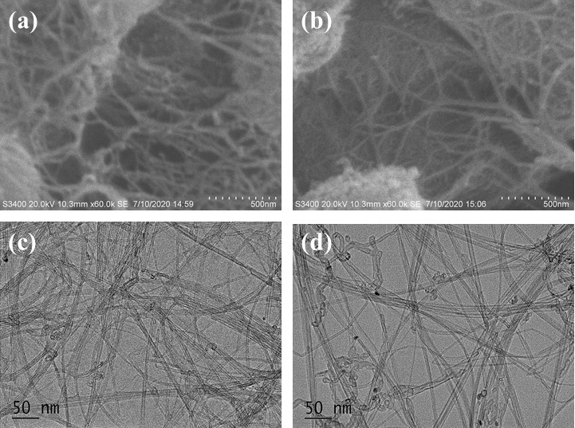
Fig. S1. SEM and TEM images of SWCNTs (a and c), N-SWCNTs (b and d).
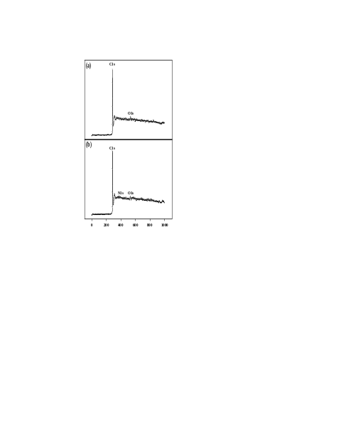
Fig. S2. XPS survey spectra of SWCNTs (a) and N-SWCNTs (b).
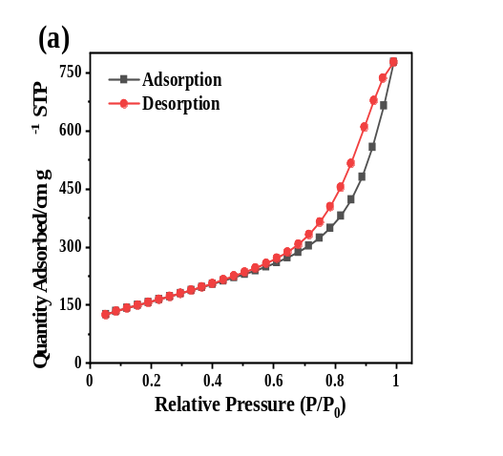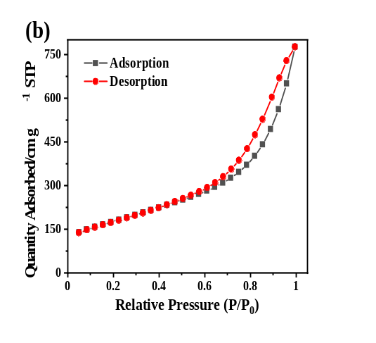
Fig. S3. N₂ adsorption-desorption isotherm of SWCNTs (a) and N-SWCNTs (b).
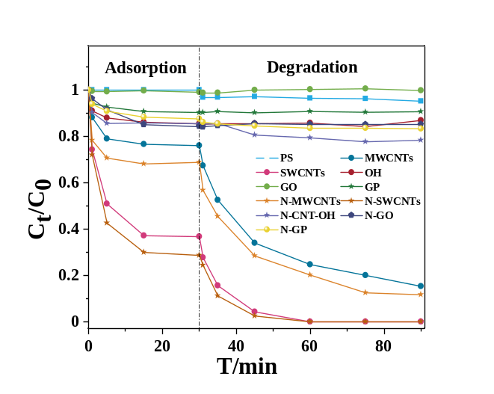
Fig. S4. Removal of BPS by five nanocarbon-based materials and their corresponding catalysts after N doping catalyzed PS. Conditions: [BPS]₀ = 10 μM, [PS]₀ = 1.0 mM, T = 25 ℃, pH₀ = 7.0, concentration of carbonaceous materials = 30 mg/L.
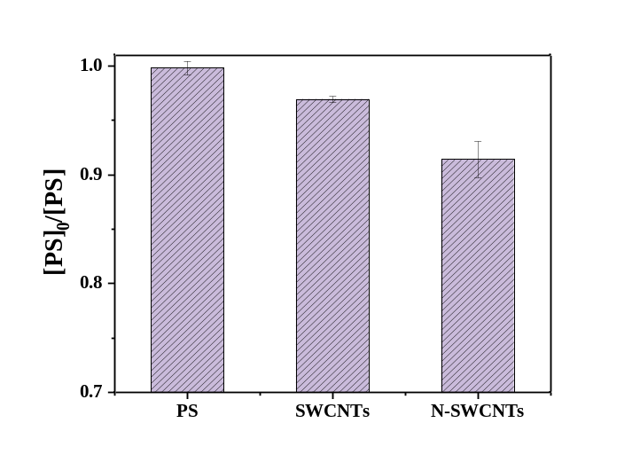
Fig. S5. Residual concentration of PS in three different systems. Conditions: [BPS]₀ = 10 μM, [PS]₀ = 1.0 mM, T = 25 ℃, pH₀ = 7.0, concentration of SWCNTs or N-SWCNTs = 20 mg/L.

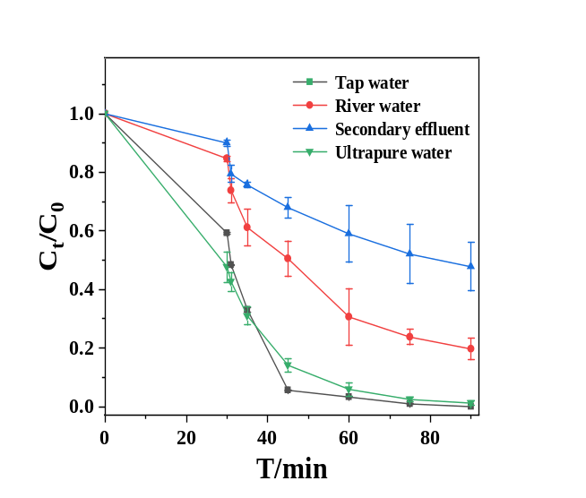
Fig. S6. Effect of water matrix on the degradation of BPS in PS/N-SWCNTs system. Conditions: [BPS]₀ = 10 μM, [PS]₀ = 1.0 mM, T = 25 ℃, concentration of N-SWCNTs = 20 mg/L.

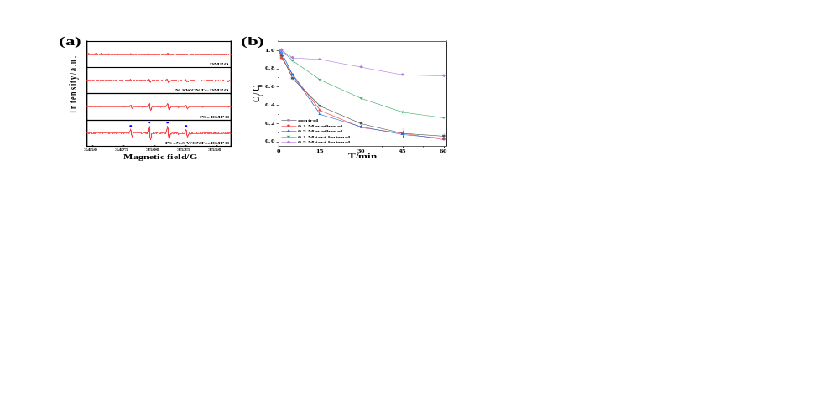
Fig. S7. EPR spectra in different systems obtained by spin trapping with 50 mM DMPO (a) and radical quenching experiments in PS/N-SWCNTs system (b). Conditions: [BPS]₀ = 10 μM, [PS]₀ = 1.0 mM, [methanol]₀ = [tert-Butanol]₀ = 100 mM, T = 25 ℃, pH₀ = 7.0, concentration of N-SWCNTs = 20 mg/L.

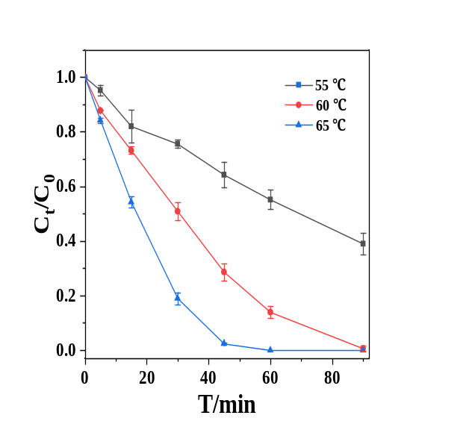
Fig. S8. Effect of temperature on the degradation of BPS in single PS system. Conditions: [BPS]₀ = 10 μM, [PS]₀ = 1.0 mM, pH₀ = 7.0.

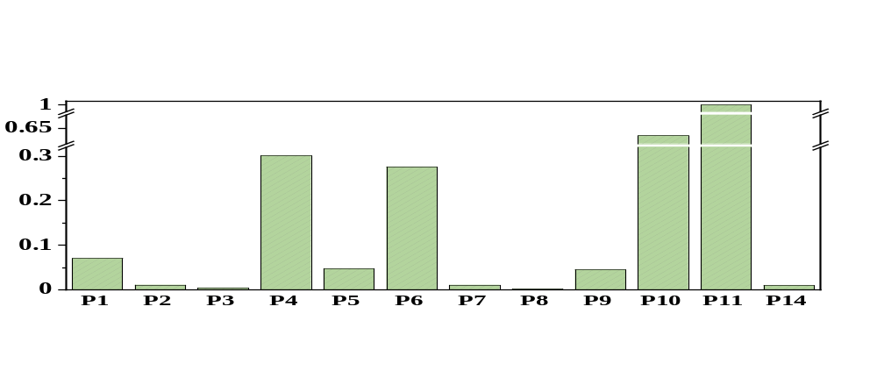
Fig. S9. The highest peak area of the identified intermediates in the PS/N-SWCNTs system. Note that the highest peak area (P11) is taken as 1 to calculate the relative yield of these 14 intermediates of BPS.

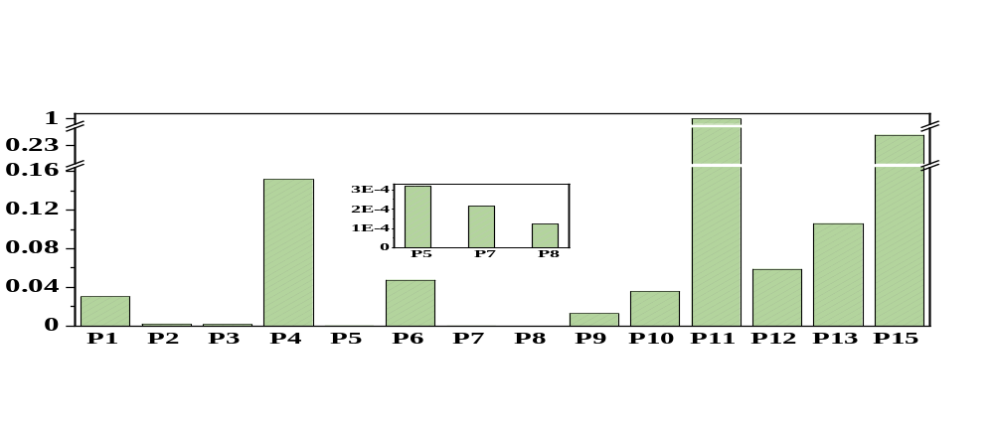
Fig. S10. The highest peak area of the identified intermediates in the PS-heat system. Note that the highest peak area (P11) is taken as 1 to calculate the relative yield of these 15 intermediates of BPS.

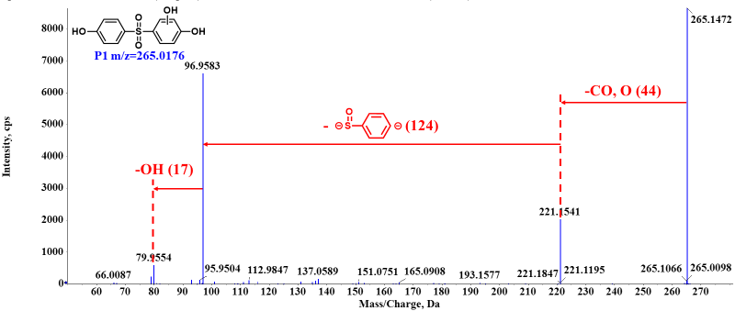
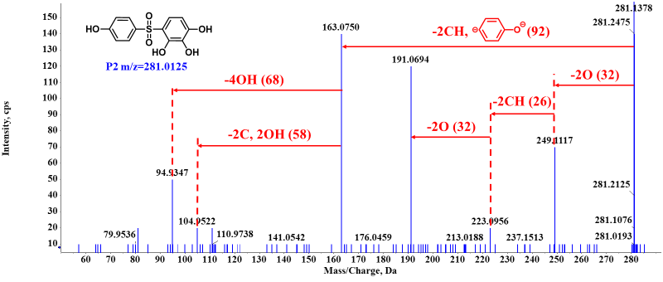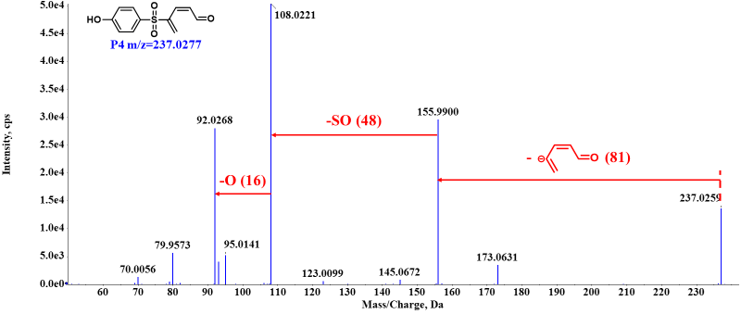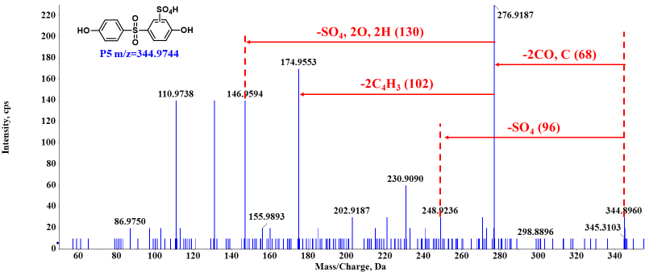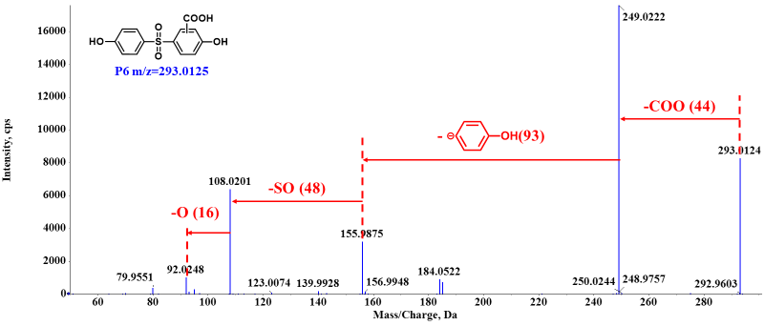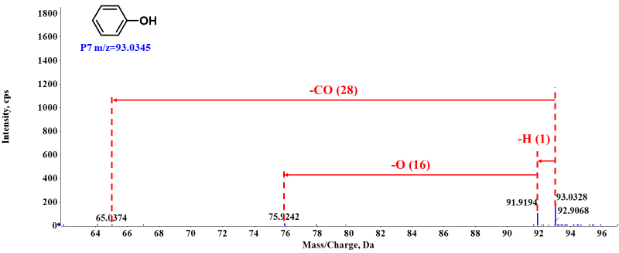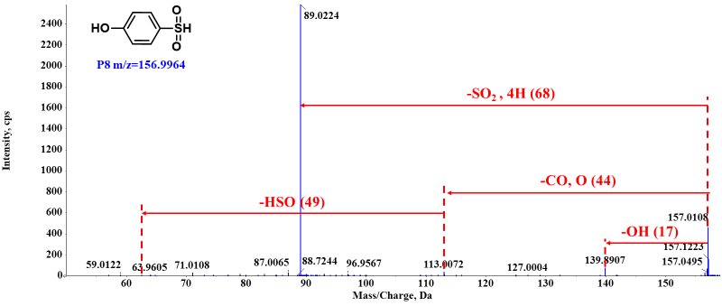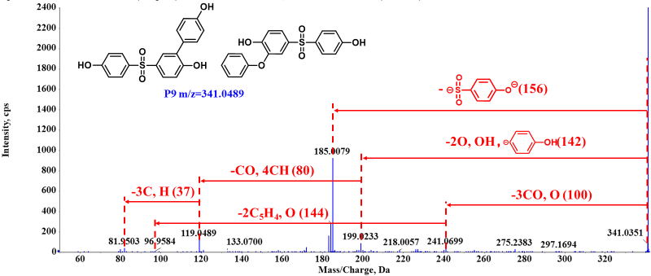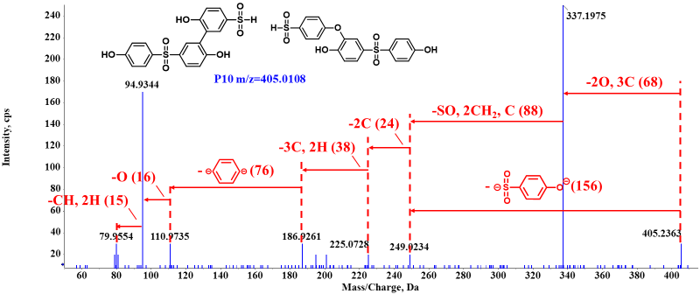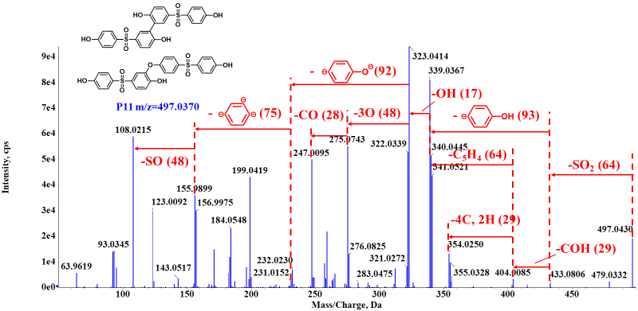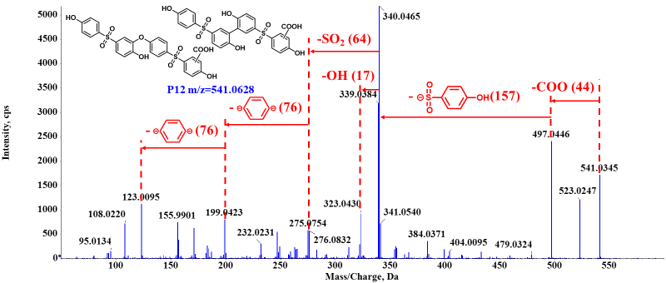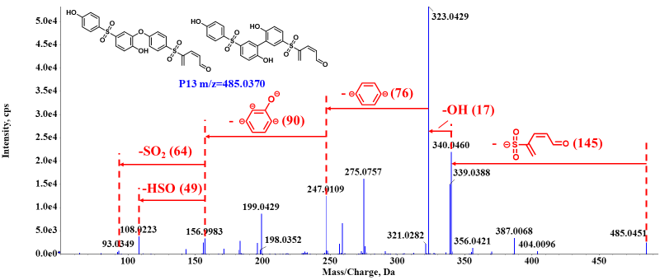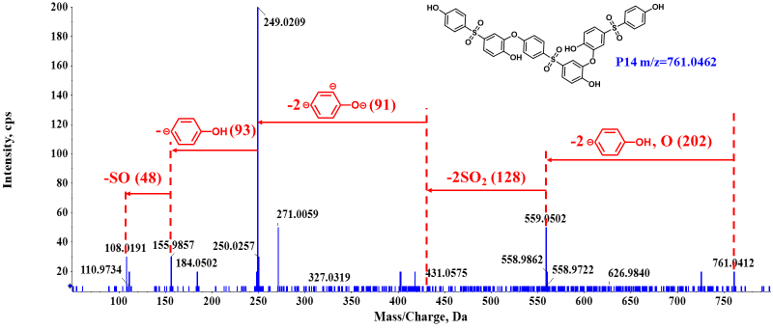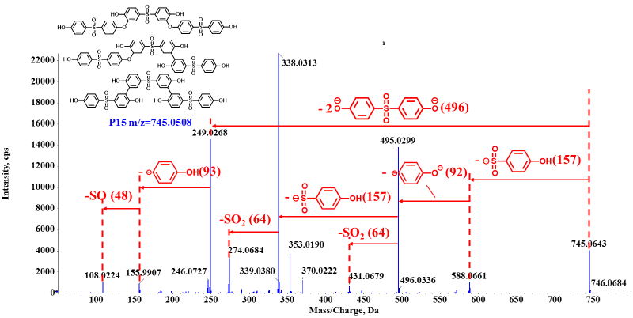
Fig. S11. The MS/MS spectra of 15 products in our two studied systems.

Table. S1. Technical data for nanocarbon-based materials.
Property | Purity | Outer Diameter | Length | Thickness
MWCNTs | >95 | 20-30 nm | 10-30 µm
SWCNTs | 90 | <2 nm | 5-15 µm
CNT-OH | >95 | 20-30 nm | 10-30 µm
GP | >98 |  |  | 6-8 nm
GO | >95 | 0.5-5 μm |  | 1-3 nm

Table. S2. Elemental composition of (N-)SWCNTs.
Samples | Atom Composition
Samples | C1s | N1s | O1s
SWCNTs | 97.89 | - | 2.11
N-SWCNTs | 96.25 | 1.16 | 2.58

Table. S3. Specific surface area of nanocarbon-based materials.
Samples | BET specific surface area (m²/g)
Samples | commercial | N doping
MWCNTs | 208.09 | 314.09
SWCNTs | 560.44 | 619.59
CNT-OH | 195.20 | 275.24
GO | 0.31 | 127.16
GP | 85.01 | 79.73

Table. S4. Water quality parameters of four water samples.*
Parameter | Unit | Tap water | River water | Secondary effluent
pH | -- | 6.95 | 7.47 | 7.27
TOC | mg/L | 3.15 | 19.98 | 22.08
Cl⁻ | mg/L | 14.27 | 42.15 | 269.63
NO₃⁻ | mg/L | 9.61 | 58.93 | 52.76
HCO₃⁻ | mg/L | ND | ND | ND
SO₄²⁻ | mg/L | 38.58 | 144.19 | 139.28
Na | mg/L | 4.79 | 8.12 | 60.41
Mg | mg/L | 5.14 | 7.60 | 17.44
K | mg/L | 2.44 | 4.67 | 11.52
Ca | mg/L | 3.04 | 6.29 | 4.91
* Total organic carbon (TOC) was measured by a TOC analyzer (Elementar, Germany). The concentrations of anions and metal ions were detected by ICS-5000 (Dionex, USA) and ICP-MS (NexION 300x, USA), respectively. ND: Not detected.

Table. S5. Mass measurements for the intermediates of BPS by LC-TOF-MS/MS analysis.
Compound | R_{t}/min | Molecular formula | Measured mass | Theoretical mass | Error/ppm
P1 | 5.962 | C₁₂H₁₀O₅S | 265.0180 | 265.0176 | -1.51
 | 7.018 | C₁₂H₁₀O₅S | 265.0184 | 265.0176 | -3.02
P2 | 7.035 | C₁₂H₁₀O₆S | 281.0127 | 281.0125 | -0.71
P3 | 5.972 | C₁₂H₈O₅S | 263.0017 | 263.0014 | -1.14
P4 | 5.671 | C₁₁H₁₀O₄S | 237.0229 | 237.0227 | -0.84
P5 | 6.038 | C₁₂H₁₀O₈S₂ | 344.9754 | 344.9744 | -2.90
P6 | 7.752 | C₁₃H₁₀O₆S | 293.0128 | 293.0125 | -1.02
P7 | 8.124 | C₆H₆O | 93.0339 | 93.0345 | 6.45
P8 | 1.669 | C₆H₆O₃S | 156.9965 | 156.9964 | -0.64
P9 | 9.148 | C₁₈H₁₄O₅S | 341.0494 | 341.0489 | -1.47
 | 9.86 | C₁₈H₁₄O₅S | 341.0495 | 341.0489 | -1.76
P10 | 7.932 | C₁₈H₁₄O₇S₂ | 405.0117 | 405.0108 | -2.22
 | 9.849 | C₁₈H₁₄O₇S₂ | 405.0116 | 405.0108 | -1.98
P11 | 8.367 | C₂₄H₁₈O₈S₂ | 497.0376 | 497.0370 | -1.21
 | 9.657 | C₂₄H₁₈O₈S₂ | 497.0375 | 497.0370 | -1.01
P12 | 10.204 | C₂₅H₁₈O₁₀S₂ | 541.0249 | 541.0268 | 3.51
 | 10.807 | C₂₅H₁₈O₁₀S₂ | 541.0248 | 541.0268 | 3.70
P13 | 8.622 | C₂₃H₁₈O₈S₂ | 485.0355 | 485.0370 | 3.09
 | 10.215 | C₂₃H₁₈O₈S₂ | 485.0359 | 485.0370 | 2.27
P14 | 9.443 | C₃₆H₂₆O₁₃S₃ | 761.0463 | 761.0462 | -0.13
P15 | 10.342 | C₃₆H₂₆O₁₂S₃ | 745.0473 | 745.0508 | 4.70
 | 10.555 | C₃₆H₂₆O₁₂S₃ | 745.0479 | 745.0508 | 3.89
 | 10.746 | C₃₆H₂₆O₁₂S₃ | 745.0475 | 745.0508 | 4.43

References
Cheng, X., Guo, H., Zhang, Y., Korshin, G.V., Yang, B., 2019. Insights into the mechanism of nonradical reactions of persulfate activated by carbon nanotubes: Activation performance and structure-function relationship. Water research 157, 406-414.
Cheng, X., Guo, H., Zhang, Y., Wu, X., Liu, Y., 2017. Non-photochemical production of singlet oxygen via activation of persulfate by carbon nanotubes. Water research 113, 80-88.
Duan, X., Ao, Z., Sun, H., Zhou, L., Wang, G., Wang, S., 2015a. Insights into N-doping in single-walled carbon nanotubes for enhanced activation of superoxides: a mechanistic study. Chemical Communications 51, 15249-15252.
Duan, X., Sun, H., Kang, J., Wang, Y., Indrawirawan, S., Wang, S., 2015b. Insights into Heterogeneous Catalysis of Persulfate Activation on Dimensional-Structured Nanocarbons. ACS Catalysis 5, 4629-4636.
Kang, J., Duan, X., Wang, C., Sun, H., Tan, X., Tade, M.O., Wang, S., 2018. Nitrogen-doped bamboo-like carbon nanotubes with Ni encapsulation for persulfate activation to remove emerging contaminants with excellent catalytic stability. Chemical Engineering Journal 332, 398-408.
Kong, X.-K., Chen, C.-L., Chen, Q.-W., 2014. Doped graphene for metal-free catalysis. Chemical Society Reviews 43, 2841-2857.
Lee, H., Lee, H.-J., Jeong, J., Lee, J., Park, N.-B., Lee, C., 2015. Activation of persulfates by carbon nanotubes: Oxidation of organic compounds by nonradical mechanism. Chemical Engineering Journal 266, 28-33.
Liu, H., Sun, P., Feng, M., Liu, H., Yang, S., Wang, L., Wang, Z., 2016. Nitrogen and sulfur co-doped CNT-COOH as an efficient metal-free catalyst for the degradation of UV filter BP-4 based on sulfate radicals. Applied Catalysis B: Environmental 187, 1-10.
Pan, X., Chen, J., Wu, N., Qi, Y., Xu, X., Ge, J., Wang, X., Li, C., Qu, R., Sharma, V.K., 2018. Degradation of aqueous 2, 4, 4′-Trihydroxybenzophenone by persulfate activated with nitrogen doped carbonaceous materials and the formation of dimer products. Water research 143, 176-187.
Pang, Y., Luo, K., Tang, L., Li, X., Song, Y., Li, C.-y., Wang, L.-p., 2018. Preparation and application of magnetic nitrogen-doped rGO for persulfate activation. Environmental Science and Pollution Research 25, 30575-30584.
Ren, W., Nie, G., Zhou, P., Zhang, H., Duan, X., Wang, S., 2020. The Intrinsic Nature of Persulfate Activation and N-Doping in Carbocatalysis. Environmental Science & Technology 54, 6438-6447.
Shao, P., Tian, J., Yang, F., Duan, X., Gao, S., Shi, W., Luo, X., Cui, F., Luo, S., Wang, S., 2018. Identification and regulation of active sites on nanodiamonds: establishing a highly efficient catalytic system for oxidation of organic contaminants. Advanced functional materials 28, 1705295.
Timmins, G.S., Liu, K.J., Bechara, E.J.H., Kotake, Y., Swartz, H.M., 1999. Trapping of free radicals with direct in vivo EPR detection: a comparison of 5,5-dimethyl-1-pyrroline-N-oxide and 5-diethoxyphosphoryl-5-methyl-1-pyrroline-N-oxide as spin traps for HO and SO4•−. Free Radical Biology and Medicine 27, 329-333.
Wang, X., Qin, Y., Zhu, L., Tang, H., 2015. Nitrogen-doped reduced graphene oxide as a bifunctional material for removing bisphenols: synergistic effect between adsorption and catalysis. Environmental science & technology 49, 6855-6864.
Yu, J., Tang, L., Pang, Y., Zeng, G., Wang, J., Deng, Y., Liu, Y., Feng, H., Chen, S., Ren, X., 2019. Magnetic nitrogen-doped sludge-derived biochar catalysts for persulfate activation: Internal electron transfer mechanism. Chemical Engineering Journal 364, 146-159.
Zhang, J., Su, D.S., Blume, R., Schlögl, R., Wang, R., Yang, X., Gajović, A., 2010. Surface chemistry and catalytic reactivity of a nanodiamond in the steam‐free dehydrogenation of ethylbenzene. Angewandte Chemie 122, 8822-8826.

