2.2.1 PM_{2.5}, BC and Elements
Table S1. The reference, measurement concentrations and Detection limitation of standard samples
elements（chemical compound/(ng/cm²) | reference concentration/(ng/cm²) | measurement concentration/(ng/cm²) | Detection limitation/(ng/cm²)
M(MgF₂) | 19624 | 18466 | 25.5
Al | 23100 | 23953 | 21.9
Si(SiO) | 9557 | 9676 | 19.9
S(CuS) | 12700 | 11809 | 24.2
Cl(KCl) | 8464 | 8023 | 23.1
K(KCl) | 9336 | 9415 | 17.8
Ca(CaF₂) | 9240 | 9335 | 10.6
Ti | 45500 | 44855 | 7
Mn | 24300 | 23931 | 5.2
Fe | 19100 | 19269 | 5
Cu(CuS) | 38600 | 32596 | 11.1
Zn(ZnTe) | 15826 | 14529 | 10.5
Br(CsBr) | 18098 | 20931 | 11
Cr | 18400 | 16883 | 57.7
Pb | 50600 | 45382 | 113

3.2 Common elements
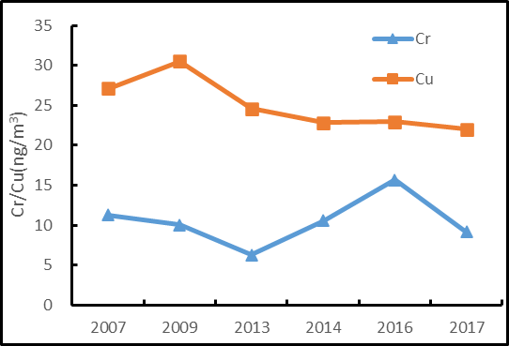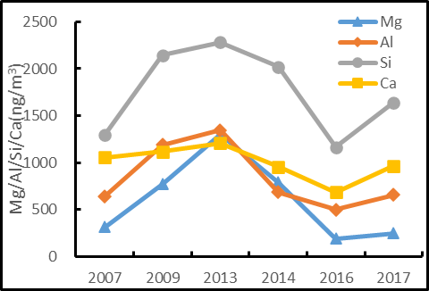
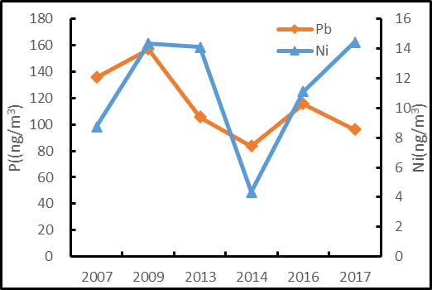
Figure S1. The concentration temporal trends of Cr, Cu, Pb, Ni and soil elements.

3.2 Element In
Only Element In were considered among the samples from 2017.1 to 2018.6, because some samples had been analyzed by PIXE, and some representative membranes, e.g. the samples collected from pollution days, were re-analyzed by NAA. There was no good time continuity. In addition, NAA is significantly sensitive for element In, therefore, this element was only discussed in the part.

Table S2 Parameters of NAA
NAA(short-irradiation)
Analysis equipment | CMRR*,CAEP*
Neutron Flux | 7.8×10¹³ n.cm⁻²·s⁻¹
Comparator, F | Fe, Zr
Monitor | Mn
Detector | HPGe*
Certified reference materials | NIST SRM 2703 (sediment,5 mg)
Analysis software | ADVNAA(Ni, et al., 2000)
Measured elements | Ba, Ti, I, Br, Mn, Mg, Cu, In, Na, V, K, Cl, Al, Ca and S
Note:
More details of parameters can refer to Yang, et al.(2019)
CMRR*:China Mianyang Research Reactor
CAEP*:China Academy of Engineering Physics
HPGe*: High Purity Germanium gamma detector, the energy resolution to ⁶⁰Co(1332.5 keV) of 1.75 keV, the relative efficiency of 48%.

3.3 Source apportionment
Table.S3. The statistics of elements in PM_{2.5} in 2007 and 2016 to 2017

 | 2007 |  |  |  |  | 2016-2017
Species | Max | Min | Mean | S/N |  | Max | Min | Mean | S.D. | S/N
Mg | 1749 | 101 | 373 | 2.3 |  | 579 | 28.2 | 222 | 115 | 5.3
Al | 5144 | 137 | 1083 | 9.2 |  | 1581 | 71.1 | 594 | 338 | 9.3
Si | 12480 | 254 | 2236 | 10 |  | 4086 | 171 | 1449 | 898 | 10
S | 15243 | 77.2 | 3912 | 9.8 |  | 9856 | 330 | 2425 | 2267 | 10
Cl | 2753 | 100 | 757 | 8.7 |  | 5361 | 32.7 | 1475 | 1074 | 6.1
K | 4067 | 30.6 | 1304 | 9.8 |  | 1470 | 158 | 570 | 280 | 9.8
Ca | 4389 | 158 | 1311 | 10 |  | 2491 | 188 | 833 | 470 | 10
Ti | 378 | 3.45 | 62.6 | 2.9 |  | 105 | 2.79 | 42.1 | 23.9 | 3.7
Cr | 51.3 | 2.04 | 11.1 | 0.1 |  | 34.5 | 1.56 | 11.7 | 7.46 | 0.2
Mn | 202 | 2.28 | 52.5 | 2.6 |  | 63.2 | 2.73 | 25.0 | 12.7 | 1.9
Fe | 3062 | 70.4 | 849 | 10 |  | 1324 | 181 | 588 | 261 | 10
Cu | 176 | 5.28 | 25.3 | 0.6 |  | 88.2 | 3.92 | 20.2 | 15.0 | 0.7
Zn | 945 | 6.06 | 206 | 6.6 |  | 781 | 0.93 | 238 | 195 | 7.1
Br | 86.0 | 14.4 | 28.1 | 0.4 |  | 116 | 21.8 | 57.7 | 15.7 | 0.8
Pb | 436 | 27.9 | 104 | 0.4 |  | 308 | 31.4 | 99.5 | 46.4 | 0.4
BC | 12451 | 417 | 5244 | 6.3 |  | 12324 | 504 | 4219 | 2379 | 7.4
*Note: unit: ng/m³

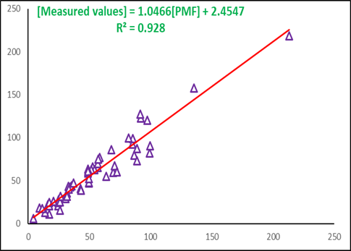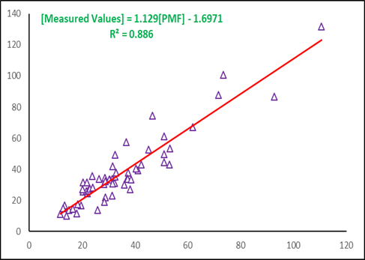
(a) (b)
Figure S2. Correlation between measured valued and PMF predicted: (a)2007 (b)2016-2017

Reference
Ni B F, et al., 2000. Automation and Computerrization of NAA. Journal of Radioanalytical Nuclear Chemistry. 244: 665~668
Yang J. K., Liu G. P., Yao Y.G., Xiao, C. J., Lin, Q. C., Tang, C. J., Wang, P. S., Jin, X. C., Ni, B. F., Cui, D. Q., 2019. Elemental analysis of PM2.5 using PIXE and NAA in Xinzhen, Beijing[J]. Journal of Radioanalytical and Nuclear Chemistry, 323(11).

