The prognostic models for predicting overall survival and cancer-specific mortality in Hepatocellular Carcinoma: a competing risk analysis
Kongying Lin^{1*}, Qizhen Huang^{2*}, Zongren Ding^{1*}, Yongyi Zeng¹†, Jingfeng Liu^{1,3}†

Table S1: Crude cumulative incidence of cancer-specific mortality estimated by CIF and Kaplan-Meier.
 | 1 year | 3 year | 5 year | 10 year
Entire set
CIF | 36.2% | 56.7% | 63.8% | 69.0%
Kaplan-Meier function | 37.2% | 60.2% | 68.9% | 76.0%
Training set
CIF | 36.2% | 56.6% | 63.9% | 69.1%
Kaplan-Meier function | 37.2% | 60.2% | 69.1% | 76.2%
Validation set
CIF | 36.4% | 56.7% | 63.5% | 68.6%
Kaplan-Meier function | 37.4% | 60.2% | 68.4% | 75.5%
CIF，Cumulative incidence function

Table S2：C-indexes of the predictive model for patients
 | Training set |  |  |  |  | Validation set |  |  |  |  | Whole set#
 | 1-year | 3-year | 5-year | 10-year |  | 1-year | 3-year | 5-year | 10-year |  | 1-year | 3-year | 5-year | 10-year
Overall survival | 0.768 | 0.745 | 0.74 | 0.736 |  | 0.764 | 0.743 | 0.74 | 0.735 |  | 0.764 | 0.742 | 0.738 | 0.734
Cancer-specific mortality
Fine and Gray regression model | 0.781 | 0.749 | 0.74 | 0.733 |  | 0.784 | 0.754 | 0.746 | 0.737 |  | 0.781 | 0.750 | 0.741 | 0.733
Traditional cox regression model | 0.783 | 0.758 | 0.753 | 0.75 |  | 0.78 | 0.759 | 0.754 | 0.75 |  | 0.779 | 0.755 | 0.751 | 0.747
# Adjusted C-indexes was calculated by ten-fold cross validation in the whole set.

Table S3. Uni- and Multivariate analysis for CSM by traditional Cox regression.
Characteristics | Univariate |  |  | Multivariate
Characteristics | HR (95% CI) | P-value |  | HR (95% CI) | P-value
Age, years
≤60 |  | Ref |  |  | Ref
61-65 | 1.004(0.959-1.051) | 0.872 |  | 0.982(0.938-1.028) | 0.443
66-70 | 1.114(1.058-1.173) | <0.001 |  | 1.095(1.04-1.154) | 0.001
71-75 | 1.308(1.237-1.383) | <0.001 |  | 1.143(1.08-1.209) | <0.001
76-80 | 1.481(1.392-1.576) | <0.001 |  | 1.208(1.134-1.286) | <0.001
81-85 | 1.698(1.574-1.832) | <0.001 |  | 1.22(1.129-1.319) | <0.001
>85 | 2.056(1.85-2.284) | <0.001 |  | 1.222(1.098-1.36) | <0.001
Race
White |  | Ref |  |  | Ref
Back | 1.188(1.134-1.245) | <0.001 |  | 1.028(0.98-1.078) | 0.255
Others | 0.876(0.84-0.915) | <0.001 |  | 0.863(0.826-0.902) | <0.001
Sex
Female |  | Ref |  |  | Ref
Male | 1.121(1.078-1.165) | <0.001 |  | 1.079(1.036-1.123) | <0.001
Marital status
Unmarried |  | Ref |  |  | Ref
Married | 0.817(0.791-0.844) | <0.001 |  | 0.93(0.899-0.962) | <0.001
Surgical therapy
No surgery |  | Ref |  |  | Ref
Local tumor destruction | 0.399(0.378-0.421) | <0.001 |  | 0.52(0.492-0.55) | <0.001
Resection | 0.317(0.299-0.337) | <0.001 |  | 0.257(0.241-0.274) | <0.001
Transplant | 0.086(0.077-0.097) | <0.001 |  | 0.115(0.102-0.13) | <0.001
Chemotherapy
No |  | Ref |  |  | Ref
Yes | 0.951(0.921-0.982) | 0.002 |  | 0.634(0.613-0.656) | <0.001
Radiotherapy
No |  | Ref |  |  | Ref
Yes | 1.42(1.342-1.502) | <0.001 |  | 0.795(0.751-0.842) | <0.001
Tumor diameter, cm
≤3 |  | Ref |  |  | Ref
3-5 | 1.671(1.594-1.752) | <0.001 |  | 1.519(1.448-1.594) | <0.001
5-10 | 2.946(2.82-3.078) | <0.001 |  | 1.902(1.805-2.005) | <0.001
>10 | 4.192(3.982-4.415) | <0.001 |  | 2.577(2.425-2.739) | <0.001
AJCC staging system
I |  | Ref |  |  | Ref
II | 1.194(1.141-1.25) | <0.001 |  | 1.413(1.348-1.481) | <0.001
III | 3.156(3.029-3.289) | <0.001 |  | 2.051(1.956-2.151) | <0.001
IV | 5.511(5.239-5.796) | <0.001 |  | 3.317(3.139-3.505) | <0.001
Abbreviations: AJCC, American Joint Committee on Cancer; CSM, cancer-specific mortality; HR, hazard ratio; CI, confidence interval;

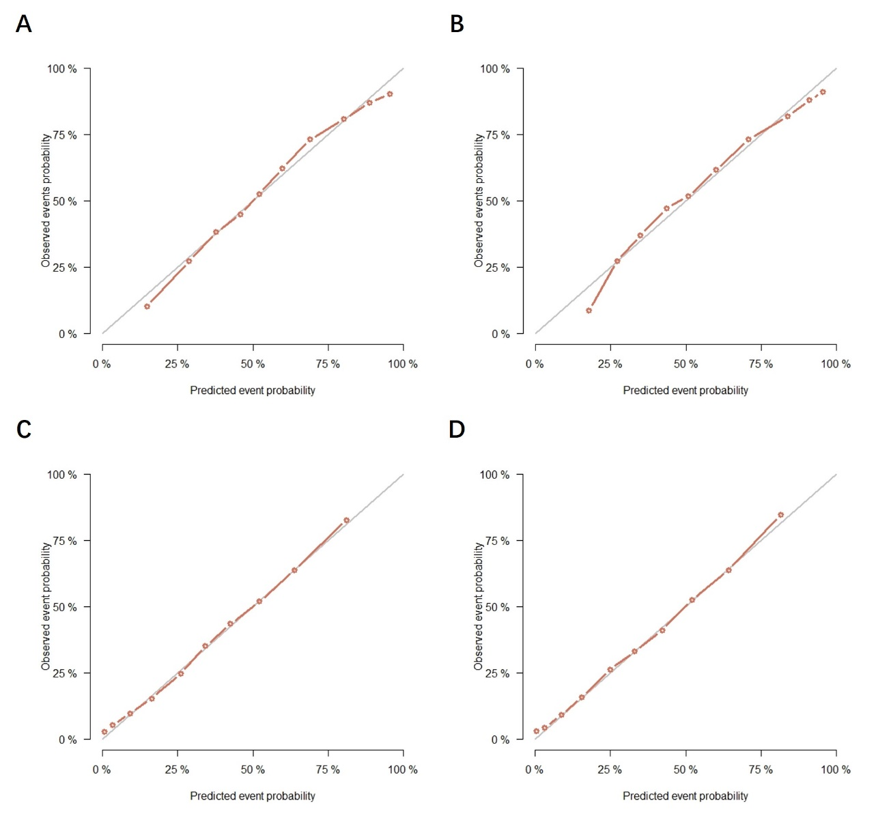
Figure S1. The calibration curves for predicting the 3-year CSM and OS in the training and validation sets. (A) CSM, training set; (B) CSM, validation set; (C) OS, training set; (D) OS, validation set.
CSM, cancer-specific mortality; OS, overall survival.
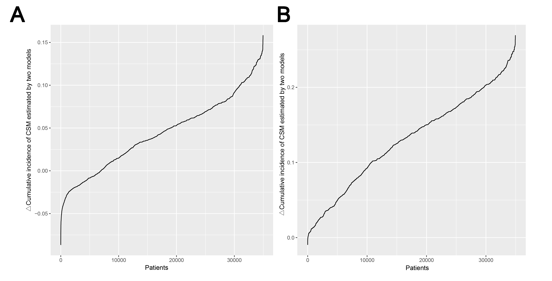
Figure S2. Difference of cumulative incidence of CSM predicted by the competing risk model and tradition Cox regression model. A. 3 year; B, 5 year. X-axis represent the patient, and the Y-axis means the difference of predicted cumulative incidence of CSM (Cox regression model minus Fine-Gray competing risk model)
CSM, cancer-specific mortality.

