Prognostic models for predicting overall and cancer-specific survival in hepatocellular carcinoma: A competing risk analysis
Kongying Lin^{1*}, Qizhen Huang^{2*}, Zongren Ding^{1*}, Yongyi Zeng¹†, Jingfeng Liu^{1,3}†

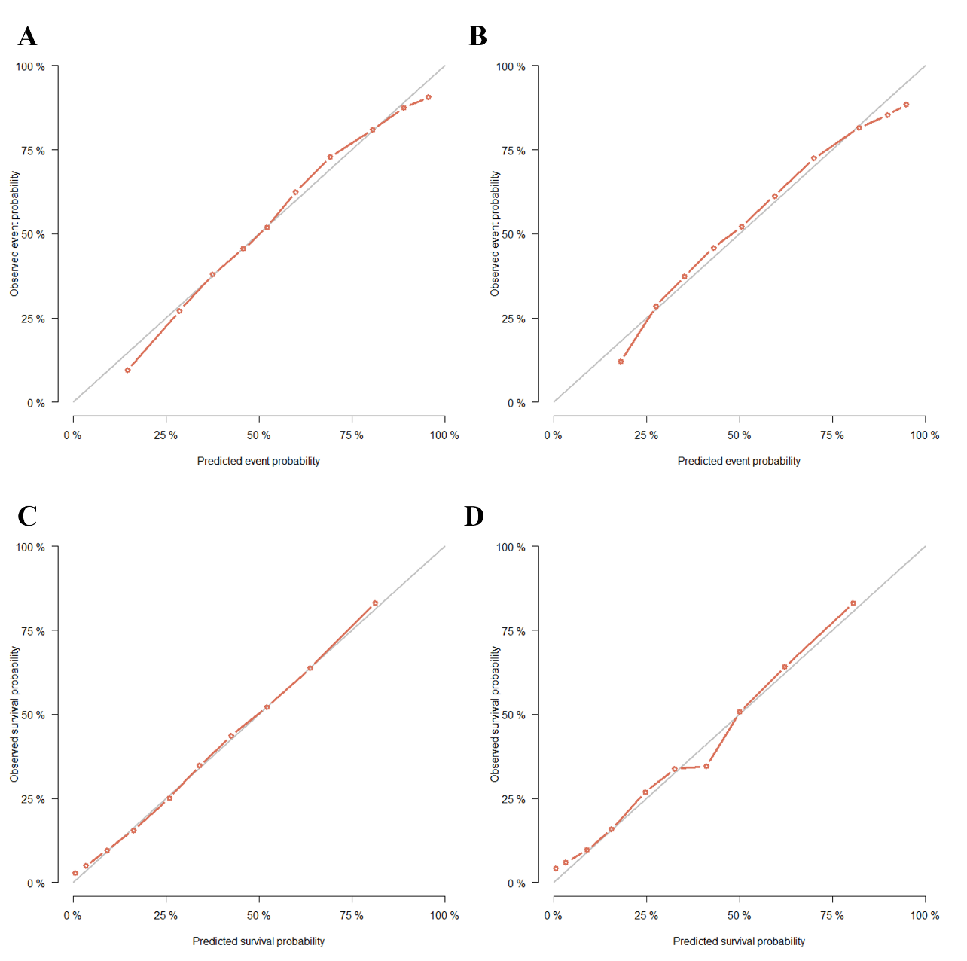
Figure S1. The calibration curves for predicting the 3-year CSS and OS in the training and validation sets. (A) CSS, training set; (B) CSS, validation set; (C) OS, training set; (D) OS, validation set.

CSS, cancer-specific survival; OS, overall survival.

