Supplemental Material
A Multi-modal Computational Fluid Dynamics Model of Left Atrial Fibrillation Haemodynamics Validated with 4D flow MRI
Louis Parker PhD^{1,2,3}, Emilie Bollache PhD^{1,2}, Shannon Soulez MS^{1,2}, Khaoula Bouazizi PhD^{1,2}, Nicolas Badenco MD^{2,4}, Daniel Giese⁵, Estelle Gandjbakhch MD PhD^{2,4}, Alban Redheuil MD, PhD^{1,2,6}, Mikael Laredo MD PhD^{1,2,4}, Nadjia Kachenoura PhD^{1,2}.

- Laboratoire d’Imagerie Biomédicale (LIB), Sorbonne Université, Institut National de la Recherche Médicale (INSERM), Centre National de la Recherche Scientifique (CNRS), Paris, France.
- ICAN Imaging, Institute of Cardiometabolism and Nutrition (ICAN), Paris, France.
- School of Engineering, University of Western Australia, Perth, Australia.
- Unité de Rythmologie, Institut de Cardiologie, Sorbonne Université, AP-HP, Hôpital Universitaire Pitié-Salpêtrière, Paris, France.
- Magnetic Resonance, Siemens Healthineers AG, Erlangen, Germany.
- Unité d’Imagerie Cardiovasculaire et Thoracique (ICT), Pitié-Salpêtrière Hospital, Paris, France.

Corresponding Author: Dr. Nadjia Kachenoura
Email: nadjia.kachenoura@inserm.fr

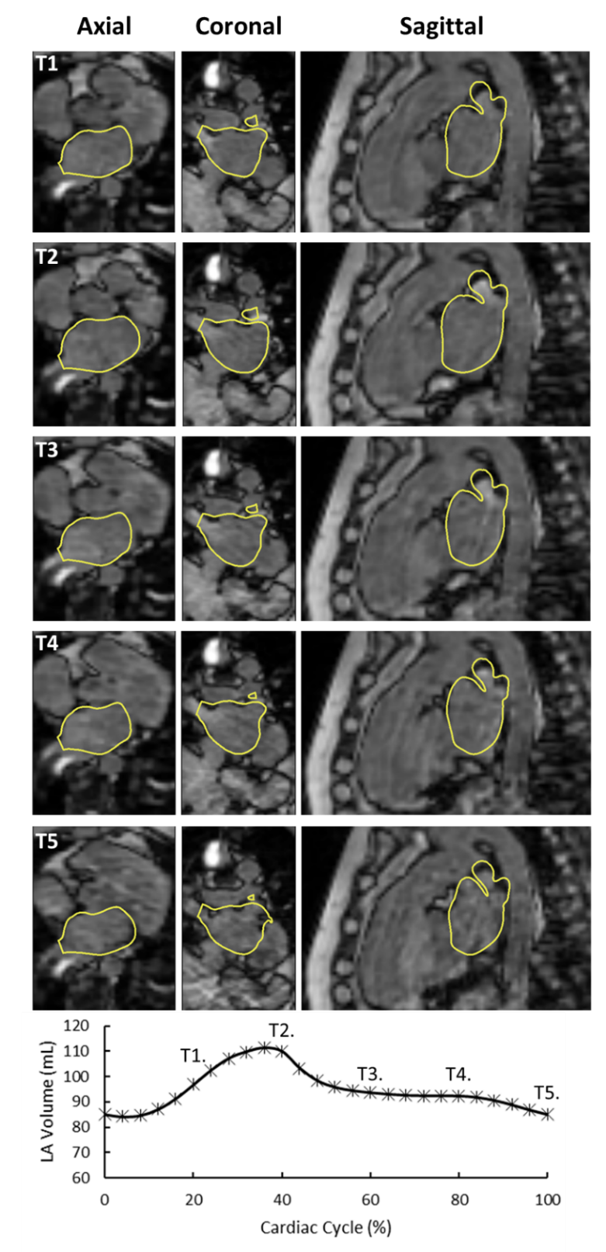
Figure S1. An example of the MRI-derived motion applied to the CT reconstruction. The left atrium (LA) CT reconstruction (Case 1) (yellow outline) shown on 5 phases of the transient 4D flow MRI magnitude images after CT/MRI sequence time-resolved registration (upper rows). Temporal positions (T1-T5) in the cardiac cycle are indicated on a plot of LA volume (bottom row).
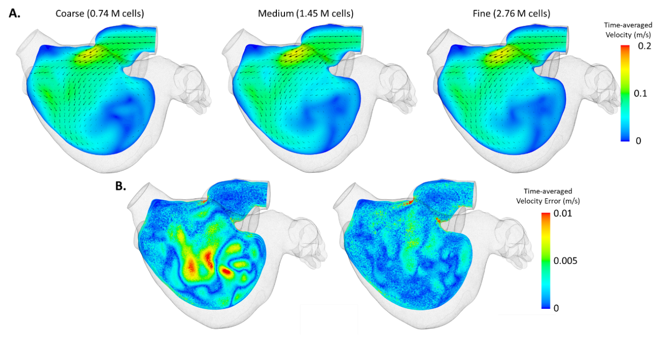
Figure S2. A. Time-average velocity across the coarse, medium and fine meshes analysed in the grid convergence study (Case 1). B. The absolute error between the coarse/medium velocities (left) and medium/fine velocities (right).
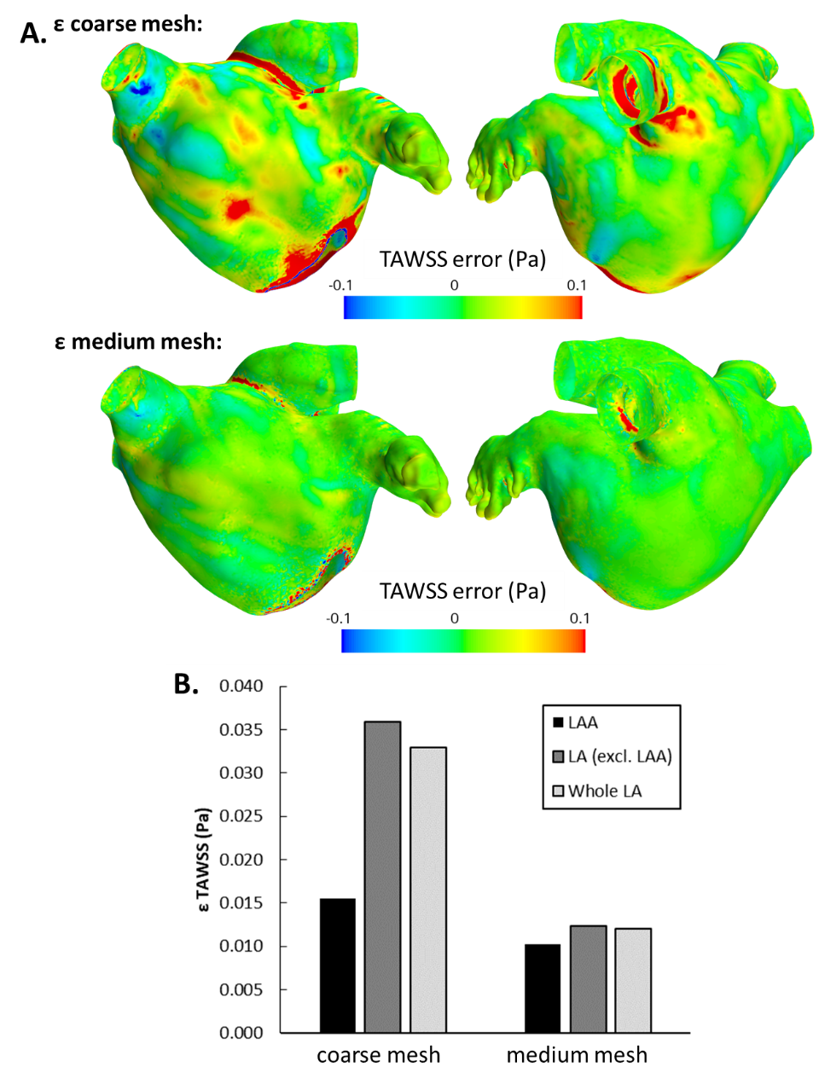
Figure S3. A. (Top) Time-averaged wall shear stress (TAWSS) error (εTAWSS) comparing the coarse (0.74M) and fine (2.76M) meshes. (Bottom) TAWSS error comparing the medium (1.45M) and fine (2.76M) meshes. B. Absolute TAWSS error for comparisons of coarse and medium meshes against the fine mesh, averaged over the left atrial appendage (LAA), left atrium (LA) and the entire LA surface (including LA and LAA).

Figure S4. The relationship between left atrial appendage (LAA) orifice area and time-averaged wall shear stress (TAWSS), averaged over the LAA surface.

Table S1. Mitral valve flow E and A wave amplitudes for cases 1 to 5 obtained from the rigid CFD model, morphing CFD model and 4 flow MRI measurements.
 |  |  | Amplitude (mL/s)
 |  | 1 |  | 2 | 3 | 4 | 5 |  | Mean |  | SD
Rigid | E wave | 139.2 |  | 125.3 | 112.9 | 143.9 | 142.5 |  | 132.8 |  | 11.9
Rigid | A wave | 101.8 |  | 104.4 | 91.2 | 141.3 | 135.2 |  | 114.8 |  | 19.8
Morphing | E wave | 159.0 |  | 231.1 | 174.7 | 258.2 | 208.2 |  | 206.2 |  | 36.2
Morphing | A wave | 45.1 |  | 124.2 | 98.5 | 73.6 | 166.7 |  | 101.6 |  | 41.8
4D flow | E wave | 225.3 |  | 320.6 | 244.3 | 273.3 | 173.5 |  | 247.4 |  | 49.0
4D flow | A wave | 186.1 |  | 179.9 | 170.2 | 267.4 | 210.9 |  | 202.9 |  | 35.0

