Figure1s: Normal Q-Q plot of standardized residuals for admission numbers

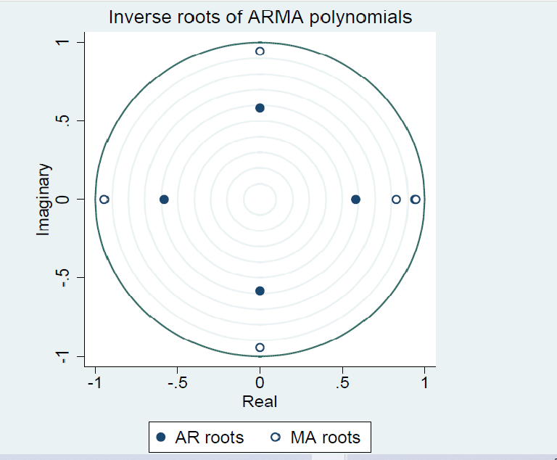

Figure2s: Eigenvalue stability test on Admission number time series

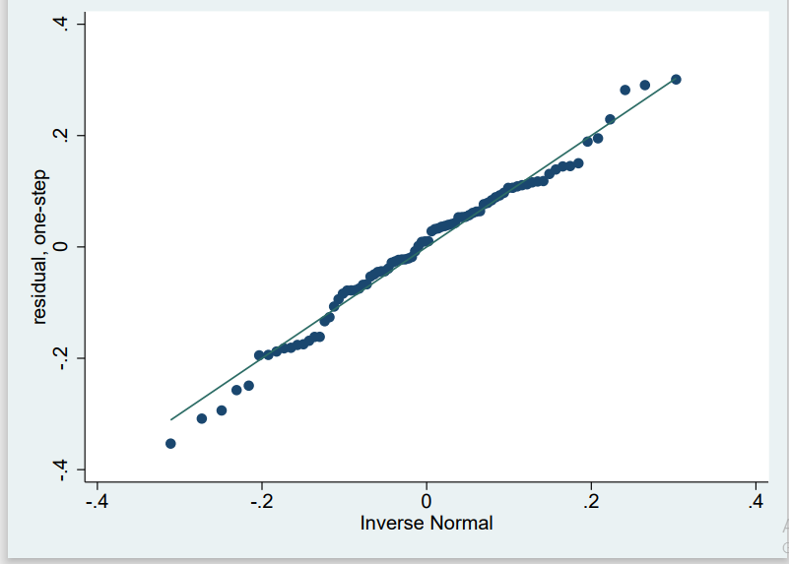

Figure 3s: Normal Q-Q plot of standardized residuals for long stay at hospital

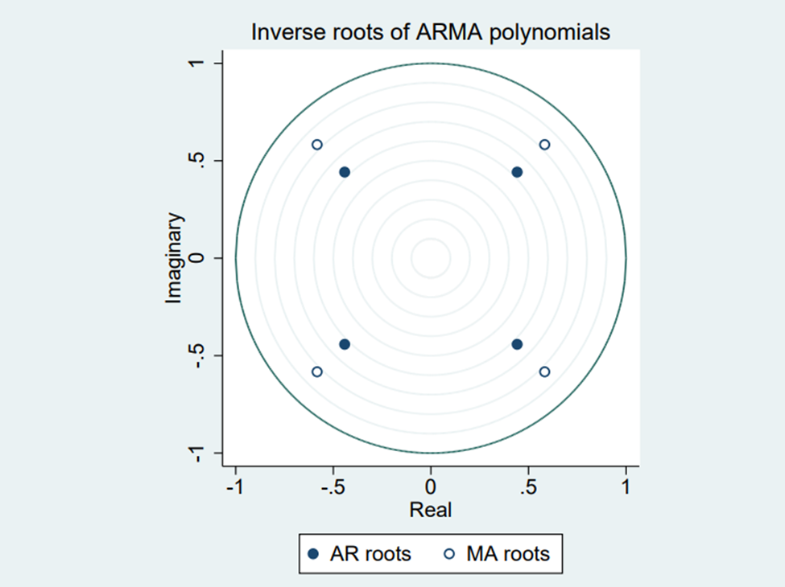

Figure4s: Eigenvalue stability test on long stay at home time series

Figure5s: Normal Q-Q plot of standardized residuals for mortality proportion time series

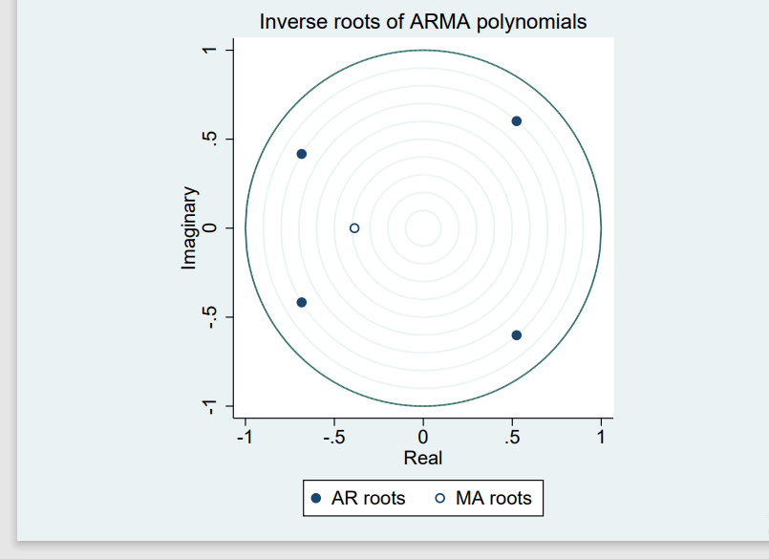
Figure 6s: Eigenvalue stability test mortality proportion time series

