Supplementary Information
S1. Further experimental details
Fig. S1 shows the raw OAM-EELS experimental measurement after background subtraction and extracted OAM profiles at $E=191$ and $198$eV, slightly above the onsets of the π* and σ* components, respectively. The σ* profile is broadened with respect to the π* profile due to the $l=+1$ and $-1$ contributions.
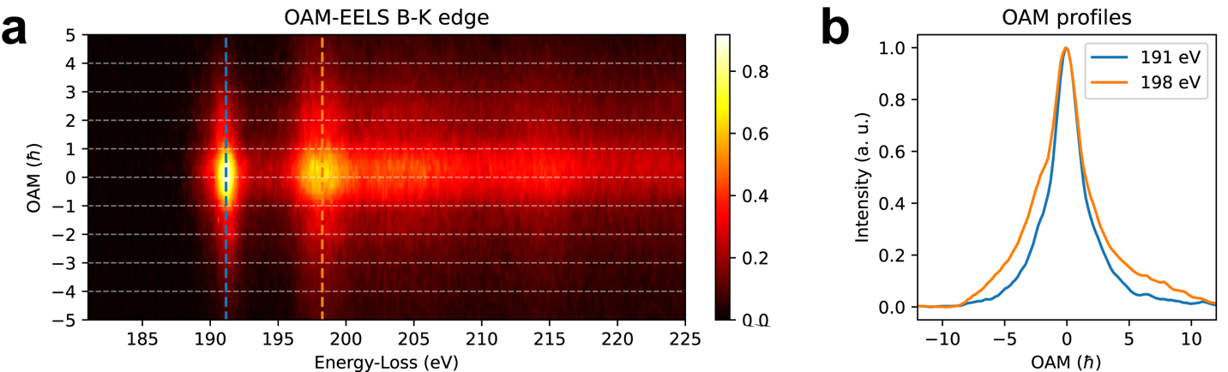
Figure S1. a) Raw 2D OAM-EELS experimental measurement after background subtraction. b) Measured OAM profiles extracted slightly above the energy onsets of the π* and σ* components in a).
In order to confirm the ability to map OAM features, Fig. S2 shows results obtained from an edge region of h-BN in scanning mode. The $15×11$ EELS dataset was processed using a k-means clustering algorithm by selecting subsets of points in the OAM domain. Two regions were identified, corresponding to the bulk and the edge of the sample, with slightly different OAM profiles. Increased OAM broadening in the edge region may result from the presence of defects or from folding (i.e., misorientation) of the sample edge. The results confirm the reliability of decomposition into π* and σ* components, as shown in Fig. S3.
The NMF-extracted components have the physical behavior that is expected from OAM decomposition (see Fig. 2 in the main text). There is a dominant component centered on $l=0$, which results from the limited resolution of the device, as discussed in the main text. The second component, which is centered on $l=0$, has the typical features of the π* unoccupied density of states (in particular the first peak at the onset). This spectrum is associated with a transition from 1s to 2p_{z} empty states. The last component does not show the first intense peak in energy (belonging to π*). It has an onset at 194 eV and features typical of a transition from 1s to sp₂ empty states, resulting from hybridization of 2s and p_{x}, p_{y} states (σ*). The OAM profile has a well-defined minimum at $l=0$, as expected from orthogonality of the sp₂ and p_{z} states. The OAM associated with these transitions is expected to be -1 and 1, based on the symmetry of the orbitals. An onset in the OAM profile intensities is visible at these values in Fig. 2b.

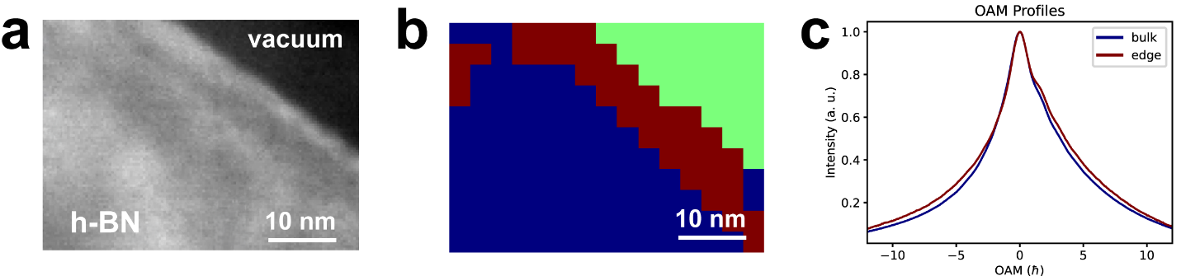
Figure S2. a) Annular dark-field image recorded from the investigated h-BN edge region. b) k-means clustering of the OAM-EELS dataset from the region shown in a). c) Resulting OAM profiles from the blue region in b) (blue) and the edge region in b) (brown).
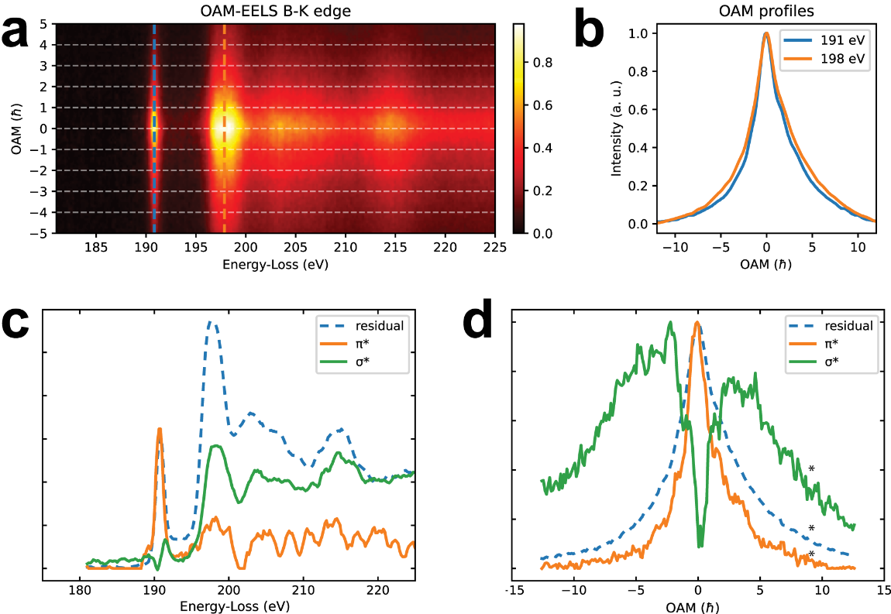
Figure S3. a) Average OAM-EELS measurement from the blue region in Fig. S2. b) Measured OAM profiles extracted slightly above the energy onsets of the π* and σ* components in a). c) Extracted energy components after NMF analysis. d) Corresponding OAM profiles. The extracted hybridized σ* and π* states are the green and orange curves, respectively. The asterisk marks the position of a residual noise spike that was removed manually.

S2. Mixed dynamic form factor approximation
On the assumption that the electron is initially in a pure state described by the density matrix $ρ_{0}\left(k_{i},k_{i}\right)=|ψ_{p}><ψ_{p}|$) and that a single scattering event occurs on a single atom, the final electron subsystem can be described by a reduced density matrix $ρ$ [32] in the form
$ρ(k_{f},{k'}_{f})=\frac{S\left(\overline{Q},{\overline{Q}}^{'},ω\right)}{Q^{2}{Q^{'}}^{2}}*ρ_{0}(k_{i},{k'}_{i})$ ,
where $Q=(\overline{k_{f}}-\overline{k_{i}},q_{E})$ and $Q'=(\overline{k_{f}}'-\overline{k_{i}'},q_{E}')$ are 3D vectors and account for kinematical effects of the exchange of momentum $\overline{k_{f}},\overline{k_{i}}$ and energy through $q_{E}=E/(ℏv)$, $E$ is the energy loss, $v$ is the electron velocity, $ℏ$ is the reduced Planck constant and$q_{E}$ is related to the characteristic scattering angle by the relation $q_{E}={2πθ}_{E}/λ$, where $λ$ is the electron wavelength, such that $θ_{E}=\frac{E}{2E_{0}}$ where $E_{0}$ is the electron beam energy. The symbol $*$ indicates convolution in reciprocal space and all of the atomic details are included in the mixed dynamic form factor $S\left(\overline{Q},{\overline{Q}}^{'},ω\right)$.
The $1/Q^{2}$ dependence adds a Lorentzian-like envelope to the dependence on exchanged momentum $\overline{q}=\overline{k_{f}}-\overline{k_{i}}$, which concentrates the scattering angle within $θ_{E}$. A crude dipole approximation in highly symmetrical systems involves writing $S\left(\overline{Q},{\overline{Q}}^{'},ω\right)≈a\overline{Q}∙{\overline{Q}}^{'}+b$ [33] in the form
$\frac{S\left(\overline{Q},{\overline{Q}}^{'},ω\right)}{Q^{2}{Q^{'}}^{2}}=\frac{a\overline{q}∙\overline{q^{'}}+c}{{(q}^{2}+{q_{E}}^{2}){(q'}^{2}+{{q'}_{E}}^{2})} =\frac{aqq^{'}\cos\left(Δϕ\right)+c}{{(q}^{2}+{q_{E}}^{2}){(q^{'}'}^{2}+{{q^{'}}_{E}}^{2})}=\frac{a qq^{'}exp(iϕ)exp(-iϕ')}{{2(q}^{2}+{q_{E}}^{2}){(q'}^{2}+{{q'}_{E}}^{2})}+\frac{a qq^{'}exp(-iϕ)exp(iϕ')}{{2(q}^{2}+{q_{E}}^{2}){(q'}^{2}+{{q'}_{E}}^{2})}+\frac{c}{{(q}^{2}+{q_{E}}^{2}){(q'}^{2}+{{q'}_{E}}^{2})}$ ,
where a and b depend on energy and $c=aq_{E}{q'}_{E}+b$. The Fourier transform provides the MDFF in direct space. For this calculation, it is convenient to Fourier transform each term separately.
In many cases, we measure only OAM and the relative coherence of these terms is less important, but can be considered anyway. We then Fourier transform the two factorized functions in the q, q’ variables. The problem becomes one of finding the inverse Fourier transform of the function
$g\left(\overline{q}\right)=\frac{a q^{n}exp(inϕ)}{q^{2}+{q_{E}}^{2}}$ .
The inverse Fourier transform with respect to separate terms is based on a 0th and 1st order Hankel transform trough the formulae
$H_{0}\left\{\frac{c}{q^{2}+{q_{E}}^{2}}\right\}={cK}_{0}(q_{E}r)$,
$H_{1}\left\{\frac{a q}{q^{2}+{q_{E}}^{2}}\right\}={aq_{E}K}_{1}(q_{E}r)$.
Both modified Bessel functions of the second kind can be approximated for large r by
$K\left(x\right)∝\frac{1}{\sqrt{x}}exp⁡(-x)$.
The three terms then give rise to a real space distribution of the form
$f_{a,m}\left(\overline{r}\right)≈\frac{exp⁡(i{mϕ}_{a})\exp\left(-\left|\overline{r}-{\overline{r}}_{a}\right|/d\right)}{\sqrt{\left|\overline{r}-{\overline{r}}_{a}\right|}}$ ,
where $m=0,+1,-1$. In this way, the Bessel function description has been retained. It should be noted that the function $K_{n}(q_{E}r)$ is divergent at $r=0$, due to the limits of the approximations for S, especially with regard to not considering the radial degrees of freedom. A common but still approximate way to account for these limits is to impose a cutoff at $|{∆\overline{r}}_{c}|=\frac{λ}{2π\sqrt{{2θ}_{E}}}$ . For the case |m|=1, we added a linear increase in amplitude of the form $f_{a,m}\left(\overline{r}\right)≈\frac{r}{|{∆\overline{r}}_{c}|}$ for r<$|{∆\overline{r}}_{c}|$.
The use of an incoherent Monte-Carlo calculation is justified by the assumption of independent atomic scattering. In this approximation, the density matrix of the system is an incoherent average of the density matrix of scattering at each atom, in the form
$ρ_{TOT}\left(k_{f},{k^{'}}_{f}\right)=\frac{1}{N}\sum_{i=0}^{N}{ρ_{i}\left(k_{f},{k^{'}}_{f}\right)}$.
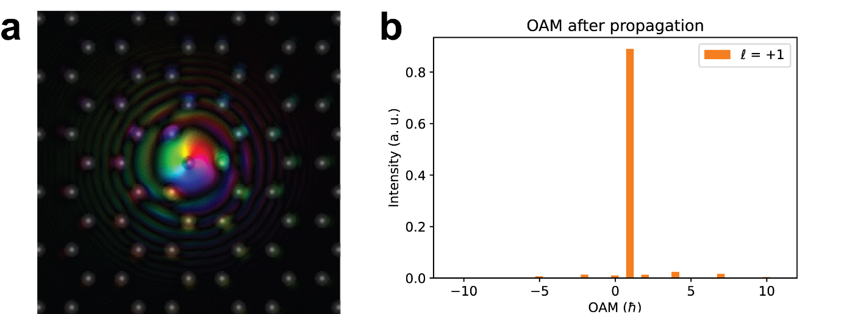
Figure S4. Simulation of the effect of propagation of a wavefunction with $l=+1$from a top B atom (centered on the probe axis) through a h-BN film of thickness $t=10$ nm. The emitted wave function was propagated using a multi-slice algorithm through the sample thickness to estimate the effect of the crystal on OAM broadening. a) Exit wave function at the lower of the sample (with color and brightness representing phase and amplitude, respectively). b) OAM profile of the exit wave function. Most of the intensity is on the $l=+1$ winding number. Small contributions at $+1±3$is seen may contribute to the tail of the OAM distribution seen at large $l$ in the experimental spectra.

S3. Further details of simulations with synthetic data
Taking into account the previously discussed effects, synthetic data were simulated to compare with the experimental measurements. XANES spectra (equivalent to EEL spectra) were calculated for photon polarization in the [001] direction for the π* component (at $l=0$) and for photon polarization in the [100] direction for the σ* component (resulting in identical contributions for $l=+1$ and $l=-1$). In order to mimic the experimental EEL spectra, the calculated spectra were convolved with a Gaussian function to include the experimental energy resolution of Δ$E=0.9$ eV and an increasing energy broadening was added based on an empirical model [37] to include final state effects (i.e., the lifetimes of the excitations), which cannot be predicted using ground state DFT calculations (Fig. S5).
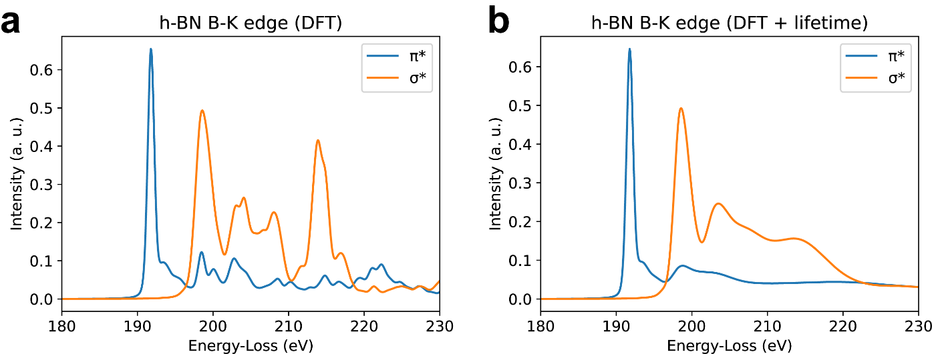
Figure S5. a) π* component (at $l=0$) and σ* component (at $l=±1)$ calculated using DFT. b) As for a), but after considering empirical lifetime broadening of the final states.
OAM profiles were then calculated by using a Monte Carlo (MC) statistical method by considering 200 scattering events in the illuminated area and a probe with a convergence semi-angle of 5.4 mrad (Fig. S6a), which was further convolved with the experimental OAM point spread function (psf), which was measured in vacuum at $E=0$eV (zero loss spectrum, Fig. S6b).
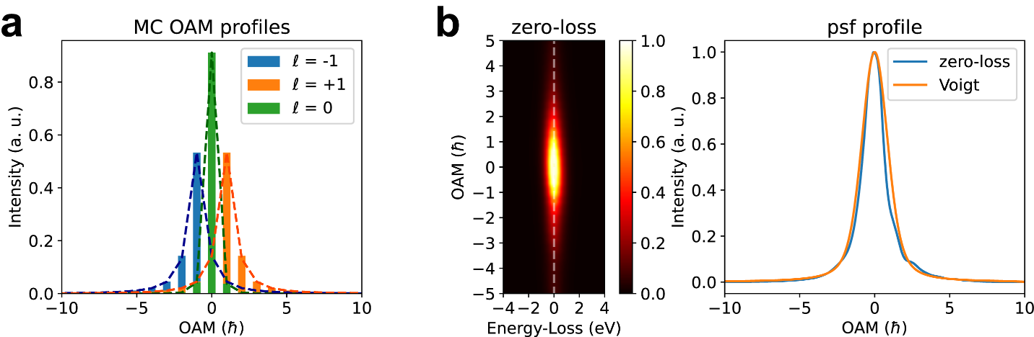
Figure S6. a) OAM distributions for winding numbers of $l=0,±1$ obtained by considering scattering delocalization (at $E∼200$ eV as for the B K edge) and a finite probe size using the procedure depicted in Fig. 3 in the manuscript. b) Experimental OAM psf measured from a zero-loss spectrum ($l=0$) and its integral along the energy axis, which is well described by a Voigt profile. These profiles are used as inputs for convolution in OAM to obtain the 2D spectrum in both the energy (x) direction and the OAM (y) dispersion direction, for comparison with the case of infinite OAM resolution shown in Fig. S7.
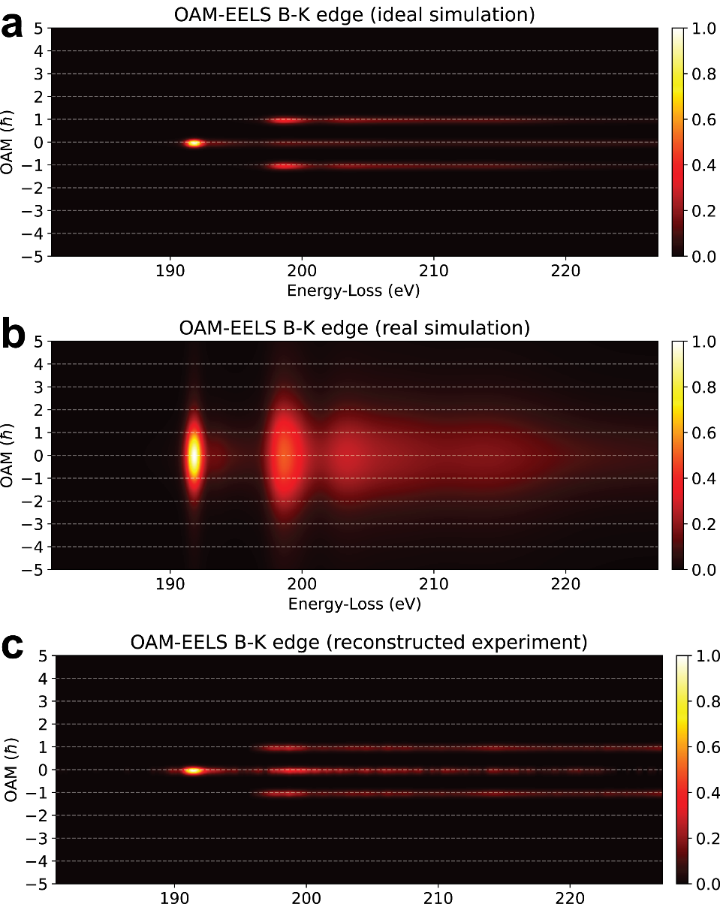
Figure S7. a) Ideal case of OAM-EELS from the B K edge for perfect (infinite) OAM resolution. b) Real case after convolution with the profiles shown in Fig. S6. c) Reconstructed OAM-EELS from the experiment show in Fig. S1a. The intensity of the three components is calculated from the integral of the OAM profiles shown in Fig. 2b in the main text. In a) and c), the spectra were convolved with a Gaussian function with $σ=0.25$ħ for better visualization.
Just as for the experimental data, the simulated 2D spectrum after convolution (Fig. S7b) was processed by extracting the first three principal components using NMF decomposition (as shown in Fig. 2 in the manuscript). The simulated profiles have many similarities to the experimental retrieved components, supporting the reliability of the method.

