Supplementary table 1. Characteristics of 25 sugarcane leaf samples collected in Cameroon for investigation of viruses causing mosaic-like symptoms.
Sugarcane  variety | Symptomsª | RT-PCR SCMV/SrMV^{b} | RT-PCR SCSMV^{c} | VANA-based metagenomics^{d} | SCSV PCR on RCA^{e} | No. of cloned SCSV genomes
B46364 | + | + | -
B46364 | - | - | -
RB92579 | + | - | - | SCSV | + | 2
RB92579 | - | - | -
CP722086 | + | + | -
CP722086 | - | - | -
RCMR180578 | + | + | -
RCMR180578 | - | - | - | -
RCMR180357 | + | - | - | SCSV | + | 1
RCMR180357 | - | - | -
Q255 | + | + | -
Q255 | - | - | - | -
KN07-0032 | + | - | - | SCSV | + | 2
KN07-0032 | - | - | -
N14 | + | + | -
N14 | - | - | -
CP09-1952 | - | - | -
B87743 | - | - | -
GT24 | - | - | -
PSR07-70 | - | - | -
KN07-0028 | - | - | -
R93136 | - | - | -
FR81258 | + | - | - | SCSV | + | 0
Clone Stage 1 | + | + | -
B87743 | + | + | -

ª + = presence of mosaic-like symptoms on the leaf blade; - = no symptoms.
^{b} SCMV = sugarcane mosaic virus, SrMV = sorghum mosaic virus; RT-PCR assay performed with ARN extracts and primers oligo1-2 [14]; + = amplicon of 327 bp, - = no amplification product.
^{c} SCSMV = sugarcane streak mosaic virus; RT-PCR assay performed with ARN extracts and primers ST2-ST5 [15]. + = amplicon of 400 bp, - = no amplification product.
^{d} VANA = virion-associated nucleic acid; SCSV = presence of sugarcane chlorotic streak virus sequences, - = absence of plant virus sequences.
^{e} SCSV PCR assay using DNA amplified by rolling circle amplification (RCA) and two primer pairs previously designed [4]

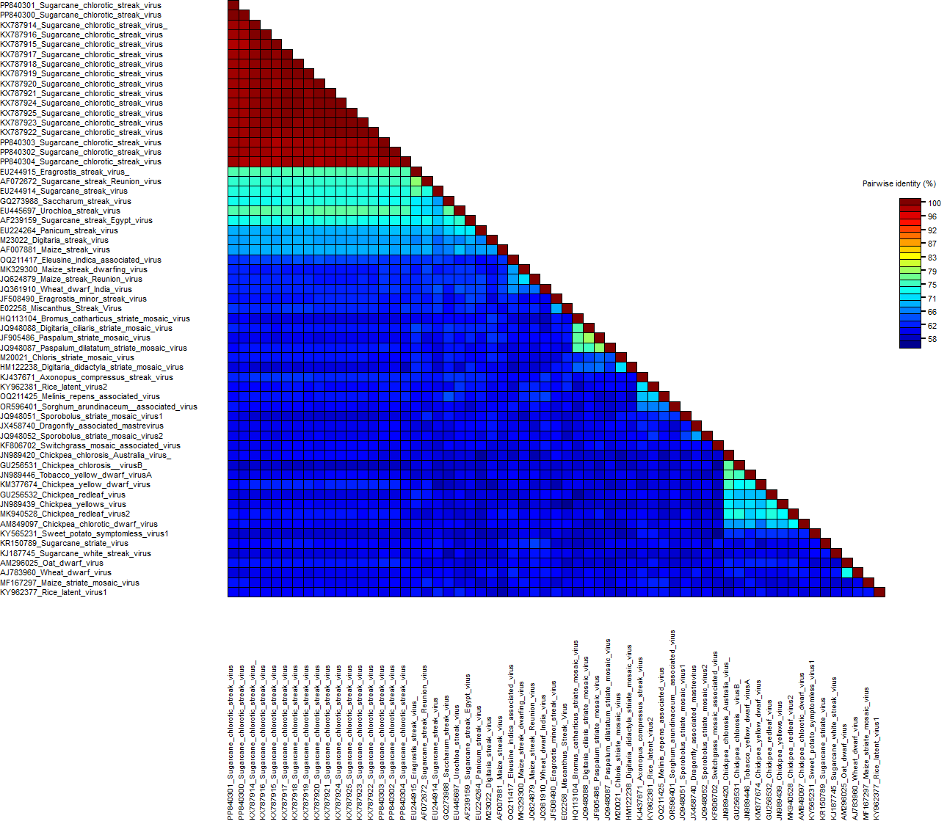
Supplementary figure 1. Identity matrix of five isolates of sugarcane chlorotic streak virus (SCSV) from Cameroon, 12 SCSV isolates from Nigeria, and 44 isolates of Mastrevirus species.

