Table 1 List of compounds of G. biloba with structures, SMILES format, and PubChem ID

Sr.  No. | Compounds | PubChem ID | SMILES format | Structure
 | Quercetin | 5280343 | C1=CC(=C(C=C1C2=C(C(=O)C3=C(C=C(C=C3O2)O)O)O)O)O | 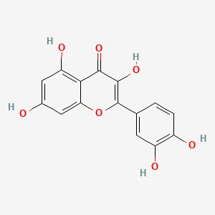
 | Kempferol | 5280863 | C1=CC(=CC=C1C2=C(C(=O)C3=C(C=C(C=C3O2)O)O)O)O | 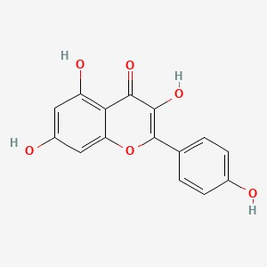
 | Isorhamnetin | 5281654 | COC1=C(C=CC(=C1)C2=C(C(=O)C3=C(C=C(C=C3O2)O)O)O)O | 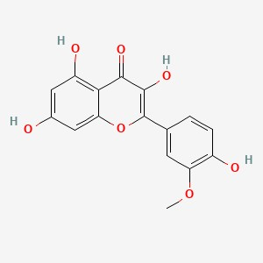
 | Luteolin | 5280445 | C1=CC(=C(C=C1C2=CC(=O)C3=C(C=C(C=C3O2)O)O)O)O | 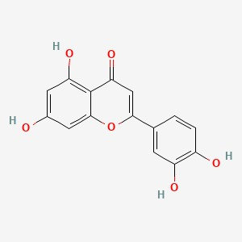
 | Rutin | 5280805 | CC1C(C(C(C(O1)OCC2C(C(C(C(O2)OC3=C(OC4=CC(=CC(=C4C3=O)O)O)C5=CC(=C(C=C5)O)O)O)O)O)O)O)O | 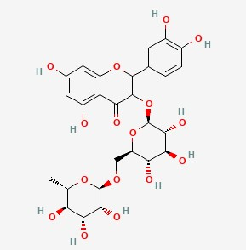
 | Myricetin | 5281672 | C1=C(C=C(C(=C1O)O)O)C2=C(C(=O)C3=C(C=C(C=C3O2)O)O)O | 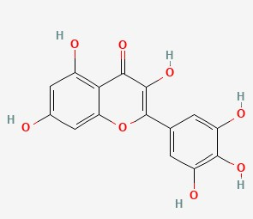
 | Ginkgolide A | 9909368 | CC1C(=O)OC2C1(C34C(=O)OC5C3(C2)C6(C(C5)C(C)(C)C)C(C(=O)OC6O4)O)O | 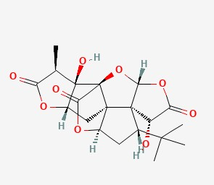
 | Ginkgolide B | 65243 | CC1C(=O)OC2C1(C34C(=O)OC5C3(C2O)C6(C(C5)C(C)(C)C)C(C(=O)OC6O4)O)O | 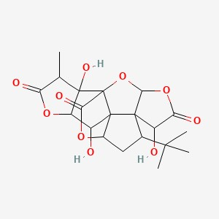
 | Ginkgolide C | 24721502 | CC1C(=O)OC2C1(C34C(=O)OC5C3(C2O)C6(C(C5O)C(C)(C)C)C(C(=O)OC6O4)O)O
 | Ginkgolide J | 24721483 | CC1C(=O)OC2C1(C34C(=O)OC5C3(C2)C6(C(C5O)C(C)(C)C)C(C(=O)OC6O4)O)O | 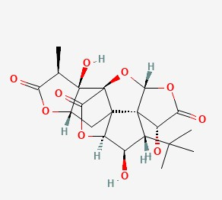
 | Ginkgolide M | 12310208 | CC1C2C(C(C34C25C(=O)OC3C(C(C46C(C(=O)OC6O5)O)C(C)(C)C)O)O)OC1=O | 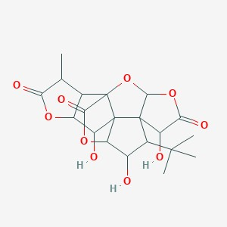
 | Sciadopitysin | 5281696 | COC1=CC=C(C=C1)C2=CC(=O)C3=C(O2)C(=C(C=C3O)O)C4=C(C=CC(=C4)C5=CC(=O)C6=C(C=C(C=C6O5)OC)O)OC | 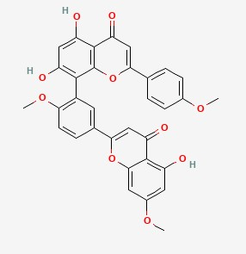
 | Ginkgetin | 5271805 | COC1=C(C=C(C=C1)C2=CC(=O)C3=C(C=C(C=C3O2)OC)O)C4=C(C=C(C5=C4OC(=CC5=O)C6=CC=C(C=C6)O)O)O | 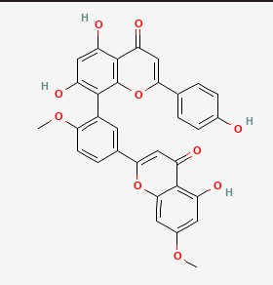
 | Isoginkgetin | 5318569 | COC1=CC=C(C=C1)C2=CC(=O)C3=C(O2)C(=C(C=C3O)O)C4=C(C=CC(=C4)C5=CC(=O)C6=C(C=C(C=C6O5)O)O)OC | 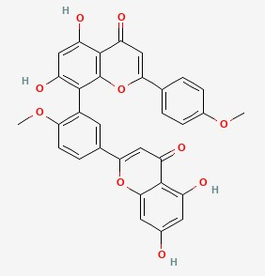
 | Amentoflavone | 5281600 | C1=CC(=CC=C1C2=CC(=O)C3=C(O2)C(=C(C=C3O)O)C4=C(C=CC(=C4)C5=CC(=O)C6=C(C=C(C=C6O5)O)O)O)O | 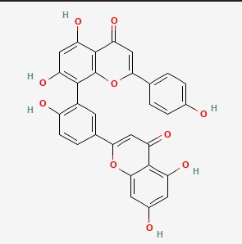
 | Bilobetin | 5315459 | COC1=C(C=C(C=C1)C2=CC(=O)C3=C(C=C(C=C3O2)O)O)C4=C(C=C(C5=C4OC(=CC5=O)C6=CC=C(C=C6)O)O)O | 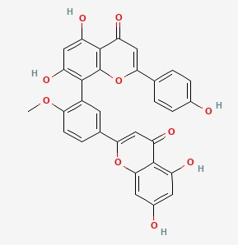
 | 5’-methoxybilobetin | 5319411 | COC1=CC(=CC(=C1OC)C2=C(C=C(C3=C2OC(=CC3=O)C4=CC=C(C=C4)O)O)O)C5=CC(=O)C6=C(C=C(C=C6O5)O)O | 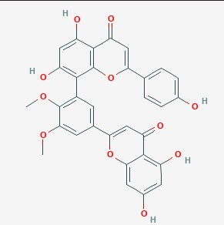
 | Bilobalide | 73581 | CC(C)(C)C1(CC2C3(C14C(C(=O)OC4OC3=O)O)CC(=O)O2)O | 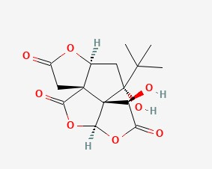
 | Ginkgolic acid | 5281858 | CCCCCCC=CCCCCCCCC1=C(C(=CC=C1)O)C(=O)O | 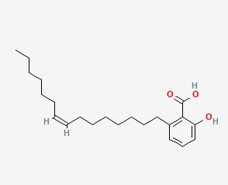
 | Shikimic acid | 8742 | C1C(C(C(C=C1C(=O)O)O)O)O | 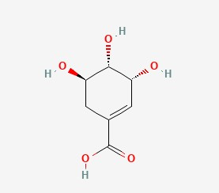
 | Kynurenic acid | 3845 | C1=CC=C2C(=C1)C(=O)C=C(N2)C(=O)O | 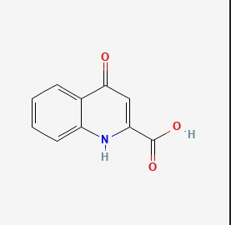
 | Proanthocyanidin | 107876 | C1C(C(OC2=CC(=CC(=C21)O)O)C3=CC(=C(C=C3)O)O)OC4(C(C(C5=C(C=C(C=C5O4)O)O)O)O)C6=CC(=C(C=C6)O)O | 