SUPPLEMENTARY (S) Files
S1- PDB and PDBQT structures of target proteins (Myeloperoxidase (MPO, PDB ID: 5MFA), ERAP (PDB ID: 5ABO), DPP4 (PDB ID: 3GOB), PPAR-α (PDB ID: 6W9L), and ET_{B} (PDB ID: 5X93))
Name of Protein | PDB STRUCTURE | PDBQT
MPO | 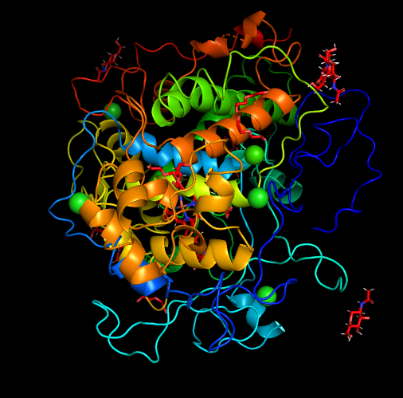 | 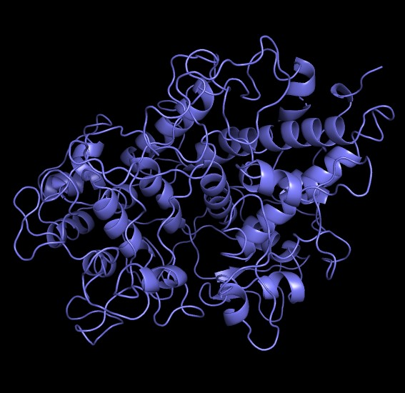
ERAP-2 | 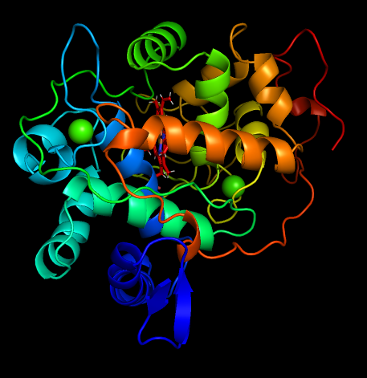 | 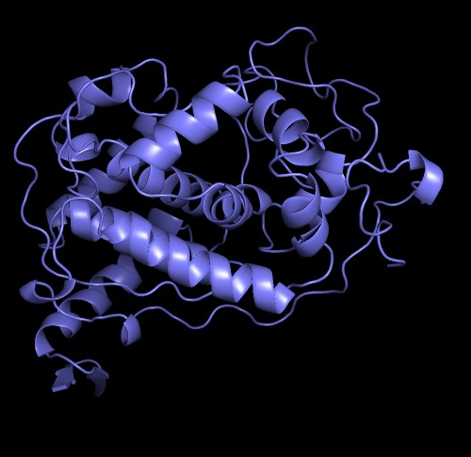
DPP-4 | 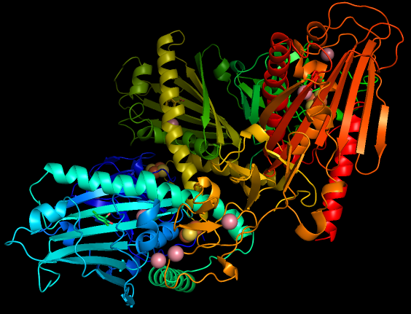 | 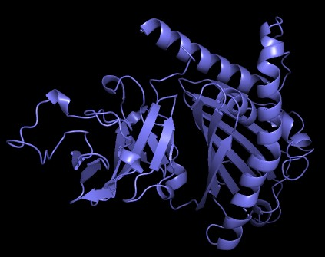
PPAR-α | 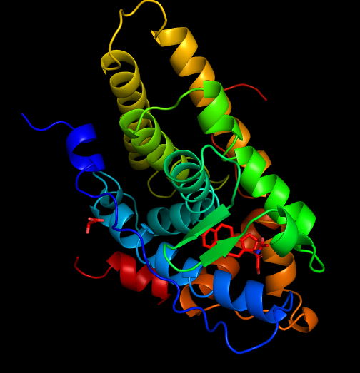 | 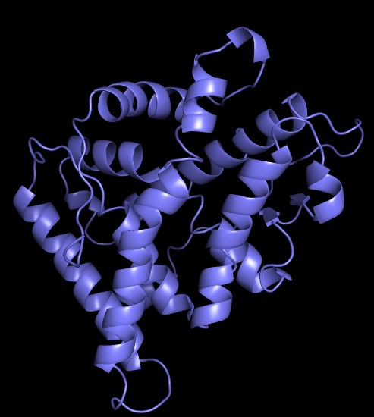
ET_{B} | 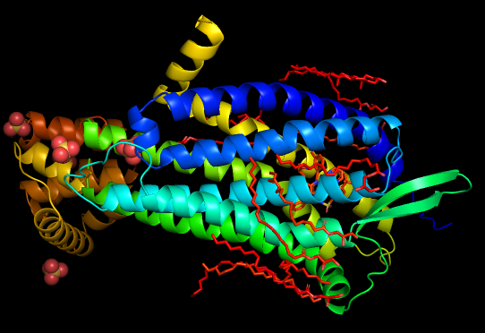 | 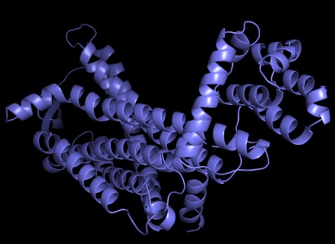

S2- Pearson correlation coefficient calculated across datasets (3GOB, 5MFA, 5X93, 6W9L, and 5ABO) that were derived from various software tools (RASPD+ and VINA)
Correlations | 3GOB  RASPD+ | VINA | 5MFA  RASPD+ | VINA.1 | 5X93  RASPD+ | VINA.2 | 6W9L  RASPD+ | VINA.3 | 5ABO  RASPD+ | VINA.4
3GOB  RASPD+ | 1 | 0.562729 | 0.955973 | 0.448988 | 0.865735 | 0.44454 | 0.72263 | 0.258236 | 0.955693 | 0.142315
VINA | 0.562729 | 1 | 0.685354 | 0.512537 | 0.664074 | 0.494242 | 0.382188 | 0.316079 | 0.681689 | 0.323478
5MFA  RASPD+ | 0.955973 | 0.685354 | 1 | 0.461301 | 0.933597 | 0.501137 | 0.587954 | 0.289635 | 0.987414 | 0.18876
VINA.1 | 0.448988 | 0.512537 | 0.461301 | 1 | 0.329994 | 0.933867 | 0.455269 | 0.895641 | 0.464446 | 0.821456
5X93  RASPD+ | 0.865735 | 0.664074 | 0.933597 | 0.329994 | 1 | 0.396386 | 0.568567 | 0.211387 | 0.9433 | 0.05889
VINA.2 | 0.44454 | 0.494242 | 0.501137 | 0.933867 | 0.396386 | 1 | 0.426633 | 0.929571 | 0.503157 | 0.860615
6W9L  RASPD+ | 0.72263 | 0.382188 | 0.587954 | 0.455269 | 0.568567 | 0.426633 | 1 | 0.339029 | 0.649649 | 0.092743
VINA.3 | 0.258236 | 0.316079 | 0.289635 | 0.895641 | 0.211387 | 0.929571 | 0.339029 | 1 | 0.302519 | 0.872048
5ABO  RASPD | 0.955693 | 0.681689 | 0.987414 | 0.464446 | 0.9433 | 0.503157 | 0.649649 | 0.302519 | 1 | 0.163929
VINA.4 | 0.142315 | 0.323478 | 0.18876 | 0.821456 | 0.05889 | 0.860615 | 0.092743 | 0.872048 | 0.163929 | 1

S3- Molecular docking interactions of MPO with sixteen compounds each of G. biloba
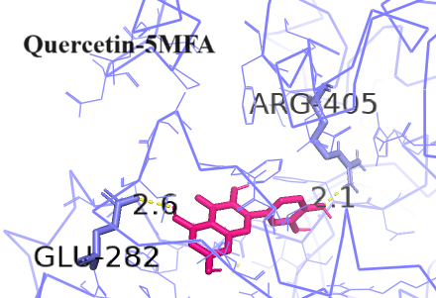 | 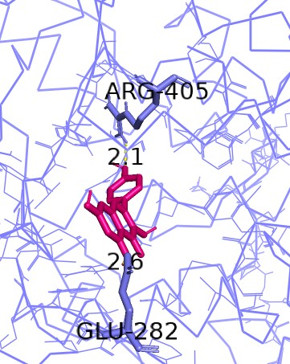
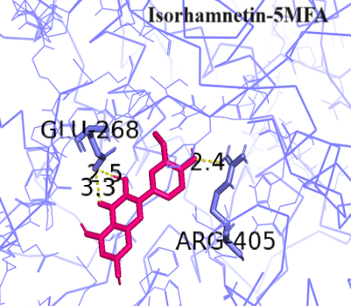 | 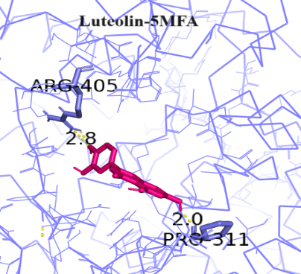
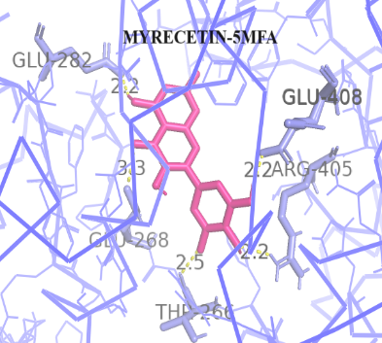 | 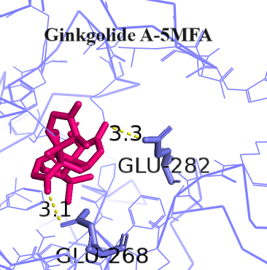
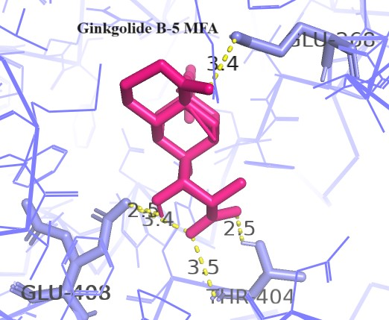 | 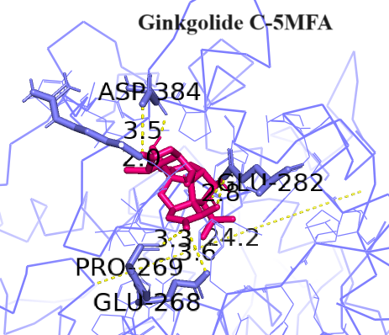
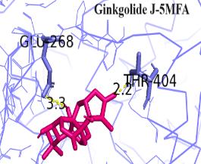 | 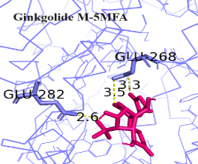
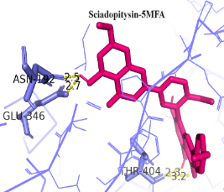 | 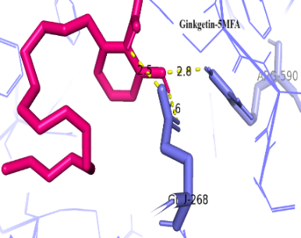
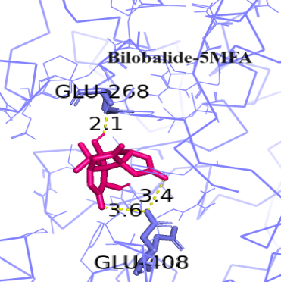 | 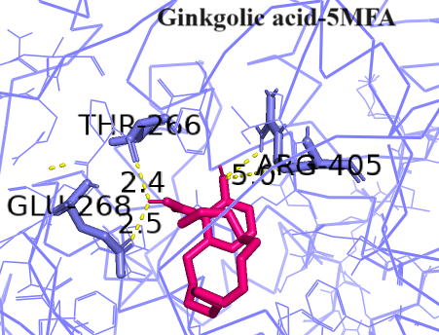
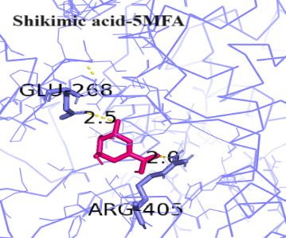 | 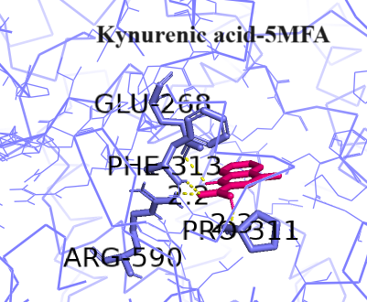

S4- Molecular docking interactions of ERAP-2 with seventeen compounds of G. biloba
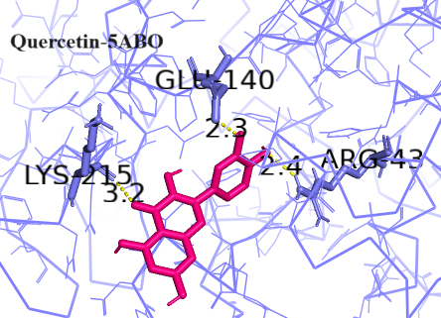 | 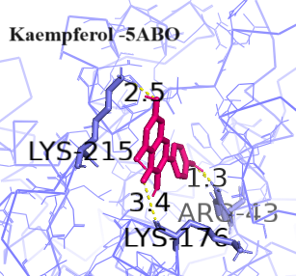
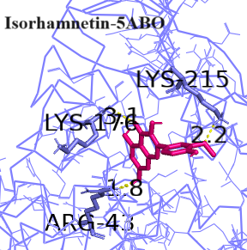 |  | 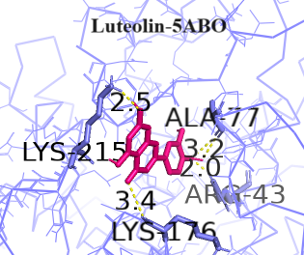
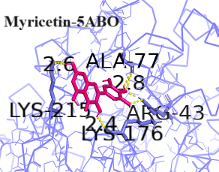 |  | 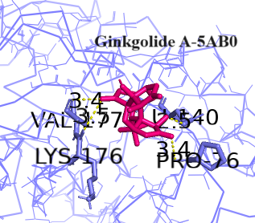
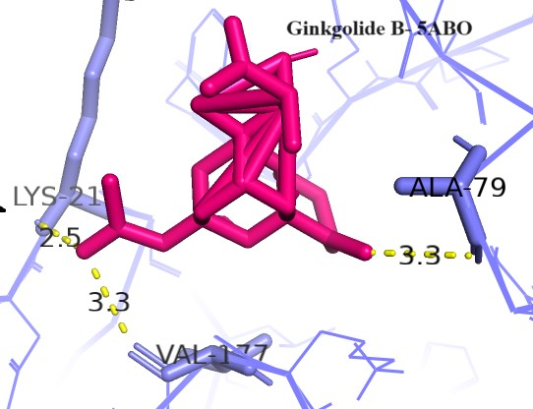 |  | 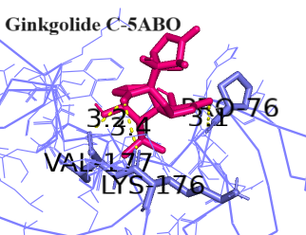
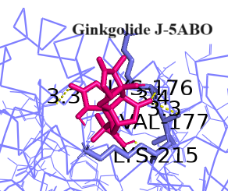 |  | 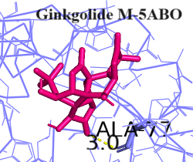
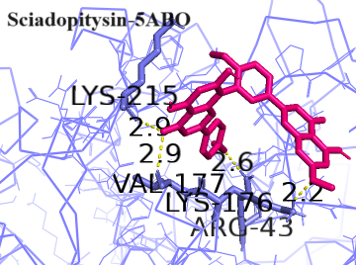 |  | 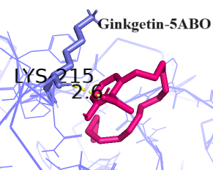
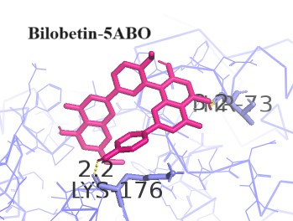 |  | 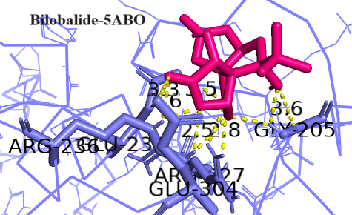
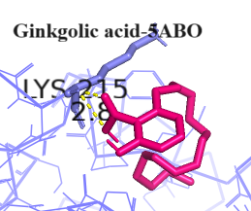 |  | 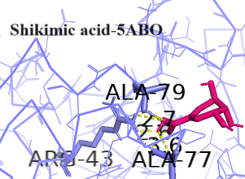
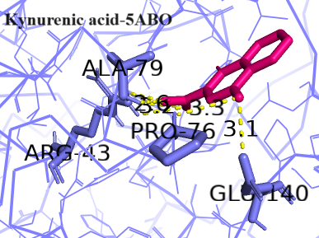

S5- Molecular docking interactions of DPP-4 with sixteen compounds of G. biloba
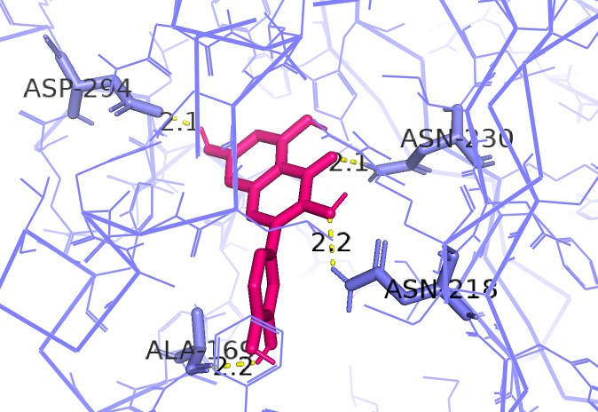 | 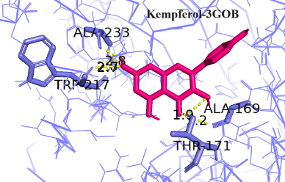
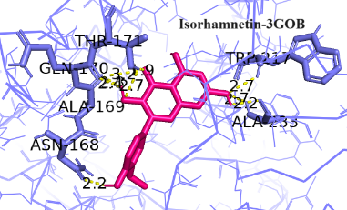 | 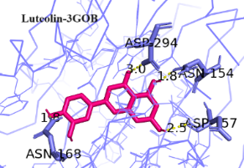
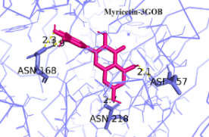 | 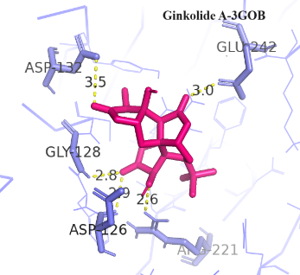
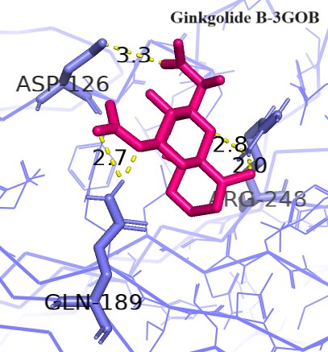 | 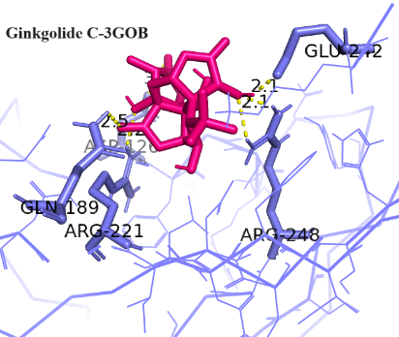
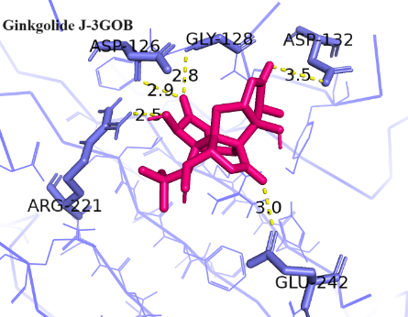

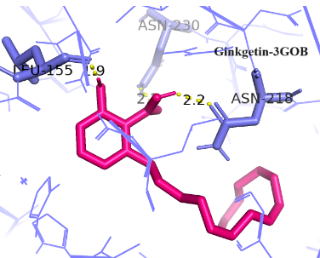 | 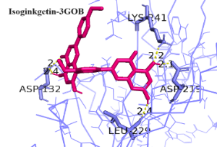
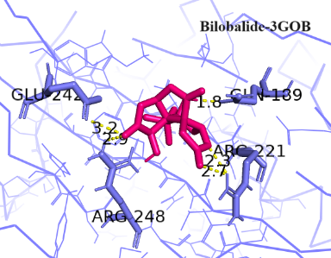 | 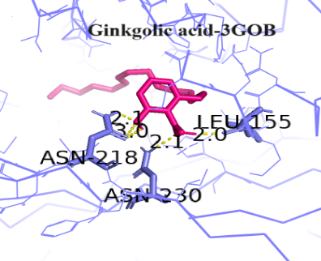
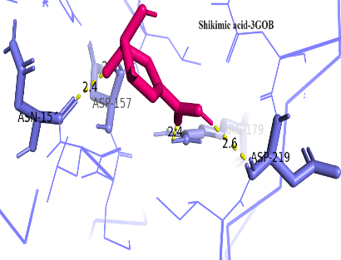 | 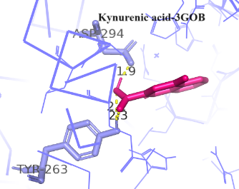

S6- molecular docking interactions of PPARα with seventeen compounds of G. biloba
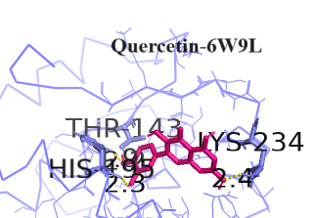 | 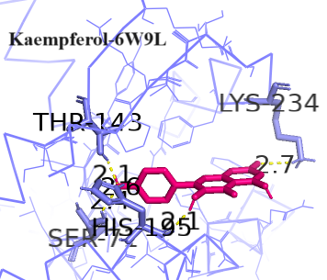
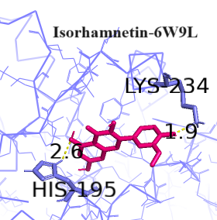 | 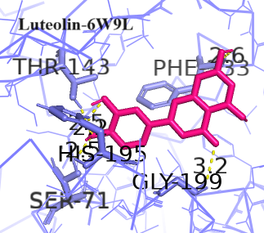
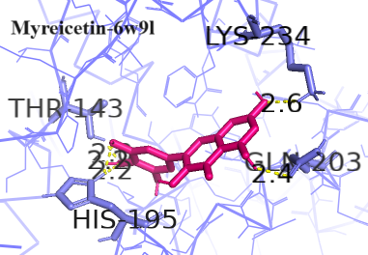 | 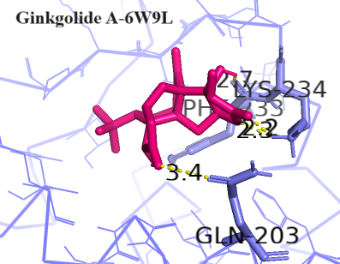
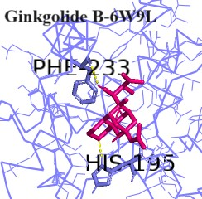 | 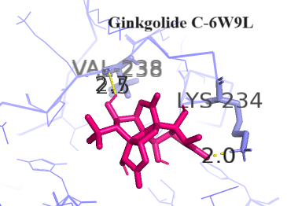
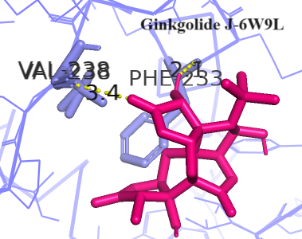 | 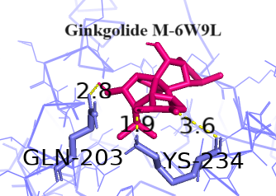
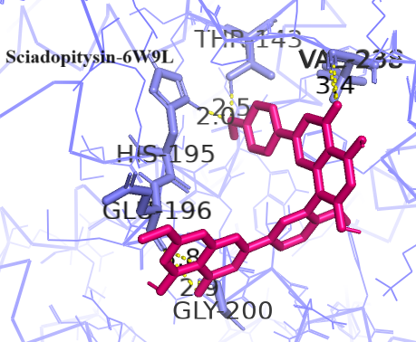 | 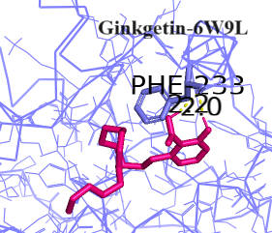
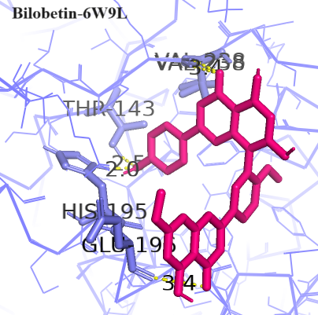 | 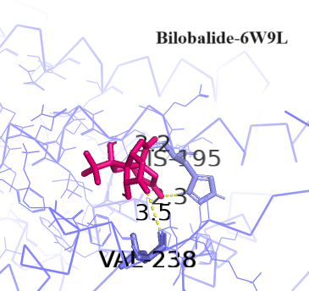
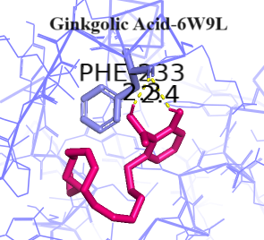 | 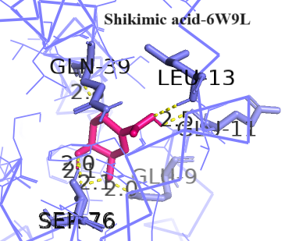
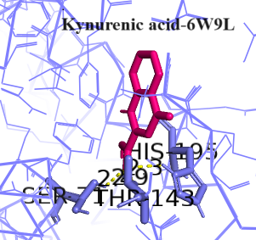

S7- Molecular docking interactions of ET_{B} with seventeen compounds of G. biloba
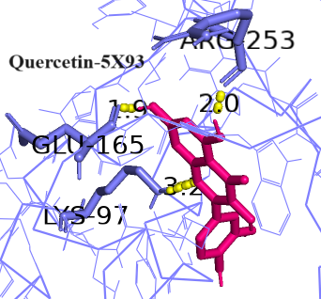 | 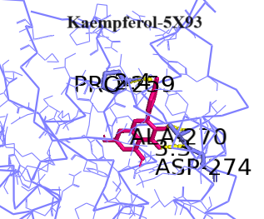
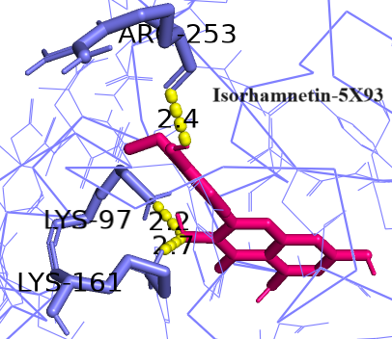 | 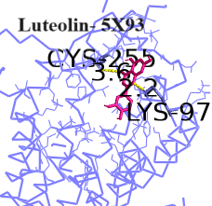
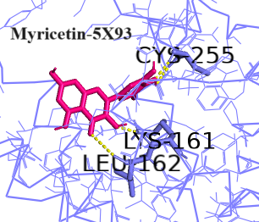 | 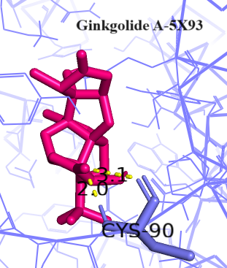
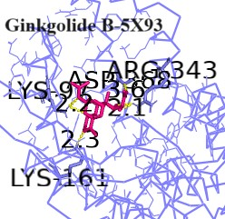 | 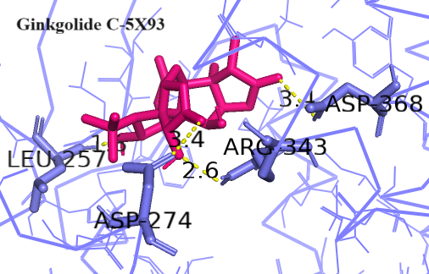
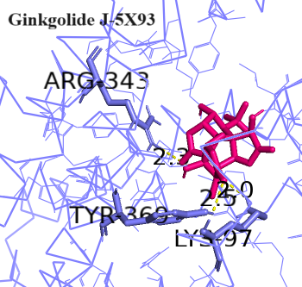 | 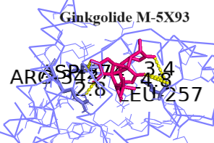
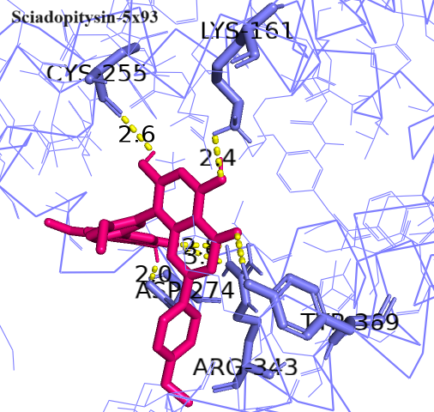 | 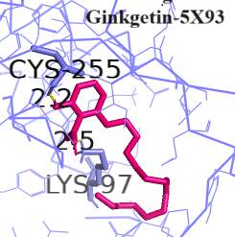
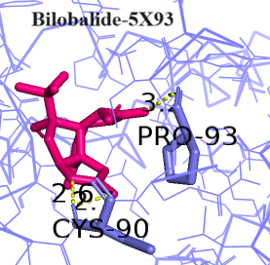 | 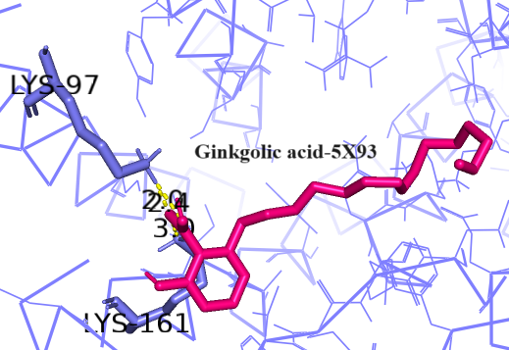
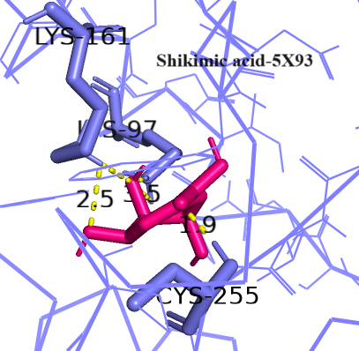 | 