Supplemental Materials

Figure legend
Supplementary Figure. 1. Kaplan-Meier curves for the relapse-free survival rates of PPC and NPC stage IA endometrial cancer patients
NPC: negative peritoneal cytology, PPC: positive peritoneal cytology, RFS: Relapse-free survival

Supplementary Figure. 2. Kaplan-Meier curves for the relapse-free survival rate of PPC stage IA endometrial cancer patients for different histological types
PPC: positive peritoneal cytology, RFS: Relapse-free survival

Supplementary Figure. 3. Kaplan- Meier curves for overall survival rates of PPC stage IA endometrial cancer patients with and without adjuvant chemotherapy (type II).
PPC: positive peritoneal cytology

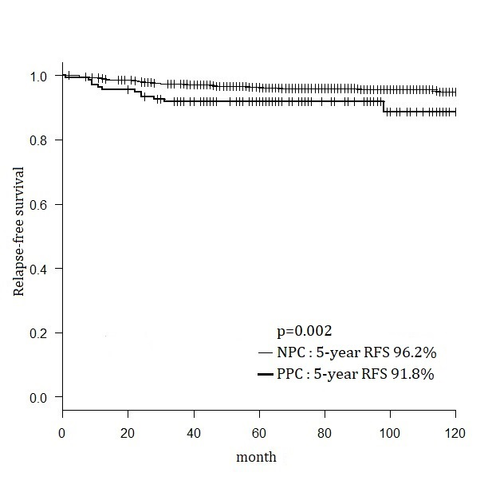

Supplementary Figure. 1

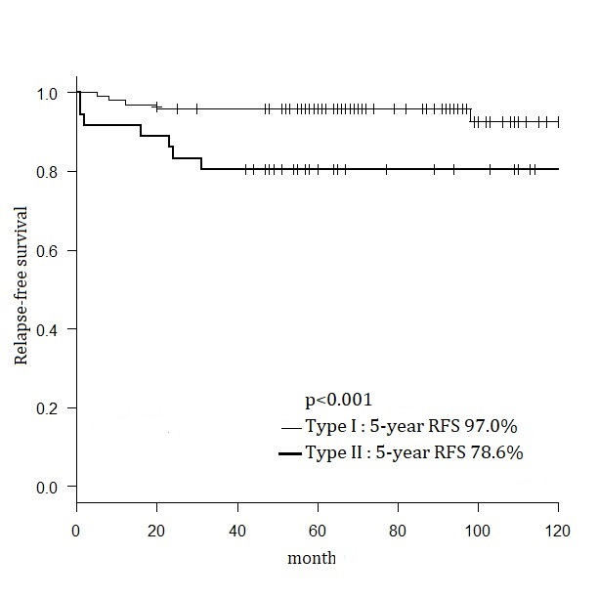

Supplementary Figure. 2

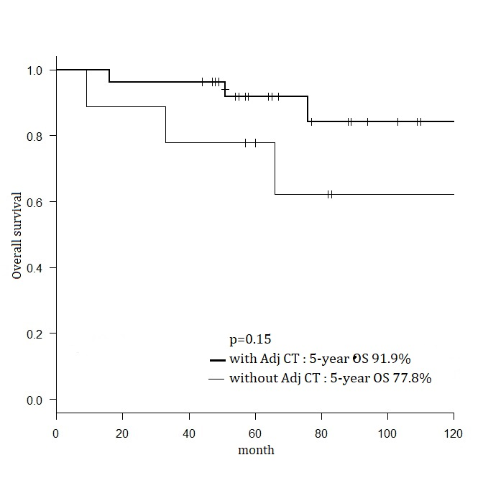

Supplementary Figure. 3

